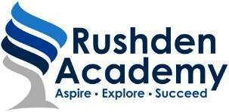



8th December 2020 Our ref : PCH/jes

Dear Parents and Carers

**Sixth Form applications**

Following our very successful Year 11 Post 16 Pathway meetings that took place last week, I am writing to inform you that we are now accepting applications for the Sixth Form at Rushden Academy.

Post 16, we work closely with our partners to offer a wide range of A level and Level 3 BTEC courses, with a proven track record. Year on year our students gain places at top universities including Oxford and Cambridge.

In addition to their subject lessons, students also follow a wide ranging PSHE and enrichment programme that includes residential trips, university visits, overseas visits, theatre trips, and sporting competitions.

An online application form can be completed via this link:- [Application form](https://forms.gle/3BY9HCmwfaWeepZp9)

Alternatively a paper copy can be made available on request. I have also included a link to the Sixth Form prospectus with this email, so that you can look in more depth at the courses that we have on offer.

If you have any questions or require any further information, then please do not hesitate to contact myself via the email address given below.

Yours sincerely



Mr P Chapman

Head of Sixth Form

[p.chapman@rushden-academy.net](mailto:p.chapman@rushden-academy.net)

