**Figure 5 Close u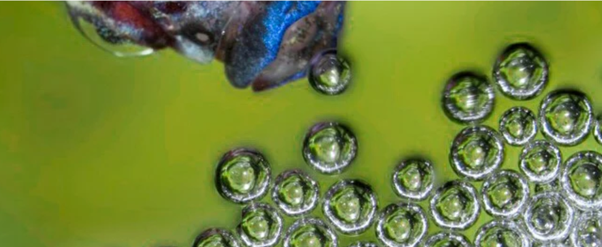p image of a Beta Fish forming a bubble structure.**