TECHNICAL HOW-TO GUIDE

Leakage-Safe Evaluation of an ROI Classifier
Reproduce five-fold model evidence with fold-local synthetic augmentation
Finley Thomson · Monem Moheq · Srinivas Suggu · Jarrod Hwang
CMPT 310 – D100 Introduction to Artificial Intelligence, Summer 2026
This guide shows another CMPT 310 student how to install, run, inspect, and troubleshoot the project’s canonical model-evaluation pipeline. The key technique is keeping synthetic generation inside each training fold, so every reported test result comes from a real project unseen during fitting or distribution estimation.
Input  A 224-row project-level CSV with seven prediction features and Low/Medium/High labels. | Process  Stratified five-fold evaluation of a majority baseline and random forests. | Output  CSV/JSON metrics, confusion matrices, comparison plot, and reproducibility manifest.

What you will learn
- Create an isolated Python environment and verify the data contract.
- Run a fast real-only comparison and the full custom/synthetic experiment.
- Explain why generating synthetic samples before splitting would leak information.
- Read accuracy, macro-F1, ordinal error, and normalized confusion matrices.
- Diagnose missing modules, columns, stale artifacts, and slow custom training.

Prerequisites
Item | Recommended | Check
Python | 3.11+; evidence runtime 3.12.13 | python --version
Shell | Terminal, PowerShell, or VS Code | Open at repository root
Disk | At least 500 MB | Use a new output folder
Files | Model/, Data/, requirements.txt | Do not run inside Model/
Scope: This guide reproduces evaluation from the included final modeling CSV. Historical preprocessing scripts are not a clean raw-to-final pipeline because some upstream files and a local coordinate-conversion module are absent.

1. Set up the environment and verify the data

1 · Open the repository root
The directory should contain Model, Data, Artifacts, tests, and requirements.txt.
cd CMPT310_Project_Group-14
python --version

2 · Create and activate a virtual environment
python -m venv .venv
# macOS/Linux
source .venv/bin/activate
# Windows PowerShell
.venv\Scripts\Activate.ps1

3 · Install the canonical dependencies
The evaluation requires NumPy, pandas, scikit-learn, and Matplotlib.
python -m pip install --upgrade pip
python -m pip install -r requirements.txt

4 · Run the tests before a model experiment
Expected result: Ran 5 tests ... OK
python -m unittest discover -s tests -v

5 · Confirm the modeling table exists
The evaluator checks columns, missing values, consecutive labels, and outcome-column leakage.
Data/CSVs/Sorted/TH_DATA_BY_PROJECT_FINAL.csv

Required feature headers
- Initial Assessment
- Income
- Cost Per Unit
- Distance To Downtown
- Distance To Nearest Transit Stop
- Distance to Nearest Park
- Distance to Nearest Public School
Leakage rule: Final Assessment, ROI, and Classification are needed for labeling and evaluation but must never be added to FEATURE_COLUMNS.

Data-flow mental model
Real table  224 labeled projects | Stratified split  ~179 train / 44–45 test | Optional synthesis  Fit generator on train only | Fit model  Real or real+synthetic train | Score  Held-out real test

2. Run the evaluation and find the outputs

1 · Run the fast, recommended comparison
This evaluates the majority baseline and scikit-learn forests using real-only and synthetic training data.
python -m Model.EvaluateModels \
+ --models dummy sklearn \
+ --output-dir Artifacts/FinalRun

2 · Read the terminal summary
A successful run reports dataset size, class balance, fold sizes, and final metrics.
Loaded 224 real projects ...
Classes: Low ROI=75, Medium ROI=74, High ROI=75
scikit RF (real only): accuracy=0.446±0.085, macro-F1=0.444±0.084
scikit RF (+3000 synthetic): accuracy=0.384±0.048, macro-F1=0.306±0.037

3 · Optionally run the custom forest
The custom implementation is slower. Reduce trees only for debugging, not for comparison with saved evidence.
python -m Model.EvaluateModels \
+ --models dummy sklearn custom \
+ --output-dir Artifacts/FinalRunAll

4 · Inspect the artifact directory
The folder contains one comparison plus per-model summaries, fold metrics, class metrics, and confusion matrices.
Artifacts/FinalRun/
├── model_comparison.csv / .png
├── run_manifest.json
├── scikit_rf_real_only_metrics.json
├── scikit_rf_real_only_fold_metrics.csv
├── scikit_rf_real_only_per_class_metrics.csv
└── scikit_rf_real_only_confusion_matrix_*.png
Reproducibility check: run the same command twice with seed 310 in two new directories and compare metric CSV/JSON files. Timestamps and absolute manifest paths can differ; numeric evidence should match.

Useful command-line variations
Use --data for another compatible table, --seed 310 for the deterministic seed, and --synthetic-samples to compare augmentation sizes. Always pair each configuration with a distinct --output-dir.

3. Interpret the visual evidence
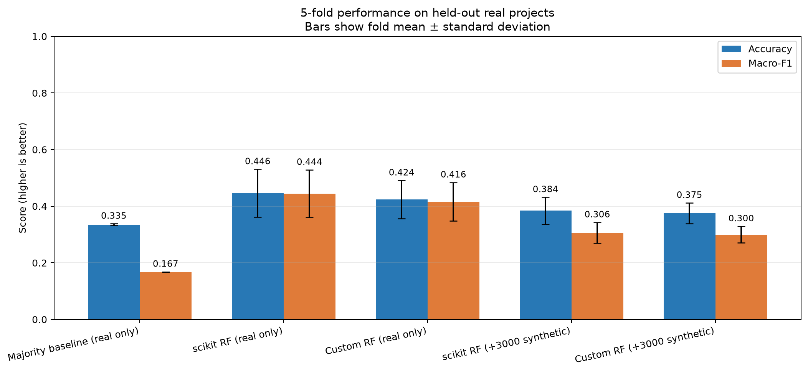  Figure 1. Fold means and standard deviations on real held-out projects. | 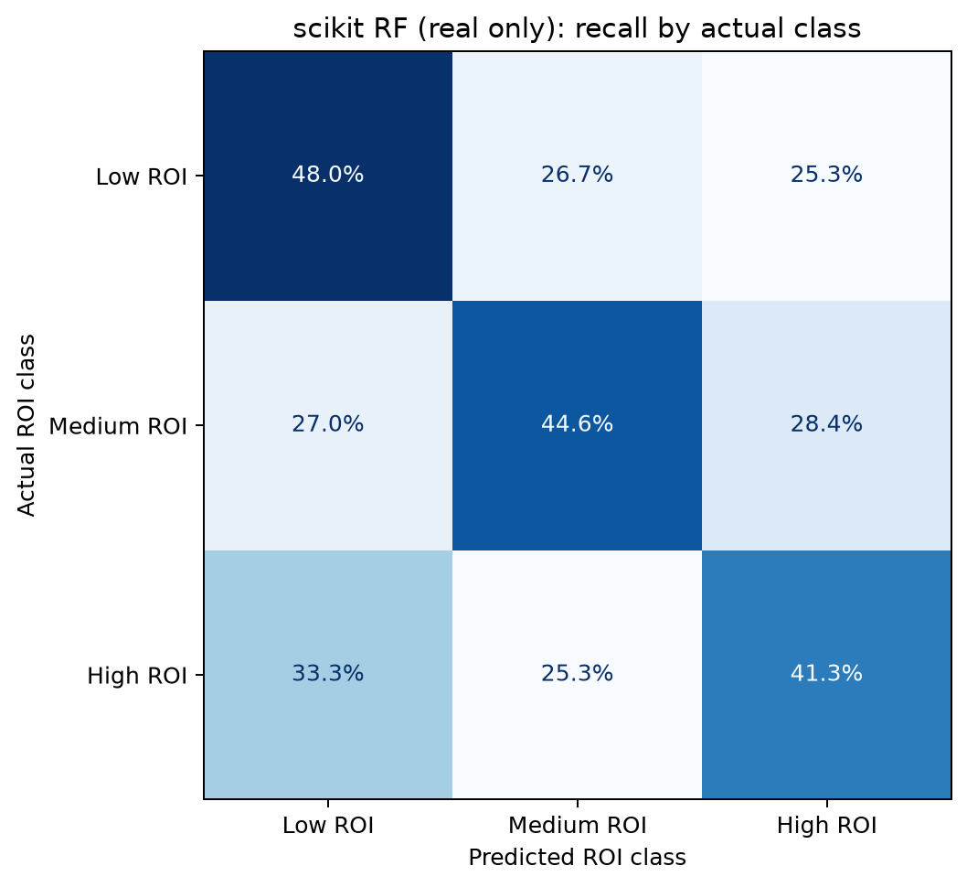  Figure 2. Each row sums to 100%; the diagonal is class recall.

Read the comparison chart
- Start with the baseline: 33.5% accuracy but 16.7% macro-F1. Predicting one class fails the other two.
- The real-only scikit-learn forest is highest at 44.6% accuracy and 44.4% macro-F1.
- The selected model varies by about 8.5 percentage points across folds; this is not a deployment guarantee.
- Both synthetic variants decline, so augmentation is a negative result.

Read the normalized confusion matrix
Rows are actual classes and columns are predicted classes. Diagonal recall is 48.0% Low, 44.6% Medium, and 41.3% High. The top-right and bottom-left cells are severe two-level errors: 44 cases, or 19.6% of the dataset.
Macro-F1  Averages class-specific F1 without support weighting. It exposes failure to predict a class. | Ordinal MAE  A one-level miss costs 1 and Low↔High costs 2. Lower is better; selected model 0.750 versus baseline 1.000.

Understand the fold-local code
for train_indices, test_indices in splitter.split(real_data, y_all):
train_real = real_data.iloc[train_indices]
test_real = real_data.iloc[test_indices]
synth_data = generate(train_real, n=synthetic_samples)
training_data = concat(train_real, synth_data)
model.fit(training_data[features], training_data[target])
predictions = model.predict(test_real[features]) # real only
Do not overclaim: 85.0% mean training accuracy versus 44.6% test accuracy is a large overfit signal. Report modest evidence above baseline, not an accurate investment predictor.

4. Troubleshooting, code samples, and reuse
Symptom | Likely cause | Fix
ModuleNotFoundError: Model | Command started inside Model/ or as a file path. | Return to repository root and run python -m Model.EvaluateModels.
NumPy/pandas/sklearn/Matplotlib missing | Wrong or inactive environment. | Activate .venv and reinstall requirements.txt.
Dataset is missing columns | Headers changed or an intermediate CSV was supplied. | Use the final CSV and preserve exact headers.
Modeling columns contain missing values | Input merge left unmatched values. | Audit the join/imputation; do not silently drop rows after seeing results.
Custom run takes much longer | Pure-Python tree search across folds. | Omit custom for a smoke test or reduce trees only while debugging.
Old and new values appear together | An output directory was reused. | Use a new empty output directory for each run.
Legacy preprocessing import fails | Missing upstream data, haversine, or local coordinate module. | Use the canonical final CSV until legacy inputs are repaired/documented.

Minimal metrics code sample
from sklearn.metrics import accuracy_score, f1_score
accuracy = accuracy_score(y_true, y_pred)
macro_f1 = f1_score(
y_true, y_pred, labels=[0, 1, 2],
average='macro', zero_division=0,
)
ordinal_mae = abs(y_pred - y_true).mean()

Final evidence checklist
- Save the exact command, dataset hash, seed, versions, fold metrics, and confusion matrices.
- Keep held-out evidence real; label synthetic rows as training-only.
- Report the baseline, variance, per-class behavior, generalization gap, and severe errors.
- Do not expose project addresses, applicant names, email, or SFU student numbers.
- Use the real-only forest as the current best model and describe augmentation honestly.

References
- scikit-learn developers. Cross-validation: evaluating estimator performance.
- scikit-learn developers. Random forests and other randomized tree ensembles.
- City of Calgary. Building Permits and Historical Property Assessments.
- Group 14 source: Model/EvaluateModels.py, Model/CrossValidation.py, Model/Evaluation.py, and Data/Code/SyntheticData.py.
Originality and permission statement: This guide was written for this project and does not reproduce an instructor or external guide. Short API concepts are cited above. The authors retain copyright and grant Simon Fraser University permission to share this guide for academic use.

