PROJECT WRITE-UP · GROUP 14

Calgary Residential Development
ROI Classifier
CMPT 310 – D100 Introduction to Artificial Intelligence, Summer 2026
Finley Thomson · Monem Moheq · Srinivas Suggu · Jarrod Hwang
224  completed Calgary projects | 7  pre-outcome inputs | 3  ordered ROI classes | 5  stratified folds

1. System explanation
We built an offline supervised-learning pipeline that classifies completed Calgary residential developments as Low, Medium, or High ROI. Its intended use is research and early-stage triage: ranking projects for deeper expert review. It is not a deployed valuation service and must not be used as financial advice.

Input, target, and output
The final modeling table combines building-permit and historical assessment records with community-income and proximity features. Application years span 2017–2023 and completion years span 2018–2023. The classes are nearly balanced: 75 Low, 74 Medium, and 75 High.
ROI = [Final Assessment − (Initial Assessment + Estimated Development Cost)] ÷ (Initial Assessment + Estimated Development Cost)
The classifier receives seven values available before the outcome: initial assessment, community income, cost per unit, distance to downtown, and distance to the nearest transit stop, park, and public school. Final assessment, ROI, and Classification are explicitly excluded from prediction features.

AI and evaluation pipeline
1 · Sources  Permits, assessments, income and amenities | 2 · Prepare  Clean addresses, group permits and match records | 3 · Engineer  Seven financial, neighbourhood and access inputs | 4 · Evaluate  Fold-local training; held-out real projects | 5 · Evidence  Metrics, matrices, plots and manifest
The canonical evaluator compares a majority-class baseline, scikit-learn random forest, and optional custom random forest. A separate experiment generates 3,000 multivariate-lognormal rows from each fold’s training data. Synthetic rows never enter the held-out evidence.
Reliability controls: fixed seed 310; stratified folds; train-fold-only synthetic generation; outcome-column and schema checks; an explicit baseline; accuracy, macro-F1, balanced accuracy, ordinal MAE, and severe Low↔High error reporting.

Evaluation, results, and limitations
Each real project appears once in held-out evidence, producing 224 out-of-fold predictions. Forests use 100 trees, maximum depth 7, three candidate features per split, and minimum leaf size 5. Macro-F1 gives each class equal weight; ordinal MAE measures how far predictions move across the ordered labels.
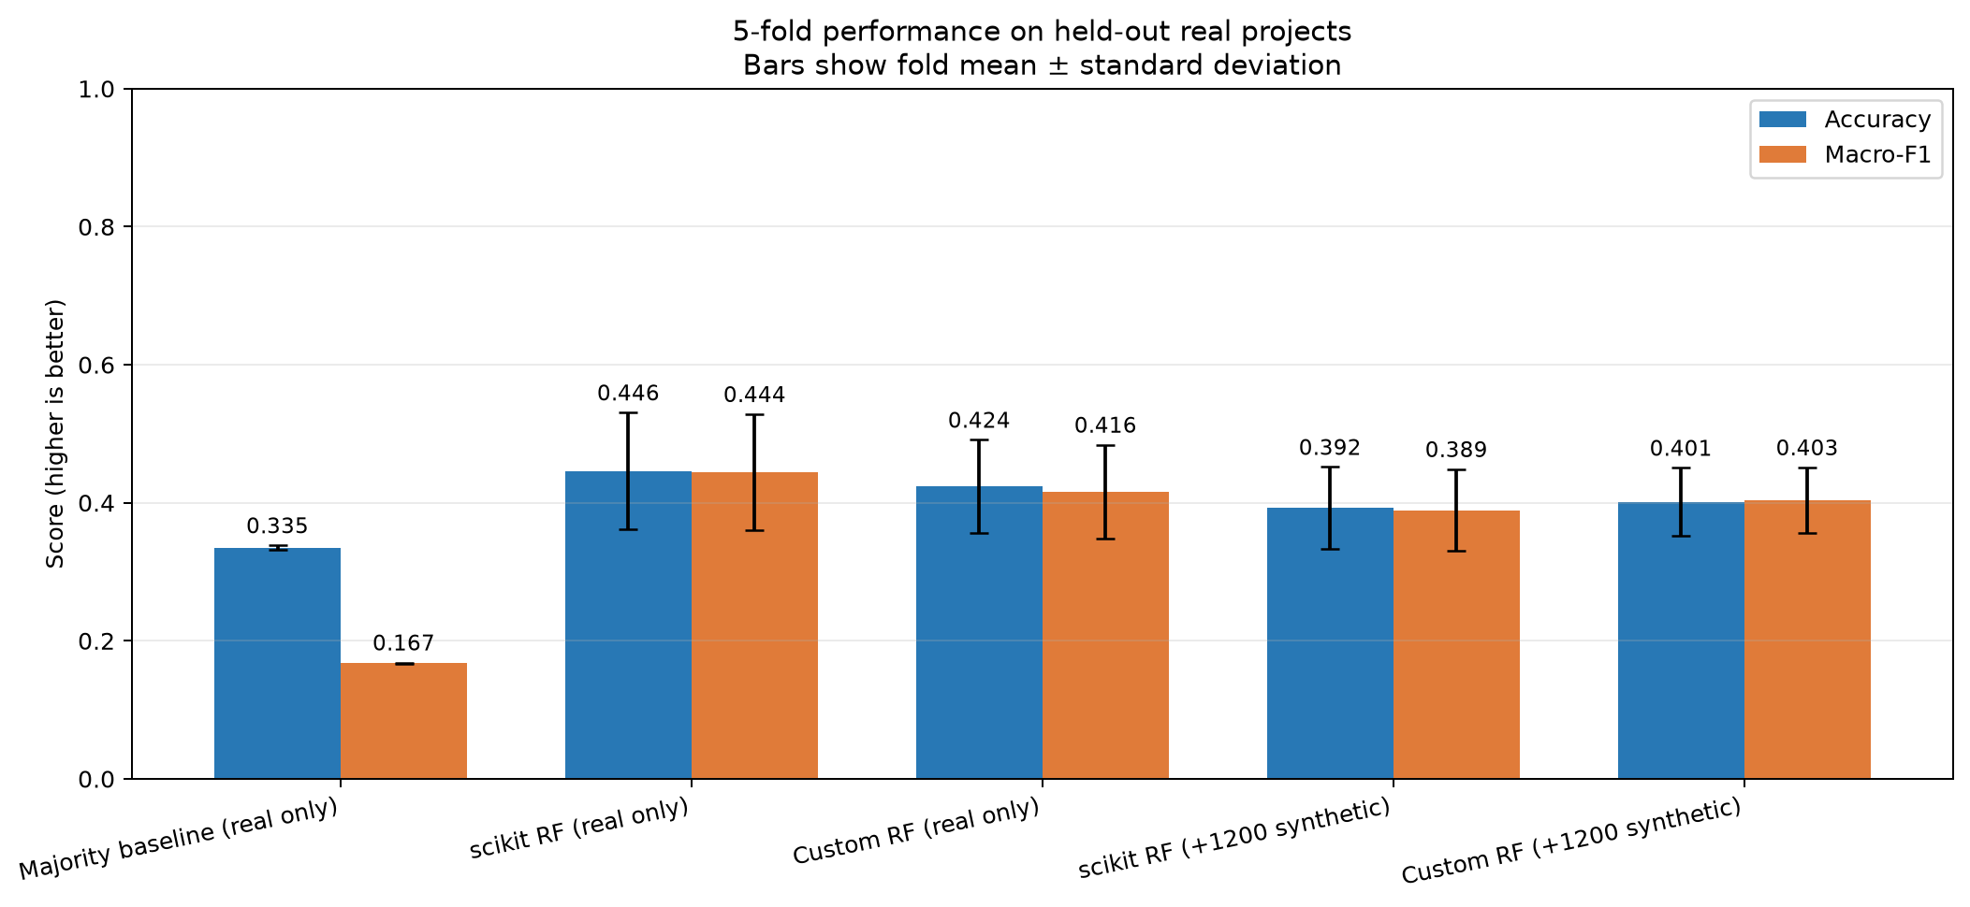  Figure 1. Five-fold mean ± standard deviation on held-out real projects. | 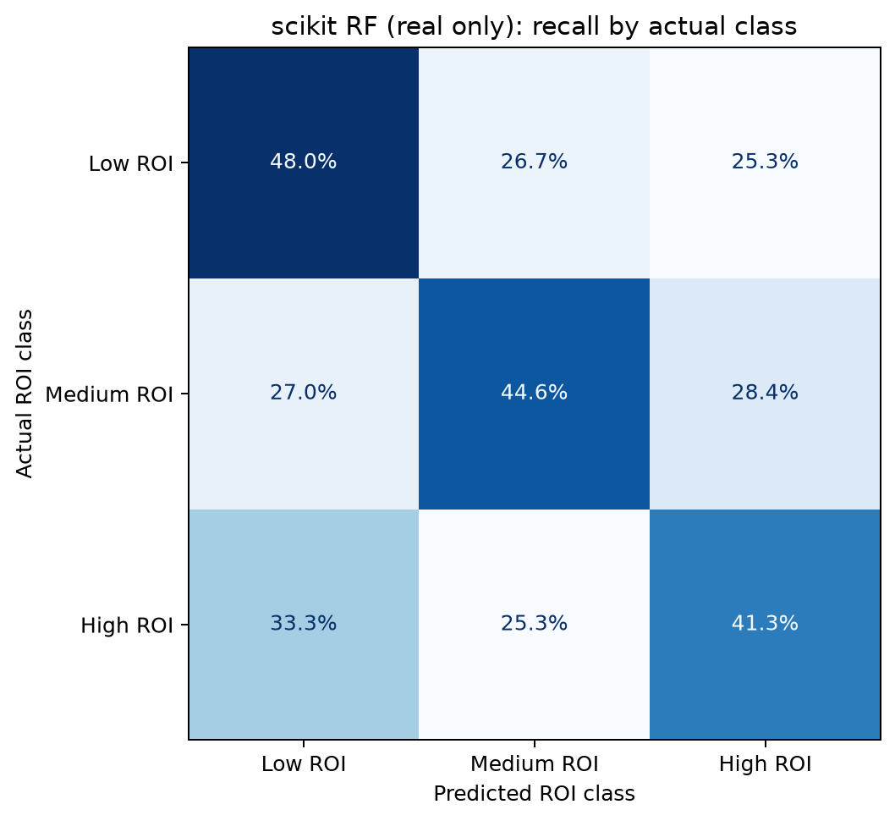  Figure 2. Row-normalized confusion matrix; diagonal cells are class recall.
Model | Training | Accuracy | Macro-F1 | Ordinal MAE | Severe
Majority baseline | Real only | 33.5% | 16.7% | 1.000 | 75
scikit-learn RF | Real only | 44.6% ± 8.5% | 44.4% ± 8.4% | 0.750 | 44
Custom RF | Real only | 42.4% ± 6.7% | 41.6% ± 6.8% | 0.777 | 45
scikit-learn RF | +3,000/fold | 38.4% ± 4.8% | 30.6% ± 3.7% | 0.902 | 64
Custom RF | +3,000/fold | 37.5% ± 3.7% | 30.0% ± 2.9% | 0.920 | 66

Interpretation
The real-only scikit-learn forest is the best tested model. It improves accuracy by 11.1 percentage points and macro-F1 by 27.7 points over the baseline. Recall remains modest—48.0% for Low, 44.6% for Medium, and 41.3% for High—and 44 predictions are severe Low↔High mistakes (19.6%).
The synthetic-data hypothesis failed. Adding 3,000 generated rows per fold reduced both accuracy and macro-F1; the augmented scikit-learn model predicted no Medium cases. We therefore select the real-only model and report augmentation as a negative result.
Generalization warning: mean training accuracy is 85.0% versus 44.6% held-out accuracy—a 40.5-point gap. The small single-city sample, assessment-value proxy, random rather than temporal validation, and lack of external testing prevent operational use.
Risk mitigation already used  - Outcome columns excluded from inputs.  - Every test row is real and held out.  - Fixed seeds, baseline comparison, and class-sensitive metrics.  - Severe ordered errors reported explicitly. | Recommended next iteration  - Audit matching, thresholds, units, and outliers.  - Collect more real data and reserve a later-year/external test set.  - Tune inside nested validation and calibrate probabilities.  - Validate synthetic distributions before reuse.

2. Feature table
Completeness follows the rubric’s 0–5 scale. Author cells list contributors responsible for substantial repository implementation of the submitted component.
Description | Platform | Complete | Code | Author(s) | Notes
Prepare final Calgary modeling table | Local | 4/5 | Python | Finley Thomson | 224-row CSV is validated for model inputs; raw preparation involved manual historical steps.
Generate fold-local synthetic records | Local | 4/5 | Python | Finley Thomson; Jarrod Hwang | Seeded and integrated. Training-fold isolation prevents direct test leakage; augmentation reduced performance.
Implement custom tree and forest | Local | 4/5 | Python | Finley Thomson; Jarrod Hwang | Working and reproducible; slower than scikit-learn and has limited boundary coverage.
Leakage-safe stratified CV | Local | 5/5 | Python | Finley Thomson; Jarrod Hwang | Five folds, real held-out evidence, fold-local generation, and deterministic configuration.
Compare baseline and sklearn RF | Local | 5/5 | Python | Jarrod Hwang | Canonical CLI reports accuracy, macro-F1, ordinal error, and severe errors.
Export evaluation evidence | Local | 5/5 | Python | Jarrod Hwang | Produces JSON/CSV summaries, class/fold metrics, matrices, plots, hash, and manifest.

Completeness scale applied
- 5 – Complete: working, tested, integrated, and clear for the submitted scope.
- 4 – Working: integrated with minor coverage, polish, or reproducibility limits.
- 3 – Partial: demonstrates the concept but needs manual or non-portable steps.
- 2 or below: prototype, research, or unimplemented; not claimed as final.

Submitted code organization
CMPT310_Group14_Code_Submission/
├── Model/ # evaluator, CV, metrics, custom tree/forest
├── Data/Code/ # fold-local synthetic generator
├── Data/CSVs/Sorted/ # final modeling table
├── Artifacts/Milestone2/ # figures, CSV and JSON evidence
├── tests/ # deterministic checks
├── requirements*.txt
├── run_evaluation.sh / run_tests.sh
└── README.md

Practical software-quality assessment
Functional suitability  Evaluation, baseline, forests, metrics and artifacts work; no live inference UI is claimed. | Reliability  Fixed seeds and held-out evidence support repeatability; the small dataset creates high variance. | Performance  scikit-learn runs quickly; the custom implementation is deliberately opt-in.
Maintainability  Evaluation responsibilities are separated; raw preprocessing remains outside the clean run path. | Compatibility  Runs locally on Python 3.11+ from the included final CSV. | Security and usability  No credentials or student IDs are included; explicit warnings reduce financial risk.

3. External tools, libraries, and data
Software used by the submitted run path  Tool Purpose  Python 3.12.13 Tested runtime and CLI orchestration.  NumPy Arrays, sampling, covariance, numeric work.  pandas CSV I/O, validation, tabular features.  scikit-learn Folds, scaling, baseline, RF, metrics.  Matplotlib Comparison and confusion-matrix figures. | Data sources  - City of Calgary Building Permits (c2es-76ed).  - Historical Property Assessments (4ur7-wsgc).  - Calgary Transit Stops (muzh-c9qc).  - Parks Sites (kami-qbfh) and Schools (fd9t-tdn2).  - CMHC Housing Market Information Portal income tables.

Installation and execution
python -m venv .venv
source .venv/bin/activate # Windows: .venv\Scripts\activate
python -m pip install -r requirements.txt
python -m Model.EvaluateModels --models dummy sklearn --output-dir Artifacts/FinalRun
python -m unittest discover -s tests -v

Reproducibility evidence
- 224 rows with no missing model values.  - 75 Low, 74 Medium, 75 High.  - Seed, folds, hyperparameters, and features recorded.  - Dataset hash written to the manifest. | - Five automated tests pass in a fresh extraction.  - Saved and fresh-run metrics agree.  - Count and normalized matrices are included.  - All test evidence is real and out of fold.

Limitations, portability, and responsible use
The clean submission scopes reproducibility to evaluation from the included final modeling CSV. Historical raw-data preparation depended on manual extracts and local utilities, so it is not represented as a one-command pipeline. Results may not transfer across cities, time periods, project types, market conditions, or assessment policies.
Responsible-use statement: the output must not be used to approve, reject, price, or finance a real development. It is an educational result based on historical public-data proxies and requires expert interpretation.

References
- City of Calgary Open Data datasets c2es-76ed, 4ur7-wsgc, muzh-c9qc, kami-qbfh, and fd9t-tdn2.
- Canada Mortgage and Housing Corporation, Housing Market Information Portal.
- scikit-learn documentation: RandomForestClassifier, StratifiedKFold, StandardScaler, and model metrics.
- Group 14 project repository and generated evidence under Artifacts/Milestone2.

