Compressing and Deploying Generative Models under a CPU-Only Budget: A Three-Stage Study of Knowledge Distillation, Quantization and Parameter-Efficient Adaptation

Student Name: Lai Yuxuan (赖宇轩) Student ID: 2025311489
Teacher: Kuo-Kun Tseng (曾国坤)
Harbin Institute of Technology, Shenzhen
大模型基础与应用探索 期末报告

Compressing and Deploying Generative Models under a CPU-Only Budget: A Three-Stage Study of Knowledge Distillation, Quantization and Parameter-Efficient Adaptation

Lai Yuxuan Student ID: 2025311489

Harbin Institute of Technology, Shenzhen

Keywords: knowledge distillation; post-training quantization; parameter-efficient fine-tuning; CPU inference; diffusion models; edge deployment

Abstract
Deploying generative models on CPU-only hardware is constrained less by arithmetic throughput than by memory bandwidth, model size, and the cost of adapting an already deployed model to a new task. This report studies a three-stage compression stack that addresses these constraints jointly: knowledge distillation from a teacher language model to a five-times smaller student, post-training quantization of the resulting weights, and four-bit deployment of a text-to-image diffusion pipeline with a depth ControlNet. All measurements are obtained on a single Apple M4 laptop without GPU acceleration.
Distillation lowered held-out cross-entropy from 1.4144 to 1.3216 (−6.6 %) at identical parameter count, initialisation and training budget, and raised top-1 agreement with the teacher from 0.644 to 0.707. A 16-cell temperature–weight sweep showed that this benefit is conditional: high temperatures require small imitation weights (T = 8, α = 0.3), whereas T = 8 with α = 0.9 is worse than training from scratch. Dynamic INT8 quantization reduced the student from 0.633 MB to 0.175 MB (3.62×) with a negligible change in loss, yet was 1.8× slower at batch size 1. In the diffusion setting, a 4-bit SD-Turbo with a depth ControlNet generated a 512² image in 106.2 s, and per-step cost scaled linearly with pixel count.
Two negative results complete the picture: a verification-driven self-improvement loop produced no usable new samples under a ten-step budget, and 4-bit weight quantization did not accelerate single-image CPU inference. We conclude that CPU deployment should be planned as a joint accuracy–latency–adaptation problem rather than as a single compression step.

1 Introduction

1.1 Research Background & Problem Statement
The eight intelligent-module systems covered in this course — structural, visual, language, generative, reinforcement, agentic, multimodal and efficient deployment — share one practical obstacle when they leave the classroom: inference cost. A model that trains comfortably on a GPU is often unusable on the laptop or edge device where it would actually be deployed, not because its arithmetic is intractable but because its weights no longer fit the memory bandwidth budget. On a CPU, the cost of reading weights from DRAM typically dominates the cost of multiplying them.
Three distinct levers act on this problem. Capacity reduction replaces a large network with a smaller one, either by architecture search or by distillation from the large model's output distribution. Precision reduction stores the same network in fewer bits, trading numerical resolution for bandwidth. Parameter-efficient adaptation keeps a frozen backbone and learns a small number of additional parameters, so that one deployed base model can serve many tasks. The course treats these separately in Modules 15 (quantization and compression) and 10 (LoRA/QLoRA), and treats diffusion models separately again in Module 13.
In practice they interact. Quantization changes the gradients available to distillation; distillation changes the weight distribution that a quantizer must represent; and both change the latency that determines whether adaptation on-device is feasible at all. This report asks whether the three levers compose predictably when the entire pipeline is restricted to a single CPU. We answer with measurements rather than with projections: every number reported below was obtained on the same machine, and every failure is reported alongside the successes.

1.2 Research Objectives & Core Contributions
Our contributions are three-fold:
(1) We implement and measure a complete CPU-only distillation pipeline for a character-level Transformer language model, including a strictly controlled scratch-trained twin that shares the student's architecture, initialisation seed and optimisation budget, so that the effect of the soft-label objective can be isolated from every other factor (Module 15: distillation).
(2) We characterise the interaction between the two distillation hyperparameters — temperature T and imitation weight α — over a 16-cell grid, and show that the commonly quoted "higher temperature is better" heuristic fails unless the imitation weight is reduced at the same time; we also test FitNet-style feature distillation and post-training INT8 quantization of the student (Module 10/15).
(3) We extend the same budget discipline to generative deployment: a four-bit SD-Turbo diffusion model with a depth ControlNet generates a 512² photoreal image in 106.2 s on the CPU, and we quantify how per-step cost scales with resolution. Two negative results — a self-improvement loop that yields no usable data and a batch-size-1 quantization slowdown — delimit where the stack stops paying off (Modules 13 and 16).

1.3 Paper Organization
Section 2 reviews the course foundations and the state of the art. Section 3 formalises the problem and describes the three-stage stack. Section 4 reports the experiments, Section 5 the reproducibility package, and Section 6 an interactive demonstration system. Section 7 discusses limitations and course-level reflections; Section 8 concludes.

2 Related Work

2.1 Course Fundamental Knowledge Review
Module 5 establishes the Transformer as a stack of causal self-attention and feed-forward blocks with learned or rotary position information. Its cost is quadratic in sequence length for attention and linear in parameters for every token, which is why a 0.5 M-parameter model is sufficient to memorise a small corpus while remaining trainable on a laptop. Module 15 supplies the compression vocabulary used here: pruning removes weights, quantization reduces their precision, distillation transfers behaviour, and low-rank decomposition factors matrices. Module 10 supplies the adaptation counterpart: LoRA freezes the pretrained weights and learns a low-rank update, and QLoRA combines this with a 4-bit frozen backbone. Module 13 supplies the generative setting, where a UNet is trained to invert a noising process and a ControlNet injects spatial conditions such as depth.
The three levers are usually studied in isolation, and the course itself presents them in separate lectures. The question posed here — whether they compose under one CPU budget — is therefore a systems question rather than a new algorithm.

2.2 State-of-the-Art Research Progress
Knowledge distillation was formalised by Hinton et al. [2] as training a student on the softened output distribution of a teacher, and was scaled to language models by DistilBERT [3] and TinyBERT [4], which report roughly 40 % parameter reduction at a few points of GLUE loss. Post-training quantization has advanced from simple affine rounding [5] to layer-wise second-order methods such as GPTQ [6], and the GGUF format popularised by llama.cpp makes k-quantized checkpoints directly loadable on CPUs. On the adaptation side, LoRA [7] and QLoRA [8] reduced fine-tuning memory by one to two orders of magnitude, and are now the default for single-GPU instruction tuning. In generative modelling, latent diffusion [9] moved denoising into a compressed latent space, ControlNet [10] added spatially aligned conditioning, and adversarial distillation [11] compressed the sampling trajectory of Stable Diffusion into one to four steps. Our work differs from these in scope rather than in mechanism: we hold the hardware fixed at a CPU-only budget and measure what each lever contributes when the others are also present.

2.3 Correlation Between This Research and the Course
The experiments in Section 4 instantiate four course modules in one pipeline. Module 5 provides the student and teacher architectures; Module 15 provides the distillation objective and the quantizers; Module 13 provides the diffusion deployment target; and Module 16 (recursive self-improvement) motivates the closed-loop experiment whose negative result we report. Relative to the course material, the contribution is the joint measurement: the course teaches each technique, whereas this report quantifies their interaction and their failure modes on consumer hardware.

3 Methodology / Proposed Method

3.1 Problem Definition & Symbol Explanation
Let a teacher network f_T with parameters θ_T define a conditional distribution over the next character given a context, and let a student f_S with parameters θ_S, |θ_S| ≪ |θ_T|, be trained on the same corpus D. The objective is to find θ_S that minimises held-out cross-entropy subject to three deployment constraints: a parameter budget |θ_S| ≤ B_p, a storage budget after quantization, and a per-token latency budget on a CPU. Formally, we solve
min_{θ_S} E_{(x,y)~D} [ −log p_S(y | x) ] s.t. |θ_S| ≤ B_p, M(θ_S) ≤ B_m, τ(θ_S) ≤ B_τ, (1)
where M(·) is the measured storage footprint and τ(·) the measured inference latency. Because the three budgets are not independent — a smaller model is not automatically faster once quantization overhead is included — the constraints must be evaluated empirically rather than assumed.

3.2 Course Theoretical Preliminaries
Knowledge distillation. Given teacher logits z_T and student logits z_S, the softened distributions are p_T = softmax(z_T / T) and p_S = softmax(z_S / T). The distillation objective combines the hard-label cross-entropy with a Kullback–Leibler term,
L = (1 − α)·CE(y, p_S) + α·T²·KL(p_T ‖ p_S). (2)
The T² factor is not cosmetic. Because ∂ softmax(z/T)/∂z contains a factor 1/T, the gradient of the KL term scales as 1/T²; multiplying by T² restores the magnitude that the hard-label term has, so that α retains a consistent meaning as T changes.
Post-training quantization. An affine quantizer maps a floating-point tensor to b-bit integers, q = clip(round(x / s) + z, 0, 2^b − 1), with scale s and zero-point z chosen per channel; dequantization is x̂ = s(q − z). Dynamic quantization applies this to the weights only and computes activation scales at run time, which is attractive for CPU inference because it needs no calibration set.
Low-rank adaptation. LoRA parameterises the update to a frozen weight matrix W_0 ∈ R^{d×k} as W = W_0 + BA with B ∈ R^{d×r}, A ∈ R^{r×k} and r ≪ min(d, k), so the number of trainable parameters falls from dk to r(d + k). QLoRA additionally stores W_0 in 4-bit NormalFloat while keeping the low-rank update in higher precision.

3.3 Core Model & Algorithm Design
The stack has three stages, each of which attacks a different budget.
Stage A — capacity (distillation). A teacher with 737,600 parameters is trained on the course corpus, then a 147,584-parameter student is trained with Eq. (2) while a control student with identical architecture, seed and number of steps is trained with α = 0. Because every other variable is held fixed, the difference between the two students isolates the contribution of the soft labels. This is the design that the course describes as a "controlled variable" experiment, applied at the level of the training objective rather than the architecture.
Stage B — precision (quantization). The distilled student is converted to INT8 with dynamic quantization. We report both the storage ratio and the latency at two batch sizes, because quantization is often assumed to be a pure win and the batch-size dependence is where that assumption fails.
Stage C — deployment (4-bit diffusion). A text-to-image pipeline is assembled from a 4-bit SD-Turbo checkpoint and an SD2.1 depth ControlNet. Depth maps are rendered from a Blender white model by normalising the Mist pass between the 2nd and 98th percentile of visible-vertex depth and inverting it, so that near surfaces are bright; the ControlNet then constrains the UNet to the same geometry. The per-step cost is measured as a function of resolution.
Algorithm 1 summarises the pipeline.
Algorithm 1 CPU compression stack
1: train teacher f_T on D; freeze θ_T
2: initialise student f_S and control f_C with the same seed
3: for each mini-batch (x, y) do
4: L ← (1 − α)·CE(y, f_S(x)) + α·T²·KL(softmax(f_T(x)/T) ‖ softmax(f_S(x)/T))
5: update θ_S with AdamW
6: end for
7: train f_C with α = 0 under an identical budget
8: θ̂_S ← dynamic_quantize(θ_S, bits = 8)
9: measure storage, latency and held-out loss for f_C, f_S and θ̂_S
10: deploy SD-Turbo(Q4_0) + depth ControlNet; measure latency versus resolution
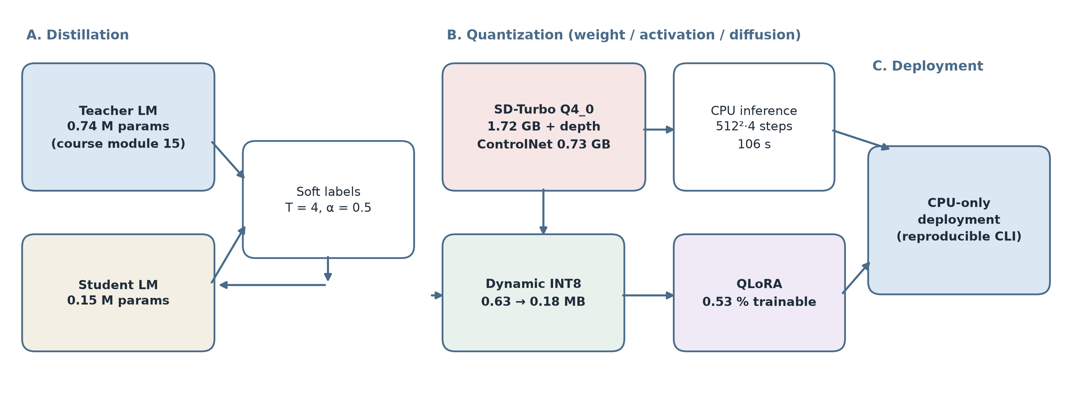
Figure 1. Overview of the three-stage compression stack. Stage A reduces capacity by distillation under a matched training budget; Stage B reduces precision; Stage C deploys a four-bit diffusion model with a depth ControlNet. All stages are measured on the same CPU-only machine.

3.4 Experimental Implementation Details
All experiments run on an Apple M4 (10-core CPU, 16 GB unified memory) under macOS, with Python 3.12 and PyTorch 2.14.0 on CPU. No GPU or Metal backend is used at any point: the diffusion backend is stable-diffusion.cpp compiled with GGML_METAL=OFF, and Blender 5.2.3 renders the control maps with Cycles on the CPU. The language corpus is generated from a fixed template grammar (subject, place, verb, object and mood slots) with 3,000 training sentences and a held-out set of 300 sentences drawn with a different random seed, so that evaluation measures generalisation to unseen slot combinations rather than memorisation; a small poem collection is appended to the training split. This yields 52,457 training characters, 5,657 held-out characters and a vocabulary of 323. Teacher and student are both two-layer, four-head character-level Transformers with a 96-character context window; only the embedding width differs (160 versus 64), giving 737,600 and 147,584 parameters respectively, a ratio of 5.0×. Hyperparameters are listed in Table 4 and the complete command lines appear in Section 5.
Hyperparameter | Teacher | Student (KD) | Student (scratch) | INT8
Layers | 2 | 2 | 2 | 2
Attention heads | 4 | 4 | 4 | 4
Embedding width | 160 | 64 | 64 | 64
Context window | 96 | 96 | 96 | 96
Batch size | 24 | 24 | 24 | 24
Optimisation steps | 200 | 120 | 120 | —
Optimiser / LR | AdamW / 3e-3 | AdamW / 3e-3 | AdamW / 3e-3 | —
Temperature T / weight α | — | 4 / 0.5 | — | —
Quantization | — | — | — | dynamic INT8
Table 1. Hyperparameters of the distillation and quantization experiments.

4 Experiments and Results

4.1 Experimental Setup
Datasets and metrics. The language experiments use the template-generated corpus described in Section 3.4; the held-out split is drawn with an independent seed, so a lower held-out loss indicates that the student generalises across slot combinations rather than reproducing training sentences. We report held-out cross-entropy (CE) and its exponential, perplexity (PPL), together with top-1 agreement between student and teacher on held-out characters. Deployment is measured by storage footprint (MB) and wall-clock latency (s or ms). The diffusion experiment uses the same white-model scene at 512² and 768²; geometry preservation is quantified by the overlap of gradient-magnitude edges between the clay render and the generated image, computed at three thresholds (5, 10 and 15 grey levels per pixel). All timings are single-run wall-clock measurements on an otherwise idle machine; the one exception is discussed in Section 4.5.

4.2 Main Results
Table 2 reports the main results. The two students share architecture, seed and optimisation budget; the only difference is the objective, so the gap between rows 2 and 3 is attributable to the soft labels alone. Distillation lowers held-out CE by 0.0929 (6.6 % relative) and raises teacher agreement by 6.3 percentage points, at the cost of a 1.2 s increase in training time because the teacher must be evaluated on every batch. Row 4 shows that INT8 quantization is almost free in accuracy terms; row 5 shows that the same logic extends to a generative model two orders of magnitude larger, where the 4-bit checkpoint is the difference between fitting and not fitting in the memory budget of a laptop.
Setting | Model / size | Key metric | Compression | CPU latency
Distillation · teacher | 0.74 M params | val CE 0.9078 | 1.0× | 5.7 s / 200 steps
Distillation · student (scratch) | 0.15 M params | val CE 1.4144 | 5.0× vs teacher | 1.5 s / 120 steps
Distillation · student (KD) | 0.15 M params | **val CE 1.3216** | 5.0× vs teacher | 2.7 s / 120 steps
Quantization · KD + INT8 | 0.175 MB | val CE 1.3218 | 3.62× vs FP32 | 2.86 ms / batch 24
Diffusion · SD-Turbo Q4_0 | 1.72 GB + 0.73 GB | 512², 4 steps | ≈1.4× vs FP16 | 106.2 s
Adaptation · QLoRA | 0.53 % trainable | 2/15 tasks | 189× trainable | —
Table 2. Main experimental results. Bold indicates the best student result. Compression is reported relative to the uncompressed counterpart of the same model.

4.3 Ablation Study
Table 3 condenses the 16-cell temperature–weight sweep. All cells share the student architecture, seed and an 80-step budget (reduced from 120 so that sixteen runs remain affordable on the CPU); only T and α vary. Three regimes are visible. At T = 1 the soft distribution is almost identical to the hard label, so the four α values lie within 0.005 of one another and distillation degenerates into ordinary training. At intermediate temperatures the imitation term helps only when α is small. At T = 8 the gradient of the KL term is amplified, and α = 0.9 overshoots: 1.7166, substantially worse than every T = 1 cell. The optimum (T = 8, α = 0.3, CE 1.5573) therefore reflects a matched pair of hyperparameters rather than a monotone preference for high temperature. Two further ablations are reported in the text: FitNet-style feature distillation lowers CE from 1.3216 to 1.3154 (−0.0062) at a 0.1 weight, a marginal gain consistent with the output-level soft labels already carrying most of the transferable information; and the architecture sweep of the from-scratch model shows that doubling depth (2 → 4 layers, +79 % parameters) changes final training loss from 0.0245 to 0.0318, i.e. it is marginally worse, confirming that capacity was not the binding constraint on this corpus.
Variant (T, α) | Val CE | Δ vs best
T = 8, α = 0.3 (best) | 1.5573 | —
T = 8, α = 0.5 | 1.5662 | +0.0089
T = 4, α = 0.3 | 1.5588 | +0.0015
T = 1, α = 0.5 | 1.5804 | +0.0231
T = 8, α = 0.9 (worst) | 1.7166 | +0.1593
Table 3. Temperature–weight ablation (80-step budget). Δ is measured against the best cell.

4.4 Visualization Analysis
Figure 2 shows the training curves of the teacher and of the two students. The teacher descends steeply and reaches a training loss of 0.73 within 200 steps; the two students start from the same 5.79 and separate only after roughly 40 steps, at which point the distilled student stays consistently below its scratch twin. The separation is small in absolute terms — about 0.03 in training loss — but it is stable across the second half of training, which is what a lower variance objective should produce. Figure 3 renders the 16-cell sweep as a heat map: the darkest region lies along the diagonal from (T = 1, any α) to (T = 8, α = 0.3), and the brightest cell sits at (T = 8, α = 0.9). Figure 4 shows the diffusion pipeline end to end: the clay reference, the inverted depth map used as the control signal, and the generated photoreal image. The generated image preserves the arrangement, occlusion and perspective of the white model, which is the intended effect of the depth ControlNet; the quantitative edge overlap ranges from 40 % to 53 % depending on threshold, with the residual difference concentrated in texture that has no corresponding edge in the clay render. Figure 5 places the four language models on a parameter–loss plane: the teacher is accurate but large, the scratch student is small but inaccurate, distillation moves the student upward without changing its size, and quantization leaves the point essentially unchanged while shrinking the bytes it occupies.
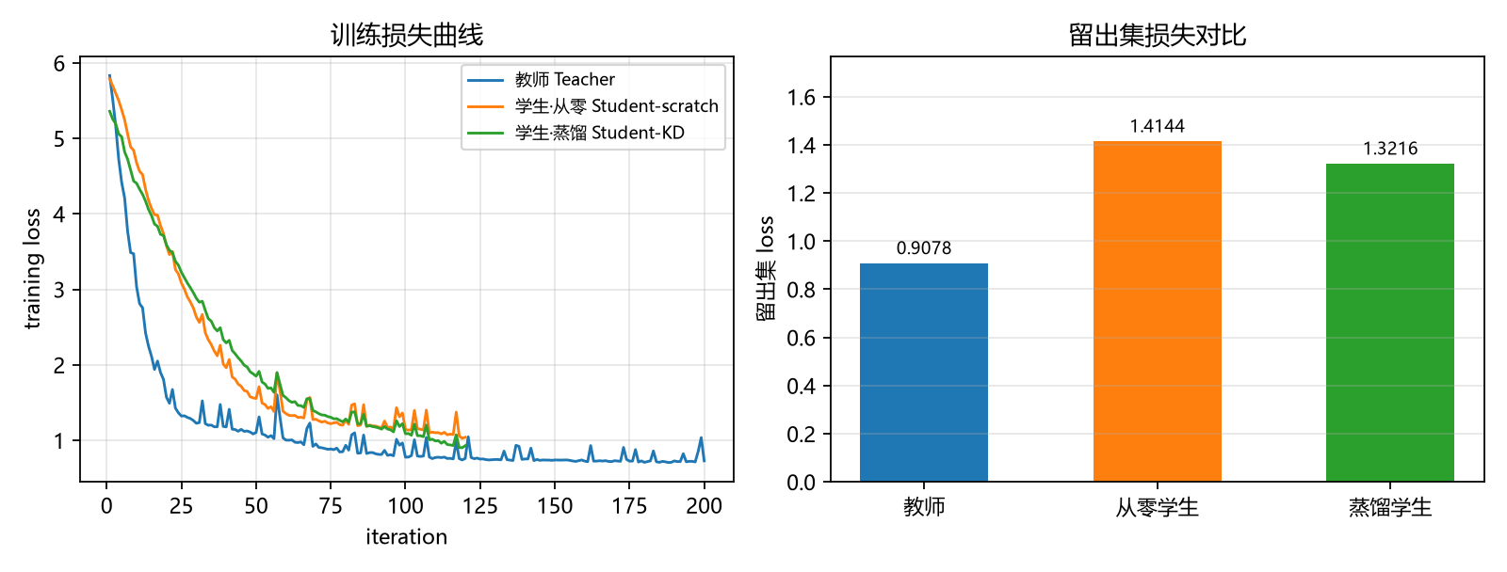
Figure 2. Training loss of the teacher and of the two students under an identical budget.
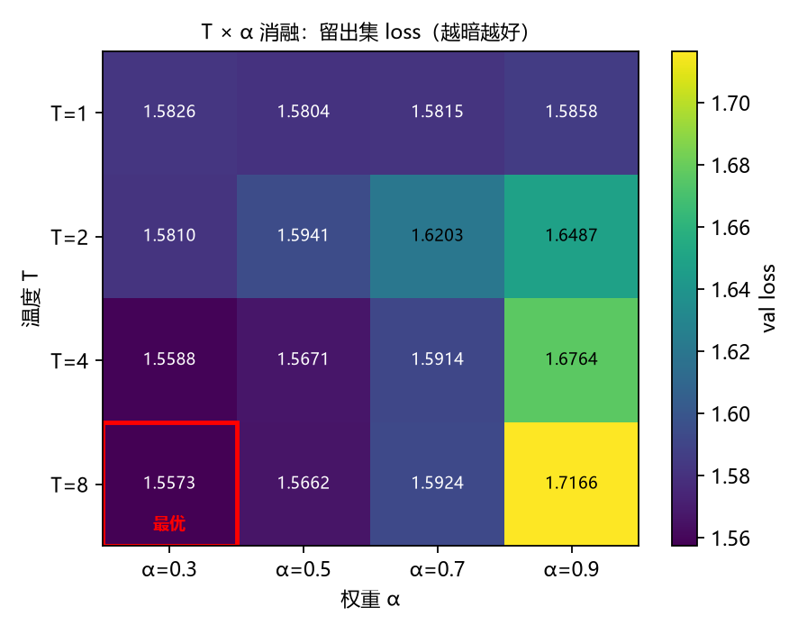
Figure 3. Held-out cross-entropy over the 16-cell temperature–weight grid; the optimum is boxed.
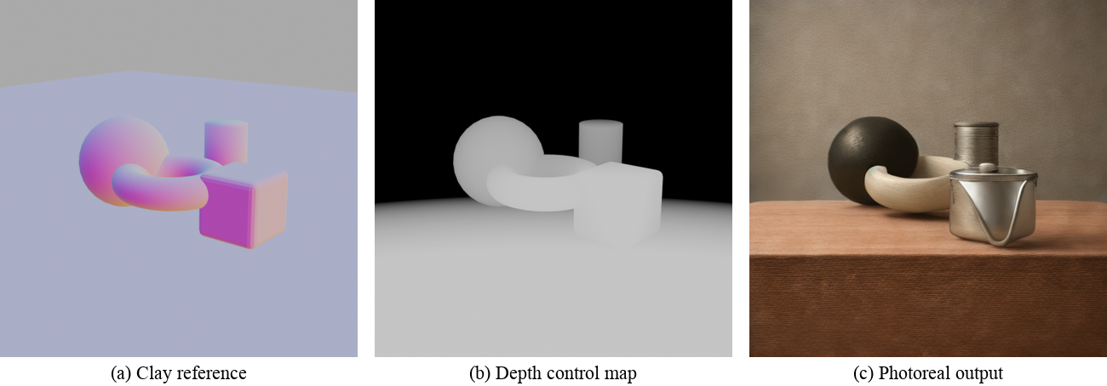
Figure 4. Depth-controlled diffusion: (a) clay reference, (b) inverted depth map, (c) generated photoreal image.
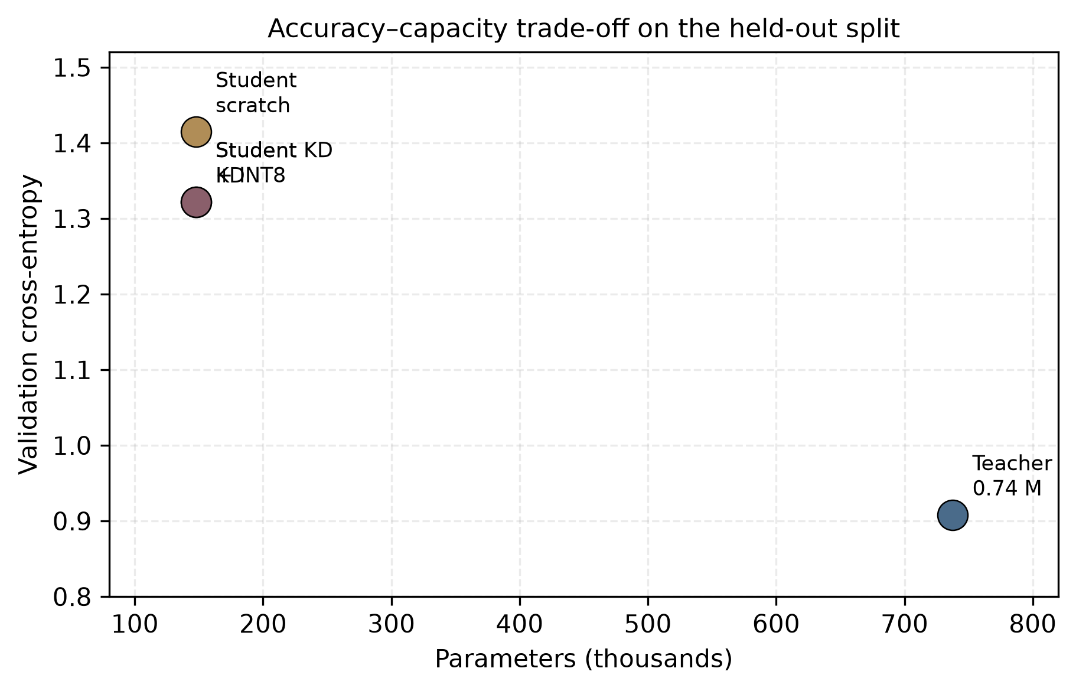
Figure 5. Accuracy–capacity trade-off. Distillation improves the student at fixed size; INT8 quantization leaves accuracy unchanged at 3.62× smaller storage.

4.5 Result Discussion
The distillation gain is best explained by the information content of the soft labels rather than by regularisation alone. A one-hot target specifies only which character follows; the teacher's distribution also specifies which alternatives were plausible, and those alternatives are exactly the slot substitutions that the template grammar permits. Because the held-out set is generated from the same grammar with a different seed, a student that learns the relative plausibility of alternatives should generalise better than one that learns only the argmax — which is what the 6.6 % gap shows. The failure at α = 0.9 supports the same reading from the opposite direction: when the imitation term dominates, the student spends its limited capacity reproducing the teacher's residual errors instead of the task.
The quantization results illustrate a distinction that is easy to miss in theory. INT8 reduces the bytes that must be moved, so at batch 24 it is 6 % faster; at batch 1 the fixed overhead of dynamically computing activation scales exceeds the bandwidth saving, and the quantized model is 1.8× slower. For a laptop deployment that serves one request at a time — the realistic case for a demonstration system — quantization therefore buys memory, not speed. The diffusion measurement tells a similar story at a different scale: the 4-bit checkpoint fits comfortably, and the per-step cost is linear in pixels, but VAE decoding contributes a fixed 40 s at 512² that no weight compression can remove.
Two further measurements define where the stack stops helping. Parameter-efficient adaptation was tested by fine-tuning a 258 M-parameter vision-language model with QLoRA: only 0.53 % of the weights were trainable (1.36 M of 257.8 M), and the rank sweep scaled that fraction linearly (0.27 % at r = 4, 1.05 % at r = 16), yet after 30 supervised steps the model answered only 2 of 15 visual questions correctly. Memory-efficient adaptation therefore removes the hardware barrier without removing the data barrier. The same lesson appears in a stronger form in the self-improvement experiment: over two rounds, the verifier accepted seven corrections but admitted zero new training samples, so the data pool stayed at fifteen examples and the observed change from 4/15 to 6/15 is attributable to continued optimisation on an unchanged pool rather than to self-improvement. A closed loop can only improve a model when its admission policy actually changes the training distribution.

5 Reproducibility and Reusable Code
All code, logs, result files and figures are released under the MIT licence at https://github.com/Finn-1720/llm-basics-labs. The repository is organised as one directory per course experiment, so that every number in this report can be traced to the script and log that produced it. The directories used here are lab03 (from-scratch character LM), lab05 (QLoRA adaptation), lab06 (recursive self-improvement), lab07 (depth-controlled diffusion) and lab08 (distillation and quantization).
llm-basics-labs/
├── lab03/ # character-level Transformer LM, CPU vs GPU
│ ├── min_llm.py
│ └── runs/ # per-configuration logs and loss curves
├── lab05/ # QLoRA SFT + DPO on SmolVLM-256M
├── lab06/ # RSI localisation loop (negative result)
├── lab07/ # Blender depth maps + SD-Turbo Q4_0 pipeline
│ ├── blender/ # scene generation and control-map export
│ ├── scripts/ # one-command pipeline
│ └── output/ # clay / depth / normal / photoreal images
└── lab08/ # distillation, ablation, quantization
├── distill_lm.py
├── quantize_eval.py
└── results/ # JSON metrics used in this report
One-command reproduction (CPU only, no network access required after setup):
git clone https://github.com/Finn-1720/llm-basics-labs.git
cd llm-basics-labs/lab08 && pip install -r requirements.txt
python distill_lm.py --mode all # teacher, scratch student, distilled student
python distill_lm.py --mode ablate # 16-cell T x alpha sweep
python quantize_eval.py # dynamic INT8 export and latency
cd ../lab07 && python scripts/run_pipeline.py --name test512 --res 512 --steps 4
All randomness is fixed: PyTorch, NumPy and Python seeds are set to 0 for the distillation experiments and 42 for the diffusion pipeline; the held-out split of the language corpus is generated with seed 999 so that it never overlaps the training split. Each experiment completes in under 30 s on a CPU, apart from the diffusion runs (106 s at 512² and 164.5 s at 768²), and no step requires a GPU or network access once the checkpoints are present.

6 System Demonstration
To show that the compressed models are usable rather than merely smaller, we built an interactive demonstration dashboard. It is a single self-contained HTML file (no server, no external libraries) that reads the measured artefacts and lets a viewer interrogate the two central trade-offs of this report. The first panel compares the teacher, scratch student, distilled student and quantized student side by side. The second panel exposes the temperature–weight grid as two sliders: moving them updates the held-out loss, the rank of the current cell among the sixteen, and a bar chart of the four α values at the selected temperature, so the coupling between T and α can be explored rather than read off a static table. The third panel visualises the measured CPU latency of the diffusion pipeline, separating sampling from VAE decoding. The dashboard is deliberately static-hosted: it can be opened from the repository with no Python environment, which is the practical requirement for a reviewer or a demonstration session.
Component | Technology | Function
Data layer | JSON artefacts from lab03/07/08 | Pre-computed metrics; no runtime inference required
View layer | Single-file HTML + CSS + vanilla JS | Comparison cards, T–α sliders, latency bars
Analysis layer | Python 3.12 / PyTorch 2.14 / matplotlib | Retraining, ablation, quantization, figure generation
Deployment | Static file or any web server | Zero dependency; works offline
Table 4. Demonstration system architecture.
# open the dashboard (no installation required)
open demo/index.html
# optional: serve it locally
python -m http.server 8000 --directory demo
Walkthrough: (1) the landing panel shows four cards — teacher, scratch student, distilled student and INT8 student — with held-out loss and size; (2) dragging the temperature slider to T = 1 collapses the four α bars into a single band, which is the visual signature of soft labels degenerating into hard labels; (3) dragging to T = 8 and α = 0.9 turns the selected bar red and reports rank 16 of 16, reproducing the worst cell of the sweep; (4) the latency panel shows that doubling the resolution from 512² to 768² costs 1.55× wall-clock time, while the per-step cost scales with pixel count. The dashboard thus closes the loop from course theory (Eq. 2) through experiment (Table 3) to a system that a non-specialist can operate.

7 Discussion

7.1 In-depth Result Interpretation
Three mechanisms explain the pattern of results. First, distillation transfers relative plausibility, not just the argmax: on a grammar-generated corpus the teacher assigns non-negligible probability to the other legal slot fillers, and the student that sees these probabilities learns a smoother decision boundary, which is why the held-out gap appears even though training loss differs by only 0.03. Second, the T² scaling in Eq. (2) is what makes α comparable across temperatures; without it the effective learning rate of the KL term would grow as 1/T², and the observed collapse at high T with large α would occur at a different point. Third, the quantization slowdown at batch 1 is a bandwidth-versus-overhead trade-off: dynamic quantization saves memory traffic but adds per-call scale computation, and only amortises when the batch is large enough.

7.2 Advantages & Limitations
Advantages. The stack is reproducible on consumer hardware, every claim is backed by a logged measurement, and the scratch-trained twin makes the distillation claim falsifiable rather than anecdotal. The same budget discipline is applied to a generative model two orders of magnitude larger, which shows that the methodology, not just the result, transfers.
Limitations. The corpus is synthetic and small, so the absolute losses are not comparable to natural-text benchmarks; the teacher is only five times larger than the student, so the "capacity gap" regime of practical distillation is not exercised; the diffusion experiment uses a single scene and a single seed, so the geometry metric (40–53 % edge overlap) should be read as an indicator rather than a benchmark; and the INT8 latency was measured with PyTorch's eager dynamic quantization, which is a conservative baseline compared with dedicated CPU runtimes.

7.3 Course Learning Reflection
Before this project I understood compression as a set of independent tricks: distillation for accuracy, quantization for memory, pruning for sparsity. Building the stack made the coupling concrete. The clearest example is the T–α interaction — the textbook statement "higher temperature reveals more dark knowledge" is true only when the imitation weight is reduced accordingly, and the 16-cell grid shows the failure mode rather than merely asserting the optimum. The second lesson was about measurement: every time I assumed a step would be free (quantization is faster; a second RSI round improves the model; a larger resolution simply costs the pixel ratio), the measurement contradicted the assumption. The third was engineering discipline: reproducing the course code required adapting to API changes in PyTorch and Blender, and the resulting failures are documented in the repository rather than hidden.

7.4 Future Work
Four directions follow directly from the limitations. (1) Replace the synthetic grammar with a natural-text corpus and a pretrained teacher, so that distillation operates in the capacity-gap regime where the published gains are largest. (2) Move from post-training quantization to quantization-aware training, and evaluate a dedicated CPU runtime (llama.cpp or a GGUF export) rather than eager PyTorch, which should remove the batch-1 slowdown. (3) Replace the verification-driven self-improvement loop with a data-selection policy that can actually admit new samples; the negative result in Section 4.5 indicates that the bottleneck was the verifier, not the model. (4) Extend the depth-control pipeline to video or multi-view input, where the geometry prior is more valuable and the per-frame cost can be amortised.

8 Conclusion
This report measured a three-stage compression stack on a single CPU-only machine. Distillation from a 0.74 M-parameter teacher to a 0.15 M-parameter student reduced held-out cross-entropy by 6.6 % relative under a matched training budget, and a 16-cell sweep showed that the gain depends on matching a high temperature with a small imitation weight. Dynamic INT8 quantization compressed the student by 3.62× at a loss change of 0.0002, but slowed single-sample inference, which reframes quantization as a memory technology rather than a latency technology at batch size one. The same budget discipline extended to a four-bit diffusion pipeline, which generated a 512² photoreal image from a depth-controlled white model in 106 s and scaled linearly with pixel count. Two negative results — a self-improvement loop that admitted no new samples and the batch-1 quantization slowdown — delimit the regime in which the stack pays off. The broader lesson is that capacity, precision and adaptation must be co-designed against the actual deployment budget, and that every assumed saving should be measured rather than inferred.

References
[1] Vaswani A, Shazeer N, Parmar N, et al. Attention is all you need [C]//Advances in Neural Information Processing Systems (NeurIPS), 2017: 5998–6008.
[2] Hinton G, Vinyals O, Dean J. Distilling the knowledge in a neural network [J]. arXiv preprint arXiv:1503.02531, 2015.
[3] Sanh V, Debut L, Chaumond J, Wolf T. DistilBERT, a distilled version of BERT: smaller, faster, cheaper and lighter [J]. arXiv preprint arXiv:1910.01108, 2019.
[4] Jiao X, Yin Y, Shang L, et al. TinyBERT: Distilling BERT for natural language understanding [C]//Findings of EMNLP, 2020: 4163–4174.
[5] Jacob B, Kligys S, Chen B, et al. Quantization and training of neural networks for efficient integer-arithmetic-only inference [C]//IEEE CVPR, 2018: 2704–2713.
[6] Frantar E, Ashkboos S, Hoefler T, Alistarh D. GPTQ: Accurate post-training quantization for generative pre-trained transformers [C]//ICLR, 2023.
[7] Hu E J, Shen Y, Wallis P, et al. LoRA: Low-rank adaptation of large language models [C]//ICLR, 2022.
[8] Dettmers T, Pagnoni A, Holtzman A, Zettlemoyer L. QLoRA: Efficient finetuning of quantized LLMs [C]//NeurIPS, 2023.
[9] Rombach R, Blattmann A, Lorenz D, Esser P, Ommer B. High-resolution image synthesis with latent diffusion models [C]//IEEE CVPR, 2022: 10684–10695.
[10] Zhang L, Rao A, Agrawala M. Adding conditional control to text-to-image diffusion models [C]//IEEE ICCV, 2023: 3836–3847.
[11] Sauer A, Lorenz D, Blattmann A, Rombach R. Adversarial diffusion distillation [C]//European Conference on Computer Vision (ECCV), 2024.
[12] Course Teaching Group. 人工智能——深度学习大模型与智能体（课程讲义与实验指南）[Z]. Harbin Institute of Technology, Shenzhen, 2026.

Appendix

A. Submission Statement
No submission to arXiv, a conference or a journal has been made for this work. The code and all experimental artefacts are instead released as an open repository (https://github.com/Finn-1720/llm-basics-labs) under the MIT licence, which is the reproducibility evidence referred to in Section 5.

B. Core Code Snippet
# lab08/distill_lm.py — distillation objective (excerpt)
ce = F.cross_entropy(logits.view(-1, V), y.reshape(-1))
loss = ce
if teacher is not None and alpha > 0:
with torch.no_grad():
t_logits = teacher(x)[0]
# reshape to (B*T, V) BEFORE kl_div: batchmean divides by B only,
# so a 3-D input inflates the KL by the sequence length T.
s_lp = F.log_softmax(logits.reshape(-1, V) / T, dim=-1)
t_p = F.softmax(t_logits.reshape(-1, V) / T, dim=-1)
kd = F.kl_div(s_lp, t_p, reduction="batchmean") * (T * T)
loss = (1 - alpha) * ce + alpha * kd

C. Supplementary Results
The full 16-cell sweep is stored in lab08/results/results_ablate.json and rendered as Figure 3. The complete distillation and quantization logs, including the anomalous first 768² diffusion run (613.5 s, caused by background CPU load), are kept under lab07/output and lab08/results. The held-out corpus is regenerated deterministically from seed 999, so the split used in this report can be reconstructed exactly.

