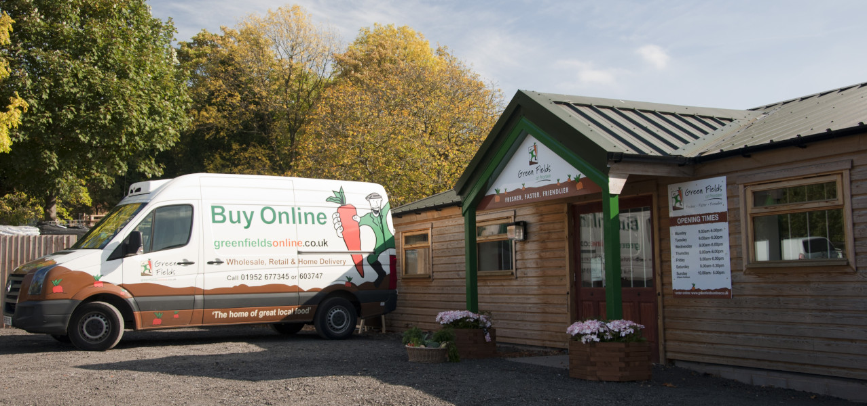
Task 1 DEsign Brief
Finley Stainthorpe

Table of Contents
Business context 1
Empathy map 3
Customer 3
Seller 4
User Stories 4
Customer 4
Seller 5
Functional Requirements 6
Non-Functional Requirements 8
Decomposition 10
KPIs 12
Business KPIs 12
System KPIs 13
User acceptance criteria 14
Description of proposed solution 14
Justification 14
Risks and mitigation 16
Legal and Regulatory requirements 17
Appendices 18
Software 18
Legal and Regulations 18

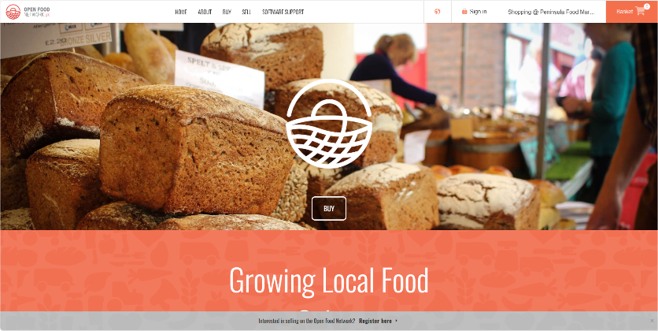
Research
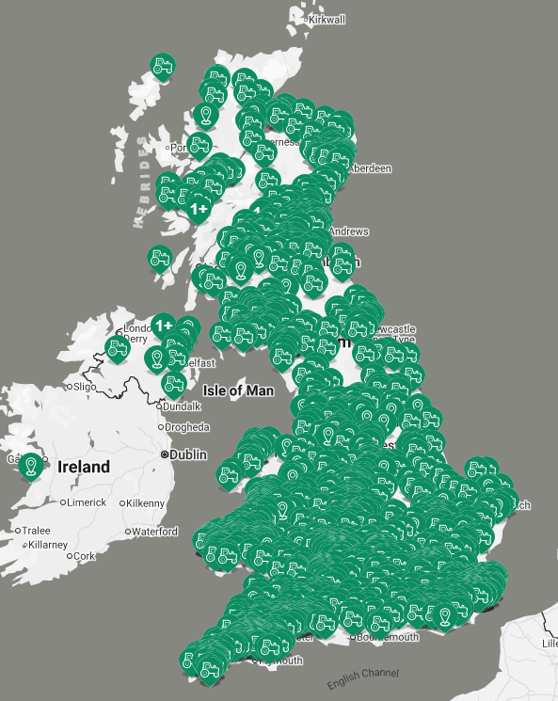
There are not many websites/ apps which are quite like what GHL want. From my research all have been able to find is hard to navigate, hard to understand and generally bad existing solutions. For example this site Open food network. Their homepage looks welcoming and you can see fresh produce which is good. You can access most pages from the navigation bar at the top with clear labels for each button. Also worth mentioning, there is a long load time for all oprtions off this page i counted 10 seconds to get me to the buy page. Despite this it does seem they are rather big showing a map of all thier sellers.
Although after clicking a few of the places most of them seem to be closed shops or just duplicates.

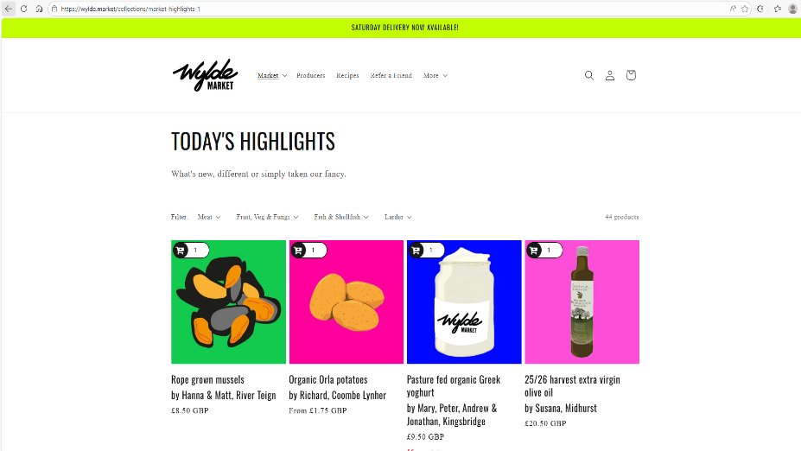
I also found another simmalar site which was very good it had fast load times and a really nice minimalistic style through out.
The producers profiles where also nice having heartwarming descriptions for each one. 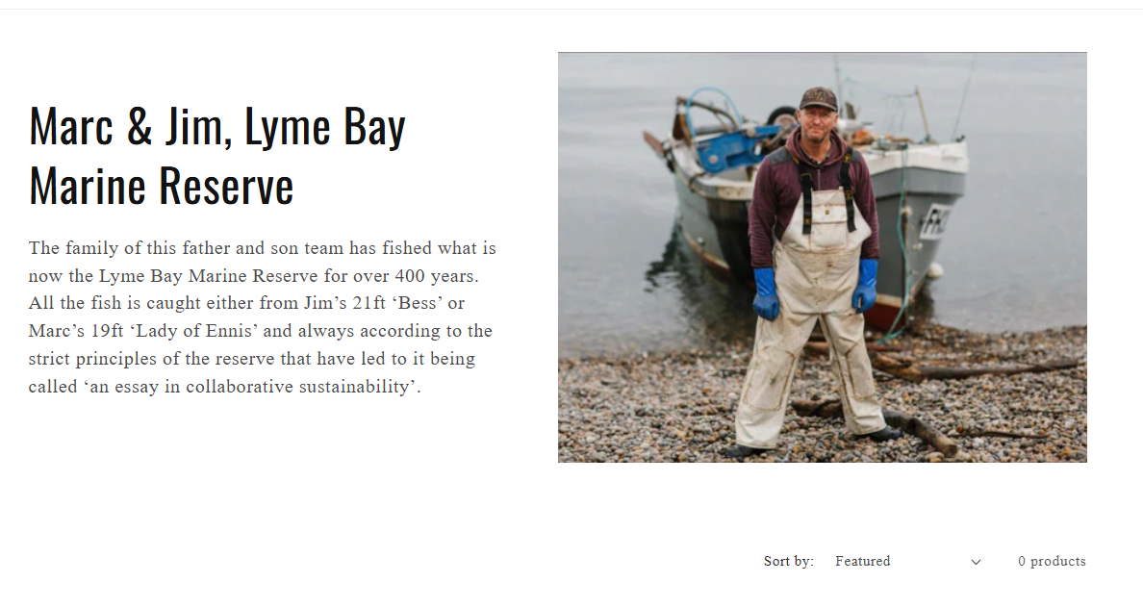

Business context
Greenfield local hub is a cooperative of local farmers and food producers who have come together to sell their fresh farm produce to a wide customer base. GHL already have a wide range of features the company uses for example they have a retail outlet, collective marketing, product management, stock control and traceability. GHL need a digital solution to help with things such as order management and scheduling and tracking features as well as wanting a loyalty scheme, special discounts and offers.

I am proposing a website which will allow customers and sellers to be able to buy and sell their goods, track orders and deliveries, as well as give sellers useful analytics which will help them drive more sales and bring more people to the site, users will also be able to search for items they need and add them to their cart, checkout process will be kept simple with pay by card or cash options and collection or delivery with a fee added automatically for delivery. This solution will massively help GHL pushing their efficiency and simplicity to the next level.

Empathy map
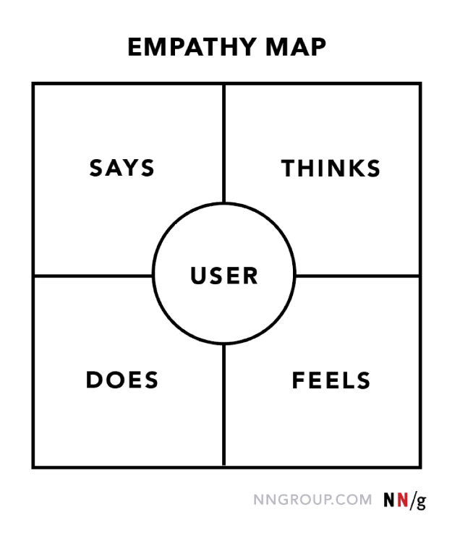

Customer

Says
“This is cheaper at the supermarket”
“How do I know this isn’t a scam”
“how fast is delivery to my house?”

Thinks
“I want to be able to track my order”
“is the site secure?”
“I hope delivery is fast”
“Let me read the reviews first”

Feels
exited about the freshness of the product they are getting
happy they are buying from a local source
anxious about the delivery not coming on time
happy they can look at where the produce has come from

Does
Compares prices around different sites
checks how much delivery fee is
Reads farmers profiles to find out more about their products
shares site with friends

Seller

Says
“how do I make an account”
“how do I know if someone has brought off me”
“where do I see the orders delivery address”
“how do I get my money when the customer pays through card?”

Thinks
“what products can I sell”
“is there any commission fees”
“how will I deliver products”
“how much do I charge”

Feels
worried about commission
worried about how to fulfil deliveries
exited to reach a new customer base
happy he can sell his product to local people

Does
Makes a seller account
sets up a profile telling people about the goods and the farm
lists a product
finds other local farmers on the site

User Stories

Customer

Story
As a customer, I want to browse products by category so that I can find items quickly.

Acceptance Criteria
To fulfil this requirement the system must have a easy to access categories section in the marketplace. This requires the seller to select a category for their product when listing it for sale.

Story
As a customer, I want to place an order for collection or delivery so that I can choose the most convenient option.

Acceptance Criteria
To fulfil this requirement the system must allow users to select delivery or collection when they go to checkout. This will also need to take the users address and add on a delivery fee to their total.

Story
As a customer, I want to view my order history so that I can check previous purchases.

Acceptance Criteria
To fulfil this requirement the system must store all users past orders to their account so they can view old orders and track orders which have not yet been delivered. This would also allow us to add a repeat order feature where the user can copy an order instantly instead of having to add all the items to basket individually.

Seller

Story
As a seller, I want to be able to update my stock levels so that the customers only see what is available.

Acceptance Criteria
To fulfil this requirement the system must allow sellers to view and edit their products after being posted. The system will also edit stock numbers automatically after orders to prevent stock the sellers don’t have being purchased.

Story
As a seller, I want to be able to look at useful sales data to help me keep track of my finances.

Acceptance Criteria
To fulfil this requirement the system will save all sellers sales data to their account and allow them to view it in useful formats such as charts and graphs this data should also be able to be downloaded by the seller in a excel format to allow smooth compatibility with their existing finances. The system should also allow sellers to enter the their price per product to allow for useful profit data to be given as well rather than just their revenue.

Story
As a seller, I want to be able to view incoming orders so that I can prepare them on time.

Acceptance Criteria
To fulfil this requirement the system will have a page for sellers to look at there orders as they come in. This will tell the seller useful information about the orders such as what they have ordered, delivery address, payment type, phone number and when the user ordered. This menu will also allow us to add a tracking feature for the user by allowing sellers to update the status of orders for example preparing, prepared, ready for collection or out for delivery.

Functional Requirements

Homepage
The homepage is the hub for the whole site it is the first impression for the user. It allows you to get to whatever page you need to from one place. It also contains useful information such as what the site is about, the company’s history, the companies goals and instructions on how to use the site.

Sellers page
The sellers page will be the sellers main selling point it allows sellers to tell people information about themselves there farm and have there products they are selling. This page will also have a reviews section where buyers can leave reviews on you and your products encouraging good service from all sellers.

Product Catalogue
The product catalogue will be the main place users will be all the products listed on the site will be here. Users can search products by name or categories they will be able to see popular products and highly rated products. Each product on this page will show just enough information for the buyer to look at such as price, a photo of the product, an add to cart button , who is selling it and the sellers rating.

Product Details page
Once a user has clicked on a product from the catalogue they will be able to see more information about the product such as a description, more photos, average delivery time, the sellers general location, how much stock the seller has and some of the product or sellers reviews. This page will also allow users to select a quantity of the product they would like to add to their cart.

Basket
The basket will have its own page where buyers can have a final check of what they are ordering and make changes to quantity and or remove items from the basket also showing their total payable amount. Once the user is happy with their basket they will be able to enter the checkout.

Checkout
The checkout will give users the option to pay by card through the site or pay in cash. If card is selected the user will have to input their card details to check out. This is also where users will select if they would like their order to collect or for delivery. If delivery is selected the user will be prompted to input there address and phone number and email to be sent to the seller and a delivery fee will be automatically applied to the total. Once all of that is complete the user can check out and will receive an order confirmation screen and also an email confirmation. If the user selects collection the sellers available collection dates and times will be shown and the user can select a date and time to collect the order and also receive an email with their collection number.

Customer account
Customers will be able to make an account or login to an existing one. If the user is creating an account they will be prompted for a username, email, password and a confirmation password. Once a user account has been created they will be able to purchase products, leave reviews, check on their orders and manage their account. If the user selects login they will be prompted for their username and password which will be validated and log them in to the account.

Order history
On the order history page users will be shown all their previous orders and current orders which they have placed. Each order will show them useful information such as the price of the order, what they ordered, an option to repeat the order and also show them the status of current orders.

Seller dashboard
The seller dashboard will be where the seller can add products, edit their profile, change stock numbers, see their seller analytics, check on incoming orders, update the status of orders, look at their reviews and contact customers. It is vital that this page works as efficiently as possible for the sellers ease.

Stock management
Stock management will be an all in one place for the seller to view and edit all their products and stock levels. They will be able to enter a new stock number remove stock sold elsewhere and edit images and information about the product to keep their page fresh and their information correct.

Loyalty scheme
Sellers will be able to set up their own loyalty scheme and discounts on their products, for example buy 5kg of potatoes get 1kg free or after 3 orders get free delivery etc. This will be a good feature to push sales and gain customer attention.

Order tracking
order tracking will mainly be managed by the seller who will be able to update order statuses, contact customers and give estimated delivery dates and times. This is vital for customer satisfaction as it doesn’t leave the buyer worrying about their order. The system will also implement email updates automatically sending the buyer an email when their order status gets updated meaning they don’t have to be constantly on the site.

Non-Functional Requirements

Security
Security is vital for this system as we are handling a lot of personal information and also card details. All card details and personal information will be stored encrypted using AES-265 with a 256 bit key and use end to end encryption for data in transit storing the keys on a high security separate server than the data. The system must also validate all inputs to prevent against any form of SQL injection or errors due to incorrect data limited selection boxes will be used as much as possible for dates / times. For seller accounts and admin accounts MFA(Multi factor authentication) will be required to protect the integrity of the system and its users. We will also use automated security testing and compliance checks to scan and detect vulnerabilities from any third party components. Throughout the systems lifetime security will be constantly upgraded to stop any new threats.

Performance
To maintain the sites performance we must use a clear performance guideline before we start building. We will do this by simplifying code as much as we can so that processes run smooth and fast. Another concern is for the performance of the servers due to GHL already being an established business we should expect a sudden rush of traffic and do thorough testing of how traffic flows through the server before launch. Another simple way of optimizing performance is the use of cookies for users data to be automatically saved the most efficient way possible. As the system and business grow we will continue to provide performance testing and optimizing to keep the site running smooth throughout its lifetime.

Maintainability
To keep the software maintainable we will incorporate automatic testing tools to perform tests such as Unit tests. This provides a good way to prove that the code works and hence eliminates the worry of breaking something when other developers make changes to the code. Another thing to implement to help future developers is logging meaningful events. Providing detailed logs is vital in providing developers with a journal of its execution. These logs must contain messages that describe what’s going on along with the relevant context as key-value pairs. Along the same lines we must also display useful user messages this will allow users to contact support/admins with a message that tells them exactly what is wrong meaning a faster fix for the user. Finally we will implement good documentation on our code to help new developers pick it up faster. We will do this through using good coding standards such as notes in the code, meaning variable and function names and having a clear written guide on what everything does.

Usability
Usability will be optimised by setting a clear criteria for a user interface that is easy to use and accessible to a wide audience. To do this we must focus on 5 key factors learnability helping users understand the interface, efficiency helping users navigate through the site quickly, memorability helping the user return to the interface after a break and immediately be efficient, error handling and frequency helps minimise user mistakes and provides clear and helpful feedback when errors occur and finally satisfaction the overall user experience and aesthetic pleasure of the design.

Accessibility
Accessibility will be optimised by setting a clear criteria for a user interface that is easy to use and accessible to a wide audience. To tackle this we will implement the software standard WCAG 3 accessibility guidelines. This helps the system allow a wider audience of people to use the site properly. This helps people with impaired vision by using a changeable text size, also helping people who are colour blind by having a contrast setting and finally the site needs to be able to be used by just a keyboard. It is also important to note that the site is primarily made for farmers who quite often are older and less good with technology which a good guide on how to use the site should be placed somewhere prominent such as on the home page.

Reliability
Reliability will be upheld to the current software standard which means the site must have a 99.9% uptime meaning there can be no more than 1 hour of downtime per month. We will also implement reliable fault tolerance and recoverability helping the system withstand hardware/software failures and recover data without any losses. Good error handling will be added preventing the system from being down for to long, to do this we will have a fail safe which will restart the system within 30 seconds of a failure. Data will also have to be kept consistent across the system.

Decomposition

User registration and login
The user registration and login will allow users to login to their accounts on the site and register for new accounts. Accounts can be made by the user entering their username password and email address this will then be added to the systems accounts database which will allow them to login to their account. This allows the user to access their data such as past orders, deliveries and sellers can access their products and dashboard.

Browsing products
When the user goes to browse products data will be sent from the database which holds all the items for sale. The user will then be shown the main browse page which holds the products in categories such as most popular items, highly rated items, new items and a section where they can choose a category of produce to be shown for example eggs, milk, flour etc.

Searching and filtering
When a user searches an item their input will be compared to the database with all the items for sale and products matching their search will be shown. If the user makes a spelling mistake or is searching a general term we will have sub names for all products to still show them what they are searching for. To filter products the user can select from a range of options such as highest rated product, highest rated sellers, most popular items. The user will also be able to filter items in a price range and by category.

Managing basket
For a user to mange their basket we will have clear options on the page for the user to be able to remove items from their basket and an option to change the quantity of items they would like. They will also be shown the total for their basket by adding the prices of all the items actively in the basket together.

Placing an order
When the user places an order they will be asked if they would like to pay by cash or card. This will prompt them for their card details and email which when entered will be encrypted with end to end encryption to be sent back to the payment handling service. Once the payment is successful the user will get a confirmation screen and email containing an order number the total price and a thank you message.

Choosing collection or delivery
When the user is checking out collection or delivery options are given. If the user selects collection they will be prompted to choose a time and date which they would like to collect at. Once this is complete and payment is selected they will receive their order number, confirmation email and collection location which can be shown when collecting their item. If they choose delivery the user will be prompted for their address and a phone number to be sent to the seller for delivery.

Updating stock
When a seller wants to update stock they can go to their dashboard where they will be shown an option to manage stock once this is selected they can see all of their items for sale which have been loaded from the sellers account database. They can then proceed to change stock numbers by simply typing it in next to the product. Once they have confirmed this the sites for sale database will be updated and users will be able to see the new stock. We will also implement a notification system where users can set to get a notification when an item is back in stock.

Managing product details
Sellers can use their dashboard to manage stock and see all the items they are currently selling. This page allows them to select an item to edit which opens the products page where they can change the photo description name etc. Once the seller has updated the product and confirmed the changes the updates will be sent to the for sale database and show up for users.

Loyalty Rewards
In the seller dashboard there will be a section to manage loyalty rewards here sellers will be able to add these rewards and discount as and when they want. When a new deal is added for example 2 kg of potatoes for the price of one users will be able to see this on the products page and when the item is added to their cart the discount will be automatically applied before checkout. For loyalty rewards the seller could launch a reward such as get 3 deliveries and the 4th one is free this will be saved to the loyalty data base and when a user account has made three deliveries on the 4th the delivery fee will be automatically removed from the total.

Tracking orders
For tracking orders we will use an email system where the seller can check their current orders in the dashboard and update them accordingly for example when the order has been prepared the seller can update this and the user will receive an email. The seller will also have the option to add an estimated delivery date which the user will receive by email as well.

KPIs

Business KPIs

Number of completed orders per week
This will track the number of completed orders which have happened on the site. We will monitor this using a function built in to the site which we already have for the sellers analytics dashboard. We plan on this stat being higher than their current weekly order number to show that the digital system works and is worth their money. This stat is critical for GHL as it will be there base line for how successful the site is. This depends on people being able to use the site easily and having good marketing of it from GHL. Weekly order numbers will be included in our reports to GHL.

Repeat customer rate
This will track the number of customers who have purchased from the site more than once. This will be measured by filtering users from the database with more than 1 completed order. The target for this stat should be high as we are implementing the loyalty scheme system, sellers discounts and stock notifications for customers. Repeat customer rate is crucial to the site as it allows sellers to keep selling on the site rather than elsewhere and will show GHL that the new system is working. For this to be maintained we need to make sure the loyalty scheme and discounts work flawlessly.

Average order value
Measures the average order value over all of the orders in the database. This will be monitored by a function in the system which reads the past orders data base adds all the values and divided them by the amount of orders. This will help the company as this can provide a good insight to improvements that could maybe be made from the companies side and could be useful to include in things like surveys and ads.

Product page conversion rate
This measures how many customers clicked on your product page compared to those who clicked and brought. This is a really helpful insight for sellers to have as this can show them that they need new photos a better description etc. We will measure this by comparing the users who have viewed the item to who has brought the item giving us our stat. This is also useful for us and GHL as if all numbers are down there could be a problem to do with the site itself not the sellers page.

Basket abandonment rate
This will measure how many people add things to their basket and don’t actually checkout. This can be a very good stat that can highlight a lot of problems such as the user not trusting the site, products being to expensive or even just the user not being able to figure out how to check out. This can be measured by just checking the basket database and seeing how many users have items in their carts.

Percentage of successful deliveries or collections
This stat measures the amount of successful checkouts to the amount of successful deliveries/ collections. This stat should always be above 99.9% as if orders are not being delivered it effects customer satisfaction and if collections are not being picked up it effect seller satisfaction. This is helpful for GHL as it allows them to take action against sellers who do not deliver their orders and buyers who don’t collect collections.

System KPIs

Number of producers actively using the dashboard
This stat will show us how many sellers are actively using the dashboard. This can be measured by just simply comparing the amount of sellers online and the amount of sellers on the dashboard. This number should be close to 80 percent as if the sellers are not on the dashboard they will not be able to see their current orders and may miss some decreasing customer satisfaction. It is also helpful because it can let us know if any servers need upgrading for increased amount of sellers and items for sale.

Page load time
This measures the amount of time it takes for the site and moving to a new page to load. This can be measured using a Cloudflare service which will actively give us lots of analytics on site load time. This number needs to be low around 3 seconds maximum to keep customers and sellers efficient as possible and remove the risk of people leaving the site significantly.
Conversion rate
This indicated how well the website prompts the users to complete the action desired by the sellers and GHL. For example if GHL wants to have 100 daily sales and 130 accounts registered per day then we would need to take those two goals per specific amount of time and divide it by the total number of users and multiply it by 100%. It is vital that this rate is high as if the rate is low that would mean that the website is not doing what it is meant to do.

User acceptance criteria
Users can find products in a small number of clicks
Customers can place an order without confusion
Producers can update stock without technical help
Users can access the site on mobile
Order history is visible in accounts
Accessibility features work correctly

Description of proposed solution
The final proposal is an interactive website that will include the following:
- inclusive solution
The solution will be inclusive for all users and have simple efficient ways of navigating the site and edit the site to all users wants and needs.
- easy and efficient buying and selling
The solution will allow users to easily view all produce on the site and find what they want quick with search and filter tools.
- seller analytics, order processing and loyalty rewards
The solution will give sellers an extensive set of tools to push sales with detailed and useful analytics. Easy access to view manage and edit orders and currently available items.
- buyer tracking and loyalty rewards
The solution will allow buyers to get live updates on their orders and contact sellers with any questions they might have. They will also be able to get loyalty rewards from sellers with the deals being shown to them on their account and frequently purchased products.

Justification

Provide information about the producers, their methods and the benefits of buying locally
The site will use its home page to promote the benefits of users buying locally including information about global warming and tax on farmers etc. Sellers can also customise their profiles to show information about them their farm and their methods which the customer will be able to see on their product page. This will help buyers understand the mission of GHL and encourage good practices going forward.

Allow customers to view products with transparent pricing and availability
Customers will be able to check on items in the market place and clearly see the price of the item that the seller has set. They will also be able to see the quantity of items that the seller has available. This can also all be changed by the seller so stock levels are kept accurate and produce is kept available. This helps GHL by allowing the workload of stock levels and pricing to be up to the sellers saving them a lot of money.

Allow customers to Place orders for collection or delivery
Customers will be able to select collection or delivery at checkout this will then get the information needed from them and send that information to sellers. This helps GHL as the delivery of products is a very expensive and time rich part of their business but by leaving sellers in charge of delivery they save so much money and time increasing revenue and efficiency.

Allow customers to manage their accounts and view order history
Customers will be able to manage their account on the accounts page once they are signed in this will allow customer data to be updated as soon as it changes beating the traditional paper / excel file GHL are using now by a mile. This increases the order fulfilment rate as you will always have a way of contacting the customers even if they change their phone number or email.

Provide a dashboard to enable sellers to manage stock levels, update product details and view orders and allow sellers and users to use order management, scheduling and tracking features

The sellers dashboard will contain an extensive set of tools to help sellers keep on top of their orders, check their analytics, change stock levels, update their profile, add discounts and add/edit the items they are selling. This helps GHL as it allows the farmers to get their story across to the people who are buying from them. This drives sales and increases customer satisfaction. Sellers can not only view orders now but also update the status of orders with automated emails sent to the customer, contact customers and add estimated delivery dates. This is the most crucial part of the whole system as it allows customers to not be left in the dark about their order and increases trust, encourages returning customers and allows the sellers to get orders out as fast as possible.

A loyalty scheme that provides discounts and special offers
Sellers will be able to set their own loyalty schemes, discounts and special offers in the sellers dashboard. This is another big thing for GHL as it was mentioned in the market research that they did meaning there is customers who want to use this and it comes at no loss to GHL. By allowing sellers to add their own discounts and loyalty it means that the sellers can drive their own sales with competitive deals and prices making them more money keeping sellers happy while also costing GHL nothing driving sales, customer satisfaction and seller satisfaction through the roof.

Accessibility features to support a wide range of users.
The site aims to allow all types of users to be able to use the site. We have done this by adding the latest and greatest WACG 3 accessibility guidelines to the site which covers over 99.99% of people globally.

Risks and mitigation

Informational inaccuracy
This could lead to loss of orders, poor customer experience and in the long term even reputational damage. The way to mitigate this is to have a member of staff allocated to doing admin on the site making sure information is up to date and moderating items which are coming on to the site and reviews. This is vital to keep a good reputation with customers as the site needs to be a safe place and there is a risk of items not meant for the site to be sold. That needs to be stopped as soon as it comes in. So for this i will be adding an admin page which will allow admins to check posts before they are uploaded for harmful content.

refunds and disputes
Refunds can be very painful for sellers and buyers alike. To cover this we will have a clear refund policy for buyers in which they will have to file an appeal to an admin and provide valid evidence of why they think they should get a refund and also get information from the seller. For this to work we will need to have a system that will hold the sellers site balance until either the buyer has confirmed the order or until 6 hours have passed since delivery. The buyer can either choose to dispute a full refund or just a partial refund for the damaged produce.

Sellers incoming orders data loss
This can lead to sellers not being able to fulfil orders and leave buyers unhappy. To prevent this we will make sure to use the correct mitigation strategies such as extensive testing of this area, regular testing throughout the solutions lifetime and end to end encryption so we can rule out data being intercepted.

Data Breaches
Alot of personal data is stored on the site for example passwords, emails, card details, phone numbers and names and more. So it is absolutely vital that we protect this, to do so we will use state of the art AES-265 encryption with a 256 bit key and use end to end encryption for data in transit storing the keys on a high security separate server than the data. The system must also validate all inputs to prevent against any form of SQL injection or errors due to incorrect data limited selection boxes will be used as much as possible for dates / times. For seller accounts and admin accounts MFA(Multi factor authentication) will be required to protect the integrity of the system and its users. We will also use automated security testing and compliance checks to scan and detect vulnerabilities from any third party components. Throughout the systems lifetime security will be constantly upgraded to stop any new threats.

Legal and Regulatory requirements

UK GDPR for personal data
To comply to the GDPR we must identify all personal data collected, stores and processed, integrate data protection in to the solution from the start of the development phase, implement functions to obtain, record and manage user consent e.g. cookies, ensure only necessary data is collected, create a function for users to be able to request data access or data to be deleted.

Security and compliance (ISO 27001, HIPAA, PCI-DSS)
To comply with these guidelines we must implement end to end encryption of all data in transit and at rest, use role based access control and unique login credentials which comply with security guidelines, require admin/ seller accounts to use MFA multi factor authentication, have detailed audit logs to track data access, use software composition analysis to detect vulnerabilities finally implement secure automatic session timeouts.

Intellectual property (IP) and licencing
To comply with these guidelines we must simply audit all open source components with licence obligations, ensure any contracts clearly define ownership of the developed IP and verify if software such as encryption software is subject to export restrictions.

Software Development Life Cycle and process
To comply with these guidelines we must maintain detailed documentation of systems architecture and data flows, Implement procedures for managing changes to code and system requirements, conduct comprehensive user acceptance testing UAT to verify security and functionality.

secure payment handling
To ensure secure payment handling we will probably use an external system such as stripe to handle payments. As they are a very reputable company for this and have state of the art security and are always updating security features to keep up with hackers.

Emurging regulations (AI ACT)
Ai is taking the world by storm and with that it poses a lot of threat these new guidelines will help us mitigate risk. To do that we must ensure AI systems are transparent and explainable and audit algorithms for discrimination and bias. Although this shouldn’t be a problem on our site it very much could be in the future.

Appendices

Software
performance - https://checklist.gg/templates/performance-testing-checklist
security - https://www.securitycompass.com/blog/software-security-requirements-checklist/
maintainability - https://medium.com/capital-one-tech/developing-maintainable-software-a-checklist-for-developers-capital-one-6f160a6ceaae
non-functional requirements - https://www.perforce.com/blog/alm/what-are-non-functional-requirements-examples
non-functional requirements - https://www.geeksforgeeks.org/software-engineering/non-functional-requirements-in-software-engineering/

Legal and Regulations
GDPR - https://gdpr.eu/checklist
GDPR - https://captaincompliance.com/education/gdpr-compliance-checklist
HIPPA - https://www.herocoders.com/blog/compliant-software-development-using-checklists-to-ensure-regulatory-compliance
HIPPA - https://www.securitycompass.com/blog/software-security-requirements-checklist
IP - https://www.termsfeed.com/blog/software-licenses-audit
SDSC -https://www.cripps.co.uk/thinking/software-development-legal-checklist
GXP - https://www.tricentis.com/learn/gxp-compliance-checklist-what-you-need-to-know
AI ACT - https://www.farrer.co.uk/news-and-insights/the-eu-ai-act--what-does-it-mean-for-uk-organisations-that-use-or-provide-ai-systems/

