MULTIMEDIA UNIVERSITY OF KENYA
FACULTY OF COMPUTING AND INFORMATION TECHNOLOGY
DEPARTMENT OF INFORMATION TECHNOLOGY
COURSE: BACHELOR OF SCIENCE IN INFORMATION TECHNOLOGY
KAZI CONNECT: A TRUSTED SERVICE MARKETPLACE FOR UNIVERSITY STUDENTS
SOFTWARE REQUIREMENTS SPECIFICATION
Prepared in line with ISO/IEC/IEEE 29148:2018
Version 1.0
October 2026
Group Members:
[Member Name] [Registration Number]
[Member Name] [Registration Number]
[Member Name] [Registration Number]
[Member Name] [Registration Number]
[Member Name] [Registration Number]

DOCUMENT CONTROL
Table 1: Revision history
Version | Date | Author | Description of change
1.0 | 10 October 2026 | Project group | First complete draft, derived from the Kazi Connect concept paper and the requirements discussion held with the project group.

Table 2: Approval
Role | Name | Signature | Date
Project supervisor
Group representative

TABLE OF CONTENTS
1. INTRODUCTION 6
1.1 Purpose 6
1.2 Scope 6
1.3 Product Overview 7
1.3.1 Product Perspective 7
1.3.2 Product Functions 8
1.3.3 User Characteristics 9
1.3.4 Limitations 9
1.4 Definitions, Acronyms and Abbreviations 9
1.5 References 10
1.6 Document Conventions 10
1.7 Document Structure 11
2. BUSINESS REQUIREMENTS 12
2.1 Business Background 12
2.2 Business Problem 12
2.3 Business Objectives 12
2.4 Stakeholders 13
2.5 Business Model 13
2.6 Business Rules 13
2.7 Functional Business Requirements 14
2.8 Non-Functional Business Requirements 15
2.9 Assumptions and Dependencies 15
3. USER REQUIREMENTS 17
3.1 Account Model 17
3.2 Use Cases 17
3.3 User Stories 18
3.3.1 Registration and Accounts 18
3.3.2 Verification and Badge 19
3.3.3 Listings, Pricing and Search 19
3.3.4 Booking, Payment and Delivery 20
3.3.5 Communication, Reviews and Safety 21
3.3.6 Administration 21
3.4 Functional User Requirements 22
3.5 Non-Functional User Requirements 23
4. SYSTEM REQUIREMENTS 24
4.1 System Overview 24
4.2 Booking Lifecycle and Payment Flow 24
4.3 Functional System Requirements 26
4.3.1 Accounts and Authentication (ACC) 26
4.3.2 Student Verification (VER) 27
4.3.3 Verified Badge (KYC) 27
4.3.4 Profiles and Listings (LST) 28
4.3.5 Pricing and Estimates (PRC) 28
4.3.6 Search and Location (SRC) 29
4.3.7 Recommendation Score (REC) 29
4.3.8 Booking and Job Rules (BKG) 30
4.3.9 Payments and Ledger (PAY) 30
4.3.10 Delivery and Confirmation (DLV) 31
4.3.11 Disputes (DSP) 32
4.3.12 Chat (CHT) 32
4.3.13 Ratings and Reviews (REV) 33
4.3.14 Reports and Safety (SAF) 33
4.3.15 Notifications (NTF) 34
4.3.16 Administration (ADM) 34
4.3.17 Privacy and Data Rights (PRV) 35
4.4 Non-Functional System Requirements 35
4.4.1 Performance and Capacity (PER) 35
4.4.2 Security (SEC) 36
4.4.3 Privacy and Compliance (PRI) 36
4.4.4 Reliability and Availability (REL) 37
4.4.5 Maintainability and Portability (MNT) 37
4.4.6 Auditability (AUD) 37
4.5 External Interface Requirements 38
4.5.1 User Interfaces 38
4.5.2 Software Interfaces 38
4.5.3 Communication Interfaces 38
4.6 Data Requirements 39
5. VERIFICATION 41
6. TRACEABILITY MATRIX 42
APPENDIX A: DEFAULT CONFIGURATION VALUES 43
APPENDIX B: INITIAL SERVICE CATEGORIES AND JOB RULES 44
APPENDIX C: OPEN ISSUES 45
\ZJZZZZZZZZZZZZZZZZZZZZZZZZZZZ

1. INTRODUCTION

1.1 Purpose
This Software Requirements Specification (SRS) defines the requirements for Kazi Connect, a web-based marketplace in which clients hire verified service providers for local services. The platform is built first for students of Multimedia University of Kenya (MMU) and is also open to members of the public.
The document turns the Kazi Connect concept paper into business, user and system requirements. The project group will design, build and test the prototype against these requirements. The intended readers are the project group, the project supervisor, the examiners in the Department of Information Technology, and any developer who extends the platform in future.

1.2 Scope
Kazi Connect lets a client find a nearby provider, check the provider's verification status and reputation, book a service, and pay through M-Pesa. The platform holds the payment until the provider reports the job as delivered and the client confirms it. The platform then releases the payment to the provider less a commission that depends on the provider's account category. Each completed job produces ratings that build the reputation of both parties.
The following features are in scope for the prototype:
- Client and provider accounts, with an upgrade path from client to provider and a mode switch for providers who want to hire.
- Student and General account categories, with mandatory yearly reverification of student email addresses.
- An optional, paid verified badge based on review of student and national identity documents.
- Provider profiles, service listings, and price estimates that providers may price above or below.
- Location-based search using a free map and GPS service.
- Booking with job rules for each service category.
- M-Pesa payment through the Daraja STK Push API, with funds held by the platform, release on confirmation, and automatic release after 48 hours.
- Commission rates by account category, set by admins.
- Cancellations, refunds and disputes.
- In-app chat between clients and providers.
- Two-way ratings: clients review providers and providers rate clients.
- Email notifications.
- An admin console with configuration, moderation and reporting.
The following items are out of scope for the prototype:
- Movement of real money. All M-Pesa transactions run in the Daraja sandbox.
- Native Android and iOS applications. The web interface is responsive and works in mobile browsers.
- Payment methods other than M-Pesa.
- Notifications by SMS or push message. SMS is used only to send phone verification codes.
- Automated identity checks against government databases. Admins review identity documents manually.
- Campuses other than MMU. The design supports adding them later through configuration.

1.3 Product Overview

1.3.1 Product Perspective
Kazi Connect is a new, self-contained web system. It connects to Safaricom's M-Pesa Daraja API for payments, a free map and geolocation service for location features, an SMTP email service for notifications, and an SMS gateway for phone verification codes. Figure 1 shows the system and the parties it exchanges information with.
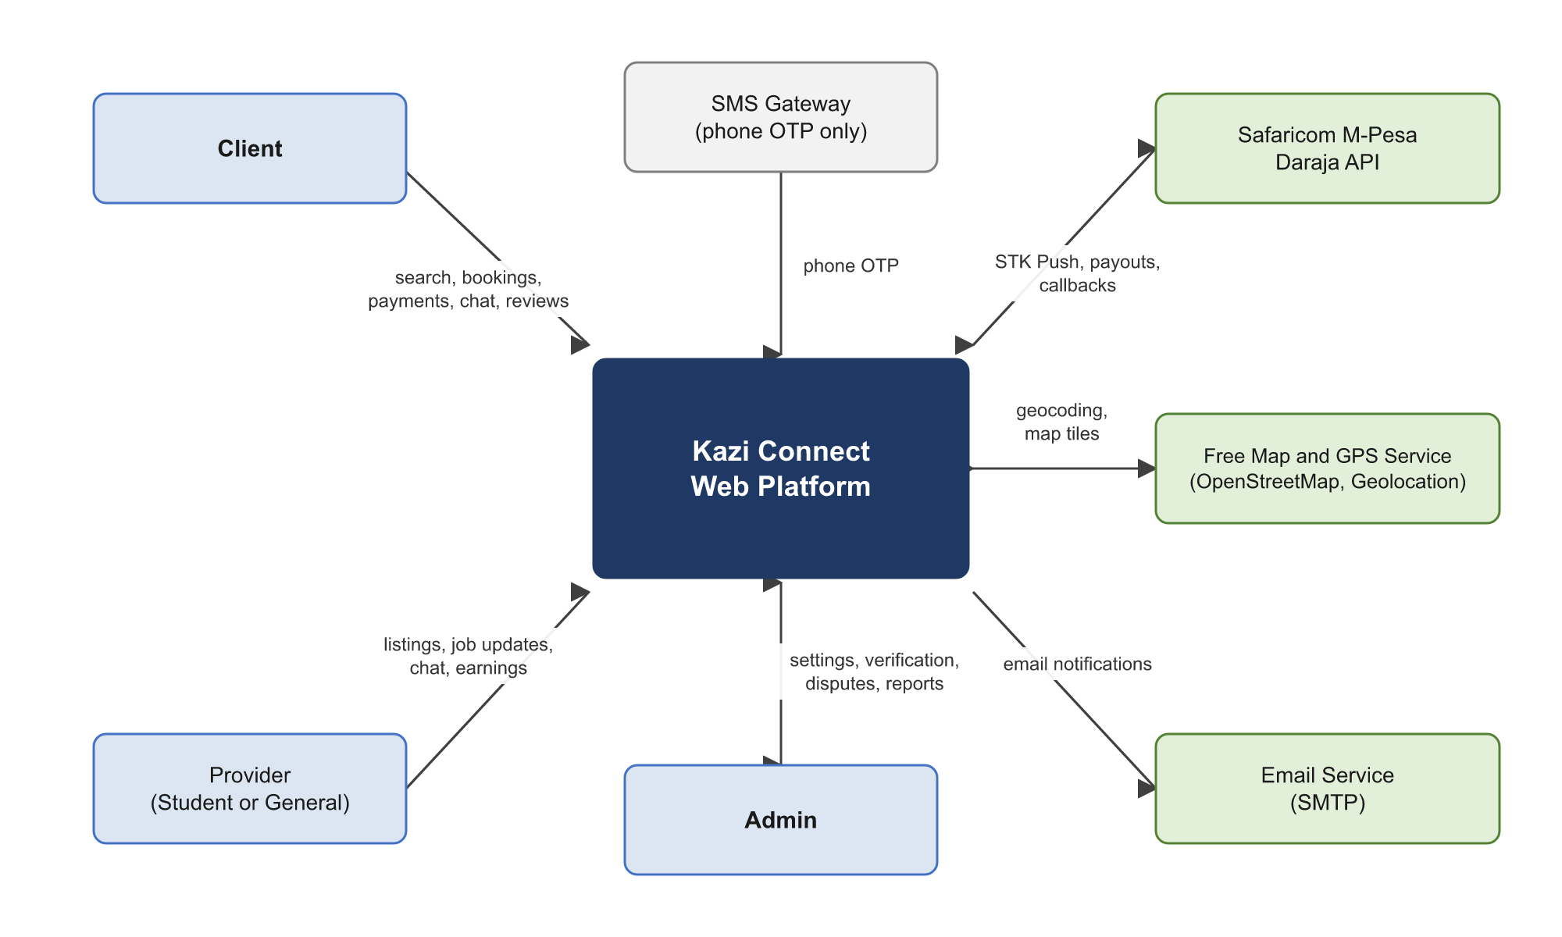
Figure 1: System context of Kazi Connect

1.3.2 Product Functions
At a high level the system performs the following functions:
- Registers and verifies users, and manages client, provider and admin accounts.
- Verifies student status through MMU email addresses and repeats the check every year.
- Processes optional verified badge applications for a fee.
- Publishes provider profiles and service listings with suggested price estimates.
- Finds providers by service, location and other filters, and ranks them by a recommendation score.
- Manages bookings from request to completion, including job rules, cancellations and disputes.
- Collects payments by M-Pesa, holds them, and pays providers after confirmation or after 48 hours.
- Provides chat between clients and providers.
- Records ratings and reviews for completed, paid jobs.
- Sends email notifications for key events.
- Gives admins tools to configure the platform, review documents, resolve disputes and view reports.

1.3.3 User Characteristics
Table 3: User classes
User class | Description | Expected skill level
Client | Any member of the public or student who wants to hire a service. Includes households and small businesses near the MMU campus. | Basic smartphone and M-Pesa use. No technical training assumed.
Provider (Student) | An MMU student who offers services and has verified a current MMU student email address. | Comfortable with web applications and M-Pesa.
Provider (General) | A member of the public who offers services and has verified a phone number and email address. | Basic smartphone and M-Pesa use.
Admin | A member of the platform team who configures the platform, reviews documents, resolves disputes and moderates content. | Trained in the admin console and platform policies.

1.3.4 Limitations
- The prototype uses the Daraja sandbox. A production launch needs Safaricom go-live approval and a legal review of how client funds are held, including any requirements of the Central Bank of Kenya.
- Free map, geocoding and email services have usage limits. The system must respect them and cache results where the terms allow.
- Student verification depends on MMU continuing to issue student email addresses on a known domain.
- Personal data handling must comply with the Data Protection Act, 2019.

1.4 Definitions, Acronyms and Abbreviations
Table 4: Definitions
Term | Meaning
Account category | The Student or General label on an account. It determines the commission rate charged on provider earnings.
Admin | A platform staff account with access to the admin console.
Auto-release | Automatic payment to the provider when the client neither confirms nor disputes a delivered job within 48 hours.
B2C | Business to Customer. The Daraja API used to send money from the platform to a customer's M-Pesa account.
Client mode | The view in which a user hires services. Every account has it.
Commission | The percentage of a job price the platform keeps before paying the provider.
Daraja | Safaricom's developer platform for M-Pesa APIs.
DPA | Data Protection Act, 2019 (Kenya).
Held funds | Money paid by a client that the platform keeps until the job is confirmed, auto-released or resolved.
Job rules | Conditions set by admins for a service category that both parties accept before a booking is confirmed.
KES | Kenya Shillings.
KYC | Know Your Customer. Here, the review of identity documents for the verified badge.
MMU | Multimedia University of Kenya.
MoSCoW | Prioritisation scheme: Must have, Should have, Could have, Won't have.
OTP | One-Time Password.
Provider mode | The view in which a user with a provider account offers services.
Recommendation score | A calculated value used to rank providers in search results.
SRS | Software Requirements Specification.
STK Push | The Daraja Lipa na M-Pesa Online API that sends a payment prompt to a customer's phone.
Verified badge | A profile mark awarded after an admin reviews a user's identity documents.

1.5 References
- ISO/IEC/IEEE 29148:2018, Systems and software engineering: Life cycle processes, Requirements engineering.
- Kazi Connect: A Trusted Service Marketplace for University Students, Concept Paper, Multimedia University of Kenya, 2026.
- Republic of Kenya. (2019). Data Protection Act, No. 24 of 2019. Government Printer.
- Safaricom PLC. Daraja API documentation (Authorization, M-Pesa Express (STK Push), STK Push Query, B2C).
- OpenStreetMap Foundation. Tile Usage Policy and Nominatim Usage Policy.
- W3C. Web Content Accessibility Guidelines (WCAG) 2.1.
- OWASP Foundation. OWASP Top 10 (2021).

1.6 Document Conventions
Each requirement has a unique identifier in the following form:
Table 5: Requirement identifiers
Prefix | Meaning | Example
BR-F | Functional business requirement | BR-F-04
BR-NF | Non-functional business requirement | BR-NF-01
BRU | Business rule | BRU-08
US | User story | US-13
UR-F | Functional user requirement | UR-F-10
UR-NF | Non-functional user requirement | UR-NF-03
SR-F-xxx | Functional system requirement in module xxx | SR-F-PAY-06
SR-NF-xxx | Non-functional system requirement in area xxx | SR-NF-SEC-02

Priorities follow the MoSCoW scheme. Must requirements are needed for the prototype to be accepted. Should requirements are important and planned for the prototype if time allows. Could requirements are desirable extras. The word "shall" marks a mandatory requirement, "should" marks a recommended one, and "may" marks an option.
Values shown as defaults, such as time limits and thresholds, are listed in Appendix A. Admins can change them unless a business rule fixes them.

1.7 Document Structure
This SRS follows the content of ISO/IEC/IEEE 29148:2018 and arranges it in three levels agreed by the project group. Section 2 states the business requirements. Section 3 states the user requirements, with user stories. Section 4 states the system requirements, including interfaces and data. Each level has its own functional and non-functional requirements. Section 5 describes how requirements will be verified, Section 6 traces requirements back to the project objectives, and the appendices hold default values, job rules and open issues.

2. BUSINESS REQUIREMENTS

2.1 Business Background
Local services in Kenya, such as tutoring, cleaning, photography and design, are usually arranged through friends, referrals and social media groups. These channels give a client no reliable way to check a stranger's identity or track record, and they give no protection when money changes hands. At the same time, many university students have marketable skills and no credible way to prove them to paying customers.
Kazi Connect addresses both problems with a marketplace built on three trust mechanisms: verified identity, protected payment, and visible reputation. MMU is the launch community because it offers a concentrated group of student providers, nearby demand, and easy verification through university email.

2.2 Business Problem
Clients cannot easily tell which local service providers are safe and competent. Young people with real skills lack a way to prove them and reach customers. Informal channels offer no identity verification, no consistent review record and no payment protection, which leads to lost income, lost opportunities and avoidable risk for both sides.

2.3 Business Objectives
Table 6: Business objectives
ID | Objective | Success measure for the pilot
BO-1 | Give clients a dependable way to judge the safety and competence of local providers. | At least 80% of surveyed pilot clients agree that profile information helped them choose a provider.
BO-2 | Give young people, starting with MMU students, a credible way to prove their skills and earn income. | At least 50 verified student providers with a published listing during the pilot.
BO-3 | Protect both parties in every on-platform transaction. | 100% of paid bookings end in release, refund or a recorded dispute decision, with no unaccounted funds in the ledger.
BO-4 | Launch within the MMU community and prepare for other campuses. | A new university email domain can be enabled through admin configuration with no code change.
BO-5 | Sustain the platform through commission and badge fees. | Commission and badge revenue are recorded and reported correctly for every transaction in sandbox testing.
BO-6 | Handle personal data lawfully and securely. | All privacy and compliance requirements in Section 4.4.3 pass inspection before the pilot.

2.4 Stakeholders
Table 7: Stakeholders
Stakeholder | Interest in the system
Clients | Find safe, competent providers nearby and pay with protection.
Student providers | Earn income, build a reputation, and pay a lower commission.
General providers | Reach local customers and build a reputation.
Admins | Run the platform, keep it safe, and resolve problems fairly.
Project group | Deliver a working prototype that meets the project objectives.
Project supervisor and examiners | Assess that the system meets its objectives and academic standards.
Multimedia University of Kenya | Its student email domain supports verification. Its students form the first provider community.
Safaricom (M-Pesa Daraja) | Provides the payment API and its rules of use.
Office of the Data Protection Commissioner | Oversees compliance with the Data Protection Act, 2019.

2.5 Business Model
The platform earns revenue in two ways. First, it keeps a commission on each paid job. Admins set one rate for Student providers and one for General providers, and the Student rate is lower. Second, it charges a fee to users who apply for a verified badge. The prototype keeps running costs low by using free tiers of map, geocoding and email services and the free Daraja sandbox.

2.6 Business Rules
Table 8: Business rules
ID | Rule
BRU-01 | Every user first registers as a client. Client registration needs only a verified email address and phone number, and no documents.
BRU-02 | A client who wants to offer services upgrades to a provider account by completing the extra steps in SR-F-ACC-08.
BRU-03 | A provider can switch to client mode to hire services using the same login.
BRU-04 | Every account has a category, Student or General. The Student category requires a verified MMU student email address.
BRU-05 | Student email verification is valid for 12 months. Reverification is mandatory every year. An account whose verification lapses moves to the General category until the student reverifies.
BRU-06 | Admins set the commission rate for each category. The Student rate shall be lower than the General rate.
BRU-07 | A booking uses the commission rate in force, and the provider's category, at the moment the client pays.
BRU-08 | The client pays the full job price through M-Pesa STK Push before the service is delivered.
BRU-09 | The platform holds the payment until the provider marks the job delivered and the client confirms delivery.
BRU-10 | If the client neither confirms nor raises a dispute within 48 hours of the provider marking the job delivered, the platform releases the payment to the provider automatically.
BRU-11 | A dispute freezes the held payment until an admin decides the outcome.
BRU-12 | Providers set their own prices. The system shows an estimate based on the service category and the provider's experience, and the provider may price above or below it.
BRU-13 | Each service category has job rules set by admins. The client and the provider shall accept them before a booking is confirmed.
BRU-14 | Only a client who paid for a completed booking may review the provider for that booking. Only the provider on a completed booking may rate the client for that booking.
BRU-15 | Any user may apply for a verified badge by paying a fee set by admins and submitting a national ID, plus a student ID for Student accounts. The badge raises the user's recommendation score.
BRU-16 | Clients and providers may choose to arrange a service outside the platform. A service arranged outside the platform has no payment protection, dispute support or reviews.
BRU-17 | The platform sends notifications by email.
BRU-18 | Only an existing admin can create an admin account. There is no public admin registration.

2.7 Functional Business Requirements
Table 9: Functional business requirements
ID | Requirement | Priority
BR-F-01 | The business shall operate a two-sided marketplace that connects clients with providers of local services. | Must
BR-F-02 | The business shall verify the email address and phone number of every user before the user can book or offer a service. | Must
BR-F-03 | The business shall distinguish Student and General accounts on profiles and in commission rates. | Must
BR-F-04 | The business shall collect payment before a service is delivered and hold it until delivery is confirmed, auto-released or resolved. | Must
BR-F-05 | The business shall earn a commission on each paid job at rates set by admins. | Must
BR-F-06 | The business shall offer an optional, paid verified badge based on identity document review. | Must
BR-F-07 | The business shall build public reputations for providers and clients from ratings tied to paid, completed jobs. | Must
BR-F-08 | The business shall resolve disputes between clients and providers through admins. | Must
BR-F-09 | The business shall apply job rules to each service category to manage safety and expectations. | Must
BR-F-10 | The business shall launch at MMU and shall be able to add other universities by approving their student email domains. | Should
BR-F-11 | The business shall give admins reports on users, bookings, revenue, verification and disputes. | Should

2.8 Non-Functional Business Requirements
Table 10: Non-functional business requirements
ID | Requirement | Priority
BR-NF-01 | The business shall comply with the Data Protection Act, 2019, including lawful purpose, data minimisation, security and data subject rights. | Must
BR-NF-02 | The prototype shall use the Daraja sandbox only. A production launch shall wait for Safaricom go-live approval and a legal review of holding client funds. | Must
BR-NF-03 | The Student commission rate shall stay lower than the General rate so the platform remains affordable for students. | Must
BR-NF-04 | The prototype shall use free or free-tier external services where possible. | Should
BR-NF-05 | The business shall publish terms of use, a privacy notice, a provider code of conduct and the job rules before users can transact. | Must
BR-NF-06 | Adding a new campus shall require configuration only. | Should
BR-NF-07 | Fees shall be shown to users before they commit to any payment. | Must

2.9 Assumptions and Dependencies
- MMU student email addresses use a known domain that admins can configure.
- Users have a phone registered for M-Pesa and an email address they can access.
- The Daraja sandbox is available for STK Push, STK Push Query and B2C testing.
- A free map tile, geocoding and email service is available within its usage limits.
- An SMS gateway with a free or test tier is available for phone verification codes.
- Admins are available to review badge applications and disputes within the target times in Appendix A.

3. USER REQUIREMENTS

3.1 Account Model
Accounts are split at the first level into client accounts and provider accounts. Signing up as a client is quick and needs no documents. A client who wants to offer services upgrades to a provider account and completes extra steps. A provider keeps the ability to hire, and switches to client mode to do so with the same login. Every account also has a category, Student or General, and may carry an optional verified badge. Admin accounts are separate and are created by existing admins. Figure 2 summarises the model.
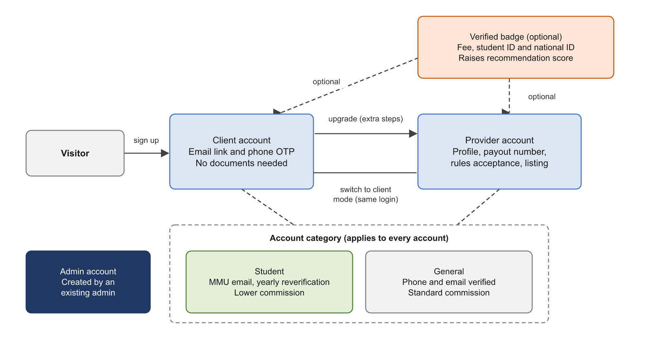
Figure 2: Account model

3.2 Use Cases
Figure 3 shows the main use cases for each actor. Client and Provider are both kinds of Registered user, so both share the use cases linked to Registered user.
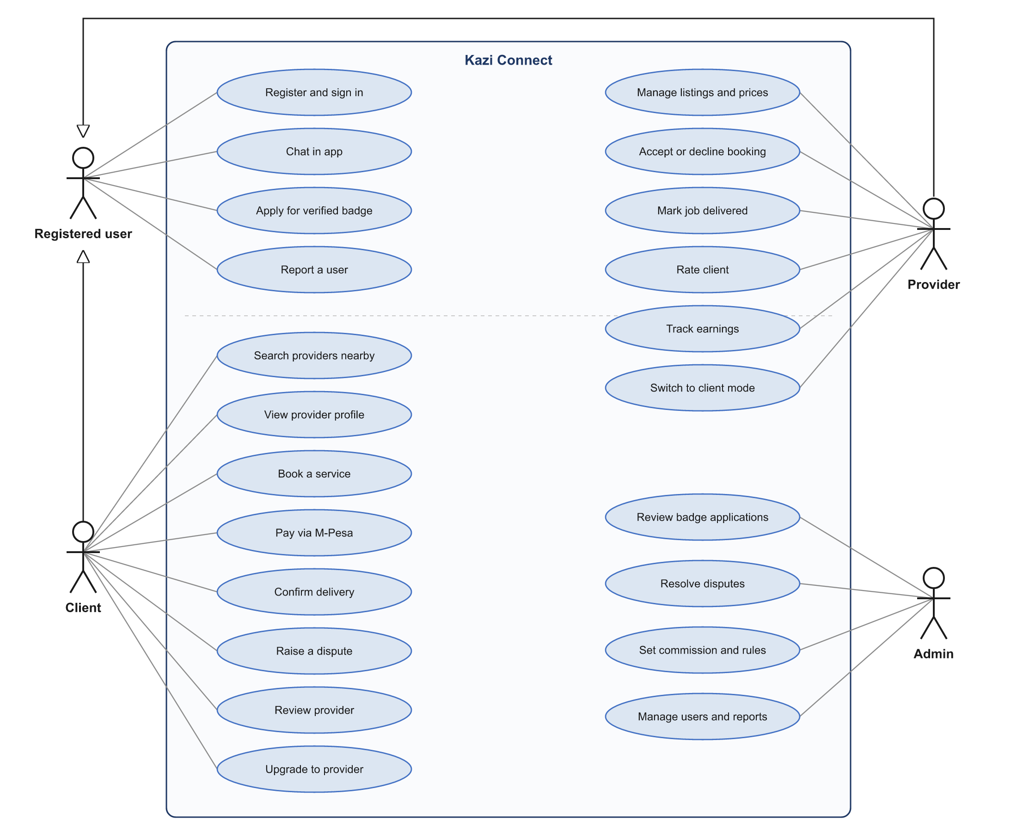
Figure 3: Use case diagram

3.3 User Stories
The user stories below are grouped by area. Each one has acceptance criteria that the team will use in acceptance testing.

3.3.1 Registration and Accounts
Table 11: User stories: registration and accounts
ID | User story | Acceptance criteria | Priority
US-01 | As a visitor, I want to sign up as a client with my name, email and phone number so that I can start hiring quickly. | I receive an email link and an SMS code.  My account becomes active once both are verified.  No documents are requested. | Must
US-02 | As a client, I want to upgrade to a provider account so that I can offer my services. | The system lists the upgrade steps and shows my progress.  My provider account becomes active only when every step is complete. | Must
US-03 | As a provider, I want to switch to client mode so that I can hire a service with the same login. | A switch is visible on every page.  The current mode is clearly shown.  My client and provider bookings are listed separately. | Must
US-04 | As a user, I want to manage my personal data so that I stay in control of it. | I can view and edit my details.  I can download my data.  I can request deletion of my account. | Should

3.3.2 Verification and Badge
Table 12: User stories: verification and badge
ID | User story | Acceptance criteria | Priority
US-05 | As an MMU student, I want to verify my student email so that I get the Student category and the lower commission. | A link is sent to my MMU student email.  After I click it, my profile shows the Student label. | Must
US-06 | As a student, I want reminders before my yearly reverification is due so that I keep my Student status. | I receive emails 30, 7 and 1 days before expiry.  If I do not reverify, my account moves to General and I am told by email. | Must
US-07 | As a user, I want to apply for a verified badge so that clients trust me more and I rank higher in search. | I see the fee before paying.  I pay by STK Push and upload my documents.  I receive the decision by email, with a reason if rejected. | Must

3.3.3 Listings, Pricing and Search
Table 13: User stories: listings, pricing and search
ID | User story | Acceptance criteria | Priority
US-08 | As a provider, I want to create service listings with photos, a price and a service area so that clients can find me. | I can save a draft, publish, pause and edit a listing.  A published listing appears in search for clients inside my service area. | Must
US-09 | As a provider, I want to see a price estimate for my service so that I can price myself fairly. | The estimate reflects the category and my experience level.  I may set a price above or below it within the category limits. | Must
US-10 | As a client, I want to search for services near me so that I can find a provider who can reach me. | I can use my current location or choose a place on a map.  I can filter by category, distance, price, rating, category label and badge.  Results show on a list and a map. | Must
US-11 | As a client, I want to view a provider's profile so that I can decide whether to hire them. | The profile shows the Student or General label, badge, ratings, reviews, completed jobs, experience level and prices. | Must

3.3.4 Booking, Payment and Delivery
Table 14: User stories: booking, payment and delivery
ID | User story | Acceptance criteria | Priority
US-12 | As a client, I want to request a booking for a date, time and place so that the provider knows what I need. | I see and accept the job rules and the provider's terms before sending.  The provider is notified by email. | Must
US-13 | As a provider, I want to accept or decline booking requests so that I only take jobs I can do. | I accept the job rules when I accept.  Requests I do not answer within 24 hours expire. | Must
US-14 | As a client, I want to pay through an M-Pesa prompt on my phone so that payment is quick and protected. | After the provider accepts, I receive an STK Push prompt.  I see the amount before paying.  The booking shows Paid once M-Pesa confirms. | Must
US-15 | As a provider, I want to mark a job as delivered so that my payment can be released. | The client is emailed and has 48 hours to confirm or dispute. | Must
US-16 | As a client, I want to confirm delivery or raise a dispute so that I only pay for work that was done. | Confirming releases the payment.  Raising a dispute freezes the payment. | Must
US-17 | As a provider, I want to be paid automatically if the client does not respond in 48 hours so that my money is not held indefinitely. | Payment is released at the end of the window when no dispute is open.  Both parties are emailed. | Must
US-18 | As a client, I want to cancel a booking and receive any refund due so that I am treated fairly when plans change. | The refund amount is shown before I confirm the cancellation.  Refunds follow the cancellation policy. | Must
US-19 | As a provider, I want to see my earnings, held funds, commission and payouts so that I can track my income. | The earnings page lists each booking with gross price, commission and net payout. | Should

3.3.5 Communication, Reviews and Safety
Table 15: User stories: communication, reviews and safety
ID | User story | Acceptance criteria | Priority
US-20 | As a client or provider, I want to chat in the app so that we can agree on details. | Messages arrive within a few seconds.  I receive an email when I have unread messages. | Must
US-21 | As a client who paid for a completed job, I want to rate and review the provider so that others can benefit from my experience. | I can give 1 to 5 stars and a comment within 14 days.  Only clients who paid can review. | Must
US-22 | As a provider, I want to rate the client after a completed job so that other providers know what to expect. | I can give 1 to 5 stars and a comment within 14 days. | Must
US-23 | As a user, I want to report unsafe behaviour or a policy breach so that admins can act. | I can report a user, listing, message or review.  I receive confirmation that the report was received. | Must
US-24 | As a user, I want email notifications for important events so that I do not miss anything. | Emails are sent for the events in SR-F-NTF-02. | Must

3.3.6 Administration
Table 16: User stories: administration
ID | User story | Acceptance criteria | Priority
US-25 | As an admin, I want to review badge applications so that only genuine users receive the badge. | I can view documents, approve or reject with a reason, and every view is logged. | Must
US-26 | As an admin, I want to resolve disputes so that held funds go to the right party. | I can see the booking, chat history and evidence.  I can release, refund or split the funds and record my reasons. | Must
US-27 | As an admin, I want to set commission rates, fees, price estimates and job rules so that the platform runs on current policy. | Changes apply to new payments only and are recorded in the audit log. | Must
US-28 | As an admin, I want to suspend accounts and moderate reviews and reports so that the platform stays safe. | Suspended users cannot book or receive bookings.  Hidden reviews keep a record of the reason. | Must
US-29 | As an admin, I want dashboards and reports so that I can monitor the platform. | I can see key figures and export reports to CSV. | Should

3.4 Functional User Requirements
Table 17: Functional user requirements
ID | Requirement | Priority
UR-F-01 | A visitor shall be able to register a client account using a name, email address, phone number and password. | Must
UR-F-02 | A client shall be able to upgrade to a provider account by completing the provider steps. | Must
UR-F-03 | A provider shall be able to switch between provider mode and client mode without signing in again. | Must
UR-F-04 | A user shall be able to verify an MMU student email address to obtain the Student category, and to reverify it every year. | Must
UR-F-05 | A user shall be able to apply and pay for a verified badge and track the application. | Must
UR-F-06 | A provider shall be able to create, edit, publish, pause and remove service listings. | Must
UR-F-07 | A provider shall be able to view a price estimate and set a price above or below it. | Must
UR-F-08 | A client shall be able to search for providers by service, location and filters, and view results on a list and a map. | Must
UR-F-09 | A client shall be able to view a provider's full public profile and reviews. | Must
UR-F-10 | A client shall be able to request a booking after accepting the job rules and provider terms. | Must
UR-F-11 | A provider shall be able to accept or decline a booking request. | Must
UR-F-12 | A client shall be able to pay for an accepted booking through M-Pesa STK Push. | Must
UR-F-13 | A provider shall be able to mark a job as started and as delivered. | Must
UR-F-14 | A client shall be able to confirm delivery or raise a dispute. | Must
UR-F-15 | A client or provider shall be able to cancel a booking under the cancellation policy. | Must
UR-F-16 | Both parties shall be able to submit evidence in a dispute and read the decision. | Must
UR-F-17 | Clients and providers shall be able to exchange chat messages and images. | Must
UR-F-18 | A paying client shall be able to review the provider, and the provider shall be able to rate the client, after completion. | Must
UR-F-19 | A user shall be able to report a user, listing, message or review. | Must
UR-F-20 | A provider shall be able to view earnings, held funds, commission and payout history. A client shall be able to view payment history and receipts. | Should
UR-F-21 | A user shall be able to view, update and download personal data and request account deletion. | Should
UR-F-22 | An admin shall be able to configure rates, fees, time limits, categories, estimates and job rules. | Must
UR-F-23 | An admin shall be able to review badge applications, resolve disputes, handle reports and manage accounts. | Must
UR-F-24 | An admin shall be able to view dashboards and export reports. | Should

3.5 Non-Functional User Requirements
Table 18: Non-functional user requirements
ID | Requirement | Priority
UR-NF-01 | A new user shall be able to complete client registration, including both verifications, in under 3 minutes. | Must
UR-NF-02 | A client shall be able to go from a provider profile to a submitted booking request in no more than 4 steps. | Should
UR-NF-03 | At least 90% of first-time users in usability testing shall complete a search, booking and payment without help. | Should
UR-NF-04 | The interface shall be usable on screens from 360 pixels wide upwards. | Must
UR-NF-05 | The interface shall meet WCAG 2.1 Level AA for contrast, keyboard access, labels and text alternatives. | Should
UR-NF-06 | The interface language shall be English. A Kiswahili version may follow. | Must
UR-NF-07 | Every action that changes data shall give clear on-screen confirmation or an error message that explains how to fix the problem. | Must
UR-NF-08 | Trust indicators (account category, badge, rating, completed jobs) shall be visible on every search result and profile. | Must
UR-NF-09 | Money amounts shall be shown in whole Kenya Shillings and times in East Africa Time. | Must
UR-NF-10 | The usability of the prototype shall reach a System Usability Scale score of at least 70 in pilot testing. | Should

4. SYSTEM REQUIREMENTS

4.1 System Overview
Kazi Connect is a web application with three layers. The presentation layer is a responsive web interface for users and admins. The application layer provides a REST API and a WebSocket service for chat, organised into the modules shown in Figure 4. The data layer holds a relational database, encrypted storage for identity documents and evidence files, and an audit log. A scheduler runs timed tasks such as auto-release and reverification reminders. The choice of programming languages and frameworks is left to the project group, within the constraints in this section.
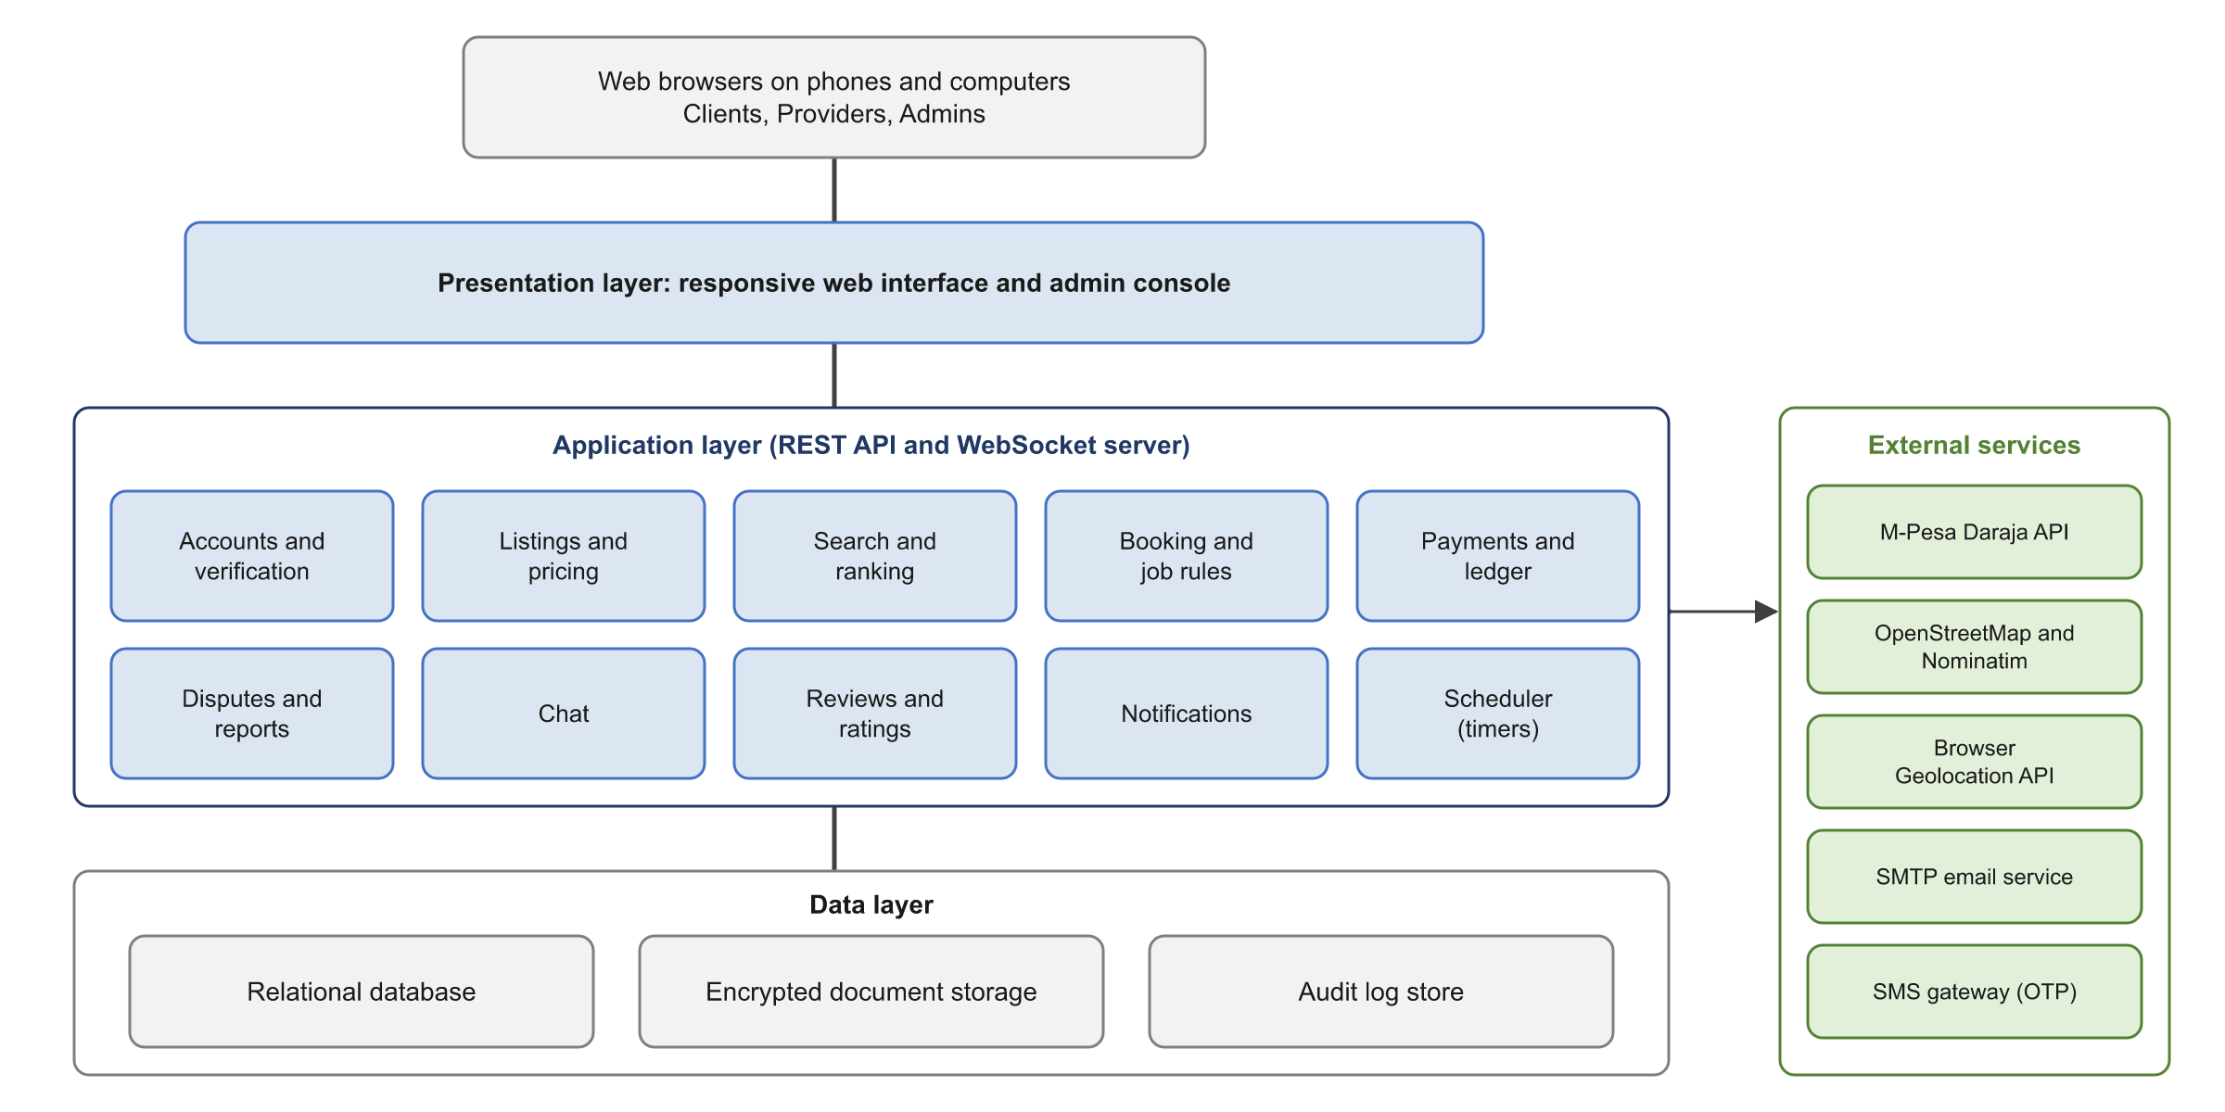
Figure 4: Logical architecture

4.2 Booking Lifecycle and Payment Flow
Figure 5 shows the states a booking passes through. Figure 6 shows the messages exchanged when a client pays and the provider is paid.
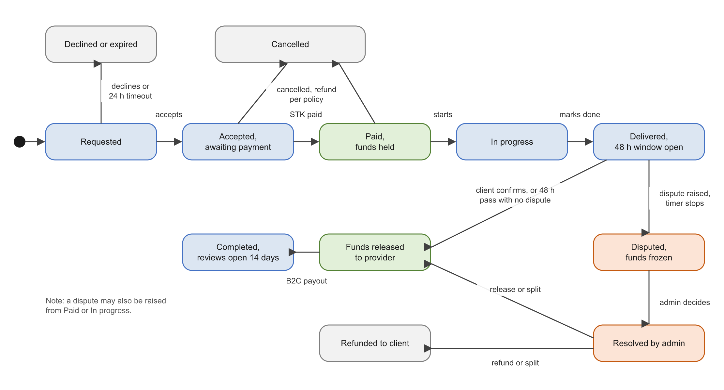
Figure 5: Booking lifecycle
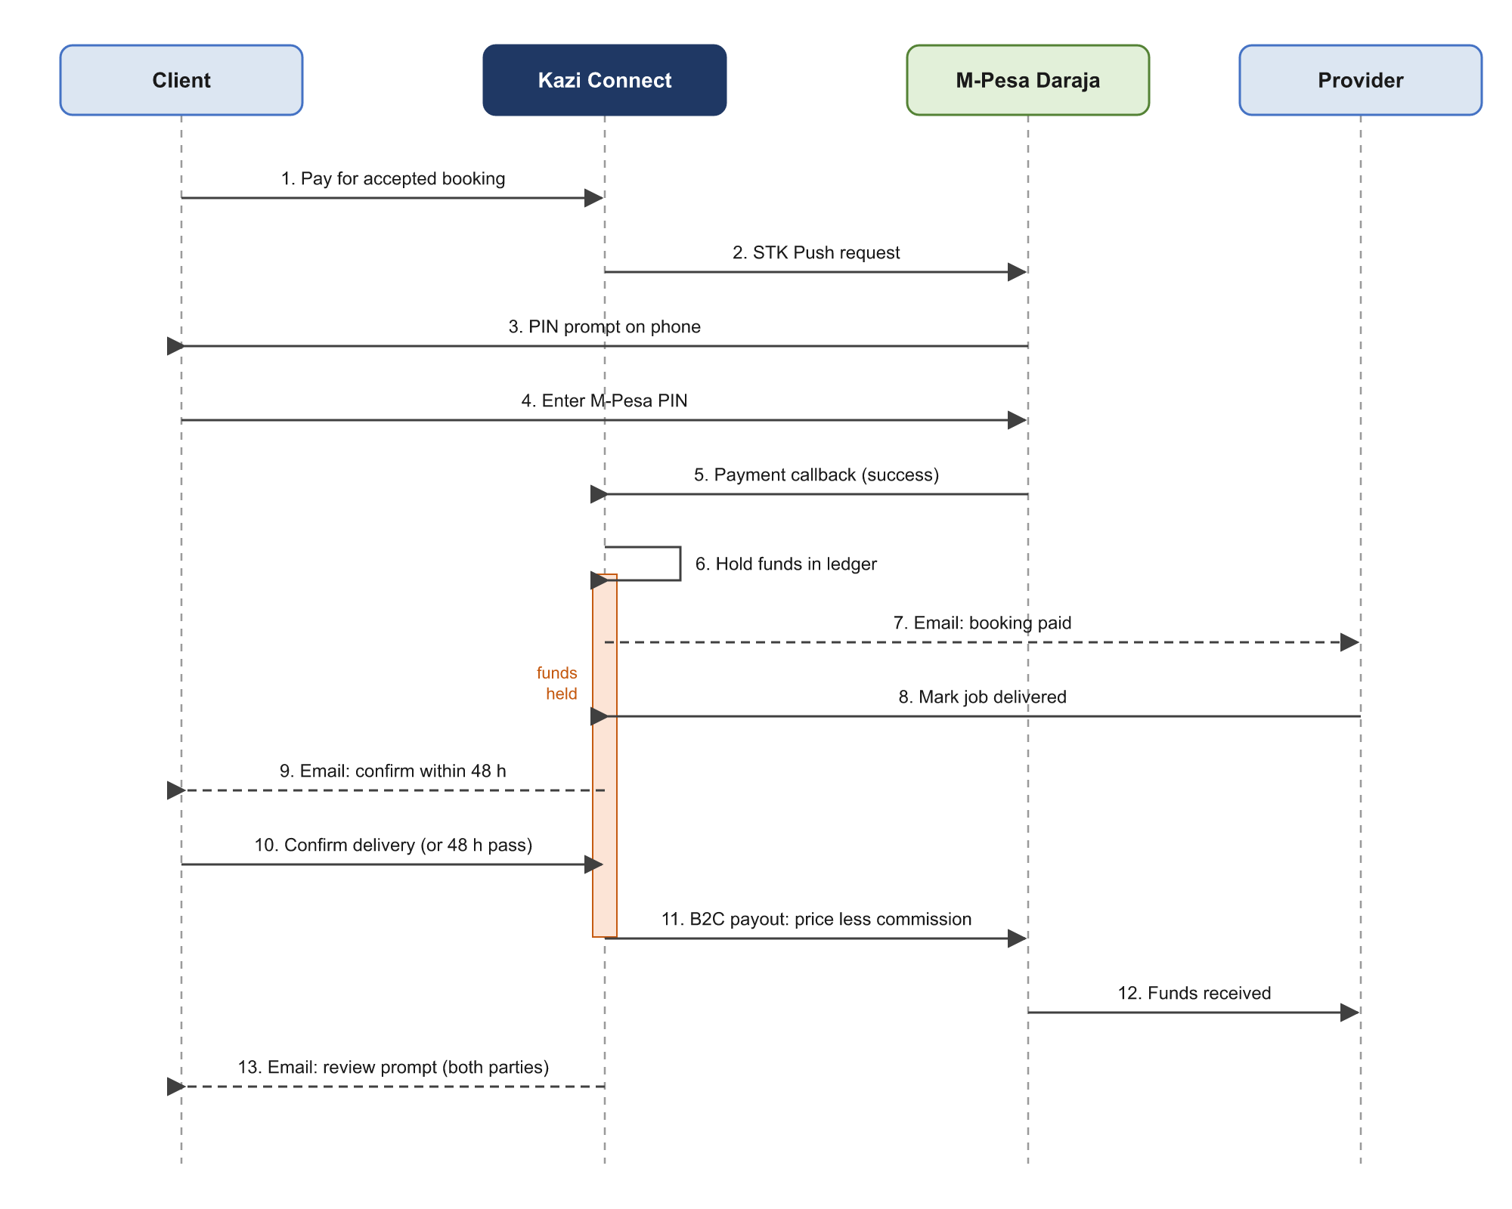
Figure 6: Payment and release sequence

4.3 Functional System Requirements

4.3.1 Accounts and Authentication (ACC)
Table 19: Accounts and authentication requirements
ID | Requirement | Priority
SR-F-ACC-01 | The system shall let a visitor register a client account with full name, email address, Kenyan mobile number (+2547XXXXXXXX or +2541XXXXXXXX) and password. | Must
SR-F-ACC-02 | The system shall verify the email address with a single-use link that expires after 24 hours. | Must
SR-F-ACC-03 | The system shall verify the phone number with a 6-digit OTP sent by SMS. The OTP shall expire after 5 minutes and allow 3 attempts. A number shall receive at most 5 OTPs per hour. | Must
SR-F-ACC-04 | The system shall allow each email address and phone number on one account only. | Must
SR-F-ACC-05 | The system shall require passwords of at least 8 characters containing letters and numbers, and shall store them hashed with Argon2id or bcrypt. | Must
SR-F-ACC-06 | The system shall let users sign in with email or phone and password, and shall lock sign-in for 15 minutes after 5 failed attempts. | Must
SR-F-ACC-07 | The system shall let users reset a password through an emailed link that expires after 30 minutes. | Must
SR-F-ACC-08 | The system shall upgrade a client to a provider when the user has: (a) added a profile photo, bio and skills; (b) verified an M-Pesa payout number by OTP; (c) chosen a category, completing student email verification if Student; (d) accepted the provider code of conduct; and (e) created at least one listing. | Must
SR-F-ACC-09 | The system shall show a provider upgrade checklist with the status of each step, and keep the provider role Pending until every step is complete. | Must
SR-F-ACC-10 | The system shall let a provider switch between provider mode and client mode in one action without signing in again, and shall show the current mode on every page. | Must
SR-F-ACC-11 | The system shall keep separate dashboards, booking lists and ratings for a user's client activity and provider activity. | Must
SR-F-ACC-12 | The system shall allow only an existing admin with the Super admin role to create admin accounts, and shall require an emailed OTP as a second factor at every admin sign-in. | Must
SR-F-ACC-13 | The system shall support the account statuses Pending verification, Active, Suspended, Banned and Deactivated. | Must
SR-F-ACC-14 | The system shall let users deactivate their own account. Deactivation shall be blocked while the user has held funds or an open dispute. | Should

4.3.2 Student Verification (VER)
Table 20: Student verification requirements
ID | Requirement | Priority
SR-F-VER-01 | The system shall grant the Student category only after the user verifies an email address on an approved university domain. Admins maintain the list of approved domains, starting with the MMU student domain. | Must
SR-F-VER-02 | The student email may differ from the sign-in email. The system shall verify it with a single-use link that expires after 24 hours. | Must
SR-F-VER-03 | The system shall link each student email address to one account only. | Must
SR-F-VER-04 | The system shall record the verification date and set an expiry date 12 months later. | Must
SR-F-VER-05 | The system shall email reverification reminders 30, 7 and 1 days before expiry. | Must
SR-F-VER-06 | On expiry, the system shall change the account to the General category, update the profile label, apply the General commission to new payments, and email the user. Bookings already paid shall keep their recorded rate. | Must
SR-F-VER-07 | The system shall restore the Student category as soon as the user reverifies. | Must

4.3.3 Verified Badge (KYC)
Table 21: Verified badge requirements
ID | Requirement | Priority
SR-F-KYC-01 | The system shall let any Active user apply for a verified badge. | Must
SR-F-KYC-02 | The system shall show the badge fee set by admins and collect it by STK Push before the application enters the review queue. | Must
SR-F-KYC-03 | The system shall require images of the front and back of the national ID for every applicant, and of the student ID for Student accounts. Files shall be JPG, PNG or PDF, at most 5 MB each. | Must
SR-F-KYC-04 | The system shall encrypt identity documents at rest, restrict access to admins with the verification permission, and log every view. | Must
SR-F-KYC-05 | The system shall let an admin approve or reject an application. A rejection shall include a reason that is emailed to the user. | Must
SR-F-KYC-06 | The system shall let a rejected applicant resubmit once within 30 days without paying the fee again. | Should
SR-F-KYC-07 | The system shall display the badge beside the user's name and add the badge weight to the recommendation score. | Must
SR-F-KYC-08 | The badge shall be valid for 12 months. The system shall send renewal reminders 30 and 7 days before it expires. | Should
SR-F-KYC-09 | The system shall delete identity document images 30 days after the decision and keep only the decision record (user, document types, outcome, admin, date). | Must

4.3.4 Profiles and Listings (LST)
Table 22: Profile and listing requirements
ID | Requirement | Priority
SR-F-LST-01 | The system shall show on each provider profile: name, photo, account category label, badge, bio, skills, average rating, number of completed jobs, experience level, member since date, approximate service area and response rate. | Must
SR-F-LST-02 | A listing shall contain a service category, title, description, up to 6 photos, price, pricing unit (per job, per hour or per session), service area radius, availability and optional provider terms. | Must
SR-F-LST-03 | The system shall support the listing states Draft, Published, Paused and Removed. | Must
SR-F-LST-04 | A price change shall apply to new booking requests only. | Must
SR-F-LST-05 | The system shall prevent publishing a listing in a category marked higher-risk when admins require a verified badge for that category and the provider has none. | Should
SR-F-LST-06 | The system shall show client profiles to providers with the client's average rating and number of completed bookings. | Must

4.3.5 Pricing and Estimates (PRC)
Table 23: Pricing requirements
ID | Requirement | Priority
SR-F-PRC-01 | The system shall let admins set, for each category and pricing unit, an estimate range and a minimum and maximum allowed price. | Must
SR-F-PRC-02 | The system shall assign each provider an experience level: Entry (0 to 4 completed jobs), Intermediate (5 to 19 completed jobs and average rating of at least 4.0), or Experienced (20 or more completed jobs and average rating of at least 4.3). Admins may change these thresholds. | Must
SR-F-PRC-03 | The system shall show the provider an estimate range for the chosen category and unit, adjusted to the provider's experience level. Higher levels shall receive a higher range. | Must
SR-F-PRC-04 | Where at least 10 bookings in the category were completed in the past 90 days, the system shall also show the median price paid. | Should
SR-F-PRC-05 | The system shall let the provider set any price within the category minimum and maximum, above or below the estimate. | Must
SR-F-PRC-06 | The system shall show the provider the commission and the net amount they will receive for the price entered. | Must
SR-F-PRC-07 | The system shall show the client the total payable before payment. The client pays the listed price and the commission is deducted from the provider's payout. | Must

4.3.6 Search and Location (SRC)
Table 24: Search and location requirements
ID | Requirement | Priority
SR-F-SRC-01 | The system shall obtain the user's location from the browser Geolocation API after asking for consent, or let the user type a place or drop a pin on a map. | Must
SR-F-SRC-02 | The system shall use OpenStreetMap tiles with a map library such as Leaflet, and a free geocoding service such as Nominatim, and shall follow their usage policies, including caching and a limit of 1 geocoding request per second. | Must
SR-F-SRC-03 | The system shall let clients search by keyword and category and filter by distance (1, 3, 5, 10 or 20 km), price range, minimum rating, account category, verified badge and available date. | Must
SR-F-SRC-04 | The system shall return only providers whose service area covers the client's search location. | Must
SR-F-SRC-05 | The system shall sort results by recommendation score by default, and also by distance, price or rating. | Must
SR-F-SRC-06 | The system shall show results on a list and on a map, 20 per page. | Must
SR-F-SRC-07 | The system shall show a provider's location to clients only as an approximate area until a booking is accepted. | Must

4.3.7 Recommendation Score (REC)
Table 25: Recommendation score requirements
ID | Requirement | Priority
SR-F-REC-01 | The system shall compute a recommendation score for each provider from average rating weighted by number of ratings, completed jobs, verified badge, current Student verification, response rate, cancellation rate and upheld disputes. Distance shall be added at search time. | Must
SR-F-REC-02 | The system shall let admins set the weight of each factor. | Should
SR-F-REC-03 | The system shall recompute a provider's score after a completed booking, a new rating, a badge change or a dispute decision, and at least once a day. | Must
SR-F-REC-04 | The system shall give new providers a temporary score boost for their first 30 days to help them get a first booking. | Could
SR-F-REC-05 | The system shall publish a plain explanation of the factors that affect ranking. | Should

4.3.8 Booking and Job Rules (BKG)
Table 26: Booking requirements
ID | Requirement | Priority
SR-F-BKG-01 | The system shall let a client request a booking with listing, date, start time, quantity or duration, service location or remote delivery, and notes. | Must
SR-F-BKG-02 | Before the request is sent, the system shall show the category job rules and the provider's terms, and require the client to accept them. | Must
SR-F-BKG-03 | The system shall let the provider accept or decline. When accepting, the provider shall accept the same job rules. A request with no answer after 24 hours shall expire. | Must
SR-F-BKG-04 | After acceptance, the client shall have 2 hours to pay. An unpaid booking shall be cancelled at the end of that time. | Must
SR-F-BKG-05 | The system shall warn a provider who accepts a booking that overlaps an existing paid booking. | Should
SR-F-BKG-06 | The system shall move bookings only through the states and transitions in Figure 5, and shall record the time and actor of every transition. | Must
SR-F-BKG-07 | The system shall apply this cancellation policy: (a) either party may cancel before payment at no cost; (b) a client who cancels a paid booking more than 24 hours before the start receives a full refund; (c) a client who cancels within 24 hours of the start pays the late cancellation fee set for the category, which goes to the provider less commission, and the remainder is refunded; (d) a provider who cancels a paid booking causes a full refund to the client, and the cancellation counts against the provider's cancellation rate. | Must
SR-F-BKG-08 | The system shall let admins mark a category as higher-risk and set extra job rules for it. | Must
SR-F-BKG-09 | The system shall let the provider mark a job as started, and shall show both parties the booking details, including date, time and location. | Should

4.3.9 Payments and Ledger (PAY)
Table 27: Payment requirements
ID | Requirement | Priority
SR-F-PAY-01 | After a provider accepts a booking, the system shall start a Daraja STK Push for the full price to the client's verified phone number or another M-Pesa number the client enters. | Must
SR-F-PAY-02 | On a successful callback the system shall record the M-Pesa receipt number, amount, phone number and time, and move the booking to Paid. | Must
SR-F-PAY-03 | On failure, cancellation or timeout, the system shall show the reason and allow up to 3 retries within the payment window. | Must
SR-F-PAY-04 | If no callback arrives within 60 seconds, the system shall check the result with the STK Push Query API. | Should
SR-F-PAY-05 | The system shall handle each callback once only, using the CheckoutRequestID to detect duplicates. | Must
SR-F-PAY-06 | The system shall keep a ledger in which every movement of money (hold, release, commission, refund, payout, badge fee) is an entry that cannot be edited or deleted. | Must
SR-F-PAY-07 | The system shall release held funds when the client confirms delivery, when the 48-hour window ends with no open dispute, or when an admin decides a dispute. | Must
SR-F-PAY-08 | The system shall calculate commission using the rate stored on the booking at payment time, and round amounts to whole shillings in the provider's favour. | Must
SR-F-PAY-09 | The system shall pay the provider the price less commission through the Daraja B2C API to the provider's verified payout number, record the result, retry failed payouts up to 3 times and alert admins after the final failure. | Must
SR-F-PAY-10 | The system shall pay refunds to the number that made the payment through the Daraja B2C API. | Must
SR-F-PAY-11 | The system shall email a receipt to the client after payment and to the provider after payout. | Must
SR-F-PAY-12 | The system shall reconcile ledger totals with Daraja transaction records once a day and report differences to admins. | Should
SR-F-PAY-13 | The prototype shall use Daraja sandbox credentials only and shall show a visible "test mode" banner. | Must

4.3.10 Delivery and Confirmation (DLV)
Table 28: Delivery and confirmation requirements
ID | Requirement | Priority
SR-F-DLV-01 | The system shall let the provider mark a paid or in-progress booking as delivered and optionally attach proof (images or files, up to 5, at most 5 MB each). | Must
SR-F-DLV-02 | When a job is marked delivered, the system shall email the client with links to confirm or dispute and start a 48-hour timer. | Must
SR-F-DLV-03 | The client shall be able to confirm delivery only after the provider marks the job delivered. | Must
SR-F-DLV-04 | The system shall email the client a reminder when 24 hours of the window remain. | Should
SR-F-DLV-05 | When the window ends with no confirmation and no open dispute, the system shall release the funds and email both parties. | Must
SR-F-DLV-06 | The scheduler shall check for expired windows at least every 5 minutes. | Must

4.3.11 Disputes (DSP)
Table 29: Dispute requirements
ID | Requirement | Priority
SR-F-DSP-01 | The system shall let either party raise a dispute on a booking from the time it is paid until its funds are released. | Must
SR-F-DSP-02 | A dispute shall include a reason (not delivered, poor quality, incomplete, safety concern, price disagreement or other), a description and up to 5 evidence files. | Must
SR-F-DSP-03 | Raising a dispute shall freeze the held funds and stop the auto-release timer. | Must
SR-F-DSP-04 | The system shall email the other party, who may respond with a statement and evidence within 48 hours. | Must
SR-F-DSP-05 | The system shall give the assigned admin the booking details, the chat history between the parties, all evidence, and both parties' history on the platform. | Must
SR-F-DSP-06 | The admin shall decide one outcome: full release to the provider, full refund to the client, or a split with amounts stated. Commission shall apply only to the provider's share. | Must
SR-F-DSP-07 | The admin shall record written reasons. The system shall email the decision to both parties and carry out the payments. | Must
SR-F-DSP-08 | The system shall flag disputes that are open for more than 5 working days on the admin dashboard. | Should
SR-F-DSP-09 | A party may appeal once within 7 days of the decision. A different admin shall review the appeal, and the appeal decision is final. | Should
SR-F-DSP-10 | Upheld disputes shall count in the recommendation score of the provider and in the record of the client. | Should

4.3.12 Chat (CHT)
Table 30: Chat requirements
ID | Requirement | Priority
SR-F-CHT-01 | The system shall provide one conversation for each client and provider pair, linked to their bookings. A client may message a provider from a listing before booking. | Must
SR-F-CHT-02 | The system shall support text messages and image attachments of up to 5 MB. | Must
SR-F-CHT-03 | The system shall deliver messages within 5 seconds using WebSockets, with polling as a fallback. | Must
SR-F-CHT-04 | The system shall show unread counts and send an email when a message stays unread for 10 minutes, at most once per conversation per hour. | Must
SR-F-CHT-05 | When a message contains a phone number or email address, the system shall deliver it unchanged and show both parties a notice that services arranged outside the platform have no payment protection, dispute support or reviews. | Must
SR-F-CHT-06 | The system shall let users block another user and report a message. | Must
SR-F-CHT-07 | The system shall keep chat history for 12 months after the last booking between the parties. Admins may read it only when handling a dispute or report, and every access shall be logged. | Must

4.3.13 Ratings and Reviews (REV)
Table 31: Rating and review requirements
ID | Requirement | Priority
SR-F-REV-01 | After funds are released, the system shall let the client who paid rate the provider from 1 to 5 stars with an optional comment of up to 1,000 characters, within 14 days. | Must
SR-F-REV-02 | After funds are released, the system shall let the provider rate the client from 1 to 5 stars with an optional comment, within 14 days. | Must
SR-F-REV-03 | The system shall accept one review per party per booking and reject reviews from anyone else. | Must
SR-F-REV-04 | The system shall publish both reviews when both are submitted or when the 14 days end, whichever comes first. | Should
SR-F-REV-05 | For a disputed booking, the review window shall open when the dispute is decided. | Must
SR-F-REV-06 | The system shall let users report a review. Admins may hide a review that breaks policy and shall record the reason. Admins shall be unable to edit review text. | Must
SR-F-REV-07 | The system shall show average ratings and the number of ratings on profiles. | Must

4.3.14 Reports and Safety (SAF)
Table 32: Reports and safety requirements
ID | Requirement | Priority
SR-F-SAF-01 | The system shall let users report a user, listing, message or review with a category and description. | Must
SR-F-SAF-02 | The system shall place reports in an admin queue and email the reporter an acknowledgement. | Must
SR-F-SAF-03 | The system shall let admins suspend or ban accounts. A suspended user shall be unable to book or receive bookings. Held funds of a suspended user shall be handled by an admin. | Must
SR-F-SAF-04 | The system shall flag an account for review when it receives 3 upheld reports. | Should
SR-F-SAF-05 | The system shall show a safety page with emergency numbers (999 and 112) and a link to it from every active booking. | Should

4.3.15 Notifications (NTF)
Table 33: Notification requirements
ID | Requirement | Priority
SR-F-NTF-01 | The system shall send all notifications by email through an SMTP or transactional email service. | Must
SR-F-NTF-02 | The system shall email users for: email verification, password reset, booking request, acceptance, decline or expiry, payment received, job delivered, confirmation reminder, funds released, payout sent, refund sent, dispute opened, dispute response, dispute decision, review received, student reverification reminders and expiry, badge decision and renewal, unread chat messages, and account status changes. | Must
SR-F-NTF-03 | The system shall let admins edit email templates. | Could
SR-F-NTF-04 | The system shall log each email and retry failed sends up to 3 times. | Must
SR-F-NTF-05 | The system shall let users opt out of chat digest emails. Emails about bookings, payments, disputes and security shall always be sent. | Should

4.3.16 Administration (ADM)
Table 34: Administration requirements
ID | Requirement | Priority
SR-F-ADM-01 | The system shall support admin roles: Super admin, Verification admin, Dispute admin and Support admin, each with its own permissions. | Should
SR-F-ADM-02 | The system shall let admins set the Student and General commission rates, and shall reject a Student rate that is equal to or higher than the General rate. New rates apply to payments made after the change. | Must
SR-F-ADM-03 | The system shall let admins set the badge fee, auto-release window, cancellation fees, response and payment windows, experience thresholds, score weights and approved university domains. | Must
SR-F-ADM-04 | The system shall let admins create and edit service categories with their estimate ranges, price limits, job rules and higher-risk flag. | Must
SR-F-ADM-05 | The system shall let admins search users and view, suspend, reinstate or ban accounts. | Must
SR-F-ADM-06 | The system shall provide queues for badge applications, disputes and reports. | Must
SR-F-ADM-07 | The system shall show a dashboard with users by role and category, bookings by state, total value of payments, commission earned, badge revenue, open disputes, average resolution time and upcoming student verification expiries. | Should
SR-F-ADM-08 | The system shall let admins export reports to CSV. | Should
SR-F-ADM-09 | The system shall record every admin action in the audit log with the admin, action, time, and values before and after the change. | Must

4.3.17 Privacy and Data Rights (PRV)
Table 35: Privacy requirements
ID | Requirement | Priority
SR-F-PRV-01 | The system shall show the privacy notice at registration and record the user's consent, with separate consent for location access. | Must
SR-F-PRV-02 | The system shall let users view and update their personal data and download it in JSON or CSV. | Should
SR-F-PRV-03 | The system shall process deletion requests within 30 days, keeping only records the law requires, such as financial records for the period in the retention policy. | Must
SR-F-PRV-04 | The system shall collect only the personal data listed in Section 4.6. | Must

4.4 Non-Functional System Requirements

4.4.1 Performance and Capacity (PER)
Table 36: Performance requirements
ID | Requirement | Priority
SR-NF-PER-01 | Pages shall load within 3 seconds for 95% of requests on a 4G mobile connection. | Must
SR-NF-PER-02 | Search results shall return within 2 seconds for 95% of queries with up to 1,000 published listings. | Must
SR-NF-PER-03 | The system shall send an STK Push request within 5 seconds of the client choosing to pay. | Must
SR-NF-PER-04 | The prototype shall support 500 concurrent users and 10,000 registered users with no loss of performance beyond the limits above. | Should

4.4.2 Security (SEC)
Table 37: Security requirements
ID | Requirement | Priority
SR-NF-SEC-01 | All traffic shall use HTTPS with TLS 1.2 or higher. | Must
SR-NF-SEC-02 | The system shall enforce role-based access control on every API endpoint. | Must
SR-NF-SEC-03 | User sessions shall expire after 30 minutes of inactivity, and admin sessions after 15 minutes. | Must
SR-NF-SEC-04 | The system shall protect against the OWASP Top 10 risks, including injection, cross-site scripting and cross-site request forgery. | Must
SR-NF-SEC-05 | Identity documents and evidence files shall be encrypted at rest with AES-256 and served only through access-checked links that expire after 5 minutes. | Must
SR-NF-SEC-06 | API keys, Daraja credentials and other secrets shall be stored only in environment variables or a secrets store. | Must
SR-NF-SEC-07 | The Daraja callback endpoint shall use a secret path token and accept requests only from Safaricom's published IP addresses. | Must
SR-NF-SEC-08 | The system shall rate limit sign-in, OTP, search and messaging endpoints. | Must
SR-NF-SEC-09 | Uploaded files shall be checked for allowed type and size before storage. | Must

4.4.3 Privacy and Compliance (PRI)
Table 38: Privacy and compliance requirements
ID | Requirement | Priority
SR-NF-PRI-01 | Personal data processing shall follow the principles of the Data Protection Act, 2019. | Must
SR-NF-PRI-02 | The project shall complete a data protection impact assessment for identity documents and location data before the pilot. | Should
SR-NF-PRI-03 | The platform operator shall register with the Office of the Data Protection Commissioner before any production launch. | Must
SR-NF-PRI-04 | Personal data shall be retained for the periods in the data retention table in Section 4.6 and deleted or anonymised afterwards. | Must

4.4.4 Reliability and Availability (REL)
Table 39: Reliability requirements
ID | Requirement | Priority
SR-NF-REL-01 | The system shall be available 99% of the time each month during the pilot, excluding planned maintenance announced by email 24 hours ahead. | Should
SR-NF-REL-02 | No confirmed payment, ledger entry or dispute decision shall be lost. Ledger writes shall use database transactions. | Must
SR-NF-REL-03 | The database shall be backed up daily and backups kept for 30 days. The recovery point objective is 24 hours and the recovery time objective is 8 hours. | Must
SR-NF-REL-04 | Scheduled tasks missed during downtime shall run as soon as the system restarts. | Must

4.4.5 Maintainability and Portability (MNT)
Table 40: Maintainability and portability requirements
ID | Requirement | Priority
SR-NF-MNT-01 | Source code shall be kept in a version control repository with documented build and deployment steps. | Must
SR-NF-MNT-02 | Automated tests shall cover at least 70% of the code in the booking, payment, dispute and ledger modules. | Should
SR-NF-MNT-03 | The REST API shall be documented in OpenAPI format. | Should
SR-NF-MNT-04 | The interface shall work on the latest two versions of Chrome, Firefox, Safari and Edge, and on Chrome for Android. | Must
SR-NF-MNT-05 | Application servers shall be stateless so that more servers can be added as usage grows. | Could

4.4.6 Auditability (AUD)
Table 41: Auditability requirements
ID | Requirement | Priority
SR-NF-AUD-01 | The audit log shall record admin actions, access to identity documents and chat history, and every change of booking state and ledger entry. | Must
SR-NF-AUD-02 | Audit records shall be append-only and kept for at least 12 months. | Must
SR-NF-AUD-03 | All times shall be stored in UTC and shown in East Africa Time (UTC+3). | Must

4.5 External Interface Requirements

4.5.1 User Interfaces
The web interface shall include at least the following screens:
- Public pages: home, search results with map, provider profile, listing, sign up, sign in, safety page, terms, privacy notice.
- Client mode: dashboard, booking request form, payment status, booking detail with confirm and dispute actions, chat, reviews, payment history.
- Provider mode: upgrade checklist, profile editor, listing editor with price estimate, booking requests, booking detail, earnings, chat.
- Account: settings, student verification, badge application, data download and deletion.
- Admin console: dashboard, users, categories and job rules, settings, badge queue, dispute queue, report queue, audit log, exports.

4.5.2 Software Interfaces
Table 42: Software interfaces
Interface | Purpose | Details
M-Pesa Daraja: OAuth | Obtain access tokens | Token requested with consumer key and secret; cached until shortly before expiry.
M-Pesa Daraja: STK Push | Collect client payments and badge fees | Sends amount, phone, account reference (booking ID) and callback URL. Result arrives by callback.
M-Pesa Daraja: STK Push Query | Confirm payment status | Used when no callback arrives within 60 seconds.
M-Pesa Daraja: B2C | Pay providers and refund clients | Sends amount and phone number. Result and timeout URLs record the outcome.
Browser Geolocation API | Get the user's position | Used only after the user grants permission.
OpenStreetMap tiles with Leaflet | Display maps | Attribution shown as the tile policy requires.
Nominatim (or equivalent free geocoder) | Convert addresses to coordinates and back | Maximum 1 request per second; results cached.
SMTP or transactional email service | Send all notifications | Free tier for the prototype; sending domain configured with SPF and DKIM.
SMS gateway | Send phone verification OTPs | A test or free tier provider, such as Africa's Talking sandbox.

4.5.3 Communication Interfaces
- Browser to server: HTTPS with JSON request and response bodies.
- Chat: secure WebSocket (WSS), with HTTPS polling as a fallback.
- Server to Daraja: HTTPS. Daraja to server: HTTPS callbacks to a public URL.
- Server to email service: SMTP over TLS or HTTPS API.

4.6 Data Requirements
Figure 7 shows the main entities and their relationships. The entity table that follows describes all entities, including supporting entities left out of the figure for clarity.
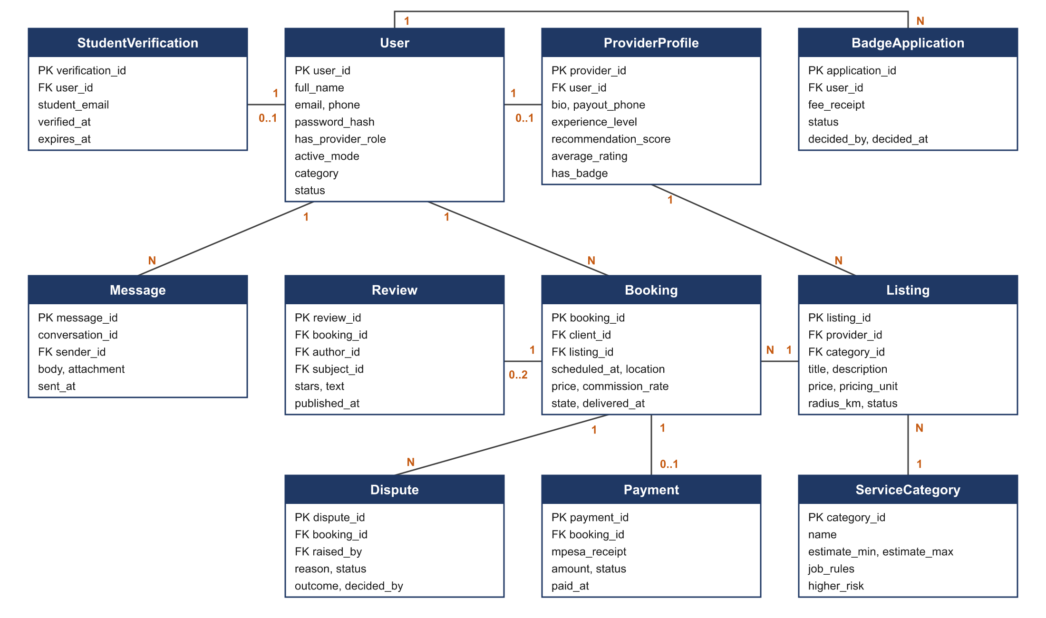
Figure 7: Entity relationship diagram (main entities)
Table 43: Data entities
Entity | Description
User | A person with an account. Holds identity, contact details, password hash, roles, active mode, category and status.
StudentVerification | A verified student email with its verification and expiry dates.
ProviderProfile | Provider details for a user who has upgraded, including payout number, experience level and recommendation score.
BadgeApplication | A verified badge application with fee receipt, document references, status and decision.
ServiceCategory | A type of service with estimate range, price limits, job rules and higher-risk flag.
Listing | A service offered by a provider with price, unit, service area and status.
Booking | A request from a client for a listing, with schedule, location, price, stored commission rate and state.
Payment | An M-Pesa STK Push payment with receipt number and status.
Transfer | A B2C payout to a provider or refund to a client with its result.
LedgerEntry | An unchangeable record of a money movement linked to a booking or badge fee.
Dispute | A dispute on a booking with reason, evidence, responses, outcome and decision.
Review | A rating and comment from one party of a booking about the other.
Conversation and Message | Chat threads between a client and provider and the messages in them.
Report | A user report about a user, listing, message or review, with its handling.
Notification | A record of each email sent and its delivery status.
Setting | A configurable value such as a commission rate or time limit, with change history.
AuditLog | An append-only record of sensitive actions.

Table 44: Data retention
Data | Retention period
Identity document images | 30 days after the badge decision
Badge decision records | While the account exists, plus 12 months
Chat messages | 12 months after the last booking between the parties
Payment, transfer and ledger records | 5 years, or the period required by tax law
Dispute records and evidence | 2 years after the decision
Audit log | At least 12 months
Account data after a deletion request | Deleted or anonymised within 30 days, except financial records

5. VERIFICATION
Each requirement will be verified by one or more of the methods below before the prototype is accepted.
Table 45: Verification methods
Requirement group | Method | How it will be verified
Business rules and business requirements | Inspection, demonstration | Walk-through of the system with the supervisor against each rule; demonstration of commission and auto-release behaviour.
User stories | Acceptance test | One test script per story based on its acceptance criteria, run by the group and by pilot users.
Payment and ledger requirements | Test | Automated and manual tests in the Daraja sandbox covering success, failure, timeout, duplicate callbacks, refunds, splits and payout failures. Ledger totals checked after each test run.
Timers (auto-release, expiry, reminders) | Test | Tests with shortened time settings and a controllable clock.
Usability requirements | Test | Usability sessions with at least 10 MMU students and 5 non-students, measuring task completion and System Usability Scale score.
Performance requirements | Test, analysis | Load tests with simulated users and timing measurements on a 4G connection.
Security requirements | Test, inspection | OWASP ZAP scan, code review against the OWASP Top 10, and access control tests for each role.
Privacy requirements | Inspection | Review of data fields, retention jobs, consent records and the privacy and compliance requirements.

6. TRACEABILITY MATRIX
The table below links the specific objectives in the concept paper to the requirements in this document. Specific objectives 1 and 2 are research objectives. Their findings are the source of the business requirements, and they are met through the study that accompanies this project.
Table 46: Traceability from objectives to requirements
Specific objective (concept paper) | Business requirements | User stories | System requirement modules
1. Analyse the challenges clients face in verifying providers and the barriers young people face in proving their skills. | BO-1, BO-2, BR-F-02, BR-F-07 | Research input to all stories | Research input
2. Examine the limitations of existing channels in verification, protected payment and reputation tracking. | BR-F-04, BR-F-06, BR-F-07, BR-F-08 | Research input to all stories | Research input
3. Design and develop a user-friendly web platform with separate student and general accounts that supports verification, profiles, location-based search and booking. | BO-2, BO-4, BR-F-01 to BR-F-03, BR-F-06, BR-F-09, BR-F-10, BR-NF-06 | US-01 to US-13, US-20, US-23, US-25 | ACC, VER, KYC, LST, PRC, SRC, REC, BKG, CHT, SAF, ADM, PRV
4. Implement secure M-Pesa payment with release on confirmation and account-based commission, with ratings and reviews. | BO-3, BO-5, BR-F-04, BR-F-05, BR-F-07, BR-F-08, BR-NF-02, BR-NF-03 | US-14 to US-19, US-21, US-22, US-26, US-27 | PAY, DLV, DSP, REV, NTF, ADM

APPENDIX A: DEFAULT CONFIGURATION VALUES
Admins can change these values in the admin console unless the note says the value is fixed by a business rule.
Table 47: Default configuration values
Setting | Default value | Notes
Student commission rate | To be set by admins | Must be lower than the General rate (BRU-06).
General commission rate | To be set by admins
Verified badge fee | To be set by admins
Auto-release window | 48 hours | Fixed by BRU-10.
Booking response window | 24 hours
Payment window after acceptance | 2 hours
Late cancellation period | 24 hours before start
Late cancellation fee | 20% of the job price | Can be set per category.
Email verification link validity | 24 hours
Phone OTP validity | 5 minutes, 3 attempts
Student verification validity | 12 months | Fixed by BRU-05.
Reverification reminders | 30, 7 and 1 days before expiry
Verified badge validity | 12 months
Badge resubmission period | 30 days, no new fee
Review window | 14 days after release
Dispute response window | 48 hours
Dispute resolution target | 5 working days
Appeal window | 7 days after decision
Experience thresholds | Entry 0 to 4 jobs; Intermediate 5 to 19 jobs and rating 4.0 or more; Experienced 20 or more jobs and rating 4.3 or more
New provider score boost | 30 days
Search page size | 20 results

APPENDIX B: INITIAL SERVICE CATEGORIES AND JOB RULES
Admins will confirm and extend these rules before the pilot. Providers may add their own terms to a listing, and those terms may add to the category rules without weakening them.
Table 48: Initial categories and job rules
Category | Risk level | Job rules
Tutoring | Higher-risk when the learner is under 18 | Sessions with a learner under 18 take place with a parent or guardian present on the premises.  Sessions at a private home take place in a shared area of the home.  Session length and subject are stated in the booking.
Home cleaning | Higher-risk | Work takes place between 7:00 and 19:00.  The client or an adult representative is present at the start and end of the job.  The client lists the rooms and tasks in the booking.  Cleaning products are supplied by the party named in the booking.
Photography | Standard | The booking states the event, hours, number of edited photos and delivery date.  The client and provider agree in the booking how the photos may be used.  Delivery means sending the final photos through an agreed link.
Graphic design | Standard | The booking states the deliverables, file formats, number of revisions and deadline.  The provider keeps the client's materials confidential.  Delivery means sending final files through the platform chat or an agreed link.

APPENDIX C: OPEN ISSUES
Table 49: Open issues
ID | Issue | Owner
OI-01 | Set the Student and General commission rates for the pilot. | Project group with supervisor
OI-02 | Set the verified badge fee. | Project group
OI-03 | Confirm the MMU student email domain with the university ICT department. | Project group
OI-04 | Choose the SMS gateway for phone OTPs. SMS is used only for verification codes; all notifications go by email (BRU-17). | Project group
OI-05 | Choose the free email service and check its daily sending limit against expected pilot volume. | Project group
OI-06 | Obtain legal advice on holding client funds before any production launch. | Project group with supervisor
OI-07 | Confirm the late cancellation fee and the split between provider and platform. | Project group
OI-08 | Confirm the job rules in Appendix B with a sample of clients and providers. | Project group

