SkillBridge
System Design Documentation
Peer-to-Peer Skill Exchange Platform for University Students

Table of Contents

1. Introduction

1.1 Purpose
This document presents the technical design and architectural structure of the SkillBridge platform. It describes how the system is structured, how different modules interact, how data flows through the platform, and how components support the functional and non-functional requirements.
This document serves as the primary technical blueprint for the implementation of SkillBridge.

1.2 Scope
The system design covers the following areas:
- System architecture
- Database design
- Module decomposition
- Authentication design
- Skill matching logic
- Credit transaction flow
- User interface structure
- API and request flow
- Security mechanisms
- System scalability considerations

2. Design Goals
The design of SkillBridge is guided by the following principles:
- Simplicity and ease of use for university students
- Modular and maintainable architecture
- Secure handling of user data and sessions
- Efficient skill discovery and matching
- Fair and transparent exchange mechanisms
- Scalability for future expansion
- Clear separation between frontend, backend, and database layers

3. High-Level System Architecture
SkillBridge follows a three-tier client-server architecture, with clear separation of concerns between the presentation, application, and data layers.

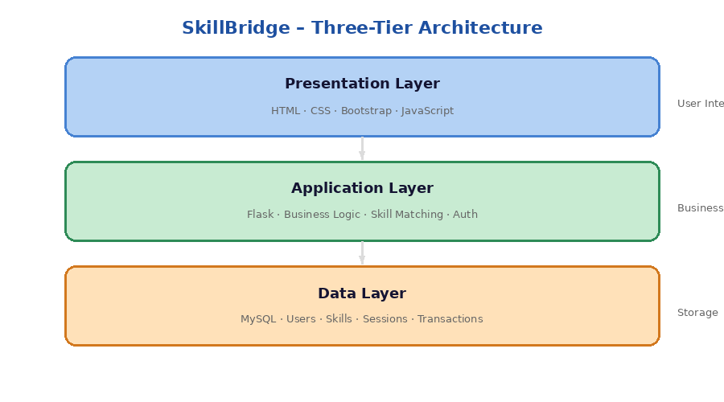
Figure 1 – Three-Tier Architecture of SkillBridge

Layer | Description
Presentation Layer | Handles the user interface and user interactions (HTML, CSS, Bootstrap, JavaScript)
Application Layer | Handles business logic and system operations (Flask framework)
Data Layer | Handles storage and retrieval of system data (MySQL RDBMS)

3.1 Presentation Layer
The presentation layer is implemented using HTML, CSS, Bootstrap, and JavaScript. Its responsibilities include rendering pages, capturing user input, displaying matches and sessions, and handling client-side form validation.

3.2 Application Layer
The application layer is implemented using Flask. It handles authentication, skill matching logic, session scheduling, credit transaction processing, feedback handling, business rule validation, and database communication.

3.3 Data Layer
The data layer uses MySQL. It provides persistent storage of user data, maintains relational integrity, handles transaction consistency, and supports efficient query operations.

4. System Modules
The SkillBridge platform is divided into the following modular components, each with clearly defined responsibilities:

Module | Primary Responsibility
Authentication Module | User registration, login/logout, session management, access control
Profile Management Module | Profile creation/updates, avatar and bio management
Skill Management Module | Listing skills to teach/learn, categorization, search & filter
Matching Engine Module | Compare offered vs. desired skills, rank peer recommendations
Exchange Management Module | Create/schedule/confirm/cancel exchange sessions
Credit Ledger Module | Award and deduct credits, record history, display balances
Feedback & Reputation Module | Accept ratings/reviews, calculate reputation metrics

4.4 Matching Engine Module
The matching engine is the core algorithmic component. It compares learner needs against teacher offerings and ranks results by multiple factors:
- Skill compatibility – direct skill match between learner desire and teacher offering
- User ratings – historical reputation drawn from the reviews table
- Exchange mode compatibility – time-credit vs. direct swap preference alignment
- Session availability – overlap in scheduled availability windows

4.6 Credit Ledger Module
The credit ledger enforces the core fairness principle of SkillBridge: one hour taught equals one credit earned. The module records every earning and spending event transactionally.

5. Database Design

5.1 Overview
SkillBridge uses a relational database model following Third Normal Form (3NF). The schema minimizes redundancy, maintains consistency, and enforces relational integrity through foreign keys.

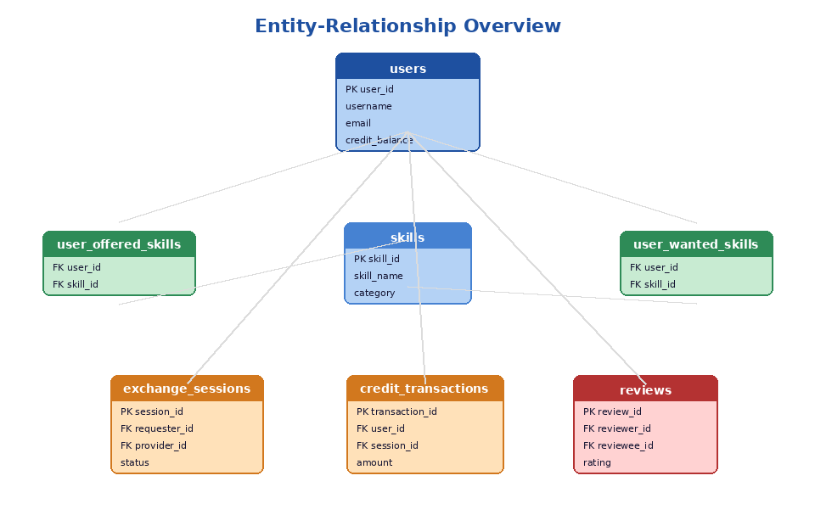
Figure 2 – Entity-Relationship Overview

5.2 Main Entities
Entity | Purpose
users | Stores student account information and credit balances
skills | Stores the master skill catalogue
user_offered_skills | Stores skills a user can teach (M:N bridge)
user_wanted_skills | Stores skills a user wants to learn (M:N bridge)
exchange_sessions | Stores scheduled exchanges between users
credit_transactions | Stores credit ledger records
reviews | Stores user ratings and feedback

5.3 Key Relationships
One-to-Many: One user can have many offered skills, wanted skills, exchange sessions, and reviews.
Many-to-Many: The user–skill relationship is resolved through the user_offered_skills and user_wanted_skills junction tables.

5.4 Primary & Foreign Keys
Table | Primary Key | Notable Foreign Keys
users | user_id | —
skills | skill_id | —
user_offered_skills | (user_id, skill_id) | user_id → users, skill_id → skills
user_wanted_skills | (user_id, skill_id) | user_id → users, skill_id → skills
exchange_sessions | session_id | requester_id, provider_id → users
credit_transactions | transaction_id | user_id → users, session_id → exchange_sessions
reviews | review_id | reviewer_id, reviewee_id → users, session_id → exchange_sessions

6. Authentication & Security Design
SkillBridge uses session-based authentication with secure password hashing. The five-step authentication flow is illustrated below:

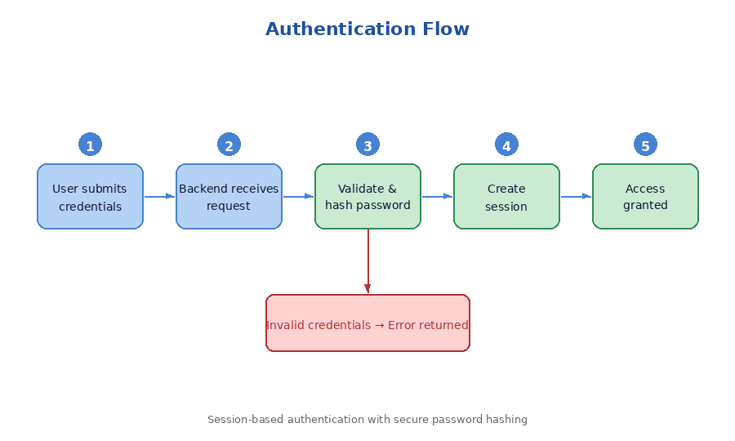
Figure 3 – Authentication Flow

6.1 Password Security
- Passwords are never stored in plain text
- Passwords are hashed using a secure algorithm before storage
- Hash verification is performed at login without reconstructing the original password

6.2 Access Control
The system restricts access to authenticated pages, session management routes, and user-specific resources. Protected routes validate the active session before processing.

6.3 Input Validation
Validation is applied on both the client side (immediate feedback) and the server side (authoritative check). This dual-layer approach reduces invalid data, security vulnerabilities, and database inconsistencies.

7. Skill Matching Design
The matching engine is responsible for connecting learners with the most suitable peer teachers. The workflow is visualised below:

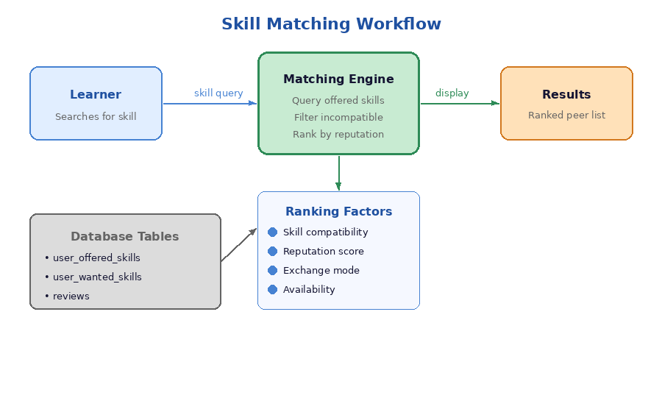
Figure 4 – Skill Matching Workflow

7.1 Matching Logic
When a user searches for a skill, the engine queries all users offering that skill, filters out incompatible or invalid candidates, and ranks results by skill compatibility, reputation score, and exchange preference.

7.2 Future Expansion
The matching system is designed to be extended with AI-assisted recommendations, availability-aware matching, interest-based suggestions, and reputation-weighted ranking.

8. Credit System Design
The time-credit system ensures fairness by rewarding teaching effort. One hour taught equals one credit earned; credits are later spent when receiving instruction.

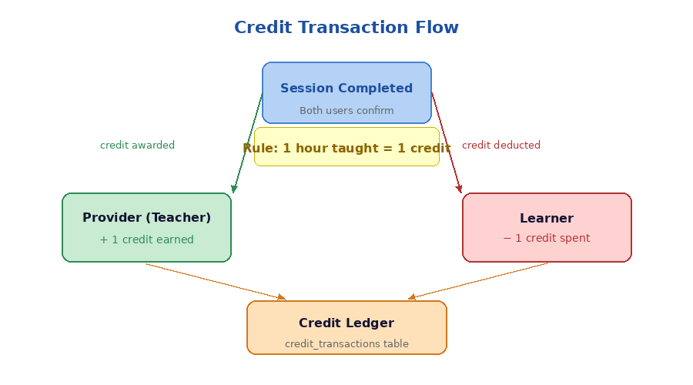
Figure 5 – Credit Transaction Flow

8.1 Credit Integrity
The system prevents duplicate transaction records, unauthorized credit modification, and incomplete session processing through transactional database operations.

9. User Interface Design

9.1 Design Principles
- Simplicity and readability
- Minimal navigation complexity
- Fast task completion
- Accessibility for all users

9.2 Main Screens
Screen | Purpose
Landing Page | Introduce the platform to new visitors
Login / Register | User authentication and account creation
Dashboard | Main user control panel
Profile Page | Manage profile information and settings
Skills Page | Manage teachable and desired skills
Matches Page | View recommended peer matches
Session Page | Manage exchange sessions
Feedback Page | Submit and view ratings/reviews
Credit Summary | View credit balance and transaction history

10. API & Request Flow Design
Every user interaction follows a consistent request lifecycle through the system:

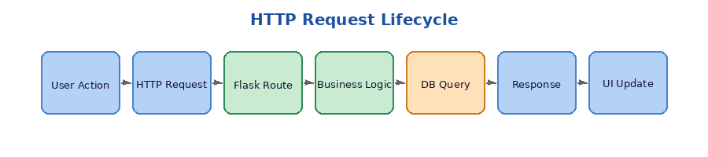
Figure 6 – HTTP Request Lifecycle

10.1 REST-Oriented Routes
Route | Purpose
/register | User registration
/login | User authentication
/skills | Skill management
/matches | Matching results
/sessions | Exchange session handling
/reviews | Ratings and feedback

11. Error Handling Design
Comprehensive error handling prevents system crashes and improves user experience:
- Validation error messages for invalid form input
- Authentication failure handling with informative feedback
- Database exception handling with graceful degradation
- Session expiration handling with automatic redirect to login
- Missing page (404) handling with helpful navigation

12. Scalability & Future Expansion
The modular architecture supports future extension without major redesign. Potential improvements include:
- Mobile application support
- Real-time messaging between matched users
- Video-based remote teaching sessions
- AI-enhanced skill matching and recommendations
- Push notification systems
- Administrative moderation tools
- Multi-university deployment

13. Agile Development Planning

13.1 Development Methodology
The project follows Agile development principles with iterative sprints featuring incremental feature delivery, continuous testing, frequent evaluation, and ongoing refinement.

13.2 Sprint Structure
Sprint | Major Deliverable
Sprint 1 | Database schema and authentication
Sprint 2 | Profile and skill management
Sprint 3 | Matching engine and session scheduling
Sprint 4 | Credit system and reviews
Sprint 5 | UI refinement and testing
Sprint 6 | Final debugging and documentation

14. Version Control & Collaboration

14.1 GitHub Workflow
- Each major feature is developed in its own branch
- Changes are reviewed before merging to the main branch
- Commit messages must be descriptive and concise
- Stable, reviewed code is merged into main

14.2 Documentation Files
The project maintains the following living documents: architecture.md, database.md, requirements_specification.md, feasibility_study.md, and system_design.md. These evolve throughout development.

15. Risks & Mitigation
Risk | Possible Impact | Mitigation
Complex matching logic | Poor recommendations | Start with simple rule-based matching; iterate
Credit inconsistencies | User distrust | Use transactional database validation
Poor usability | Low adoption | Conduct iterative usability testing per sprint
Tight timeline | Incomplete features | Prioritise core functionality first
Security weaknesses | Data compromise | Implement secure authentication practices from day one

16. Conclusion
The SkillBridge system design provides a structured technical foundation for the development of the platform. The architecture emphasizes modularity, maintainability, usability, and scalability while supporting the core objective of structured peer-to-peer skill exchange among university students.

The diagrams and design decisions documented here will guide the implementation, testing, and future evolution of the system throughout the Agile development lifecycle.

