Wind turbine

**What is it?**

A wind turbine is a device that converts the kinetic energy of wind into electrical energy.

**How it works?**

A wind turbine turns wind energy into electricity using the aerodynamic force from the rotor blades, which work like an airplane wing or helicopter rotor blade. When wind flows across the blade, the air pressure on one side of the blade decreases. The difference in air pressure across the two sides of the blade creates both lift and drag. The force of the lift is stronger than the drag and this causes the rotor to spin. The rotor connects to the generator, either directly (if it’s a direct drive turbine) or through a shaft and a series of gears (a gearbox) that speed up the rotation and allow for a physically smaller generator. This translation of aerodynamic force to the rotation of a generator creates electricity.

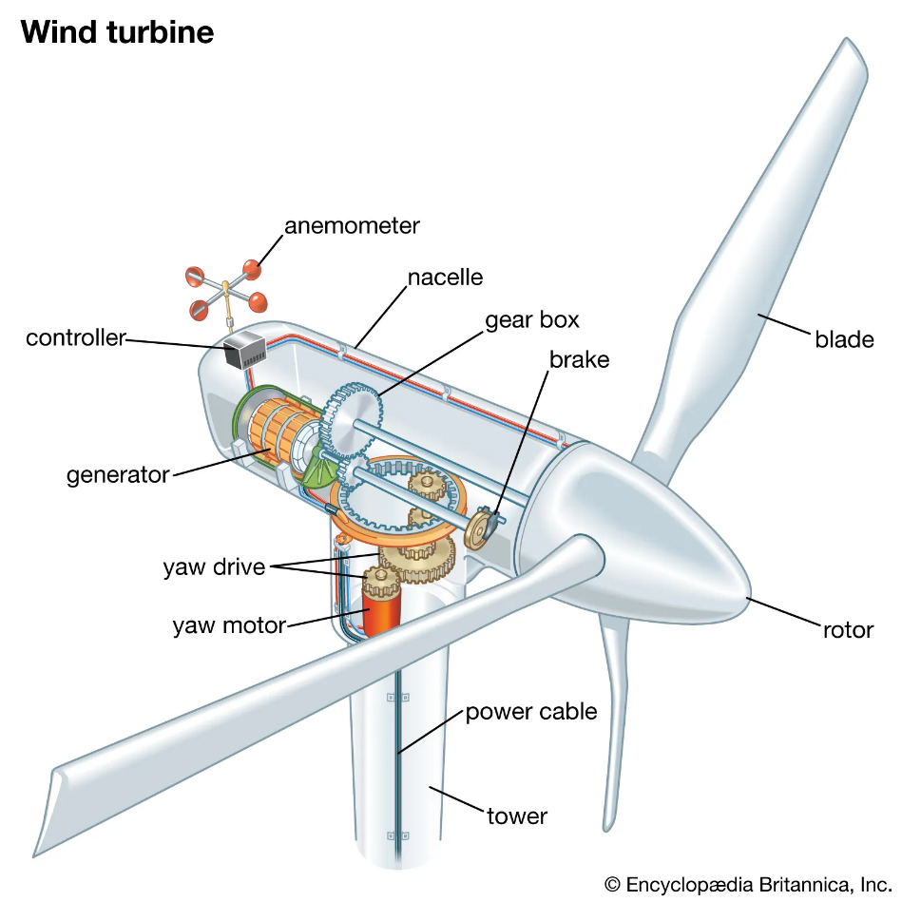

**There are 2 types of wind turbines**

The more famous is the horizontal axis turbines. Most commonly, they have three blades and operate "upwind," with the turbine pivoting at the top of the tower so the blades face into the wind.

There is another type of turbine, the vertical axes turbines. These turbines are omnidirectional, meaning they don’t need to be adjusted to point into the wind to operate. Vertical designs produce less power and are less common.

**There are 3 primary designs:**

**HAWT (Horizontal Axis Wind Turbines):**

Most wind turbine have a gearbox, which turns the slow rotation of the blades into a quicker rotation that is more suitable to drive an electrical generator. Some turbines use a different type of generator suited to slower rotational speed input. These don't need a gearbox and are called direct drive, meaning they couple the rotor directly to the generator with no gearbox in between. While permanent magnet direct-drive generators can be more costly due to the rare earth materials required, these gearless turbines are sometimes preferred over gearbox generators because they "eliminate the gear-speed increaser, which is susceptible to significant accumulated fatigue torque loading, related reliability issues, and maintenance costs." There is also the pseudo direct drive mechanism, which has some advantages over the permanent magnet direct drive mechanism.

**VAWT** **(Vertical Axis Wind Turbines):**

One advantage of this arrangement is that the turbine does not need to be pointed into the wind to be effective, which is an advantage on a site where the wind direction is highly variable. It is also an advantage when the turbine is integrated into a building because it is inherently less steerable. Also, the generator and gearbox can be placed near the ground, using a direct drive from the rotor assembly to the ground-based gearbox, improving accessibility for maintenance. However, these designs produce much less energy averaged over time, which is a major drawback

What is a cyber-physical system?

Definition: CPSs are systems formed by collaborative entities with computational capacity, which are intensively connected with the surrounding physical world and the phenomena taking place in it, providing and using both the data provision and processing services available on the network"

cyber-physical system' (CPS), which is a system that integrates electronics and software, sensors and actuators, and has communication capabilities. A cyber-physical system is autonomous and therefore "embeds" the elements mentioned above.

A CPS interacts with its environment in which it takes data, processes it and through a feedback loop control or influences the process with which it is associated. CPSs are used to control and monitor physical processes and thus "augment" these processes with new functionality.

Because of its communication capabilities, a CPS can act in collaboration with other systems and/or exchange data with remote systems. Communication can be wired via an industrial bus for example and/or wireless. When a CPS uses the communication technologies of the Internet, it becomes a building block of the Internet of Things.

A CPS is characterised by a high degree of complexity that is partly intrinsic (the integration described above) and mainly due to the interconnection and dynamic interactions with other systems. CPSs are most often used in networks. Networking allows distributed intelligence to be played with the different CPSs and their individual characteristics. CPS networks are scalable and reconfigurable, i.e., CPSs can be added or removed.

The smart factory is based on CPSs that autonomously exchange information, control processes and trigger actions according to "circumstances". Such a system acquires a capacity for self-adaptation and agility based on the analysis of key parameters.

For example, an urgent incoming order can be automatically inserted into the production process because the various CPSs and supply chain IT systems will have checked the availability of materials, reordered production, controlled the change of tools on the appropriate machines and the personalised printing on the packaging, edited the transport documents, etc. The CPSs can also trigger an action in the event of an emergency.

The CPS can also trigger an alert for preventive maintenance, as all the monitored parameters show a high probability of failure. This "prediction" is obtained both by correlating the parameters with previously described failure scenarios (risk analysis, FMEA, case histories) and by correlating them with the history of stored data.

The data collected via the CPS can also be reworked to provide customers with value-added services (for a fee), such as statistics, analysis, traceability, etc.

<https://nouvelleindustrie.wordpress.com/2017/10/29/quest-ce-quun-systeme-cyber-physique/>

Calculation

Control

Communication

Cyber

Physical

Information system

CPS