**Question 1**

(code in poisson.py)

|  |  |  |  |  |
| --- | --- | --- | --- | --- |
| **Firing rate in Hz** | **Refractory Period in ms** | **Seconds of Spike Train in seconds** | **Window Width in ms** | **Fano Factor** |
| 35 | 0 | 1000 | 10 | 0.9949 |
| 35 | 0 | 1000 | 50 | 0.9852 |
| 35 | 0 | 1000 | 100 | 1.0182 |
| 35 | 5 | 1000 | 10 | 0.7478 |
| 35 | 5 | 1000 | 50 | 0.6775 |
| 35 | 5 | 1000 | 100 | 0.6821 |

Coefficient of Variation with 0ms refractory period = 0.9974

Coefficient of Variation with 5ms refractory period = 0.8195

**Question 2**

(code in poisson.py)

|  |  |
| --- | --- |
| **Window Width in ms** | **Fano Factor** |
| 10 | 1.1177 |
| 50 | 2.9175 |
| 100 | 4.0836 |

Coefficient of Variation = 2.0085

**Question 3** (code in load.py)

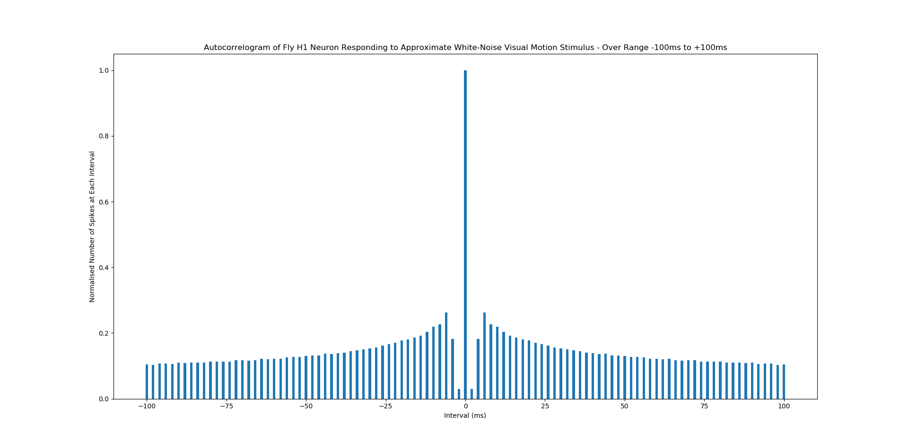

**Question 4** (code in load.py)

