**JasperReport 联合报表**

联合报表一般用于复杂业务场景的报表，有的一个PDF中可能会包含多个报表，或者生成的PDF并不是一个报表，而是一个固定数据的PDF。这样就需要用到子报表或者联合报表。

本文档中使用的示例，是crm-partner中其中一个业务场景需要用到联合报表，所以这个例子是基于这个业务场景写出来的，业务场景如下：partner订单中有一步出库的操作，出库的时候，需要打印出库单，而出库单分为两个部分：出库单的订单信息和出库单的出库产品详情信息，这是两个报表，但是这两个报表需要一起打印，所以这两个报表需要放到一个PDF中。如下图所示：

第一个报表：

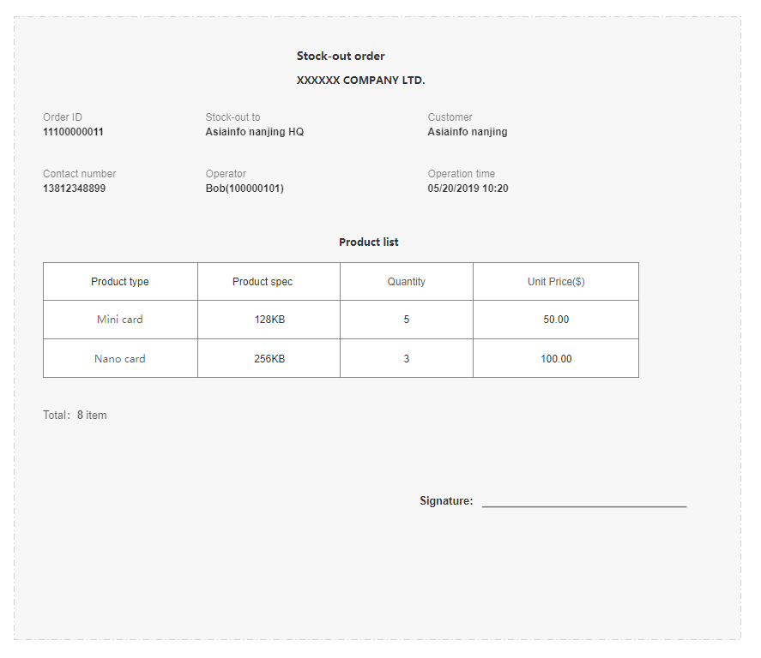

第二个报表：

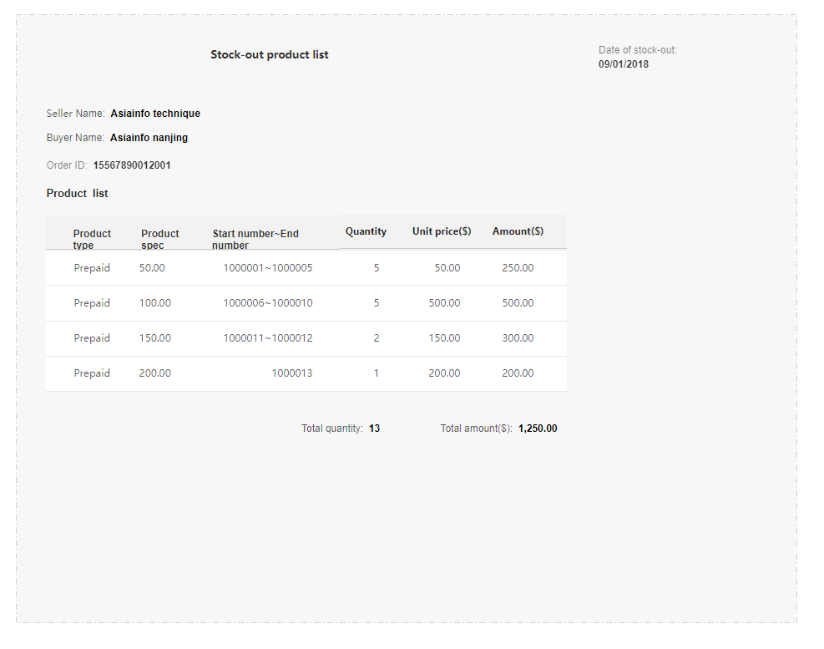

需要把这两个报表放入到一个PDF中，第一个报表在PDF的前几页，第二个报表在第一个报表的后面。

实现思路：因为是两个报表，而且第一个报表中有签字的项目，所以第一个报表签字的那一页肯定要单独占一页，所以不能用子报表，只能做两个报表，然后把两个报表合到一起，最后生成的PDF就是第一个报表的结束后另起一页生成第二个报表。

开撸：

一：打开TIBCO Jaspersoft Studio 6.9.0（Ireport 5.0 也可以）

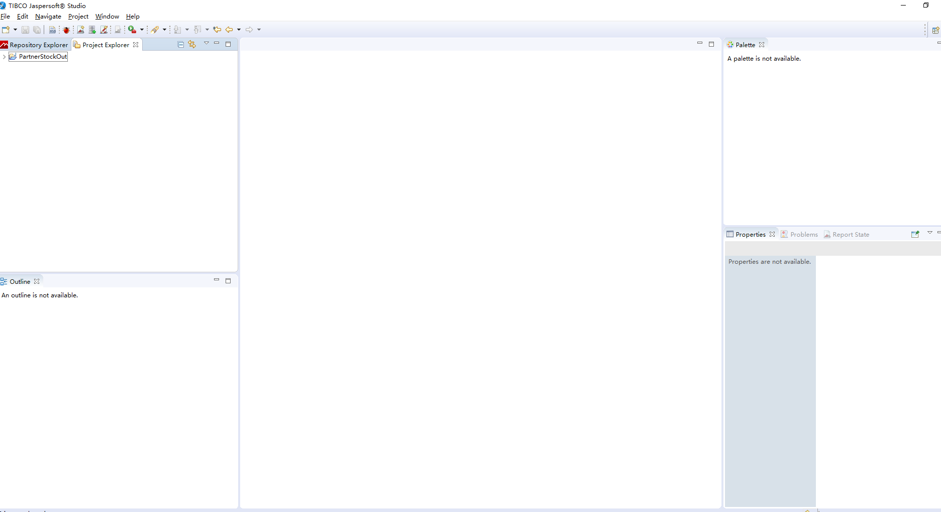

二：新建一个JasperReports Project

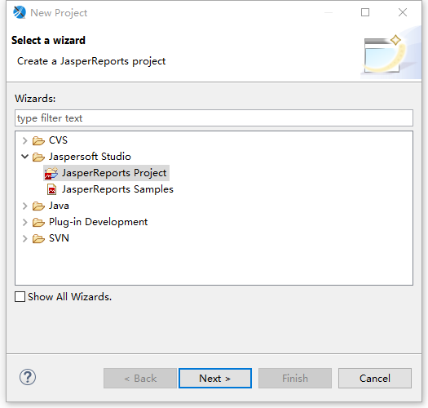

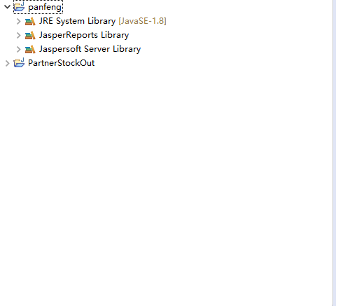

三：新建一个Book（这里我用的名字是mainBook.jrxml）

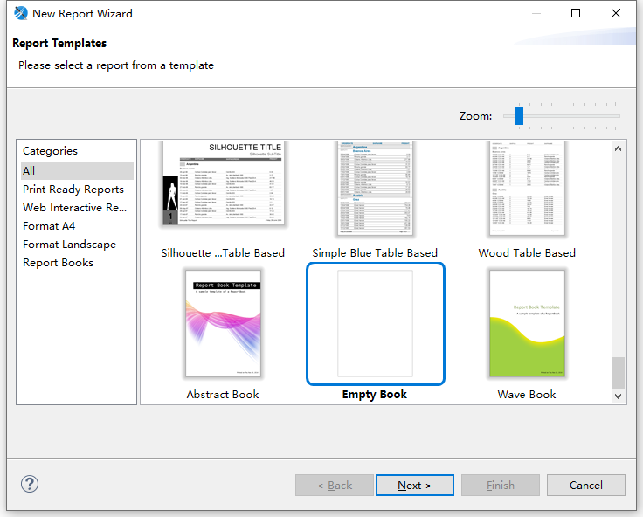

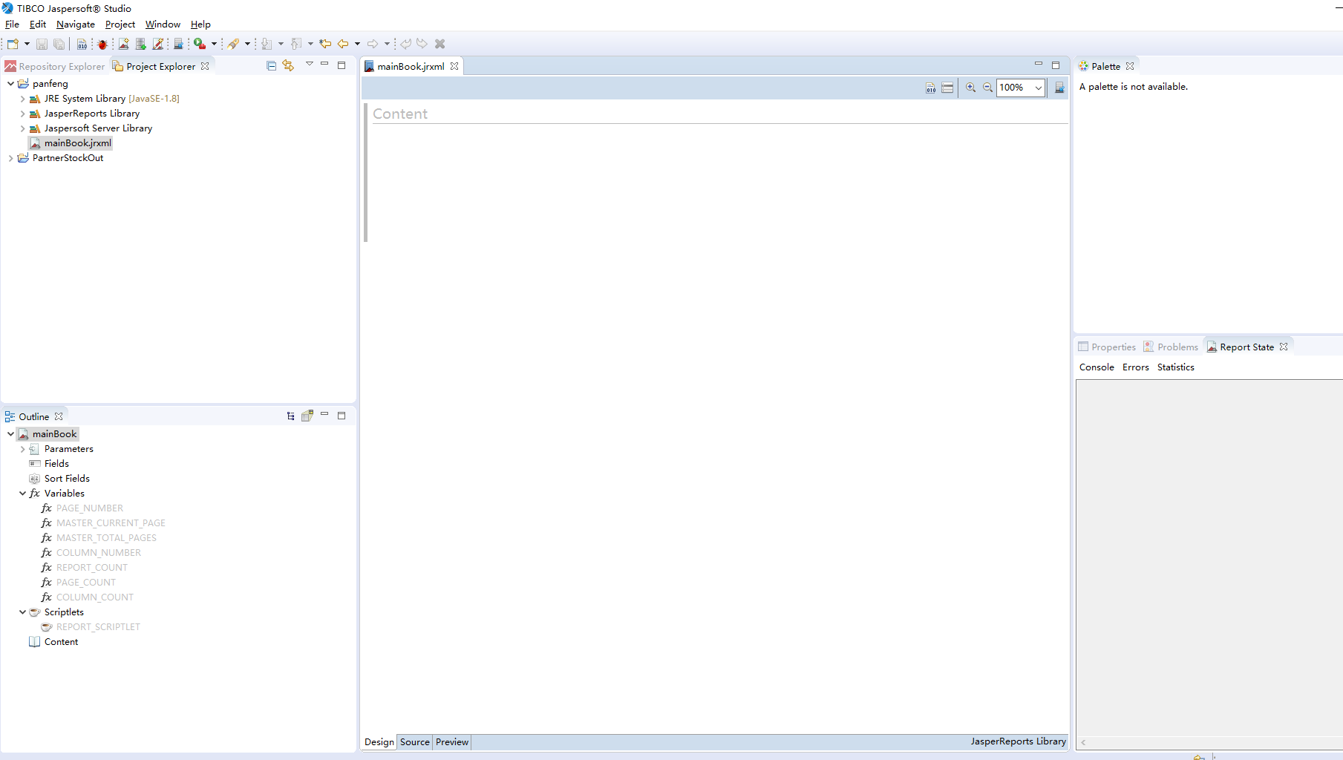

* book类型的jasper 是专门用来放其他的报表的，可以把每一个报表都放入到这里面，然后生成一个PDF

五：新建第一个报表的Jasper（我这里叫order.jrxml）

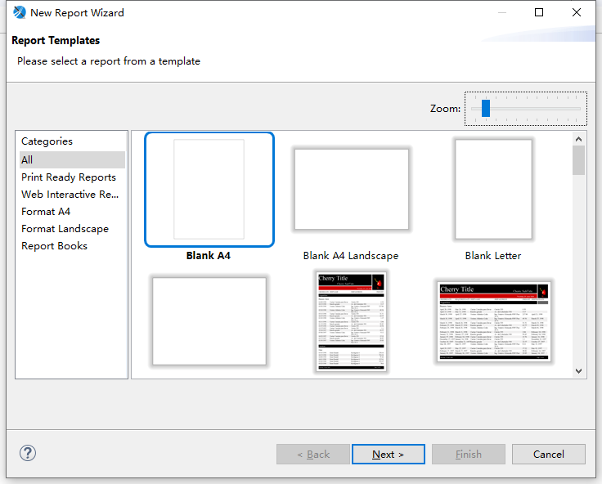

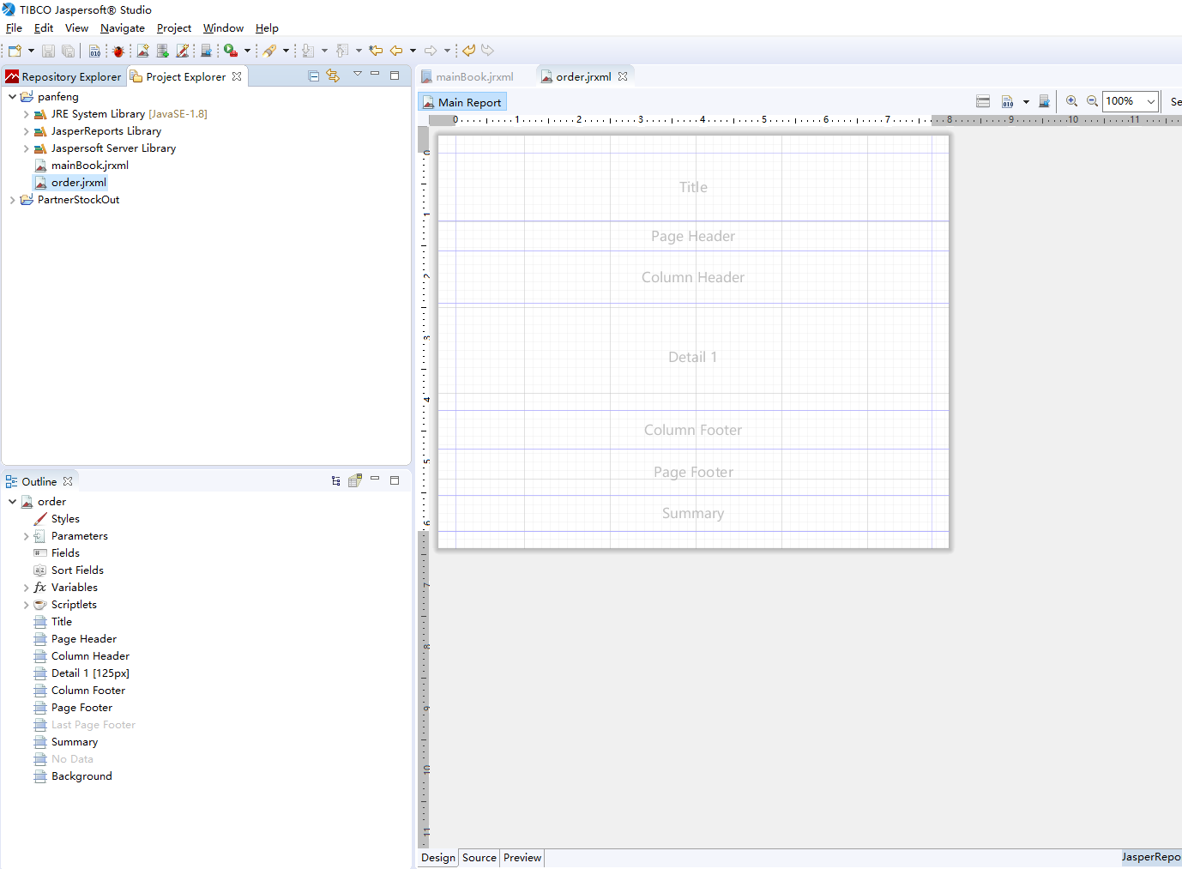

父报表中无法设置子报表中REPORT_PARAMETERS_MAP的值，所以我们要在子报表中新建一个Parameter，永于接收Java代码传过来的map。

六、新建一个Parameter，类型为java.util.Map（我这里叫def）

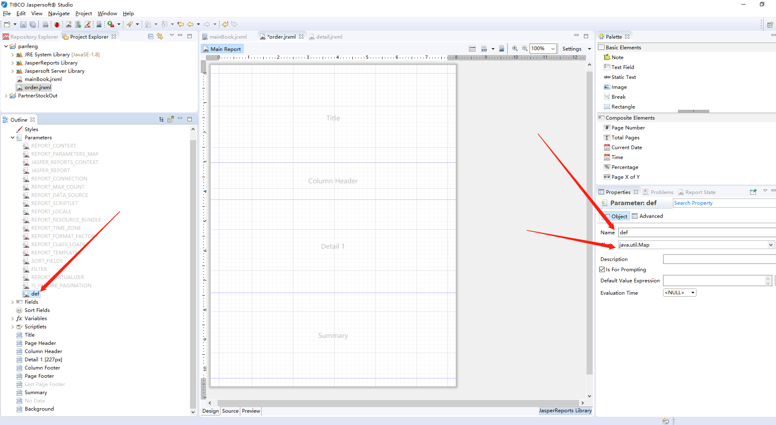

按照第一个报表的要求，将第一个报表中的内容画出来，过程略。画完的源代码如下：

<?xml version="1.0" encoding="UTF-8"?>

<!-- Created with Jaspersoft Studio version 6.9.0.final using JasperReports Library version 6.9.0-cb8f9004be492ccc537180b49c026951f4220bf3 -->

<jasperReport xmlns="http://jasperreports.sourceforge.net/jasperreports" xmlns:xsi="http://www.w3.org/2001/XMLSchema-instance" xsi:schemaLocation="http://jasperreports.sourceforge.net/jasperreports http://jasperreports.sourceforge.net/xsd/jasperreport.xsd" name="simple" pageWidth="595" pageHeight="842" whenNoDataType="BlankPage" columnWidth="555" leftMargin="20" rightMargin="20" topMargin="20" bottomMargin="20" whenResourceMissingType="Empty" uuid="577773f0-368b-412e-bc96-9b9ae2890da6">

<property name="com.jaspersoft.studio.data.defaultdataadapter" value="One Empty Record"/>

<parameter name="def" class="java.util.Map"/>

<queryString>

<![CDATA[]]>

</queryString>

<field name="resType" class="java.lang.String"/>

<field name="productType" class="java.lang.String"/>

<field name="productSpec" class="java.lang.String"/>

<field name="quantiy" class="java.lang.Integer"/>

<field name="unitPrice" class="java.lang.String"/>

<background>

<band splitType="Stretch"/>

</background>

<title>

<band height="217" splitType="Stretch">

<staticText>

<reportElement positionType="FixRelativeToBottom" isPrintRepeatedValues="false" x="200" y="7" width="130" height="30" uuid="738950fb-db24-4f6d-a2d2-5618c625104f"/>

<textElement textAlignment="Center" verticalAlignment="Middle">

<font size="13" isBold="true"/>

<paragraph lineSpacingSize="0.0"/>

</textElement>

<text><![CDATA[Stock-out order]]></text>

</staticText>

<staticText>

<reportElement x="180" y="40" width="170" height="30" uuid="d62af3a1-3bf1-47a7-943e-3155d6e2d622"/>

<textElement textAlignment="Center" verticalAlignment="Middle">

<font isBold="true"/>

</textElement>

<text><![CDATA[XXXXXX COMPANY LTD.]]></text>

</staticText>

<staticText>

<reportElement x="0" y="80" width="70" height="20" uuid="52e1d092-5f92-4e44-8215-dbf15e8c31c3"/>

<textElement textAlignment="Left" verticalAlignment="Middle"/>

<text><![CDATA[Order ID]]></text>

</staticText>

<staticText>

<reportElement x="196" y="79" width="70" height="20" uuid="16a2e0c1-5053-4a1a-88f1-c23e8e8d9519"/>

<textElement textAlignment="Left" verticalAlignment="Middle"/>

<text><![CDATA[Stock-out to]]></text>

</staticText>

<staticText>

<reportElement x="374" y="80" width="70" height="20" uuid="149f4642-f54b-4ac0-afe9-8f2cc6efcc83"/>

<textElement textAlignment="Left" verticalAlignment="Middle"/>

<text><![CDATA[Customer]]></text>

</staticText>

<staticText>

<reportElement x="2" y="131" width="88" height="20" uuid="2e4bc7fe-9152-49b1-b0b7-cb750283792f"/>

<textElement textAlignment="Left" verticalAlignment="Middle"/>

<text><![CDATA[Contact number]]></text>

</staticText>

<staticText>

<reportElement x="190" y="131" width="70" height="20" uuid="502fb79b-93bc-436a-afb8-bc0e0d32d867"/>

<textElement textAlignment="Left" verticalAlignment="Middle"/>

<text><![CDATA[Operator]]></text>

</staticText>

<staticText>

<reportElement x="374" y="131" width="74" height="20" uuid="591b3a82-57e5-4ad8-af69-6e76bccb4f7e"/>

<textElement textAlignment="Left" verticalAlignment="Middle"/>

<text><![CDATA[Operation time]]></text>

</staticText>

<textField>

<reportElement x="0" y="100" width="150" height="19" uuid="38786bf4-75d2-4b7f-b449-b59b89f3a691"/>

<textFieldExpression><![CDATA[$P{def}.get( "orderId" )]]></textFieldExpression>

</textField>

<textField>

<reportElement x="190" y="100" width="150" height="19" uuid="15ac62e9-e906-450d-a389-49e051820731"/>

<textFieldExpression><![CDATA[$P{def}.get( "stockTo" )]]></textFieldExpression>

</textField>

<textField>

<reportElement x="370" y="100" width="150" height="19" uuid="5dbc78ab-5deb-4324-9965-30bccaf31cd9"/>

<textFieldExpression><![CDATA[$P{def}.get( "customer" )]]></textFieldExpression>

</textField>

<textField>

<reportElement x="0" y="154" width="150" height="19" uuid="508ec321-9512-4999-9a18-65ba0d954a97"/>

<textFieldExpression><![CDATA[$P{def}.get( "contactNumber" )]]></textFieldExpression>

</textField>

<textField>

<reportElement x="180" y="160" width="150" height="19" uuid="82e03e59-ccac-4150-b6d1-042760a4bbc2"/>

<textFieldExpression><![CDATA[$P{def}.get( "operator" )]]></textFieldExpression>

</textField>

<textField>

<reportElement x="370" y="160" width="150" height="19" uuid="d17a9df1-ae67-4211-9026-69c138e17e5c"/>

<textFieldExpression><![CDATA[$P{def}.get( "operatorTime" )]]></textFieldExpression>

</textField>

</band>

</title>

<pageHeader>

<band splitType="Stretch">

<property name="com.jaspersoft.studio.unit.height" value="px"/>

</band>

</pageHeader>

<columnHeader>

<band height="90" splitType="Stretch">

<staticText>

<reportElement x="216" y="8" width="100" height="30" uuid="db39194f-afea-43b0-9973-ea4462e615ad"/>

<textElement textAlignment="Center" verticalAlignment="Middle"/>

<text><![CDATA[Product list]]></text>

</staticText>

<staticText>

<reportElement x="18" y="60" width="100" height="30" uuid="254a92af-4f56-41a8-b394-65ea56ca00a5"/>

<box topPadding="0" leftPadding="0" bottomPadding="0" rightPadding="0">

<topPen lineWidth="1.0" lineStyle="Solid" lineColor="#000000"/>

<leftPen lineWidth="1.0" lineStyle="Solid" lineColor="#000000"/>

<bottomPen lineWidth="1.0" lineStyle="Solid" lineColor="#000000"/>

<rightPen lineWidth="1.0" lineStyle="Solid" lineColor="#000000"/>

</box>

<textElement textAlignment="Center" verticalAlignment="Middle"/>

<text><![CDATA[Res Type]]></text>

</staticText>

<staticText>

<reportElement x="118" y="60" width="100" height="30" uuid="2f18c34c-7338-4fbf-8f75-e5c8ebd4a900"/>

<box topPadding="0" leftPadding="0" bottomPadding="0" rightPadding="0">

<topPen lineWidth="1.0" lineStyle="Solid" lineColor="#000000"/>

<leftPen lineWidth="1.0" lineStyle="Solid" lineColor="#000000"/>

<bottomPen lineWidth="1.0" lineStyle="Solid" lineColor="#000000"/>

<rightPen lineWidth="1.0" lineStyle="Solid" lineColor="#000000"/>

</box>

<textElement textAlignment="Center" verticalAlignment="Middle"/>

<text><![CDATA[Product type]]></text>

</staticText>

<staticText>

<reportElement x="218" y="60" width="100" height="30" uuid="e3d95df4-a168-4217-a1b4-199a56c2c426"/>

<box topPadding="0" leftPadding="0" bottomPadding="0" rightPadding="0">

<topPen lineWidth="1.0" lineStyle="Solid" lineColor="#000000"/>

<leftPen lineWidth="1.0" lineStyle="Solid" lineColor="#000000"/>

<bottomPen lineWidth="1.0" lineStyle="Solid" lineColor="#000000"/>

<rightPen lineWidth="1.0" lineStyle="Solid" lineColor="#000000"/>

</box>

<textElement textAlignment="Center" verticalAlignment="Middle"/>

<text><![CDATA[Product spec]]></text>

</staticText>

<staticText>

<reportElement x="318" y="60" width="100" height="30" uuid="9fcbe8f3-7a85-4296-b5f6-55d9629cc9d9"/>

<box topPadding="0" leftPadding="0" bottomPadding="0" rightPadding="0">

<topPen lineWidth="1.0" lineStyle="Solid" lineColor="#000000"/>

<leftPen lineWidth="1.0" lineStyle="Solid" lineColor="#000000"/>

<bottomPen lineWidth="1.0" lineStyle="Solid" lineColor="#000000"/>

<rightPen lineWidth="1.0" lineStyle="Solid" lineColor="#000000"/>

</box>

<textElement textAlignment="Center" verticalAlignment="Middle"/>

<text><![CDATA[Quantity]]></text>

</staticText>

<staticText>

<reportElement x="418" y="60" width="100" height="30" uuid="6f9df7c0-b4bb-4321-9ecb-2327b5fde2a2"/>

<box topPadding="0" leftPadding="0" bottomPadding="0" rightPadding="0">

<topPen lineWidth="1.0" lineStyle="Solid" lineColor="#000000"/>

<leftPen lineWidth="1.0" lineStyle="Solid" lineColor="#000000"/>

<bottomPen lineWidth="1.0" lineStyle="Solid" lineColor="#000000"/>

<rightPen lineWidth="1.0" lineStyle="Solid" lineColor="#000000"/>

</box>

<textElement textAlignment="Center" verticalAlignment="Middle"/>

<text><![CDATA[Unit Price($)]]></text>

</staticText>

</band>

</columnHeader>

<detail>

<band height="227" splitType="Stretch">

<textField>

<reportElement x="18" y="0" width="100" height="30" uuid="9e7726a5-39ff-4a5f-ba6a-de9de1f52036"/>

<box topPadding="0" leftPadding="0" bottomPadding="0" rightPadding="0">

<topPen lineWidth="0.0" lineStyle="Solid" lineColor="#000000"/>

<leftPen lineWidth="1.0" lineStyle="Solid" lineColor="#000000"/>

<bottomPen lineWidth="1.0" lineStyle="Solid" lineColor="#000000"/>

<rightPen lineWidth="1.0" lineStyle="Solid" lineColor="#000000"/>

</box>

<textElement textAlignment="Center" verticalAlignment="Middle"/>

<textFieldExpression><![CDATA[$F{resType}]]></textFieldExpression>

</textField>

<textField>

<reportElement x="118" y="0" width="100" height="30" uuid="02fa0b95-ecc0-4000-bf68-45c55c38f0a3"/>

<box topPadding="0" leftPadding="0" bottomPadding="0" rightPadding="0">

<topPen lineWidth="0.0" lineStyle="Solid" lineColor="#000000"/>

<leftPen lineWidth="1.0" lineStyle="Solid" lineColor="#000000"/>

<bottomPen lineWidth="1.0" lineStyle="Solid" lineColor="#000000"/>

<rightPen lineWidth="1.0" lineStyle="Solid" lineColor="#000000"/>

</box>

<textElement textAlignment="Center" verticalAlignment="Middle"/>

<textFieldExpression><![CDATA[$F{productType}]]></textFieldExpression>

</textField>

<textField>

<reportElement x="218" y="0" width="100" height="30" uuid="96e5d8b2-718c-4392-931d-b0e195255f8c"/>

<box topPadding="0" leftPadding="0" bottomPadding="0" rightPadding="0">

<topPen lineWidth="0.0" lineStyle="Solid" lineColor="#000000"/>

<leftPen lineWidth="1.0" lineStyle="Solid" lineColor="#000000"/>

<bottomPen lineWidth="1.0" lineStyle="Solid" lineColor="#000000"/>

<rightPen lineWidth="1.0" lineStyle="Solid" lineColor="#000000"/>

</box>

<textElement textAlignment="Center" verticalAlignment="Middle"/>

<textFieldExpression><![CDATA[$F{productSpec}]]></textFieldExpression>

</textField>

<textField>

<reportElement x="318" y="0" width="100" height="30" uuid="4b8b06ec-8e77-4f01-acaf-235d76235670"/>

<box topPadding="0" leftPadding="0" bottomPadding="0" rightPadding="0">

<topPen lineWidth="0.0" lineStyle="Solid" lineColor="#000000"/>

<leftPen lineWidth="1.0" lineStyle="Solid" lineColor="#000000"/>

<bottomPen lineWidth="1.0" lineStyle="Solid" lineColor="#000000"/>

<rightPen lineWidth="1.0" lineStyle="Solid" lineColor="#000000"/>

</box>

<textElement textAlignment="Center" verticalAlignment="Middle"/>

<textFieldExpression><![CDATA[$F{quantiy}]]></textFieldExpression>

</textField>

<textField>

<reportElement x="418" y="0" width="100" height="30" uuid="52d6d901-a0d6-4d90-9ab1-95d5262df1e2"/>

<box topPadding="0" leftPadding="0" bottomPadding="0" rightPadding="0">

<topPen lineWidth="0.0" lineStyle="Solid" lineColor="#000000"/>

<leftPen lineWidth="1.0" lineStyle="Solid" lineColor="#000000"/>

<bottomPen lineWidth="1.0" lineStyle="Solid" lineColor="#000000"/>

<rightPen lineWidth="1.0" lineStyle="Solid" lineColor="#000000"/>

</box>

<textElement textAlignment="Center" verticalAlignment="Middle"/>

<textFieldExpression><![CDATA[$F{unitPrice}]]></textFieldExpression>

</textField>

</band>

</detail>

<columnFooter>

<band splitType="Stretch">

<property name="com.jaspersoft.studio.unit.height" value="px"/>

</band>

</columnFooter>

<pageFooter>

<band splitType="Stretch">

<property name="com.jaspersoft.studio.unit.height" value="px"/>

</band>

</pageFooter>

<summary>

<band height="208" splitType="Stretch">

<staticText>

<reportElement x="10" y="11" width="50" height="19" uuid="7034db49-547e-43bb-a0cd-5412606ce090"/>

<textElement textAlignment="Center" verticalAlignment="Middle"/>

<text><![CDATA[Total:]]></text>

</staticText>

<textField>

<reportElement x="60" y="11" width="30" height="19" uuid="c4c23d9a-1eb3-4e23-b805-973d470f43c7"/>

<textElement textAlignment="Center" verticalAlignment="Middle">

<font isBold="true"/>

</textElement>

<textFieldExpression><![CDATA[$P{SORT_FIELDS}.size()]]></textFieldExpression>

</textField>

<staticText>

<reportElement x="90" y="11" width="50" height="19" uuid="0aacb614-70da-4b2e-a775-5956a3fa4287"/>

<textElement textAlignment="Center" verticalAlignment="Middle"/>

<text><![CDATA[item]]></text>

</staticText>

<staticText>

<reportElement x="324" y="110" width="221" height="45" uuid="17402daf-0cf8-4158-829c-c8def34b8758"/>

<textElement textAlignment="Left" verticalAlignment="Bottom"/>

<text><![CDATA[Signature:_____________________________]]></text>

</staticText>

</band>

</summary>

</jasperReport>

六：同样的方法，新建第二个报表（我这里叫detail.jrxml），添加一个Parameter（我这里还是def）。将内容按照第二个报表的要求画出来，过程略，画完的源代码如下：

<?xml version="1.0" encoding="UTF-8"?>

<!-- Created with Jaspersoft Studio version 6.9.0.final using JasperReports Library version 6.9.0-cb8f9004be492ccc537180b49c026951f4220bf3 -->

<jasperReport xmlns="http://jasperreports.sourceforge.net/jasperreports" xmlns:xsi="http://www.w3.org/2001/XMLSchema-instance" xsi:schemaLocation="http://jasperreports.sourceforge.net/jasperreports http://jasperreports.sourceforge.net/xsd/jasperreport.xsd" name="detail" pageWidth="595" pageHeight="842" whenNoDataType="BlankPage" columnWidth="555" leftMargin="20" rightMargin="20" topMargin="20" bottomMargin="20" whenResourceMissingType="Empty" uuid="b29c343f-aaff-409c-87d1-7d600fe2871c">

<property name="com.jaspersoft.studio.data.defaultdataadapter" value="One Empty Record"/>

<parameter name="def" class="java.util.Map"/>

<queryString>

<![CDATA[]]>

</queryString>

<field name="productType" class="java.lang.String"/>

<field name="productSpec" class="java.lang.String"/>

<field name="serNumber" class="java.lang.String"/>

<field name="quantity" class="java.lang.String"/>

<field name="unitPrice" class="java.lang.String"/>

<field name="amount" class="java.lang.String"/>

<background>

<band splitType="Stretch"/>

</background>

<title>

<band height="230" splitType="Stretch">

<staticText>

<reportElement x="170" y="0" width="170" height="50" uuid="fe121539-fdb0-4840-8ee6-830ebca07c71"/>

<textElement textAlignment="Center" verticalAlignment="Middle">

<font size="15" isBold="true"/>

</textElement>

<text><![CDATA[Stock-out product list]]></text>

</staticText>

<staticText>

<reportElement x="360" y="0" width="80" height="20" uuid="98325ef6-887e-4973-9b3c-02a130841fcc"/>

<text><![CDATA[Date of stock-out: ]]></text>

</staticText>

<textField>

<reportElement x="440" y="0" width="110" height="20" uuid="e72fb238-762d-48dd-bff8-c45215f668bf"/>

<textFieldExpression><![CDATA[$P{def}.get( "stockDate" )]]></textFieldExpression>

</textField>

<staticText>

<reportElement x="0" y="60" width="70" height="20" uuid="4b3acbc6-0031-4fe5-942f-64143558ae2d"/>

<text><![CDATA[Seller Name:]]></text>

</staticText>

<staticText>

<reportElement x="0" y="90" width="70" height="20" uuid="878ffb96-f5eb-4762-a4aa-80a7ab9b5f89"/>

<text><![CDATA[Buyer Name:]]></text>

</staticText>

<staticText>

<reportElement x="0" y="120" width="70" height="20" uuid="ca85de01-be92-487b-86b2-33ff8d56b67e"/>

<text><![CDATA[Order ID:]]></text>

</staticText>

<textField>

<reportElement x="80" y="60" width="170" height="20" uuid="f10a0b72-6b92-438b-b6ac-afd4e5ad2fd5"/>

<textFieldExpression><![CDATA[$P{def}.get( "sellerNames" )]]></textFieldExpression>

</textField>

<textField>

<reportElement x="80" y="90" width="170" height="20" uuid="d886521d-3657-4e7f-8577-921569209699"/>

<textFieldExpression><![CDATA[$P{def}.get( "buyerName" )]]></textFieldExpression>

</textField>

<textField>

<reportElement x="80" y="120" width="170" height="20" uuid="84daca9d-512d-419c-a099-c8f822a63ce9"/>

<textFieldExpression><![CDATA[$P{def}.get( "OrderId" )]]></textFieldExpression>

</textField>

</band>

</title>

<pageHeader>

<band height="38" splitType="Stretch">

<property name="com.jaspersoft.studio.unit.height" value="px"/>

<staticText>

<reportElement x="200" y="0" width="170" height="38" uuid="4221acc6-0853-4f8f-9037-866214974555"/>

<textElement textAlignment="Center" verticalAlignment="Middle">

<font size="18" isBold="true"/>

</textElement>

<text><![CDATA[Product list]]></text>

</staticText>

</band>

</pageHeader>

<columnHeader>

<band height="63" splitType="Stretch">

<staticText>

<reportElement x="0" y="32" width="100" height="30" uuid="e71c01eb-a7be-476f-9aa5-8a9d49f7aab5"/>

<box>

<topPen lineWidth="1.0" lineStyle="Solid" lineColor="#000000"/>

<leftPen lineWidth="1.0" lineStyle="Solid" lineColor="#000000"/>

<bottomPen lineWidth="1.0" lineStyle="Solid" lineColor="#000000"/>

<rightPen lineWidth="1.0" lineStyle="Solid" lineColor="#000000"/>

</box>

<textElement textAlignment="Center" verticalAlignment="Bottom"/>

<text><![CDATA[

Product type]]></text>

</staticText>

<staticText>

<reportElement x="100" y="32" width="80" height="30" uuid="99cb82fa-d6b8-4284-a224-324392cc250e"/>

<box>

<topPen lineWidth="1.0" lineStyle="Solid" lineColor="#000000"/>

<leftPen lineWidth="1.0" lineStyle="Solid" lineColor="#000000"/>

<bottomPen lineWidth="1.0" lineStyle="Solid" lineColor="#000000"/>

<rightPen lineWidth="1.0" lineStyle="Solid" lineColor="#000000"/>

</box>

<textElement textAlignment="Center" verticalAlignment="Bottom"/>

<text><![CDATA[

Product spec]]></text>

</staticText>

<staticText>

<reportElement x="180" y="32" width="100" height="30" uuid="bc7900a6-69f1-4825-a15b-db3bb0e4bb9d"/>

<box>

<topPen lineWidth="1.0" lineStyle="Solid" lineColor="#000000"/>

<leftPen lineWidth="1.0" lineStyle="Solid" lineColor="#000000"/>

<bottomPen lineWidth="1.0" lineStyle="Solid" lineColor="#000000"/>

<rightPen lineWidth="1.0" lineStyle="Solid" lineColor="#000000"/>

</box>

<textElement textAlignment="Center" verticalAlignment="Bottom"/>

<text><![CDATA[serNumber]]></text>

</staticText>

<staticText>

<reportElement x="280" y="32" width="100" height="30" uuid="900620c1-580b-4209-9dc9-3634d96f12e5"/>

<box>

<topPen lineWidth="1.0" lineStyle="Solid" lineColor="#000000"/>

<leftPen lineWidth="1.0" lineStyle="Solid" lineColor="#000000"/>

<bottomPen lineWidth="1.0" lineStyle="Solid" lineColor="#000000"/>

<rightPen lineWidth="1.0" lineStyle="Solid" lineColor="#000000"/>

</box>

<textElement textAlignment="Center" verticalAlignment="Bottom"/>

<text><![CDATA[quantity]]></text>

</staticText>

<staticText>

<reportElement x="380" y="32" width="100" height="30" uuid="fc681e55-8341-40e5-b1a1-548f0f6a9ff4"/>

<box>

<topPen lineWidth="1.0" lineStyle="Solid" lineColor="#000000"/>

<leftPen lineWidth="1.0" lineStyle="Solid" lineColor="#000000"/>

<bottomPen lineWidth="1.0" lineStyle="Solid" lineColor="#000000"/>

<rightPen lineWidth="1.0" lineStyle="Solid" lineColor="#000000"/>

</box>

<textElement textAlignment="Center" verticalAlignment="Bottom"/>

<text><![CDATA[

Unit price($)]]></text>

</staticText>

<staticText>

<reportElement x="480" y="32" width="70" height="30" uuid="ddc33bec-f18a-4bea-8819-e9fd5427b3fe"/>

<box>

<topPen lineWidth="1.0" lineStyle="Solid" lineColor="#000000"/>

<leftPen lineWidth="1.0" lineStyle="Solid" lineColor="#000000"/>

<bottomPen lineWidth="1.0" lineStyle="Solid" lineColor="#000000"/>

<rightPen lineWidth="1.0" lineStyle="Solid" lineColor="#000000"/>

</box>

<textElement textAlignment="Center" verticalAlignment="Bottom"/>

<text><![CDATA[Amount($)]]></text>

</staticText>

</band>

</columnHeader>

<detail>

<band height="369" splitType="Stretch">

<textField>

<reportElement x="0" y="0" width="100" height="20" uuid="3dba8974-285a-4afa-aa83-51f3364753e0"/>

<box>

<topPen lineWidth="0.0" lineStyle="Solid" lineColor="#000000"/>

<leftPen lineWidth="1.0" lineStyle="Solid" lineColor="#000000"/>

<bottomPen lineWidth="1.0" lineStyle="Solid" lineColor="#000000"/>

<rightPen lineWidth="1.0" lineStyle="Solid" lineColor="#000000"/>

</box>

<textElement textAlignment="Center"/>

<textFieldExpression><![CDATA[$F{productType}]]></textFieldExpression>

</textField>

<textField>

<reportElement x="100" y="0" width="80" height="20" uuid="ac6b0229-0148-4269-961f-869eef21531d"/>

<box>

<topPen lineWidth="0.0" lineStyle="Solid" lineColor="#000000"/>

<leftPen lineWidth="1.0" lineStyle="Solid" lineColor="#000000"/>

<bottomPen lineWidth="1.0" lineStyle="Solid" lineColor="#000000"/>

<rightPen lineWidth="1.0" lineStyle="Solid" lineColor="#000000"/>

</box>

<textElement textAlignment="Center"/>

<textFieldExpression><![CDATA[$F{productSpec}]]></textFieldExpression>

</textField>

<textField>

<reportElement x="180" y="0" width="100" height="20" uuid="0d80feac-8bb3-4074-a134-12159a212b13"/>

<box>

<topPen lineWidth="0.0" lineStyle="Solid" lineColor="#000000"/>

<leftPen lineWidth="1.0" lineStyle="Solid" lineColor="#000000"/>

<bottomPen lineWidth="1.0" lineStyle="Solid" lineColor="#000000"/>

<rightPen lineWidth="1.0" lineStyle="Solid" lineColor="#000000"/>

</box>

<textElement textAlignment="Center"/>

<textFieldExpression><![CDATA[$F{serNumber}]]></textFieldExpression>

</textField>

<textField>

<reportElement x="280" y="0" width="100" height="20" uuid="aa1e479a-6017-48be-acdf-bfd0ee309fdb"/>

<box>

<topPen lineWidth="0.0" lineStyle="Solid" lineColor="#000000"/>

<leftPen lineWidth="1.0" lineStyle="Solid" lineColor="#000000"/>

<bottomPen lineWidth="1.0" lineStyle="Solid" lineColor="#000000"/>

<rightPen lineWidth="1.0" lineStyle="Solid" lineColor="#000000"/>

</box>

<textElement textAlignment="Center"/>

<textFieldExpression><![CDATA[$F{quantity}]]></textFieldExpression>

</textField>

<textField>

<reportElement x="380" y="0" width="100" height="20" uuid="68977f7e-ebfb-4ed3-bb4c-b80e336df018"/>

<box>

<topPen lineWidth="0.0" lineStyle="Solid" lineColor="#000000"/>

<leftPen lineWidth="1.0" lineStyle="Solid" lineColor="#000000"/>

<bottomPen lineWidth="1.0" lineStyle="Solid" lineColor="#000000"/>

<rightPen lineWidth="1.0" lineStyle="Solid" lineColor="#000000"/>

</box>

<textElement textAlignment="Center"/>

<textFieldExpression><![CDATA[$F{unitPrice}]]></textFieldExpression>

</textField>

<textField>

<reportElement x="480" y="0" width="70" height="20" uuid="7e6dcfbf-8745-48f7-8785-ee3492ae1571"/>

<box>

<topPen lineWidth="0.0" lineStyle="Solid" lineColor="#000000"/>

<leftPen lineWidth="1.0" lineStyle="Solid" lineColor="#000000"/>

<bottomPen lineWidth="1.0" lineStyle="Solid" lineColor="#000000"/>

<rightPen lineWidth="1.0" lineStyle="Solid" lineColor="#000000"/>

</box>

<textElement textAlignment="Center"/>

<textFieldExpression><![CDATA[$F{amount}]]></textFieldExpression>

</textField>

</band>

</detail>

<columnFooter>

<band splitType="Stretch">

<property name="com.jaspersoft.studio.unit.height" value="px"/>

</band>

</columnFooter>

<pageFooter>

<band splitType="Stretch">

<property name="com.jaspersoft.studio.unit.height" value="px"/>

</band>

</pageFooter>

<summary>

<band height="78" splitType="Stretch">

<staticText>

<reportElement x="240" y="0" width="70" height="20" uuid="97beb2b0-e68c-46f8-a6a7-8d48687d6742"/>

<text><![CDATA[Total quantity:]]></text>

</staticText>

<textField>

<reportElement x="310" y="0" width="70" height="20" uuid="e0acab83-58fd-4458-b3db-1d879b30984a"/>

<textFieldExpression><![CDATA[$P{def}.get( "totalQuantity" )]]></textFieldExpression>

</textField>

<staticText>

<reportElement x="400" y="2" width="80" height="16" uuid="0107ad24-9fc7-458b-8eb0-63e57d67f4c4"/>

<text><![CDATA[Total amount($):]]></text>

</staticText>

<textField>

<reportElement x="480" y="1" width="60" height="18" uuid="355874a7-e48d-4b9b-bf3b-05729edaed5b"/>

<textFieldExpression><![CDATA[$P{def}.get( "totalAmount" )]]></textFieldExpression>

</textField>

</band>

</summary>

</jasperReport>

七：在主报表（即Book类型的那个报表）中新建两个Page

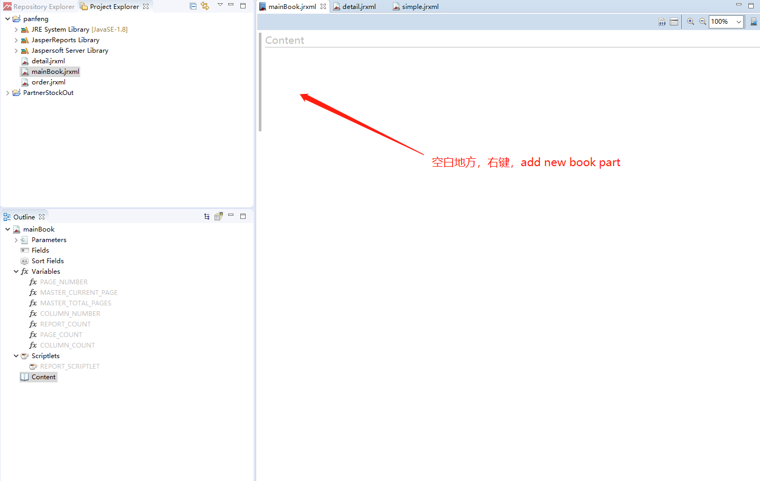

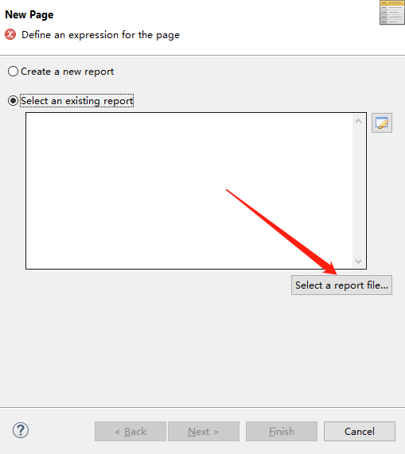

选择使用子报表，从Map中获取一个参数作为子报表的页面，参数后面在Java代码里面设置

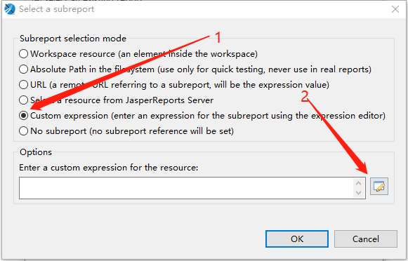

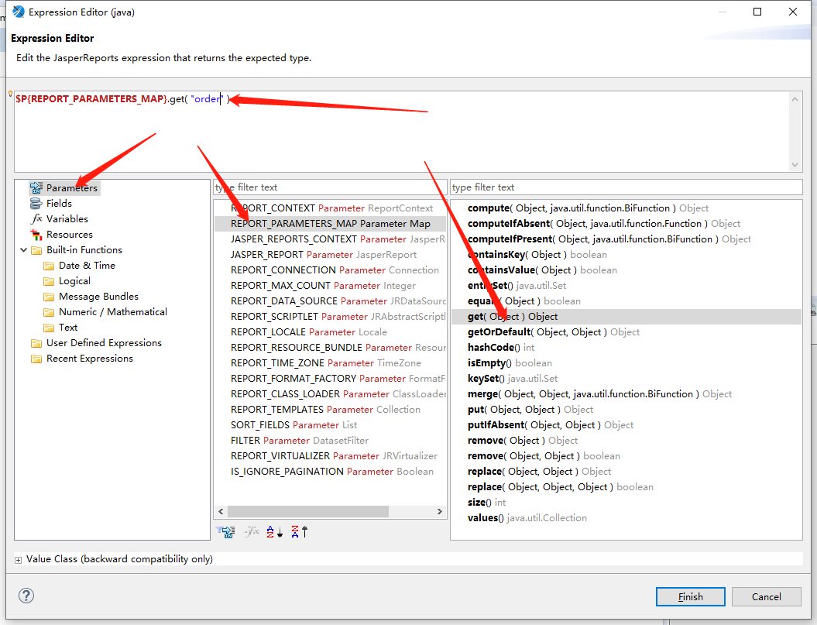

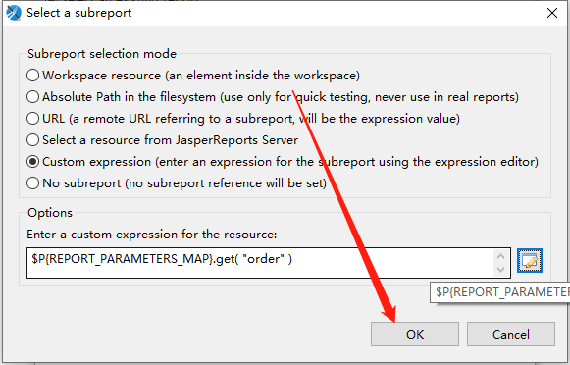

第一个页面添加完成！

八：添加第二个页面，同上。过程略，

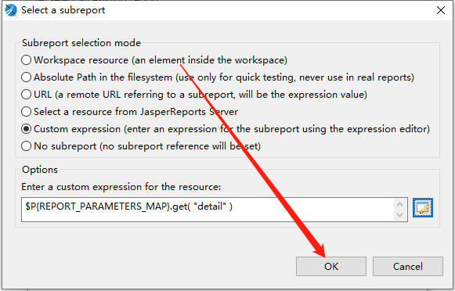

两个个页面添加完成！

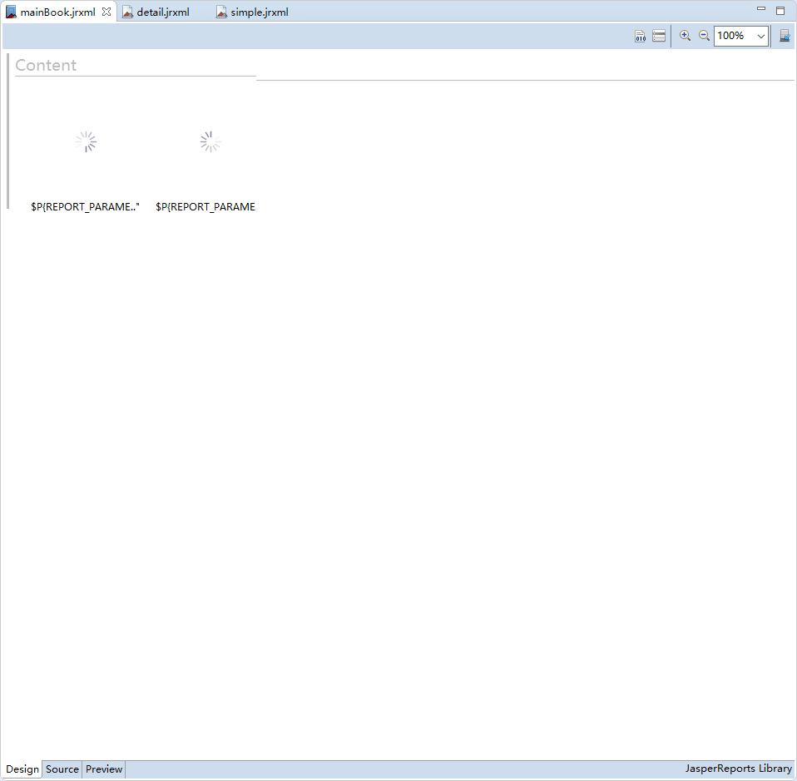

九：为两个页面设置数据源和参数列表

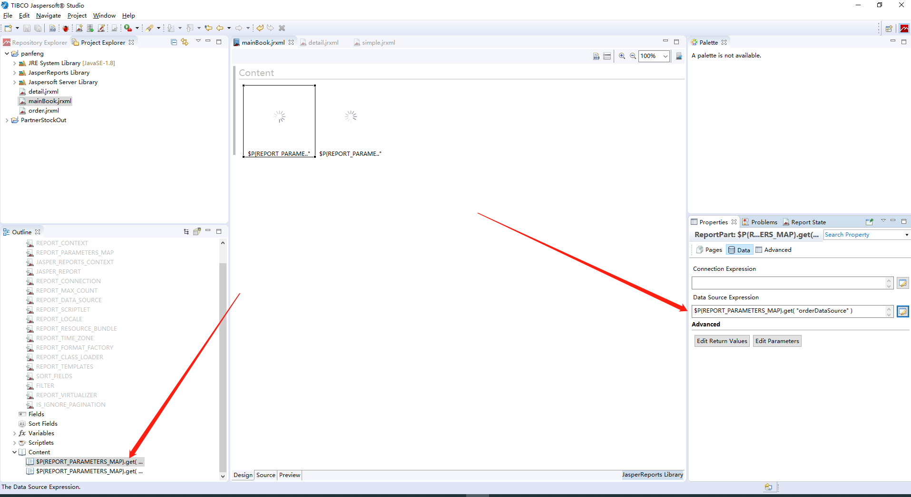

第一个页面数据源设置完成，接下来设置参数列表：

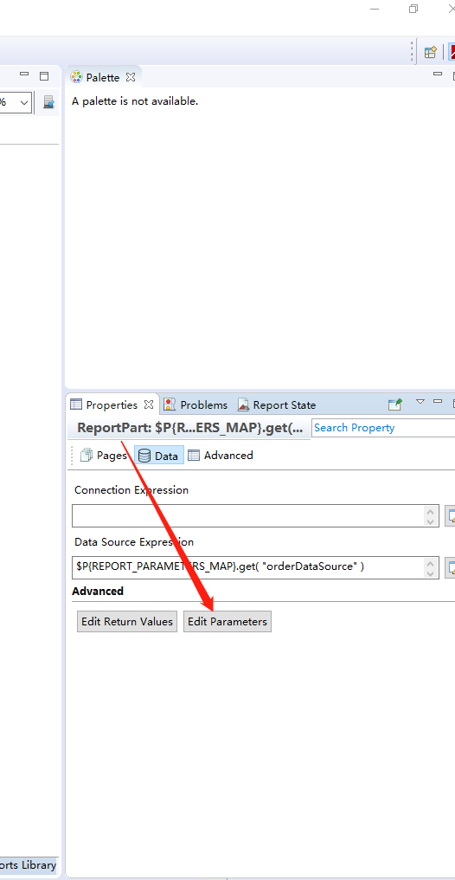

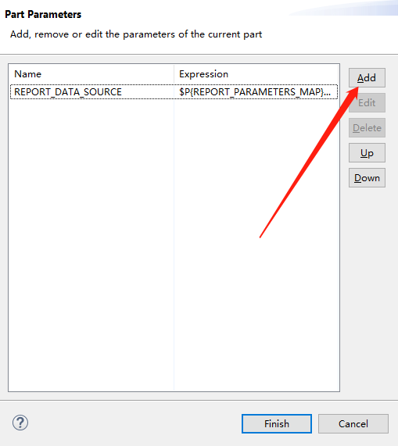

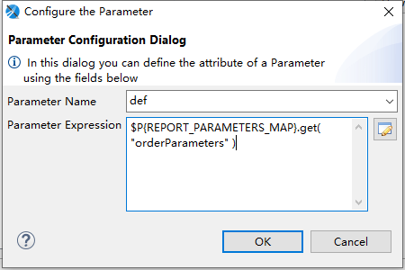

注意这里的参数名一定要和第一个jrxml 中设置的自定义的Parameter名称一样

十：设置第二个页面的数据源和参数列表，同上，过程略

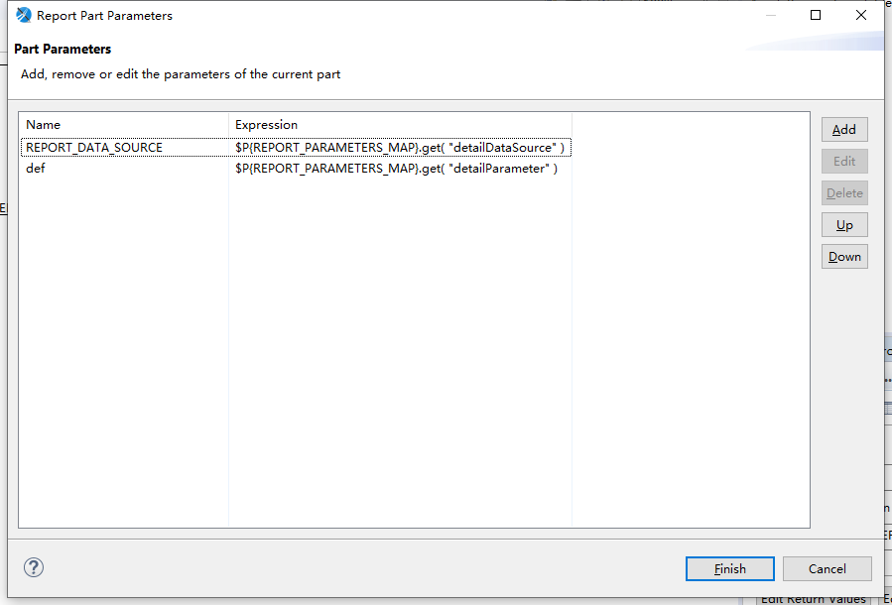

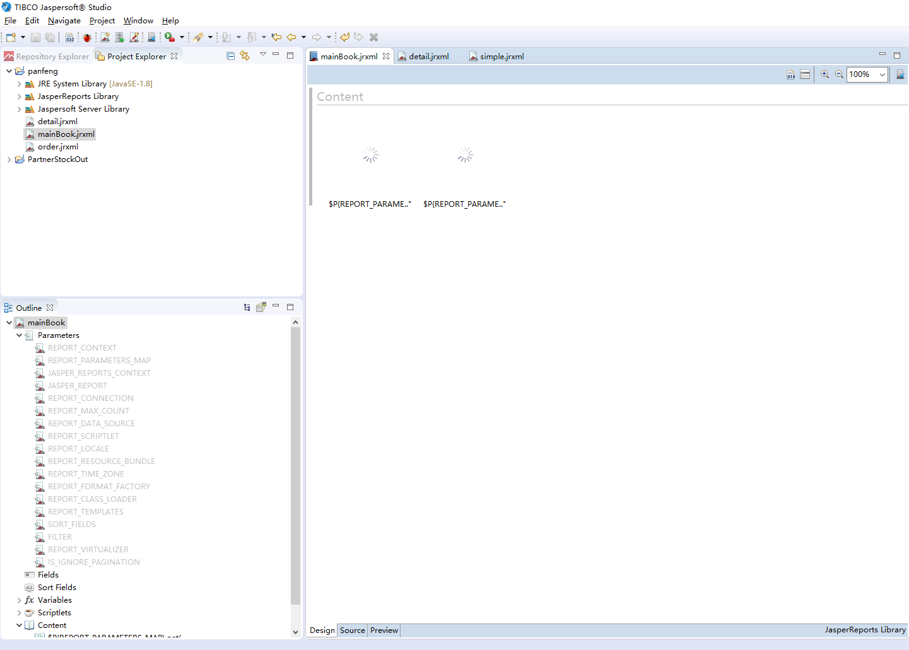

至此，Jasper操作完成。mainBook.jrxml代码如下：

<?xml version="1.0" encoding="UTF-8"?>

<!-- Created with Jaspersoft Studio version 6.9.0.final using JasperReports Library version 6.9.0-cb8f9004be492ccc537180b49c026951f4220bf3 -->

<jasperReport xmlns="http://jasperreports.sourceforge.net/jasperreports" xmlns:xsi="http://www.w3.org/2001/XMLSchema-instance" xsi:schemaLocation="http://jasperreports.sourceforge.net/jasperreports http://jasperreports.sourceforge.net/xsd/jasperreport.xsd" name="mainBook" pageWidth="595" pageHeight="842" sectionType="Part" columnWidth="555" leftMargin="20" rightMargin="20" topMargin="30" bottomMargin="30" uuid="d2716064-8ae4-40cf-a575-33afba400e3a">

<property name="com.jaspersoft.studio.data.defaultdataadapter" value="One Empty Record"/>

<property name="net.sf.jasperreports.print.create.bookmarks" value="true"/>

<queryString>

<![CDATA[]]>

</queryString>

<detail>

<part uuid="e7d6642f-dc45-4aed-9dca-9e75128cc9f9">

<p:subreportPart xmlns:p="http://jasperreports.sourceforge.net/jasperreports/parts" xsi:schemaLocation="http://jasperreports.sourceforge.net/jasperreports/parts http://jasperreports.sourceforge.net/xsd/parts.xsd">

<subreportParameter name="REPORT_DATA_SOURCE">

<subreportParameterExpression><![CDATA[$P{REPORT_PARAMETERS_MAP}.get( "orderDataSource" )]]></subreportParameterExpression>

</subreportParameter>

<subreportParameter name="def">

<subreportParameterExpression><![CDATA[$P{REPORT_PARAMETERS_MAP}.get( "orderParameters" )]]></subreportParameterExpression>

</subreportParameter>

<subreportExpression><![CDATA[$P{REPORT_PARAMETERS_MAP}.get( "order" )]]></subreportExpression>

</p:subreportPart>

</part>

<part uuid="c1be8747-14ac-4b49-b15a-fbb93efa5a8e">

<p:subreportPart xmlns:p="http://jasperreports.sourceforge.net/jasperreports/parts" xsi:schemaLocation="http://jasperreports.sourceforge.net/jasperreports/parts http://jasperreports.sourceforge.net/xsd/parts.xsd">

<subreportParameter name="REPORT_DATA_SOURCE">

<subreportParameterExpression><![CDATA[$P{REPORT_PARAMETERS_MAP}.get( "detailDataSource" )]]></subreportParameterExpression>

</subreportParameter>

<subreportParameter name="def">

<subreportParameterExpression><![CDATA[$P{REPORT_PARAMETERS_MAP}.get( "detailParameter" )]]></subreportParameterExpression>

</subreportParameter>

<subreportExpression><![CDATA[$P{REPORT_PARAMETERS_MAP}.get( "detail" )]]></subreportExpression>

</p:subreportPart>

</part>

</detail>

</jasperReport>

十一：新建一个Java Maven工程：

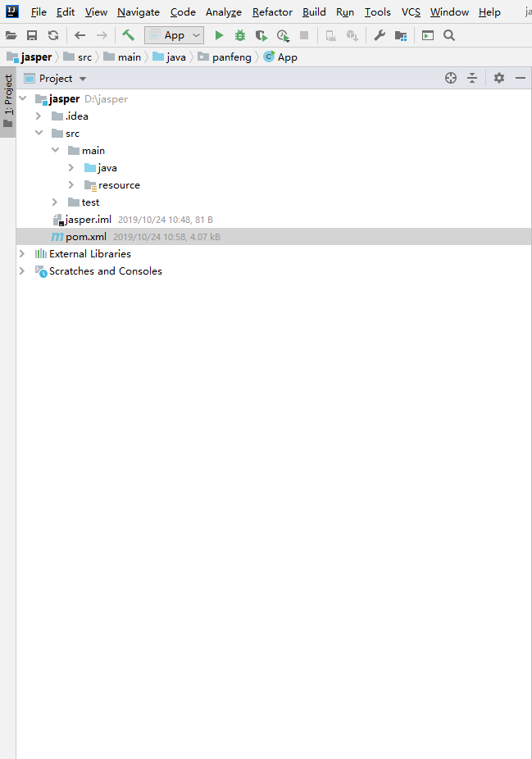

加入以下依赖（文本框显示不全，建议复制）：

*<!-- jasperreports Start -->  
<!-- 该包的作用完成ireport中Preview按扭功能。通过该包可以通过java来ireport生成摸班（.jrxml或.jasper)填充数据源并导出pdf,excel,html等格式文件 -->****<*dependency*>  
 <*groupId*>***net.sf.jasperreports***</*groupId*>  
 <*artifactId*>***jasperreports***</*artifactId*>  
 <*version*>***6.8.1***</*version*>  
 <*exclusions*>  
 <*exclusion*>  
 <*artifactId*>***itext***</*artifactId*>  
 <*groupId*>***com.lowagie***</*groupId*>  
 </*exclusion*>  
 </*exclusions*>  
  
</*dependency*>  
  
<*dependency*>  
 <*groupId*>***com.lowagie***</*groupId*>  
 <*artifactId*>***itext***</*artifactId*>  
 <*version*>***2.1.7***</*version*>  
</*dependency*>  
<*dependency*>*** *<!-- 生成pdf所依赖的包 -->* ***<*groupId*>***com.itextpdf***</*groupId*>  
 <*artifactId*>***itextpdf***</*artifactId*>  
 <*version*>***5.5.11***</*version*>  
</*dependency*>  
<*dependency*>  
 <*groupId*>***com.itextpdf***</*groupId*>  
 <*artifactId*>***itext-pdfa***</*artifactId*>  
 <*version*>***5.5.11***</*version*>  
</*dependency*>  
<*dependency*>  
 <*groupId*>***com.itextpdf***</*groupId*>  
 <*artifactId*>***itext-asian***</*artifactId*>  
 <*version*>***5.2.0***</*version*>  
</*dependency*>****<!--将.jrxml编译成.jasper.如果你不使用java编译，而使用ireport工具编译则无须导入该 包 -->****<*dependency*>  
 <*groupId*>***org.codehaus.groovy***</*groupId*>  
 <*artifactId*>***groovy-all***</*artifactId*>  
 <*version*>***2.4.13***</*version*>  
</*dependency*>****<!-- jasperreports End -->*

十二：将新建的三个jrxml复制到resource目录

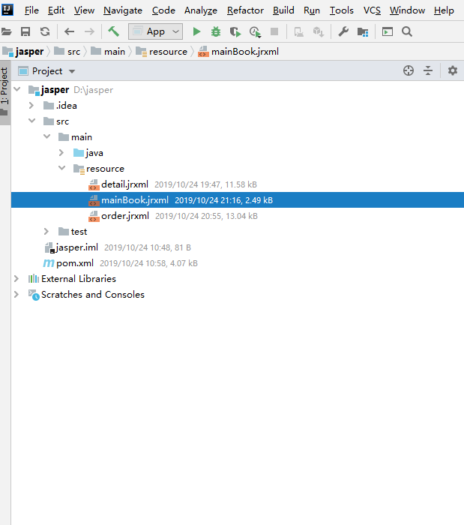

十三：分别新建两个jrxml对应数据源的DTO（如果项目中有可以使用的DTO，这一步可以略过，我这里是因为要写Demo，没有对应DTO，所以临时建了两个）。

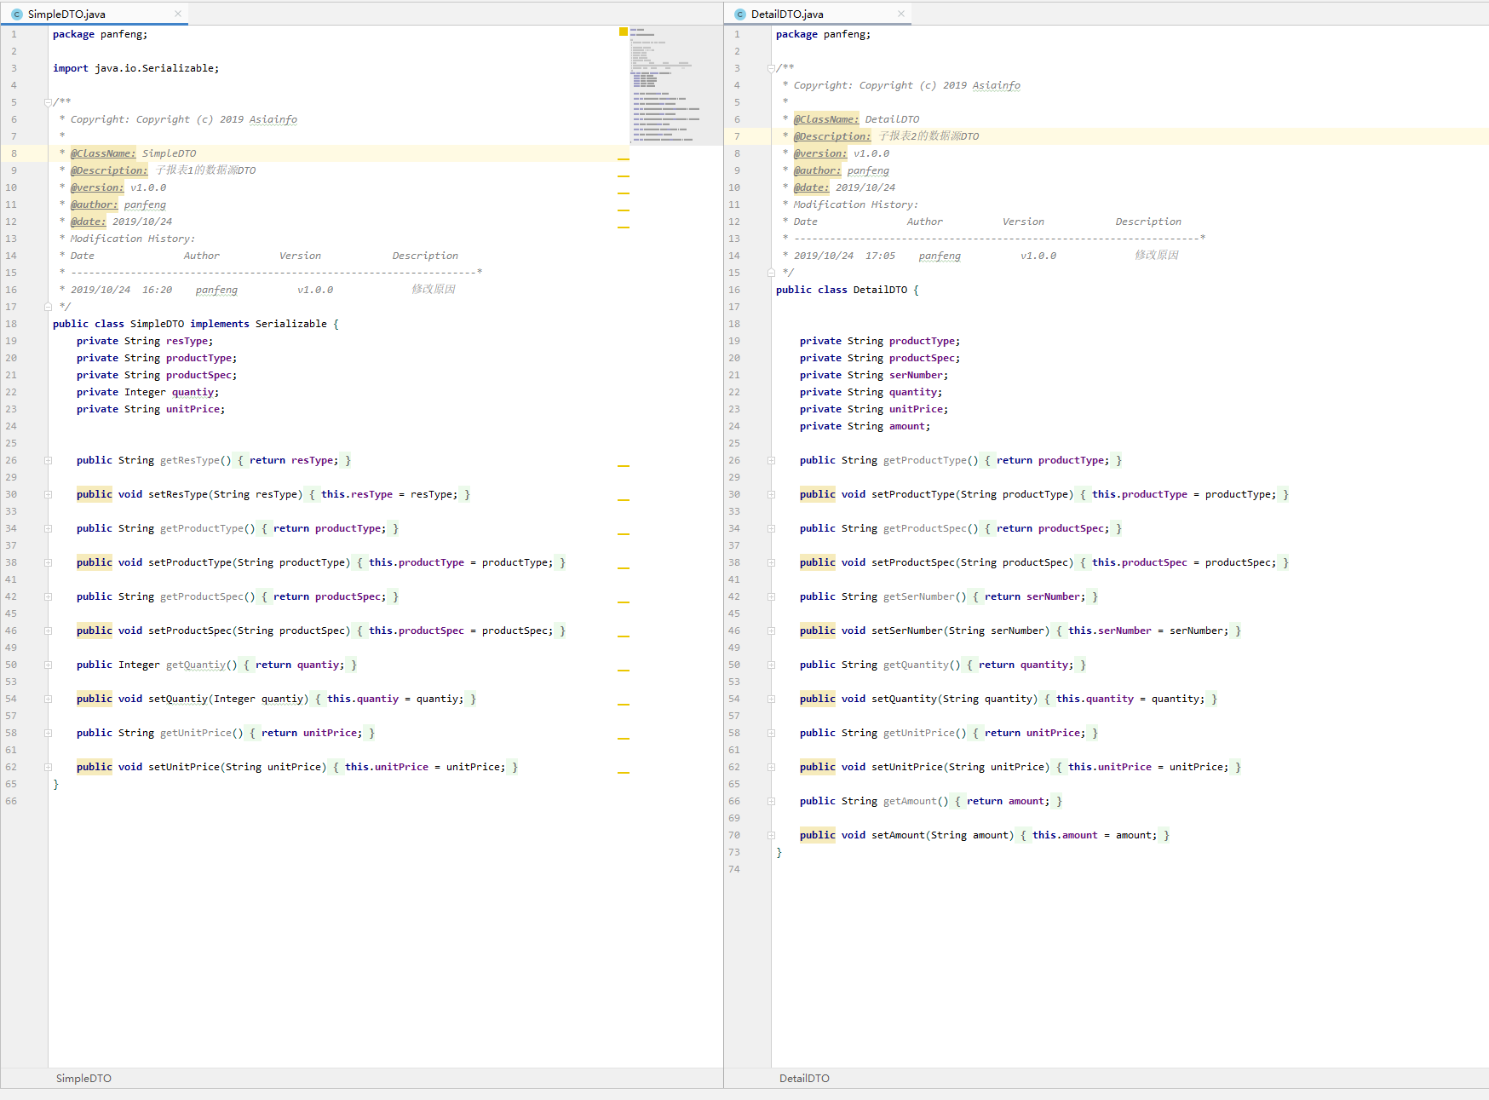

十四：编写Java代码

1．报表1的数据源和参数列表

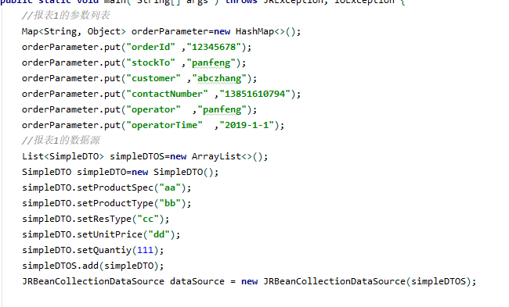

2、报表2的数据源和参数列表

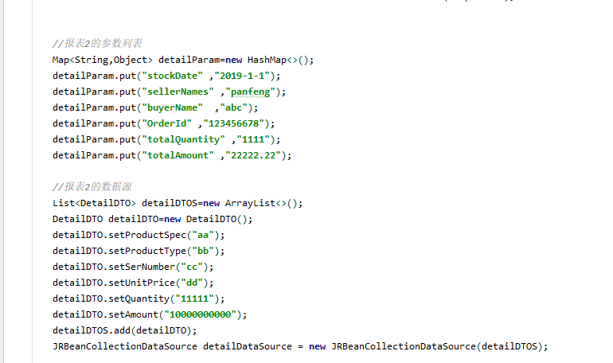

3、获取三个文件的流

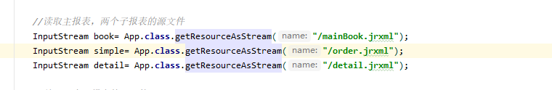

4、编译两个子报表的源文件

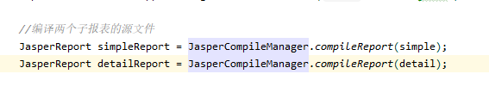

5、创建一个Map，作为主报表的参数列表

Map***<***String,Object***>*** bookParam=**new** HashMap***<>()***;

6、设置主报表的两个子报表

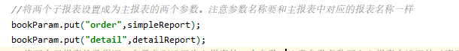

* 注：这里的两个参数的名称应该和主报表对应的子报表获取的参数名称一样，如下：

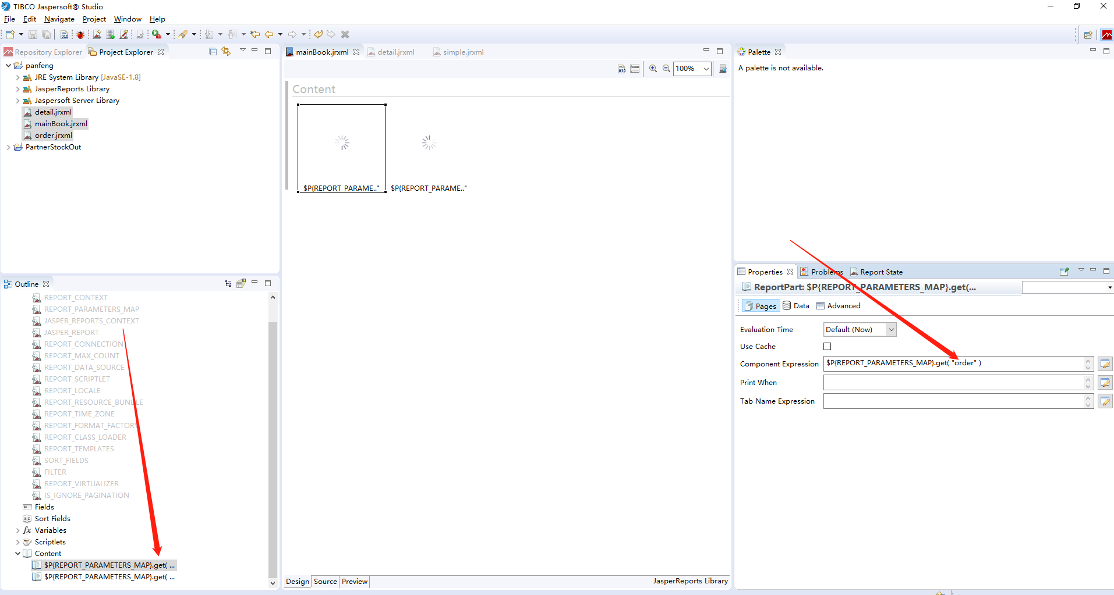

第二个同理。参数值为对应的编译出来的子报表。

7、设置两个字报表的数据源、参数列表。

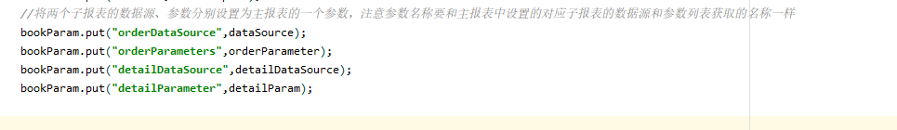

注：这里设置的数据源和参数列表的名称，应该和主报表中对应子报表的数据源和参数列表的获取Key一致，如下：

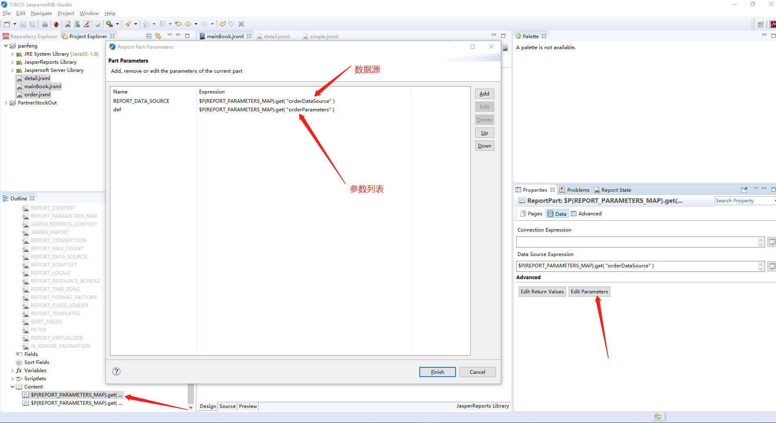

8、编译主报表并打印成PDF，传入主报表的参数：

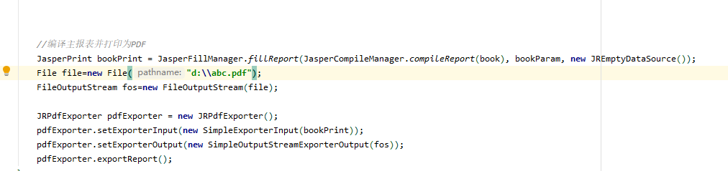

注：测试Demo我是用的文件输出流，并没有关流。在项目中使用，输出流应该用HTTP的响应输出流

完整代码如下（文本框显示不全，可以复制下来看）：

**package** panfeng;  
  
**import** net.sf.jasperreports.engine.*;  
**import** net.sf.jasperreports.engine.data.JRBeanCollectionDataSource;  
**import** net.sf.jasperreports.engine.export.JRPdfExporter;  
**import** net.sf.jasperreports.export.SimpleExporterInput;  
**import** net.sf.jasperreports.export.SimpleOutputStreamExporterOutput;  
  
**import** java.io.*;  
**import** java.util.ArrayList;  
**import** java.util.HashMap;  
**import** java.util.List;  
**import** java.util.Map;  
  
*/**  
 * Hello world!  
 *  
 */***public class** App   
***{* public static void** main***(*** String***[]*** args ***)* throws** JRException, IOException ***{*** *//报表1的参数列表* Map***<***String, Object***>*** orderParameter=**new** HashMap***<>()***;  
 orderParameter.put***(*"orderId"** ,**"12345678"*)***;  
 orderParameter.put***(*"stockTo"** ,**"panfeng"*)***;  
 orderParameter.put***(*"customer"** ,**"abczhang"*)***;  
 orderParameter.put***(*"contactNumber"** ,**"13851610794"*)***;  
 orderParameter.put***(*"operator"** ,**"panfeng"*)***;  
 orderParameter.put***(*"operatorTime"** ,**"2019-1-1"*)***;  
 *//报表1的数据源* List***<***SimpleDTO***>*** simpleDTOS=**new** ArrayList***<>()***;  
 SimpleDTO simpleDTO=**new** SimpleDTO***()***;  
 simpleDTO.setProductSpec***(*"aa"*)***;  
 simpleDTO.setProductType***(*"bb"*)***;  
 simpleDTO.setResType***(*"cc"*)***;  
 simpleDTO.setUnitPrice***(*"dd"*)***;  
 simpleDTO.setQuantiy***(***111***)***;  
 simpleDTOS.add***(***simpleDTO***)***;  
 JRBeanCollectionDataSource dataSource = **new** JRBeanCollectionDataSource***(***simpleDTOS***)***;  
  
  
 *//报表2的参数列表* Map***<***String,Object***>*** detailParam=**new** HashMap***<>()***;  
 detailParam.put***(*"stockDate"** ,**"2019-1-1"*)***;  
 detailParam.put***(*"sellerNames"** ,**"panfeng"*)***;  
 detailParam.put***(*"buyerName"** ,**"abc"*)***;  
 detailParam.put***(*"OrderId"** ,**"123456678"*)***;  
 detailParam.put***(*"totalQuantity"** ,**"1111"*)***;  
 detailParam.put***(*"totalAmount"** ,**"22222.22"*)***;  
  
 *//报表2的数据源* List***<***DetailDTO***>*** detailDTOS=**new** ArrayList***<>()***;  
 DetailDTO detailDTO=**new** DetailDTO***()***;  
 detailDTO.setProductSpec***(*"aa"*)***;  
 detailDTO.setProductType***(*"bb"*)***;  
 detailDTO.setSerNumber***(*"cc"*)***;  
 detailDTO.setUnitPrice***(*"dd"*)***;  
 detailDTO.setQuantity***(*"11111"*)***;  
 detailDTO.setAmount***(*"10000000000"*)***;  
 detailDTOS.add***(***detailDTO***)***;  
 JRBeanCollectionDataSource detailDataSource = **new** JRBeanCollectionDataSource***(***detailDTOS***)***;  
  
 *//读取主报表，两个子报表的源文件* InputStream book= App.**class**.getResourceAsStream***(*"/mainBook.jrxml"*)***;  
 InputStream simple= App.**class**.getResourceAsStream***(*"/order.jrxml"*)***;  
 InputStream detail= App.**class**.getResourceAsStream***(*"/detail.jrxml"*)***;  
  
 *//编译两个子报表的源文件* JasperReport simpleReport = JasperCompileManager.*compileReport****(***simple***)***;  
 JasperReport detailReport = JasperCompileManager.*compileReport****(***detail***)***;  
  
  
 *//设置主报表的参数* Map***<***String,Object***>*** bookParam=**new** HashMap***<>()***;  
 *//将两个子报表设置成为主报表的两个参数。注意参数名称要和主报表中对应的报表名称一样* bookParam.put***(*"order"**,simpleReport***)***;  
 bookParam.put***(*"detail"**,detailReport***)***;  
 *//将两个子报表的数据源、参数分别设置为主报表的一个参数，注意参数名称要和主报表中设置的对应子报表的数据源和参数列表获取的名称一样* bookParam.put***(*"orderDataSource"**,dataSource***)***;  
 bookParam.put***(*"orderParameters"**,orderParameter***)***;  
 bookParam.put***(*"detailDataSource"**,detailDataSource***)***;  
 bookParam.put***(*"detailParameter"**,detailParam***)***;  
  
  
  
 *//编译主报表并打印为PDF* JasperPrint bookPrint = JasperFillManager.*fillReport****(***JasperCompileManager.*compileReport****(***book***)***, bookParam, **new** JREmptyDataSource***())***;  
 File file=**new** File***(*"d:\\abc.pdf"*)***;  
 FileOutputStream fos=**new** FileOutputStream***(***file***)***;  
  
 JRPdfExporter pdfExporter = **new** JRPdfExporter***()***;  
 pdfExporter.setExporterInput***(*new** SimpleExporterInput***(***bookPrint***))***;  
 pdfExporter.setExporterOutput***(*new** SimpleOutputStreamExporterOutput***(***fos***))***;  
 pdfExporter.exportReport***()***;  
 ***}  
}***

十五，运行demo。生成PDF，生成的PDF如下：

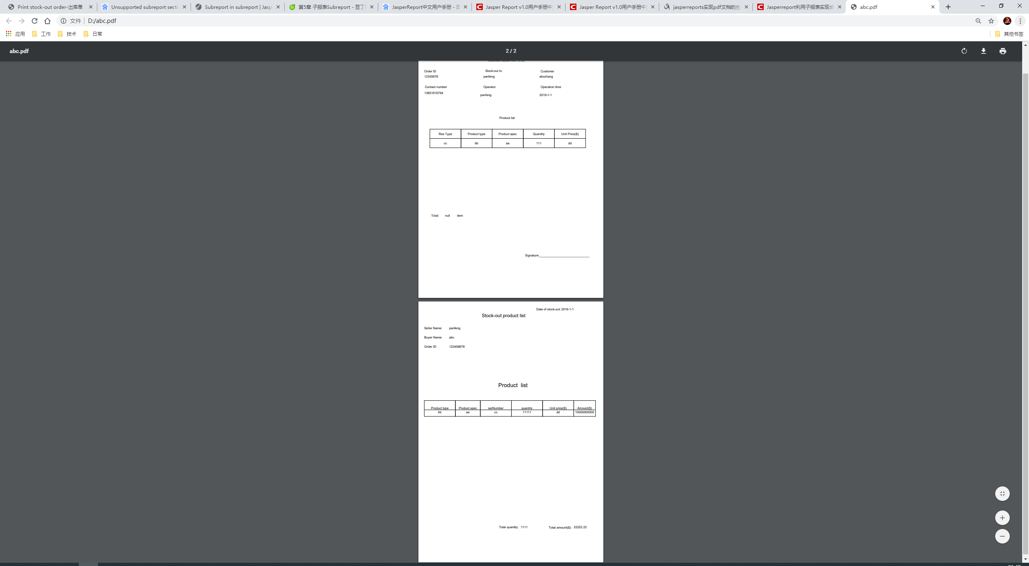

可以看到是两个报表合在一起的一个PDF！

工程在这里（可以直接拖到本地）：

