Lab 4 Final Report

# Team Members

Team member: Matthew Coffey

Team member: Finn McGlothlin

# Implementation Diagram

(Draw your design similar to the one shown below)

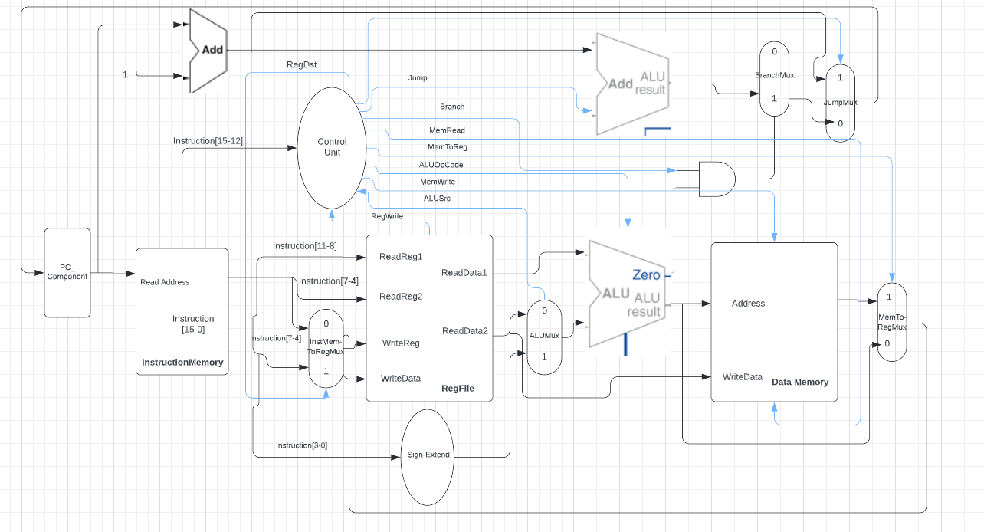

# Datapath

The image above documents the connections between the units and the shows the overview of the whole code. Our code starts at the PC component and updates that on the falling edge of the clock. That new program counter then goes to the instruction memory and gets the new instruction that needs to be ran. Then, the instruction gets split up into the register file, the sign-extender, and the control unit. The control unit sends the correct signals to all the components. The register file pulls the contents out of the registers and sends them to the ALU. The sign-extender extends the sign bit and sends that to the ALU and the branch adder. The ALU takes the inputs and computes the necessary results. The zero flag dictates whether or not the branch operation is taken. The output of the ALU either goes into the Data Memory or the memory to reg mux. Finally, the data gets sent back to the register file and the next program counter is sent to the PC component.

# ALU Control

As specified in the lab 4 design documents we were to design our ALU to compute at the very least 15 MIPS assembly instructions which were compiled and stored in our Instruction Memory component. As per our design document, we implemented 15 different ALU operations, all of which were one of the three Instructions formats: R-Type, I-Type, and J-Type.

**R-Type instructions:**

The add instruction was signified by the opcode “0000” and was computed by the ALU by adding the input signals ReadData1 and RegToALUMuxIn. The control signals associated with the add instruction were: RegDst = ‘1’, Jump = ‘0’, Branch = ‘0’, MemRead = ‘0’, MemToReg = ‘0’, MemWrite = ‘0’, ALUSrc = ‘0’, and RegWrite = ‘1’.

The next instruction our ALU supported was the sub operation. The subtract operation was signified by the opcode “0001” and was computed by the ALU by subtracting the input signals ReadData1 and RegToALUMuxIn. The control signals associated with the sub instruction were: RegDst = ‘1’, Jump = ‘0’, Branch = ‘0’, MemRead = ‘0’, MemToReg = ‘0’, MemWrite = ‘0’, ALUSrc = ‘0’, and RegWrite = ‘1’.

The next instruction our ALU supported was the bitwise or operation. The or operation was signified by the opcode “0010” and was computed by the ALU by using the built in VHDL or with both the input signals ReadData1 and RegToALUMuxIn. The control signals associated with the or instruction were: RegDst = ‘1’, Jump = ‘0’, Branch = ‘0’, MemRead = ‘0’, MemToReg = ‘0’, MemWrite = ‘0’, ALUSrc = ‘0’, and RegWrite = ‘1’.

The next instruction our ALU supported was the exclusive or operation(xor). The xor operation was signified by the opcode “0011” and was computed by the ALU by using the built in VHDL xor with both the input signals ReadData1 and RegToALUMuxIn. The control signals associated with the xor instruction were: RegDst = ‘1’, Jump = ‘0’, Branch = ‘0’, MemRead = ‘0’, MemToReg = ‘0’, MemWrite = ‘0’, ALUSrc = ‘0’, and RegWrite = ‘1’.

Of all the R-Type instructions listed above we ended up only using the or and xor operations as the adding and subtracting that was necessary for the sample program was done using constants.

**I-Type Instructions:**

The first I-Type instruction the ALU implemented was the multiply operation(mul). The mul operation was signified by the opcode “0100” and was computed by the ALU by using an addition operation inside a for loop. The operands used in the algorithm were ReadData1 from the register file and the sign extended constant RegToALUMuxIn received from the mux. The control signals associated with the mul instruction were: RegDst = ‘0’, Jump = ‘0’, Branch = ‘0’, MemRead = ‘0’, MemToReg = ‘0’, MemWrite = ‘0’, ALUSrc = ‘1’, and RegWrite = ‘1’.

The second I-Type instruction the ALU implemented was the divide operation(div). The div operation was signified by the opcode “0101” and was computed by the ALU by using the built in VHDL division operator. The operands used in the algorithm were ReadData1 from the register file and the sign extended constant RegToALUMuxIn received from the mux. The control signals associated with the mul instruction were: RegDst = ‘0’, Jump = ‘0’, Branch = ‘0’, MemRead = ‘0’, MemToReg = ‘0’, MemWrite = ‘0’, ALUSrc = ‘1’, and RegWrite = ‘1’.

The third I-Type instruction the ALU implemented was the add immediate operation(addi). The addi operation was signified by the opcode “0110” and was computed by the ALU by using the built in VHDL addition and concatenation operators. The operands used in the algorithm were ReadData1 from the register file and the sign extended constant RegToALUMuxIn received from the mux. The control signals associated with the addi instruction were: RegDst = ‘0’, Jump = ‘0’, Branch = ‘0’, MemRead = ‘0’, MemToReg = ‘0’, MemWrite = ‘0’, ALUSrc = ‘1’, and RegWrite = ‘1’.

The fourth I-Type instruction the ALU implemented was the subtract immediate operation(subi). The subi operation was signified by the opcode “0111” and was computed by the ALU by using the built in VHDL subtraction operator. The operands used in the algorithm were ReadData1 from the register file and the sign extended constant RegToALUMuxIn received from the mux. The control signals associated with the subi instruction were: RegDst = ‘0’, Jump = ‘0’, Branch = ‘0’, MemRead = ‘0’, MemToReg = ‘0’, MemWrite = ‘0’, ALUSrc = ‘1’, and RegWrite = ‘1’.

These four instructions were all used inside our implementation of the sample program. In implementing these operations, we were limited by the number of bits we could use for our constant operand inputs meaning we would need some other way to perform 16-bit constant operations. In order to accomplish this we split the addi instructions up and combined them with Shift logical left operation(sll) which in the end made 16-bit arithmetic possible.

The next I-Type instruction we implemented was the load word instruction (lw).The lw instruction is signified by the opcode “1000” and utitlizes a VHDL add operation inside of the ALU to add the sign-extended offset value with the Rt value. The resulting value is then passed to the Data Memory via the ALUResult signal which finds the data associated with that place in memory and passes that value to the DataMemToRegMux. The memory is then written back to the specified destination register inside of the Register file. The control signal associated with the lw instruction are as follows: RegDst = ‘0’, Jump = ‘0’, Branch = ‘0’, MemRead = ‘1’, MemToReg = ‘1’, MemWrite = ‘0’, ALUSrc = ‘1’, and RegWrite = ‘1’.

The next I-Type instruction we decided to implement was the store word instruction (sw). The sw instruction is represented by the opcode “1001” and utilizes a VHDL add operation inside of the ALU to add the sign-extended offset value with the Rt value. The resulting value is then passed to the Data Memory via the ALUResult signal and is used to in order to specify where the Rs register data value should be written to inside of the Data Memory. The control signals associated with the sw instruction are as follows: RegDst = ‘X’, Jump = ‘0’, Branch = ‘0’, MemRead = ‘0’, MemToReg = ‘X’, MemWrite = ‘1’, ALUSrc = ‘1’, and RegWrite = ‘0’.

The next three I-Type instructions that were implemented were all variations of Branch instructions. The first Branch instruction is the branch on equal (Beq) and represented by the opcode “1010”. The second Branch instruction is the branch on less than represented by the opcode “1011”. The last branch instruction we implemented is the branch on greater than which is represented by the opcode “1100. For all of these instructions we first subtract the Rs value by the rt value and output the result of the subtraction to the ALUResultOut signal. If the instruction is Beq we then test if the resulting subtraction value is equal to zero and if so, we set the zero-output signal to ‘1’. If the instruction is Blt we test if the Rs value is less than the Rt value and if so, we use the same zero-output signal and set it to ‘1’. If the instruction is Bgt we test if the Rs value is greater than the Rt value and if so, we use the same zero-output signal and set it to ‘1’. The outputs of these ALU operations are then used later in conjunction with the control unit signals, an and operation, a BranchMux component, and a JumpMux component to determine whether we will branch to a different point in our Instruction Memory. The control signals associated with the each of the branch instructions are as follows: RegDst = ‘X’, Jump = ‘0’, Branch = ‘1’, MemRead = ‘0’, MemToReg = ‘X’, MemWrite = ‘0’, ALUSrc = ‘0’, and RegWrite = ‘0’.

The final I-Type instruction that we implemented in our ALU is the shift left logical(sll) instruction. The sll instruction is represented by the opcode “1110” and utilized the VHDL sll operator to shift by a given constant value. The control signals associated with the sll instruction were as follows: RegDst = ‘0’, Jump = ‘0’, Branch = ‘0’, MemRead = ‘0’, MemToReg = ‘0’, MemWrite = ‘0’, ALUSrc = ‘1’, and RegWrite = ‘1’.

**J-Type instructions:**

The final two instructions that we implemented in our ALU were the J-Type instructions jump(j) and jump return (jr). The jump instruction was represented by the ALU by the opcode “1101” and the jump return instruction was represented by the instruction “1111”. These instructions utilize other components outside of the ALU such as the BranchJumpAdder and multiple other muxes to compute the next PC value which will specify the instruction that we are jumping to. Inside the ALU we will still set the ALUResultsignal to be all zeros. The control signal values associated for both the jump and jump return operation are as follows: RegDst = ‘X’, Jump = ‘1’, Branch = ‘0’, MemRead = ‘X’, MemToReg = ‘X’, MemWrite = ‘0’, ALUSrc = ‘X’, and RegWrite = ‘0’.

# Control Unit

The control unit component we created in our 16-bit RISC processor design takes a 4-bit input from the InstructionMemory component. These bits represent the instructions Op code and are the 15-12 bits (MSB). Considering that our design only needed these 4-bits to represent all 15 instructions we chose to implement in our ALU we did not need a separate ALU control unit. The outputs of the control unit are the following signals: RegDst, Jump, Branch, MemRead, MemToReg, ALUOpcode, MemWrite, ALUSrc, and RegWrite.

The control unit implements a case statement as logic that determines the instruction is to be run. Based on the given instruction, the control unit output signals were set to values that would then help the processor know how to perform the specified instruction at various points inside the Datapath.

The first control signal used inside of the Datapath is the RegDst signal. This was used as an input into the InstMemToRegMux to specify what type of instruction i.e., R-Type, I-Type, and J-Type. If the instruction were to be a R-Type we would set the RegDst signal to be ‘1’ and if it was I-Type or J-type, then RegDst was set to ‘0’.

The next control signal used in the control unit was the RegWrite signal. The RegWrite signal was used to tell the register file component whether or not it should be writing a Data Memory value into a Register. The RegWrite signal was set to ‘1’ when the register file was needed to write a value received from the Data Memory to a register and was set to ‘0’ if it did not.

The next output signal the control unit implemented was the ALUSrc signal. This signal was used as an input to the ALUMux to determine whether the ALU should be using the value received from the sign-extension component or the ReadData2 signal coming from the Register file. If the instruction was I-type or J-type the ALUSrc value would be ‘1’ and if it was R-Type the value would be ‘0’.

The next output signal the control unit implemented was the MemWrite signal. The MemWrite signal is used as an input to the Data Memory component and determines when the Data Memory should be writing(storing) a value into the data memory. This control signal is explicitly used for the store word (sw) operation and is ‘1’ when we are writing a value into the Data Memory, and ‘0’ when we do not need to write to the Data Memory.

The next output control signal is the ALUOpCode. In our instruction design we decided to eliminate the bits that are normally reserved for the function and instead decoded all the possible instruction using just the 4 most significant bits of the instructions. In doing this, we eliminated the need for the ALU control unit and instead passed the ALUOpcode signal directly to the ALU.

The next output signal we implemented was the MemToReg signal. This signal was used as an input into the DataMemToReg mux in order to specify if the Data Memory should be writing values into the register file. For example if a add instruction was specified we would need to write the result of the ALU operation to the destination register in the Register file. When it is necessary to write values back to a register the control signal is set to ‘1’ and is set to ‘0’ when unnecessary.

The next output signal from the control unit is the MemRead signal. This signal was set as an input to the Data Memory and was for the lw instruction. The signal is set to ‘1’ when a value needs to be read from the data memory and is set to ‘0’ when there is no value needed.

The next output signal is the Branch signal. The Branch signal was used alongside the zero signal coming from the ALU for the three I-Type branch instructions in order to determine when a branch to a different place in the Instruction Memory should occur. When a branch instruction is decoded the value is set to ‘1’ and is set to ‘0’ otherwise. The last output control signal we implemented in the control unit was the jump signal. The jump signal is set to ‘1’ whenever a J-Type instruction is decoded signifying that we need to jump to a different PC value. It is set to ‘0’ when the instruction type is not J-Type. Below are the control signal’s setups for each of our 16 possible instructions.

|  |  |  |  |  |  |  |  |  |  |
| --- | --- | --- | --- | --- | --- | --- | --- | --- | --- |
| inst | RegDst | Jump | Branch | MemRead | MemToReg | MemWrite | ALUSrc | RegWrite | ALUctrOpCode |
| add | 1 | 0 | 0 | 0 | 0 | 0 | 0 | 1 | 0000 |
| sub | 1 | 0 | 0 | 0 | 0 | 0 | 0 | 1 | 0001 |
| or | 1 | 0 | 0 | 0 | 0 | 0 | 0 | 1 | 0010 |
| xor | 1 | 0 | 0 | 0 | 0 | 0 | 0 | 1 | 0011 |
| mul | 0 | 0 | 0 | 0 | 0 | 0 | 1 | 1 | 0100 |
| div | 0 | 0 | 0 | 0 | 0 | 0 | 1 | 1 | 0101 |
| addi | 0 | 0 | 0 | 0 | 0 | 0 | 1 | 1 | 0110 |
| subi | 0 | 0 | 0 | 0 | 0 | 0 | 1 | 1 | 0111 |
| lw | 0 | 0 | 0 | 1 | 1 | 0 | 1 | 1 | 1000 |
| sw | X | 0 | 0 | 0 | X | 1 | 1 | 0 | 1001 |
| beq | X | 0 | 1 | 0 | X | 0 | 0 | 0 | 1010 |
| blt | X | 0 | 1 | 0 | X | 0 | 0 | 0 | 1011 |
| bgt | X | 0 | 1 | 0 | X | 0 | 0 | 0 | 1100 |
| sll | 0 | 0 | 0 | 0 | 0 | 0 | 1 | 1 | 1110 |
| j | X | 1 | 0 | X | X | 0 | X | 0 | 1101 |
| jr | X | 1 | 0 | X | X | 0 | X | 0 | 1111 |

# Simulation Results Memory and Register File at clock cycle 0

## Memory and register file contents at clock cycle 0

|  |  |  |
| --- | --- | --- |
| Address 0x… | Hex Value | Binary Value 0b… |
| 0 | x"0101" | 100000001 |
| 1 | x"0101" | 100000001 |
| 2 | x"0110" | 100010000 |
| 3 | x"0011" | 10001 |
| 4 | x"00F0" | 11110000 |
| 5 | x"00FF" | 11111111 |
| 6 | x"0005" | 101 |
| 7 | x"0006" | 110 |
| 8 | x"0007" | 111 |
| 9 | x"0008" | 1000 |
| a | x"0009" | 1001 |
| b | x"000A" | 1010 |
| c | x"000B" | 1011 |
| d | x"000C" | 1100 |
| e | x"000D" | 1101 |
| f | x"000E" | 1110 |
| 10 | x"0101" | 100000001 |
| 11 | x"0101" | 100000001 |
| 12 | x"0110" | 100010000 |
| 13 | x"00F0" | 11110000 |
| 14 | x"0011" | 10001 |
| 15 | x"0000" | 10110 |
| 16 | x"00F0" | 11110000 |
| 17 | x"0016" | 10110 |
| 18 | x"0000" | 0 |
| 19 | x"0018" | 11010 |
| 1a | x"0019" | 11011 |
| 1b | x"001A" | 11100 |
| 1c | x"001B" | 11101 |
| 1d | x"001C" | 11110 |
| 1e | x"001D" | 11111 |
| 1f | x"001E" | 100000 |
| 20 | x"001F" | 100001 |
| 21 | x"0020" | 100010 |
| 22 | x"0021" | 100011 |
| 23 | x"0022" | 100100 |
| 24 | x"0023" | 100101 |
| 25 | x"0024" | 100110 |
| 26 | x"0025" | 100111 |
| 27 | x"0026" | 101000 |
| 28 | x"0027" | 101001 |
| 29 | x"0028" | 101010 |
| 2a | x"0029" | 101011 |
| 2b | x"002A" | 101100 |
| 2c | x"002B" | 101101 |
| 2d | x"002C" | 101110 |
| 2e | x"002D" | 101111 |
| 2f | x"002E" | 110000 |
| 30 | x"002F" | 110001 |
| 31 | x"0030" | 110010 |
| 32 | x"0031" | 110011 |
| 33 | x"0032" | 110100 |
| 34 | x"0033" | 110101 |
| 35 | x"0034" | 110110 |
| 36 | x"0035" | 110111 |
| 37 | x"0036" | 111000 |
| 38 | x"0037" | 111001 |
| 39 | x"0038" | 111010 |
| 3a | x"0039" | 111011 |
| 3b | x"003A" | 111100 |
| 3c | x"003B" | 111101 |
| 3d | x"003C" | 111110 |
| 3e | x"003D" | 111111 |
| 3f | x"003E" | 1000000 |
| 40 | x"003F" | 1000001 |
| 41 | x"0040" | 1000010 |
| 42 | x"0041" | 1000011 |
| 43 | x"0042" | 1000100 |
| 44 | x"0043" | 1000101 |
| 45 | x"0044" | 1000110 |
| 46 | x"0045" | 1000111 |
| 47 | x"0046" | 1001000 |
| 48 | x"0047" | 1001001 |
| 49 | x"0048" | 1001010 |
| 4a | x"0049" | 1001011 |
| 4b | x"004A" | 1001100 |
| 4c | x"004B" | 1001101 |
| 4d | x"004C" | 1001110 |
| 4e | x"004D" | 1001111 |
| 4f | x"004E" | 1010000 |
| 50 | x"004F" | 1010001 |
| 51 | x"0050" | 1010010 |
| 52 | x"0051" | 1010011 |
| 53 | x"0052" | 1010100 |
| 54 | x"0053" | 1010101 |
| 55 | x"0054" | 1010110 |
| 56 | x"0055" | 1010111 |
| 57 | x"0056" | 1011000 |
| 58 | x"0057" | 1011001 |
| 59 | x"0058" | 1011010 |
| 5a | x"0059" | 1011011 |
| 5b | x"005A" | 1011100 |
| 5c | x"005B" | 1011101 |
| 5d | x"005C" | 1011110 |
| 5e | x"005D" | 1011111 |
| 5f | x"005E" | 1100000 |
| 60 | x"005F" | 1100001 |
| 61 | x"0060" | 1100010 |
| 62 | x"0061" | 1100011 |
| 63 | x"0062" | 1100100 |
| 64 | x"0063" | 1100101 |
| 65 | x"0064" | 1100110 |
| 66 | x"0065" | 1100111 |
| 67 | x"0066" | 1101000 |
| 68 | x"0067" | 1101001 |
| 69 | x"0068" | 1101010 |
| 6a | x"0069" | 1101011 |
| 6b | x"006A" | 1101100 |
| 6c | x"006B" | 1101101 |
| 6d | x"006C" | 1101110 |
| 6e | x"006D" | 1101111 |
| 6f | x"006E" | 1110000 |
| 70 | x"006F" | 1110001 |
| 71 | x"0070" | 1110010 |
| 72 | x"0071" | 1110011 |
| 73 | x"0072" | 1110100 |
| 74 | x"0073" | 1110101 |
| 75 | x"0074" | 1110110 |
| 76 | x"0075" | 1110111 |
| 77 | x"0076" | 1111000 |
| 78 | x"0077" | 1111001 |
| 79 | x"0078" | 1111010 |
| 7a | x"0079" | 1111011 |
| 7b | x"007A" | 1111100 |
| 7c | x"007B" | 1111101 |
| 7d | x"007C" | 1111110 |
| 7e | x"007D" | 1111111 |
| 7f | x"007E" | 10000000 |
| 80 | x"007F" | 10000001 |
| 81 | x"0080" | 10000010 |
| 82 | x"0081" | 10000011 |
| 83 | x"0082" | 10000100 |
| 84 | x"0083" | 10000101 |
| 85 | x"0084" | 10000110 |
| 86 | x"0085" | 10000111 |
| 87 | x"0086" | 10001000 |
| 88 | x"0087" | 10001001 |
| 89 | x"0088" | 10001010 |
| 8a | x"0089" | 10001011 |
| 8b | x"008A" | 10001100 |
| 8c | x"008B" | 10001101 |
| 8d | x"008C" | 10001110 |
| 8e | x"008D" | 10001111 |
| 8f | x"008E" | 10010000 |
| 90 | x"008F" | 10010001 |
| 91 | x"0090" | 10010010 |
| 92 | x"0091" | 10010011 |
| 93 | x"0092" | 10010100 |
| 94 | x"0093" | 10010101 |
| 95 | x"0094" | 10010110 |
| 96 | x"0095" | 10010111 |
| 97 | x"0096" | 10011000 |
| 98 | x"0097" | 10011001 |
| 99 | x"0098" | 10011010 |
| 9a | x"0099" | 10011011 |
| 9b | x"009A" | 10011100 |
| 9c | x"009B" | 10011101 |
| 9d | x"009C" | 10011110 |
| 9e | x"009D" | 10011111 |
| 9f | x"009E" | 10100000 |
| a0 | x"009F" | 10100001 |
| a1 | x"00a0" | 10100010 |
| a2 | x"00a1" | 10100011 |
| a3 | x"00a2" | 10100100 |
| a4 | x"00a3" | 10100101 |
| a5 | x"00a4" | 10100110 |
| a6 | x"00a5" | 10100111 |
| a7 | x"00a6" | 10101000 |
| a8 | x"00a7" | 10101001 |
| a9 | x"00a8" | 10101010 |
| aa | x"00a9" | 10101011 |
| ab | x"00aa" | 10101100 |
| ac | x"00ab" | 10101101 |
| ad | x"00ac" | 10101110 |
| ae | x"00ad" | 10101111 |
| af | x"00ae" | 10110000 |
| b0 | x"00af" | 10110001 |
| b1 | x"00b0" | 10110010 |
| b2 | x"00b1" | 10110011 |
| b3 | x"00b2" | 10110100 |
| b4 | x"00b3" | 10110101 |
| b5 | x"00b4" | 10110110 |
| b6 | x"00b5" | 10110111 |
| b7 | x"00b6" | 10111000 |
| b8 | x"00b7" | 10111001 |
| b9 | x"00b8" | 10111010 |
| ba | x"00b9" | 10111011 |
| bb | x"00ba" | 10111100 |
| bc | x"00bb" | 10111101 |
| bd | x"00bc" | 10111110 |
| be | x"00bd" | 10111111 |
| bf | x"00be" | 11000000 |
| c0 | x"00bf" | 11000001 |
| c1 | x"00c0" | 11000010 |
| c2 | x"00c1" | 11000011 |
| c3 | x"00c2" | 11000100 |
| c4 | x"00c3" | 11000101 |
| c5 | x"00c4" | 11000110 |
| c6 | x"00c5" | 11000111 |
| c7 | x"00c6" | 11001000 |
| c8 | x"00c7" | 11001001 |
| c9 | x"00c8" | 11001010 |
| ca | x"00c9" | 11001011 |
| cb | x"00ca" | 11001100 |
| cc | x"00cb" | 11001101 |
| cd | x"00cc" | 11001110 |
| ce | x"00cd" | 11001111 |
| cf | x"00ce" | 11010000 |
| d0 | x"00cf" | 11010001 |
| d1 | x"00d0" | 11010010 |
| d2 | x"00d1" | 11010011 |
| d3 | x"00d2" | 11010100 |
| d4 | x"00d3" | 11010101 |
| d5 | x"00d4" | 11010110 |
| d6 | x"00d5" | 11010111 |
| d7 | x"00d6" | 11011000 |
| d8 | x"00d7" | 11011001 |
| d9 | x"00d8" | 11011010 |
| da | x"00d9" | 11011011 |
| db | x"00da" | 11011100 |
| dc | x"00db" | 11011101 |
| dd | x"00dc" | 11011110 |
| de | x"00dd" | 11011111 |
| df | x"00de" | 11100000 |
| e0 | x"00df" | 11100001 |
| e1 | x"00e0" | 11100010 |
| e2 | x"00e1" | 11100011 |
| e3 | x"00e2" | 11100100 |
| e4 | x"00e3" | 11100101 |
| e5 | x"00e4" | 11100110 |
| e6 | x"00e5" | 11100111 |
| e7 | x"00e6" | 11101000 |
| e8 | x"00e7" | 11101001 |
| e9 | x"00e8" | 11101010 |
| ea | x"00e9" | 11101011 |
| eb | x"00ea" | 11101100 |
| ec | x"00eb" | 11101101 |
| ed | x"00ec" | 11101110 |
| ee | x"00ed" | 11101111 |
| ef | x"00ee" | 11110000 |
| f0 | x"00ef" | 11110001 |
| f1 | x"00f0" | 11110010 |
| f2 | x"00f1" | 11110011 |
| f3 | x"00f2" | 11110100 |
| f4 | x"00f3" | 11110101 |
| f5 | x"00f4" | 11110110 |
| f6 | x"00f5" | 11110111 |
| f7 | x"00f6" | 11111000 |
| f8 | x"00f7" | 11111001 |
| f9 | x"00f8" | 11111010 |
| fa | x"00f9" | 11111011 |
| fb | x"00fa" | 11111100 |
| fc | x"00fb" | 11111101 |
| fd | x"00fc" | 11111110 |
| fe | x"00fd" | 11111111 |
| ff | x"00fe" | 100000000 |

Register file (data):

|  |  |  |
| --- | --- | --- |
| Address 0x… | Hex Value | Binary Value 0b… |
| 0 | x"0000" | 0 |
| 1 | x"0040" | 1000000 |
| 2 | x"1010" | 1000000010000 |
| 3 | x"000F" | 1111 |
| 4 | x"00F0" | 11110000 |
| 5 | x"0010" | 10000 |
| 6 | x"0005" | 101 |
| 7 | x"0000" | 0 |
| 8 | x"0000" | 0 |
| 9 | x"0000" | 0 |
| a | x"0000" | 0 |
| b | x"0000" | 0 |
| c | x"0000" | 0 |
| d | x"0000" | 0 |
| e | x"0000" | 0 |
| f | x"0000" | 0 |

## Memory and register file contents for each loop:

You need to print out the data (not instructions) in your memory and register file after each loop. L, M, N should be the clock cycle numbers after each loop (e.g., L = 55 cycles after the first loop, N = 110 cycles after the second loop, etc). Your program should count the number of clock cycles after executing instructions.

After the first loop, clock cycle: 27 (end of 27)

Memory (data + instruction):

|  |  |  |  |
| --- | --- | --- | --- |
| Address 0x… | | Hex Value | Binary Value 0b… |
| 0 | | x"0101" | 100000001 |
| 1 | | x"0101" | 100000001 |
| 2 | | x"0110" | 100010000 |
| 3 | | x"0011" | 10001 |
| 4 | | x"00F0" | 11110000 |
| 5 | | x"00FF" | 11111111 |
| 6 | | x"0005" | 101 |
| 7 | | x"0006" | 110 |
| 8 | | x"0007" | 111 |
| 9 | | x"0008" | 1000 |
| a | | x"0009" | 1001 |
| b | | x"000A" | 1010 |
| c | | x"000B" | 1011 |
| d | | x"000C" | 1100 |
| e | x"000D" | | 1101 |
| f | x"000E" | | 1110 |
| 10 | x"FF00" | | 1111111100000000 |
| 11 | x"0101" | | 100000001 |
| 12 | x"0110" | | 100010000 |
| 13 | x"00F0" | | 11110000 |
| 14 | x"0011" | | 10001 |
| 15 | x"0000" | | 10110 |
| 16 | x"00F0" | | 11110000 |
| 17 | x"0016" | | 10110 |
| 18 | x"0000" | | 0 |
| 19 | x"0018" | | 11010 |
| 1a | x"0019" | | 11011 |
| 1b | x"001A" | | 11100 |
| 1c | x"001B" | | 11101 |
| 1d | x"001C" | | 11110 |
| 1e | x"001D" | | 11111 |
| 1f | x"001E" | | 100000 |
| 20 | x"001F" | | 100001 |
| 21 | x"0020" | | 100010 |
| 22 | x"0021" | | 100011 |
| 23 | x"0022" | | 100100 |
| 24 | x"0023" | | 100101 |
| 25 | x"0024" | | 100110 |
| 26 | x"0025" | | 100111 |
| 27 | x"0026" | | 101000 |
| 28 | x"0027" | | 101001 |
| 29 | x"0028" | | 101010 |
| 2a | x"0029" | | 101011 |
| 2b | x"002A" | | 101100 |
| 2c | x"002B" | | 101101 |
| 2d | x"002C" | | 101110 |
| 2e | x"002D" | | 101111 |
| 2f | x"002E" | | 110000 |
| 30 | x"002F" | | 110001 |
| 31 | x"0030" | | 110010 |
| 32 | x"0031" | | 110011 |
| 33 | x"0032" | | 110100 |
| 34 | x"0033" | | 110101 |
| 35 | x"0034" | | 110110 |
| 36 | x"0035" | | 110111 |
| 37 | x"0036" | | 111000 |
| 38 | x"0037" | | 111001 |
| 39 | x"0038" | | 111010 |
| 3a | x"0039" | | 111011 |
| 3b | x"003A" | | 111100 |
| 3c | x"003B" | | 111101 |
| 3d | x"003C" | | 111110 |
| 3e | x"003D" | | 111111 |
| 3f | x"003E" | | 1000000 |
| 40 | x"003F" | | 1000001 |
| 41 | x"0040" | | 1000010 |
| 42 | x"0041" | | 1000011 |
| 43 | x"0042" | | 1000100 |
| 44 | x"0043" | | 1000101 |
| 45 | x"0044" | | 1000110 |
| 46 | x"0045" | | 1000111 |
| 47 | x"0046" | | 1001000 |
| 48 | x"0047" | | 1001001 |
| 49 | x"0048" | | 1001010 |
| 4a | x"0049" | | 1001011 |
| 4b | x"004A" | | 1001100 |
| 4c | x"004B" | | 1001101 |
| 4d | x"004C" | | 1001110 |
| 4e | x"004D" | | 1001111 |
| 4f | x"004E" | | 1010000 |
| 50 | x"004F" | | 1010001 |
| 51 | x"0050" | | 1010010 |
| 52 | x"0051" | | 1010011 |
| 53 | x"0052" | | 1010100 |
| 54 | x"0053" | | 1010101 |
| 55 | x"0054" | | 1010110 |
| 56 | x"0055" | | 1010111 |
| 57 | x"0056" | | 1011000 |
| 58 | x"0057" | | 1011001 |
| 59 | x"0058" | | 1011010 |
| 5a | x"0059" | | 1011011 |
| 5b | x"005A" | | 1011100 |
| 5c | x"005B" | | 1011101 |
| 5d | x"005C" | | 1011110 |
| 5e | x"005D" | | 1011111 |
| 5f | x"005E" | | 1100000 |
| 60 | x"005F" | | 1100001 |
| 61 | x"0060" | | 1100010 |
| 62 | x"0061" | | 1100011 |
| 63 | x"0062" | | 1100100 |
| 64 | x"0063" | | 1100101 |
| 65 | x"0064" | | 1100110 |
| 66 | x"0065" | | 1100111 |
| 67 | x"0066" | | 1101000 |
| 68 | x"0067" | | 1101001 |
| 69 | x"0068" | | 1101010 |
| 6a | x"0069" | | 1101011 |
| 6b | x"006A" | | 1101100 |
| 6c | x"006B" | | 1101101 |
| 6d | x"006C" | | 1101110 |
| 6e | x"006D" | | 1101111 |
| 6f | x"006E" | | 1110000 |
| 70 | x"006F" | | 1110001 |
| 71 | x"0070" | | 1110010 |
| 72 | x"0071" | | 1110011 |
| 73 | x"0072" | | 1110100 |
| 74 | x"0073" | | 1110101 |
| 75 | x"0074" | | 1110110 |
| 76 | x"0075" | | 1110111 |
| 77 | x"0076" | | 1111000 |
| 78 | x"0077" | | 1111001 |
| 79 | x"0078" | | 1111010 |
| 7a | x"0079" | | 1111011 |
| 7b | x"007A" | | 1111100 |
| 7c | x"007B" | | 1111101 |
| 7d | x"007C" | | 1111110 |
| 7e | x"007D" | | 1111111 |
| 7f | x"007E" | | 10000000 |
| 80 | x"007F" | | 10000001 |
| 81 | x"0080" | | 10000010 |
| 82 | x"0081" | | 10000011 |
| 83 | x"0082" | | 10000100 |
| 84 | x"0083" | | 10000101 |
| 85 | x"0084" | | 10000110 |
| 86 | x"0085" | | 10000111 |
| 87 | x"0086" | | 10001000 |
| 88 | x"0087" | | 10001001 |
| 89 | x"0088" | | 10001010 |
| 8a | x"0089" | | 10001011 |
| 8b | x"008A" | | 10001100 |
| 8c | x"008B" | | 10001101 |
| 8d | x"008C" | | 10001110 |
| 8e | x"008D" | | 10001111 |
| 8f | x"008E" | | 10010000 |
| 90 | x"008F" | | 10010001 |
| 91 | x"0090" | | 10010010 |
| 92 | x"0091" | | 10010011 |
| 93 | x"0092" | | 10010100 |
| 94 | x"0093" | | 10010101 |
| 95 | x"0094" | | 10010110 |
| 96 | x"0095" | | 10010111 |
| 97 | x"0096" | | 10011000 |
| 98 | x"0097" | | 10011001 |
| 99 | x"0098" | | 10011010 |
| 9a | x"0099" | | 10011011 |
| 9b | x"009A" | | 10011100 |
| 9c | x"009B" | | 10011101 |
| 9d | x"009C" | | 10011110 |
| 9e | x"009D" | | 10011111 |
| 9f | x"009E" | | 10100000 |
| a0 | x"009F" | | 10100001 |
| a1 | x"00a0" | | 10100010 |
| a2 | x"00a1" | | 10100011 |
| a3 | x"00a2" | | 10100100 |
| a4 | x"00a3" | | 10100101 |
| a5 | x"00a4" | | 10100110 |
| a6 | x"00a5" | | 10100111 |
| a7 | x"00a6" | | 10101000 |
| a8 | x"00a7" | | 10101001 |
| a9 | x"00a8" | | 10101010 |
| aa | x"00a9" | | 10101011 |
| ab | x"00aa" | | 10101100 |
| ac | x"00ab" | | 10101101 |
| ad | x"00ac" | | 10101110 |
| ae | x"00ad" | | 10101111 |
| af | x"00ae" | | 10110000 |
| b0 | x"00af" | | 10110001 |
| b1 | x"00b0" | | 10110010 |
| b2 | x"00b1" | | 10110011 |
| b3 | x"00b2" | | 10110100 |
| b4 | x"00b3" | | 10110101 |
| b5 | x"00b4" | | 10110110 |
| b6 | x"00b5" | | 10110111 |
| b7 | x"00b6" | | 10111000 |
| b8 | x"00b7" | | 10111001 |
| b9 | x"00b8" | | 10111010 |
| ba | x"00b9" | | 10111011 |
| bb | x"00ba" | | 10111100 |
| bc | x"00bb" | | 10111101 |
| bd | x"00bc" | | 10111110 |
| be | x"00bd" | | 10111111 |
| bf | x"00be" | | 11000000 |
| c0 | x"00bf" | | 11000001 |
| c1 | x"00c0" | | 11000010 |
| c2 | x"00c1" | | 11000011 |
| c3 | x"00c2" | | 11000100 |
| c4 | x"00c3" | | 11000101 |
| c5 | x"00c4" | | 11000110 |
| c6 | x"00c5" | | 11000111 |
| c7 | x"00c6" | | 11001000 |
| c8 | x"00c7" | | 11001001 |
| c9 | x"00c8" | | 11001010 |
| ca | x"00c9" | | 11001011 |
| cb | x"00ca" | | 11001100 |
| cc | x"00cb" | | 11001101 |
| cd | x"00cc" | | 11001110 |
| ce | x"00cd" | | 11001111 |
| cf | x"00ce" | | 11010000 |
| d0 | x"00cf" | | 11010001 |
| d1 | x"00d0" | | 11010010 |
| d2 | x"00d1" | | 11010011 |
| d3 | x"00d2" | | 11010100 |
| d4 | x"00d3" | | 11010101 |
| d5 | x"00d4" | | 11010110 |
| d6 | x"00d5" | | 11010111 |
| d7 | x"00d6" | | 11011000 |
| d8 | x"00d7" | | 11011001 |
| d9 | x"00d8" | | 11011010 |
| da | x"00d9" | | 11011011 |
| db | x"00da" | | 11011100 |
| dc | x"00db" | | 11011101 |
| dd | x"00dc" | | 11011110 |
| de | x"00dd" | | 11011111 |
| df | x"00de" | | 11100000 |
| e0 | x"00df" | | 11100001 |
| e1 | x"00e0" | | 11100010 |
| e2 | x"00e1" | | 11100011 |
| e3 | x"00e2" | | 11100100 |
| e4 | x"00e3" | | 11100101 |
| e5 | x"00e4" | | 11100110 |
| e6 | x"00e5" | | 11100111 |
| e7 | x"00e6" | | 11101000 |
| e8 | x"00e7" | | 11101001 |
| e9 | x"00e8" | | 11101010 |
| ea | x"00e9" | | 11101011 |
| eb | x"00ea" | | 11101100 |
| ec | x"00eb" | | 11101101 |
| ed | x"00ec" | | 11101110 |
| ee | x"00ed" | | 11101111 |
| ef | x"00ee" | | 11110000 |
| f0 | x"00ef" | | 11110001 |
| f1 | x"00f0" | | 11110010 |
| f2 | x"00f1" | | 11110011 |
| f3 | x"00f2" | | 11110100 |
| f4 | x"00f3" | | 11110101 |
| f5 | x"00f4" | | 11110110 |
| f6 | x"00f5" | | 11110111 |
| f7 | x"00f6" | | 11111000 |
| f8 | x"00f7" | | 11111001 |
| f9 | x"00f8" | | 11111010 |
| fa | x"00f9" | | 11111011 |
| fb | x"00fa" | | 11111100 |
| fc | x"00fb" | | 11111101 |
| fd | x"00fc" | | 11111110 |
| fe | x"00fd" | | 11111111 |
| ff | x"00fe" | | 100000000 |

Register file (data):

|  |  |  |
| --- | --- | --- |
| Address 0x… | Hex Value | Binary Value 0b… |
| 0 | x"0000" | 0 |
| 1 | x"0008" | 1000 |
| 2 | x"1018" | 1000000011000 |
| 3 | x"000F" | 1111 |
| 4 | x"00F0" | 11110000 |
| 5 | x"0010" | 10000 |
| 6 | x"0004" | 100 |
| 7 | x"0101" | 100000001 |
| 8 | x"0100" | 100000000 |
| 9 | x"FF00" | 1111111100000000 |
| a | x"0000" | 0 |
| b | x"0000" | 0 |
| c | x"0000" | 0 |
| d | x"0000" | 0 |
| e | x"0000" | 0 |
| f | x"0000" | 0 |

After the second loop, clock cycle: 54

Memory Table: …

|  |  |  |
| --- | --- | --- |
| Address 0x… | Hex Value | Binary Value 0b… |
| 0 | x"0101" | 100000001 |
| 1 | x"0101" | 100000001 |
| 2 | x"0110" | 100010000 |
| 3 | x"0011" | 10001 |
| 4 | x"00F0" | 11110000 |
| 5 | x"00FF" | 11111111 |
| 6 | x"0005" | 101 |
| 7 | x"0006" | 110 |
| 8 | x"0007" | 111 |
| 9 | x"0008" | 1000 |
| a | x"0009" | 1001 |
| b | x"000A" | 1010 |
| c | x"000B" | 1011 |
| d | x"000C" | 1100 |
| e | x"000D" | 1101 |
| f | x"000E" | 1110 |
| 10 | x"FF00" | 1111111100000000 |
| 11 | x"0101" | 100000001 |
| 12 | x"FF00" | 1111111100000000 |
| 13 | x"00F0" | 11110000 |
| 14 | x"0011" | 10001 |
| 15 | x"0000" | 10110 |
| 16 | x"00F0" | 11110000 |
| 17 | x"0016" | 10110 |
| 18 | x"0000" | 0 |
| 19 | x"0018" | 11010 |
| 1a | x"0019" | 11011 |
| 1b | x"001A" | 11100 |
| 1c | x"001B" | 11101 |
| 1d | x"001C" | 11110 |
| 1e | x"001D" | 11111 |
| 1f | x"001E" | 100000 |
| 20 | x"001F" | 100001 |
| 21 | x"0020" | 100010 |
| 22 | x"0021" | 100011 |
| 23 | x"0022" | 100100 |
| 24 | x"0023" | 100101 |
| 25 | x"0024" | 100110 |
| 26 | x"0025" | 100111 |
| 27 | x"0026" | 101000 |
| 28 | x"0027" | 101001 |
| 29 | x"0028" | 101010 |
| 2a | x"0029" | 101011 |
| 2b | x"002A" | 101100 |
| 2c | x"002B" | 101101 |
| 2d | x"002C" | 101110 |
| 2e | x"002D" | 101111 |
| 2f | x"002E" | 110000 |
| 30 | x"002F" | 110001 |
| 31 | x"0030" | 110010 |
| 32 | x"0031" | 110011 |
| 33 | x"0032" | 110100 |
| 34 | x"0033" | 110101 |
| 35 | x"0034" | 110110 |
| 36 | x"0035" | 110111 |
| 37 | x"0036" | 111000 |
| 38 | x"0037" | 111001 |
| 39 | x"0038" | 111010 |
| 3a | x"0039" | 111011 |
| 3b | x"003A" | 111100 |
| 3c | x"003B" | 111101 |
| 3d | x"003C" | 111110 |
| 3e | x"003D" | 111111 |
| 3f | x"003E" | 1000000 |
| 40 | x"003F" | 1000001 |
| 41 | x"0040" | 1000010 |
| 42 | x"0041" | 1000011 |
| 43 | x"0042" | 1000100 |
| 44 | x"0043" | 1000101 |
| 45 | x"0044" | 1000110 |
| 46 | x"0045" | 1000111 |
| 47 | x"0046" | 1001000 |
| 48 | x"0047" | 1001001 |
| 49 | x"0048" | 1001010 |
| 4a | x"0049" | 1001011 |
| 4b | x"004A" | 1001100 |
| 4c | x"004B" | 1001101 |
| 4d | x"004C" | 1001110 |
| 4e | x"004D" | 1001111 |
| 4f | x"004E" | 1010000 |
| 50 | x"004F" | 1010001 |
| 51 | x"0050" | 1010010 |
| 52 | x"0051" | 1010011 |
| 53 | x"0052" | 1010100 |
| 54 | x"0053" | 1010101 |
| 55 | x"0054" | 1010110 |
| 56 | x"0055" | 1010111 |
| 57 | x"0056" | 1011000 |
| 58 | x"0057" | 1011001 |
| 59 | x"0058" | 1011010 |
| 5a | x"0059" | 1011011 |
| 5b | x"005A" | 1011100 |
| 5c | x"005B" | 1011101 |
| 5d | x"005C" | 1011110 |
| 5e | x"005D" | 1011111 |
| 5f | x"005E" | 1100000 |
| 60 | x"005F" | 1100001 |
| 61 | x"0060" | 1100010 |
| 62 | x"0061" | 1100011 |
| 63 | x"0062" | 1100100 |
| 64 | x"0063" | 1100101 |
| 65 | x"0064" | 1100110 |
| 66 | x"0065" | 1100111 |
| 67 | x"0066" | 1101000 |
| 68 | x"0067" | 1101001 |
| 69 | x"0068" | 1101010 |
| 6a | x"0069" | 1101011 |
| 6b | x"006A" | 1101100 |
| 6c | x"006B" | 1101101 |
| 6d | x"006C" | 1101110 |
| 6e | x"006D" | 1101111 |
| 6f | x"006E" | 1110000 |
| 70 | x"006F" | 1110001 |
| 71 | x"0070" | 1110010 |
| 72 | x"0071" | 1110011 |
| 73 | x"0072" | 1110100 |
| 74 | x"0073" | 1110101 |
| 75 | x"0074" | 1110110 |
| 76 | x"0075" | 1110111 |
| 77 | x"0076" | 1111000 |
| 78 | x"0077" | 1111001 |
| 79 | x"0078" | 1111010 |
| 7a | x"0079" | 1111011 |
| 7b | x"007A" | 1111100 |
| 7c | x"007B" | 1111101 |
| 7d | x"007C" | 1111110 |
| 7e | x"007D" | 1111111 |
| 7f | x"007E" | 10000000 |
| 80 | x"007F" | 10000001 |
| 81 | x"0080" | 10000010 |
| 82 | x"0081" | 10000011 |
| 83 | x"0082" | 10000100 |
| 84 | x"0083" | 10000101 |
| 85 | x"0084" | 10000110 |
| 86 | x"0085" | 10000111 |
| 87 | x"0086" | 10001000 |
| 88 | x"0087" | 10001001 |
| 89 | x"0088" | 10001010 |
| 8a | x"0089" | 10001011 |
| 8b | x"008A" | 10001100 |
| 8c | x"008B" | 10001101 |
| 8d | x"008C" | 10001110 |
| 8e | x"008D" | 10001111 |
| 8f | x"008E" | 10010000 |
| 90 | x"008F" | 10010001 |
| 91 | x"0090" | 10010010 |
| 92 | x"0091" | 10010011 |
| 93 | x"0092" | 10010100 |
| 94 | x"0093" | 10010101 |
| 95 | x"0094" | 10010110 |
| 96 | x"0095" | 10010111 |
| 97 | x"0096" | 10011000 |
| 98 | x"0097" | 10011001 |
| 99 | x"0098" | 10011010 |
| 9a | x"0099" | 10011011 |
| 9b | x"009A" | 10011100 |
| 9c | x"009B" | 10011101 |
| 9d | x"009C" | 10011110 |
| 9e | x"009D" | 10011111 |
| 9f | x"009E" | 10100000 |
| a0 | x"009F" | 10100001 |
| a1 | x"00a0" | 10100010 |
| a2 | x"00a1" | 10100011 |
| a3 | x"00a2" | 10100100 |
| a4 | x"00a3" | 10100101 |
| a5 | x"00a4" | 10100110 |
| a6 | x"00a5" | 10100111 |
| a7 | x"00a6" | 10101000 |
| a8 | x"00a7" | 10101001 |
| a9 | x"00a8" | 10101010 |
| aa | x"00a9" | 10101011 |
| ab | x"00aa" | 10101100 |
| ac | x"00ab" | 10101101 |
| ad | x"00ac" | 10101110 |
| ae | x"00ad" | 10101111 |
| af | x"00ae" | 10110000 |
| b0 | x"00af" | 10110001 |
| b1 | x"00b0" | 10110010 |
| b2 | x"00b1" | 10110011 |
| b3 | x"00b2" | 10110100 |
| b4 | x"00b3" | 10110101 |
| b5 | x"00b4" | 10110110 |
| b6 | x"00b5" | 10110111 |
| b7 | x"00b6" | 10111000 |
| b8 | x"00b7" | 10111001 |
| b9 | x"00b8" | 10111010 |
| ba | x"00b9" | 10111011 |
| bb | x"00ba" | 10111100 |
| bc | x"00bb" | 10111101 |
| bd | x"00bc" | 10111110 |
| be | x"00bd" | 10111111 |
| bf | x"00be" | 11000000 |
| c0 | x"00bf" | 11000001 |
| c1 | x"00c0" | 11000010 |
| c2 | x"00c1" | 11000011 |
| c3 | x"00c2" | 11000100 |
| c4 | x"00c3" | 11000101 |
| c5 | x"00c4" | 11000110 |
| c6 | x"00c5" | 11000111 |
| c7 | x"00c6" | 11001000 |
| c8 | x"00c7" | 11001001 |
| c9 | x"00c8" | 11001010 |
| ca | x"00c9" | 11001011 |
| cb | x"00ca" | 11001100 |
| cc | x"00cb" | 11001101 |
| cd | x"00cc" | 11001110 |
| ce | x"00cd" | 11001111 |
| cf | x"00ce" | 11010000 |
| d0 | x"00cf" | 11010001 |
| d1 | x"00d0" | 11010010 |
| d2 | x"00d1" | 11010011 |
| d3 | x"00d2" | 11010100 |
| d4 | x"00d3" | 11010101 |
| d5 | x"00d4" | 11010110 |
| d6 | x"00d5" | 11010111 |
| d7 | x"00d6" | 11011000 |
| d8 | x"00d7" | 11011001 |
| d9 | x"00d8" | 11011010 |
| da | x"00d9" | 11011011 |
| db | x"00da" | 11011100 |
| dc | x"00db" | 11011101 |
| dd | x"00dc" | 11011110 |
| de | x"00dd" | 11011111 |
| df | x"00de" | 11100000 |
| e0 | x"00df" | 11100001 |
| e1 | x"00e0" | 11100010 |
| e2 | x"00e1" | 11100011 |
| e3 | x"00e2" | 11100100 |
| e4 | x"00e3" | 11100101 |
| e5 | x"00e4" | 11100110 |
| e6 | x"00e5" | 11100111 |
| e7 | x"00e6" | 11101000 |
| e8 | x"00e7" | 11101001 |
| e9 | x"00e8" | 11101010 |
| ea | x"00e9" | 11101011 |
| eb | x"00ea" | 11101100 |
| ec | x"00eb" | 11101101 |
| ed | x"00ec" | 11101110 |
| ee | x"00ed" | 11101111 |
| ef | x"00ee" | 11110000 |
| f0 | x"00ef" | 11110001 |
| f1 | x"00f0" | 11110010 |
| f2 | x"00f1" | 11110011 |
| f3 | x"00f2" | 11110100 |
| f4 | x"00f3" | 11110101 |
| f5 | x"00f4" | 11110110 |
| f6 | x"00f5" | 11110111 |
| f7 | x"00f6" | 11111000 |
| f8 | x"00f7" | 11111001 |
| f9 | x"00f8" | 11111010 |
| fa | x"00f9" | 11111011 |
| fb | x"00fa" | 11111100 |
| fc | x"00fb" | 11111101 |
| fd | x"00fc" | 11111110 |
| fe | x"00fd" | 11111111 |
| ff | x"00fe" | 100000000 |

Register File: **…**

|  |  |  |
| --- | --- | --- |
| Address 0x… | Hex Value | Binary Value 0b… |
| 0 | x"0000" | 0 |
| 1 | x"0001" | 1 |
| 2 | x"1019" | 1000000011001 |
| 3 | x"000F" | 1111 |
| 4 | x"00F0" | 11110000 |
| 5 | x"0012" | 10010 |
| 6 | x"0003" | 11 |
| 7 | x"0110" | 100010000 |
| 8 | x"0100" | 100000000 |
| 9 | x"FF00" | 1111111100000000 |
| a | x"0000" | 0 |
| b | x"0000" | 0 |
| c | x"0000" | 0 |
| d | x"0000" | 0 |
| e | x"0000" | 0 |
| f | x"0000" | 0 |

After the 3rd loop, clock cycle: 81

Memory Table: …

|  |  |  |
| --- | --- | --- |
| Address 0x… | Hex Value | Binary Value 0b… |
| 0 | x"0101" | 100000001 |
| 1 | x"0101" | 100000001 |
| 2 | x"0110" | 100010000 |
| 3 | x"0011" | 10001 |
| 4 | x"00F0" | 11110000 |
| 5 | x"00FF" | 11111111 |
| 6 | x"0005" | 101 |
| 7 | x"0006" | 110 |
| 8 | x"0007" | 111 |
| 9 | x"0008" | 1000 |
| a | x"0009" | 1001 |
| b | x"000A" | 1010 |
| c | x"000B" | 1011 |
| d | x"000C" | 1100 |
| e | x"000D" | 1101 |
| f | x"000E" | 1110 |
| 10 | x"FF00" | 1111111100000000 |
| 11 | x"0101" | 100000001 |
| 12 | x"FF00" | 1111111100000000 |
| 13 | x"00F0" | 11110000 |
| 14 | x"00FF" | 11111111 |
| 15 | x"0000" | 10110 |
| 16 | x"00F0" | 11110000 |
| 17 | x"0016" | 10110 |
| 18 | x"0000" | 0 |
| 19 | x"0018" | 11010 |
| 1a | x"0019" | 11011 |
| 1b | x"001A" | 11100 |
| 1c | x"001B" | 11101 |
| 1d | x"001C" | 11110 |
| 1e | x"001D" | 11111 |
| 1f | x"001E" | 100000 |
| 20 | x"001F" | 100001 |
| 21 | x"0020" | 100010 |
| 22 | x"0021" | 100011 |
| 23 | x"0022" | 100100 |
| 24 | x"0023" | 100101 |
| 25 | x"0024" | 100110 |
| 26 | x"0025" | 100111 |
| 27 | x"0026" | 101000 |
| 28 | x"0027" | 101001 |
| 29 | x"0028" | 101010 |
| 2a | x"0029" | 101011 |
| 2b | x"002A" | 101100 |
| 2c | x"002B" | 101101 |
| 2d | x"002C" | 101110 |
| 2e | x"002D" | 101111 |
| 2f | x"002E" | 110000 |
| 30 | x"002F" | 110001 |
| 31 | x"0030" | 110010 |
| 32 | x"0031" | 110011 |
| 33 | x"0032" | 110100 |
| 34 | x"0033" | 110101 |
| 35 | x"0034" | 110110 |
| 36 | x"0035" | 110111 |
| 37 | x"0036" | 111000 |
| 38 | x"0037" | 111001 |
| 39 | x"0038" | 111010 |
| 3a | x"0039" | 111011 |
| 3b | x"003A" | 111100 |
| 3c | x"003B" | 111101 |
| 3d | x"003C" | 111110 |
| 3e | x"003D" | 111111 |
| 3f | x"003E" | 1000000 |
| 40 | x"003F" | 1000001 |
| 41 | x"0040" | 1000010 |
| 42 | x"0041" | 1000011 |
| 43 | x"0042" | 1000100 |
| 44 | x"0043" | 1000101 |
| 45 | x"0044" | 1000110 |
| 46 | x"0045" | 1000111 |
| 47 | x"0046" | 1001000 |
| 48 | x"0047" | 1001001 |
| 49 | x"0048" | 1001010 |
| 4a | x"0049" | 1001011 |
| 4b | x"004A" | 1001100 |
| 4c | x"004B" | 1001101 |
| 4d | x"004C" | 1001110 |
| 4e | x"004D" | 1001111 |
| 4f | x"004E" | 1010000 |
| 50 | x"004F" | 1010001 |
| 51 | x"0050" | 1010010 |
| 52 | x"0051" | 1010011 |
| 53 | x"0052" | 1010100 |
| 54 | x"0053" | 1010101 |
| 55 | x"0054" | 1010110 |
| 56 | x"0055" | 1010111 |
| 57 | x"0056" | 1011000 |
| 58 | x"0057" | 1011001 |
| 59 | x"0058" | 1011010 |
| 5a | x"0059" | 1011011 |
| 5b | x"005A" | 1011100 |
| 5c | x"005B" | 1011101 |
| 5d | x"005C" | 1011110 |
| 5e | x"005D" | 1011111 |
| 5f | x"005E" | 1100000 |
| 60 | x"005F" | 1100001 |
| 61 | x"0060" | 1100010 |
| 62 | x"0061" | 1100011 |
| 63 | x"0062" | 1100100 |
| 64 | x"0063" | 1100101 |
| 65 | x"0064" | 1100110 |
| 66 | x"0065" | 1100111 |
| 67 | x"0066" | 1101000 |
| 68 | x"0067" | 1101001 |
| 69 | x"0068" | 1101010 |
| 6a | x"0069" | 1101011 |
| 6b | x"006A" | 1101100 |
| 6c | x"006B" | 1101101 |
| 6d | x"006C" | 1101110 |
| 6e | x"006D" | 1101111 |
| 6f | x"006E" | 1110000 |
| 70 | x"006F" | 1110001 |
| 71 | x"0070" | 1110010 |
| 72 | x"0071" | 1110011 |
| 73 | x"0072" | 1110100 |
| 74 | x"0073" | 1110101 |
| 75 | x"0074" | 1110110 |
| 76 | x"0075" | 1110111 |
| 77 | x"0076" | 1111000 |
| 78 | x"0077" | 1111001 |
| 79 | x"0078" | 1111010 |
| 7a | x"0079" | 1111011 |
| 7b | x"007A" | 1111100 |
| 7c | x"007B" | 1111101 |
| 7d | x"007C" | 1111110 |
| 7e | x"007D" | 1111111 |
| 7f | x"007E" | 10000000 |
| 80 | x"007F" | 10000001 |
| 81 | x"0080" | 10000010 |
| 82 | x"0081" | 10000011 |
| 83 | x"0082" | 10000100 |
| 84 | x"0083" | 10000101 |
| 85 | x"0084" | 10000110 |
| 86 | x"0085" | 10000111 |
| 87 | x"0086" | 10001000 |
| 88 | x"0087" | 10001001 |
| 89 | x"0088" | 10001010 |
| 8a | x"0089" | 10001011 |
| 8b | x"008A" | 10001100 |
| 8c | x"008B" | 10001101 |
| 8d | x"008C" | 10001110 |
| 8e | x"008D" | 10001111 |
| 8f | x"008E" | 10010000 |
| 90 | x"008F" | 10010001 |
| 91 | x"0090" | 10010010 |
| 92 | x"0091" | 10010011 |
| 93 | x"0092" | 10010100 |
| 94 | x"0093" | 10010101 |
| 95 | x"0094" | 10010110 |
| 96 | x"0095" | 10010111 |
| 97 | x"0096" | 10011000 |
| 98 | x"0097" | 10011001 |
| 99 | x"0098" | 10011010 |
| 9a | x"0099" | 10011011 |
| 9b | x"009A" | 10011100 |
| 9c | x"009B" | 10011101 |
| 9d | x"009C" | 10011110 |
| 9e | x"009D" | 10011111 |
| 9f | x"009E" | 10100000 |
| a0 | x"009F" | 10100001 |
| a1 | x"00a0" | 10100010 |
| a2 | x"00a1" | 10100011 |
| a3 | x"00a2" | 10100100 |
| a4 | x"00a3" | 10100101 |
| a5 | x"00a4" | 10100110 |
| a6 | x"00a5" | 10100111 |
| a7 | x"00a6" | 10101000 |
| a8 | x"00a7" | 10101001 |
| a9 | x"00a8" | 10101010 |
| aa | x"00a9" | 10101011 |
| ab | x"00aa" | 10101100 |
| ac | x"00ab" | 10101101 |
| ad | x"00ac" | 10101110 |
| ae | x"00ad" | 10101111 |
| af | x"00ae" | 10110000 |
| b0 | x"00af" | 10110001 |
| b1 | x"00b0" | 10110010 |
| b2 | x"00b1" | 10110011 |
| b3 | x"00b2" | 10110100 |
| b4 | x"00b3" | 10110101 |
| b5 | x"00b4" | 10110110 |
| b6 | x"00b5" | 10110111 |
| b7 | x"00b6" | 10111000 |
| b8 | x"00b7" | 10111001 |
| b9 | x"00b8" | 10111010 |
| ba | x"00b9" | 10111011 |
| bb | x"00ba" | 10111100 |
| bc | x"00bb" | 10111101 |
| bd | x"00bc" | 10111110 |
| be | x"00bd" | 10111111 |
| bf | x"00be" | 11000000 |
| c0 | x"00bf" | 11000001 |
| c1 | x"00c0" | 11000010 |
| c2 | x"00c1" | 11000011 |
| c3 | x"00c2" | 11000100 |
| c4 | x"00c3" | 11000101 |
| c5 | x"00c4" | 11000110 |
| c6 | x"00c5" | 11000111 |
| c7 | x"00c6" | 11001000 |
| c8 | x"00c7" | 11001001 |
| c9 | x"00c8" | 11001010 |
| ca | x"00c9" | 11001011 |
| cb | x"00ca" | 11001100 |
| cc | x"00cb" | 11001101 |
| cd | x"00cc" | 11001110 |
| ce | x"00cd" | 11001111 |
| cf | x"00ce" | 11010000 |
| d0 | x"00cf" | 11010001 |
| d1 | x"00d0" | 11010010 |
| d2 | x"00d1" | 11010011 |
| d3 | x"00d2" | 11010100 |
| d4 | x"00d3" | 11010101 |
| d5 | x"00d4" | 11010110 |
| d6 | x"00d5" | 11010111 |
| d7 | x"00d6" | 11011000 |
| d8 | x"00d7" | 11011001 |
| d9 | x"00d8" | 11011010 |
| da | x"00d9" | 11011011 |
| db | x"00da" | 11011100 |
| dc | x"00db" | 11011101 |
| dd | x"00dc" | 11011110 |
| de | x"00dd" | 11011111 |
| df | x"00de" | 11100000 |
| e0 | x"00df" | 11100001 |
| e1 | x"00e0" | 11100010 |
| e2 | x"00e1" | 11100011 |
| e3 | x"00e2" | 11100100 |
| e4 | x"00e3" | 11100101 |
| e5 | x"00e4" | 11100110 |
| e6 | x"00e5" | 11100111 |
| e7 | x"00e6" | 11101000 |
| e8 | x"00e7" | 11101001 |
| e9 | x"00e8" | 11101010 |
| ea | x"00e9" | 11101011 |
| eb | x"00ea" | 11101100 |
| ec | x"00eb" | 11101101 |
| ed | x"00ec" | 11101110 |
| ee | x"00ed" | 11101111 |
| ef | x"00ee" | 11110000 |
| f0 | x"00ef" | 11110001 |
| f1 | x"00f0" | 11110010 |
| f2 | x"00f1" | 11110011 |
| f3 | x"00f2" | 11110100 |
| f4 | x"00f3" | 11110101 |
| f5 | x"00f4" | 11110110 |
| f6 | x"00f5" | 11110111 |
| f7 | x"00f6" | 11111000 |
| f8 | x"00f7" | 11111001 |
| f9 | x"00f8" | 11111010 |
| fa | x"00f9" | 11111011 |
| fb | x"00fa" | 11111100 |
| fc | x"00fb" | 11111101 |
| fd | x"00fc" | 11111110 |
| fe | x"00fd" | 11111111 |
| ff | x"00fe" | 100000000 |

Register File: **…**

|  |  |  |
| --- | --- | --- |
| Address 0x… | Hex Value | Binary Value 0b… |
| 0 | x"0000" | 0 |
| 1 | x"0001" | 1 |
| 2 | x"1019" | 1000000011001 |
| 3 | x"003c" | 111100 |
| 4 | x"00cc" | 11001100 |
| 5 | x"0014" | 10100 |
| 6 | x"0002" | 10 |
| 7 | x"0011" | 10001 |
| 8 | x"0100" | 100000000 |
| 9 | x"00FF" | 11111111 |
| a | x"0000" | 0 |
| b | x"0000" | 0 |
| c | x"0000" | 0 |
| d | x"0000" | 0 |
| e | x"0000" | 0 |
| f | x"0000" | 0 |

After the 4th loop, clock cycle: 108

Memory Table: …

|  |  |  |
| --- | --- | --- |
| Address 0x… | Hex Value | Binary Value 0b… |
| 0 | x"0101" | 100000001 |
| 1 | x"0101" | 100000001 |
| 2 | x"0110" | 100010000 |
| 3 | x"0011" | 10001 |
| 4 | x"00F0" | 11110000 |
| 5 | x"00FF" | 11111111 |
| 6 | x"0005" | 101 |
| 7 | x"0006" | 110 |
| 8 | x"0007" | 111 |
| 9 | x"0008" | 1000 |
| a | x"0009" | 1001 |
| b | x"000A" | 1010 |
| c | x"000B" | 1011 |
| d | x"000C" | 1100 |
| e | x"000D" | 1101 |
| f | x"000E" | 1110 |
| 10 | x"FF00" | 1111111100000000 |
| 11 | x"0101" | 100000001 |
| 12 | x"FF00" | 1111111100000000 |
| 13 | x"00F0" | 11110000 |
| 14 | x"00FF" | 11111111 |
| 15 | x"0000" | 10110 |
| 16 | x"00FF" | 11111111 |
| 17 | x"0016" | 10110 |
| 18 | x"0000" | 0 |
| 19 | x"0018" | 11010 |
| 1a | x"0019" | 11011 |
| 1b | x"001A" | 11100 |
| 1c | x"001B" | 11101 |
| 1d | x"001C" | 11110 |
| 1e | x"001D" | 11111 |
| 1f | x"001E" | 100000 |
| 20 | x"001F" | 100001 |
| 21 | x"0020" | 100010 |
| 22 | x"0021" | 100011 |
| 23 | x"0022" | 100100 |
| 24 | x"0023" | 100101 |
| 25 | x"0024" | 100110 |
| 26 | x"0025" | 100111 |
| 27 | x"0026" | 101000 |
| 28 | x"0027" | 101001 |
| 29 | x"0028" | 101010 |
| 2a | x"0029" | 101011 |
| 2b | x"002A" | 101100 |
| 2c | x"002B" | 101101 |
| 2d | x"002C" | 101110 |
| 2e | x"002D" | 101111 |
| 2f | x"002E" | 110000 |
| 30 | x"002F" | 110001 |
| 31 | x"0030" | 110010 |
| 32 | x"0031" | 110011 |
| 33 | x"0032" | 110100 |
| 34 | x"0033" | 110101 |
| 35 | x"0034" | 110110 |
| 36 | x"0035" | 110111 |
| 37 | x"0036" | 111000 |
| 38 | x"0037" | 111001 |
| 39 | x"0038" | 111010 |
| 3a | x"0039" | 111011 |
| 3b | x"003A" | 111100 |
| 3c | x"003B" | 111101 |
| 3d | x"003C" | 111110 |
| 3e | x"003D" | 111111 |
| 3f | x"003E" | 1000000 |
| 40 | x"003F" | 1000001 |
| 41 | x"0040" | 1000010 |
| 42 | x"0041" | 1000011 |
| 43 | x"0042" | 1000100 |
| 44 | x"0043" | 1000101 |
| 45 | x"0044" | 1000110 |
| 46 | x"0045" | 1000111 |
| 47 | x"0046" | 1001000 |
| 48 | x"0047" | 1001001 |
| 49 | x"0048" | 1001010 |
| 4a | x"0049" | 1001011 |
| 4b | x"004A" | 1001100 |
| 4c | x"004B" | 1001101 |
| 4d | x"004C" | 1001110 |
| 4e | x"004D" | 1001111 |
| 4f | x"004E" | 1010000 |
| 50 | x"004F" | 1010001 |
| 51 | x"0050" | 1010010 |
| 52 | x"0051" | 1010011 |
| 53 | x"0052" | 1010100 |
| 54 | x"0053" | 1010101 |
| 55 | x"0054" | 1010110 |
| 56 | x"0055" | 1010111 |
| 57 | x"0056" | 1011000 |
| 58 | x"0057" | 1011001 |
| 59 | x"0058" | 1011010 |
| 5a | x"0059" | 1011011 |
| 5b | x"005A" | 1011100 |
| 5c | x"005B" | 1011101 |
| 5d | x"005C" | 1011110 |
| 5e | x"005D" | 1011111 |
| 5f | x"005E" | 1100000 |
| 60 | x"005F" | 1100001 |
| 61 | x"0060" | 1100010 |
| 62 | x"0061" | 1100011 |
| 63 | x"0062" | 1100100 |
| 64 | x"0063" | 1100101 |
| 65 | x"0064" | 1100110 |
| 66 | x"0065" | 1100111 |
| 67 | x"0066" | 1101000 |
| 68 | x"0067" | 1101001 |
| 69 | x"0068" | 1101010 |
| 6a | x"0069" | 1101011 |
| 6b | x"006A" | 1101100 |
| 6c | x"006B" | 1101101 |
| 6d | x"006C" | 1101110 |
| 6e | x"006D" | 1101111 |
| 6f | x"006E" | 1110000 |
| 70 | x"006F" | 1110001 |
| 71 | x"0070" | 1110010 |
| 72 | x"0071" | 1110011 |
| 73 | x"0072" | 1110100 |
| 74 | x"0073" | 1110101 |
| 75 | x"0074" | 1110110 |
| 76 | x"0075" | 1110111 |
| 77 | x"0076" | 1111000 |
| 78 | x"0077" | 1111001 |
| 79 | x"0078" | 1111010 |
| 7a | x"0079" | 1111011 |
| 7b | x"007A" | 1111100 |
| 7c | x"007B" | 1111101 |
| 7d | x"007C" | 1111110 |
| 7e | x"007D" | 1111111 |
| 7f | x"007E" | 10000000 |
| 80 | x"007F" | 10000001 |
| 81 | x"0080" | 10000010 |
| 82 | x"0081" | 10000011 |
| 83 | x"0082" | 10000100 |
| 84 | x"0083" | 10000101 |
| 85 | x"0084" | 10000110 |
| 86 | x"0085" | 10000111 |
| 87 | x"0086" | 10001000 |
| 88 | x"0087" | 10001001 |
| 89 | x"0088" | 10001010 |
| 8a | x"0089" | 10001011 |
| 8b | x"008A" | 10001100 |
| 8c | x"008B" | 10001101 |
| 8d | x"008C" | 10001110 |
| 8e | x"008D" | 10001111 |
| 8f | x"008E" | 10010000 |
| 90 | x"008F" | 10010001 |
| 91 | x"0090" | 10010010 |
| 92 | x"0091" | 10010011 |
| 93 | x"0092" | 10010100 |
| 94 | x"0093" | 10010101 |
| 95 | x"0094" | 10010110 |
| 96 | x"0095" | 10010111 |
| 97 | x"0096" | 10011000 |
| 98 | x"0097" | 10011001 |
| 99 | x"0098" | 10011010 |
| 9a | x"0099" | 10011011 |
| 9b | x"009A" | 10011100 |
| 9c | x"009B" | 10011101 |
| 9d | x"009C" | 10011110 |
| 9e | x"009D" | 10011111 |
| 9f | x"009E" | 10100000 |
| a0 | x"009F" | 10100001 |
| a1 | x"00a0" | 10100010 |
| a2 | x"00a1" | 10100011 |
| a3 | x"00a2" | 10100100 |
| a4 | x"00a3" | 10100101 |
| a5 | x"00a4" | 10100110 |
| a6 | x"00a5" | 10100111 |
| a7 | x"00a6" | 10101000 |
| a8 | x"00a7" | 10101001 |
| a9 | x"00a8" | 10101010 |
| aa | x"00a9" | 10101011 |
| ab | x"00aa" | 10101100 |
| ac | x"00ab" | 10101101 |
| ad | x"00ac" | 10101110 |
| ae | x"00ad" | 10101111 |
| af | x"00ae" | 10110000 |
| b0 | x"00af" | 10110001 |
| b1 | x"00b0" | 10110010 |
| b2 | x"00b1" | 10110011 |
| b3 | x"00b2" | 10110100 |
| b4 | x"00b3" | 10110101 |
| b5 | x"00b4" | 10110110 |
| b6 | x"00b5" | 10110111 |
| b7 | x"00b6" | 10111000 |
| b8 | x"00b7" | 10111001 |
| b9 | x"00b8" | 10111010 |
| ba | x"00b9" | 10111011 |
| bb | x"00ba" | 10111100 |
| bc | x"00bb" | 10111101 |
| bd | x"00bc" | 10111110 |
| be | x"00bd" | 10111111 |
| bf | x"00be" | 11000000 |
| c0 | x"00bf" | 11000001 |
| c1 | x"00c0" | 11000010 |
| c2 | x"00c1" | 11000011 |
| c3 | x"00c2" | 11000100 |
| c4 | x"00c3" | 11000101 |
| c5 | x"00c4" | 11000110 |
| c6 | x"00c5" | 11000111 |
| c7 | x"00c6" | 11001000 |
| c8 | x"00c7" | 11001001 |
| c9 | x"00c8" | 11001010 |
| ca | x"00c9" | 11001011 |
| cb | x"00ca" | 11001100 |
| cc | x"00cb" | 11001101 |
| cd | x"00cc" | 11001110 |
| ce | x"00cd" | 11001111 |
| cf | x"00ce" | 11010000 |
| d0 | x"00cf" | 11010001 |
| d1 | x"00d0" | 11010010 |
| d2 | x"00d1" | 11010011 |
| d3 | x"00d2" | 11010100 |
| d4 | x"00d3" | 11010101 |
| d5 | x"00d4" | 11010110 |
| d6 | x"00d5" | 11010111 |
| d7 | x"00d6" | 11011000 |
| d8 | x"00d7" | 11011001 |
| d9 | x"00d8" | 11011010 |
| da | x"00d9" | 11011011 |
| db | x"00da" | 11011100 |
| dc | x"00db" | 11011101 |
| dd | x"00dc" | 11011110 |
| de | x"00dd" | 11011111 |
| df | x"00de" | 11100000 |
| e0 | x"00df" | 11100001 |
| e1 | x"00e0" | 11100010 |
| e2 | x"00e1" | 11100011 |
| e3 | x"00e2" | 11100100 |
| e4 | x"00e3" | 11100101 |
| e5 | x"00e4" | 11100110 |
| e6 | x"00e5" | 11100111 |
| e7 | x"00e6" | 11101000 |
| e8 | x"00e7" | 11101001 |
| e9 | x"00e8" | 11101010 |
| ea | x"00e9" | 11101011 |
| eb | x"00ea" | 11101100 |
| ec | x"00eb" | 11101101 |
| ed | x"00ec" | 11101110 |
| ee | x"00ed" | 11101111 |
| ef | x"00ee" | 11110000 |
| f0 | x"00ef" | 11110001 |
| f1 | x"00f0" | 11110010 |
| f2 | x"00f1" | 11110011 |
| f3 | x"00f2" | 11110100 |
| f4 | x"00f3" | 11110101 |
| f5 | x"00f4" | 11110110 |
| f6 | x"00f5" | 11110111 |
| f7 | x"00f6" | 11111000 |
| f8 | x"00f7" | 11111001 |
| f9 | x"00f8" | 11111010 |
| fa | x"00f9" | 11111011 |
| fb | x"00fa" | 11111100 |
| fc | x"00fb" | 11111101 |
| fd | x"00fc" | 11111110 |
| fe | x"00fd" | 11111111 |
| ff | x"00fe" | 100000000 |

Register File: **…**

|  |  |  |
| --- | --- | --- |
| Address 0x… | Hex Value | Binary Value 0b… |
| 0 | x"0000" | 0 |
| 1 | x"0001" | 1 |
| 2 | x"1019" | 1000000011001 |
| 3 | x"00F0" | 11110000 |
| 4 | x"003C" | 111100 |
| 5 | x"0018" | 11000 |
| 6 | x"0001" | 1 |
| 7 | x"00F0" | 11110000 |
| 8 | x"0100" | 100000000 |
| 9 | x"00FF" | 11111111 |
| a | x"0000" | 0 |
| b | x"0000" | 0 |
| c | x"0000" | 0 |
| d | x"0000" | 0 |
| e | x"0000" | 0 |
| f | x"0000" | 0 |

After the 5th loop, clock cycle: 135

Memory Table: …

|  |  |  |
| --- | --- | --- |
| Address 0x… | Hex Value | Binary Value 0b… |
| 0 | x"0101" | 100000001 |
| 1 | x"0101" | 100000001 |
| 2 | x"0110" | 100010000 |
| 3 | x"0011" | 10001 |
| 4 | x"00F0" | 11110000 |
| 5 | x"00FF" | 11111111 |
| 6 | x"0005" | 101 |
| 7 | x"0006" | 110 |
| 8 | x"0007" | 111 |
| 9 | x"0008" | 1000 |
| a | x"0009" | 1001 |
| b | x"000A" | 1010 |
| c | x"000B" | 1011 |
| d | x"000C" | 1100 |
| e | x"000D" | 1101 |
| f | x"000E" | 1110 |
| 10 | x"FF00" | 1111111100000000 |
| 11 | x"0101" | 100000001 |
| 12 | x"FF00" | 1111111100000000 |
| 13 | x"00F0" | 11110000 |
| 14 | x"00FF" | 11111111 |
| 15 | x"0000" | 10110 |
| 16 | x"00FF" | 11111111 |
| 17 | x"0016" | 10110 |
| 18 | x"00FF" | 11111111 |
| 19 | x"0018" | 11010 |
| 1a | x"0019" | 11011 |
| 1b | x"001A" | 11100 |
| 1c | x"001B" | 11101 |
| 1d | x"001C" | 11110 |
| 1e | x"001D" | 11111 |
| 1f | x"001E" | 100000 |
| 20 | x"001F" | 100001 |
| 21 | x"0020" | 100010 |
| 22 | x"0021" | 100011 |
| 23 | x"0022" | 100100 |
| 24 | x"0023" | 100101 |
| 25 | x"0024" | 100110 |
| 26 | x"0025" | 100111 |
| 27 | x"0026" | 101000 |
| 28 | x"0027" | 101001 |
| 29 | x"0028" | 101010 |
| 2a | x"0029" | 101011 |
| 2b | x"002A" | 101100 |
| 2c | x"002B" | 101101 |
| 2d | x"002C" | 101110 |
| 2e | x"002D" | 101111 |
| 2f | x"002E" | 110000 |
| 30 | x"002F" | 110001 |
| 31 | x"0030" | 110010 |
| 32 | x"0031" | 110011 |
| 33 | x"0032" | 110100 |
| 34 | x"0033" | 110101 |
| 35 | x"0034" | 110110 |
| 36 | x"0035" | 110111 |
| 37 | x"0036" | 111000 |
| 38 | x"0037" | 111001 |
| 39 | x"0038" | 111010 |
| 3a | x"0039" | 111011 |
| 3b | x"003A" | 111100 |
| 3c | x"003B" | 111101 |
| 3d | x"003C" | 111110 |
| 3e | x"003D" | 111111 |
| 3f | x"003E" | 1000000 |
| 40 | x"003F" | 1000001 |
| 41 | x"0040" | 1000010 |
| 42 | x"0041" | 1000011 |
| 43 | x"0042" | 1000100 |
| 44 | x"0043" | 1000101 |
| 45 | x"0044" | 1000110 |
| 46 | x"0045" | 1000111 |
| 47 | x"0046" | 1001000 |
| 48 | x"0047" | 1001001 |
| 49 | x"0048" | 1001010 |
| 4a | x"0049" | 1001011 |
| 4b | x"004A" | 1001100 |
| 4c | x"004B" | 1001101 |
| 4d | x"004C" | 1001110 |
| 4e | x"004D" | 1001111 |
| 4f | x"004E" | 1010000 |
| 50 | x"004F" | 1010001 |
| 51 | x"0050" | 1010010 |
| 52 | x"0051" | 1010011 |
| 53 | x"0052" | 1010100 |
| 54 | x"0053" | 1010101 |
| 55 | x"0054" | 1010110 |
| 56 | x"0055" | 1010111 |
| 57 | x"0056" | 1011000 |
| 58 | x"0057" | 1011001 |
| 59 | x"0058" | 1011010 |
| 5a | x"0059" | 1011011 |
| 5b | x"005A" | 1011100 |
| 5c | x"005B" | 1011101 |
| 5d | x"005C" | 1011110 |
| 5e | x"005D" | 1011111 |
| 5f | x"005E" | 1100000 |
| 60 | x"005F" | 1100001 |
| 61 | x"0060" | 1100010 |
| 62 | x"0061" | 1100011 |
| 63 | x"0062" | 1100100 |
| 64 | x"0063" | 1100101 |
| 65 | x"0064" | 1100110 |
| 66 | x"0065" | 1100111 |
| 67 | x"0066" | 1101000 |
| 68 | x"0067" | 1101001 |
| 69 | x"0068" | 1101010 |
| 6a | x"0069" | 1101011 |
| 6b | x"006A" | 1101100 |
| 6c | x"006B" | 1101101 |
| 6d | x"006C" | 1101110 |
| 6e | x"006D" | 1101111 |
| 6f | x"006E" | 1110000 |
| 70 | x"006F" | 1110001 |
| 71 | x"0070" | 1110010 |
| 72 | x"0071" | 1110011 |
| 73 | x"0072" | 1110100 |
| 74 | x"0073" | 1110101 |
| 75 | x"0074" | 1110110 |
| 76 | x"0075" | 1110111 |
| 77 | x"0076" | 1111000 |
| 78 | x"0077" | 1111001 |
| 79 | x"0078" | 1111010 |
| 7a | x"0079" | 1111011 |
| 7b | x"007A" | 1111100 |
| 7c | x"007B" | 1111101 |
| 7d | x"007C" | 1111110 |
| 7e | x"007D" | 1111111 |
| 7f | x"007E" | 10000000 |
| 80 | x"007F" | 10000001 |
| 81 | x"0080" | 10000010 |
| 82 | x"0081" | 10000011 |
| 83 | x"0082" | 10000100 |
| 84 | x"0083" | 10000101 |
| 85 | x"0084" | 10000110 |
| 86 | x"0085" | 10000111 |
| 87 | x"0086" | 10001000 |
| 88 | x"0087" | 10001001 |
| 89 | x"0088" | 10001010 |
| 8a | x"0089" | 10001011 |
| 8b | x"008A" | 10001100 |
| 8c | x"008B" | 10001101 |
| 8d | x"008C" | 10001110 |
| 8e | x"008D" | 10001111 |
| 8f | x"008E" | 10010000 |
| 90 | x"008F" | 10010001 |
| 91 | x"0090" | 10010010 |
| 92 | x"0091" | 10010011 |
| 93 | x"0092" | 10010100 |
| 94 | x"0093" | 10010101 |
| 95 | x"0094" | 10010110 |
| 96 | x"0095" | 10010111 |
| 97 | x"0096" | 10011000 |
| 98 | x"0097" | 10011001 |
| 99 | x"0098" | 10011010 |
| 9a | x"0099" | 10011011 |
| 9b | x"009A" | 10011100 |
| 9c | x"009B" | 10011101 |
| 9d | x"009C" | 10011110 |
| 9e | x"009D" | 10011111 |
| 9f | x"009E" | 10100000 |
| a0 | x"009F" | 10100001 |
| a1 | x"00a0" | 10100010 |
| a2 | x"00a1" | 10100011 |
| a3 | x"00a2" | 10100100 |
| a4 | x"00a3" | 10100101 |
| a5 | x"00a4" | 10100110 |
| a6 | x"00a5" | 10100111 |
| a7 | x"00a6" | 10101000 |
| a8 | x"00a7" | 10101001 |
| a9 | x"00a8" | 10101010 |
| aa | x"00a9" | 10101011 |
| ab | x"00aa" | 10101100 |
| ac | x"00ab" | 10101101 |
| ad | x"00ac" | 10101110 |
| ae | x"00ad" | 10101111 |
| af | x"00ae" | 10110000 |
| b0 | x"00af" | 10110001 |
| b1 | x"00b0" | 10110010 |
| b2 | x"00b1" | 10110011 |
| b3 | x"00b2" | 10110100 |
| b4 | x"00b3" | 10110101 |
| b5 | x"00b4" | 10110110 |
| b6 | x"00b5" | 10110111 |
| b7 | x"00b6" | 10111000 |
| b8 | x"00b7" | 10111001 |
| b9 | x"00b8" | 10111010 |
| ba | x"00b9" | 10111011 |
| bb | x"00ba" | 10111100 |
| bc | x"00bb" | 10111101 |
| bd | x"00bc" | 10111110 |
| be | x"00bd" | 10111111 |
| bf | x"00be" | 11000000 |
| c0 | x"00bf" | 11000001 |
| c1 | x"00c0" | 11000010 |
| c2 | x"00c1" | 11000011 |
| c3 | x"00c2" | 11000100 |
| c4 | x"00c3" | 11000101 |
| c5 | x"00c4" | 11000110 |
| c6 | x"00c5" | 11000111 |
| c7 | x"00c6" | 11001000 |
| c8 | x"00c7" | 11001001 |
| c9 | x"00c8" | 11001010 |
| ca | x"00c9" | 11001011 |
| cb | x"00ca" | 11001100 |
| cc | x"00cb" | 11001101 |
| cd | x"00cc" | 11001110 |
| ce | x"00cd" | 11001111 |
| cf | x"00ce" | 11010000 |
| d0 | x"00cf" | 11010001 |
| d1 | x"00d0" | 11010010 |
| d2 | x"00d1" | 11010011 |
| d3 | x"00d2" | 11010100 |
| d4 | x"00d3" | 11010101 |
| d5 | x"00d4" | 11010110 |
| d6 | x"00d5" | 11010111 |
| d7 | x"00d6" | 11011000 |
| d8 | x"00d7" | 11011001 |
| d9 | x"00d8" | 11011010 |
| da | x"00d9" | 11011011 |
| db | x"00da" | 11011100 |
| dc | x"00db" | 11011101 |
| dd | x"00dc" | 11011110 |
| de | x"00dd" | 11011111 |
| df | x"00de" | 11100000 |
| e0 | x"00df" | 11100001 |
| e1 | x"00e0" | 11100010 |
| e2 | x"00e1" | 11100011 |
| e3 | x"00e2" | 11100100 |
| e4 | x"00e3" | 11100101 |
| e5 | x"00e4" | 11100110 |
| e6 | x"00e5" | 11100111 |
| e7 | x"00e6" | 11101000 |
| e8 | x"00e7" | 11101001 |
| e9 | x"00e8" | 11101010 |
| ea | x"00e9" | 11101011 |
| eb | x"00ea" | 11101100 |
| ec | x"00eb" | 11101101 |
| ed | x"00ec" | 11101110 |
| ee | x"00ed" | 11101111 |
| ef | x"00ee" | 11110000 |
| f0 | x"00ef" | 11110001 |
| f1 | x"00f0" | 11110010 |
| f2 | x"00f1" | 11110011 |
| f3 | x"00f2" | 11110100 |
| f4 | x"00f3" | 11110101 |
| f5 | x"00f4" | 11110110 |
| f6 | x"00f5" | 11110111 |
| f7 | x"00f6" | 11111000 |
| f8 | x"00f7" | 11111001 |
| f9 | x"00f8" | 11111010 |
| fa | x"00f9" | 11111011 |
| fb | x"00fa" | 11111100 |
| fc | x"00fb" | 11111101 |
| fd | x"00fc" | 11111110 |
| fe | x"00fd" | 11111111 |
| ff | x"00fe" | 100000000 |

Register File: **…**

|  |  |  |
| --- | --- | --- |
| Address 0x… | Hex Value | Binary Value 0b… |
| 0 | x"0000" | 0 |
| 1 | x"0001" | 1 |
| 2 | x"1019" | 1000000011001 |
| 3 | x"03C0" | 1111000000 |
| 4 | x"03FC" | 1111111100 |
| 5 | x"001A" | 11010 |
| 6 | x"0000" | 0 |
| 7 | x"0000" | 0 |
| 8 | x"0100" | 100000000 |
| 9 | x"00FF" | 11111111 |
| a | x"0000" | 0 |
| b | x"0000" | 0 |
| c | x"0000" | 0 |
| d | x"0000" | 0 |
| e | x"0000" | 0 |
| f | x"0000" | 0 |

# Integrated output data from the simulation results

Summarize the output **data (not instructions)** for the memory and register file for n loops of the test program.

Memory (data):

|  |  |  |  |  |  |  |
| --- | --- | --- | --- | --- | --- | --- |
| Address | Hex value after each loop | | | | | |
| Initial | 1st | 2nd | 3rd | 4th | 5th |
| 0x10 | x"0101" | x"FF00" | x"FF00" | x"FF00" | x"FF00" | x"FF00" |
| 0x12 | x"0110" | x"0110" | x"FF00" | x"FF00" | x"FF00" | x"FF00" |
| 0x14 | x"0011" | x"0011" | x"0011" | x"00FF" | x"00FF" | x"00FF" |
| 0x16 | x"00F0" | x"00F0" | x"00F0" | x"00F0" | x"00FF" | x"00FF" |
| 0x18 | x"0000" | x"0000" | x"0000" | x"0000" | x"0000" | x"00FF" |

Register file (data):

|  |  |  |  |  |  |  |
| --- | --- | --- | --- | --- | --- | --- |
| Address | Hex value after each loop | | | | | |
| Initial | 1st | 2nd | 3rd | 4th | 5th |
| 0 | x"0000" | x"0000" | x"0000" | x"0000" | x"0000" | x"0000" |
| 1 | x"0040" | x"0008" | x"0001" | x"0001" | x"0001" | x"0001" |
| 2 | x"1010" | x"1018" | x"1019" | x"1019" | x"1019" | x"1019" |
| 3 | x"000F" | x"000F" | x"000F" | x"003c" | x"00F0" | x"03C0" |
| 4 | x"00F0" | x"00F0" | x"00F0" | x"00cc" | x"003C" | x"03FC" |
| 5 | x"0010" | x"0010" | x"0012" | x"0014" | x"0018" | x"001A" |
| 6 | x"0005" | x"0004" | x"0003" | x"0002" | x"0001" | x"0000" |
| 7 | x"0000" | x"0101" | x"0110" | x"0011" | x"00F0" | x"0000" |
| 8 | x"0000" | x"0100" | x"0100" | x"0100" | x"0100" | x"0100" |
| 9 | x"0000" | x"FF00" | x"FF00" | x"00FF" | x"00FF" | x"00FF" |

# Bonus Materials (if any)

Describe the modification to the design you made to implement the bonus parts of lab4

# Discussion

We optimized the code by translating the C code to MIPS assembly and ordered the instructions in order to maximize the efficiency of the code. In the waveform, one optimization we made was making a nice waveform configuration file that has all of the possible signals ­­organized for easy access and following.

The lab works correctly however, one part that we implemented that wasn’t necessary was the shifters. We added them thinking we would grab half words instead of full words but then we went with the full word program counter. We left them in but the do nothing and don’t effect the output.

Looking at the instruction memory, you will notice there are a few nops added at the beginning of the code. This was to give the signals time to stabilize before starting the first instruction. 5 definitely aren’t necessary but they were added during testing and didn’t affect the code at all.

# Final Version of Simulator Code (Attached)

Here is a link directly to our github containing all data:

[Finnegan5095/16-bit-Risc-Lab4 (github.com)](https://github.com/Finnegan5095/16-bit-Risc-Lab4)

ALU:

----------------------------------------------------------------------------------

-- Company:

-- Engineer:

--

-- Create Date: 10/09/2022 05:09:09 PM

-- Design Name:

-- Module Name: ALU - Behavioral

-- Project Name:

-- Target Devices:

-- Tool Versions:

-- Description:

--

-- Dependencies:

--

-- Revision:

-- Revision 0.01 - File Created

-- Additional Comments:

--

----------------------------------------------------------------------------------

library IEEE;

use IEEE.STD_LOGIC_1164.ALL;

--use IEEE.STD_LOGIC_UNSIGNED.ALL;

-- Uncomment the following library declaration if using

-- arithmetic functions with Signed or Unsigned values

use IEEE.NUMERIC_STD.ALL;

--use IEEE.STD_LOGIC_ARITH.ALL;

-- Uncomment the following library declaration if instantiating

-- any Xilinx leaf cells in this code.

--library UNISIM;

--use UNISIM.VComponents.all;

entity ALU is

  Port (clk : in STD_LOGIC;

        ReadData1   : in STD_LOGIC_VECTOR(15 downto 0);

        RegToALUMuxIn   : in STD_LOGIC_VECTOR(15 downto 0);

        ALUctrOpCode  : in STD_LOGIC_VECTOR(3 downto 0);

        Zero    : out std_logic;

        Overflow    : out std_logic;

        Carryout    : out std_logic;

        ALUResultOut  : out STD_LOGIC_VECTOR(15 downto 0));

end ALU;

architecture Behavioral of ALU is

begin

    process(clk)

    Variable Result_Adder1 : signed(31 downto 0);

    Variable Adder_Zero1 : std_logic := '0';

    Variable Adder_Overflow1 : std_logic := '0';

    Variable Adder_Carryout1 : std_logic := '0';

    Variable Divisor : Integer := 0;

    Variable Mult1 : Integer := 0;

    Variable Mult2 : Integer := 0;

    Variable MultTotal : Integer := 0;

    Variable QuotientToInt : Integer := 0;

    Variable TempDiv : Integer := 0;

    Variable TempInv : signed(15 downto 0);

    Variable iTypeConstant : std_logic_vector(15 downto 0) := "0000000000000000";

    begin

        if rising_edge(clk) then

        --Case statements to determine ALUs operation and set the output with correct output signals.

         iTypeConstant(3 downto 0) := RegToALUMuxIn(3 downto 0);

        case(ALUctrOpCode) IS

            --iTypeConstant(3 downto 0) := RegToALUMuxIn(3 downto 0);

            -- Adder case

            When "0000" =>

                  ALUResultOut <= STD_LOGIC_VECTOR(SIGNED(ReadData1) + SIGNED(RegToALUMuxIn));

                  if (STD_LOGIC_VECTOR(SIGNED(ReadData1) + SIGNED(RegToALUMuxIn))) = "0000000000000000" then

                    Zero <= '1';

                else

                    Zero <= '0';

                end if;

            -- Subtraction case

            When "0001" =>

                  ALUResultOut <= STD_LOGIC_VECTOR(SIGNED(ReadData1) - SIGNED(RegToALUMuxIn));

                  if (STD_LOGIC_VECTOR(SIGNED(ReadData1) - SIGNED(RegToALUMuxIn))) = "0000000000000000" then

                    Zero <= '1';

                else

                    Zero <= '0';

                end if;

            -- Bitwise or case

            When "0010" =>

                  ALUResultOut <= (ReadData1 or RegToALUMuxIn);

                  if (ReadData1 or RegToALUMuxIn) = "0000000000000000" then -- If less than zero goes high meaning we will branch.

                        Zero <= '1';

                  else

                        Zero <= '0';

                  end if;

            -- Exclusive or case

            When "0011" =>

                  ALUResultOut <= ReadData1 xor RegToALUMuxIn;

                  if (ReadData1 xor RegToALUMuxIn) = "0000000000000000" then -- If less than zero goes high meaning we will branch.

                        Zero <= '1';

                  else

                        Zero <= '0';

                  end if;

            -- Multiply

            When "0100" =>

                Mult1 := to_integer(signed(ReadData1));

                Mult2 := to_integer(signed(iTypeConstant));

                MultTotal := 0;

                for i in 1 to Mult2 loop

                    MultTotal := MultTotal + Mult1;

                end loop;

                ALUResultOut <= STD_LOGIC_VECTOR(to_signed(MultTotal, ReadData1'length));

                if (STD_LOGIC_VECTOR(to_signed(MultTotal, ReadData1'length))) = "0000000000000000" then

                    Zero <= '1';

                else

                    Zero <= '0';

                end if;

            -- Divide

            When "0101" =>

                QuotientToInt := to_integer(signed(ReadData1));

                Divisor := to_integer(signed(iTypeConstant));

                TempDiv := 0;

                TempInv := "0000000000000000";

                --While TempDiv < QuotientToInt loop

                --       TempDiv := TempDiv + Divisor;

                --        if (TempDiv >= QuotientToInt) then

                --            exit;

                --        end if;

                --end loop;

                --if ((QuotientToInt < 0) or  (Divisor < 0)) then

                --    TempInv := not(to_signed(TempDiv, TempInv'length)) + "0000000000000001";

                --end if;

                --ALUResultOut <= STD_LOGIC_VECTOR(TempInv);

                --R <= std_logic_vector(to_signed(to_integer(signed(X) / signed(Y)),32));

                ALUResultOut <= std_logic_vector(to_signed(TO_INTEGER(signed(ReadData1) / signed(iTypeConstant)) , 16));

                --ALUResultOut <= (signed(ReadData1)) / (signed(RegToALUMuxIn));

                if (STD_LOGIC_VECTOR(TempINV)) = "0000000000000000" then

                    Zero <= '1';

                else

                    Zero <= '0';

                end if;

            -- Add Immediate

            When "0110" =>

                ALUResultOut <= STD_LOGIC_VECTOR(SIGNED(ReadData1) + SIGNED(iTypeConstant));

                if (STD_LOGIC_VECTOR(SIGNED(ReadData1) + SIGNED(iTypeConstant))) = "0000000000000000" then

                    Zero <= '1';

                else

                    Zero <= '0';

                end if;

            -- Sub Immediate

            When "0111" =>

                ALUResultOut <= STD_LOGIC_VECTOR(SIGNED(ReadData1) - SIGNED(iTypeConstant));

                if (STD_LOGIC_VECTOR(SIGNED(ReadData1) - SIGNED(iTypeConstant))) = "0000000000000000" then

                    Zero <= '1';

                else

                    Zero <= '0';

                end if;

              -- Load Word

            When "1000" =>

                ALUResultOut <= STD_LOGIC_VECTOR(SIGNED(ReadData1) + SIGNED(iTypeConstant));

                if (STD_LOGIC_VECTOR(SIGNED(ReadData1) + SIGNED(iTypeConstant))) = "0000000000000000" then

                    Zero <= '1';

                else

                    Zero <= '0';

                end if;

                  -- Store word

            When "1001" =>

                ALUResultOut <= STD_LOGIC_VECTOR(SIGNED(ReadData1) + SIGNED(iTypeConstant));

                if (STD_LOGIC_VECTOR(SIGNED(ReadData1) + SIGNED(iTypeConstant))) = "0000000000000000" then

                    Zero <= '1';

                else

                    Zero <= '0';

                end if;

                  -- Branch on equal

            When "1010" =>

                ALUResultOut <= STD_LOGIC_VECTOR(SIGNED(ReadData1) - SIGNED(RegToALUMuxIn));

                  if ((SIGNED(ReadData1) - SIGNED(RegToALUMuxIn)) = "0000000000000000") then

                    Zero <= '1';

                  else

                    Zero <= '0';

                  end if;

                -- Branch on less than

            When "1011" =>

                ALUResultOut <= STD_LOGIC_VECTOR(SIGNED(ReadData1) - SIGNED(RegToALUMuxIn));

                if ((SIGNED(ReadData1) < SIGNED(RegToALUMuxIn))) then -- If less than zero goes high meaning we will branch.

                    Zero <= '1';

                else

                    Zero <= '0';

                end if;

                 -- Branch on greater than

            When "1100" =>

                ALUResultOut <= STD_LOGIC_VECTOR(SIGNED(ReadData1) - SIGNED(RegToALUMuxIn));

                if ((SIGNED(ReadData1) > SIGNED(RegToALUMuxIn))) then -- If less than zero goes high meaning we will branch.

                    Zero <= '1';

                else

                    Zero <= '0';

                end if;

                 -- Jump

            When "1101" =>

                -- We don't need these values so we just set to zeros.

                ALUResultOut <= "0000000000000000";

                Zero <= '0';

                 -- Shift Left Logical

            When "1110" =>

                ALUResultOut <= std_logic_vector(unsigned(ReadData1) sll to_integer(unsigned(iTypeConstant)));

                --ALUResultOut <= std_logic_vector(shift_left(unsigned(ReadData1), to_integer(unsigned(iTypeConstant))));

                 -- Jump Return

            When "1111" =>

                 -- We don't need these values so we just set to zeros.

                ALUResultOut <= "0000000000000000";

                Zero <= '0';

            When others =>

                ALUResultOut <= "0000000000000000";

                Zero <= '0';

        end case;

        end if;

    end process;

end Behavioral;

ALUMux:

----------------------------------------------------------------------------------

-- Company:

-- Engineer:

--

-- Create Date: 10/27/2022 06:45:00 PM

-- Design Name:

-- Module Name: ALUMux - Behavioral

-- Project Name:

-- Target Devices:

-- Tool Versions:

-- Description:

--

-- Dependencies:

--

-- Revision:

-- Revision 0.01 - File Created

-- Additional Comments:

--

----------------------------------------------------------------------------------

library IEEE;

use IEEE.STD_LOGIC_1164.ALL;

-- Uncomment the following library declaration if using

-- arithmetic functions with Signed or Unsigned values

use IEEE.NUMERIC_STD.ALL;

-- Uncomment the following library declaration if instantiating

-- any Xilinx leaf cells in this code.

--library UNISIM;

--use UNISIM.VComponents.all;

entity ALUMux is

  Port (ReadData2 : in STD_LOGIC_VECTOR(15 downto 0);

        SignExtend : in STD_LOGIC_VECTOR(15 downto 0);

        ALUSrc  : in STD_LOGIC;

        ALUMuxOut   : out STD_LOGIC_VECTOR(15 downto 0));

end ALUMux;

architecture Behavioral of ALUMux is

begin

    process (ReadData2, ALUSrc, SignExtend)

   begin

    if (ALUSrc = '0') then

        ALUMuxOut <= ReadData2;

    elsif (ALUSrc = '1') then

        ALUMuxOut <= SignExtend;

    else

        ALUMuxOut <= "HHHHHHHHHHHHHHHH";

    end if;

    end process;

end Behavioral;

BranchJumpAdder:

----------------------------------------------------------------------------------

-- Company:

-- Engineer:

--

-- Create Date: 10/28/2022 12:46:54 AM

-- Design Name:

-- Module Name: BranchJumpAdder - Behavioral

-- Project Name:

-- Target Devices:

-- Tool Versions:

-- Description:

--

-- Dependencies:

--

-- Revision:

-- Revision 0.01 - File Created

-- Additional Comments:

--

----------------------------------------------------------------------------------

library IEEE;

use IEEE.STD_LOGIC_1164.ALL;

use IEEE.STD_LOGIC_UNSIGNED.ALL;

-- Uncomment the following library declaration if using

-- arithmetic functions with Signed or Unsigned values

use IEEE.NUMERIC_STD.ALL;

-- Uncomment the following library declaration if instantiating

-- any Xilinx leaf cells in this code.

--library UNISIM;

--use UNISIM.VComponents.all;

entity BranchJumpAdder is

   Port (ShiftInput : in STD_LOGIC_VECTOR(15 downto 0);

         PCAddress : in STD_LOGIC_VECTOR(15 downto 0);

         ALUResult  : out STD_LOGIC_VECTOR(15 downto 0));

end BranchJumpAdder;

architecture Behavioral of BranchJumpAdder is

begin

    process(PCAddress)

    begin

         ALUResult <= std_logic_vector(signed(ShiftInput) + signed(PCAddress)); --Adding the two 16-bit addresses.

    end process;

end Behavioral;

BranchMux:

----------------------------------------------------------------------------------

-- Company:

-- Engineer:

--

-- Create Date: 10/27/2022 06:55:12 PM

-- Design Name:

-- Module Name: BranchMux - Behavioral

-- Project Name:

-- Target Devices:

-- Tool Versions:

-- Description:

--

-- Dependencies:

--

-- Revision:

-- Revision 0.01 - File Created

-- Additional Comments:

--

----------------------------------------------------------------------------------

library IEEE;

use IEEE.STD_LOGIC_1164.ALL;

-- Uncomment the following library declaration if using

-- arithmetic functions with Signed or Unsigned values

use IEEE.NUMERIC_STD.ALL;

-- Uncomment the following library declaration if instantiating

-- any Xilinx leaf cells in this code.

--library UNISIM;

--use UNISIM.VComponents.all;

entity BranchMux is

  Port (PCPlusFour : in STD_LOGIC_VECTOR(15 downto 0);

        BranchALUResult : in STD_LOGIC_VECTOR(15 downto 0);

        --PCSrc  : in STD_LOGIC;

        Zero : in std_logic;

        Branch : in std_logic;

        NextPC   : out STD_LOGIC_VECTOR(15 downto 0));

end BranchMux;

architecture Behavioral of BranchMux is

signal PCSrc : std_logic;

begin

PCSrc <= (Zero and Branch);

process (PCPlusFour, BranchALUResult)

   begin

    if (PCSrc = '0') then

        NextPC <= PCPlusFour;

    elsif (PCSrc = '1') then

        NextPC <= BranchALUResult;

    else

        NextPC <= "HHHHHHHHHHHHHHHH";

    end if;

    end process;

end Behavioral;

ControlUnit:

----------------------------------------------------------------------------------

-- Company:

-- Engineer:

--

-- Create Date: 11/03/2022 05:02:03 PM

-- Design Name:

-- Module Name: ControlUnit - Behavioral

-- Project Name:

-- Target Devices:

-- Tool Versions:

-- Description:

--

-- Dependencies:

--

-- Revision:

-- Revision 0.01 - File Created

-- Additional Comments:

--

----------------------------------------------------------------------------------

library IEEE;

use IEEE.STD_LOGIC_1164.ALL;

-- Uncomment the following library declaration if using

-- arithmetic functions with Signed or Unsigned values

--use IEEE.NUMERIC_STD.ALL;

-- Uncomment the following library declaration if instantiating

-- any Xilinx leaf cells in this code.

--library UNISIM;

--use UNISIM.VComponents.all;

entity ControlUnit is

  Port (InstOpCode : in STD_LOGIC_VECTOR(15 downto 0);

        RegDst  : out STD_LOGIC;

        Jump  : out STD_LOGIC;

        Branch  : out STD_LOGIC;

        MemRead  : out STD_LOGIC;

        MemToReg  : out STD_LOGIC;

        ALUOpCode  : out STD_LOGIC_VECTOR(3 downto 0);

        MemWrite  : out STD_LOGIC;

        ALUSrc  : out STD_LOGIC;

        RegWrite  : out STD_LOGIC);

end ControlUnit;

architecture Behavioral of ControlUnit is

begin

Process(InstOpCode) is

begin

    CASE InstOpCode(15 downto 12) is

        When "0000" => -- Add (R-type)

            RegDst <= '1';

            Jump <= '0';

            Branch <= '0';

            MemRead <= '0';

            MemToReg <= '0';

            MemWrite <= '0';

            ALUSrc <= '0';

            RegWrite <= '1';

            ALUOpCode <= "0000";

        When "0001" => -- Sub (R-type)

            RegDst <= '1';

            Jump <= '0';

            Branch <= '0';

            MemRead <= '0';

            MemToReg <= '0';

            MemWrite <= '0';

            ALUSrc <= '0';

            RegWrite <= '1';

            ALUOpCode <= "0001";

        When "0010" => -- Or (R-type)

             RegDst <= '1';

            Jump <= '0';

            Branch <= '0';

            MemRead <= '0';

            MemToReg <= '0';

            MemWrite <= '0';

            ALUSrc <= '0';

            RegWrite <= '1';

            ALUOpCode <= "0010";

        When "0011" => -- Xor (R-type)

            RegDst <= '1';

            Jump <= '0';

            Branch <= '0';

            MemRead <= '0';

            MemToReg <= '0';

            MemWrite <= '0';

            ALUSrc <= '0';

            RegWrite <= '1';

            ALUOpCode <= "0011";

        When "0100" => -- mul (I-type)

            RegDst <= '0';

            Jump <= '0';

            Branch <= '0';

            MemRead <= '0';

            MemToReg <= '0';

            MemWrite <= '0';

            ALUSrc <= '1';

            RegWrite <= '1';

            ALUOpCode <= "0100";

        When "0101" => -- div (I-type)

            RegDst <= '0';

            Jump <= '0';

            Branch <= '0';

            MemRead <= '0';

            MemToReg <= '0';

            MemWrite <= '0';

            ALUSrc <= '1';

            RegWrite <= '1';

            ALUOpCode <= "0101";

        When "0110" => -- addi (I-type)

            RegDst <= '0';

            Jump <= '0';

            Branch <= '0';

            MemRead <= '0';

            MemToReg <= '0';

            MemWrite <= '0';

            ALUSrc <= '1';

            RegWrite <= '1';

            ALUOpCode <= "0110";

        When "0111" => -- subi (I-type)

            RegDst <= '0';

            Jump <= '0';

            Branch <= '0';

            MemRead <= '0';

            MemToReg <= '0';

            MemWrite <= '0';

            ALUSrc <= '1';

            RegWrite <= '1';

            ALUOpCode <= "0111";

        When "1000" => -- lw (I-type)

            RegDst <= '0';

            Jump <= '0';

            Branch <= '0';

            MemRead <= '1';

            MemToReg <= '1';

            MemWrite <= '0';

            ALUSrc <= '1';

            RegWrite <= '1';

            ALUOpCode <= "1000";

        When "1001" => -- sw (I-type)

            RegDst <= '0';

            Jump <= '0';

            Branch <= '0';

            MemRead <= '0';

            MemToReg <= '0';

            MemWrite <= '1';

            ALUSrc <= '1';

            RegWrite <= '0';

            ALUOpCode <= "1001";

        When "1010" => -- beq (I-type)

            RegDst <= '0';

            Jump <= '0';

            Branch <= '1';

            MemRead <= '0';

            MemToReg <= '0';

            MemWrite <= '0';

            ALUSrc <= '0';

            RegWrite <= '0';

            ALUOpCode <= "1010";

        When "1011" => --blt (I-type)

             RegDst <= '0';

            Jump <= '0';

            Branch <= '1';

            MemRead <= '0';

            MemToReg <= '0';

            MemWrite <= '0';

            ALUSrc <= '0';

            RegWrite <= '0';

            ALUOpCode <= "1011";

        When "1100" => --bgt (I-type)

            RegDst <= '0';

            Jump <= '0';

            Branch <= '1';

            MemRead <= '0';

            MemToReg <= '0';

            MemWrite <= '0';

            ALUSrc <= '0';

            RegWrite <= '0';

            ALUOpCode <= "1100";

        When "1110" => -- sll (I-type)

            RegDst <= '0';

            Jump <= '0';

            Branch <= '0';

            MemRead <= '0';

            MemToReg <= '0';

            MemWrite <= '0';

            ALUSrc <= '1';

            RegWrite <= '1';

            ALUOpCode <= "1110";

        When "1101" => -- j (J-type)

            RegDst <= '0';

            Jump <= '1';

            Branch <= '0';

            MemRead <= '0';

            MemToReg <= '0';

            MemWrite <= '0';

            ALUSrc <= '0';

            RegWrite <= '0';

            ALUOpCode <= "1101";

        When "1111" => -- jr (J-type)

            RegDst <= '0';

            Jump <= '1';

            Branch <= '0';

            MemRead <= '0';

            MemToReg <= '0';

            MemWrite <= '0';

            ALUSrc <= '0';

            RegWrite <= '0';

            ALUOpCode <= "1111";

        When Others =>

            RegDst <= 'X';

            Jump <= 'X';

            Branch <= 'X';

            MemRead <= 'X';

            MemToReg <= 'X';

            MemWrite <= 'X';

            ALUSrc <= 'X';

            RegWrite <= 'X';

            ALUOpCode <= "XXXX";

    end CASE;

end process;

end Behavioral;

DataMemory:

----------------------------------------------------------------------------------

-- Company:

-- Engineer:

--

-- Create Date: 10/27/2022 09:05:16 PM

-- Design Name:

-- Module Name: DataMemory - Behavioral

-- Project Name:

-- Target Devices:

-- Tool Versions:

-- Description:

--

-- Dependencies:

--

-- Revision:

-- Revision 0.01 - File Created

-- Additional Comments:

--

----------------------------------------------------------------------------------

library IEEE;

use IEEE.STD_LOGIC_1164.ALL;

-- Uncomment the following library declaration if using

-- arithmetic functions with Signed or Unsigned values

use IEEE.NUMERIC_STD.ALL;

-- Uncomment the following library declaration if instantiating

-- any Xilinx leaf cells in this code.

--library UNISIM;

--use UNISIM.VComponents.all;

entity DataMemory is

  Port (Zero : in STD_LOGIC;

        clk  : in STD_LOGIC;

        WriteData : in STD_LOGIC_VECTOR(15 downto 0);

        ALUResult : in STD_LOGIC_VECTOR(15 downto 0);

        MemWrite    : in STD_LOGIC;

        MemRead     : in STD_LOGIC;

        ReadData    : out STD_LOGIC_VECTOR(15 downto 0));

end DataMemory;

architecture Behavioral of DataMemory is

type DataMem is array (0 to 255) of STD_LOGIC_VECTOR(15 downto 0);

signal LongAssMemorySignal : DataMem := (

    x"0101",

    x"0101",

    x"0110",

    x"0011",

    x"00F0",

    x"00FF",

    x"0005",

    x"0006",

    x"0007",

    x"0008",

    x"0009",

    x"000A",

    x"000B",

    x"000C",

    x"000D",

    x"000E",

    x"0101", --0000000100000001

    x"0101",

    x"0110", --

    x"00F0",

    x"0011", --

    x"0000",

    x"00F0", --

    x"0016",

    x"0000", --

    x"0018",

    x"0019",

    x"001A",

    x"001B",

    x"001C",

    x"001D",

    x"001E",

    x"001F",

    x"0020",

    x"0021",

    x"0022",

    x"0023",

    x"0024",

    x"0025",

    x"0026",

    x"0027",

    x"0028",

    x"0029",

    x"002A",

    x"002B",

    x"002C",

    x"002D",

    x"002E",

    x"002F",

    x"0030",

    x"0031",

    x"0032",

    x"0033",

    x"0034",

    x"0035",

    x"0036",

    x"0037",

    x"0038",

    x"0039",

    x"003A",

    x"003B",

    x"003C",

    x"003D",

    x"003E",

    x"003F",

    x"0040",

    x"0041",

    x"0042",

    x"0043",

    x"0044",

    x"0045",

    x"0046",

    x"0047",

    x"0048",

    x"0049",

    x"004A",

    x"004B",

    x"004C",

    x"004D",

    x"004E",

    x"004F",

    x"0050",

    x"0051",

    x"0052",

    x"0053",

    x"0054",

    x"0055",

    x"0056",

    x"0057",

    x"0058",

    x"0059",

    x"005A",

    x"005B",

    x"005C",

    x"005D",

    x"005E",

    x"005F",

    x"0060",

    x"0061",

    x"0062",

    x"0063",

    x"0064",

    x"0065",

    x"0066",

    x"0067",

    x"0068",

    x"0069",

    x"006A",

    x"006B",

    x"006C",

    x"006D",

    x"006E",

    x"006F",

    x"0070",

    x"0071",

    x"0072",

    x"0073",

    x"0074",

    x"0075",

    x"0076",

    x"0077",

    x"0078",

    x"0079",

    x"007A",

    x"007B",

    x"007C",

    x"007D",

    x"007E",

    x"007F",

    x"0080",

    x"0081",

    x"0082",

    x"0083",

    x"0084",

    x"0085",

    x"0086",

    x"0087",

    x"0088",

    x"0089",

    x"008A",

    x"008B",

    x"008C",

    x"008D",

    x"008E",

    x"008F",

    x"0090",

    x"0091",

    x"0092",

    x"0093",

    x"0094",

    x"0095",

    x"0096",

    x"0097",

    x"0098",

    x"0099",

    x"009A",

    x"009B",

    x"009C",

    x"009D",

    x"009E",

    x"009F",

    x"00a0",

    x"00a1",

    x"00a2",

    x"00a3",

    x"00a4",

    x"00a5",

    x"00a6",

    x"00a7",

    x"00a8",

    x"00a9",

    x"00aa",

    x"00ab",

    x"00ac",

    x"00ad",

    x"00ae",

    x"00af",

    x"00b0",

    x"00b1",

    x"00b2",

    x"00b3",

    x"00b4",

    x"00b5",

    x"00b6",

    x"00b7",

    x"00b8",

    x"00b9",

    x"00ba",

    x"00bb",

    x"00bc",

    x"00bd",

    x"00be",

    x"00bf",

    x"00c0",

    x"00c1",

    x"00c2",

    x"00c3",

    x"00c4",

    x"00c5",

    x"00c6",

    x"00c7",

    x"00c8",

    x"00c9",

    x"00ca",

    x"00cb",

    x"00cc",

    x"00cd",

    x"00ce",

    x"00cf",

    x"00d0",

    x"00d1",

    x"00d2",

    x"00d3",

    x"00d4",

    x"00d5",

    x"00d6",

    x"00d7",

    x"00d8",

    x"00d9",

    x"00da",

    x"00db",

    x"00dc",

    x"00dd",

    x"00de",

    x"00df",

    x"00e0",

    x"00e1",

    x"00e2",

    x"00e3",

    x"00e4",

    x"00e5",

    x"00e6",

    x"00e7",

    x"00e8",

    x"00e9",

    x"00ea",

    x"00eb",

    x"00ec",

    x"00ed",

    x"00ee",

    x"00ef",

    x"00f0",

    x"00f1",

    x"00f2",

    x"00f3",

    x"00f4",

    x"00f5",

    x"00f6",

    x"00f7",

    x"00f8",

    x"00f9",

    x"00fa",

    x"00fb",

    x"00fc",

    x"00fd",

    x"00fe"

    --ffx"060F",

    --100x"060F"

    );

begin

process(clk)

begin

-- Write and read on the falling edge.

if (MemRead = '1') then

    ReadData <= LongAssMemorySignal(to_integer(unsigned(ALUResult)));

elsif (MemWrite = '1' and Rising_edge(clk)) then

    LongAssMemorySignal(to_integer(unsigned(WriteData))) <= ALUResult;

else --?

    --ReadData <= x"0001";

end if;

end process;

end Behavioral;

Datapath:

----------------------------------------------------------------------------------

-- Company:

-- Engineer:

--

-- Create Date: 10/28/2022 06:15:38 PM

-- Design Name:

-- Module Name: Datapath - Structural

-- Project Name:

-- Target Devices:

-- Tool Versions:

-- Description:

--

-- Dependencies:

--

-- Revision:

-- Revision 0.01 - File Created

-- Additional Comments:

--

----------------------------------------------------------------------------------

library IEEE;

use IEEE.STD_LOGIC_1164.ALL;

-- Uncomment the following library declaration if using

-- arithmetic functions with Signed or Unsigned values

use IEEE.NUMERIC_STD.ALL;

-- Uncomment the following library declaration if instantiating

-- any Xilinx leaf cells in this code.

--library UNISIM;

--use UNISIM.VComponents.all;

entity Datapath is

  Port (clk : in STD_LOGIC);

end Datapath;

architecture Structural of Datapath is

    Component ALU

        PORT (clk : in STD_LOGIC;

              ReadData1   : in STD_LOGIC_VECTOR(15 downto 0);

              RegToALUMuxIn   : in STD_LOGIC_VECTOR(15 downto 0);

              ALUctrOpCode  : in STD_LOGIC_VECTOR(3 downto 0);

              Zero    : out std_logic;

              ALUResultOut  : out STD_LOGIC_VECTOR(15 downto 0));

    END Component;

    Component ALUMux

        Port (ReadData2 : in STD_LOGIC_VECTOR(15 downto 0);

              SignExtend : in STD_LOGIC_VECTOR(15 downto 0);

              ALUSrc  : in STD_LOGIC;

              ALUMuxOut   : out STD_LOGIC_VECTOR(15 downto 0));

    End Component;

    Component BranchJumpAdder

        Port (ShiftInput : in STD_LOGIC_VECTOR(15 downto 0);

              PCAddress : in STD_LOGIC_VECTOR(15 downto 0);

              ALUResult  : out STD_LOGIC_VECTOR(15 downto 0));

    End Component;

    Component BranchMux

        Port (PCPlusFour : in STD_LOGIC_VECTOR(15 downto 0);

              BranchALUResult : in STD_LOGIC_VECTOR(15 downto 0);

              Zero : in STD_LOGIC;

              Branch : in STD_LOGIC;

              --PCSrc  : in STD_LOGIC;

              NextPC   : out STD_LOGIC_VECTOR(15 downto 0));

    End Component;

    Component DataMemory

        Port (Zero : in STD_LOGIC;

              clk  : in STD_LOGIC;

              WriteData : in STD_LOGIC_VECTOR(15 downto 0);

              ALUResult : in STD_LOGIC_VECTOR(15 downto 0);

              MemWrite    : in STD_LOGIC;

              MemRead     : in STD_LOGIC;

              ReadData    : out STD_LOGIC_VECTOR(15 downto 0));

    End Component;

    Component InstMemToRegMux

         Port (RegDst : in STD_LOGIC;

               Inst1Rs   : in STD_LOGIC_VECTOR(3 downto 0);

               Inst2Rd   : in STD_LOGIC_VECTOR(3 downto 0);

               MuxOut  : out STD_LOGIC_VECTOR(3 downto 0));

    End Component;

    Component InstructionMemory

         Port (InstAddress : in STD_LOGIC_VECTOR(15 downto 0);

               InstData    : out STD_LOGIC_VECTOR(15 downto 0));

    End Component;

    Component Instruction_Adder_Component

        Port (clk : in  STD_LOGIC;

              InstIn : in STD_LOGIC_VECTOR(15 downto 0);

              InstOut : out STD_LOGIC_VECTOR(15 downto 0));

    End Component;

    Component MemToRegMux

        Port (ReadDataMem : in STD_LOGIC_VECTOR(15 downto 0);

              ALUResult : in STD_LOGIC_VECTOR(15 downto 0);

              MemToReg  : in STD_LOGIC;

              MemToRegMuxOut   : out STD_LOGIC_VECTOR(15 downto 0));

    End Component;

    Component PC_Component

        Port (clk : in  STD_LOGIC;

              pc_in : in  STD_LOGIC_VECTOR (15 downto 0);

              pc_out : inout  STD_LOGIC_VECTOR (15 downto 0));

    End Component;

    Component RegFile

        Port (clk : in STD_LOGIC;

              InstData : in STD_LOGIC_VECTOR(15 downto 0);

              ReadReg1 : in STD_LOGIC_VECTOR(3 downto 0);

              ReadReg2 : in STD_LOGIC_VECTOR(3 downto 0);

              WriteReg : in STD_LOGIC_VECTOR(3 downto 0);

              WriteData : in STD_LOGIC_VECTOR(15 downto 0);

              RegWriteCtrl : in STD_LOGIC;

              ReadData1 : out STD_LOGIC_VECTOR(15 downto 0);

              ReadData2 : out STD_LOGIC_VECTOR(15 downto 0));

    End Component;

    Component ShiftBranch

        Port (SignExtend : in STD_LOGIC_VECTOR(15 downto 0);

              ShiftOutBranch    : out STD_LOGIC_VECTOR(15 downto 0));

    End Component;

    Component ShiftJump

        Port (ShiftAddress : in STD_LOGIC_VECTOR(11 downto 0);

              ShiftOut    : out STD_LOGIC_VECTOR(12 downto 0));

    End Component;

    Component SignExtension

        Port (DataIn : in STD_LOGIC_VECTOR(3 downto 0);

              ExtendedData : out STD_LOGIC_VECTOR(15 downto 0));

    End Component;

    Component JumpMux

        Port (Jump : in STD_LOGIC;

              --JumpAddressIn : in STD_LOGIC_VECTOR(15 downto 0);

              PCMostSig : in std_logic_vector(2 downto 0);

              ShiftJumpSignalOut : in std_logic_vector(12 downto 0);

              BranchMuxIn : in STD_LOGIC_VECTOR(15 downto 0);

              PCOut   : inout STD_LOGIC_VECTOR(15 downto 0));

    End Component;

    Component ControlUnit

        Port (InstOpCode : in STD_LOGIC_VECTOR(15 downto 0);

              RegDst  : out STD_LOGIC;

              Jump  : out STD_LOGIC;

              Branch  : out STD_LOGIC;

              MemRead  : out STD_LOGIC;

              MemToReg  : out STD_LOGIC;

              ALUOpCode  : out STD_LOGIC_VECTOR(3 downto 0);

              MemWrite  : out STD_LOGIC;

              ALUSrc  : out STD_LOGIC;

              RegWrite  : out STD_LOGIC);

    End Component;

    FOR ALL : ALU use ENTITY work.ALU(Behavioral);

    FOR ALL : ALUMux use ENTITY work.ALUMux(Behavioral);

    FOR ALL : BranchJumpAdder use ENTITY work.BranchJumpAdder(Behavioral);

    FOR ALL : BranchMux use ENTITY work.BranchMux(Behavioral);

    FOR ALL : DataMemory use ENTITY work.DataMemory(Behavioral);

    FOR ALL : InstMemToRegMux use ENTITY work.InstMemToRegMux(Behavioral);

    FOR ALL : InstructionMemory use ENTITY work.InstructionMemory(Behavioral);

    FOR ALL : Instruction_Adder_Component use ENTITY work.Instruction_Adder_Component(Behavioral);

    FOR ALL : MemToRegMux use ENTITY work.MemToRegMux(Behavioral);

    FOR ALL : PC_Component use ENTITY work.PC_Component(Behavioral);

    FOR ALL : RegFile use ENTITY work.RegFile(Behavioral);

    FOR ALL : ShiftBranch use ENTITY work.ShiftBranch(Behavioral);

    FOR ALL : ShiftJump use ENTITY work.ShiftJump(Behavioral);

    FOR ALL : SignExtension use ENTITY work.SignExtension(Behavioral);

    FOR ALL : JumpMux use ENTITY work.JumpMux(Behavioral);

    FOR ALL : ControlUnit use ENTITY work.ControlUnit(Behavioral);

    signal InitialPCSignal : STD_LOGIC_VECTOR(15 downto 0)                      := "0000000000000000";

    signal pc_out_signal : STD_LOGIC_VECTOR(15 downto 0)                        := "1111111111111111";

    signal InstDataSignal : STD_LOGIC_VECTOR(15 downto 0)                       := "0000000000000000";

    --signal InstInAdderSignal : STD_LOGIC_VECTOR(15 downto 0)                  := "0000000000000000";

    --signal InstOutAdderSignal : STD_LOGIC_VECTOR(15 downto 0)                 := "0000000000000000";

    --

    signal InstRsMuxSignal : STD_LOGIC_VECTOR(3 downto 0)                       := "0000";

    signal InstRtMuxSignal : STD_LOGIC_VECTOR(3 downto 0)                       := "0000";

    signal InstRdMuxSignal : STD_LOGIC_VECTOR(3 downto 0)                       := "0000";

    --

    signal WriteRegisterSignalReg : STD_LOGIC_VECTOR(3 downto 0)                := "0000";

    signal Instruction_Adder_Component_Signal : STD_LOGIC_VECTOR(15 downto 0)   := "0000000000000000";

    signal SignExtendedSignal : STD_LOGIC_VECTOR(15 downto 0)                   := "0000000000000000";

    signal JumpShifterSignal : STD_LOGIC_VECTOR(11 downto 0)                    := "000000000000";

    signal ReadReg1OutSignal : STD_LOGIC_VECTOR(15 downto 0)                    := "0000000000000000";

    signal ReadReg2OutSignal : STD_LOGIC_VECTOR(15 downto 0)                    := "0000000000000000";

    signal ALUMuxOutSignal : STD_LOGIC_VECTOR(15 downto 0)                      := "0000000000000000";

    signal ZeroSignal : STD_LOGIC                                               := '0';

    signal ALUResultsigOut : STD_LOGIC_VECTOR(15 downto 0)                      := "0000000000000000";

    signal DataMemorySignalOut : STD_LOGIC_VECTOR(15 downto 0)                  := "0000000000000000";

    signal MemToRegMuxOutSignal : STD_LOGIC_VECTOR(15 downto 0)                 := "0000000000000000";

    signal ShiftOutBranchSignal : STD_LOGIC_VECTOR(15 downto 0)                 := "0000000000000000";

    signal PCMostSig : STD_LOGIC_VECTOR(2 downto 0)                             := "000";

    signal BranchJumpAdderALUResult : STD_LOGIC_VECTOR(15 downto 0)             := "0000000000000000";

    signal ShiftJumpSignalOut : STD_LOGIC_VECTOR(12 downto 0)                   := "0000000000000";

    signal ZeroAndBranchSignal : STD_LOGIC                                      := '0';

    signal BranchMuxSignalOut : STD_LOGIC_VECTOR(15 downto 0)                   := "0000000000000000";

    signal JumpFullSignal : STD_LOGIC_VECTOR(15 downto 0)                       := "0000000000000000";

    signal PCOutSignal : STD_LOGIC_VECTOR(15 downto 0)                          := "1111111111111111";

    --

    --Control Unit signals.

    signal OpCodeSignal : STD_LOGIC_VECTOR(3 downto 0)                          := "0000";

    signal ALUOpCodeSignal : STD_LOGIC_VECTOR(3 downto 0)                       := "0000";

    signal RegDstSignal : STD_LOGIC                                             := '0';

    signal JumpSignal : STD_LOGIC                                               := '0';

    signal BranchSignal : STD_LOGIC                                             := '0';

    signal MemReadSignal : STD_LOGIC                                            := '0';

    signal MemToRegSignal : STD_LOGIC                                           := '0';

    signal MemWriteSignal : STD_LOGIC                                           := '0';

    signal ALUSrcSignal : STD_LOGIC                                             := '0';

    signal RegWriteSignal : STD_LOGIC                                           := '0';

begin

    PC_ComponentCall : PC_Component

    PORT MAP(

        clk => clk,

        pc_in  => PCOutSignal,

        pc_out  => pc_out_signal

    );

    InstructionMemoryCall : InstructionMemory

     PORT MAP(

        InstAddress => pc_out_signal,

        InstData  => InstDataSignal

    );

    Instruction_Adder_ComponentCall : Instruction_Adder_Component

     PORT MAP(

        clk => clk,

        InstIn => pc_out_signal,

        InstOut  => Instruction_Adder_Component_Signal

    );

    ControlUnitCall : ControlUnit

     PORT MAP(

        InstOpCode => InstDataSignal,

        RegDst => RegDstSignal,

        Jump  => JumpSignal,

        Branch  => BranchSignal,

        MemRead => MemReadSignal,

        MemToReg => MemToRegSignal,

        ALUOpCode => ALUOpCodeSignal,

        MemWrite => MemWriteSignal,

        ALUSrc => ALUSrcSignal,

        RegWrite => RegWriteSignal

    );

    InstMemToRegMuxCall : InstMemToRegMux

     PORT MAP(

        RegDst => RegDstSignal,

        Inst1Rs  => InstDataSignal(7 downto 4),

        Inst2Rd  => InstDataSignal(3 downto 0),

        MuxOut => WriteRegisterSignalReg

    );

    SignExtensionCall : SignExtension

     PORT MAP(

        DataIn => InstDataSignal(3 downto 0), --Rd

        ExtendedData  => SignExtendedSignal

    );

    ShiftBranchCall : ShiftBranch

     PORT MAP(

        SignExtend => SignExtendedSignal,

        ShiftOutBranch  => ShiftOutBranchSignal

    );

    BranchJumpAdderCall : BranchJumpAdder

     PORT MAP(

        ShiftInput => ShiftOutBranchSignal,

        PCAddress  => Instruction_Adder_Component_Signal,

        ALUResult  => BranchJumpAdderALUResult

    );

    ShiftJumpCall : ShiftJump

     PORT MAP(

        ShiftAddress => InstDataSignal(11 downto 0),

        ShiftOut  => ShiftJumpSignalOut

    );

    RegFileCall : RegFile

     PORT MAP(

        clk => clk,

        InstData => InstDataSignal,

        ReadReg1  => InstDataSignal(11 downto 8),

        ReadReg2  => InstDataSignal(7 downto 4),

        WriteReg  => WriteRegisterSignalReg,

        WriteData => MemToRegMuxOutSignal,

        RegWriteCtrl => RegWriteSignal,

        ReadData1 => ReadReg1OutSignal,

        ReadData2 => ReadReg2OutSignal

    );

    ALUMuxCall  : ALUMux

     PORT MAP(

        ReadData2 => ReadReg2OutSignal,

        SignExtend  => SignExtendedSignal,

        ALUSrc  => ALUSrcSignal,

        ALUMuxOut => ALUMuxOutSignal

    );

    ALUCall : ALU

    PORT MAP(

        clk => clk,

        ReadData1 => ReadReg1OutSignal,

        RegToALUMuxIn  => ALUMuxOutSignal,

        ALUctrOpCode  => ALUOpCodeSignal,

        Zero  => ZeroSignal,

        ALUResultOut => ALUResultsigOut

    );

    DataMemoryCall : DataMemory

    PORT MAP(

        Zero => ZeroSignal,

        clk  => clk,

        WriteData  => ReadReg2OutSignal,

        ALUResult  => ALUResultsigOut,

        MemWrite => MemWriteSignal,

        MemRead => MemReadSignal,

        ReadData => DataMemorySignalOut

    );

    MemToRegMuxCall : MemToRegMux

    PORT MAP(

        ReadDataMem => DataMemorySignalOut,

        ALUResult  => ALUResultsigOut,

        MemToReg  => MemToRegSignal,

        MemToRegMuxOut  => MemToRegMuxOutSignal

    );

    BranchMuxCall : BranchMux

    PORT MAP(

        PCPlusFour => Instruction_Adder_Component_Signal,

        BranchALUResult  => BranchJumpAdderALUResult,

        Zero => ZeroSignal,

        Branch => BranchSignal,

        --PCSrc => ZeroAndBranchSignal ,

        NextPC => BranchMuxSignalOut

    );

    JumpMuxCall : JumpMux

    PORT MAP(

        Jump => JumpSignal,

        PCMostSig => Instruction_Adder_Component_Signal(15 downto 13),

        ShiftJumpSignalOut => ShiftJumpSignalOut,

        --JumpAddressIn  => PCMostSig & ShiftJumpSignalOut,

        BranchMuxIn  => BranchMuxSignalOut,

        PCOut => PCOutSignal

    );

    --process (clk)

    --process (clk, PCOutSignal, InstDataSignal, Instruction_Adder_Component_Signal, ShiftJumpSignalOut, ZeroSignal, BranchSignal )

    --begin

    --if falling_edge(clk) then

    --     InitialPCSignal <= PCOutSignal;

    --end if;

    --if rising_edge(clk) then

    --if falling_edge(clk) then

           --InitialPCSignal <= PCOutSignal;

           --OpCodeSignal <= InstDataSignal(15 downto 12);

           --PCMostSig <= Instruction_Adder_Component_Signal(15 downto 13);

           --InstRsMuxSignal <= InstDataSignal(11 downto 8);

           --InstRtMuxSignal <= InstDataSignal(7 downto 4);

           --InstRdMuxSignal <= InstDataSignal(3 downto 0);

           --JumpShifterSignal <= InstDataSignal(11 downto 0);

           --JumpFullSignal <= PCMostSig & ShiftJumpSignalOut;

           --ZeroAndBranchSignal <= ZeroSignal and BranchSignal;

    --end if;

    --end process;

end Structural;

InstMemToRegMux:

----------------------------------------------------------------------------------

-- Company:

-- Engineer:

--

-- Create Date: 10/28/2022 06:16:24 PM

-- Design Name:

-- Module Name: InstMemToRegMux - Behavioral

-- Project Name:

-- Target Devices:

-- Tool Versions:

-- Description:

--

-- Dependencies:

--

-- Revision:

-- Revision 0.01 - File Created

-- Additional Comments:

--

----------------------------------------------------------------------------------

library IEEE;

use IEEE.STD_LOGIC_1164.ALL;

-- Uncomment the following library declaration if using

-- arithmetic functions with Signed or Unsigned values

--use IEEE.NUMERIC_STD.ALL;

-- Uncomment the following library declaration if instantiating

-- any Xilinx leaf cells in this code.

--library UNISIM;

--use UNISIM.VComponents.all;

entity InstMemToRegMux is

  Port (RegDst : in STD_LOGIC;

        Inst1Rs   : in STD_LOGIC_VECTOR(3 downto 0);

        Inst2Rd   : in STD_LOGIC_VECTOR(3 downto 0);

        MuxOut  : out STD_LOGIC_VECTOR(3 downto 0));

end InstMemToRegMux;

architecture Behavioral of InstMemToRegMux is

begin

   process (RegDst, Inst2Rd, Inst1Rs)

   begin

    if (RegDst = '0') then

        MuxOut <= Inst1Rs;

    elsif (RegDst = '1') then

        MuxOut <= Inst2Rd;

    else

        MuxOut <= "HHHH";

    end if;

    end process;

end Behavioral;

Instruction_Adder_Component:

----------------------------------------------------------------------------------

-- Company:

-- Engineer:

--

-- Create Date: 10/22/2022 04:12:25 PM

-- Design Name:

-- Module Name: Instruction_Adder_Component - Behavioral

-- Project Name:

-- Target Devices:

-- Tool Versions:

-- Description:

--

-- Dependencies:

--

-- Revision:

-- Revision 0.01 - File Created

-- Additional Comments:

--

----------------------------------------------------------------------------------

library IEEE;

use IEEE.STD_LOGIC_1164.ALL;

-- Uncomment the following library declaration if using

-- arithmetic functions with Signed or Unsigned values

use IEEE.NUMERIC_STD.ALL;

use IEEE.STD_LOGIC_UNSIGNED.ALL;

-- Uncomment the following library declaration if instantiating

-- any Xilinx leaf cells in this code.

--library UNISIM;

--use UNISIM.VComponents.all;

entity Instruction_Adder_Component is

  Port (clk : in  STD_LOGIC;

        InstIn : in STD_LOGIC_VECTOR(15 downto 0);

        InstOut : out STD_LOGIC_VECTOR(15 downto 0));

end Instruction_Adder_Component;

architecture Behavioral of Instruction_Adder_Component is

begin

process(clk, InstIn)

    variable temp : std_logic_vector(15 downto 0) := "0000000000000000";

    begin

        if rising_edge(clk) then

            temp := InstIn + "0000000000000001";

        --InstOut <= InstIn + "0000000000000001"; --Incrementing by 1.

        else

            temp := temp;

        end if;

        InstOut <= temp;

 end process;

end Behavioral;

InstructionMemory:

----------------------------------------------------------------------------------

-- Company:

-- Engineer:

--

-- Create Date: 10/27/2022 04:16:17 PM

-- Design Name:

-- Module Name: InstructionMemory - Behavioral

-- Project Name:

-- Target Devices:

-- Tool Versions:

-- Description:

--

-- Dependencies:

--

-- Revision:

-- Revision 0.01 - File Created

-- Additional Comments:

--

----------------------------------------------------------------------------------

library IEEE;

use IEEE.STD_LOGIC_1164.ALL;

-- Uncomment the following library declaration if using

-- arithmetic functions with Signed or Unsigned values

use IEEE.NUMERIC_STD.ALL;

--use IEEE.STD_LOGIC_ARITH.ALL;

--use IEEE.STD_LOGIC_UNSIGNED.ALL;

-- Uncomment the following library declaration if instantiating

-- any Xilinx leaf cells in this code.

--library UNISIM;

--use UNISIM.VComponents.all;

entity InstructionMemory is

  Port (InstAddress : in STD_LOGIC_VECTOR(15 downto 0);

        InstData    : out STD_LOGIC_VECTOR(15 downto 0));

end InstructionMemory;

architecture Behavioral of InstructionMemory is

type InstMem is array (0 to 43) of STD_LOGIC_VECTOR(15 downto 0); --Declaring array type that will store all 16-bit instructions vectors.

signal Memory : InstMem := (

        "1110000000000000",   --pc = 0  0000   Nop insertion

        "1110000000000000",   --pc = 1  0001   Nop insertion

        "1110000000000000",   --pc = 2  0010   Nop insertion

        "1110000000000000",   --pc = 3  0011   Nop insertion

        "1110000000000000",   --pc = 4  0100   Nop insertion

        "1100011000000001",   --pc = 5  0101   bgt a0 zero ZeroLine  branch 1 line (pc incremented by 2*1)

        "1101000001111111",   --pc = 6  0110   j Exit                jump 40 lines (pc incremented by 2*40)

        "0111011001100001",   --pc = 7  0111   subi a1 a1 1          subtract 1 from a1

        "1000010101110000",   --pc = 8  1000   lw t0 0(a0)           put contents of a0 into t0

        "1110100010000100",   --pc = 9  1001   sll t1 t1 4           shift t1 left four

        "0110100010000000",   --pc = 10 1010   addi t1 t1 0x0        add 0000 to t1

        "1110100010000100",   --pc = 11 1011   sll t1 t1 4           shift t1 left four

        "0110100010000001",   --pc = 12 1100   addi t1 t1 0x1        add 0001 to t1

        "1110100010000100",   --pc = 13 1101   sll t1 t1 4           shift t1 left four

        "0110100010000000",   --pc = 14 1110   addi t1 t1 0x0        add 0000 to t1

        "1110100010000100",   --pc = 15 1110   sll t1 t1 4           shift t1 left four

        "0110100010000000",   --pc = 16 10000  addi t1 t1 0x0        add 0000 to t1

        "1100011110000001",   --pc = 17 10001  bgt t0 t1 SkipIfJump  branch to SkipIfJump if t0 > t1, skip 1 lines (pc incremented by 2*1)

        "1101000000011111",   --pc = 18 10010  j Else                jump to else to avoid if statement

        "0101000100011000",   --pc = 19 10011  div v0 v0 0b1000      divide v0 by 8

        "0010001000010010",   --pc = 20 10100  or v1 v0 v1           or v1 and v0

        "1110100110010100",   --pc = 21 10101  sll t2 t2 4           shift t2 left four

        "0110100110011111",   --pc = 22 10110  addi t2 t2 0xF        add 1111 to t2

        "1110100110010100",   --pc = 23 10111  sll t2 t2 4           shift t2 left four

        "0110100110011111",   --pc = 24 11000  addi t2 t2 0xF        add 1111 to t2

        "1110100110010100",   --pc = 25 11001  sll t2 t2 4           shift t2 left four

        "0110100110010000",   --pc = 26 11010  addi t2 t2 0x0        add 0000 to t2

        "1110100110010100",   --pc = 27 11011  sll t2 t2 4           shift t2 left four

        "0110100110010000",   --pc = 28 11100  addi t2 t2 0x0        add 0000 to t2

        "1001100101010000",   --pc = 29 11101  sw t2 0(a0)           store t2 into a0

        "1101000000101010",   --pc = 30 11110  j Endif               jump endif to avoid else statement

        "0100001100110100",   --pc = 31 11111  mul v2 v2 4           multiply v2 by four

        "0011010000110100",   --pc = 32 100000  xor v3 v2 v3         xor v3 and v2

        "1110100110010100",   --pc = 33 100001  sll t2 t2 4          shift l2 left four

        "0110100110010000",   --pc = 34 100010  addi t2 t2 0x0       add 0000 to t2

        "1110100110010100",   --pc = 35 100011  sll t2 t2 4          shift l2 left four

        "0110100110010000",   --pc = 36 100100  addi t2 t2 0x0       add 0000 to t2

        "1110100110010100",   --pc = 37 100101  sll t2 t2 4          shift l2 left four

        "0110100110011111",   --pc = 38 100110  addi t2 t2 0xF       add 1111 to t2

        "1110100110010100",   --pc = 39 100111  sll t2 t2 4          shift l2 left four

        "0110100110011111",   --pc = 40 101000  addi t2 t2 0xF       add 1111 to t2

        "1001100101010000",   --pc = 41 101001  sw t2 0(a0)          store t2 into ao

        "0110010101010010",   --pc = 42 101010  addi a0 a0 2         add 2 to ao

        "1101000000000101"    --pc = 43 101011  j Loop               jump to Loop -40 lines

         );

begin

   process (InstAddress)

   begin

        if (to_integer(unsigned(InstAddress)) < 44) then

            InstData <= Memory(to_integer(unsigned(InstAddress)));

        else

--            InstData <= Memory(0);

              InstData <= "1110000000000000"; --Nop insertion.

        end if;

--        InstData <= Memory(to_integer(unsigned(InstAddress)))

--        WHEN to_integer(unsigned(InstAddress)) < 64

--        ELSE Memory(0);

   end process;

end Behavioral;

JumpMux:

----------------------------------------------------------------------------------

-- Company:

-- Engineer:

--

-- Create Date: 10/28/2022 07:13:55 PM

-- Design Name:

-- Module Name: JumpMux - Behavioral

-- Project Name:

-- Target Devices:

-- Tool Versions:

-- Description:

--

-- Dependencies:

--

-- Revision:

-- Revision 0.01 - File Created

-- Additional Comments:

--

----------------------------------------------------------------------------------

library IEEE;

use IEEE.STD_LOGIC_1164.ALL;

-- Uncomment the following library declaration if using

-- arithmetic functions with Signed or Unsigned values

use IEEE.NUMERIC_STD.ALL;

-- Uncomment the following library declaration if instantiating

-- any Xilinx leaf cells in this code.

--library UNISIM;

--use UNISIM.VComponents.all;

entity JumpMux is

  Port (Jump : in STD_LOGIC;

        ShiftJumpSignalOut : in std_logic_vector(12 downto 0);

        PCMostSig : in std_logic_vector(2 downto 0);

        --JumpAddressIn : in STD_LOGIC_VECTOR(15 downto 0);

        BranchMuxIn : in STD_LOGIC_VECTOR(15 downto 0);

        PCOut   : out STD_LOGIC_VECTOR(15 downto 0));

end JumpMux;

architecture Behavioral of JumpMux is

signal JumpAddressIn : std_logic_vector(15 downto 0);

begin

JumpAddressIn <= PCMostSig & ShiftJumpSignalOut;

process (JumpAddressIn, BranchMuxIn)

--Variable TempInv : std_logic_vector(15 downto 0);

   begin

    if (Jump = '0') then

        PCOut <= BranchMuxIn;

    elsif (Jump = '1') then

        PCOut <= JumpAddressIn;

    else

        --PCOut <= "HHHHHHHHHHHHHHHH";

        PCOut <= "0000000000000000";

    end if;

    end process;

end Behavioral;

MemToRegMux:

----------------------------------------------------------------------------------

-- Company:

-- Engineer:

--

-- Create Date: 10/27/2022 06:52:22 PM

-- Design Name:

-- Module Name: MemToRegMux - Behavioral

-- Project Name:

-- Target Devices:

-- Tool Versions:

-- Description:

--

-- Dependencies:

--

-- Revision:

-- Revision 0.01 - File Created

-- Additional Comments:

--

----------------------------------------------------------------------------------

library IEEE;

use IEEE.STD_LOGIC_1164.ALL;

-- Uncomment the following library declaration if using

-- arithmetic functions with Signed or Unsigned values

--use IEEE.NUMERIC_STD.ALL;

-- Uncomment the following library declaration if instantiating

-- any Xilinx leaf cells in this code.

--library UNISIM;

--use UNISIM.VComponents.all;

entity MemToRegMux is

  Port (ReadDataMem : in STD_LOGIC_VECTOR(15 downto 0);

        ALUResult : in STD_LOGIC_VECTOR(15 downto 0);

        MemToReg  : in STD_LOGIC;

        MemToRegMuxOut   : out STD_LOGIC_VECTOR(15 downto 0));

end MemToRegMux;

architecture Behavioral of MemToRegMux is

begin

   process (ReadDataMem, MemToReg, ALUResult)

   begin

    if (MemToReg = '0') then

        MemToRegMuxOut <= ALUResult;

    elsif (MemToReg = '1') then

        MemToRegMuxOut <= ReadDataMem;

    else

        MemToRegMuxOut <= "HHHHHHHHHHHHHHHH";

    end if;

    --MemToRegMuxOut <= ReadDataMem WHEN MemToReg = '0' ELSE ALUResult;

    end process;

end Behavioral;

PC_Component:

----------------------------------------------------------------------------------

-- Company:

-- Engineer:

-- Create Date: 10/22/2022 04:02:45 PM

-- Design Name:

-- Module Name: PC_Component - Behavioral

-- Project Name:

-- Target Devices:

-- Tool Versions:

-- Description:

-- Dependencies:

-- Revision:

-- Revision 0.01 - File Created

-- Additional Comments:

--

----------------------------------------------------------------------------------

library IEEE;

use IEEE.STD_LOGIC_1164.ALL;

use IEEE.STD_LOGIC_ARITH.ALL;

use IEEE.STD_LOGIC_UNSIGNED.ALL;

entity PC_Component is

    Port ( clk : in  STD_LOGIC;

           pc_in : in  STD_LOGIC_VECTOR (15 downto 0);

           pc_out : inout  STD_LOGIC_VECTOR (15 downto 0));

end PC_Component;

architecture Behavioral of PC_Component is

begin

process (clk, pc_in)

    variable temp : std_logic_vector(15 downto 0) := "0000000000000000";

    begin

    --if rising_edge(clk) then

    if falling_edge(clk) then

       temp := pc_in;

    else

       temp := temp;

       --pc_out <= pc_in ;--after 49ns;

    end if;

    pc_out <= temp;-- after 49ns;

end process;

end Behavioral;

RegFile:

----------------------------------------------------------------------------------

-- Company:

-- Engineer:

--

-- Create Date: 10/27/2022 04:51:27 PM

-- Design Name:

-- Module Name: RegFile - Behavioral

-- Project Name:

-- Target Devices:

-- Tool Versions:

-- Description:

--

-- Dependencies:

--

-- Revision:

-- Revision 0.01 - File Created

-- Additional Comments:

--

----------------------------------------------------------------------------------

library IEEE;

use IEEE.STD_LOGIC_1164.ALL;

-- Uncomment the following library declaration if using

-- arithmetic functions with Signed or Unsigned values

use IEEE.NUMERIC_STD.ALL;

-- Uncomment the following library declaration if instantiating

-- any Xilinx leaf cells in this code.

--library UNISIM;

--use UNISIM.VComponents.all;

entity RegFile is

  Port (clk : in STD_LOGIC;

        InstData : in STD_LOGIC_VECTOR(15 downto 0);

        ReadReg1 : in STD_LOGIC_VECTOR(3 downto 0);

        ReadReg2 : in STD_LOGIC_VECTOR(3 downto 0);

        WriteReg : in STD_LOGIC_VECTOR(3 downto 0);

        WriteData : in STD_LOGIC_VECTOR(15 downto 0);

        RegWriteCtrl : in STD_LOGIC;

        ReadData1 : out STD_LOGIC_VECTOR(15 downto 0);

        ReadData2 : out STD_LOGIC_VECTOR(15 downto 0));

end RegFile;

architecture Behavioral of RegFile is

 type RegMemArray is array(0 to 15) of STD_LOGIC_VECTOR(15 downto 0);

 signal Reg_File : RegMemArray := (

    "0000000000000000", --$Zero 0 0000

    "0000000001000000", --$v0   1 0001

    "0001000000010000", --$v1   2 0010

    "0000000000001111", --$v2   3 0011

    "0000000011110000", --$v3   4 0100

    "0000000000010000", --$a0   5 0101

    "0000000000000101", --$a1   6 0110

    "0000000000000000", --$t0   7 0111

    "0000000000000000", --$t1   8 1000

    "0000000000000000", --$t2   9 1001

    "0000000000000000", --$t3   10

    "0000000000000000", --$t4   11

    "0000000000000000", --$t5   12

    "0000000000000000", --$s0   13

    "0000000000000000", --$s1   14

    "0000000000000000" -- $ra   15

 );

begin

    -- Outputting the Register data by converting the ReadReg 4 bits to an integer index.

    process (InstData)

    begin

        --if (rising_edge(clk)) then

            ReadData1 <= Reg_File(to_integer(unsigned(ReadReg1)));

            ReadData2 <= Reg_File(to_integer(unsigned(ReadReg2)));

        --end if;

    end process;

process(WriteData)

    begin

    --Check if we are at the rising edge of the clock and that the Reg write enable signal is '1'.

    --if (rising_edge(clk) and RegWriteCtrl = '1' and not(WriteReg = "0000")) then

    --    Reg_File(to_integer(unsigned(WriteReg))) <= WriteData after 49ns;

    --else

    --    Reg_File(to_integer(unsigned(WriteReg))) <= Reg_File(to_integer(unsigned(WriteReg)));

    --end if;

    if (RegWriteCtrl = '1' and not(WriteReg = "0000")) then

        Reg_File(to_integer(unsigned(WriteReg))) <= WriteData after 49ns;

    else

        Reg_File(to_integer(unsigned(WriteReg))) <= Reg_File(to_integer(unsigned(WriteReg)));

end if;

end process;

end Behavioral;

ShiftBranch:

----------------------------------------------------------------------------------

-- Company:

-- Engineer:

--

-- Create Date: 10/28/2022 12:28:59 AM

-- Design Name:

-- Module Name: ShiftBranch - Behavioral

-- Project Name:

-- Target Devices:

-- Tool Versions:

-- Description:

--

-- Dependencies:

--

-- Revision:

-- Revision 0.01 - File Created

-- Additional Comments:

--

----------------------------------------------------------------------------------

library IEEE;

use IEEE.STD_LOGIC_1164.ALL;

-- Uncomment the following library declaration if using

-- arithmetic functions with Signed or Unsigned values

--use IEEE.NUMERIC_STD.ALL;

-- Uncomment the following library declaration if instantiating

-- any Xilinx leaf cells in this code.

--library UNISIM;

--use UNISIM.VComponents.all;

entity ShiftBranch is

  Port (SignExtend : in STD_LOGIC_VECTOR(15 downto 0);

        ShiftOutBranch    : out STD_LOGIC_VECTOR(15 downto 0));

end ShiftBranch;

architecture Behavioral of ShiftBranch is

begin

--ShiftOutBranch <= SignExtend(14 downto 0) & '0'; --Move bits over one and concatenate with 0 on LSB.

process (SignExtend)

begin

    ShiftOutBranch <= SignExtend(15 downto 0);

end process;

end Behavioral;

ShiftJump:

----------------------------------------------------------------------------------

-- Company:

-- Engineer:

--

-- Create Date: 10/28/2022 12:24:19 AM

-- Design Name:

-- Module Name: ShiftJump - Behavioral

-- Project Name:

-- Target Devices:

-- Tool Versions:

-- Description:

--

-- Dependencies:

--

-- Revision:

-- Revision 0.01 - File Created

-- Additional Comments:

--

----------------------------------------------------------------------------------

library IEEE;

use IEEE.STD_LOGIC_1164.ALL;

-- Uncomment the following library declaration if using

-- arithmetic functions with Signed or Unsigned values

use IEEE.NUMERIC_STD.ALL;

-- Uncomment the following library declaration if instantiating

-- any Xilinx leaf cells in this code.

--library UNISIM;

--use UNISIM.VComponents.all;

entity ShiftJump is

  Port (ShiftAddress : in STD_LOGIC_VECTOR(11 downto 0);

        ShiftOut    : out STD_LOGIC_VECTOR(12 downto 0));

end ShiftJump;

architecture Behavioral of ShiftJump is

begin

--ShiftOut <= ShiftAddress & '0'; --Move bits over one and concatenate with 0 on LSB.

process(ShiftAddress)

begin

    ShiftOut <= '0' & ShiftAddress; -- Shouldn't need to shift.

end process;

end Behavioral;

SignExtension:

----------------------------------------------------------------------------------

-- Company:

-- Engineer:

--

-- Create Date: 10/27/2022 06:29:49 PM

-- Design Name:

-- Module Name: SignExtension - Behavioral

-- Project Name:

-- Target Devices:

-- Tool Versions:

-- Description:

--

-- Dependencies:

--

-- Revision:

-- Revision 0.01 - File Created

-- Additional Comments:

--

----------------------------------------------------------------------------------

library IEEE;

use IEEE.STD_LOGIC_1164.ALL;

-- Uncomment the following library declaration if using

-- arithmetic functions with Signed or Unsigned values

use IEEE.NUMERIC_STD.ALL;

-- Uncomment the following library declaration if instantiating

-- any Xilinx leaf cells in this code.

--library UNISIM;

--use UNISIM.VComponents.all;

entity SignExtension is

  Port (DataIn : in STD_LOGIC_VECTOR(3 downto 0);

        ExtendedData : out STD_LOGIC_VECTOR(15 downto 0));

end SignExtension;

architecture Behavioral of SignExtension is

begin

process(DataIn)

begin

    if (DataIn(3) = '1') then

        ExtendedData <= "111111111111" & DataIn;

    else

        ExtendedData <= "000000000000" & DataIn;

    end if;

-- ExtendedData <= "111111111111" & DataIn WHEN DataIn(3) = '1' ELSE "000000000000" & DataIn;

end process;

end Behavioral;

Testbenches:

ALUTestbench:

library IEEE;

use IEEE.std_logic_1164.all;

use IEEE.numeric_std.all;

entity ALUTestbench is

end ALUTestbench;

architecture behavior of ALUTestbench is

    constant TIME_DELAY : time := 20 ns;

    constant NUM_VALS : integer := 2;

    type ALUOpCode_array is array(0 to (NUM_VALS - 1)) of std_logic_vector(3 downto 0);

    constant ALUOpCode_vals : ALUOpCode_array := ("0110", "0111");

    type ReadData1_array is array(0 to (NUM_VALS - 1)) of std_logic_vector(15 downto 0);

    constant ReadData1_vals : ReadData1_array := ("0000000011110000","0000000000001111");

    type RegToALUMuxIn_array is array(0 to (NUM_VALS - 1)) of std_logic_vector(15 downto 0);

    constant RegToALUMuxIn_vals : RegToALUMuxIn_array := ("0000000011110000","0000000000001111");

    signal ReadData1Sig : STD_LOGIC_VECTOR(15 downto 0) := "0000000000000000";

    signal RegToALUMuxInSig : STD_LOGIC_VECTOR(15 downto 0) := "0000000000000000";

    signal ALUResultOutSig : STD_LOGIC_VECTOR(15 downto 0) := "0000000000000000";

    signal ALUctrOpCodeSig : std_logic_vector (3 downto 0) := "0010";

    signal ZeroSig : std_logic := '0';

    signal clk_sig : std_logic := '0';

    begin

    DUT : entity work.ALU(behavior) port map (

                                             ReadData1 => ReadData1Sig,

                                             RegToALUMuxIn => RegToALUMuxInSig,

                                             ALUResultOut => ALUResultOutSig,

                                             ALUctrOpCode => ALUctrOpCodeSig,

                                             Zero => ZeroSig);

        clock : process

          begin

            for i in 0 to 2 * (NUM_VALS) loop

              clk_sig <= NOT clk_sig;

              wait for TIME_DELAY/2;

            end loop;

            wait;

          end process clock;

         stimulus : process

          begin

            for i in 0 to (NUM_VALS - 1) loop

              ReadData1Sig <= ReadData1_vals(i);

              RegToALUMuxInSig <= RegToALUMuxIn_vals(i);

              ALUctrOpCodeSig <= ALUOpCode_vals(i);

              wait for TIME_DELAY;

            end loop;

            wait;

  end process stimulus;

end behavior;

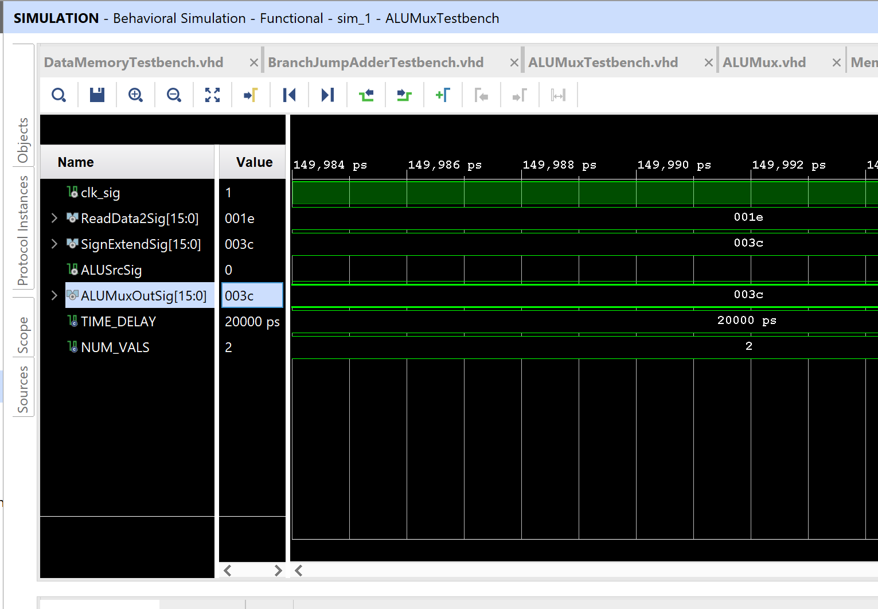

ALUMuxTestbench:

library IEEE;

use IEEE.std_logic_1164.all;

use IEEE.numeric_std.all;

entity ALUMuxTestbench is

end ALUMuxTestbench;

architecture behavior of ALUMuxTestbench is

    constant TIME_DELAY : time := 20 ns;

    constant NUM_VALS : integer := 2;

    --type InstAddress_array is array(0 to (NUM_VALS - 1)) of std_logic_vector(15 downto 0);

    --type pc_out_array is array(0 to (NUM_VALS - 1)) of std_logic_vector(15 downto 0);

    --constant InstAddress_vals : InstAddress_array := ("0000000000000000","0000000000000001");

    signal clk_sig : std_logic := '0';

    signal ReadData2Sig : std_logic_vector (15 downto 0) := "0000000000011110";

    signal SignExtendSig : std_logic_vector (15 downto 0) := "0000000000111100";

    signal ALUSrcSig : std_logic := '0';

    signal ALUMuxOutSig : std_logic_vector (15 downto 0) := "0000000000111100";

    begin

    DUT : entity work.ALUMux(behavioral) port map (

                                             ReadData2  => ReadData2Sig,

                                             SignExtend => SignExtendSig,

                                             ALUSrc     => ALUSrcSig,

                                             ALUMuxOut  => ALUMuxOutSig);

        clock : process

          begin

            for i in 0 to 2 * (NUM_VALS) loop

              clk_sig <= NOT clk_sig;

              wait for TIME_DELAY/2;

            end loop;

            wait;

          end process clock;

         stimulus : process

          begin

            for i in 0 to (NUM_VALS - 1) loop

                ReadData2Sig <= ReadData2Sig;

                SignExtendSig <= SignExtendSig;

                ALUMuxOutSig  <=  ALUMuxOutSig;

              wait for TIME_DELAY;

            end loop;

            wait;

  end process stimulus;

end behavior;

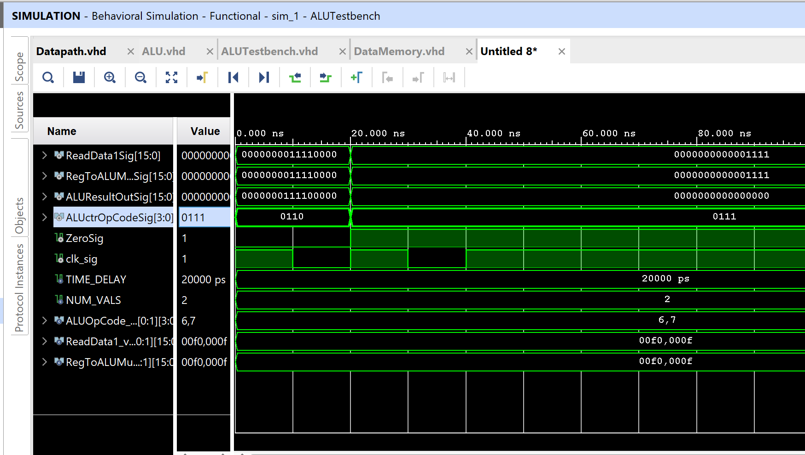

BranchJumpAdderTestbench:

library IEEE;

use IEEE.std_logic_1164.all;

use IEEE.numeric_std.all;

entity BranchJumpAdderTestbench is

end BranchJumpAdderTestbench;

architecture behavior of BranchJumpAdderTestbench is

    constant TIME_DELAY : time := 20 ns;

    constant NUM_VALS : integer := 2;

    type InstAddress_array is array(0 to (NUM_VALS - 1)) of std_logic_vector(15 downto 0);

    --type pc_out_array is array(0 to (NUM_VALS - 1)) of std_logic_vector(15 downto 0);

    constant InstAddress_vals : InstAddress_array := ("0000000000000000","0000000000000001");

    signal clk_sig : std_logic := '0';

    signal ShiftInputSig : std_logic_vector (15 downto 0) := "0000000000001010";

    signal PCAddressSig : std_logic_vector (15 downto 0) := "0000000000001111";

    signal ALUResultSig : std_logic_vector (15 downto 0) := "0000000000000000";

    begin

    DUT : entity work.BranchJumpAdder(behavioral) port map (

                                             ShiftInput =>  ShiftInputSig,

                                             PCAddress => PCAddressSig,

                                             ALUResult => ALUResultSig);

        clock : process

          begin

            for i in 0 to 2 * (NUM_VALS) loop

              clk_sig <= NOT clk_sig;

              wait for TIME_DELAY/2;

            end loop;

            wait;

          end process clock;

         stimulus : process

          begin

            for i in 0 to (NUM_VALS - 1) loop

              ShiftInputSig <= ShiftInputSig;

              PCAddressSig <= PCAddressSig;

              wait for TIME_DELAY;

            end loop;

            wait;

  end process stimulus;

end behavior;

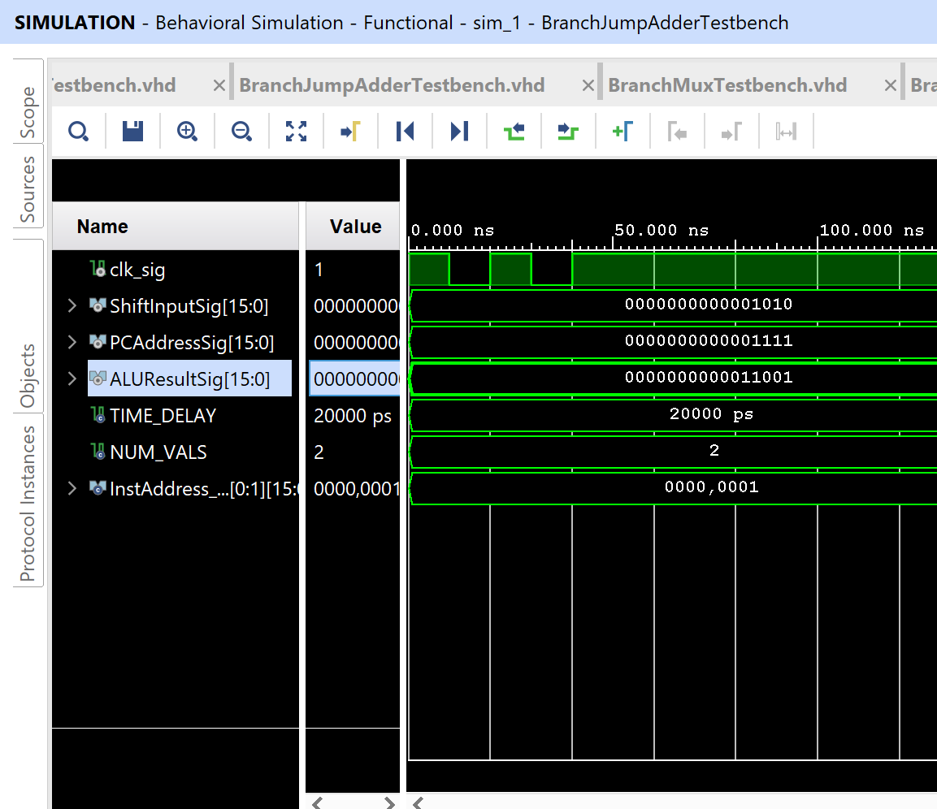

BranchMuxTestbench:

library IEEE;

use IEEE.std_logic_1164.all;

use IEEE.numeric_std.all;

entity BranchMuxTestbench is

end BranchMuxTestbench;

architecture behavior of BranchMuxTestbench is

    constant TIME_DELAY : time := 20 ns;

    constant NUM_VALS : integer := 2;

    type InstAddress_array is array(0 to (NUM_VALS - 1)) of std_logic_vector(15 downto 0);

    --type pc_out_array is array(0 to (NUM_VALS - 1)) of std_logic_vector(15 downto 0);

    constant InstAddress_vals : InstAddress_array := ("0000000000000000","0000000000000001");

    signal clk_sig : std_logic := '0';

    signal PCSrcSig : std_logic := '0';

    signal NextPCSig : std_logic_vector (15 downto 0) := "0000000000000000";

    signal PCPlusFourSig : std_logic_vector (15 downto 0) := "0000000000001001";

    signal BranchALUResultSig : std_logic_vector (15 downto 0) := "0000000000000011";

    begin

    DUT : entity work.BranchMux(behavioral) port map (

                                             PCPlusFour => PCPlusFourSig,

                                             BranchALUResult => BranchALUResultSig,

                                             PCSrc => PCSrcSig,

                                             NextPC => NextPCSig);

        clock : process

          begin

            for i in 0 to 2 * (NUM_VALS) loop

              clk_sig <= NOT clk_sig;

              wait for TIME_DELAY/2;

            end loop;

            wait;

          end process clock;

         stimulus : process

          begin

            for i in 0 to (NUM_VALS - 1) loop

              PCPlusFourSig <= PCPlusFourSig;

              BranchALUResultSig <= BranchALUResultSig;

              wait for TIME_DELAY;

            end loop;

            wait;

  end process stimulus;

end behavior;

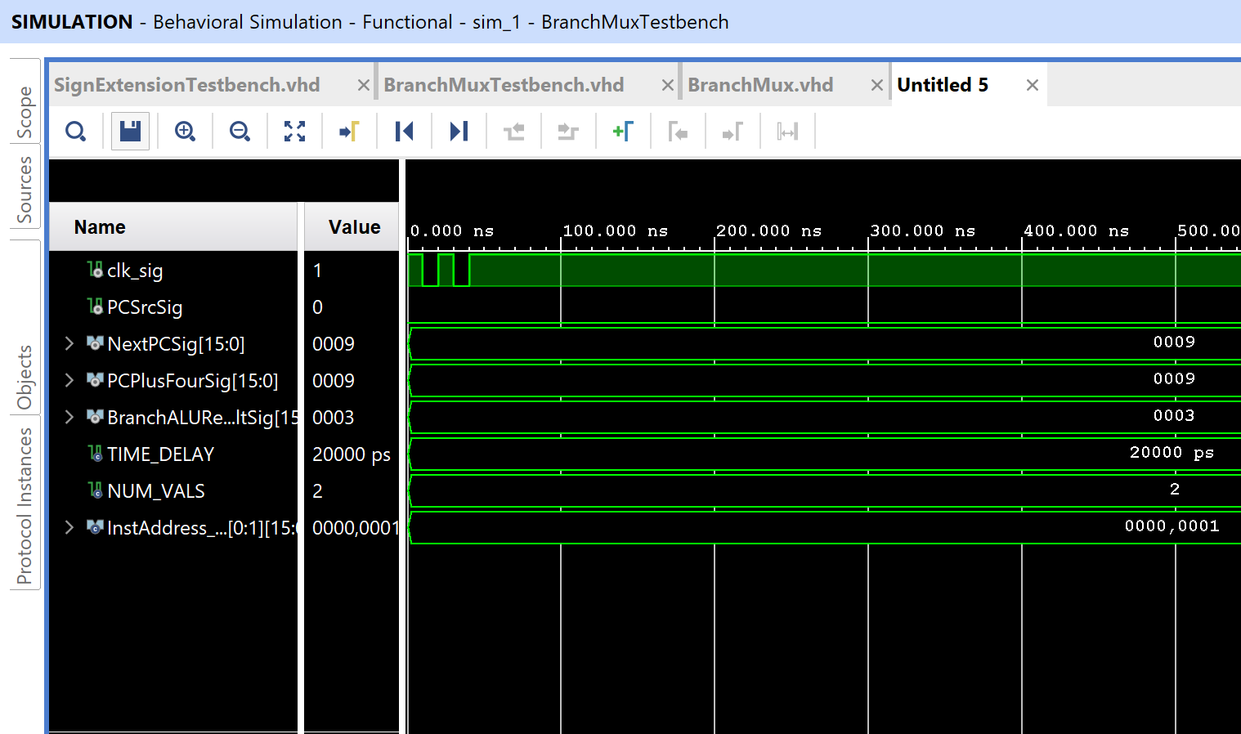

ControlUnitTestbench:

library IEEE;

use IEEE.std_logic_1164.all;

use IEEE.numeric_std.all;

entity ControlUnitTestbench is

end ControlUnitTestbench;

architecture behavioral of ControlUnitTestbench is

    constant TIME_DELAY : time := 20 ns;

    constant NUM_VALS : integer := 16;

    type OpCode_array is array(0 to (NUM_VALS - 1)) of std_logic_vector(3 downto 0);

    constant OpCode_vals : OpCode_array := ("0000", "0001", "0010", "0011", "0100", "0101", "0110", "0111", "1000", "1001", "1010", "1011", "1100", "1101", "1110", "1111");

--    type ReadData1_array is array(0 to (NUM_VALS - 1)) of std_logic_vector(15 downto 0);

--    constant ReadData1_vals : ReadData1_array := ("0000000011110000","0000000000001111");

--    type RegToALUMuxIn_array is array(0 to (NUM_VALS - 1)) of std_logic_vector(15 downto 0);

--    constant RegToALUMuxIn_vals : RegToALUMuxIn_array := ("0000000011110000","0000000000001111");

    signal InstOpCodeSig : std_logic_vector (3 downto 0) := "0000";

    signal ALUOpCodeSig : std_logic_vector (3 downto 0) := "0000";

    signal clk_sig : std_logic := '0';

    signal RegDstSig : std_logic := '0';

    signal JumpSig : std_logic := '0';

    signal BranchSig : std_logic := '0';

    signal MemReadSig : std_logic := '0';

    signal MemToRegSig : std_logic := '0';

    signal MemWriteSig : std_logic := '0';

    signal ALUSrcSig : std_logic := '0';

    signal RegWriteSig : std_logic := '0';

    begin

    DUT : entity work.ControlUnit(behavioral) port map (

                                             InstOpCode => InstOpCodeSig,

                                             ALUOpCode => ALUOpCodeSig,

                                             RegDst => RegDstSig,

                                             Jump => JumpSig,

                                             Branch => BranchSig,

                                             MemRead => MemReadSig,

                                             MemToReg => MemToRegSig,

                                             MemWrite => MemWriteSig,

                                             ALUSrc => ALUSrcSig,

                                             RegWrite => RegWriteSig

                                             );

        clock : process

          begin

            for i in 0 to 2 * (NUM_VALS) loop

              clk_sig <= NOT clk_sig;

              wait for TIME_DELAY/2;

            end loop;

            wait;

          end process clock;

         stimulus : process

          begin

            for i in 0 to (NUM_VALS - 1) loop

              InstOpCodeSig <= OpCode_vals(i);

              wait for TIME_DELAY;

            end loop;

            wait;

  end process stimulus;

end behavioral;

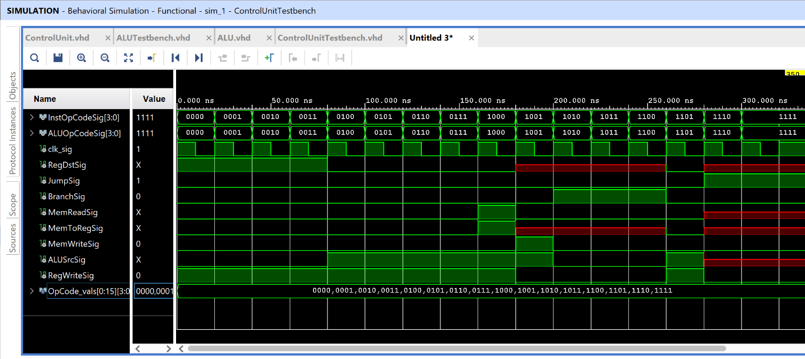

DataMemoryTestbench:

library IEEE;

use IEEE.std_logic_1164.all;

use IEEE.numeric_std.all;

entity DataMemoryTestbench is

end DataMemoryTestbench;

architecture behavior of DataMemoryTestbench is

    constant TIME_DELAY : time := 20 ns;

    constant NUM_VALS : integer := 2;

    type InstAddress_array is array(0 to (NUM_VALS - 1)) of std_logic_vector(15 downto 0);

    --type pc_out_array is array(0 to (NUM_VALS - 1)) of std_logic_vector(15 downto 0);

    constant InstAddress_vals : InstAddress_array := ("0000000000000000","0000000000000001");

    signal clk_sig : std_logic := '0';

    signal ZeroSig : std_logic := '0';

    signal MemWriteSig : std_logic := '0';

    signal MemReadSig : std_logic := '1';

    signal WriteDataSig : std_logic_vector (15 downto 0) := "0000000000000000";

    signal ALUResultSig : std_logic_vector (15 downto 0) := "0000000000000011";

    signal ReadDataSig : std_logic_vector (15 downto 0) := "0000000000000000";

    begin

    DUT : entity work.DataMemory(behavioral) port map (

                                             Zero => ZeroSig,

                                             WriteData => WriteDataSig,

                                             ALUResult => ALUResultSig,

                                             MemWrite => MemWriteSig,

                                             MemRead => MemReadSig);

        clock : process

          begin

            for i in 0 to 2 * (NUM_VALS) loop

              clk_sig <= NOT clk_sig;

              wait for TIME_DELAY/2;

            end loop;

            wait;

          end process clock;

         stimulus : process

          begin

            for i in 0 to (NUM_VALS - 1) loop

              ZeroSig <= ZeroSig;

              WriteDataSig <= WriteDataSig;

              ALUResultSig <= ALUResultSig;

              ReadDataSig <= ReadDataSig;

              wait for TIME_DELAY;

            end loop;

            wait;

  end process stimulus;

end behavior;

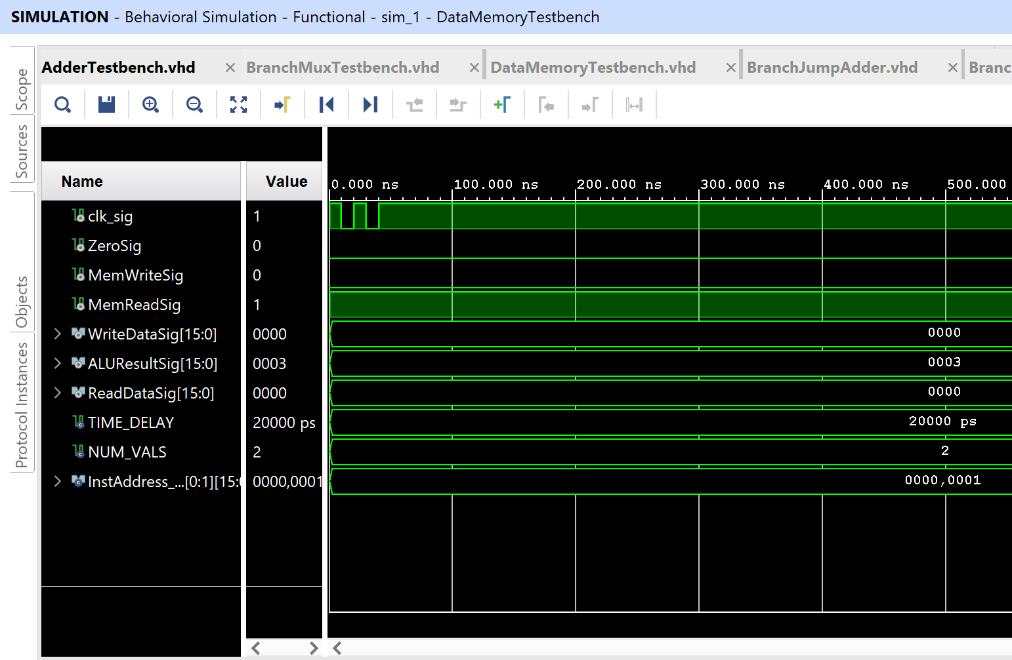

DatapathTestbench:

library IEEE;

use IEEE.std_logic_1164.all;

use IEEE.numeric_std.all;

entity DatapathTestbench is

end DatapathTestbench;

architecture structural of DatapathTestbench is

    constant TIME_DELAY : time := 100 ns;

    constant NUM_VALS : integer := 150;

    signal clk_sig : std_logic := '1';

    begin

    DUT : entity work.Datapath(structural) port map (

                                             clk => clk_sig

                                             );

        clock : process

          begin

            for i in 0 to 2 * (NUM_VALS) loop

              clk_sig <= NOT clk_sig;

              wait for TIME_DELAY/2;

            end loop;

            wait;

          end process clock;

--         stimulus : process

--          begin

--            for i in 0 to (NUM_VALS - 1) loop

--              --ReadData1Sig <= ReadData1_vals(i);

--              --RegToALUMuxInSig <= RegToALUMuxIn_vals(i);

--              --ALUctrOpCodeSig <= ALUOpCode_vals(i);

--              wait for TIME_DELAY;

--            end loop;

--            wait;

--        end process stimulus;

end structural;

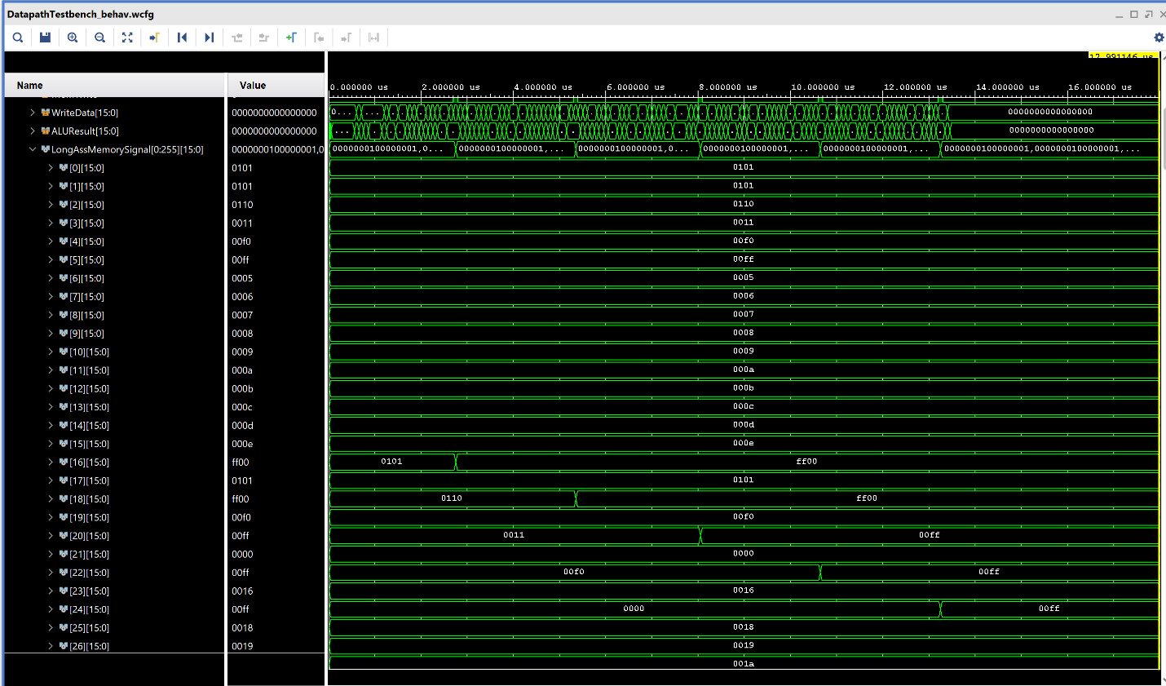

InstMemToRegMuxCall:

library IEEE;

use IEEE.std_logic_1164.all;

use IEEE.numeric_std.all;

entity InstMemToRegMuxTestbench is

end InstMemToRegMuxTestbench;

architecture behavior of InstMemToRegMuxTestbench is

    constant TIME_DELAY : time := 20 ns;

    constant NUM_VALS : integer := 2;

    type DataIn_array is array(0 to (NUM_VALS - 1)) of std_logic_vector(3 downto 0);

    --type pc_out_array is array(0 to (NUM_VALS - 1)) of std_logic_vector(15 downto 0);

    constant DataIn_vals : DataIn_array := ("0011","1100");

    signal clk_sig : std_logic := '0';

    signal RegDstSig : std_logic := '0';

    signal Inst1RsSig : std_logic_vector (3 downto 0) := "0010";

    signal Inst2RdSig : std_logic_vector (3 downto 0) := "0100";

    signal MuxOutSig : std_logic_vector (3 downto 0) := "0000";

    begin

    DUT : entity work.InstMemToRegMux(behavioral) port map (

                                             RegDst => RegDstSig,

                                             Inst1Rs => Inst1RsSig,

                                             Inst2Rd => Inst2RdSig,

                                             MuxOut => MuxOutSig);

        clock : process

          begin

            for i in 0 to 2 * (NUM_VALS) loop

              clk_sig <= NOT clk_sig;

              wait for TIME_DELAY/2;

            end loop;

            wait;

          end process clock;

         stimulus : process

          begin

            for i in 0 to (NUM_VALS - 1) loop

              Inst1RsSig <= Inst1RsSig;

              Inst2RdSig <= Inst2RdSig;

              wait for TIME_DELAY;

            end loop;

            wait;

  end process stimulus;

end behavior;

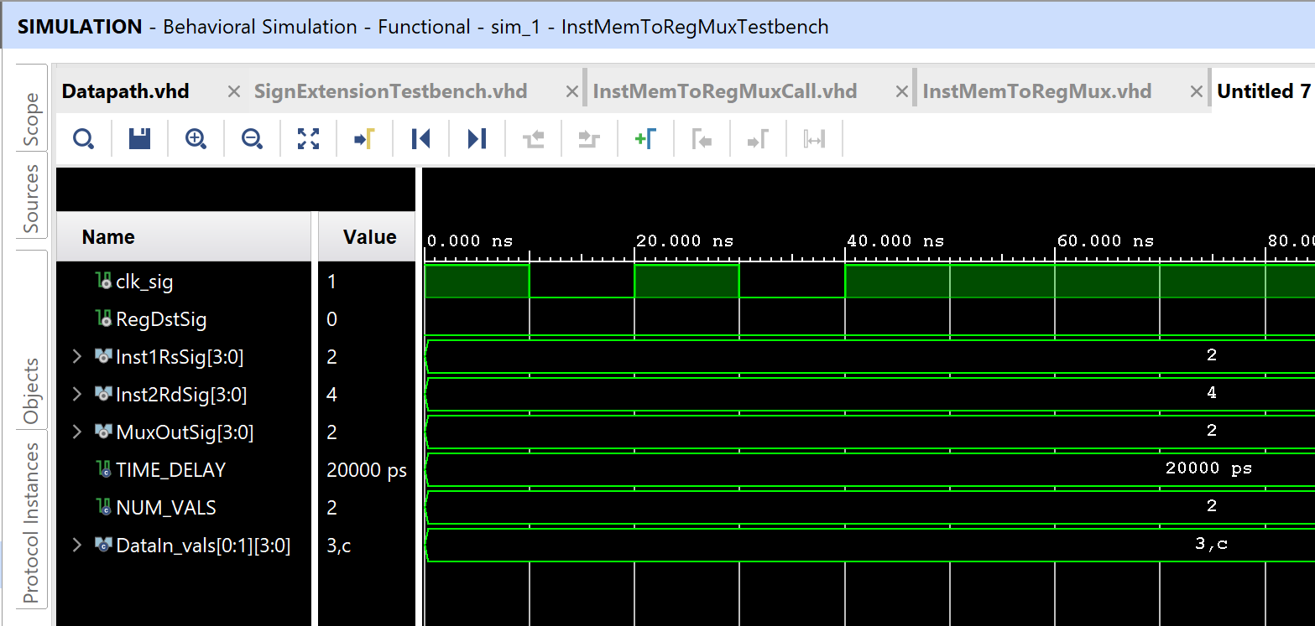

Instruction_Adder_Testbench:

library IEEE;

use IEEE.std_logic_1164.all;

use IEEE.numeric_std.all;

entity Instruction_Adder_Testbench is

end Instruction_Adder_Testbench;

architecture behavior of Instruction_Adder_Testbench is

    constant TIME_DELAY : time := 20 ns;

    constant NUM_VALS : integer := 2;

    type InstIn_array is array(0 to (NUM_VALS - 1)) of std_logic_vector(15 downto 0);

    --type pc_out_array is array(0 to (NUM_VALS - 1)) of std_logic_vector(15 downto 0);

    constant InstIn_vals : InstIn_array := ("0000000000000000","0000000000000001");

    signal clk_sig : std_logic := '0';

    signal InstInSig : std_logic_vector (15 downto 0) := "0000000000000000";

    signal InstOutSig : std_logic_vector (15 downto 0) := "0000000000000000";

    begin

    DUT : entity work.Instruction_Adder_Component(behavioral) port map (

                                             InstIn => InstInSig,

                                             InstOut => InstOutSig);

        clock : process

          begin

            for i in 0 to 2 * (NUM_VALS) loop

              clk_sig <= NOT clk_sig;

              wait for TIME_DELAY/2;

            end loop;

            wait;

          end process clock;

         stimulus : process

          begin

            for i in 0 to (NUM_VALS - 1) loop

              InstInSig <= InstIn_vals(i);

              wait for TIME_DELAY;

            end loop;

            wait;

  end process stimulus;

end behavior;

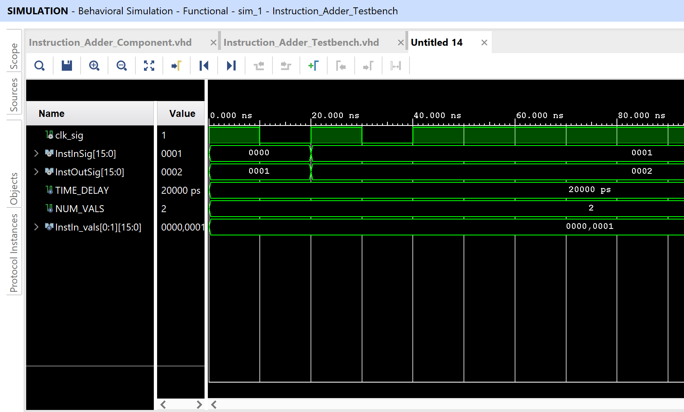

InstructionMemoryTestbench:

library IEEE;

use IEEE.std_logic_1164.all;

use IEEE.numeric_std.all;

entity InstructionMemoryTestbench is

end InstructionMemoryTestbench;

architecture behavior of InstructionMemoryTestbench is

    constant TIME_DELAY : time := 20 ns;

    constant NUM_VALS : integer := 2;

    type InstAddress_array is array(0 to (NUM_VALS - 1)) of std_logic_vector(15 downto 0);

    --type pc_out_array is array(0 to (NUM_VALS - 1)) of std_logic_vector(15 downto 0);

    constant InstAddress_vals : InstAddress_array := ("0000000000000000","0000000000000001");

    signal clk_sig : std_logic := '0';

    signal InstAddressSig : std_logic_vector (15 downto 0) := "0000000000000000";

    signal InstDataSig : std_logic_vector (15 downto 0) := "0000000000000000";

    begin

    DUT : entity work.InstructionMemory(behavioral) port map (

                                             InstAddress => InstAddressSig,

                                             InstData => InstDataSig);

        clock : process

          begin

            for i in 0 to 2 * (NUM_VALS) loop

              clk_sig <= NOT clk_sig;

              wait for TIME_DELAY/2;

            end loop;

            wait;

          end process clock;

         stimulus : process

          begin

            for i in 0 to (NUM_VALS - 1) loop

              InstAddressSig <= InstAddress_vals(i);

              wait for TIME_DELAY;

            end loop;

            wait;

  end process stimulus;

end behavior;

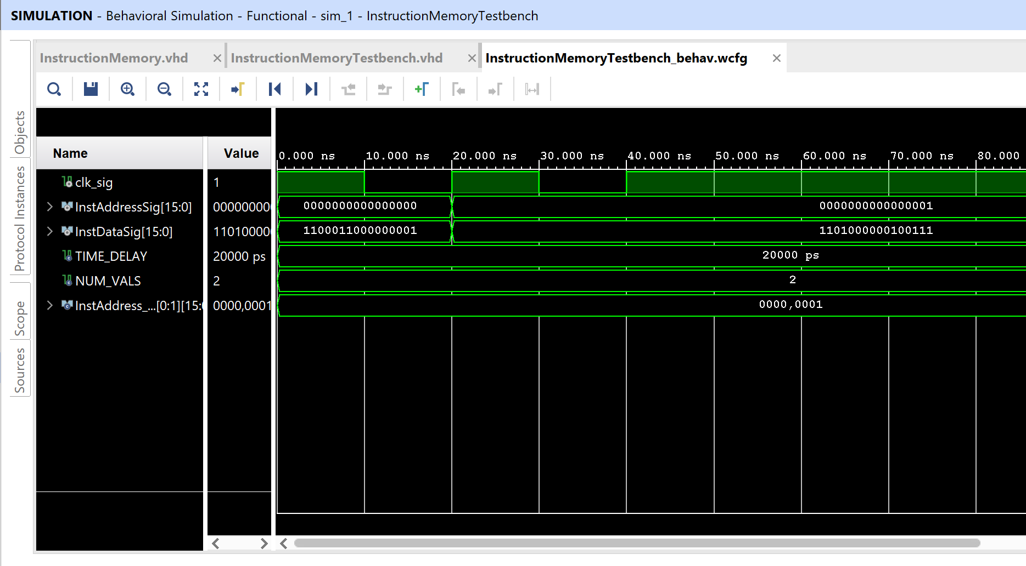

JumpMux:

library IEEE;

use IEEE.std_logic_1164.all;

use IEEE.numeric_std.all;

entity JumpMuxTestbench is

end JumpMuxTestbench;

architecture behavior of JumpMuxTestbench is

    constant TIME_DELAY : time := 20 ns;

    constant NUM_VALS : integer := 2;

    type DataIn_array is array(0 to (NUM_VALS - 1)) of std_logic_vector(3 downto 0);

    --type pc_out_array is array(0 to (NUM_VALS - 1)) of std_logic_vector(15 downto 0);

    constant DataIn_vals : DataIn_array := ("0011","1100");

    signal jump_sig : std_logic := '1';

    signal clk_sig : std_logic := '0';

    signal ShiftJumpSignalOutSignal : std_logic_vector(12 downto 0) := "0000011110000";

    signal PCMostSigSignal : std_logic_vector(2 downto 0) := "000";

    signal BranchMuxInSignal : std_logic_vector(15 downto 0) := "0000000000010010";

    signal PCOutSignal : std_logic_vector(15 downto 0) := "0000000000000000";

    begin

    DUT : entity work.JumpMux(behavioral) port map (

                                             Jump => jump_sig,

                                             ShiftJumpSignalOut => ShiftJumpSignalOutSignal,

                                             PCMostSig => PCMostSigSignal,

                                             BranchMuxIn => BranchMuxInSignal,

                                             PCOut => PCOutSignal);

        clock : process

          begin

            for i in 0 to 2 * (NUM_VALS) loop

              clk_sig <= NOT clk_sig;

              wait for TIME_DELAY/2;

            end loop;

            wait;

          end process clock;

         stimulus : process

          begin

            for i in 0 to (NUM_VALS - 1) loop

              --Inst1RsSig <= Inst1RsSig;

              --Inst2RdSig <= Inst2RdSig;

              wait for TIME_DELAY;

            end loop;

            wait;

  end process stimulus;

end behavior;

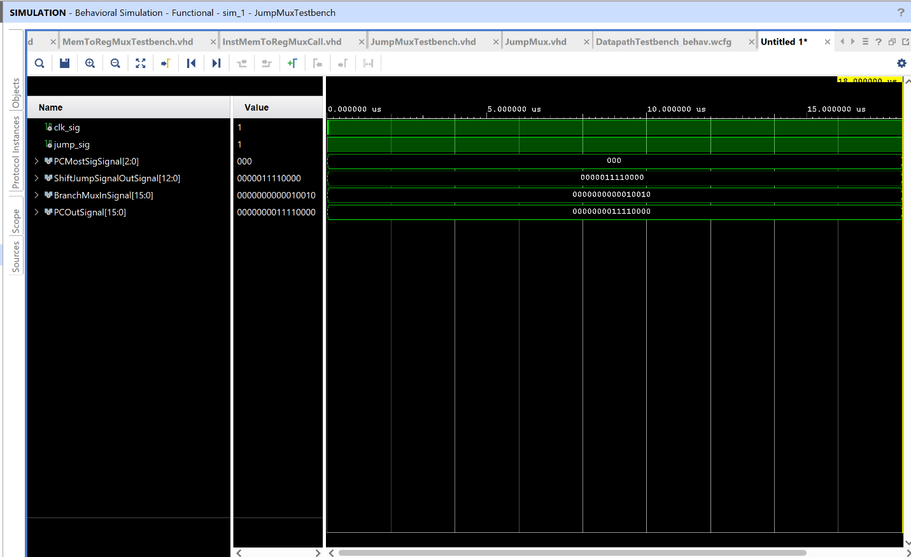

MemToRegMuxTestbench:

library IEEE;

use IEEE.std_logic_1164.all;

use IEEE.numeric_std.all;

entity MemToRegMuxTestbench is

end MemToRegMuxTestbench;

architecture behavior of MemToRegMuxTestbench is

    constant TIME_DELAY : time := 20 ns;

    constant NUM_VALS : integer := 2;

    --type InstAddress_array is array(0 to (NUM_VALS - 1)) of std_logic_vector(15 downto 0);

    --type pc_out_array is array(0 to (NUM_VALS - 1)) of std_logic_vector(15 downto 0);

    --constant InstAddress_vals : InstAddress_array := ("0000000000000000","0000000000000001");

    signal clk_sig : std_logic := '0';

    signal ReadDataMemSig : std_logic_vector (15 downto 0) := "0000000000011110";

    signal ALUResultSig : std_logic_vector (15 downto 0) := "0000000000111100";

    signal MemToRegSig : std_logic := '0';

    signal MemToRegMuxOut : std_logic_vector (15 downto 0) := "0000000000000000";

    begin

    DUT : entity work.MemToRegMux(behavioral) port map (

                                           ReadDataMem  => ReadDataMemSig,

                                           ALUResult => ALUResultSig,

                                           MemToReg => MemToRegSig,

                                           MemToRegMuxOut => MemToRegMuxOut);

        clock : process

          begin

            for i in 0 to 2 * (NUM_VALS) loop

              clk_sig <= NOT clk_sig;

              wait for TIME_DELAY/2;

            end loop;

            wait;

          end process clock;

         stimulus : process

          begin

            for i in 0 to (NUM_VALS - 1) loop

              ReadDataMemSig <= ReadDataMemSig;

              ALUResultSig <= ALUResultSig;

              MemToRegSig <= MemToRegSig;

              wait for TIME_DELAY;

            end loop;

            wait;

  end process stimulus;

end behavior;

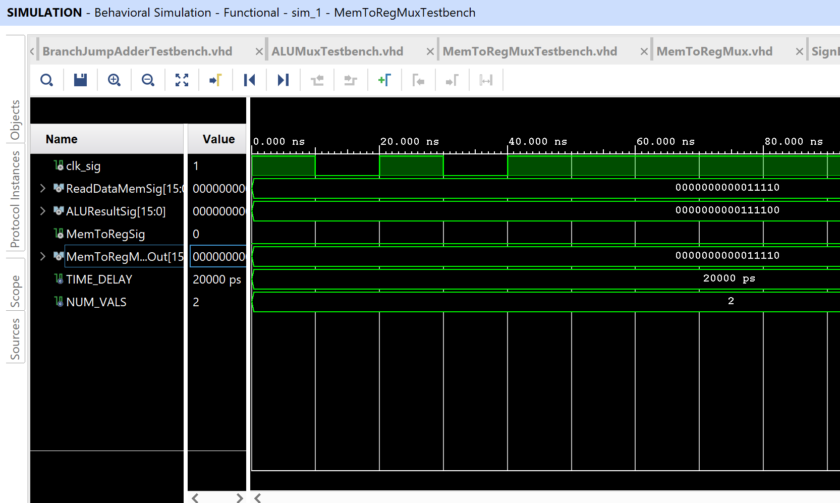

PC_testbench:

library IEEE;

use IEEE.std_logic_1164.all;

use IEEE.numeric_std.all;

entity PC_testbench is

end PC_testbench;

architecture behavior of PC_testbench is

    constant TIME_DELAY : time := 20 ns;

    constant NUM_VALS : integer := 2;

    type pc_in_array is array(0 to (NUM_VALS - 1)) of std_logic_vector(15 downto 0);

    --type pc_out_array is array(0 to (NUM_VALS - 1)) of std_logic_vector(15 downto 0);

    constant pc_in_vals : pc_in_array := ("0000000000000000","0000000000000001");

    signal clk_sig : std_logic := '0';

    signal pc_in_sig : std_logic_vector (15 downto 0) := "0000000000000000";

    signal pc_out_sig : std_logic_vector (15 downto 0) := "0000000000000000";

    begin

    DUT : entity work.PC_Component(behavioral) port map (

                                             clk => clk_sig,

                                             pc_in => pc_in_sig,

                                             pc_out => pc_out_sig);

        clock : process

          begin

            for i in 0 to 2 * (NUM_VALS) loop

              clk_sig <= NOT clk_sig;

              wait for TIME_DELAY/2;

            end loop;

            wait;

          end process clock;

         stimulus : process

          begin

            for i in 0 to (NUM_VALS - 1) loop

              pc_in_sig <= pc_in_vals(i);

              wait for TIME_DELAY;

            end loop;

            wait;

  end process stimulus;

end behavior;

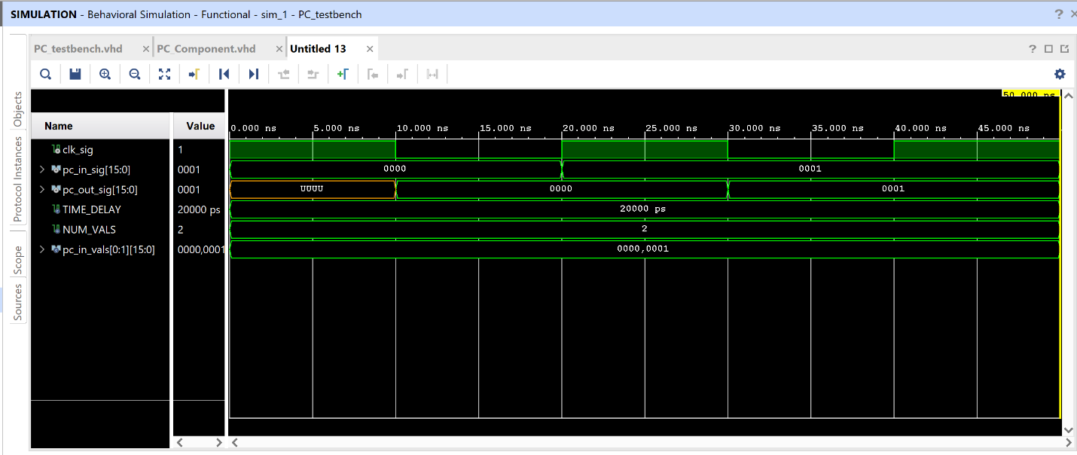

RegFileTestbench:

library IEEE;

use IEEE.std_logic_1164.all;

use IEEE.numeric_std.all;

entity RegFileTestbench is

end RegFileTestbench;

architecture behavior of RegFileTestbench is

    constant TIME_DELAY : time := 20 ns;

    constant NUM_VALS : integer := 2;

    type ReadReg1_array is array(0 to (NUM_VALS - 1)) of std_logic_vector(3 downto 0);

    type ReadReg2_array is array(0 to (NUM_VALS - 1)) of std_logic_vector(3 downto 0);

    --type pc_out_array is array(0 to (NUM_VALS - 1)) of std_logic_vector(15 downto 0);

    constant ReadReg1_vals : ReadReg1_array := ("0011","0001");

    constant ReadReg2_vals : ReadReg2_array := ("0101","0100");

    signal clk_sig : std_logic := '0';

    signal ReadReg1Sig : std_logic_vector (3 downto 0) := "0000";

    signal ReadReg2Sig : std_logic_vector (3 downto 0) := "0000";

    signal WriteRegSig : std_logic_vector (3 downto 0) := "1010";

    signal WriteDataSig : std_logic_vector (15 downto 0) := "0000000111100000";

    signal RegWriteControlSig : std_logic := '1';

    signal ReadData1Sig : std_logic_vector (15 downto 0) := "0000000111100000";

    signal ReadData2Sig : std_logic_vector (15 downto 0) := "0000000111100000";

    begin

    DUT : entity work.RegFile(behavioral) port map (

                                            clk => clk_sig,

                                            ReadReg1 => ReadReg1Sig,

                                            ReadReg2 => ReadReg2Sig,

                                            WriteReg => WriteRegSig,

                                            WriteData => WriteDataSig,

                                            RegWriteCtrl => RegWriteControlSig,

                                            ReadData1 => ReadData1Sig,

                                            ReadData2 => ReadData2Sig);

        clock : process

          begin

            for i in 0 to 2 * (NUM_VALS) loop

              clk_sig <= NOT clk_sig;

              wait for TIME_DELAY/2;

            end loop;

            wait;

          end process clock;

         stimulus : process

          begin

            for i in 0 to (NUM_VALS - 1) loop

              ReadReg1Sig <= ReadReg1_vals(i);

              ReadReg2Sig <= ReadReg2_vals(i);

              wait for TIME_DELAY;

            end loop;

            wait;

  end process stimulus;

end behavior;

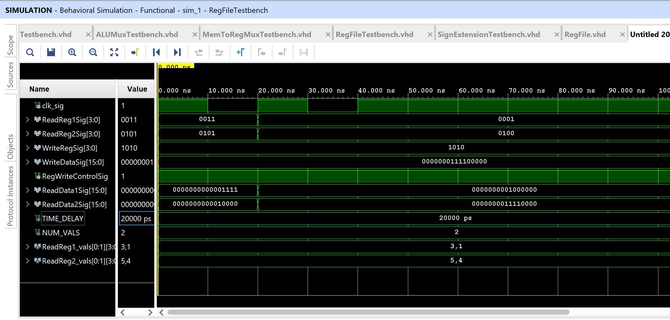

ShiftBranchTestbench:

library IEEE;

use IEEE.std_logic_1164.all;

use IEEE.numeric_std.all;

entity ShiftBranchTestbench is

end ShiftBranchTestbench;

architecture behavior of ShiftBranchTestbench is

    constant TIME_DELAY : time := 20 ns;

    constant NUM_VALS : integer := 2;

    type SignExtend_array is array(0 to (NUM_VALS - 1)) of std_logic_vector(15 downto 0);

    --type pc_out_array is array(0 to (NUM_VALS - 1)) of std_logic_vector(15 downto 0);

    constant SignExtend_vals : SignExtend_array := ("0000000000000011","1111111111110011");

    signal clk_sig : std_logic := '0';

    signal SignExtendSig : std_logic_vector (15 downto 0) := "0000000000000000";

    signal ShiftOutBranchSig : std_logic_vector (15 downto 0) := "0000000000000000";

    begin

    DUT : entity work.ShiftBranch(behavioral) port map (

                                             SignExtend => SignExtendSig,

                                             ShiftOutBranch => ShiftOutBranchSig);

        clock : process

          begin

            for i in 0 to 2 * (NUM_VALS) loop

              clk_sig <= NOT clk_sig;

              wait for TIME_DELAY/2;

            end loop;

            wait;

          end process clock;

         stimulus : process

          begin

            for i in 0 to (NUM_VALS - 1) loop

              SignExtendSig <= SignExtend_vals(i);

              wait for TIME_DELAY;

            end loop;

            wait;

  end process stimulus;

end behavior;

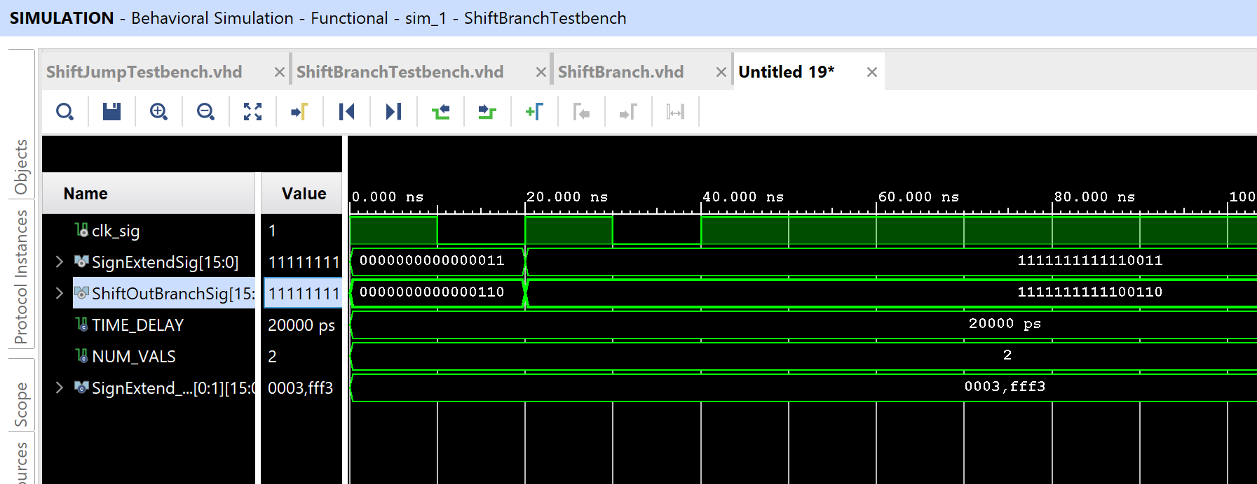

ShiftJumpTestbench:

library IEEE;

use IEEE.std_logic_1164.all;

use IEEE.numeric_std.all;

entity ShiftJumpTestbench is

end ShiftJumpTestbench;

architecture behavior of ShiftJumpTestbench is

    constant TIME_DELAY : time := 20 ns;

    constant NUM_VALS : integer := 2;

    type ShiftAddress_array is array(0 to (NUM_VALS - 1)) of std_logic_vector(11 downto 0);

    --type pc_out_array is array(0 to (NUM_VALS - 1)) of std_logic_vector(15 downto 0);

    constant ShiftAddress_vals : ShiftAddress_array := ("000000100111","000000011010");

    signal clk_sig : std_logic := '0';

    signal ShiftAddressSig : std_logic_vector (11 downto 0) := "000000000000";

    signal ShiftOutSig : std_logic_vector (12 downto 0) := "0000000000000";

    begin

    DUT : entity work.ShiftJump(behavioral) port map (

                                             ShiftAddress => ShiftAddressSig,

                                             ShiftOut => ShiftOutSig);

        clock : process

          begin

            for i in 0 to 2 * (NUM_VALS) loop

              clk_sig <= NOT clk_sig;

              wait for TIME_DELAY/2;

            end loop;

            wait;

          end process clock;

         stimulus : process

          begin

            for i in 0 to (NUM_VALS - 1) loop

              ShiftAddressSig <= ShiftAddress_vals(i);

              wait for TIME_DELAY;

            end loop;

            wait;

  end process stimulus;

end behavior;

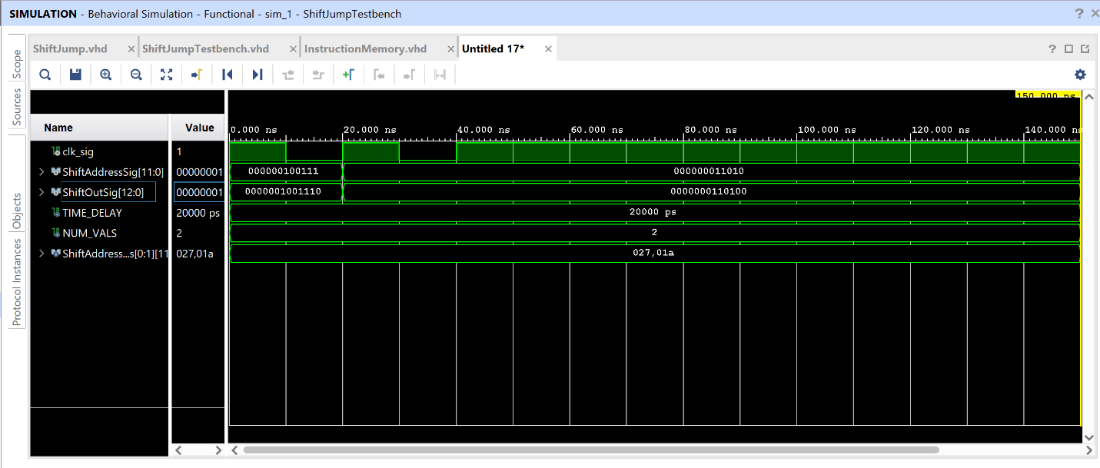

SignExtensionTestbench:

library IEEE;

use IEEE.std_logic_1164.all;

use IEEE.numeric_std.all;

entity SignExtensionTestbench is

end SignExtensionTestbench;

architecture behavior of SignExtensionTestbench is

    constant TIME_DELAY : time := 20 ns;

    constant NUM_VALS : integer := 2;

    type DataIn_array is array(0 to (NUM_VALS - 1)) of std_logic_vector(3 downto 0);

    --type pc_out_array is array(0 to (NUM_VALS - 1)) of std_logic_vector(15 downto 0);

    constant DataIn_vals : DataIn_array := ("0011","1100");

    signal clk_sig : std_logic := '0';

    signal DataInSig : std_logic_vector (3 downto 0) := "0000";

    signal ExtendedDataSig : std_logic_vector (15 downto 0) := "0000000000000000";

    begin

    DUT : entity work.SignExtension(behavioral) port map (

                                             DataIn => DataInSig,

                                             ExtendedData => ExtendedDataSig);

        clock : process

          begin

            for i in 0 to 2 * (NUM_VALS) loop

              clk_sig <= NOT clk_sig;

              wait for TIME_DELAY/2;

            end loop;

            wait;

          end process clock;

         stimulus : process

          begin

            for i in 0 to (NUM_VALS - 1) loop

              DataInSig <= DataIn_vals(i);

              wait for TIME_DELAY;

            end loop;

            wait;

  end process stimulus;

end behavior;

