Device’s Technical Specifications

# 1. System Architecture

The Aftermarket Device is designed to control the load supply of the appliance bought by them who are not eligible of paying by EMI. It consists of Several core components that handles supply control, data acquisition, tamper Alert algorithm and GET update from the Server.

# 2. Block Diagram

Block Diagram: Block diagram has been shown, displaying functionality blocks and its

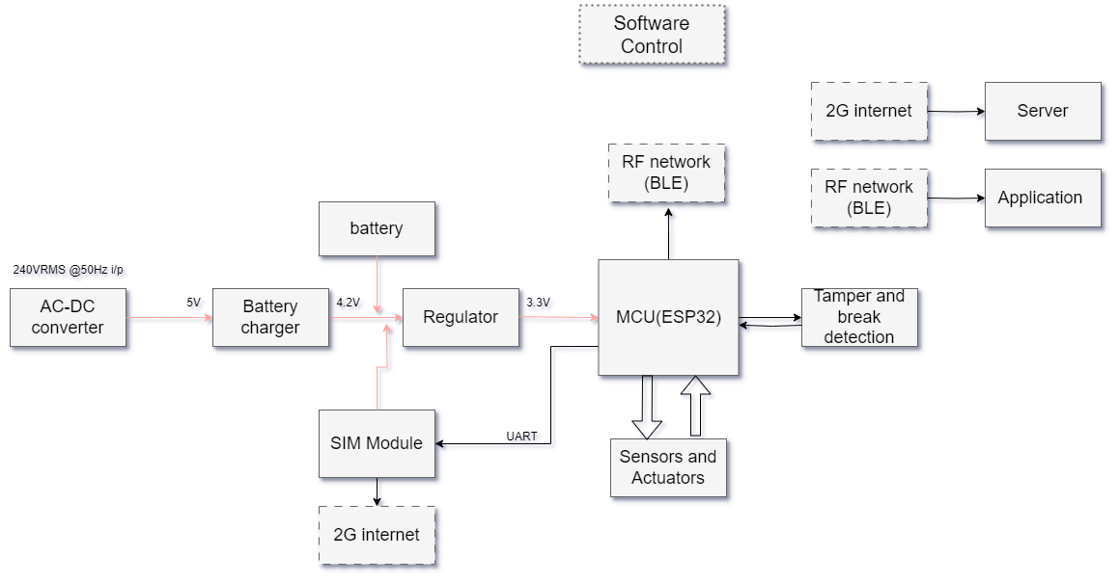

## Components Overview:

1. Microcontroller: ESP32-S2

2. Sensors:

- ACS712ELCTR-20A-T (Current sensor)

- TSOP38238 (IR detection sensor)

- H11AA1 (Optocoupler/Optoisolator)

3. Communication Module: ESP32 (Bluetooth/BLE), SIM800L (internet/Iot)

4. Power Management: Li-Ion battery (3.7V, 1500mAh) with charging circuit

## Data Flow:

1. Input: Sensors collects IR response (to trigger remote device start), voltage detection and data of consumed current.

2. Processing: MCU processes sensor data.

3. Output: Processed data is transmitted via Wi-Fi to a cloud server, and receives instruction or commands as well as data from it , obtained periodically from either server or app nearby.

# 3. Hardware Specifications

Microcontroller:

* ESP32S2- Xtensa dual-core 32-bit LX6 microprocessor, up to 240 MHz, 520 KB SRAM ,448 KB ROM,3 UART interface along with SPI, i2C ,I2S, Wi-Fi/internet, BLE support.
* SIM800L: 2G GSM/GPRS module, integrated TCP/IP stack, supports SMS, MMS, and voice calls, serial UART interface, low power consumption, and wide operating voltage range (3.4V to 4.4V).

Sensors:

* ACS712ELCTR-20A-T Current range: 0 -20A
* TSOP38238 carrier frequency value :38kHz
* H11AA1- Voltage range 0-5.3kV RMS

Power:

* Power source: Li-Ion 3.7V, 1500mAh battery
* Charging Circuit: Supports 5V input
* Power consumption: 440mA in active mode, 3.7mA- 5mA in sleep mode

# 4. Software/Firmware Design

The device firmware is modular, designed for efficient real-time data handling and communication.

## Firmware Structure:

* Sensor Interface Module: Reads data from ACS712 and H11AA1 and reads IR Responses of TSOP38238, which kickstarts the MCU.
* Communication Module: Manages data transmission over Wi-Fi using the ESP32 module.
* SC (Short Circuit) and touch sensing algorithm (For tamper and Break detection).
* Power Management: Implements deep sleep modes to conserve battery.

## Protocols Used:

- UART: For MCU and SIM module communication.

- Wi-Fi: Data is transmitted over HTTP to a cloud-based server.

-Bluetooth Low Energy – Acknowledgment packets between nearby connected app and Device

# 5. Product Functionality

## Operation Workflow:

1. Device remotely powers on MCU and initializes sensors.
2. Monitors Voltage, Current wire and device tamper continously
3. Data is transmitted via Wi-Fi to the cloud server and performs acknowledgment maneuvers with the application affiliated to the device periodically.
4. Enters low-power mode between readings and lack of external power (e.g. mains supply).

## User Interface:

- Data is viewable on app dashboard, providing real-time and historical analytics.

# 6. Performance Benchmarks

* Current Measurement Accuracy: Total output error 1.5% at 25°C ambient temperature
* Battery Life: 48 hours of continuous use with a 3.7V, 1500mAh battery.

# 7. Security and Safety Features

Data Security:

* Wi-Fi communication encrypted using SSL/TLS encryption
* Data transmitted to the cloud server via HTTPS.
* BLE transmitted with AES-128 used for encryption

Safety Features:

* Over-voltage and over-current protection for battery charging circuit.
* Isolation of digital and analog circuit from main supply.

# 8. Scalability and Upgradability

# 9. Future Technical Roadmap

- Version 2.0: Plan to upgrade GSM version for high-speed internet data and GPRS and GNSS for location tracking for portable products.

- Cloud Integration: Enhance cloud services for predictive analytics and AI-driven insights.

-Addition of more sensor for more detailed information of surroundings.

# 10. Hardware visualization

