Task 1:
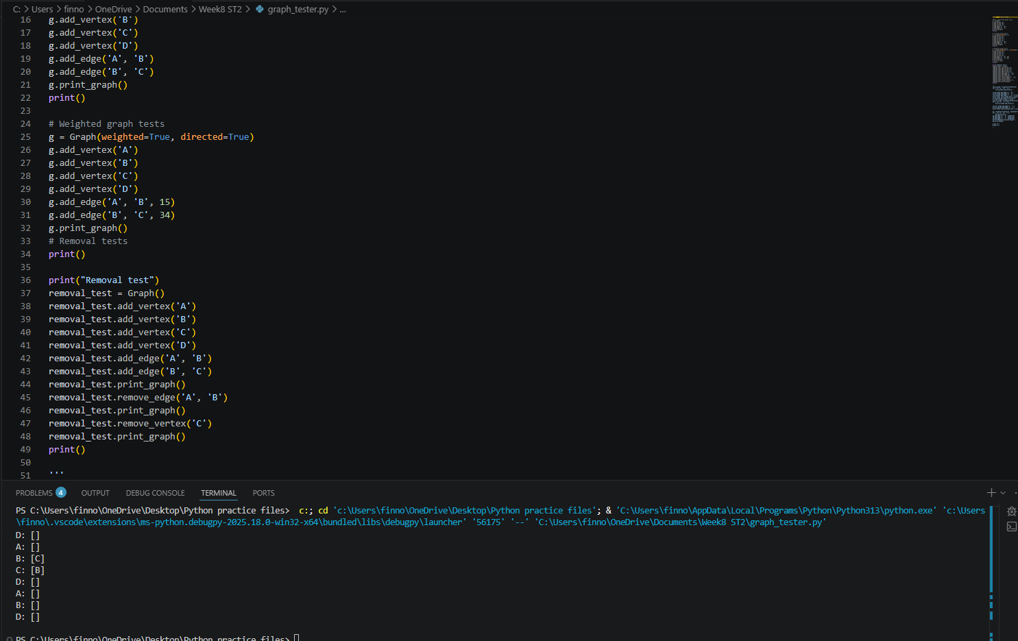
Task2/3:
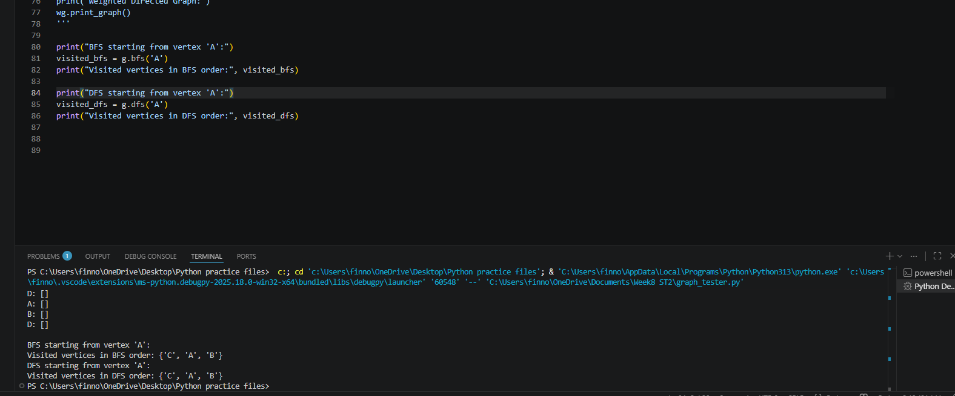

Task 4:
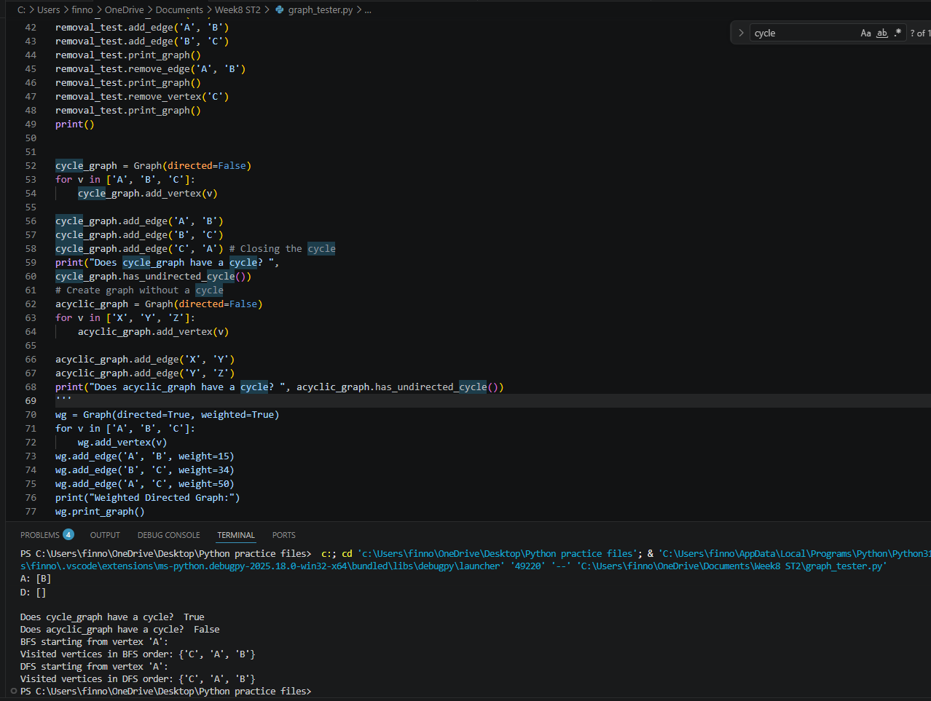

Task 5:
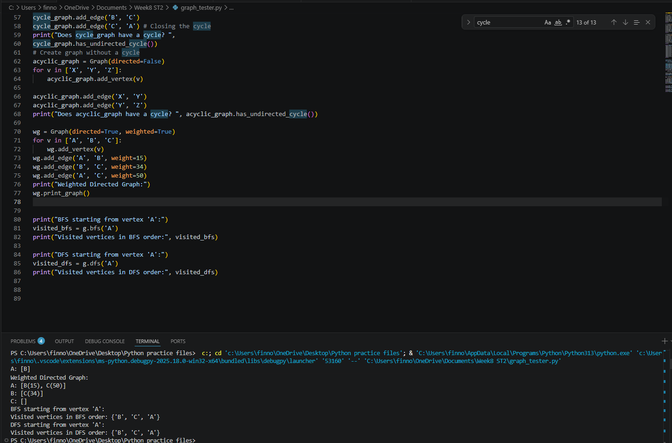

Task 5 discussion:
When adding weights to a graph, you transform the queue structure and render search algorithms such as our current implementation of DFS and BFS redundant. As paths now have various weights associated with them, the shortest path is not the one with the fewest vertices; it is the one with the lowest total weight. To find the shortest path within the graph, you would be more inclined to use algorithms such as Dijkstra’s, which takes weight into account.

Task 6:
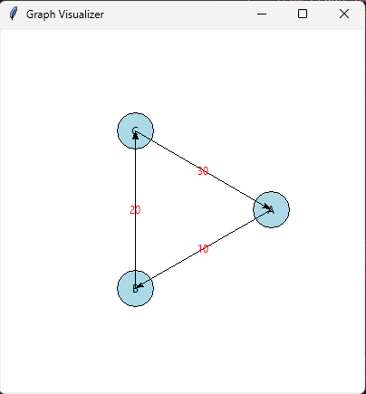
Task 7:
100 vertices 300 edges:
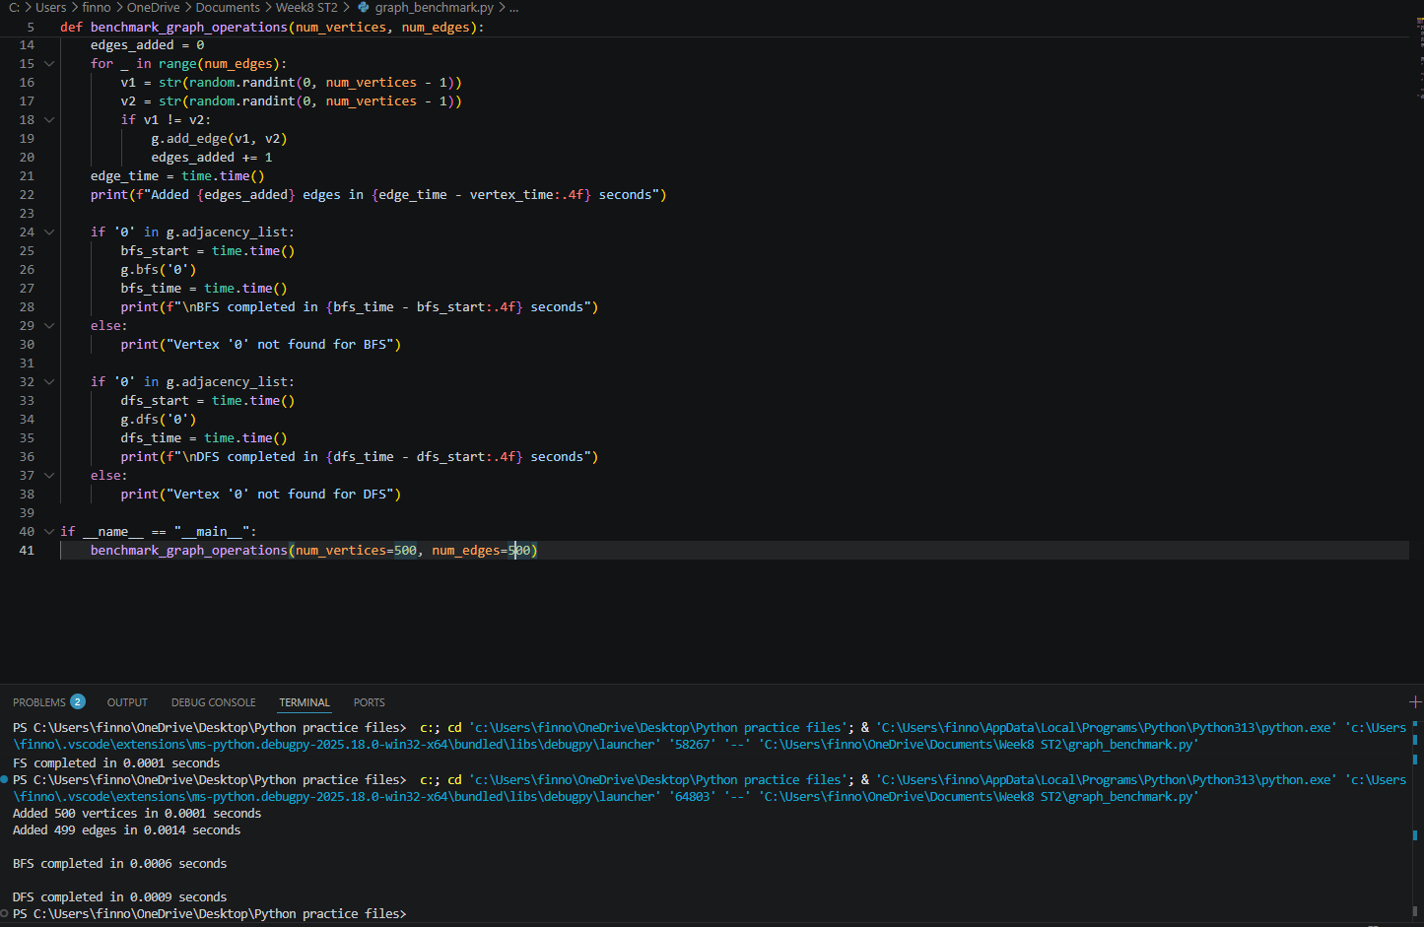

500 vertices 500 edges
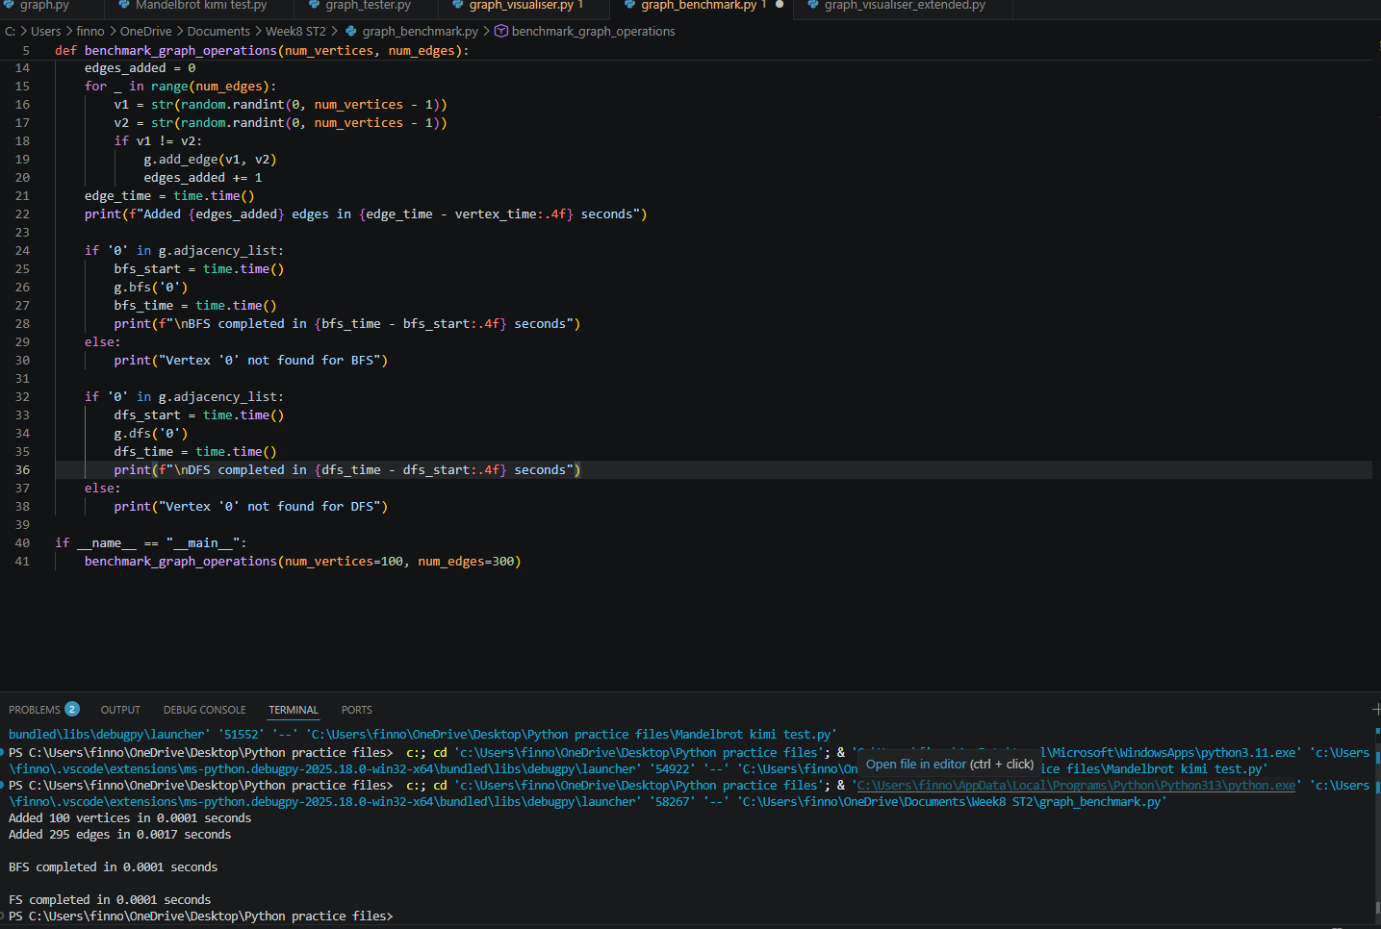
1000 vertices 3000 deges
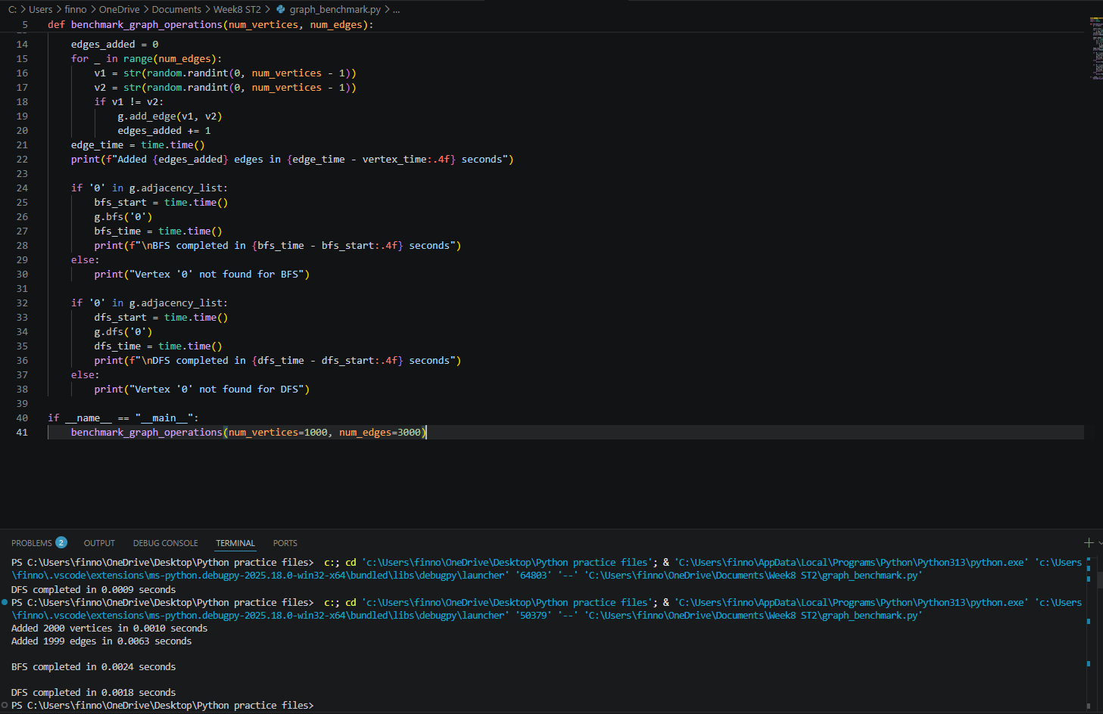

2000 edges 2000 vertices


Q7: discussions
In an adjacency list representation, adding a vertex is marginally faster than adding an edge because it requires only a single dictionary insertion to create an empty list, whereas adding an edge involves multiple hash lookups to retrieve existing adjacency lists, tuple creation for storing the neighbor (and optional weight), and list append operations. When traversing the graph, BFS and DFS share the same time complexity for complete traversals, as both must visit every node and examine every edge exactly once. This is shown within my results as there is little variance in the times between the two algorithms with dfs only being marginally faster in some cases.

Task 8: