BSL Tree:
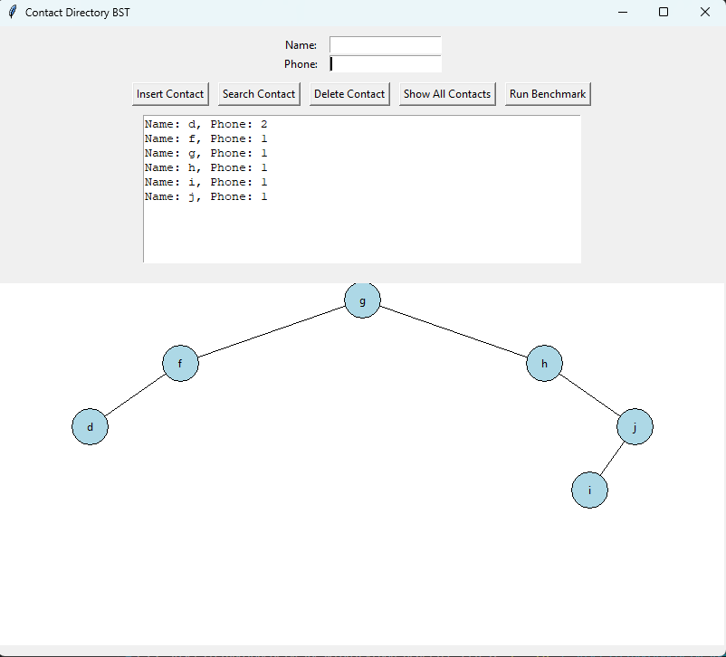
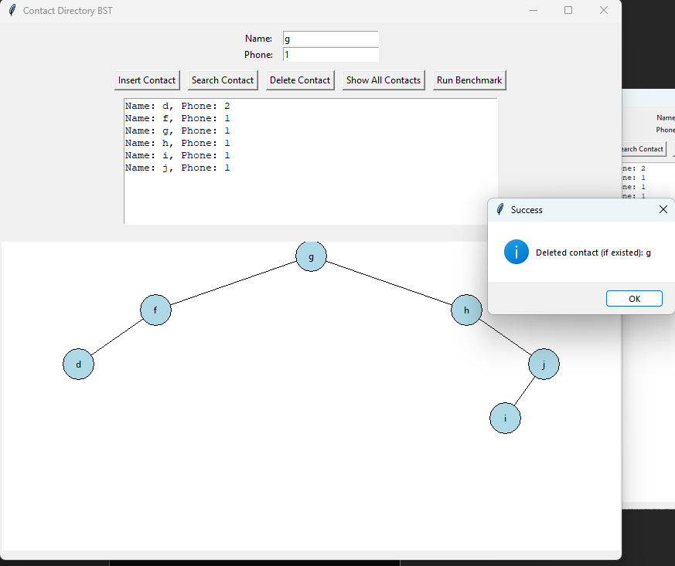
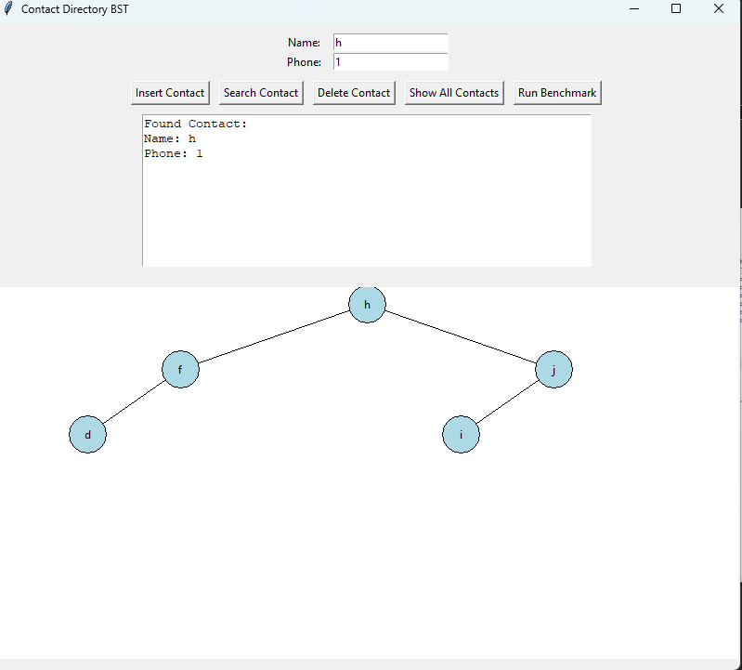
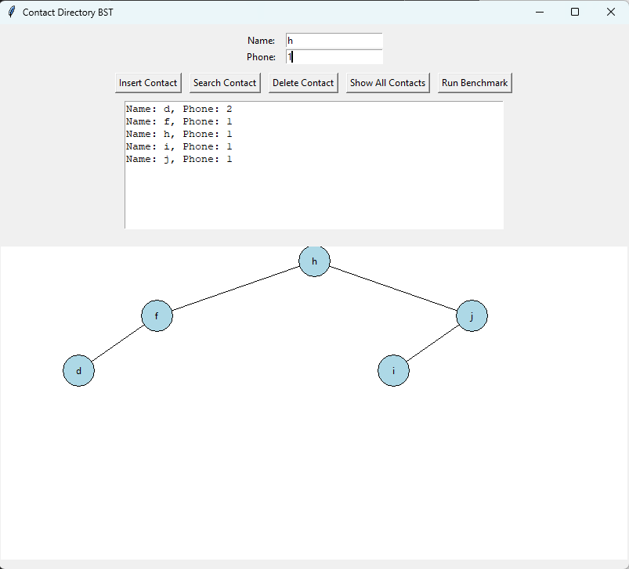

AVL Tree:
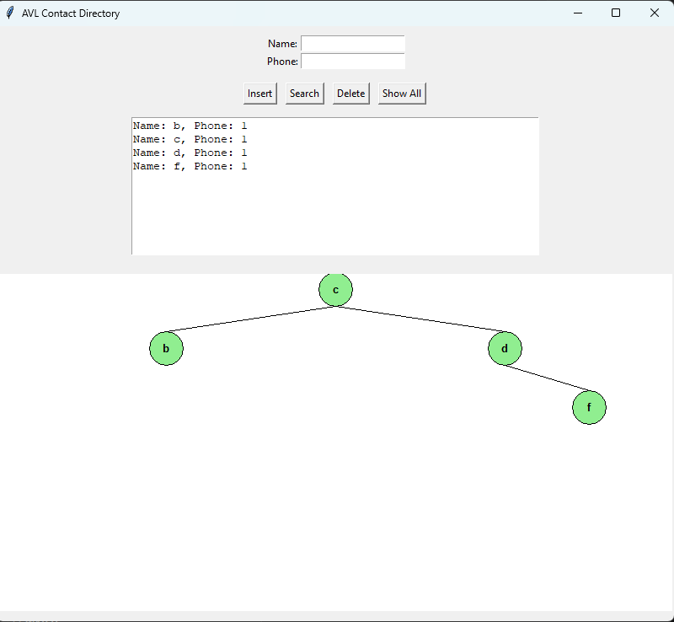
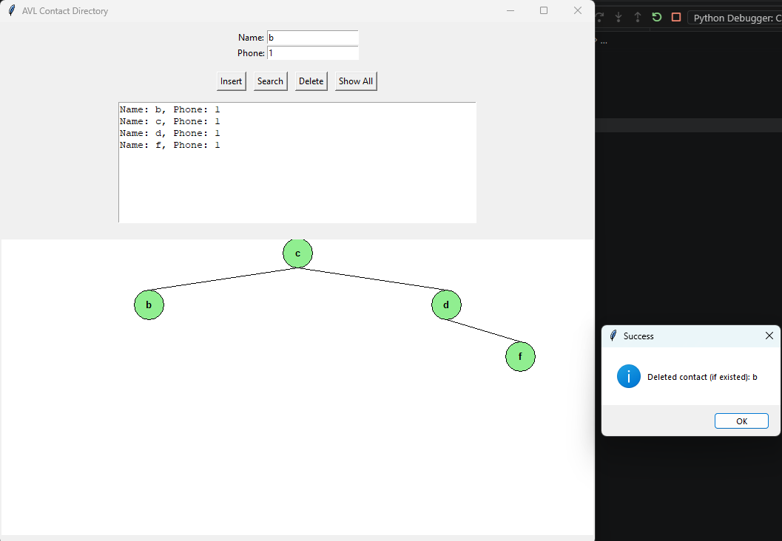
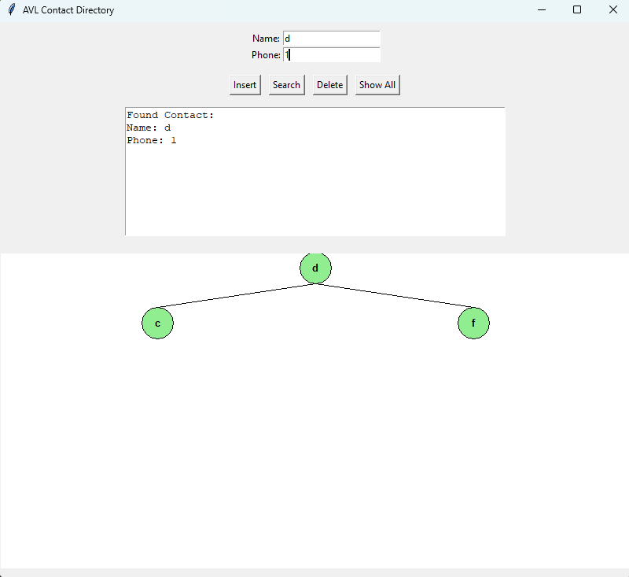

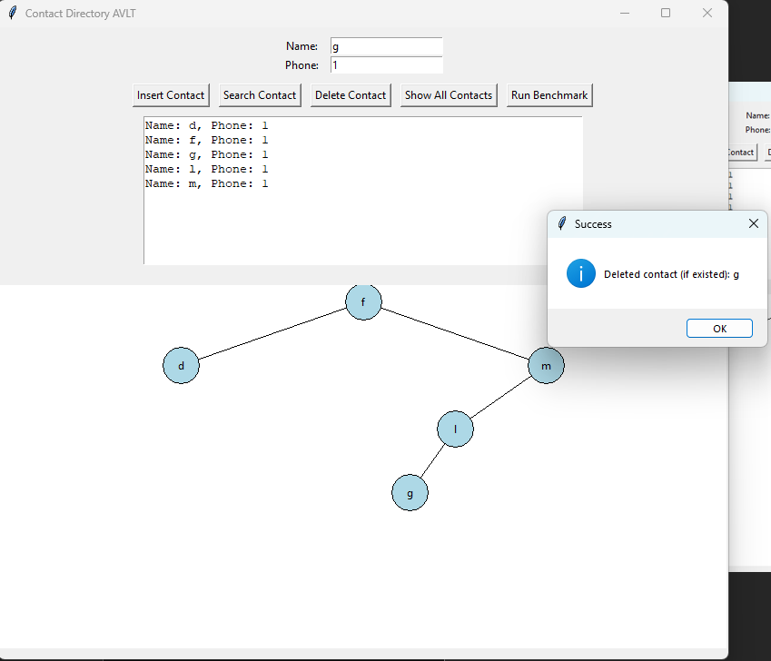
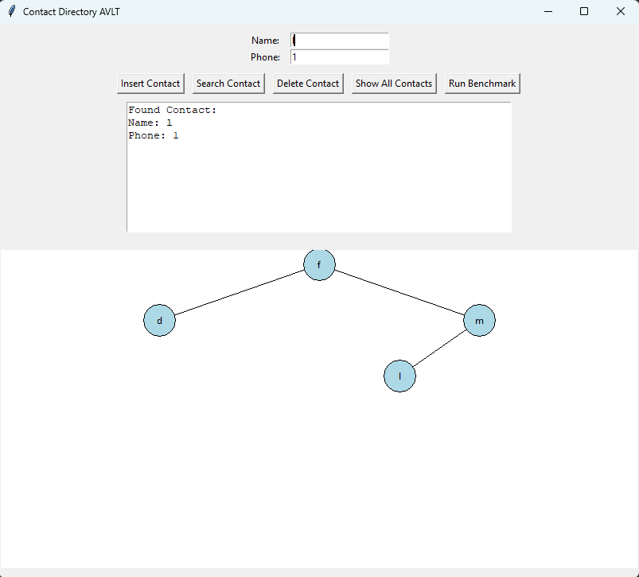

Benchmark Q4:
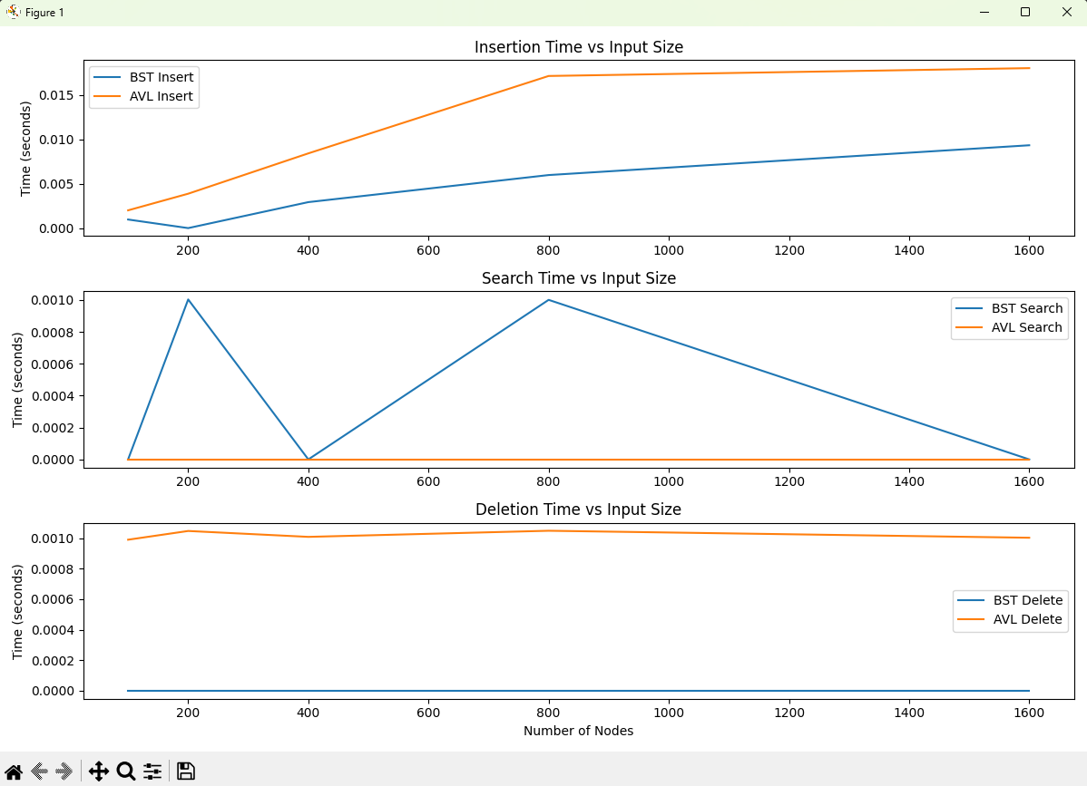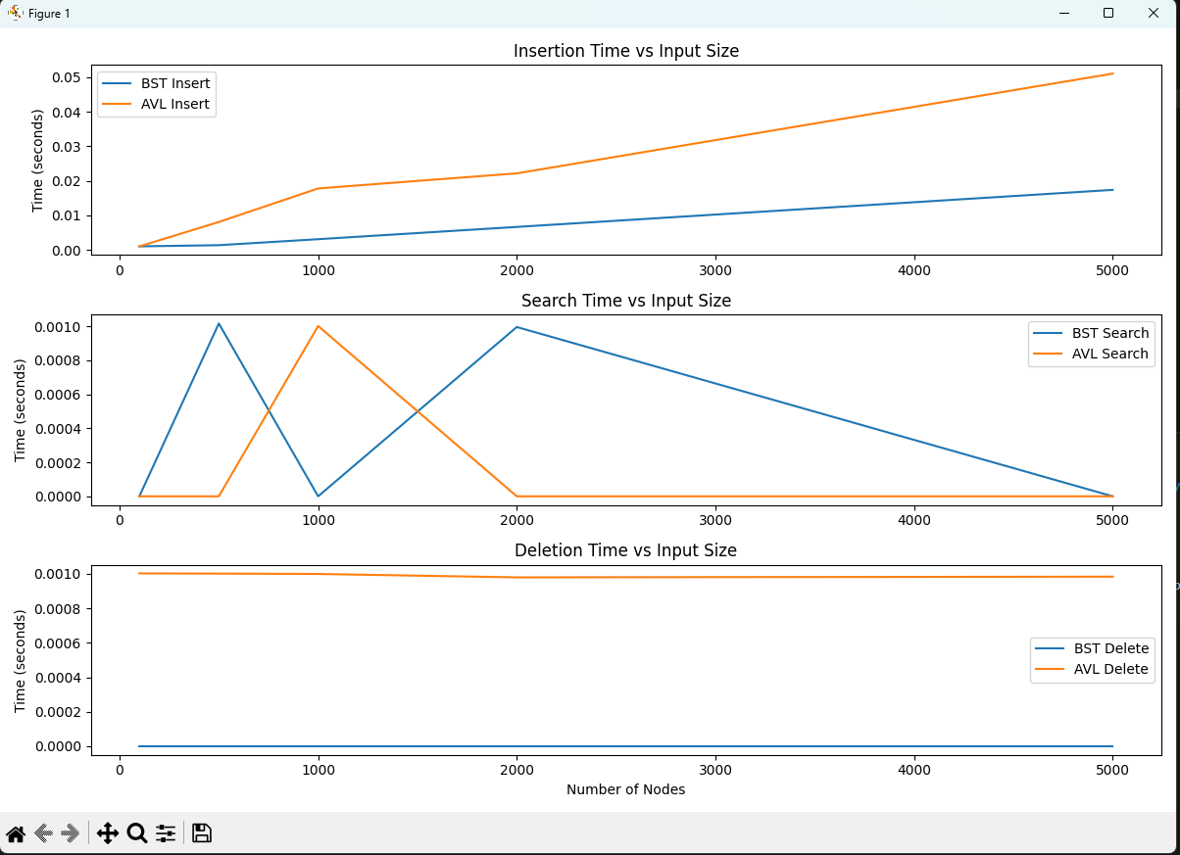
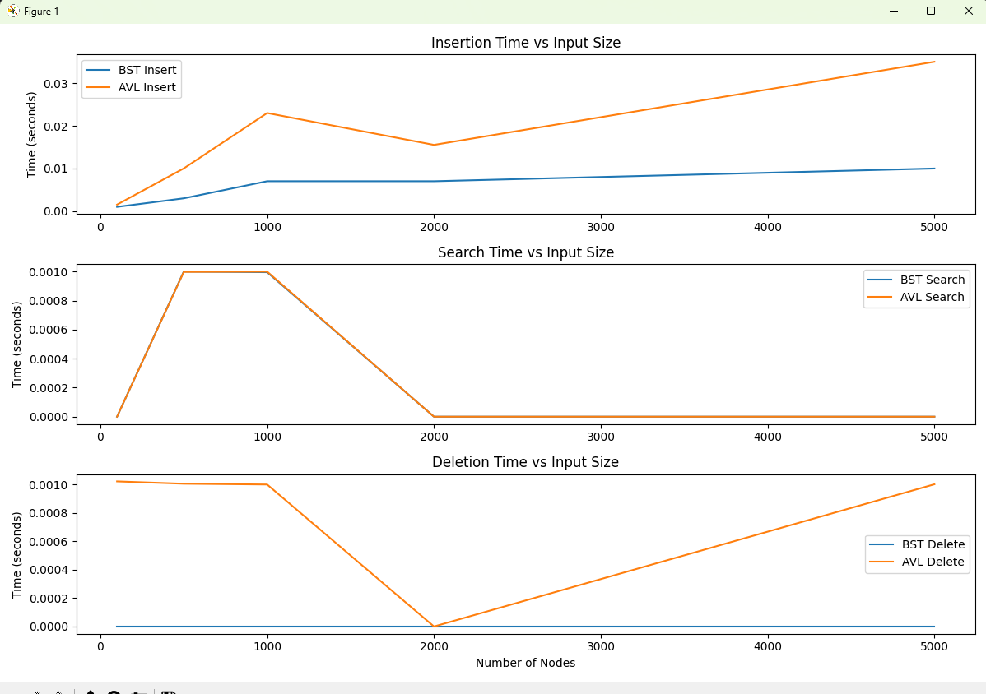
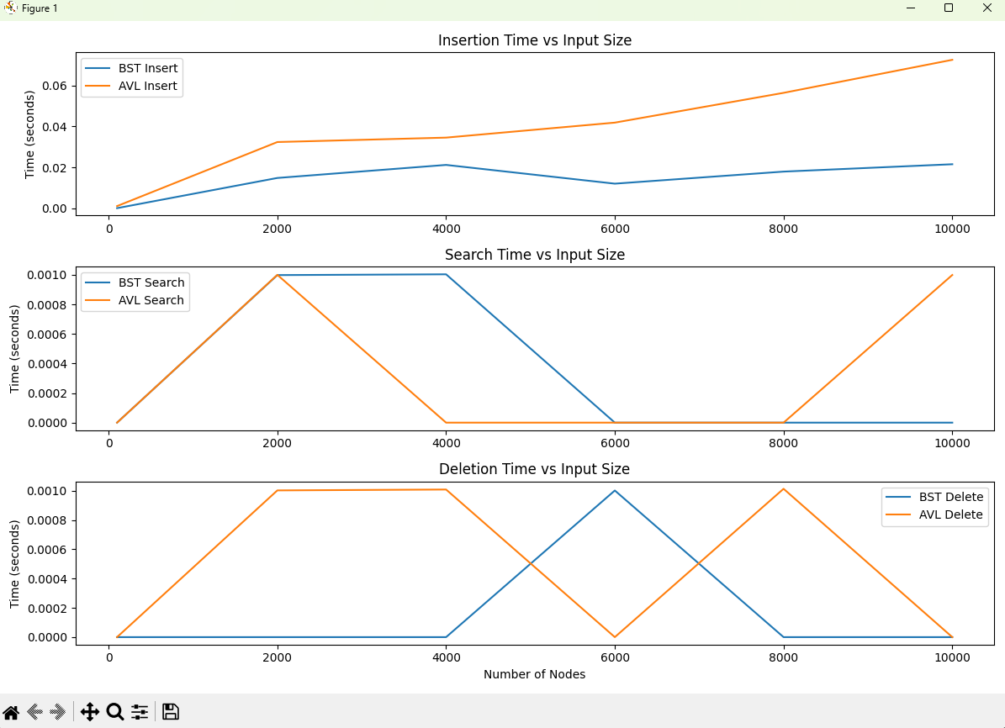

Q4 discussions:
"The results for insertion remain consistent with what you would expect, with the BST outperforming the AVL tree in speed. Within these graphs, the search and deletion comparisons appear quite erratic and do not follow strict rules. This is likely due to the speed at which these operations are performed, meaning the timer cannot reliably track them. Overall, due to limitations in how the code is written and the resolution of the time.perf_counter() function, these comparisons are only partially consistent with the expected results. I cannot accurately determine whether the BST degrades in certain data orders for search and delete due to the previously stated limitations. The BST experienced no significant degradation in insertion time within my tests, as expected, though this is likely due to the limited number of tests which are not sufficient to produce outlier results. AVL rotations are still likely to be the best choice for large data sets, as search and deletion should in theory become efficient enough to justify the additional cost in insertion time."

