Final Year Project Technical Report
BSc (Hons) Computing



Rota Scheduling App

Fionntan Doherty
L00172559

Declaration

- I have accurately identified and included the sources of all facts, ideas, opinions, and viewpoints from others in the assignment references. All direct quotations, paraphrasing, and discussions of ideas from books, journal articles, internet sources, course materials, or any other sources used are properly acknowledged and cited in the assignment references.
- I have not used unauthorised artificial intelligence tools or aids.
- I understand and am compliant with ATU's policy and procedures regarding Academic Integrity and I am aware of the consequences of any violations.
- I have followed the referencing guidelines recommended in the assignment instructions and / or programme documentation.
- I understand that not adhering to the word limits on each section will result in penalties.
- By signing this form or by submitting material online I confirm that this assignment, or any part of it, has not been previously submitted by me or any other person for assessment on this or any other programme of study.
- By signing this form or by submitting material for assessment online I confirm that I have read and understood AQAE022 Academic Integrity Policy.

I confirm I agree to this declaration. ☐

Print Signature: Fionntan Doherty

Date: 27/11/2025

Acknowledgements
I would like to thank my lecturers, whose expertise and encouragement played an important in shaping my understanding and helping me produce this report.
Table of Contents
Final Year Project Technical Report 1
1. Project Overview 1
1.1. Purpose 1
1.2. Objectives 1
1.2.1. One liner 1
1.2.2. Sub-Item 1
1.3. Project Scope 2
1.4. Definitions and Acronyms 2
2. Requirements 4
2.1. Functional Requirements 4
User (Staff) Features 4
Admin Features 5
AI Scheduling 5
Database & Data Management 6
2.2. Non-Functional Requirements 6
Performance 6
Security 6
Usability 6
Reliability 7
Scalability 7
Maintainability 7
3) System Architecture & Design 8
3.1 Hardware & Software Requirements 8
Development Environment 8
Runtime Environment 8
3.2 High-Level System Architecture 8
Frontend (Client) 8
Backend (Server) 8
Database Layer 9
AI Scheduling Component 9
3.3 Key Components and Interactions 9
3.4 Workflow Descriptions 10
Staff Workflow 10
Admin Workflow 10
3.5 Design and Implementation Constraints 10
3.6 System Qualities 10
3.7 Security Protocols 11
3.8 Testing Strategy (Overview) 11
4 Data Requirements 12
4.1 Data Model Overview 12
4.2 Entity-Relationship Diagram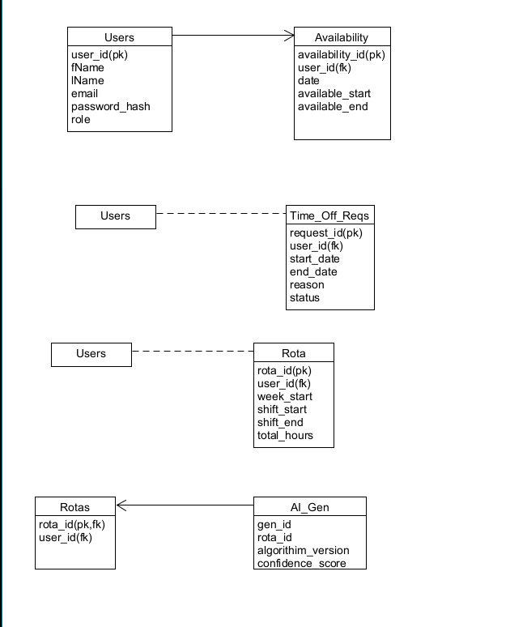 12
4.3 Database Schema 13
Table: Users 13
Field 13
Type 13
Description 13
Table: Availability 13
Field 13
Type 13
Description 13
Table: Time_Off_Request 13
Field 13
Type 13
Description 13
Table: Rotas 14
Field 14
Type 14
Description 14
Table: AI_Generated 14
Field 14
Type 14
Description 14
Trello Kanban Table 15
4.4 Data Flow Description 15
5. Implementation 16
5.1 Introduction 16
5.2 System Architecture 16
Frontend (React) 16
Backend (Node.js with Express) 16
Database (MySQL) 17
AI Scheduling Module (Python + Google OR-Tools) 17
5.3 Technologies Used 17
5.4 Development Process 18
5.5 Implementation Areas 18
5.5.1 User Authentication 18
5.5.2 Staff Interface 19
5.5.3 Admin Interface 19
5.5.4 AI Scheduling Module 19
5.5.5 Database Implementation 19
5.6 Challenges and Risks 19
5.7 Known Limitations 20
6) Testing & Evaluation 20
6.1 Testing Overview 20
6.2 Functional Testing 20
6.3 Integration Testing 21
6.4 Results and Evaluation 22
7. Conclusion 22
References i
Appendix B: Code Listing / GitHub Project Link ii

Table of Figures
Figure 1 Atlantic Technological University Donegal Logo 2
Figure 2 ATU Donegal, Letterkenny 2

Project Overview

Purpose
The purpose of this project is to design and develop an AI-assisted rota management system aimed at simplifying and improving the staff scheduling process for small to medium-sized businesses. The system will streamline the way staff interact with their work schedules by allowing users to view their weekly rotas, submit availability, request time off, and track their allocated hours.

For administrators, the system will provide a comprehensive management interface through which they can create, edit and approve entries, manage staff records and respond to absence or holiday requests. A core aim of project is to reduce the significant amount of manual effort typically involved in constructing weekly rotas, while also addressing common issues such as understaffing, overstaffing and unfair distribution of hours.

By integrating an AI-driven scheduling component, the application will support automated, unbiased decision-making on staff availability, business requirements, and organisational constraints. This approach is intended to improve efficiency, enhance fairness and provide a more reliable method of generating consistent weekly schedules.

Objectives

One liner
- To create an intuitive, user-friendly rota management system enhanced by AI-driven scheduling.

Sub-Item
- To develop a secure login system enabling staff and administrators to access personalised rota information.
- To display weekly working hours, including past, present and upcoming schedules, through a simple, clear and easy navigable interface.
- To allow employees to submit availability, request leave and track holiday entitlement directly within the application.
- To allow employees to view the full weekly rota, providing transparency around shift allocation and team coverage.
- To provide administrators with the ability to manage staff profiles, review and approve or decline leave requests, and adjust rota entries where necessary.
- To integrate an AI component capable of generating optimised rotas based on staff availability, preferences, workload balance considerations and business staffing requirements.
- To ensure that the system is scalable, adjustable and usable across a range of industries beyond hospitality.

Project Scope
This project will involve the design, development and evaluation of a responsive rota management application accessible on both mobile and desktop devices. The system will include dedicated interfaces for staff and administrators, offering features such as rota viewing, availability submission, AI-driven schedule generation and an administrative control panel for rota oversight.

A secure database will be implemented to store user data, rota entries, availability records, and leave requests. Staff members will be uniquely identified using a staff ID or employee number to ensure accurate data handling and reduce the risk of scheduling conflicts.

The primary focus of the primary will be usability, accessibility and workflow automation, ensuring that both employees and managers can operate the system with minimal training. While the application will include essential scheduling functionality, external integrations such as payroll systems, HR platforms or automated notifications are considered outside the scope of current project. These may be explored as potential future development if the application is expanded beyond the initial academic year.

Definitions and Acronyms
AI - Artificial Intelligence: | Technologies that enable computer systems to perform tasks that typically require human intelligence, such as pattern recognition, reasoning, and decision-making.
Rota | A timetable or schedule that outlines staff working hours, shift allocations, and responsibilities.
UI – User Interface. | The visual layout and interactive components of the application that the user interacts with
UX – User Experience: | The overall ease of use, efficiency, and satisfaction a user experiences when interacting with the system.
IDE – Integrated Development Environment: | A software application that provides tools to assist programmers in writing, testing, and debugging code efficiently.
VS / VS Code – Visual Studio / Visual Studio Code: | IDE/editor tools used for software development.
HR – Human Resources: | A department or set of responsibilities related to managing employee information, staffing, payroll, and organisational policies.
GDPR – General Data Protection Regulation: | A data protection law in the EU/UK that governs the collection, storage, and processing of personal information.
API – Application Programming Interface: | A set of rules that allows different software components to communicate with one another, typically using HTTP requests.
HTTPS – Hypertext Transfer Protocol Secure: | The secure version of HTTP. Ensures encrypted communication between a user’s browser and a server.
JWT – JSON Web Token | A compact, secure token format used for verifying user identity and managing login sessions in web applications.
Hashing | A cryptographic process used to convert data (e.g., passwords) into a fixed-length, irreversible value for secure storage.
CRUD – Create, Read, Update, Delete: | The four basic operations performed on a database or persistent data store.
SQL – Structured Query Language: | A standard language used to manage and query databases.
SQLite: | A lightweight, file-based relational database system used to store application data locally.
Unique Identifier / Staff ID: | A numeric or alphanumeric value assigned to each staff member to distinguish them in the database.
CP – Constraint Programming: | A computational method used to solve scheduling and optimisation problems by applying rules and constraints — used by OR-Tools.
OR-Tools: | An open-source optimisation library developed by Google used for solving routing, scheduling, and constraint-based problems.
JSON – JavaScript Object Notation: | A lightweight data format used for sending and receiving structured data between the frontend, backend, and AI scheduler.
Front-End: | The part of the application that users directly interact with (UI/UX).
Back-End: | The server-side logic responsible for processing data, managing requests, and communicating with the database and AI module.
Authentication: | The process of verifying a user’s identity when logging into the system.
Authorisation: | Controlling what each user (staff/admin) is allowed to access or modify within the system.
Encryption: | The process of encoding data to prevent unauthorised access, used to protect sensitive information.
Scheduling Algorithm: | The computational method used to assign staff to shifts based on rules, availability, and constraints.
CP-SAT | (Constraint Programming – Satisfiability) solver is used to evaluate possible shift assignments and determine a feasible solution that satisfies all defined constraints

Requirements

Functional Requirements

User (Staff) Features
- User Authentication
- Users must be able to create an account or log in securely using a username or email and password.
- The system must verify the identity of each user through encrypted credentials and session handling.
- View Rota
- Users must be able to view their weekly schedule, including start/end times, total hours worked and assigned roles.
- Users must be able to view past and upcoming rotas.
- Rotas should display weekly hours at a glance to support transparency and planning.
- Submit Availability
  - Users must be able to submit their availability for upcoming weeks using an intuitive form.
  - The system must validate availability inputs and store them securely in the database.
- Request Leave / Time Off
  - Users must be able to request annual leave, sick leave or general absences.
  - Users must be able to view the status of their requests (pending, approved, declined)
  - Users should receive notification or visual confirmation when request status changes.
- View Holiday Entitlement
  - Users must be able to access their remaining holiday balance.
  - Users must be able to view previous leave taken and understand accrual patterns.

Admin Features
- Admin Authentication
  - Administrators must have access to a dedicated login route with elevated permissions.
  - Only authenticated admins should access sensitive features such as rota editing, staff management and approval workflow.
- Manage Staff Profiles
  - Administrators must be able to add new staff, update profile details, and remove staff from the system.
  - Admins should be able to assign roles, employment status (full-time/ part-time), and contracted hours.
- Review Leave Requests
  - Administrators must be able to approve, or decline leave requests submitted by staff.
  - The system should log all decisions and store them in the database for auditing purposes.
- Edit Rota Manually
  - Administrators must be able to manually create or adjust shifts where necessary.
  - Admins must be able to override AI-generated schedules to address special cases or staffing emergencies.

AI Scheduling
- Generate Rota Automatically
  - The system must be able to generate a weekly rota using the AI scheduling module.
  - The AI must consider staff availability, business requirements, fairness rules and staffing constraints.
- Analyse Staff Data
  - The AI must analyse user-submitted data (availability, assigned shifts, historical patterns) to produce accurate and balanced schedules.
  - The system should ensure that maximum working hours are not exceeded, and fairness is maintained across employees.
- Provide Optimised Output
  - The AI must return the schedule in a structured data format (e.g. JSON) for display and further editing.
  - The module must flag conflicts or infeasible schedules for administrators to review.

Database & Data Management
- Store User Data
  - The system must store staff information, rota entries, availability submissions and leave requests in a secure relational database.
  - Each user must be uniquely identified using a staff ID or employee number.
- Retrieve and Update Rota Information
  - The system must dynamically retrieve and display rota updates across both staff and admin dashboards.
  - Changes to rotas must be propagated in real time or upon refresh.
- Maintain Data Integrity
  - All database operations must ensure referential integrity, preventing orphaned records or mismatched staff entries.

Non-Functional Requirements

Performance
- The system should generate an AI-powered rota within 5 seconds under typical scheduling loads.
- Screen transitions, rota loading and data retrieval operations should complete within 2 seconds.
- The application must support multiple concurrent users without performance degradation.

Security
- All passwords must be encrypted using secure hashing algorithms (e.g. bcrypt).
- User data must be processed and stored in compliance with GDPR guidelines.
- Clear permissions boundaries must exist between staff and admin accounts.
- Sensitive operations (profile editing, rota approval, AI generation) must require authenticated and authorised access.

Usability
- The interface should be simple, intuitive and require minimal training for both staff and administrators.
- Key features such as rota viewing, availability submissions and requests must be accessible within two clicks.
- The design should be mobile and desktop friendly.

Reliability
- The system should maintain 99% up time during active usage periods.
- The system must fail safely, ensuring no loss of data during errors or unexpected shutdowns.
- Regular backups should be enabled or supported.

Scalability
- The system must support small teams (5-20 staff) and scale to larger organisations with 100+ employees.
- The database schema must allow for future extensions (e.g. payroll linking, wage calculations, shift templates.)
- The AI scheduling module should be adaptable to increased data volume and more complex constraints.

Maintainability
- The system must be built with a modular architecture so individual components (AI module, UI, backend API) can be updated independently.
- Code should follow standard conventions and be documented to facilitate future development.
- The architecture should support versioning and incremental improvements without major redesign.

3) System Architecture & Design

3.1 Hardware & Software Requirements

Development Environment
The system will be developed using industry-standard tools that support rapid prototyping, modularity and cross-platform development:
- Operating System: Windows 11 – chosen for compatibility with development tools and ease of testing.
- Programming Language: JavaScript for the frontend and backend, as widely used in modern web applications development (Flanagan, 2020).
- Fronted Framework: React, selected for its component-based architecture, reactivity and strong support ecosystem (React Documentation, 2025)
- Backend Framework: Node.js with Express, chosen for its scalability, non-blocking event-driven model, and suitability for REST API development (Tilkov & Vinoski, 2010).
- Database: SQLite for development and testing or MySQL for deployment environments that require higher scalability.
- AI Component: Python, chosen due to its strong support for optimisation libraries and machine learning frameworks.
- IDE: Visual Studio Code (VS Code) for code editing, debugging and integrated version control.

Runtime Environment
- Client: Runs in any modern web browser (e.g. Chrome, Edge, Safari) or wrapped inside a mobile container such as React Native or Capacitor.
- Server: Hosted on a local server during development and optionally deployed to a cloud provider such as Microsoft Azure or Firebase for scalability and availability.
- Database: Local SQLite or cloud-hosted MySQL instance depending on deployment and configuration.

3.2 High-Level System Architecture
The application follows a modular, three-tier architecture consisting of the frontend (the client), the backend (the server) and the database layer, supported by a separate AI scheduling component.

Frontend (Client)
- Provides an intuitive user interface for employees and administrators.
- Displays rotas, availability forms, leave requests and administrative controls.
- Handles user interactions, form validation and navigation.
- Sends API requests to the backend using HTTPS.
- Built using React components to maximise reusability and maintainability.

Backend (Server)
- Implements RESTful API endpoints for authentication, rota retrieval, availability submission, staff management and AI scheduling requests (Richardson & Ruby, 2007)
- Validates and processes all incoming user data.
- Enforces access control rules to separate staff and admin permissions.
- Contains core business logic (e.g., granting or rejecting leave requests)
- Sends structured JSON data to the AI scheduling module.

Database Layer
Stores all persistent data, including:
  - User accounts
  - Rota Schedules
  - Availability submissions
  - Time-off requests
  - AI-generated schedules
  - Unique staff identifiers
The relational structure ensures fast lookup times and referential integrity.

AI Scheduling Component
The rota generation module will be implemented using a constraint-solving approach powered by Google OR-Tools, an optimisation library specifically designed for resource allocation and scheduling problems (Google OR-Tools,2025)
OR Tools enables the application to enforce constraints such as:
- Staff availability
- Contracted maximum hours
- Fairness rules
- Required shift coverage
- Approved leave
- Business staffing requirements
Constraint programming is well documented as a robust approach for scheduling tasks due to its ability to guarantee feasible solutions without requiring training data (Google Developers, 2025). This makes OR-Tools an appropriate method for workforce scheduling as supported by prior research in hospitality labour planning (Thomson, 2004).

3.3 Key Components and Interactions
- Authentication Module
- Handles user login, registration, session management and secure password hashing.
- Distinguishes between staff and administrator roles.
- Uses industry-standard token-based authentication (JWT).
- Staff Dashboard
  - Displays weekly rota, total assigned hours and shift details.
  - Allows staff to submit availability, request leave and review leave status.
  - Allows staff to request rota changes when issues arise (e.g., overtime or conflicts).
- Admin Dashboard
  - Provides tools for managing staff profiles and viewing the full staff list.
  - Displays employee information including unique identifiers.
  - Allows approval or refusal of leave requests.
  - Enables manual rota adjustments and overrides of AI-generated schedules.
- Rota Generation Module
  - Sends scheduling data (availability, constraints, staffing requirements) to the AI module via API-based communication.
  - Receives the optimised rota in JSON format and stores it in the database.
  - Allows administrators to preview and edit the rota before publishing.
- Notifications Module
  - Optional future features: email/SMS/push notifications, which can be chosen by the staff receiving the notification.
  - Notifications may be configurable based on user preference.

3.4 Workflow Descriptions

Staff Workflow
- Staff logs in using secure authentication.
- System retrieves rota showcasing the full rota for the week relevant to department.
- User views schedule / submits availability and requests.
- Data is validated and stored in database.
- AI uses stored data during rota generation to ensure accurate scheduling.

Admin Workflow
- Admin logs in using elevated credentials.
- Admin dashboard displays staff list, pending requests and rota overview.
- Admin review and approves/declines leave requests.
- Admin triggers the AI scheduler or manually edits rota entries.
- Final rota is published and becomes visible to staff.

3.5 Design and Implementation Constraints
- The system must comply with GDPR for handling personal employee data (ICO, 2024).
- AI-generated schedules must not violate labour regulations (e.g., maximum hours).
- The interface must support future scaling (additional departments, branches or staff numbers).
- The database must support future scaling (additional departments, branches or staff numbers).
- Cross-browser compatibility must be maintained.

3.6 System Qualities
- Maintainability: Modular architecture ensures updates to the AI, UI or backend can occur independently.
- Extensibility: Additional features (e.g. payroll integration, shift swapping, analytics) can be added via APIs.
- Usability: The UI emphasises clarity and ease of navigation, requiring minimal training.
- Security: Includes data encryption, secure authentication and role-based access control.
- Performance: Backend responses and database lookups must remain efficient even under increased under load.

3.7 Security Protocols
- Password hashing using secure algorithms (e.g., bcrypt).
- Token-based authentication (JWT) for session management.
- Role-based permissions for separating user and admin capabilities.
- Input validation to prevent SQL injection and XSS attacks.
- HTTPS for secure data transmission in production environments.

3.8 Testing Strategy (Overview)
- Unit Testing: Backend logic form validation, AI module inputs/outputs.
- Frontend Usability Testing: Ensuring UI clarity and minimal click navigation.
- Integration Testing: Backend API AI scheduler Database.
- System Testing: Full rota creation workflow, including admin overrides.
- Error Handling Tests: Incorrect inputs, missing fields, access violations and failed AI outputs.

4 Data Requirements

4.1 Data Model Overview
The rota management system requires a structed data model to store information about users, availability, rotas, time-off requests and admin actions.
Data will be stored in a relational database (e.g. SQLite or PostgreSQL), as this structure ensures:
- Consistency
- Data integrity
- Easy querying
- Clear relationships between entities
All users will be identified by a unique staff identifier, ensuring accurate tracking across the system.

4.2 Entity-Relationship Diagram

4.3 Database Schema

Table: Users
Field | Type | Description
user_id(pk) | Integer | Unique ID for each user
fName | String | Staff first name
lName | String | Staff last name
email | String | Unique login email
password_hash | String | Encrypted password
role | String | Staff or Admin

Table: Availability
Field | Type | Description
availability_id(pk) | Integer | Unique entry for availability
user_id(fk) | Integer | References USERS.users_id
date | Date | Date of availability
available_start | Time | Start time user is available
available_end | TIme | End time user is available

Table: Time_Off_Request
Field | Type | Description
request_id(pk) | Integer | Unique time-off request
users_id(fk) | Integer | Request owner
start_date | Date | First day of requested leave
end_date | Date | Last day of requested leave
reason | String | Optional reason
status | String | Pending/Approved/Rejected

Table: Rotas
Field | Type | Description
rota_id(pk) | Integer | Unique rota entry
user_id(fk) | Integer | Assigned Staff member
week_start | Date | Week the rota belongs to
shift_start | Date Time | Shift Start
shift_end | Date Time | Shift End
total_hours | Real | Automatically calculated

Table: AI_Generated
Field | Type | Description
gen_id(pk) | Integer | Unique generation record
rota_ID(fk) | Integer | Links to the rota created by AI
algorithm_version | String | Version number of AI algorithm
confidence_score | Real | How confident the AI was in this allocation

Trello Kanban Table
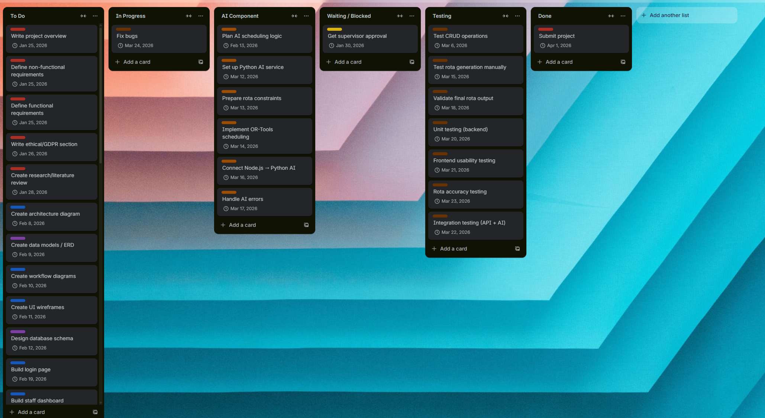
Due to limited access to Microsoft Project, which was the initially planned software for creating a Gantt chart, Trello was chosen as the primary project management tool. Trello’s Kanban-style board provided a flexible and visually intuitive way to organise tasks by status, including dedicated columns for “To Do,” “In Progress,” “Testing,” and “AI Component.” This format supported agile development principles and allowed for real-time tracking of progress and deadlines.

Data Flow Description

- Staff Data Flow
  - User logs in System retrieves USERS data.
  - User views rota Data pulled from ROTAS table.
  - User submits availability Stored in AVAILABILTY.
  - User requests time off Stored in TIME_OFF_REQS.
- Admin Data Flows
  - Admin logs in Retrieves users list from USERS.
  - Reviews time-off requests Reads from TIME_OFF_REQS.
  - Approves or rejects Updates requests status.
  - Triggers AI AI module reads AVAILABILITY and ROTAS.
  - AI writes new rota suggestion Stored in AI_GENERATED.
  - Admin approves rota Data saved into ROTAS.
- AI Data Flow
  - System gathers availability + previous shifts.
  - Prepares dataset for AI.
  - AI generates schedule.
  - AI sends rota data back to backend.
  - Backend inserts into ROTAS and AI Generated tables.

5. Implementation

5.1 Introduction
This chapter outlines the implementation of the AI-assisted rota management application, linking the development process to the aims and objectives defined earlier in the project. The primary aim was to create a user-friendly system capable of managing staff schedules while reducing manual workload through automation.
The implemented system successfully delivers core functionality, including user authentication, rota viewing, time-off request handling, and administrative control over scheduling. These features address the objective of improving accessibility and usability for both staff and administrators.
Additionally, the project aimed to explore the use of AI in scheduling. While the AI scheduling component has been mostly implemented through the integration of Google OR-Tools, further refinement is required to fully realise automated rota optimisation. Overall, the system meets a majority of the intended objectives, with some advanced features identified for future development.

5.2 System Architecture
The system follows a layered architecture consisting of four key components: frontend, backend, database, and AI scheduling module.

Frontend (React)
The frontend provides the user interface for both staff and administrators. It includes:
- Weekly rota views
- Time-off request submission forms
- Administrative dashboards
- Shift management functionality
The frontend communicates with the backend using RESTful API requests (GET, POST, PUT, DELETE) to retrieve and update data dynamically.

Backend (Node.js with Express)
The backend is implemented using Node.js and Express. It provides RESTful API endpoints responsible for:
- User authentication
- Managing schedules
- Handling time-off requests
- Processing database interactions
Business logic is handled within route controllers. The backend processes database query results and converts them into structured JSON format for frontend use.

Database (MySQL)
A relational MySQL database is used to store:
- Users
- Schedules
- Time-off requests
Primary keys are defined for each table, and ENUM fields are used to enforce controlled values. A composite unique constraint prevents duplicate shift assignments.
Currently, employee names are used instead of foreign key references. While this works for the prototype, it limits scalability and data integrity. Future improvements will replace this with proper relational links using user IDs.

AI Scheduling Module (Python + Google OR-Tools)
The AI scheduling component has been partially implemented using Python and Google OR-Tools. It generates optimised rota schedules by applying constraint-based logic. Google OR-Tools is an optimisation library that uses constraint programming techniques to solve complex scheduling and resource allocation problems. In this project, the CP-SAT (Constraint Programming – Satisfiability) solver is used to evaluate possible shift assignments and determine a feasible solution that satisfies all defined constraints.
The system:
- Retrieves staff data and approved leave from the database
- Applies constraints such as availability, maximum working hours, and staffing requirements
- Generates a feasible rota using the OR-Tools CP-SAT solver
Within the model, decision variables are used to represent whether a staff member is assigned to a particular shift, while constraints ensure valid scheduling conditions such as limiting employees to one shift per day and preventing assignments during approved leave. The solver then evaluates these constraints to produce a valid schedule.
The backend triggers the AI module, receives the generated schedule, and stores it in the database. This modular design allows the AI component to operate independently from the main application, improving maintainability and flexibility. This layered architecture ensures clear separation of concerns, improving maintainability, scalability, and ease of future development.

5.3 Technologies Used
The system was developed using a combination of modern web technologies and optimisation tools, chosen for their suitability in building scalable and maintainable applications.
- React was used for the frontend due to its component-based architecture and ability to create dynamic user interfaces.
- Node.js with Express was used for the backend to handle API requests, authentication, and business logic.
- MySQL was selected as the relational database management system to store user data, rota schedules, and time-off requests.
- Google OR-Tools was used within a Python environment to implement the AI scheduling component. This library provides constraint programming capabilities, allowing the system to generate rotas based on defined rules such as staff availability and approved leave.
- GitHub was used for version control to manage code changes and track development progress.

5.4 Development Process

The rota management application was developed using an iterative and incremental approach. Rather than attempting to build everything at once, core functionality such as user authentication, rota creation and display, and database integration was prioritised first. Developing these features early made sure that I had a functioning system before moving on to more advanced functionality, this approach also allowed for clearer testing without needing to revisit more complex components later in development.
Each feature was developed individually, tested, and refined before progressing further. This allowed issues to be identified early and reduced the risk of larger structural problems later in development.
Version control was managed using GitHub. Although the original intention was to use separate branches for each feature, development was primarily carried out on the main branch. Regular commits were made throughout the process to track progress and maintain a clear history of changes. Commit messages were written logically to reflect feature additions, improvements, and fixes, ensuring traceability across the development lifecycle.
While the iterative approach was effective, greater use of branching in version control would have improved code management and reduced potential integration issues.

5.5 Implementation Areas

5.5.1 User Authentication
A login system has been implemented using bcrypt for password hashing and secure credential validation. During authentication, passwords are compared against hashed values stored in the database.

5.5.2 Staff Interface
The staff interface includes:
- Viewing weekly and upcoming rotas
- Viewing personal shift assignments
- Submitting time-off requests
Availability submission and automatic working hour calculations are not fully implemented and are identified as future improvements.

5.5.3 Admin Interface
The admin interface includes:
- Viewing all staff profiles
- Reviewing and managing time-off requests
- Editing rotas manually
- Assigning and removing staff from shifts
Role-based permissions are partially implemented to restrict access to administrative functionality.

5.5.4 AI Scheduling Module
The AI module has been partially implemented using constraint programming. It analyses:
- Staff availability
- Time-off requests
- Scheduling constraints
The module generates a draft rota that administrators can review and adjust before final publishing.

The scheduling system is implemented using constraint programming, where decision variables and constraints are defined to model the rota problem.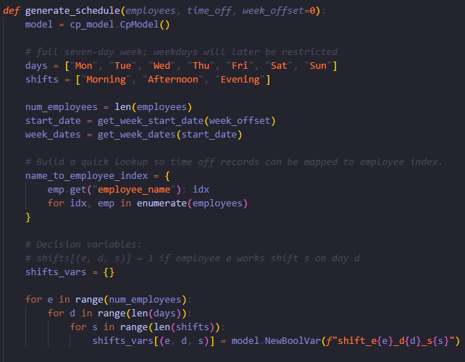
The scheduling model is initialised using the OR-Tools CP-SAT solver, where decision variables are defined to represent possible shift assignments. As shown in Figure X, a binary variable is created for each employee, day, and shift combination. These variables take a value of 1 if an employee is assigned to a shift, and 0 otherwise. This structure allows the system to evaluate all possible scheduling combinations and apply constraints to determine a valid rota.

One of the constraints implemented ensures that each employee is assigned to a maximum of one shift per day. 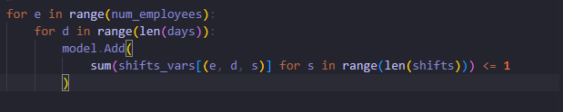
As shown above, a constraint is applied within the model to ensure that each employee can only be assigned to one shift per day. This is achieved by summing all possible shift assignments for a given employee on a specific day and enforcing that the total must be less than or equal to one. This prevents overlapping shift allocations and ensures that the generated rota is realistic and adheres to basic working conditions. This constraint is essential to maintaining schedule validity and preventing conflicting shift assignments within the generated rota.

5.5.5 Database Implementation
The database schema includes tables for users, schedules, and time-off requests. Primary keys and unique constraints are used to maintain data integrity. Parameterised queries are implemented to prevent SQL injection vulnerabilities.

5.6 Challenges and Risks
Several potential challenges are expected during implementation:
- Security limitations: While password hashing is implemented, full authentication middleware and route protection need to be improved.
- Relational design trade-offs: Using employee names rather than foreign keys simplifies development but reduces scalability and maintainability.
- Data consistency: Ensuring the rota assignments do not conflict with approved time off requests needs tweaked.
- AI modelling complexity: Translating business scheduling rules into formal constraints definitions introduces technical complexity.
- Project scope management: Time constraints limited implementation of advanced features such as automatic shift swapping and predictive demand forecasting.

5.7 Known Limitations
My current system has the following limitations:
- No full JWT or session-based authentication system
- No middleware-enforced role-based authentication system
- No automated detection of rota conflicts with approved leave (planned)
- No integration with payroll or HR systems
- No automated notifications
These limitations highlight areas for future improvement and demonstrate that the current system represents a functional prototype rather than a fully production ready solution.

6) Testing & Evaluation

6.1 Testing Overview
Testing was done throughout development to ensure that the rota management system functions correctly and reliably. The testing process focused on verifying that key features such as user authentication, rota management, and time-off request handling worked as expected. Testing was performed using a combination of manual functional testing and API testing.
The backend API built using Node.js and Express was tested by sending requests to its endpoints and checking that the correct responses were returned. This verified that the server could successfully retrieve and store data in the MySQL database.
Testing also focused on validating the interaction between the frontend, backend, and database layers. This ensured that user actions such as submitting time-off requests or viewing schedules resulted in the correct updates within the database.
Preliminary testing was also carried out on the Python scheduling module to ensure that the backend could successfully execute the script and receive the schedule data it generated.

6.2 Functional Testing
Functional testing was used to confirm that the system behaves according to the intended design. Each major feature of the application was tested individually to verify that it performs the correct operations and handles user input appropriately.
Functional testing focused on validating the behaviour of implemented features rather than fully developed production-level functionality.
Example Functional Tests
Test ID | Feature | Test Description | Expected Result | Actual Result | Status
T1 | Server Health Check | Access /api/health endpoint | Server returns status message | JSON response returned | Pass
T2 | User Login | Enter valid login credentials | User successfully authenticated | Login successful | Pass
T3 | Invalid Login | Enter incorrect password | Error message returned | Error returned | Pass
T4 | View Schedule | Request rota from /api/schedule | Schedule data returned from database | Schedule displayed | Pass
T5 | Submit Time Off | Staff submits time-off request | Request stored in database | Request successfully stored | Pass
T6 | Admin View Time Off | Admin retrieves requests | All requests returned | Data returned correctly | Pass
T7 | Database Connection | Backend connects to MySQL | Queries execute successfully | Data retrieved successfully | Pass
T8 | AI Scheduler Execution | Run Python scheduler script | Schedule generated or error handled | Script executed successfully | Pass

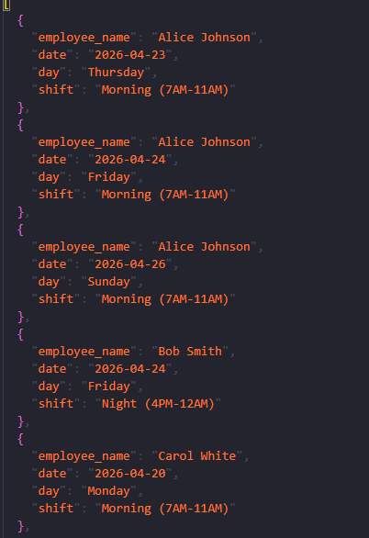
This image shows a sample of the JSON output generated by the AI scheduling module. This structured format allows the backend to process and store rota data efficiently before displaying it in the user interface. This confirms that the scheduling algorithm can generate structured output representing valid shift assignments, which can then be processed by the backend.

6.3 Integration Testing
Integration testing made sure that the different layers of the system worked together correctly. This involved verifying communication between:
• The React frontend
• The Node.js backend
• The MySQL database
• The Python scheduling module
For example, when a user submits a time-off request through the frontend interface, the request is sent to the backend API, stored in the MySQL database, and can later be retrieved by administrators through the dashboard. Successful execution of this process showed that data was correctly transferred around the system's components.
Testing confirmed that the backend can successfully run the Python scheduling module and receive the schedule it generates. This enables the system to automatically produce rotas based on the defined scheduling constraints.
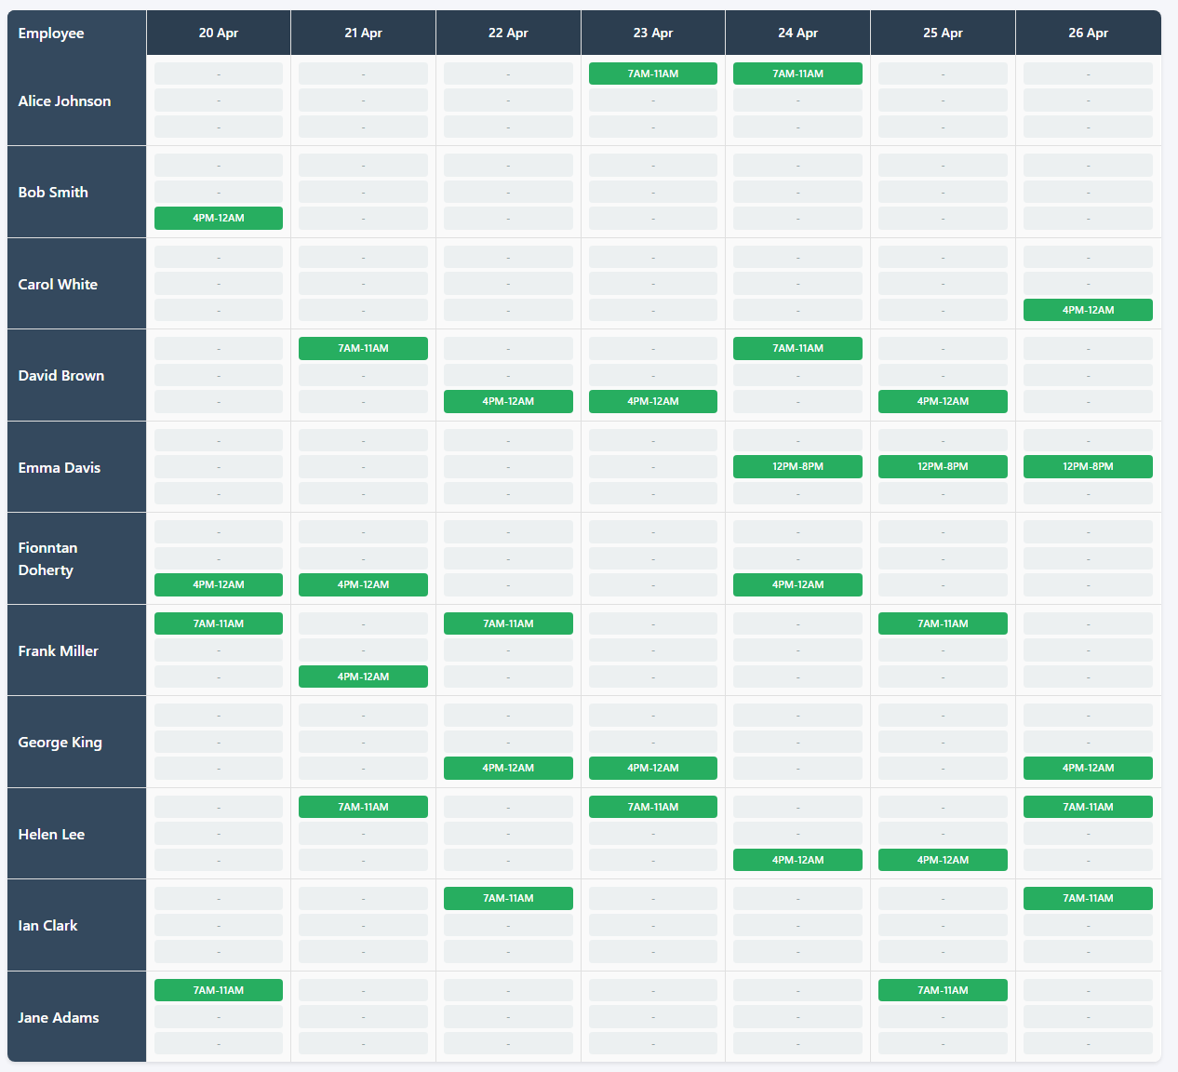
The generated schedule was successfully stored in the database and displayed within the user and admin interface. This shows that data flows correctly through the system, from the AI module to the backend and database, and is accurately rendered in the frontend interface.

6.4 Results and Evaluation
Overall, the testing process confirmed that the core functionality of the rota management system worked as intended. The backend API successfully processed requests related to authentication, schedules, and time-off management, and the MySQL database stores and was able to retrieve data reliably anytime on command.
The system’s architecture separating the frontend, backend, and database layers proved effective in supporting modular development and testing. This structure also made it easier to identify and resolve issues during development as individual components could be tested and debugged independently.
Furthermore, testing of the scheduling module demonstrated that the system can successfully run a Python script from the Node.js backend and process the results. Although the AI-based scheduling logic is still under development, the integration between components is functioning correctly and provides a strong basis for implementing the full scheduling algorithm in the future.
During testing, a few limitations were identified. For example, the scheduling module may not generate a schedule if certain requirements were not met such as when there are not enough available staff members. In addition, authentication security and role-based access control could be further improved in future versions of the system by considering these limitations.
This reflects the current state of the system as a functional prototype, where core features operate correctly but advanced automation and optimisation require further refinement.
Despite these limitations, testing indicates that the current system provides a stable foundation for rota management and can be extended with additional features for future development.

7. Conclusion
This project set out to design and develop an AI-assisted rota management application aimed at improving the efficiency and fairness of staff scheduling. Overall, the project successfully achieved its primary objectives by delivering a functional system that integrates both manual and automated scheduling features.
The developed application allows staff users to view their assigned rotas and submit time-off requests, while administrators are provided with a comprehensive management interface. Admin users can create, edit, and manage staff profiles, review and approve leave requests, and generate weekly rotas either manually or through an AI-assisted approach. This demonstrates a clear separation of roles and ensures that both user groups can interact with the system effectively.
A key achievement of the project is the successful integration of an AI scheduling component using Python and Google OR-Tools. The system can generate rotas at the press of a button by applying constraints such as staff availability and approved leave requests, which are retrieved directly from the MySQL database. This ensures that generated schedules are both feasible and aligned with user-defined conditions. The ability to combine database-driven constraints with automated scheduling represents a significant step towards reducing the manual workload typically associated with rota creation.
The system also demonstrates effective data management practices, with user information, availability, and leave requests stored and utilised dynamically. The interaction between the Node.js backend, MySQL database, and Python-based AI module highlights a modular architecture that supports scalability and future improvements.
However, there are limitations to the current implementation. While the AI scheduler successfully generates valid rotas based on defined constraints, it may not fully account for more complex real-world factors such as shift preferences, fairness over longer periods, or dynamic business demand. Additionally, certain advanced features, such as automated notifications or deeper usability refinements, were not fully implemented due to time constraints.
Future work could focus on enhancing the AI scheduling logic by incorporating additional constraints and optimisation goals, such as balancing workload distribution more evenly across staff. Improvements to the user interface and overall user experience could also be made, alongside the introduction of features such as real-time notifications, shift swapping, and integration with external systems such as payroll or HR platforms.
In conclusion, this project successfully demonstrates how AI-driven scheduling can be applied to a real-world problem. The system provides a practical and scalable solution that improves efficiency, reduces manual effort, and supports better workforce management using modern web technologies and optimisation techniques.

References
Deputy (2024) Workforce management and scheduling software. Available at: https://www.deputy.com (Accessed: 10 December 2025).
El Hajal, A. (2025) AI and the future hospitality workforce: disruption, decisions and a human touch. Hospitality Insight Report. Available at: https://www.jwu.edu/documents/research/ai-future-hospitality.pdf (Accessed: 10 December 2025).
Flanagan, D. (2020) JavaScript: The Definitive Guide. 7th edn. Sebastopol, CA: O’Reilly Media.
Google Developers (2025a) Constraint programming (CP-SAT) overview. Available at: https://developers.google.com/optimization/cp (Accessed: 10 December 2025).
Google Developers (2025b) Employee scheduling with OR-Tools. Available at: https://developers.google.com/optimization/scheduling/employee_scheduling (Accessed: 10 December 2025).
Google OR-Tools (2025) OR-Tools optimisation suite documentation. Available at: https://developers.google.com/optimization/ (Accessed: 10 December 2025).
ICO – Information Commissioner’s Office (2024) Guide to the UK GDPR. Available at: https://ico.org.uk (Accessed: 10 December 2025).
OWASP Foundation (2025) OWASP Top 10: Web Application Security Risks. Available at: https://owasp.org (Accessed: 10 December 2025).
Planday (2024) Employee scheduling and workforce planning. Available at: https://www.planday.com (Accessed: 10 December 2025).
React Documentation (2025) React: A JavaScript library for building user interfaces. Available at: https://react.dev (Accessed: 10 December 2025).
Richardson, L. and Ruby, S. (2007) RESTful Web Services. Sebastopol, CA: O’Reilly Media.
RotaReady (2024) AI-enhanced scheduling and rota planning. Available at: https://rotaready.com (Accessed: 10 December 2025).
Thompson, G.M. (2004) ‘Labour scheduling, part 1: Forecasting demand’, Cornell Hotel and Restaurant Administration Quarterly, 45(1), pp. 85–98.
Thompson, G.M. (2004) ‘Labour scheduling, part 2: Knowing the rules’, Cornell Hotel and Restaurant Administration Quarterly, 45(2), pp. 52–61.
Tilkov, S. and Vinoski, S. (2010) ‘Node.js: Using JavaScript to build high-performance network programs’, IEEE Internet Computing, 14(6), pp. 80–83.
When I Work (2024) Employee scheduling software. Available at: https://wheniwork.com

Appendix B: Code Listing / GitHub Project Link
https://github.com/Finnto2205/FinalYearProject

