Christopher Finster

Grand Canyon University

CST-250 Computer Programming in C# II

5AUG2021

https://github.com/Finsternavy/CST_250/tree/main/CarStoreApplication_w1

CarShopGUI Demonstration Screenshots

Program at launch:

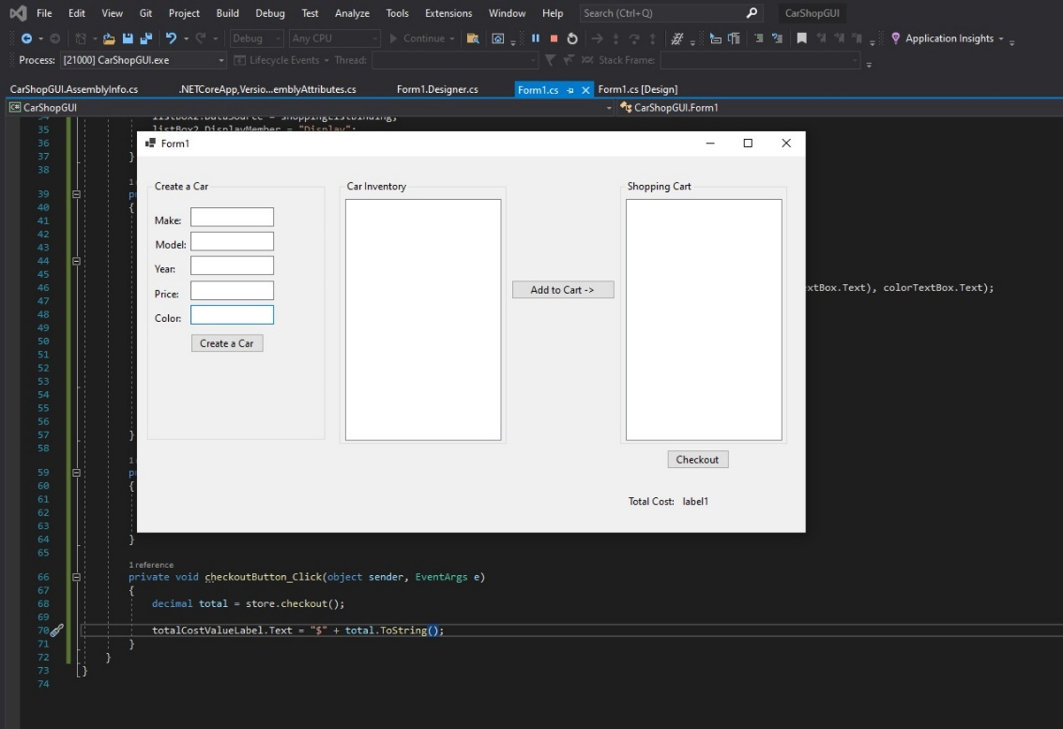

Program at Year parse error:

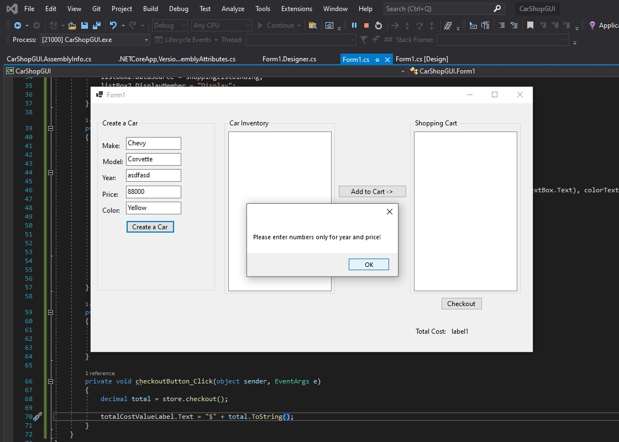

Program at Price Parse error:

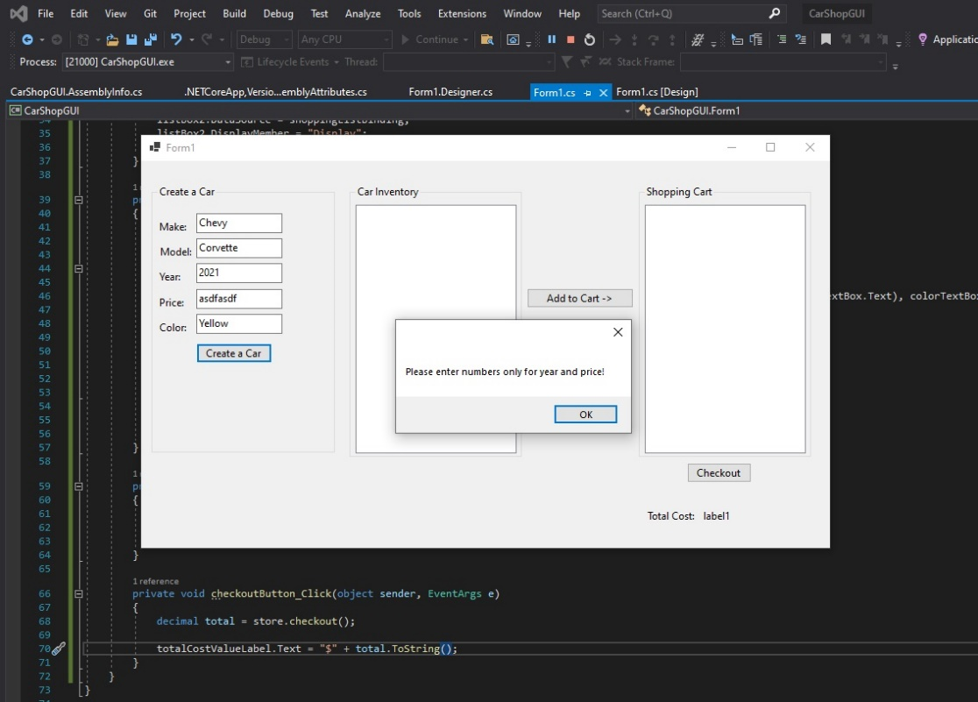

Program when ran correctly:

