Factorial

Factorial Program being run:

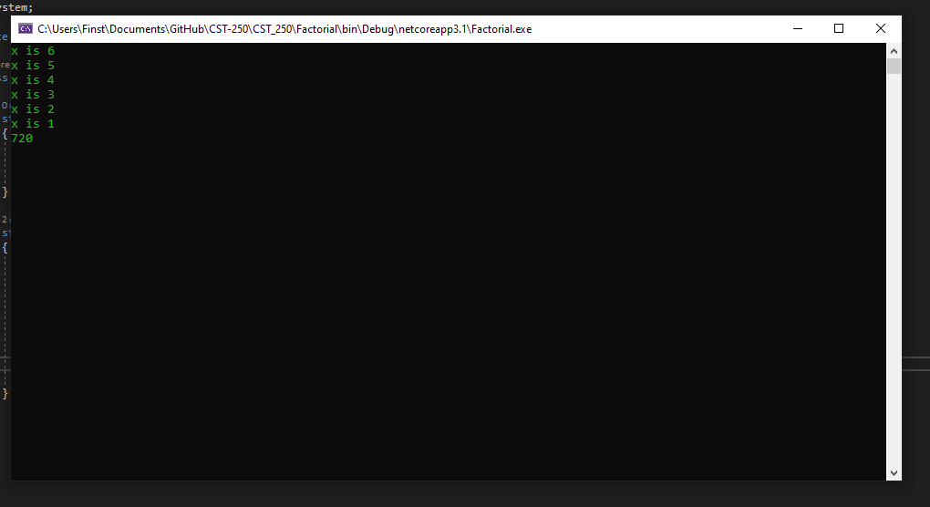

When the program is ran, the number (hard coded 6) is passed to a factorial function that checks if the number is equal to one. If it is, one is returned. If not, the number is multiplied by the result of the factorial function with the number – 1 passed to it. This will occur until the value of the passed number is 1. When it is 1, each step of the factorial will return it’s result to the previous step. This ends with every number between one and the target number being multiplied together.