Christopher Finster

Grand Canyon University

CST-250 Computer Programming in C# II

6 Aug 2021

<https://github.com/Finsternavy/CST_250>

Super Hero Maker Demo

Application at launch:

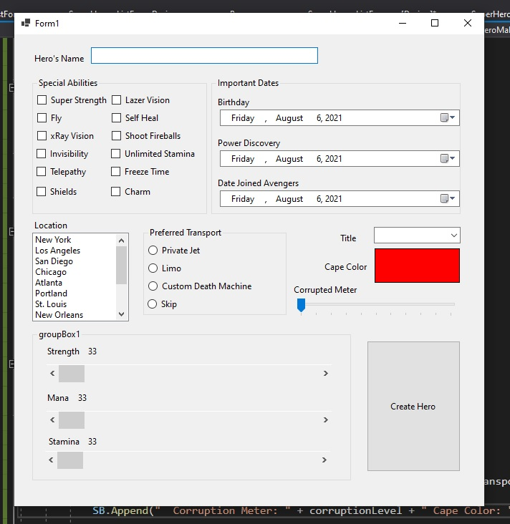

After selections (Note: Cape color selected last)

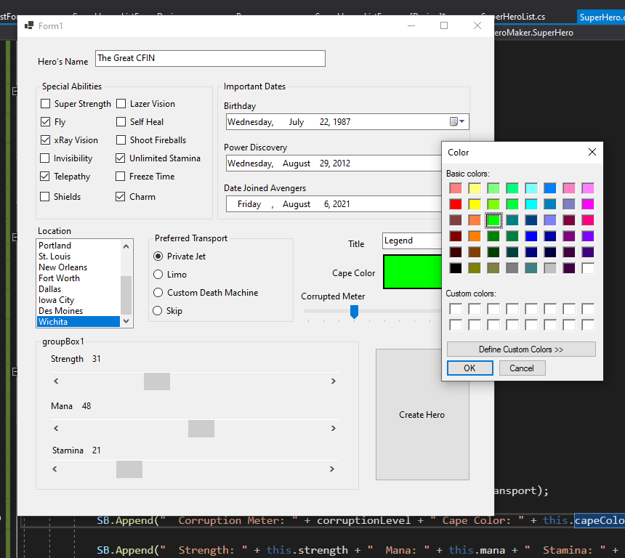

After clicking “Create Hero”

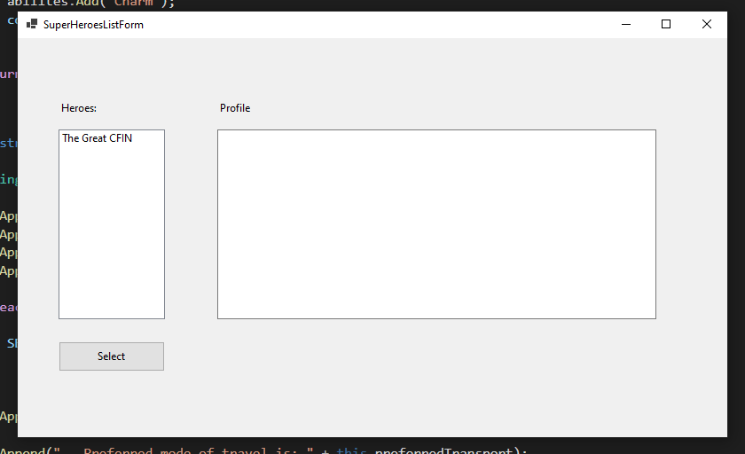

After clicking “The Great CFIN” and clicking Select button

