Christopher Finster

Grand Canyon University

CST-250 Computer Programming in C# II

8AUG2021

LINQ Demo

Program at launch:

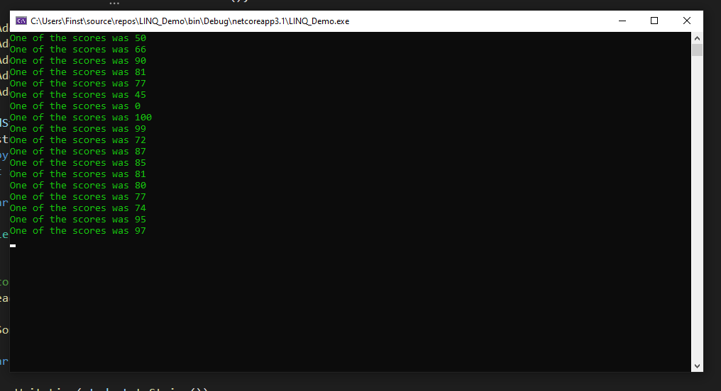

(All scores)

Enter click:

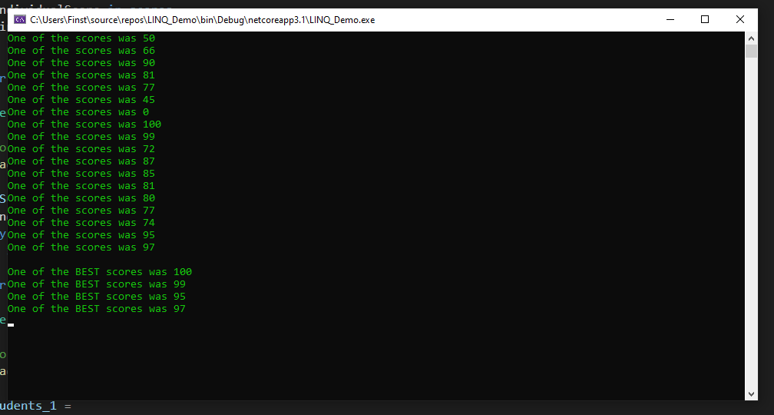

(Scores > 90)

Enter click:

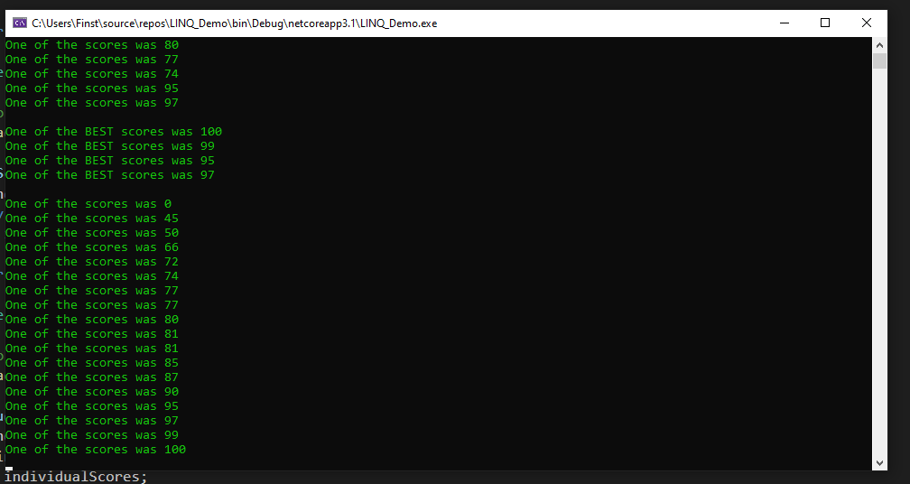

(Sorted all scores)

Enter click:

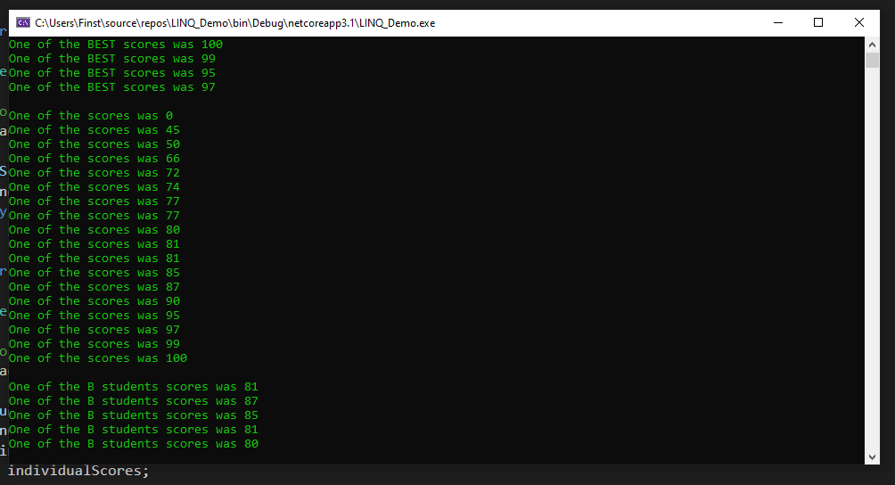

(B students)

Enter click:

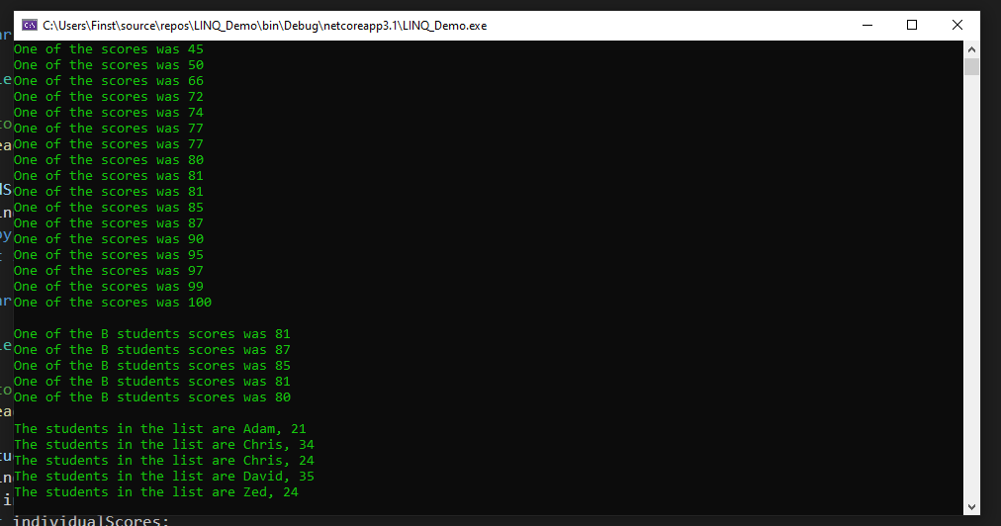

(Student LINQ sort)

Enter click:

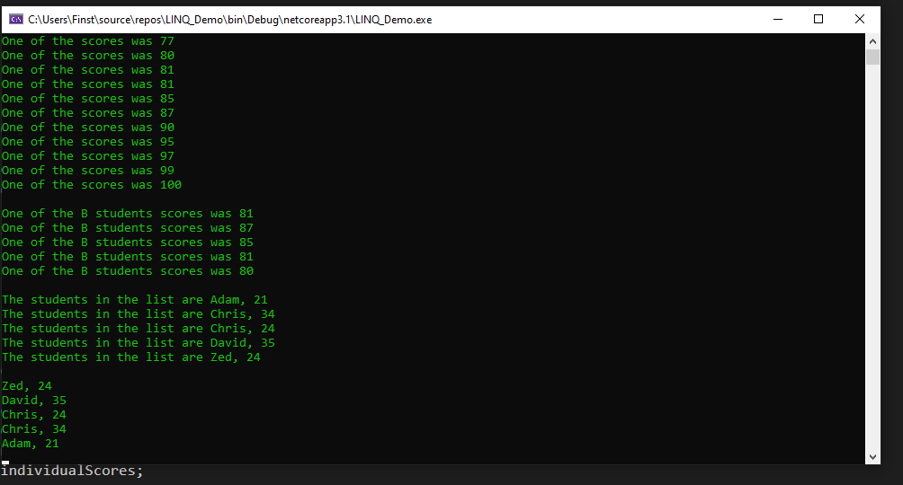

(iComparable sort)