Christopher Finster

Grand Canyon University

CST-250 Computer Programming in C# II

6 AUG 2021

https://github.com/Finsternavy/CST_250/tree/main/Minesweeper

UML Diagram

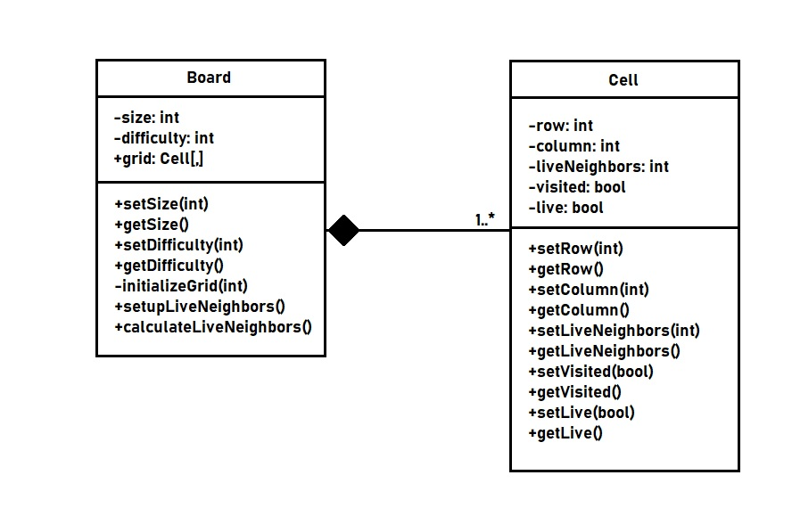

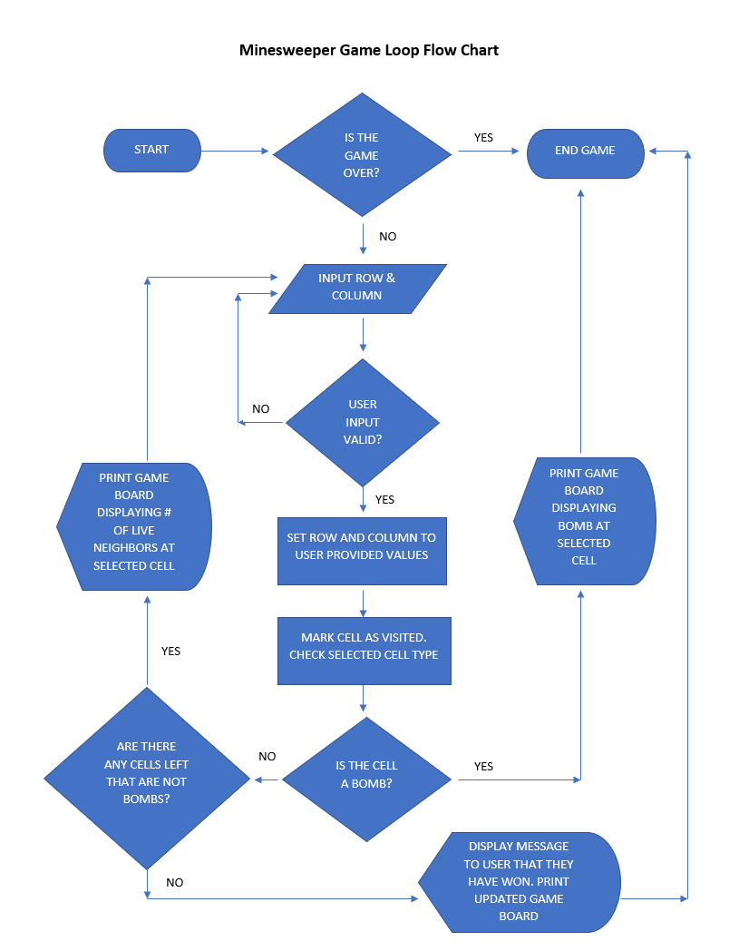

Program Screenshots

Program at launch:

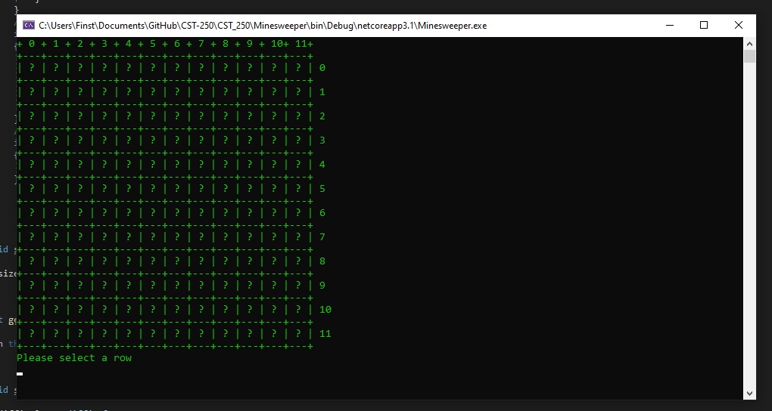

Program after three turns:

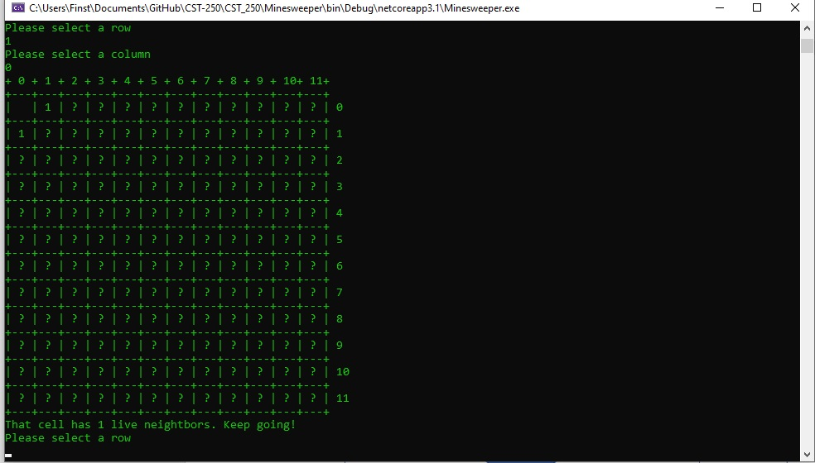

Program after selecting a bomb:

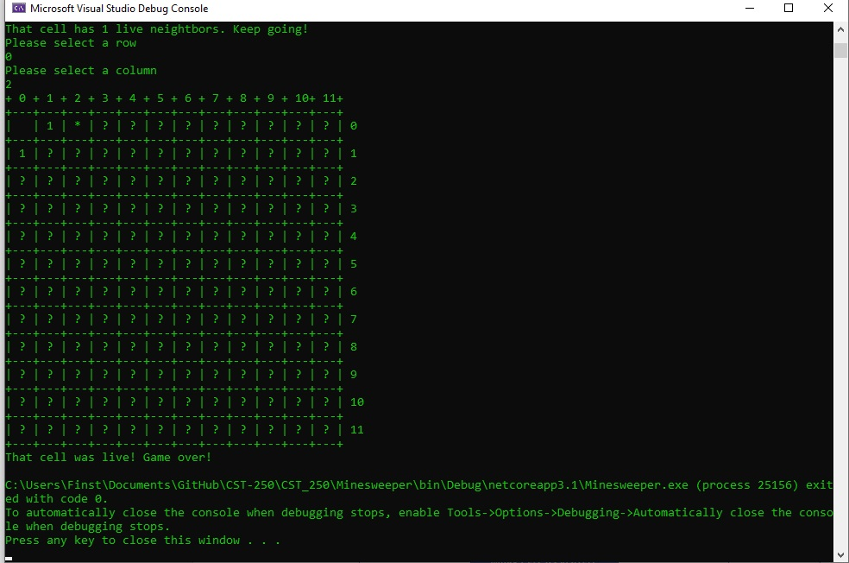

Program when invalid data is entered:

