Christopher Finster

Grand Canyon University

CST-250 Computer Programming in C# II

6 Aug 2021

https://github.com/Finsternavy/CST_250/tree/main/Minesweeper

Class UML

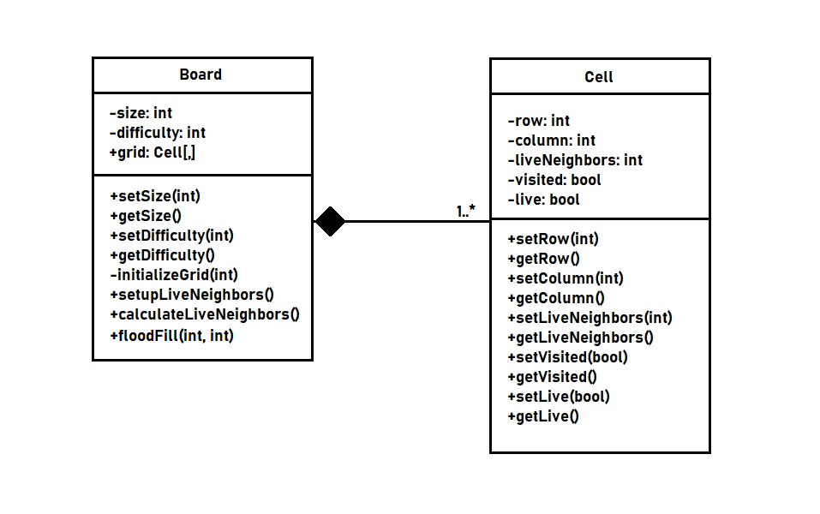

floodFill() Flow Chart

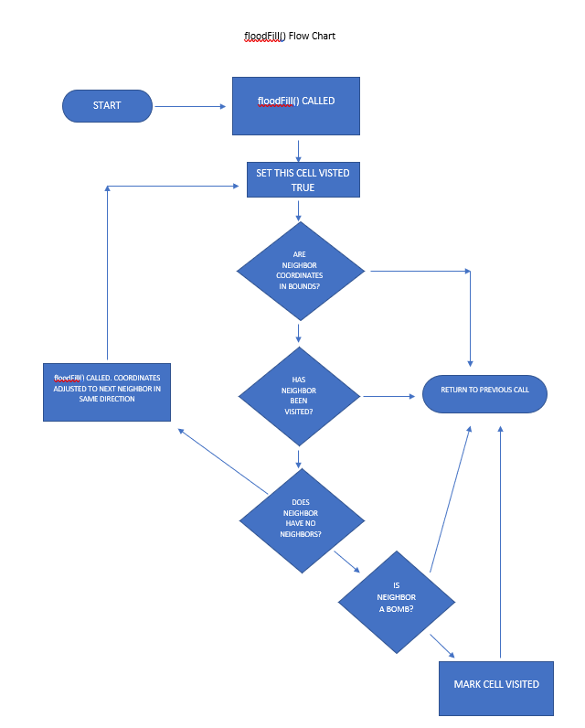

Program Screenshot

Showing success of floodFill() in action:

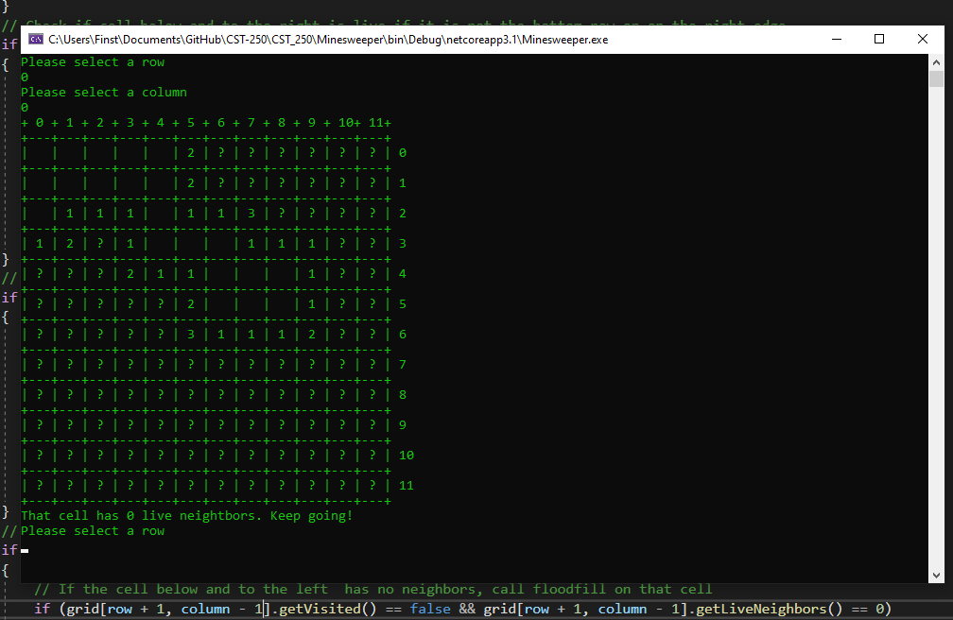

When the Cell at [0, 0] was selected, all cells touching it that also had no neighbors were shown. Additionally, all boarding cells were marked as visited showing the number of live neighbors.