Christopher Finster

Grand Canyon University

CST-250 Computer Programming in C# II

6 Aug 2021

<https://github.com/Finsternavy/CST_250/tree/main/Minesweeper>

Minesweeper Milestone 4

Program at launch:

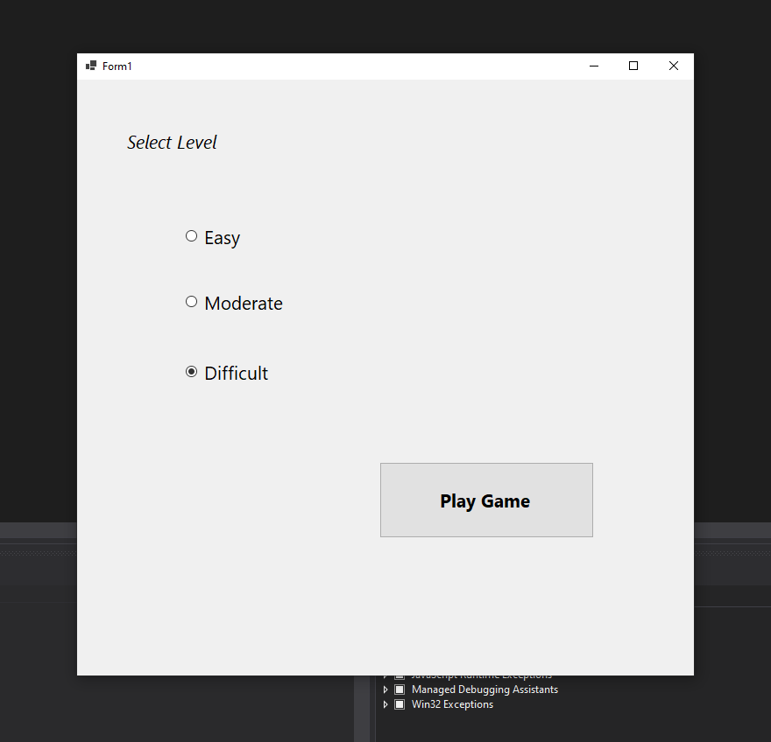

Program when Play Game is clicked:

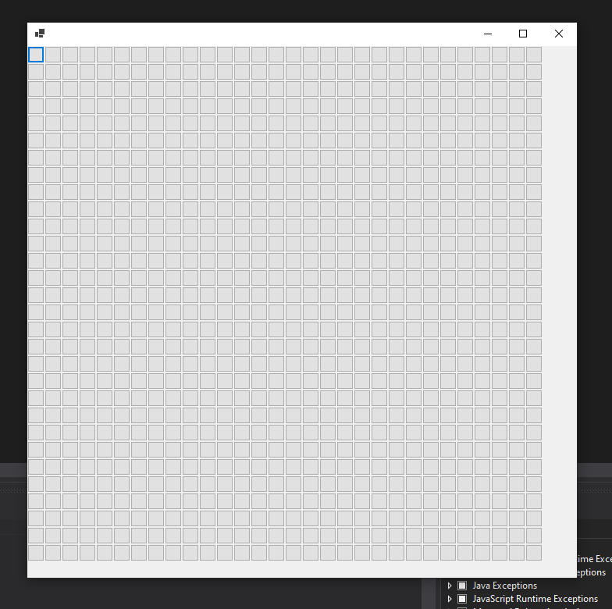

Program after clicking on several cells:

