Christopher Finster

Grand Canyon University

CST-250 Computer Programming in C# II

8AUG2021

TextFileDataAccessDemo

Program at launch:

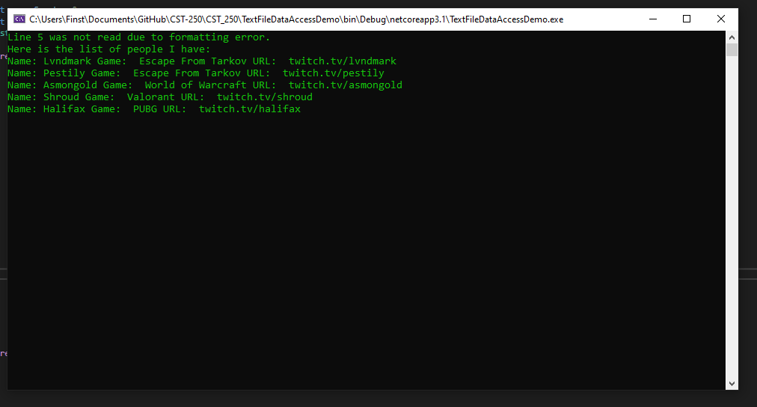

Error handling:

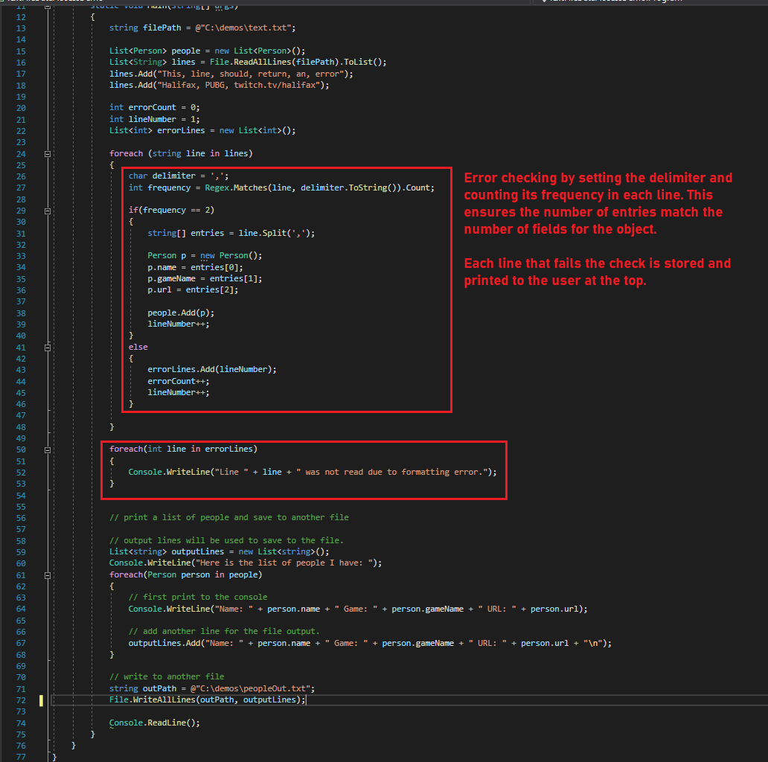

GUI Version

GUI at launch:

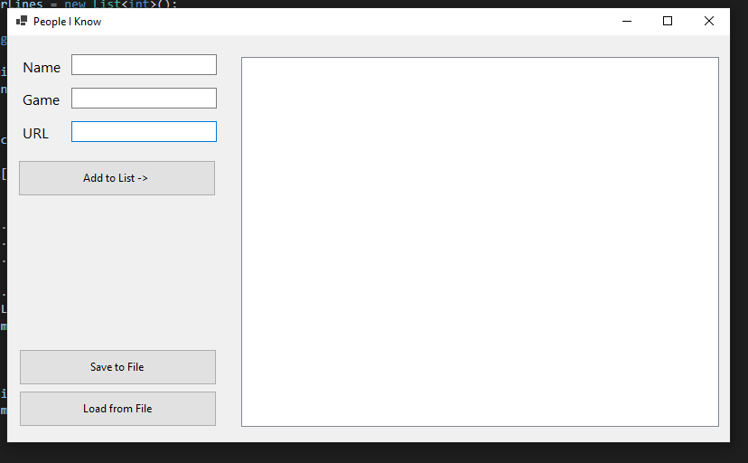

The user enters the values for each Person. When Add to list is clicked, it uses the text value of the textboxes to create a new instance of Person and stores it in a List.

On save, the properties of each Person in the list are stored to a text file with properties delimited by a ‘,’.

On load button click the text file is read in line by line, and split with ‘,’ and stored in a string[]. The string[] is used to assign each index to a property of a new instance of Person. The Person’s name is displayed in the listbox.

Example of Person’s added:

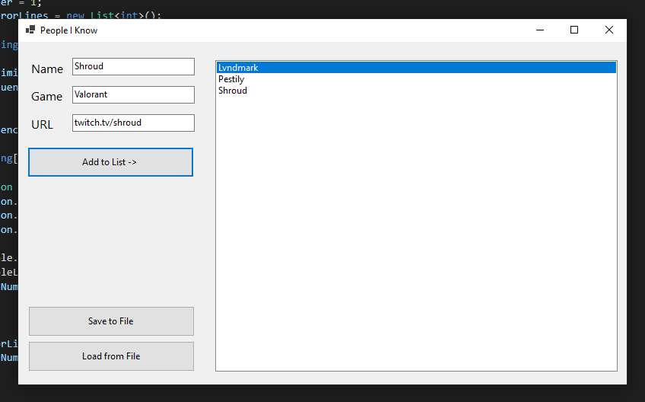

On save, a file is created (Or overwritten):

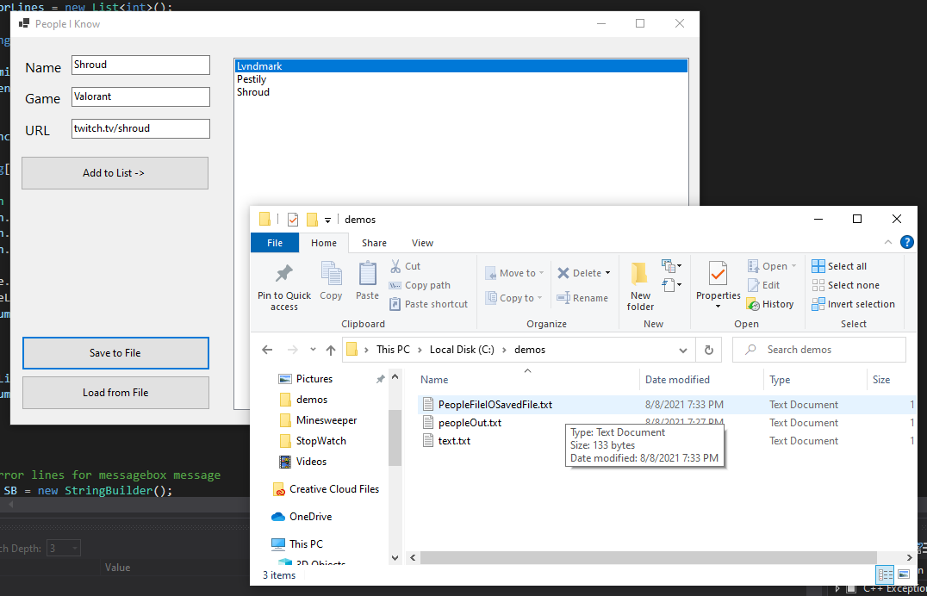

On load, the file is read in and names are displayed and erroneous line data is displayed:

Text file edited manually:

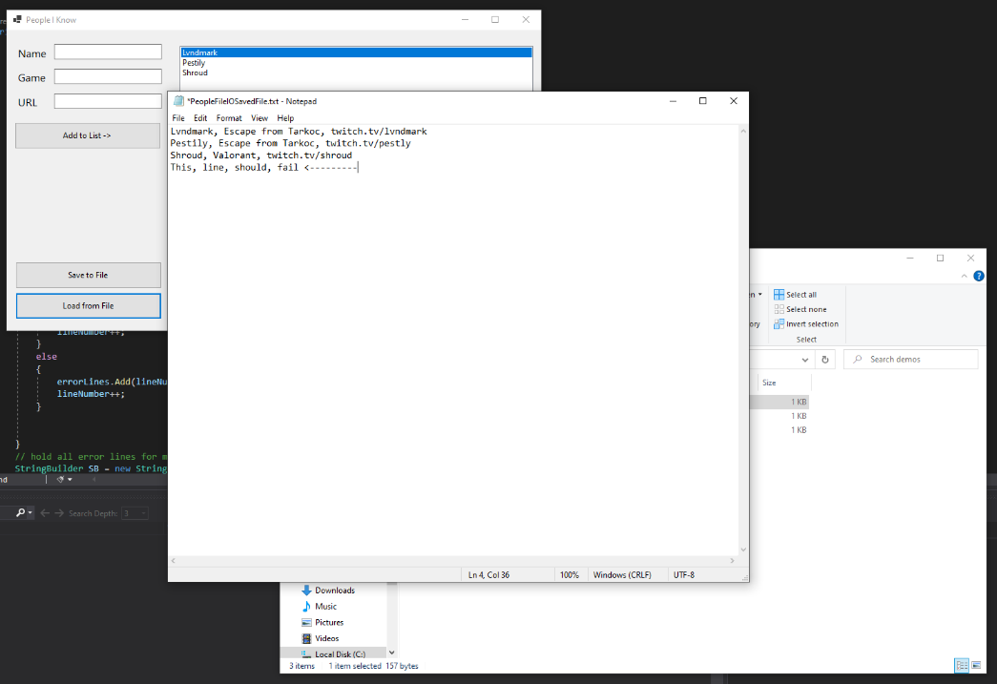

After load click:

