Christopher Finster

Grand Canyon University

CST-250 Computer Programming in C# II

6 Aug 2021

<https://github.com/Finsternavy/CST_250>

Wack-a-mole Demo

Program at launch:

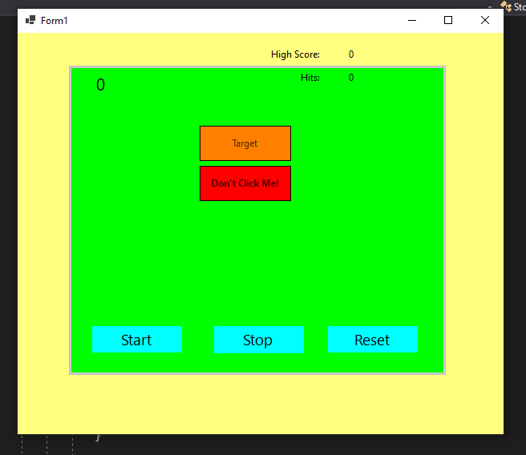

Game after start:

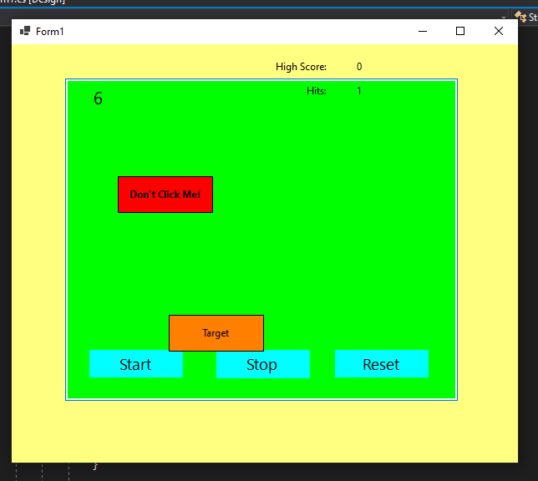

Game at the end of the round:

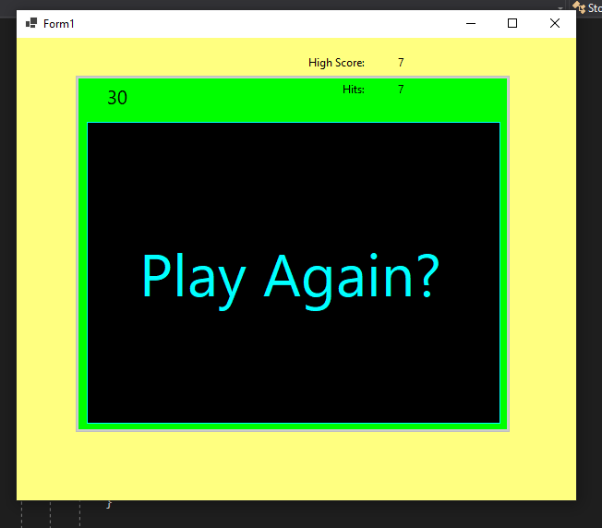

Game after clicking Play Again:

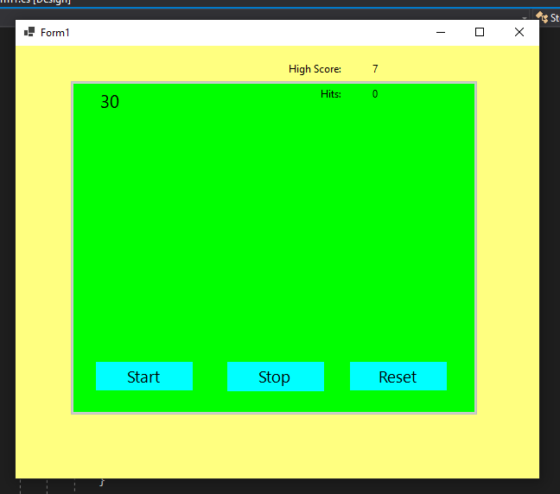

Game 2 after several “Miss clicks”:

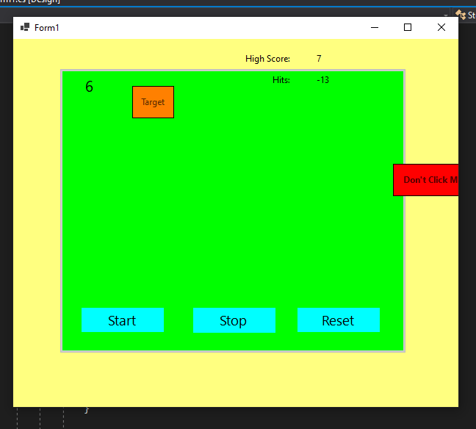

Game after reset clicked:

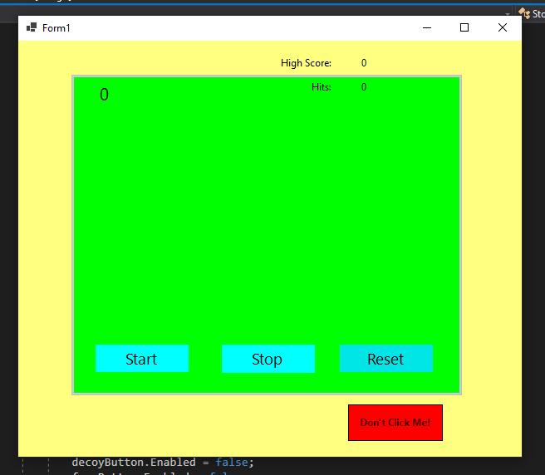

Game after reaching increased difficulty:

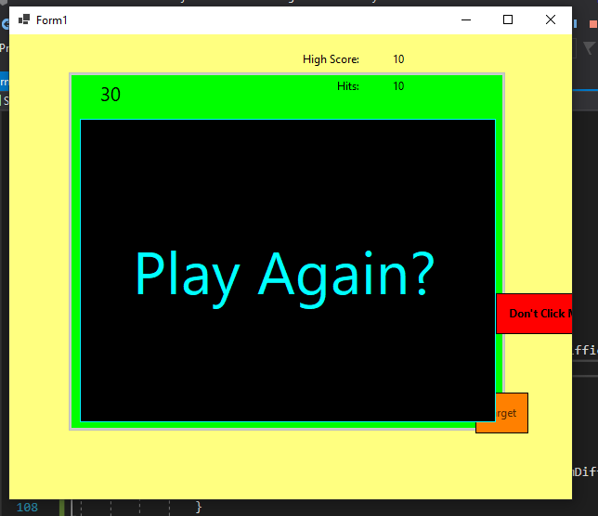

Notice the size of the target. Additionally, the interval is decreased down to 300 milliseconds.