四种客户端调用WEBSERVICE
王凡
Woshiwangfan@gmail.com
Wf141732@sohu.com

2009-08-22
目录
1. 文档概述 2
1.1. 相关文档 2
2. SERVER端 3
2.1. 代码 3
2.2. SERVER端生成Wsdl 4
2.3. 服务端安全性设置 6
3. VB调用 7
3.1. 准备 7
4. .net调用 10
4.1. 实现过程 10
5. Axis2调用 11
5.1. Axis2的安装 11
5.2. Axis2调用过程 11
6. Weblogic调用 15
6.1. Weblogic 15
7. 已解决及未解决的问题 18
7.1. 未解决的问题 18
7.2. 已解决的问题 18

文档概述

相关文档
《Web Services开发教程.doc》

SERVER端
这个主要是用weblogic的workshop开发，用weblogic开发webservice具体可见沈辉的《Web Services开发教程.doc》，这里 主要是讲客户端调用，所以服务端只作罗列。

代码
在weblogic中构建webservice可以见《Web Services开发教程.doc》，用于本次测试的Server代码如下：
Model：
package cn.com.tsingtao.logistics.model;
import java.io.Serializable;
public class test implements Serializable {
private static final long serialVersionUID = 1L;
private String NAME;
private int AGE;

public void setNAME(String name)
{
NAME=name;
}
public void setAGE(int age)
{
AGE=age;
}
public String getNAME()
{
return NAME;
}
public int getAGE()
{
return AGE;
}
}

Service代码如下：
public cn.com.tsingtao.logistics.model.test[] hello(String NAME,int AGE) {
cn.com.tsingtao.logistics.model.test[] t=new
cn.com.tsingtao.logistics.model.test[10];
for(int i=0;i<10;i++)
{
t[i] = new cn.com.tsingtao.logistics.model.test();
t[i].setNAME(NAME+i);
t[i].setAGE(AGE+i);
}
return t;
}

SERVER端生成Wsdl
在Server端生成的wsd如下：
<?xml version='1.0' encoding='UTF-8'?>
<s0:definitions name="testServiceDefinitions" targetNamespace="http://cn/com/tsingtao/logistics/service" xmlns="" xmlns:s0="http://schemas.xmlsoap.org/wsdl/" xmlns:s1="http://cn/com/tsingtao/logistics/service" xmlns:s2="http://schemas.xmlsoap.org/wsdl/soap/">
<s0:types>
<xs:schema attributeFormDefault="unqualified" elementFormDefault="qualified" targetNamespace="java:cn.com.tsingtao.logistics.model" xmlns:s0="http://schemas.xmlsoap.org/wsdl/" xmlns:s1="http://cn/com/tsingtao/logistics/service" xmlns:s2="http://schemas.xmlsoap.org/wsdl/soap/" xmlns:xs="http://www.w3.org/2001/XMLSchema">
<xs:complexType name="test">
<xs:sequence>
<xs:element minOccurs="1" name="AGE" nillable="false" type="xs:int"/>
<xs:element minOccurs="1" name="NAME" nillable="true" type="xs:string"/>
</xs:sequence>
</xs:complexType>
<xs:complexType name="ArrayOftest_literal">
<xs:sequence>
<xs:element maxOccurs="unbounded" minOccurs="0" name="test" nillable="true" type="java:test" xmlns:java="java:cn.com.tsingtao.logistics.model"/>
</xs:sequence>
</xs:complexType>
<xs:element name="ArrayOftest_literal" type="java:ArrayOftest_literal" xmlns:java="java:cn.com.tsingtao.logistics.model"/>
</xs:schema>
<xs:schema attributeFormDefault="unqualified" elementFormDefault="qualified" targetNamespace="http://cn/com/tsingtao/logistics/service" xmlns:s0="http://schemas.xmlsoap.org/wsdl/" xmlns:s1="http://cn/com/tsingtao/logistics/service" xmlns:s2="http://schemas.xmlsoap.org/wsdl/soap/" xmlns:xs="http://www.w3.org/2001/XMLSchema">
<xs:import namespace="java:cn.com.tsingtao.logistics.model"/>
<xs:element name="hello">
<xs:complexType>
<xs:sequence>
<xs:element name="NAME" type="xs:string"/>
<xs:element name="AGE" type="xs:int"/>
</xs:sequence>
</xs:complexType>
</xs:element>
<xs:element name="helloResponse">
<xs:complexType>
<xs:sequence>
<xs:element name="return" type="java:ArrayOftest_literal" xmlns:java="java:cn.com.tsingtao.logistics.model"/>
</xs:sequence>
</xs:complexType>
</xs:element>
</xs:schema>
</s0:types>
<s0:message name="hello">
<s0:part element="s1:hello" name="parameters"/>
</s0:message>
<s0:message name="helloResponse">
<s0:part element="s1:helloResponse" name="parameters"/>
</s0:message>
<s0:portType name="test">
<s0:operation name="hello" parameterOrder="parameters">
<s0:input message="s1:hello"/>
<s0:output message="s1:helloResponse"/>
</s0:operation>
</s0:portType>
<s0:binding name="testServiceSoapBinding" type="s1:test">
<s2:binding style="document" transport="http://schemas.xmlsoap.org/soap/http"/>
<s0:operation name="hello">
<s2:operation style="document"/>
<s0:input>
<s2:body parts="parameters" use="literal"/>
</s0:input>
<s0:output>
<s2:body parts="parameters" use="literal"/>
</s0:output>
</s0:operation>
</s0:binding>
<s0:service name="testService">
<s0:port binding="s1:testServiceSoapBinding" name="testSoapPort">
<s2:address location="http://localhost:7001/BSM/test"/>
</s0:port>
</s0:service>
</s0:definitions>

服务端安全性设置
这个是根据沈辉的《Web Services开发教程.doc》设置的，不作详细说明，只作罗列

在weblogic中新建用户和用户组
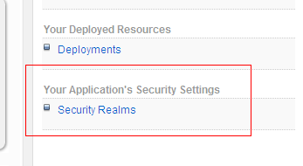
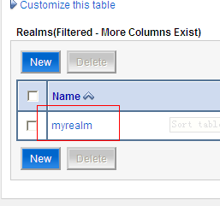
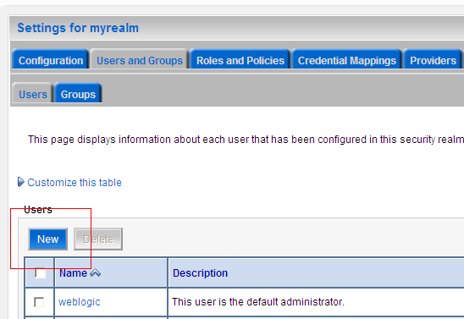
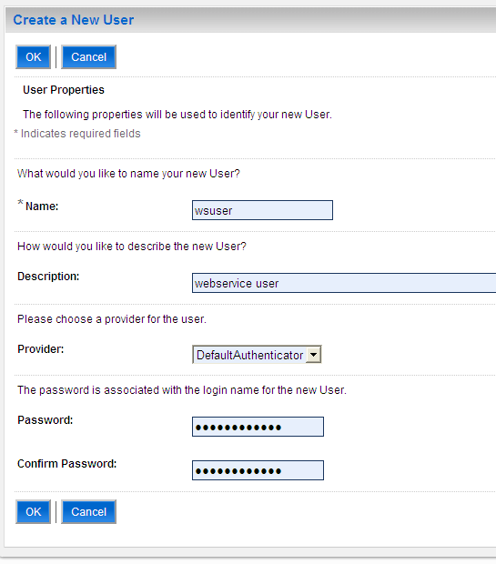
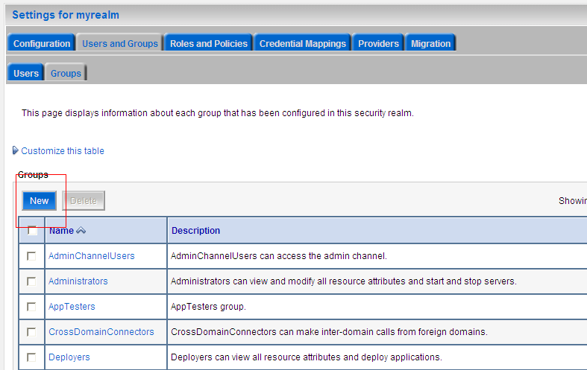
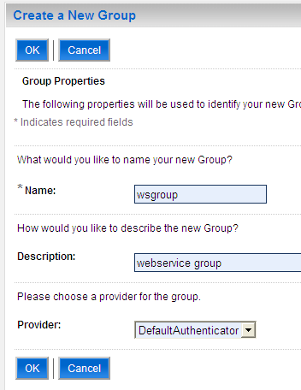
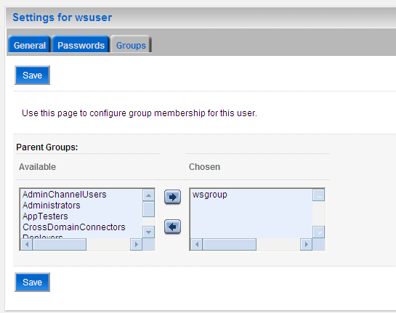

在webapp中配置安全性
在web-info\web.xml中添加红色部分
<?xml version="1.0" encoding="UTF-8"?>
<web-app id="WebApp_ID" version="2.4"
xmlns="http://java.sun.com/xml/ns/j2ee"
xmlns:xsi="http://www.w3.org/2001/XMLSchema-instance"
xsi:schemaLocation="http://java.sun.com/xml/ns/j2ee http://java.sun.com/xml/ns/j2ee/web-app_2_4.xsd">
<display-name>BSM</display-name>
<welcome-file-list>
<welcome-file>index.html</welcome-file>
<welcome-file>index.htm</welcome-file>
<welcome-file>index.jsp</welcome-file>
<welcome-file>default.html</welcome-file>
<welcome-file>default.htm</welcome-file>
<welcome-file>default.jsp</welcome-file>
</welcome-file-list>
<security-role>
<role-name>wsuser</role-name>
</security-role>

<security-constraint>
<web-resource-collection>
<web-resource-name>Secure Area</web-resource-name>
<url-pattern>/*</url-pattern>
<http-method>GET</http-method>
<http-method>POST</http-method>
</web-resource-collection>
<auth-constraint>
<role-name>wsuser</role-name>
</auth-constraint>
</security-constraint>

<login-config>
<auth-method>BASIC</auth-method>
<realm-name>myrealm</realm-name>
</login-config>
</web-app>
在web-info\weblogic.xml中添加红色部分
<?xml version="1.0" encoding="UTF-8"?>
<wls:weblogic-web-app
xmlns:wls="http://www.bea.com/ns/weblogic/weblogic-web-app"
xmlns:xsi="http://www.w3.org/2001/XMLSchema-instance"
xsi:schemaLocation="http://java.sun.com/xml/ns/javaee http://java.sun.com/xml/ns/javaee/web-app_2_5.xsd http://www.bea.com/ns/weblogic/weblogic-web-app http://www.bea.com/ns/weblogic/weblogic-web-app/1.0/weblogic-web-app.xsd">
<wls:weblogic-version>10.3</wls:weblogic-version>
<wls:context-root>BSM</wls:context-root>
<security-role-assignment>
<role-name>wsuser</role-name>
<principal-name>wsgroup</principal-name>
</security-role-assignment>
</wls:weblogic-web-app>
重新发布后在浏览器中就可以看到了
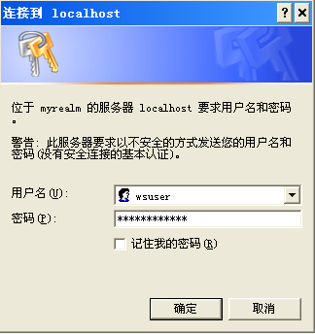

VB调用

准备
使用vb6.0调用webservice需要用到SOAP Toolkit，我们选用的是SOAP Toolkit3.0版本。

插件下载
到http://www.microsoft.com/downloads/details.aspx?familyid=c943c0dd-ceec-4088-9753-86f052ec8450&displaylang=en下载SOAP Toolkit 3.0，直接安装。

VB中添加引用
在VB中添加对插件的引用Project\References\
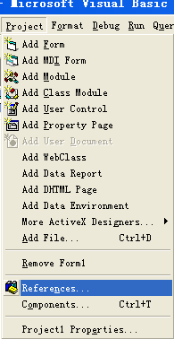
添加如下5个引用
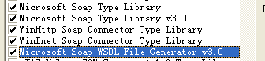

程序代码
VB调用的程序代码如下：
Private Sub Command3_Click()
Dim Serializer As SoapSerializer30
Dim reader As SoapReader30
Dim Connector As SoapConnector30
Dim strParam As String

strParam = "王凡"
'namespace
Const SoapAction = "http://cn/com/tsingtao/logistics/service"
'wsdl地址
Const END_POINT_URL = "http://localhost:7001/BSM/test?WSDL"
'新建一个connector对象
Set Connector = New HttpConnector30
Connector.Property("EndPointURL") = END_POINT_URL
Connector.Connect

Connector.Property("SoapAction") = SoapAction
‘在weblogic中我们使用的是basic认证，在这里添加用户名和密码
Connector.Property("AuthPassword") = "wsuserwsuser"
Connector.Property("AuthUser") = "wsuser"
Connector.Property("WinHTTPAuthScheme") = 1

Connector.BeginMessage

Set Serializer = New SoapSerializer30
Serializer.Init Connector.InputStream
Serializer.startEnvelope
Serializer.startBody
‘在这里添加传入的参数，有两个参数NAME和AGE，前面的是方法名，后面的为namespace，在wsdl中标红色的部分。
Serializer.startElement "hello", "http://cn/com/tsingtao/logistics/service"
Serializer.startElement "NAME"
Serializer.writeString strParam
Serializer.endElement
Serializer.startElement "AGE"
Serializer.writeString 12
Serializer.endElement
Serializer.endElement

Serializer.endBody
Serializer.endEnvelope
Serializer.Finished

Connector.EndMessage

‘reader读入返回的xml对象
Set reader = New SoapReader30
reader.Load Connector.OutputStream

If Not reader.Fault Is Nothing Then
MsgBox reader.faultstring.Text, vbExclamation
Else
Dim results As Variant
results = getResult(reader)
For i = 0 To UBound(results) - 1
MsgBox "Name:" + results(i).Item("NAME") + "," + "Age:" + results(i).Item("AGE")
Next i

End If
End Sub

‘这个函数将返回的对象组合成一个array
Function getResult(reader As SoapReader30) As Variant
Dim arr() As Object
ReDim arr(reader.RPCResult.childNodes.length)
Dim dict
For i = 0 To reader.RPCResult.childNodes.length - 1
Set dict = CreateObject("Scripting.Dictionary")
For j = 0 To reader.RPCResult.childNodes(i).childNodes.length - 1
dict.Add reader.RPCResult.childNodes(i).childNodes(j).baseName, reader.RPCResult.childNodes(i).childNodes(j).Text
Next j
Set arr(i) = dict
Next i
getResult = arr
End Function

.net调用

实现过程

在.net中添加webservice引用
在Solutions Explorer\project_name\Web References
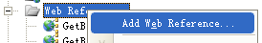
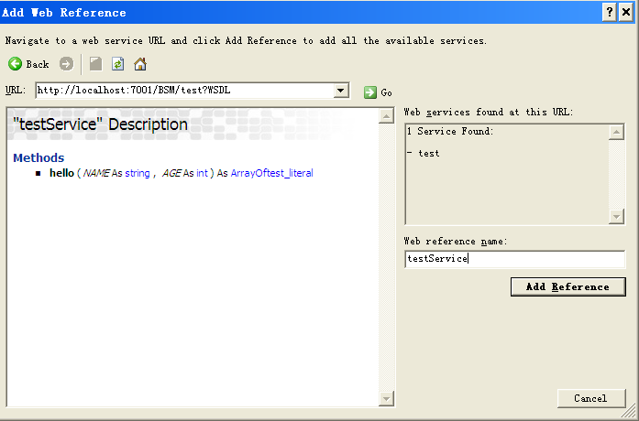

调用代码
.net的代码很简单
testService.testService request=new WebServiceT.testService.testService();
CredentialCache cache = new CredentialCache();
cache.Add(new Uri(request.Url), "Basic", new NetworkCredential("wsuser", "wsuserwsuser"));
request.Credentials = cache;
testService.test[] ts=request.hello("wangfan",12);
for(int i=0;i<ts.Length;i++)
{
MessageBox.Show("Name:"+ts[i].NAME+"Age:"+ts[i].AGE);
}

Axis2调用

Axis2的安装

在Eclipse中添加axis2的插件
在eclipse中添加axis2的生成客户端代码的工具，具体可见《Web Services开发教程.doc》

Axis2调用过程

运行向导生成客户端代码
在浏览器中将http://localhost:7001/BSM/test?WSDL另存为一个wsdl文件
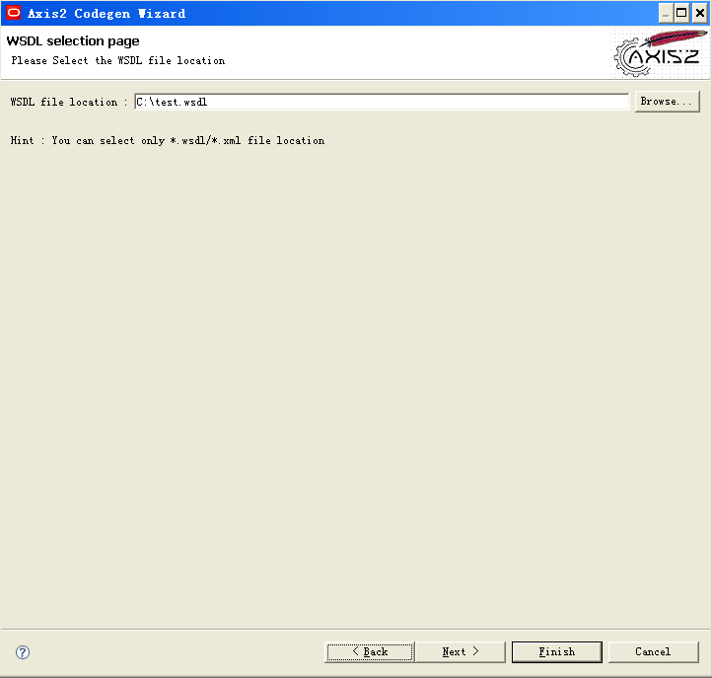
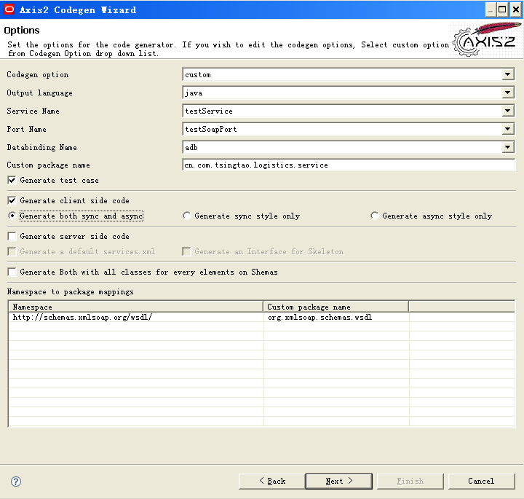
在第一次进入这个节目的时候会报红，cancel向导重新打开向导。
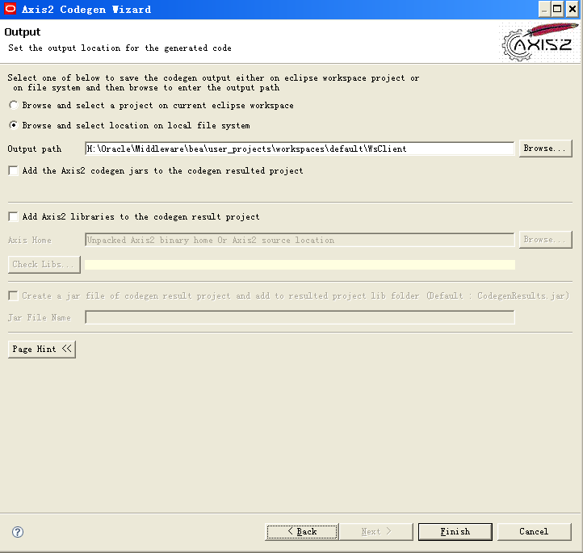

代码实现
在生成的TestServiceTest类文件中
public void testhello() throws java.lang.Exception {

TestServiceStub stub = new TestServiceStub();
TestServiceStub.Hello request = (TestServiceStub.Hello) getTestObject(TestServiceStub.Hello.class);
// TODO : Fill in the hello4 here

request.setNAME("wangfan");
request.setAGE(12);
TestServiceStub.HelloResponse r=stub.hello(request);
TestServiceStub.ArrayOftest_literal tl=r.get_return();
TestServiceStub.Test[] ts=tl.getTest();
for(int i=0;i<ts.length;i++)
{
System.out.print("Name:"+ts[i].getNAME()+";"+"Age:"+ts[i].getAGE()+"\n");
}
//assertNotNull(stub.hello(request));
}

运行报错
org.apache.axis2.AxisFault: Transport error: 401 Error: Unauthorized

Axis2的安全认证设置
单击进入hello方法，找到_operationClient
public cn.com.tsingtao.logistics.service.TestServiceStub.HelloResponse hello(
cn.com.tsingtao.logistics.service.TestServiceStub.Hello hello0)
throws java.rmi.RemoteException
{
org.apache.axis2.context.MessageContext _messageContext = null;
try {
org.apache.axis2.client.OperationClient _operationClient = _serviceClient .createClient(_operations[0].getName());
_operationClient.getOptions().setAction("\"\"");
_operationClient.getOptions().setExceptionToBeThrownOnSOAPFault(rue);
HttpTransportProperties.Authenticator basicAuthentication = new HttpTransportProperties.Authenticator();
basicAuthentication.setUsername("wsuser");
basicAuthentication.setPassword("wsuserwsuser");

_serviceClient.getOptions().setProperty( org.apache.axis2.transport.http.HTTPConstants.AUTHENTICATE, basicAuthentication);
红色部分为新增的认证信息 。

Weblogic调用

Weblogic
具体可以见《Web Services开发教程.doc》

生成jar
在服务器的代码中生存wsdl
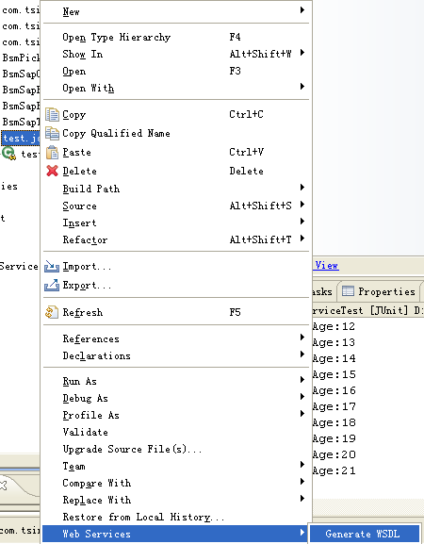
将wsdl生成jar
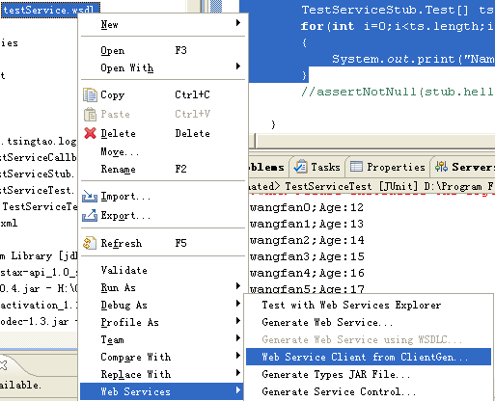

在新建的项目中添加jar引用
按以下步骤进行：
- 在<wl_server>/server/lib目录下，解压缩wseeclient.zip到一个目录中
- 选择项目，右键打开属性对话框，在ClassPath标签页中，删除"WebLogic System Library"
- 单击"Add External Jars"，将第一步解压的所有jar都添加进行
- 添加ant的类库到项目中
- 重新运行上面的客户端调用代码，此时执行就能正确

代码实现

HttpTransportInfo info = new HttpTransportInfo();
info.setUsername("wsuser".getBytes());
info.setPassword("wsuserwsuser".getBytes());

TestService_Impl im=new TestService_Impl("http://127.0.0.1:7001/BSM/test?WSDL",info);

Test_Stub t=(Test_Stub) im.getTestSoapPort();
ArrayOftest_Literal tl=t.hello("wangfanwf", 12);
Test[] ts=tl.getTest();
for(int i=0;i<ts.length;i++)
{
System.out.print("Name:"+ts[i].getNAME()+";"+"Age:"+ts[i].getAGE()+"\n");
}

