aMoneyKeel Mobile App — Development Blueprint and Status Tracker
Nov 11, 2026 · @JJ
MoneyKeel is an iPhone finance app, Build 57 on TestFlight, with no server of its own: data lives encrypted on the phone and in one Firebase cloud record per person. Every fact below was checked against the code on 2026-11-11; anything that could not be checked says Not known.
Item | Position today
Application | MoneyKeel (code folder and bundle still named finwise, co.finwise.app), version 1.1.0
Platform | iPhone only (an Android section exists in the config, never built or tested). A desktop design was drafted in June 2026, not built
Technology | React Native 0.85.3, Expo 56, TypeScript 6, Zustand 4.5 for app state, Firebase 10.12
Data architecture | No database server. Encrypted state on the phone, one encrypted cloud document per person, and the new master record saved in parts of 400 rows
Development agent | Claude Code, with outside checker agents reviewing work they did not write
Purpose | Show one person's net worth, cash flow, performance and plan, with every number traceable to its formula and inputs
Last commit | a6679cea, 2026-11-11, branch taxonomy-v1.0.7, 2 commits not pushed, 19 files changed and not committed
How to use this document. Read the executive summary first. The tracker (section 4) and the risk register (section 9) are the working tables: change a status there when work moves. Section 13 lists what this document does not know.

Decision register
The app-level choices below are what the code does today. The founder's own rulings (1,248 rows, highest DEC-10537) live in the decision log, not here.
ID | Decision | Current position | Status
D-01 | Device | iPhone only | In force
D-02 | App framework | React Native with Expo, TypeScript | In force
D-03 | Where data lives | On the phone (encrypted) plus one encrypted Firebase document per person | In force
D-04 | Server and database | None. No backend, no relational database, no migrations | Gap: see section 9
D-05 | Sign-in | Firebase Auth. Cloud rules let only the owner and a household member read the data | In force, rules tested
D-06 | Broker link | SnapTrade, through a Firebase function that holds the keys | In force
D-07 | Prices | Yahoo price feed | In force
D-08 | Crash reporting | Sentry installed, not switched on | Not switched on
D-09 | One master record for holdings | One dated list replaces three stored copies (DEC-10342, 10385, 10386, 10471) | Phase 1 built; phase 2 in progress
D-10 | Master record saved to the cloud | Yes, in encrypted parts of 400 rows (DEC-10514) | Coded, not committed
D-11 | Two broker lots stay two purchases | DEC-10515 | Tested, not verified by founder
D-12 | How money is held in code | Ordinary decimal numbers (floating point), rounded only at display | Gap: see section 9
D-13 | Currency | US dollars only | In force; other currencies Not known
D-14 | Build approval | A build is cut only on the founder's literal "cut the build" | In force

1. Executive summary
MoneyKeel works on a phone today, but it cannot yet be trusted to give every number right. Build 57 has been on TestFlight since 2026-11-08.
- What works. Three modules are on device: Net worth, Cash flow and Performance. Accounts can be linked through a broker, imported from a file, or typed in by hand.
- What is wrong. The Performance figure for wealth generated ($3,343, 2.12% over one year, from a Robinhood file) cannot be traced back to dated records. The app keeps three copies of what is held, and a sync or import overwrites dates.
- The fix under way. One dated master record now replaces the three copies:
  - Phase 1, building and checking the record, is committed.
  - Phase 2, connecting the app to it alongside the old copies, is part done and not committed.
- The honest gaps.
  - There is no server and no database, so there is no migration, rollback or server-side check.
  - Money is held in floating-point numbers.
  - Two phones can give the same row number.
  - Sentry is off, so crashes on device are not reported.
- Not known. User numbers, launch date, business owner other than the founder, budget.

2. Technology architecture as built
All logic runs on the phone. The cloud signs people in, stores encrypted copies and relays the broker link. There is no server of MoneyKeel's own.
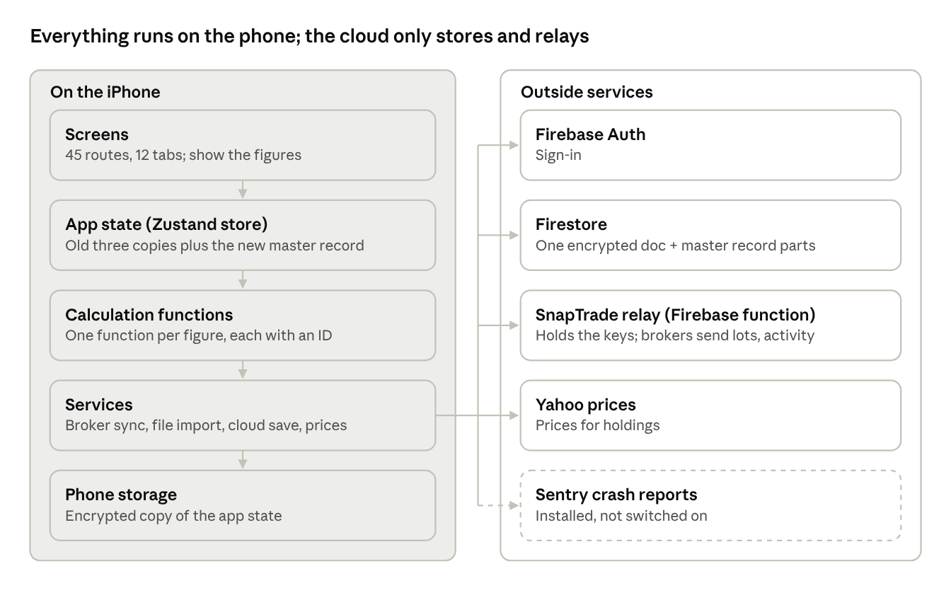
MoneyKeel as built · 5 layers on the phone, 5 outside services
The dashed box is installed but not working.
Architecture rules held vs not held
Rule | Held?
One function per figure, traceable by ID to its formula and inputs | Held for figures with IDs; new master-record functions have no IDs yet
Data encrypted on the phone and in the cloud | Held
Only the owner and household see a person's data | Held, tested by cloud rules tests
Every dated event kept, never overwritten | Held in the master record; the app still writes the old copies
Stable IDs across devices | Not held: row numbers are per phone
Linked records checked (a holding always has its account) | Not held
Exact decimal money | Not held
Data changes can be migrated and rolled back | Not held
Cloud and integrations. These are Firebase (sign-in, Firestore, one cloud function), SnapTrade for brokers, and Yahoo for prices. Firestore saves the master record at users/{uid}/assetRecord/{part}, 400 rows per part. Backups and monitoring: Not known.

3. Development lifecycle and gates
Every screen change passes these gates in order. A build is cut only after the last one.
- Start from the last approved design. Find the screen's approved drawing and the build that shipped it, and list every difference from today's code.
- Drawing first. A full-colour phone drawing is saved before any code. It shows the full screen and an empty-account state.
- Decision recorded. The ruling goes into the decision log with what it affects, what changes, and the steps to apply it. If any of the three is missing, the write is refused.
- Code with tests. A change to a screen must carry a test change, enforced by check-ui-tests.sh.
- Drawing-match audit. Every visible word on the drawing is compared, in order, with every word the built screen shows.
- Outside audit. A checker that never saw the work reviews it. The next phase starts only when the audit finds no critical or high fault.
- Journey tests. End-to-end flows run for each persona, and their findings are fixed before the build.
- Build checks. The type check, the full test suite, build-all.sh, and the screen map all run.
- Pre-build checklist to the founder. The checklist covers scope, audits, test counts and open findings.
- "Cut the build". Only these words from the founder start an EAS build. A TestFlight review follows.
Not known: whether the GitHub CI runs on this branch. Its checks run only on pushes and pull requests to main, and the work is on taxonomy-v1.0.7.

4. Master work breakdown and status tracker
One row per work item, as of 2026-11-11. The founder's day-to-day tracker is the workplan workbook (moneykeel_calc_plan_workplan_v01.xlsx); this table summarises it and does not replace it.
ID | Work item | Status | Evidence | Next step
W-01 | Net worth module | On TestFlight | Build 57 | Founder's TestFlight review
W-02 | Cash flow module | On TestFlight | Build 57 | 5 drawn words await founder's answer
W-03 | Performance module | In progress | Build 57; wealth generated not traceable | Phase 4 of the master-record plan
W-04 | Home, Plan, Menu | Blocked | Held back from Builds 55-57 by founder's scope | Not known
W-05 | Master record, phase 1 (build and check the list) | Committed | a6679cea; 248 tests; 8 outside rounds | Outside re-check of round 8 fixes
W-06 | Phase 2: broker sync writes to the list | Committed | d188fd68 … c0dfea60; outside checks rounds 1–4: every fault fixed | Questions-and-answers design
W-07 | Phase 2: file import writes to the list | Committed | d188fd68 … c0dfea60; outside checks rounds 1–4: every fault fixed | 8 lower faults (workplan)
W-08 | Phase 2: list saved to the cloud | Committed | d188fd68, a94fc8f6, f605f431, e5be48ce; only the phone that saved last may save (DEC-10685) | Cloud copy design
W-09 | Phase 2: typed entries write to the list | Committed | 11 of 11 store actions; d188fd68, 1b62fe1f | Questions-and-answers design
W-10 | Phase 2: daily value from the data's own date | Committed | Written only on an update or a price refresh, under the data's date; d188fd68, 06ef67aa | None
W-11 | Phase 2: one-time move of a phone's data | Committed | c0dfea60; simplified (DEC-10749): 16 households, shares and gains match the app | None
W-12 | Phase 2: comparison check, list against old copies | Committed | c4a137f1; 23 accounts, 16 holdings; every difference explained | None
W-13 | Phase 3: screens read only the list | Not started | Question screens to be drawn first | After the cloud copy and questions-and-answers designs
W-14 | Phase 4: six Performance numbers, one at a time | Not started | Listed in the plan | After phase 3
W-15 | ID numbers, code headers, master rows for new functions | Committed | 1b62fe1f; 108 functions; 622 of 622 formulas in words | None
W-16 | Row numbers safe across two phones | In progress | Two phones never mix: the second saves nothing and says so (a94fc8f6) | Cloud copy design (two phones, households, offline edits, delete account)
W-17 | Crash reporting switched on | Not started | Sentry installed, no key set | Not known
W-18 | Password reset no longer wipes the phone (in Build 57) | Committed | f605f431 (DEC-10749) | Ships with the next build
W-19 | Spouse signs in on the same phone: data set aside (in Build 57) | Committed | e5be48ce (DEC-10813); outside check: 4 faults fixed | Ships with the next build
W-20 | Questions-and-answers design | Not started | Workplan row, 2026-11-12 | Before phase 3

5. Finance-specific controls and testing standards
Each control below is something that runs and fails the build, unless it says otherwise.
Control | What it holds | How it is enforced
One calculation, one place | Each money figure is worked out by one function, never again on a screen | Cross-screen agreement tests
Full precision | Nothing rounds inside a calculation; rounding happens once, on display | precision_guard test
Returns over a year | Shown as a yearly rate with "a year", and the window's total beside it | Precision standard; tests
One word per concept | Each idea has one name in all app wording; retired words fail | one_term_per_concept test
Dates kept | A broker update or a file never overwrites a date the account holder gave | Master-record tests (248)
Shares change only on a transaction | A broker's history never adds shares; a difference is asked about | Master-record tests
Account holder can override | Every disagreement becomes a question; the answer can be changed later | Master-record tests
Figures in briefs | Every number in a design brief is recomputed by the code | brief_figures_guard test
Guards prove they looked | Each guard states how many records it checked | Floors in each guard test
Cloud access | Only the owner and a household member read a person's data | Firestore rules tests (emulator)
Traceability | A screen figure leads to its function, formula, inputs and decisions in one minute | Master file built by build-moneykeel-master.py; IDs such as MK-NW-M-015
Not held today: exact decimal arithmetic for money, checks between linked records (a holding pointing at a missing account), and a reconciliation against a broker's own totals. The last of these is part of phase 4.

6. Development operating model
One founder decides; Claude Code builds; outside checkers review. No other people are known to work on the app.
Role | Who | Decides or does
Founder | JJ | Every design, wording and calculation ruling; approves screens on TestFlight; says "cut the build" and "push"
Builder | Claude Code | Writes code, tests, drawings and records; applies each ruling to every file that carries it
Outside checkers | Separate agents that never saw the work | Score and find faults each round; at most 3 agents run at once (DEC-9683)
Earlier outside audits | OpenAI audit packages | Used in the past; current use Not known
Standing orders that shape the work:
- One module at a time, finished to launch-ready before the next.
- The founder leads calculation fixes one error at a time.
- Plain English under 60 words; reports as Fix · Example · Before · Now.
- Every input, figure and function is named by its ID.
- The workplan workbook is the tracker; the decision log is the one master of decisions.
- Nothing is pushed or built without the founder's word.

7. Repository structure
One repository (finwise) holds the app, the calculation code and the documents.
Folder | Holds
app/ | 45 route files, including 12 tab screens (Home, Cash flow, Invest, Plan and others)
src/ | Screens (50), components, store (useStore.ts), services (Firebase, broker sync), domain logic, tests
MoneyKeel/functions/ | Calculation functions by module: networth-and-performance, cashflow, retirement, home-screen; the master record lives here
Calculation Module code/ | Engines, build scripts (build-all.sh, build-moneykeel-master.py), decision and rulings files
MoneyKeel/documents/ | Standards, drawings, decision log, workplan
functions/ | Firebase cloud functions: the SnapTrade relay
docs/ | Older design and tracking documents; docs/README.md is the index
.github/workflows/ci.yml | Type check, full tests, and the screen-test rule, on main only
firestore.rules | Cloud access rules, with their own tests
The repository has 1,223 commits and 614 test files.

8. Governance and approval register
Builds and the decisions behind the current work, newest first.
Date | Item | Approved by | Note
2026-11-11 | Phase 1 of the master record committed; phase 2 started | JJ ("commit, and start phase 2") | Round 8 fixes not yet re-checked by an outside round
2026-11-11 | DEC-10514 master record saved to the cloud; DEC-10515 two broker lots stay two | JJ | Coded, not committed
2026-11-10 | DEC-10342, 10385, 10386, 10471: one dated master record; account holder can override; every difference asked | JJ | Built in phase 1
2026-11-08 | Build 57 cut (EAS 0dce5b98) from b680506f | JJ ("push and cut the next build") | On TestFlight
2026-11-05 | Build 56 cut (ff4fd4b1) | JJ | Build 55 import and bond fixes
Not known | Build 55 | JJ | Scope: Net worth, Cash flow, Performance only
2026-10-09 | DEC-3523: the eight MoneyKeel tenets | JJ | Every figure is checked against them
The full record is the decision log (moneykeel_log_decisions_v01.xlsx, 1,248 rows) and the design Changelog.

9. Defect and risk register
The two highest risks are wrong numbers on screen and data that cannot be recovered.
ID | Defect or risk | Severity | Example | Plan
R-01 | Wealth generated cannot be traced to dated records | Critical | $3,343 and 2.12% from the Robinhood file | Master record, phases 2 to 4
R-02 | A sync or import overwrites dates | Critical | A purchase date the account holder typed is wiped | Fixed in the list; app not yet reading it
R-03 | Values dated with the phone's date | High | File values of Jun 21 recorded as Nov 4 | Phase 2 daily value
R-04 | Return divides by a beginning value the screen never shows | High | 2.12% | Phase 4
R-05 | CD interest after it matured; shown as change in value | High | CD matured Aug 24 | Phase 4
R-06 | Accounts add to $303 against a total of $301 | Medium | Rounding | Phase 4
R-07 | No server, no migrations, no rollback | High | A bad save cannot be undone | Not decided
R-08 | Money held as floating-point numbers | Medium | Tiny sums can drift | Not decided
R-09 | Two phones can give the same row number | High | Rows from two devices collide in the cloud | Design needed
R-10 | No crash reporting on device | Medium | Sentry off | Not decided
R-11 | CI does not run on the working branch | Medium | Checks only on main | Not decided
R-12 | 19 changed files not committed | Medium | Phase 2 work | Commit after the full test suite

10. Phase status dashboard
Phase 2 of the master-record plan is under way; nothing after it has started.
Phase | Content | State | Gate to leave it
1 | Finish the list | Committed (a6679cea) | No critical or high fault in an outside round: round 8 found 8 high, fixed, not re-checked
2 | App writes to the list beside the old copies | In progress: broker, file and cloud written; typed entries, daily value, one-time move, comparison not started | Comparison check with nothing unexplained
3 | Screens read only the list | Not started | Full tests, screen checks, walk-through of the founder's two cases
4 | The six Performance numbers | Not started | Each with the founder's numbers worked by hand
5 | Before any build | Not started | Pre-build checklist and "cut the build"

11. Immediate next actions
- ☐ Run the full test suite and check-ui-tests; add the screen test for the file-import change
- ☐ Connect the 9 typed-entry store actions to the list
- ☐ Write the daily value from the data's own date, not when Home opens
- ☐ Build the one-time move of a phone's existing data
- ☐ Run the comparison check on test households, the Microsoft case and the Robinhood file
- ☐ Commit phase 2 (push only on the founder's word)
- ☐ Founder: answer whether the four data gaps get a written design before phase 3, and whether a server and database become their own phase

12. Definition of done
Work is done only when all of these hold. A coverage line ("did X on N of N units") goes with every done report.
- Complete means every row of every approved document: product requirements, screen designs and wording rules. An exclusion counts only if a document states it or the founder approved it by name beforehand.
- The whole object is covered: every tab of a file, every screen and data state, every case of a bug.
- The built screen matches its approved drawing word for word, in every data state, including an empty account.
- The calculation file and the code are both updated and match 100%.
- The type check, the full test suite, check-ui-tests and build-all.sh all pass.
- The decision is in the decision log, the changelog, its standard, the master rows and the workplan, the same day.
- The founder marks it verified, usually after reviewing it on TestFlight.

13. Information this document does not have
- Users, market size, pricing and launch date.
- Any owner, reviewer or budget besides the founder.
- Whether Android or the desktop design will be built.
- Support for currencies other than US dollars.
- Backups of the cloud data, and how to restore them.
- Monitoring and alerts once the app is live.
- The date of Build 55.
- Whether CI results are looked at, given it runs only on main.
- App Store submission plan and review status.

