Theory
R is a powerful open-source language designed for statistical computing, data analysis, and graphical representation. Before writing any program, it is essential to set up the working directory so R knows where to read/write files. R also provides a rich set of operators and built-in functions for performing calculations.

1. Working Directory Functions:
- getwd() — Returns the current working directory path.
- setwd() — Sets a new working directory.
- list.files() — Lists all files in the current working directory.

2. Arithmetic Operators:
- + Addition | - Subtraction | * Multiplication | / Division
- %/% Integer Division | %% Modulus (Remainder) | ^ Exponentiation

3. Comparison Operators:
- > Greater than | < Less than | == Equal to | != Not equal to | >= >= | <= <=

4. Logical Operators:
- & AND | | OR | ! NOT

5. Built-in Math Functions:
- sqrt(), abs(), round(), floor(), ceiling(), sum(), mean(), median(), var(), sd(), min(), max(), range()
- log(), log10(), log2(), exp() — Logarithmic and exponential functions.
- sin(), cos(), tan() — Trigonometric functions (input in radians).

Program 1a — Setting up Working Directory
Code for Program 1a — Working Directory Operations:
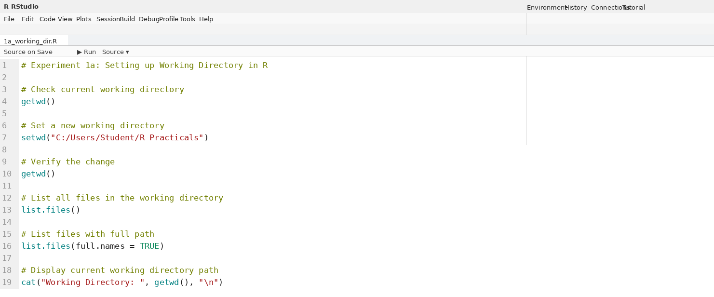
Output for Program 1a:
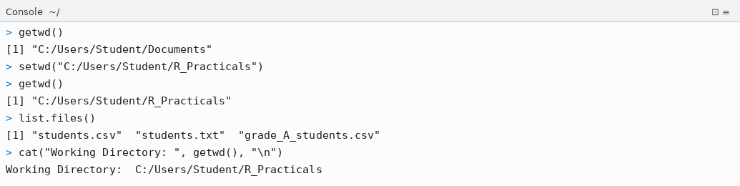

Program 1b — Basic Arithmetic Operations
Code for Program 1b — Arithmetic Operations:
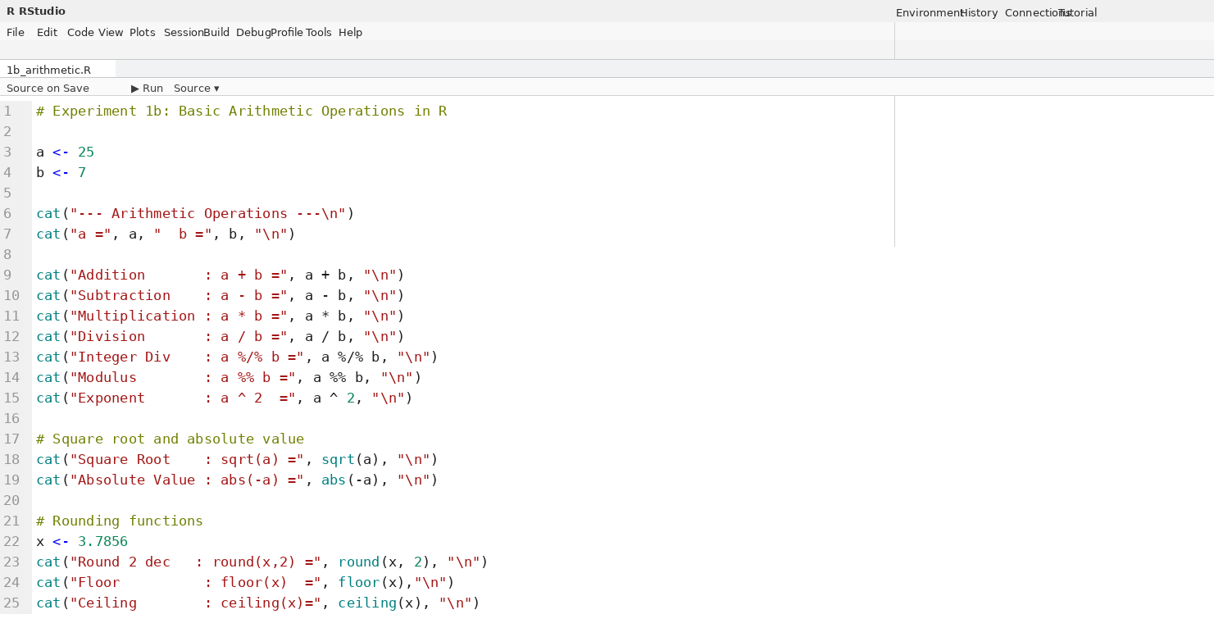
Output for Program 1b:
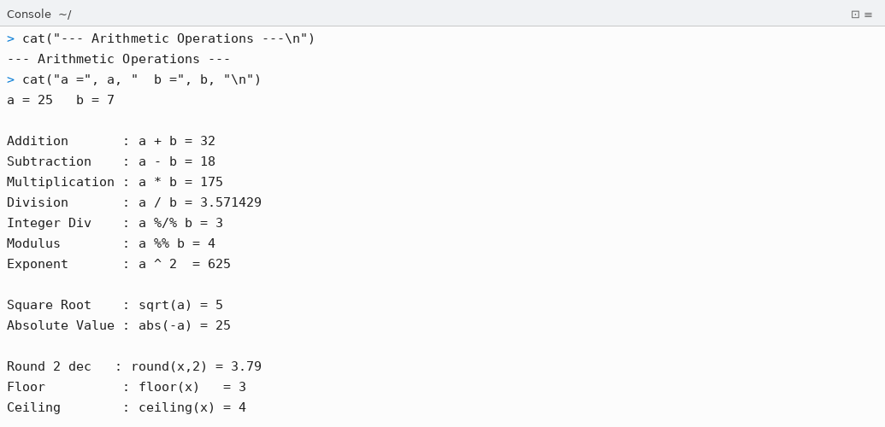

Program 1c — Comparison and Logical Operators
Code for Program 1c — Comparison and Logical Operators:
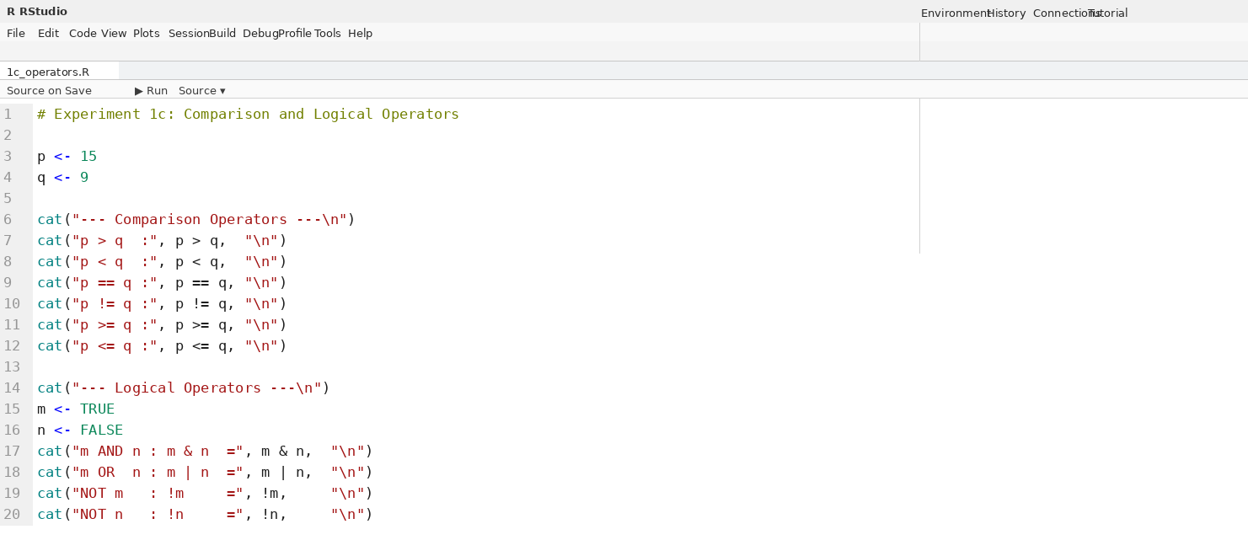
Output for Program 1c:
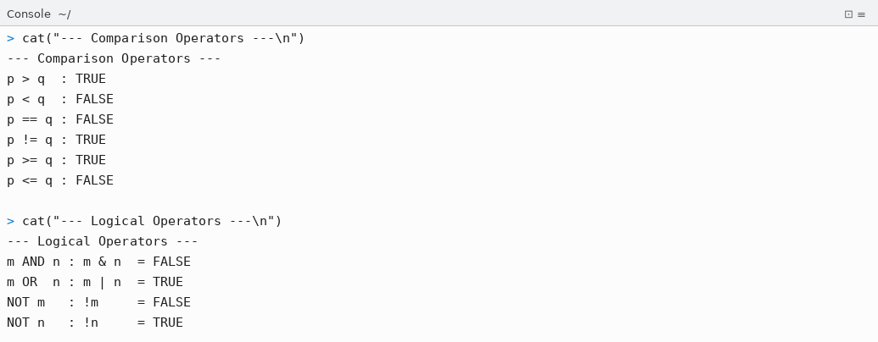

Program 1d — Variables and Data Types
Code for Program 1d — Variables and Data Types:
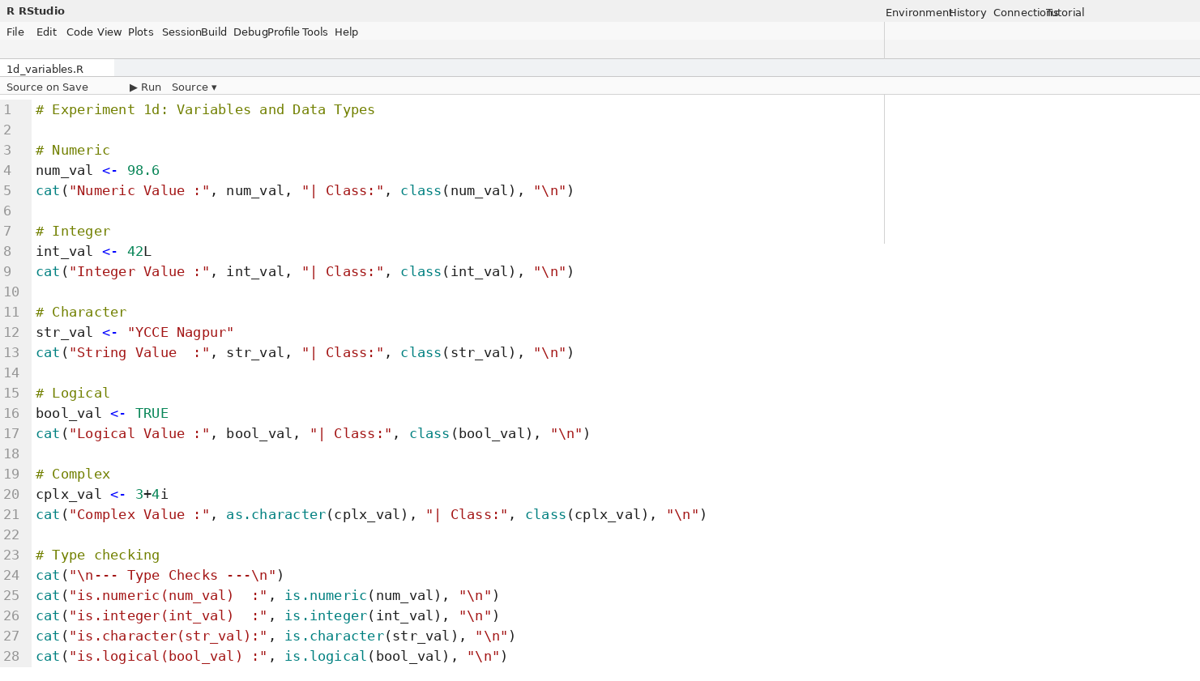
Output for Program 1d:
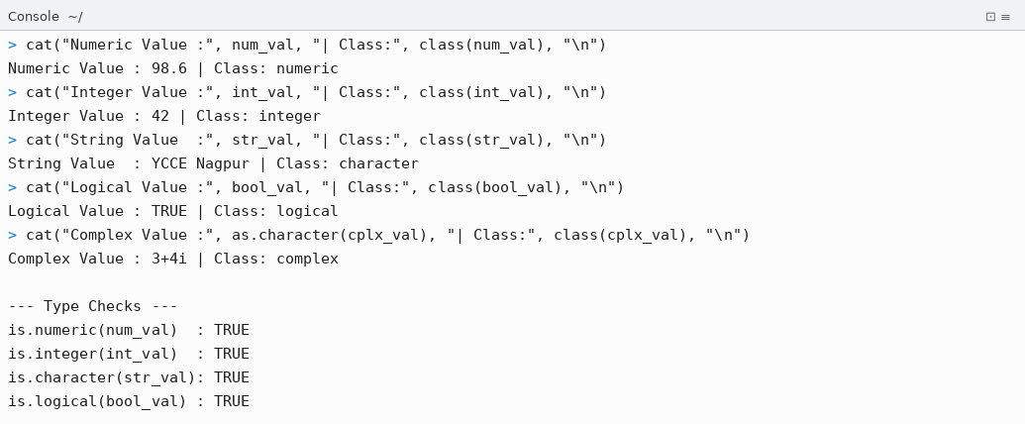

Program 1e — Built-in Mathematical Functions
Code for Program 1e — Mathematical Functions:
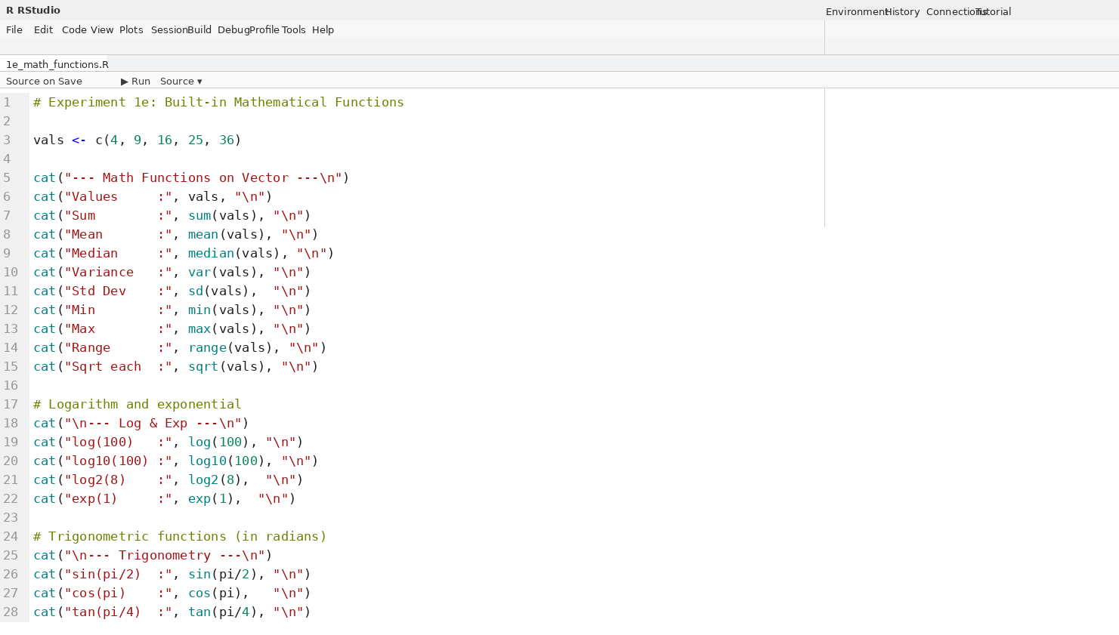
Output for Program 1e:
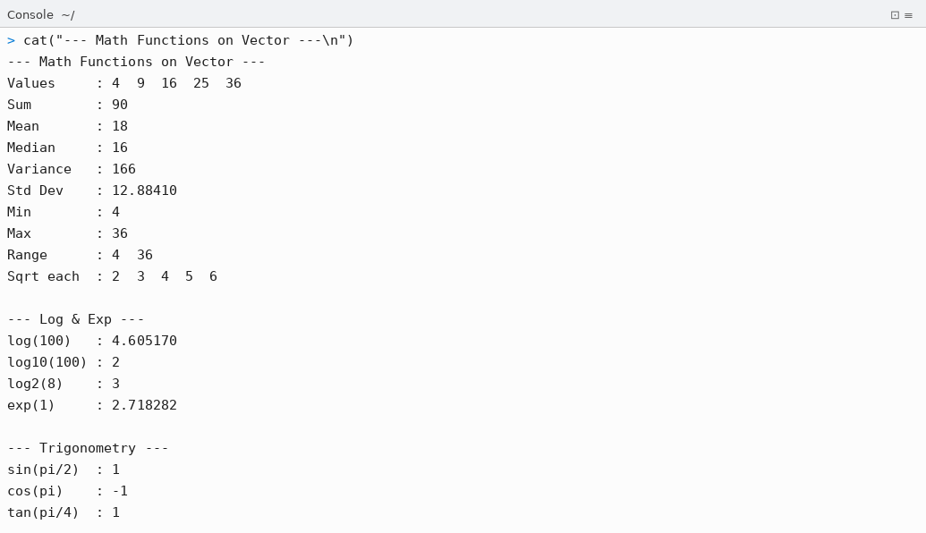

Conclusion
Thus, the following R programs for Experiment 1 were successfully written, executed in RStudio, and the outputs were verified:

- Program 1a: The working directory was set using setwd(), verified using getwd(), and all files in the directory were listed using list.files(). This establishes the correct file path context for all subsequent R programs.
- Program 1b: Basic arithmetic operations were performed on variables a=25 and b=7. All operators — addition (+), subtraction (-), multiplication (*), division (/), integer division (%/%), modulus (%%), and exponentiation (^) — were demonstrated along with rounding functions round(), floor(), and ceiling().
- Program 1c: Comparison operators (>, <, ==, !=, >=, <=) and logical operators (&, |, !) were applied to numeric and logical variables. All operators produced correct Boolean (TRUE/FALSE) results as expected.
- Program 1d: Five R data types — numeric, integer, character, logical, and complex — were declared and printed. The class() and is.*() functions were used to verify the type of each variable, confirming R's dynamic type system.
- Program 1e: Built-in mathematical functions including sum(), mean(), median(), var(), sd(), min(), max(), range(), sqrt(), log(), log10(), log2(), exp(), sin(), cos(), and tan() were applied to verify R's comprehensive math library.

All programs were executed in RStudio (R v4.5.3) and produced the expected outputs. The working directory setup and basic calculation capabilities of R were successfully demonstrated.

YCCE | M.Tech Data Science | Sem II | 2025-26 | Experiment 1 | Open Source Tools Lab

