Practical No.2
Aim: Write an R program to define and print different types of data structures commonly used in R. Your program should include the following:
Theory:
R is a programming language used for statistical computing and data analysis. It provides various basic data types and data structures to store and manipulate data efficiently.
1. Basic Data Types in R:
- Numeric: Represents decimal numbers (e.g., 10.5)
- Integer: Represents whole numbers (e.g., 10L)
- Character: Represents text or strings (e.g., "Hello")
- Logical: Represents Boolean values (TRUE/FALSE)
2. Data Structures in R:
- Vector: Collection of elements of the same data type
- List: Collection of elements of different data types
- Matrix: Two-dimensional homogeneous data structure
- Data Frame: Tabular structure with rows and columns, can hold different data types
3. Functions Used:
- print() → Displays output
- cat() → Prints formatted output
- class() → Returns the class of an object
- typeof() → Returns the internal storage type

Code for numeric:
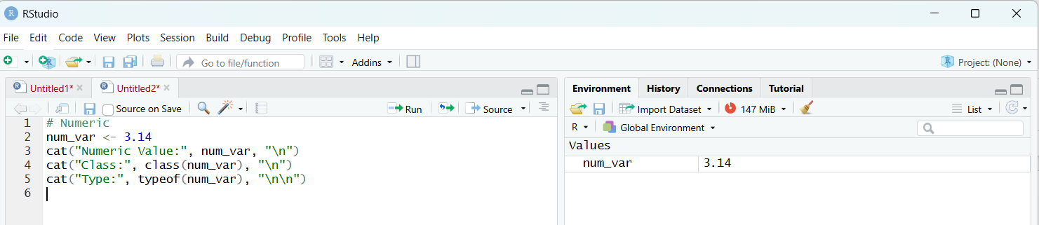
Output:
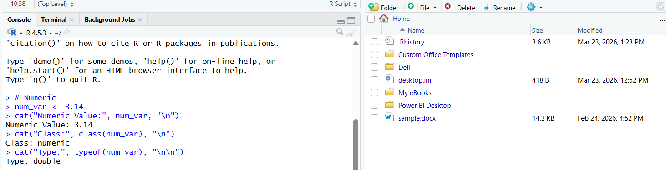
Code integer:
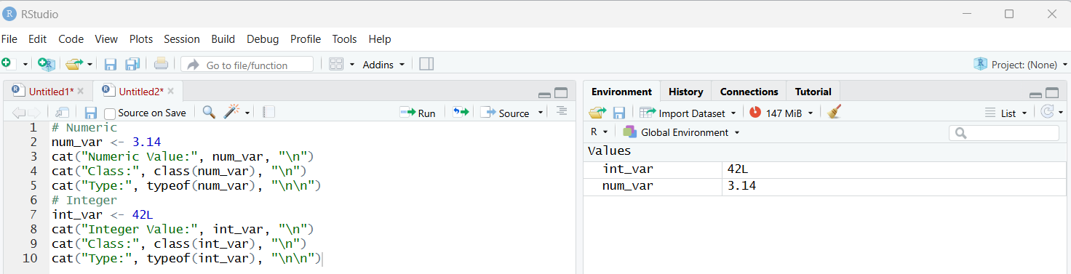
Output for integer:
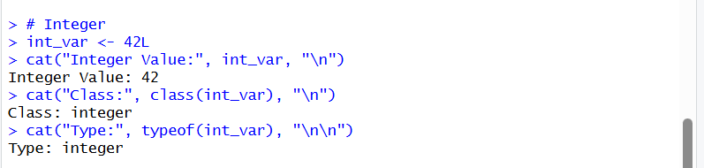

Code for character:
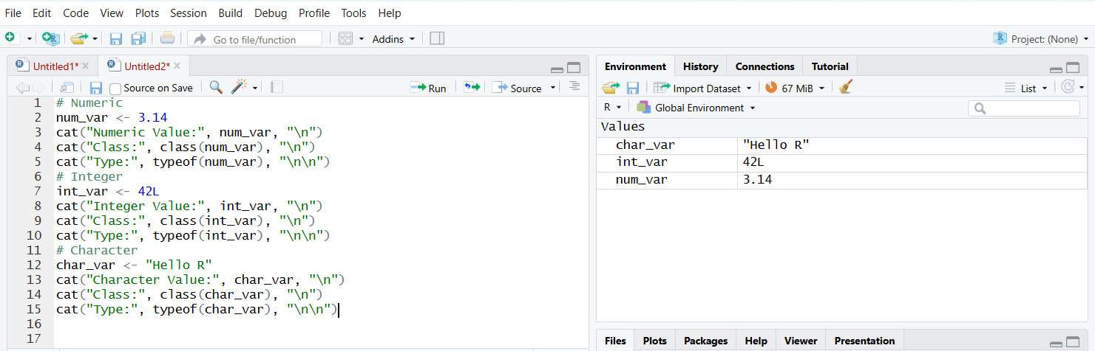
Output for character:
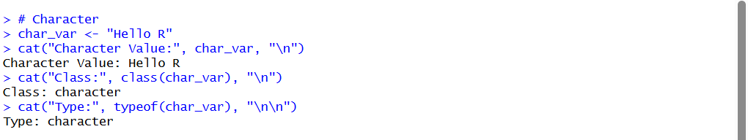
Code for logical:
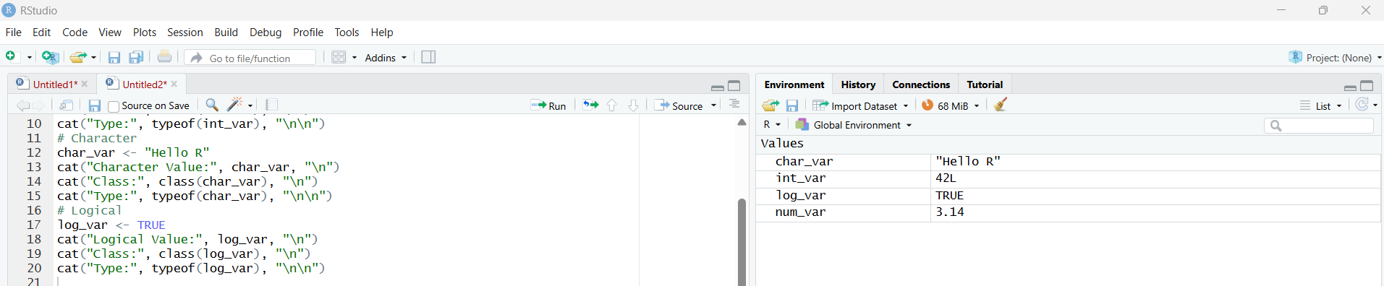
Output:
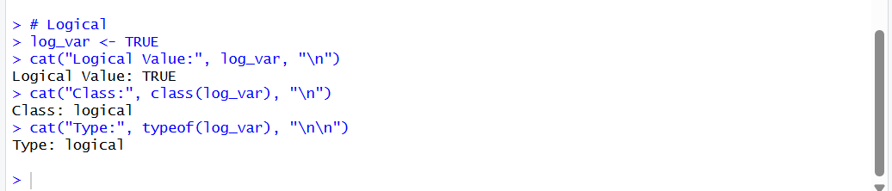
Code for vector(numeric):
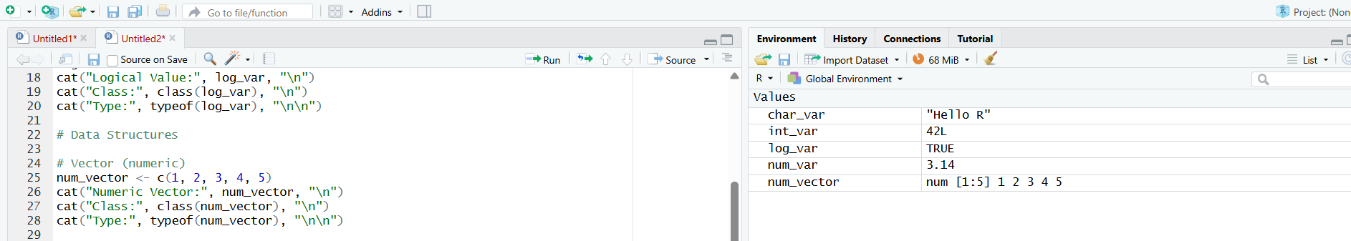
Output:
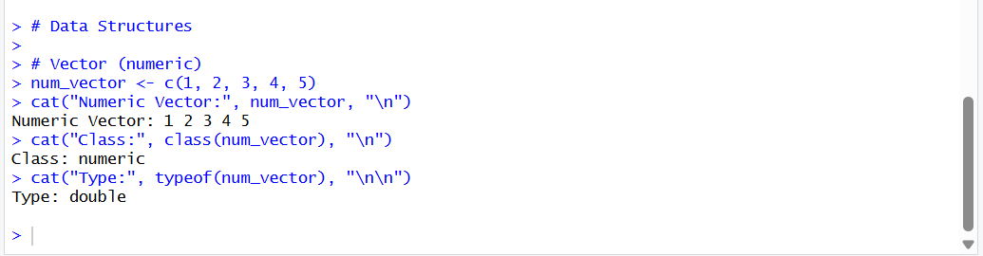
Code for vector(character)
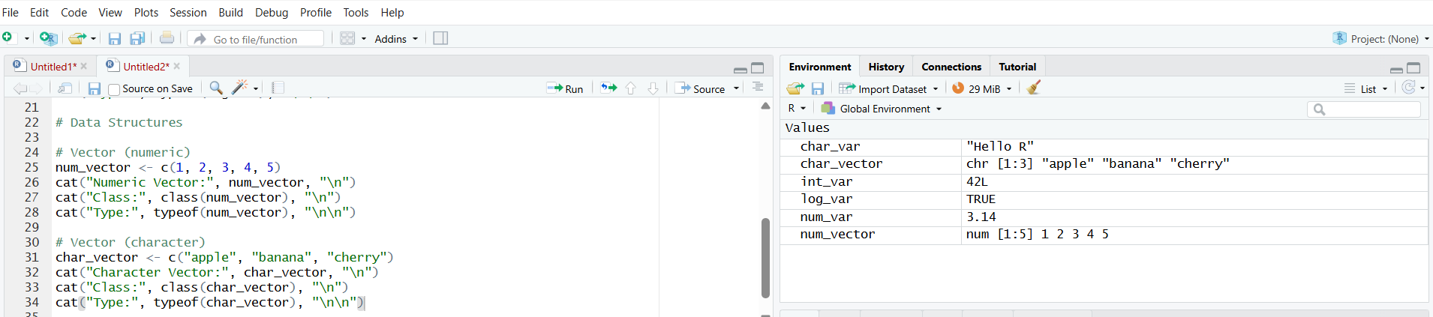
Output:
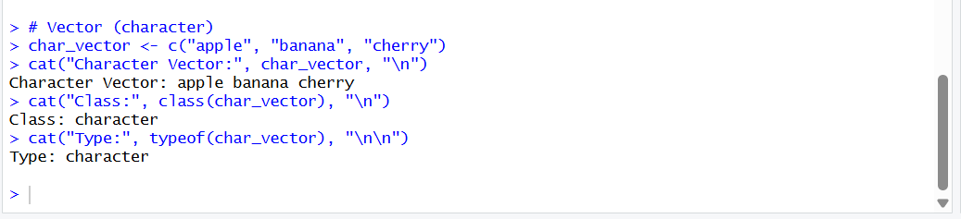

Code for list( mixed datatypes):
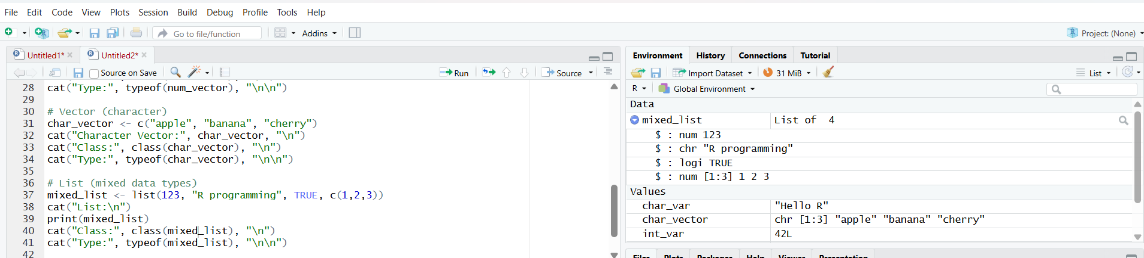

Output:
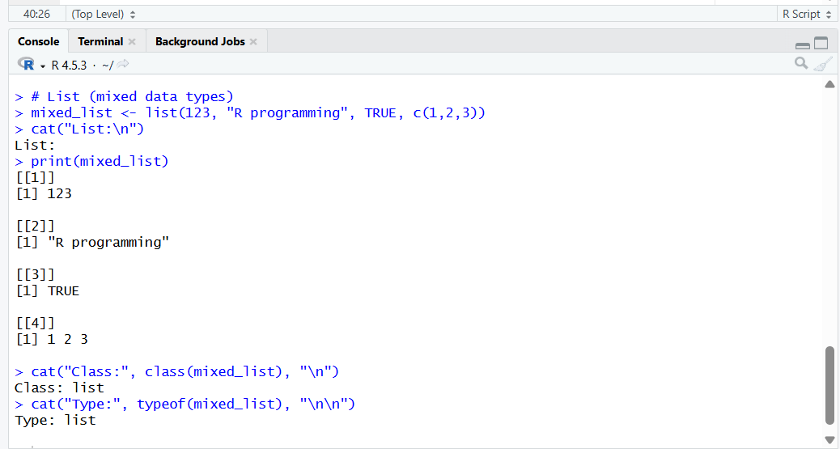
Code for matrix:
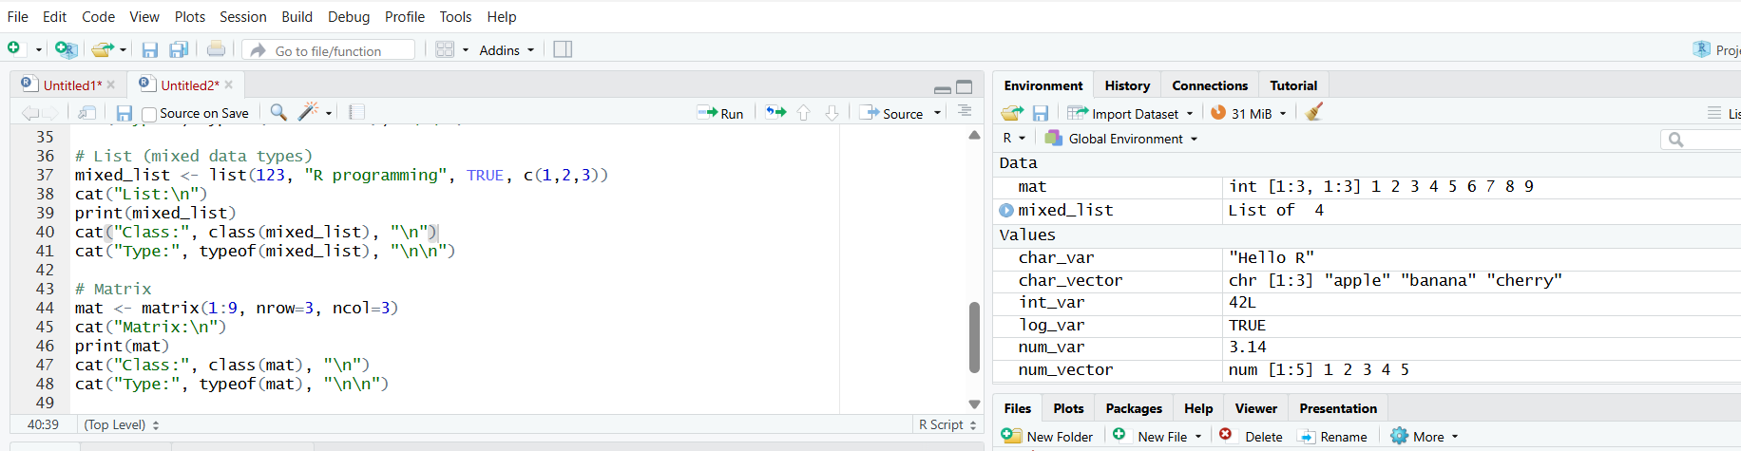
Output:
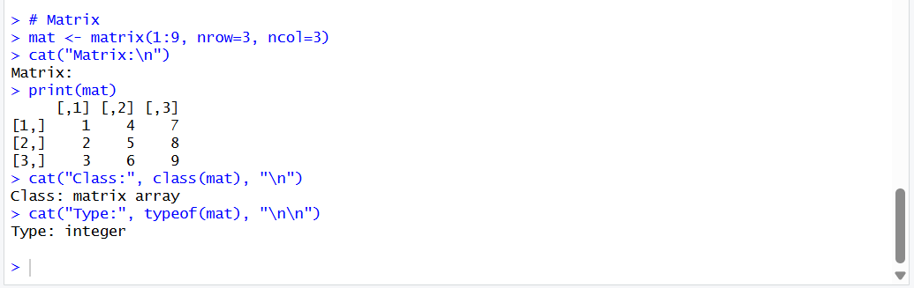

Code for dataframe:
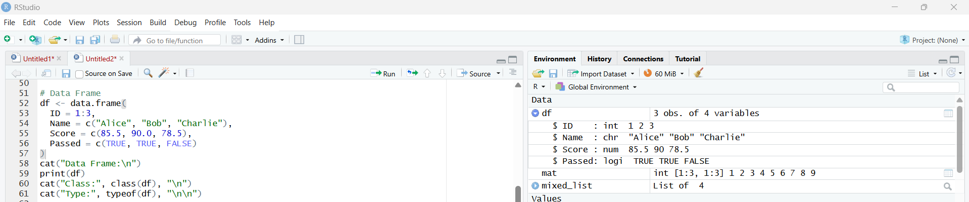
Output:
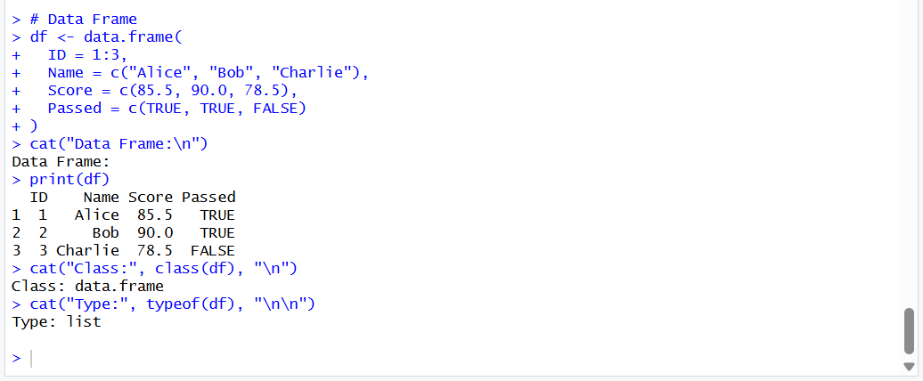

Conclusion: Thus, different basic data types (numeric, integer, character, logical) and data structures (vector, list, matrix, data frame) in R were successfully created and displayed along with their values, classes, and internal data types.

