Theory
R is a high-level programming language used for statistical computing, data analysis, and graphical representation. This practical covers two core aspects of R:

1. File Import and Export:
- read.table() / write.table() — for tab-separated .txt files.
- read.csv() / write.csv() — for comma-separated .csv files.
- readLines() — reads raw content of a file line by line.

2. Loop Control Structures:
- for loop — iterates over a sequence or vector; number of iterations known in advance.
- while loop — repeats as long as a condition is TRUE; exits when condition fails.
- repeat loop — executes indefinitely; exit is controlled explicitly using break.
- next — skips the current iteration and moves to the next.
- break — immediately exits the loop regardless of condition.

Part I — Import and Export: Text File and CSV File
Code for Program 1a — Create Data Frame and Export to TXT File:
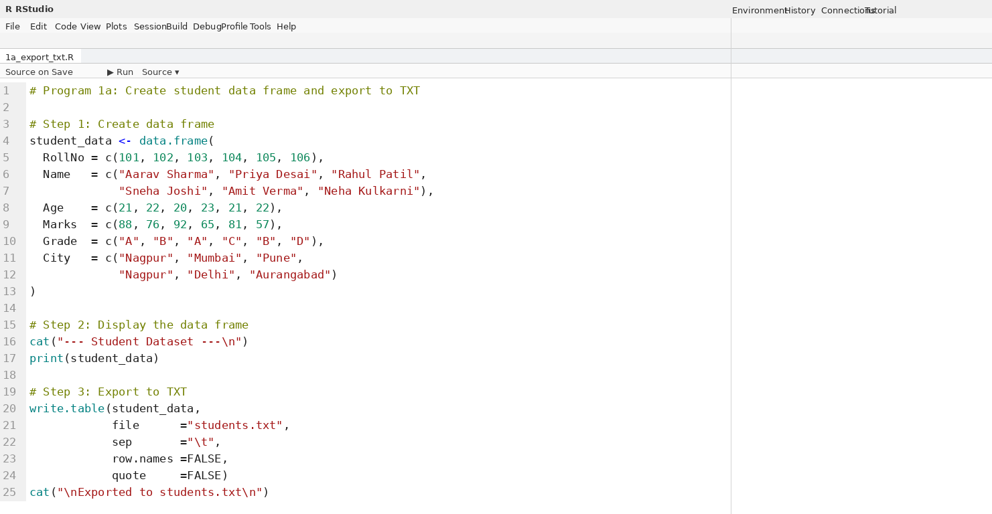
Output for Program 1a:
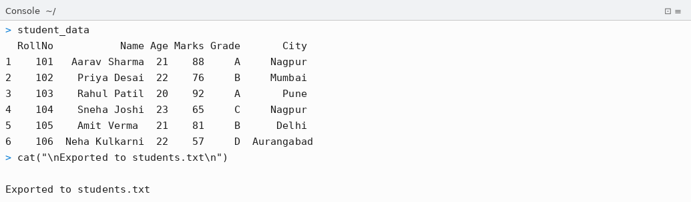
Code for Program 1b — Import from Text File and Field Operations:
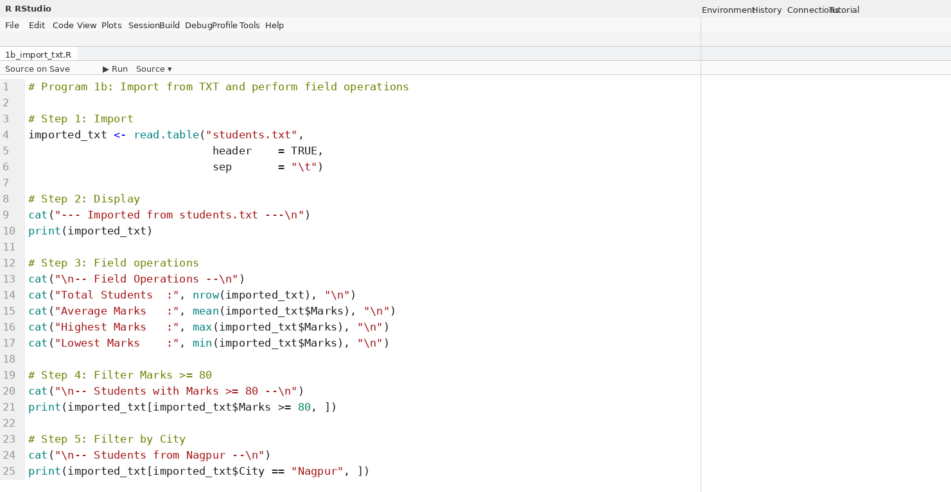
Output for Program 1b:
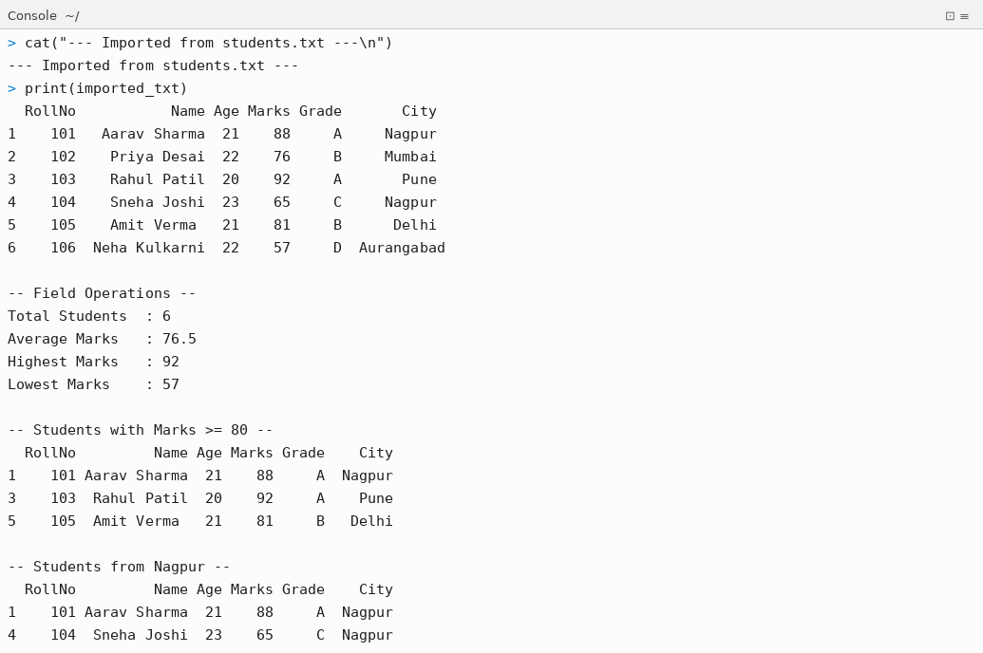
Code for Program 1c — Export to CSV File:
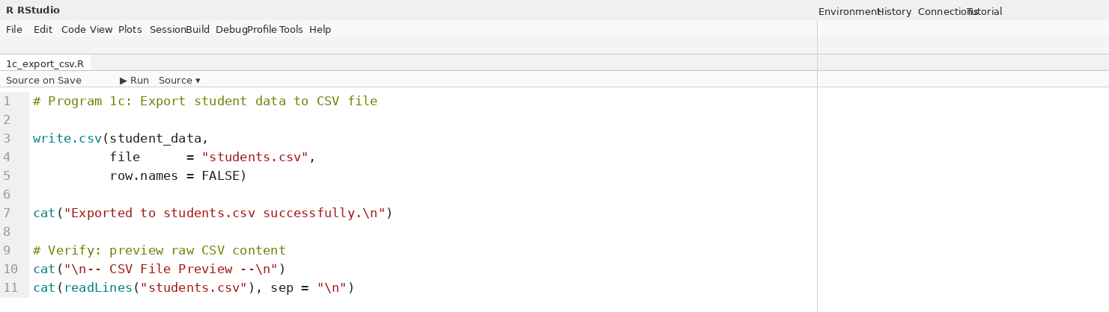
Output for Program 1c:
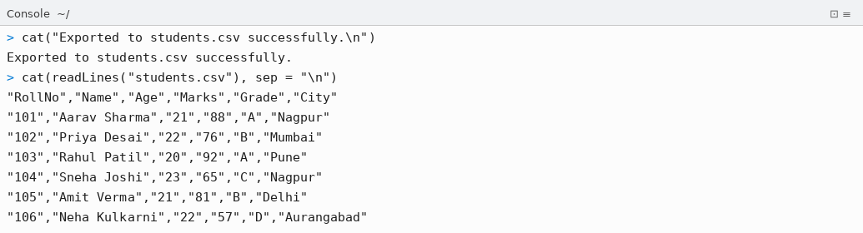
Code for Program 1d — Import from CSV and Analysis:
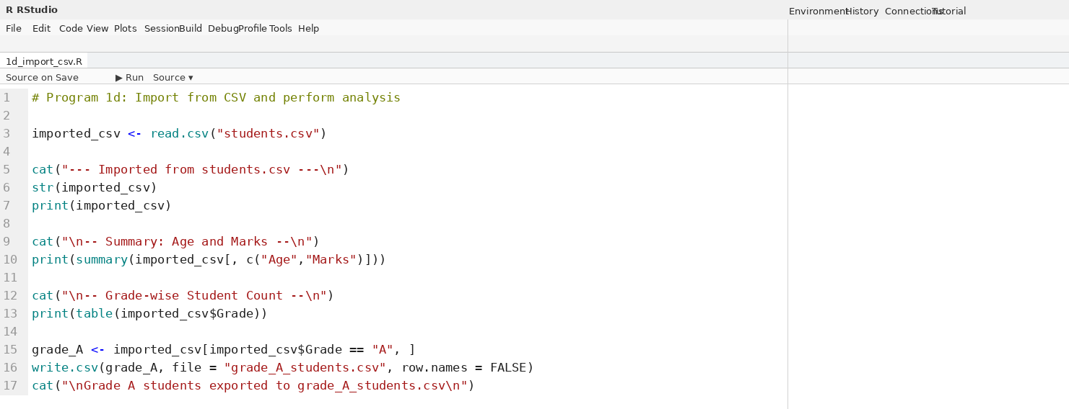
Output for Program 1d:
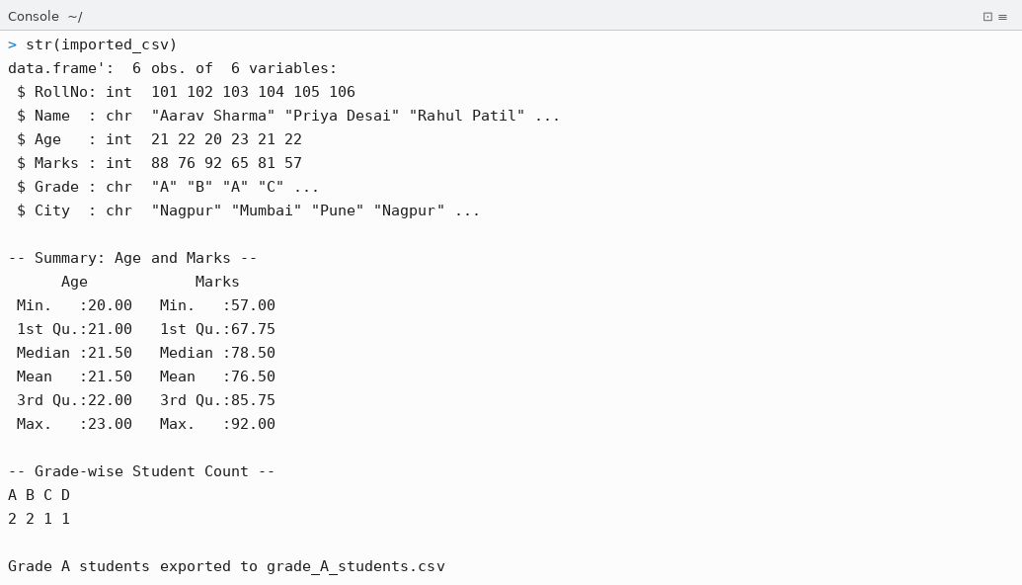

Part II — Loop Operations: for, while, repeat
Code for Program 2a — for Loop:
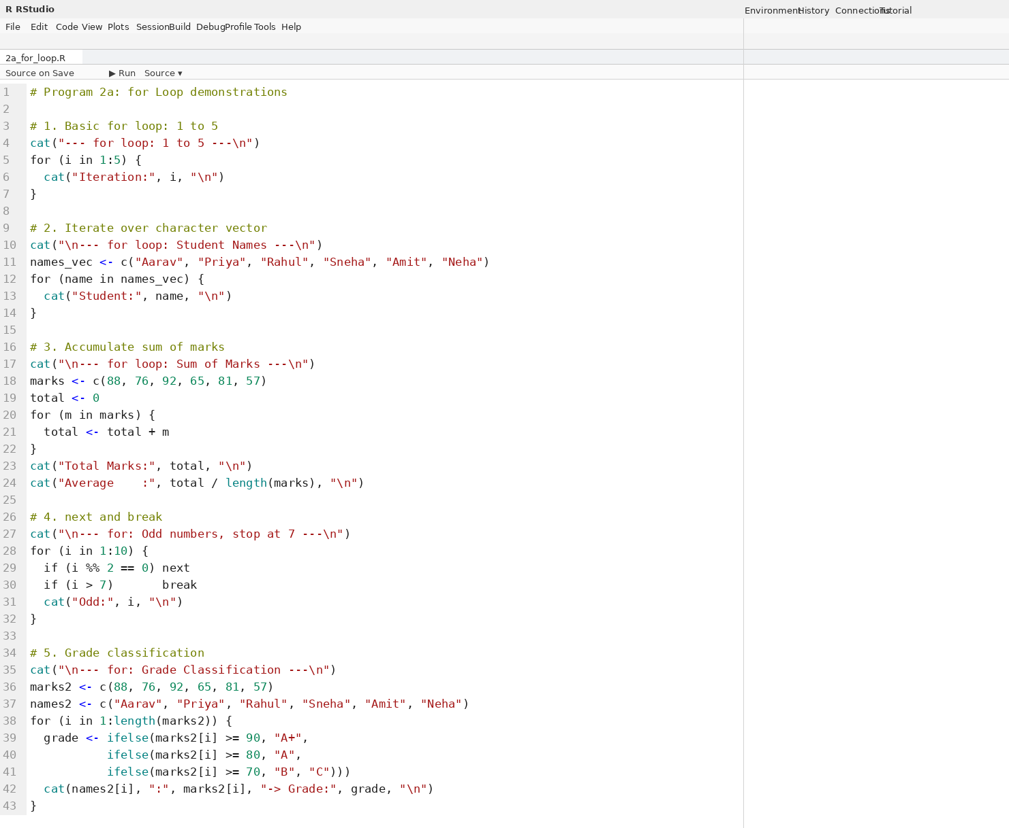
Output for Program 2a — for Loop:
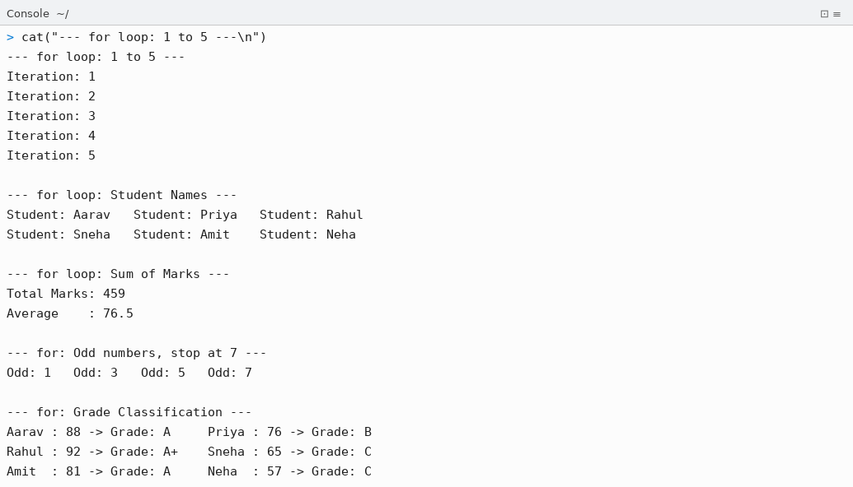
Code for Program 2b — while Loop:
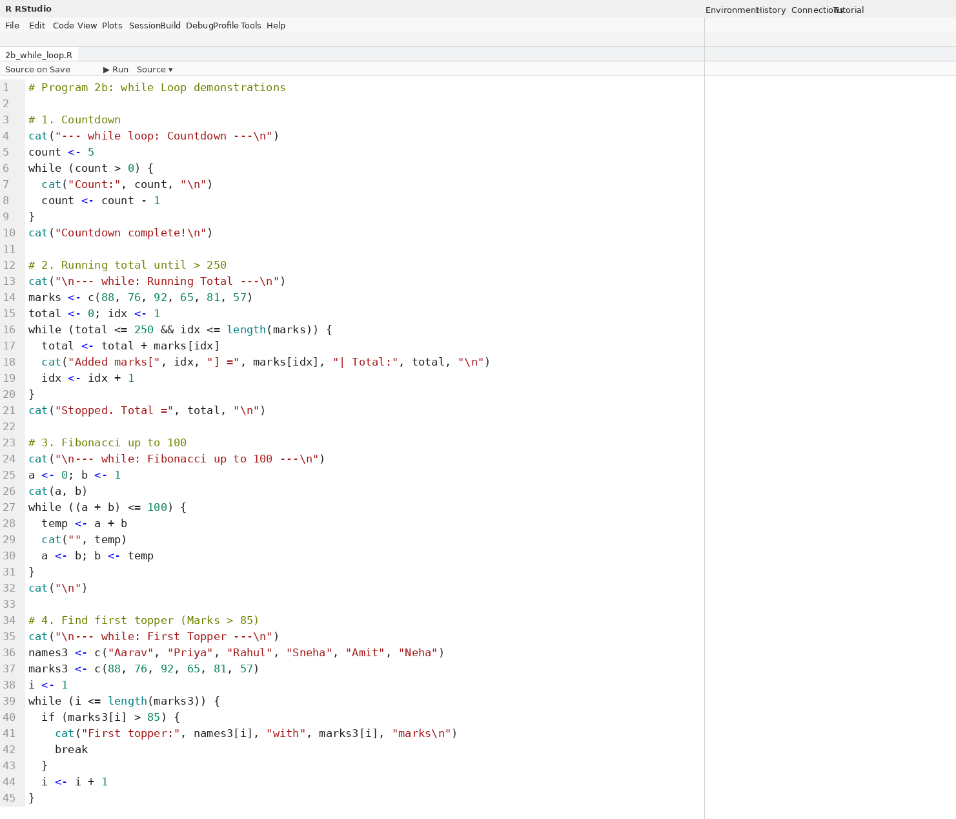
Output for Program 2b — while Loop:
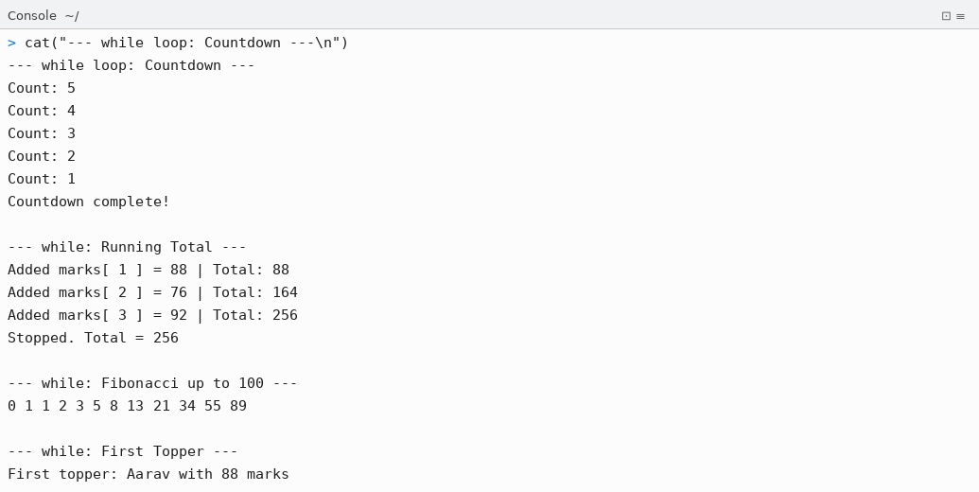
Code for Program 2c — repeat Loop:
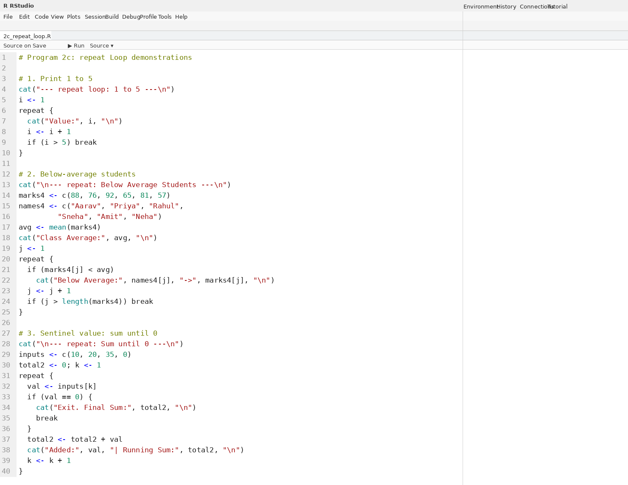
Output for Program 2c — repeat Loop:
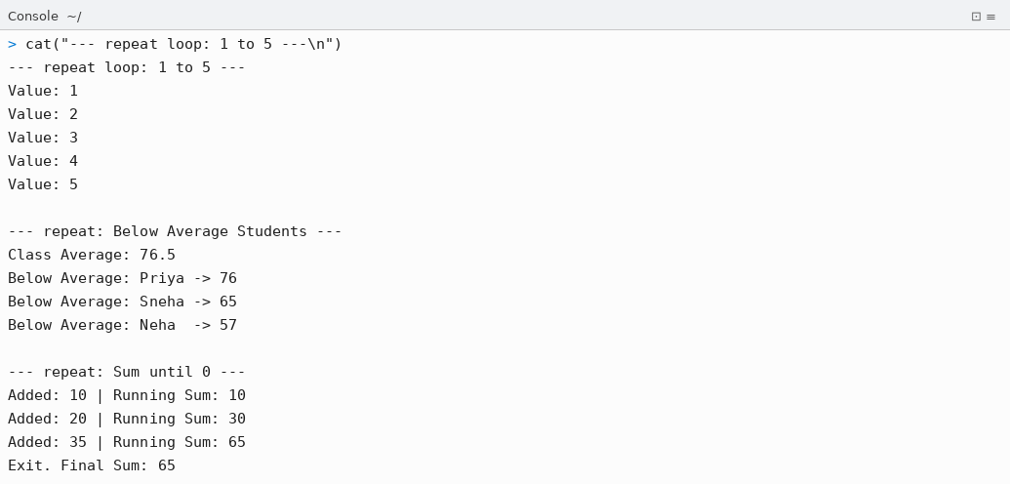

Conclusion
Thus, the following R programs were successfully written, executed in RStudio, and the outputs were verified:

- Program 1a: A 6-record student dataset (RollNo, Name, Age, Marks, Grade, City) was created as an R data frame and exported to students.txt using write.table() with tab separator.
- Program 1b: The text file was re-imported using read.table() and field-level operations (total count, average, max, min, filtering by marks and city) were performed successfully.
- Program 1c: The same student data was exported to students.csv using write.csv() and the raw CSV content was verified using readLines().
- Program 1d: The CSV was imported using read.csv(), summary statistics and grade-wise counts were generated, and a filtered subset (Grade A students) was exported to a new file.
- Program 2a (for loop): Demonstrated sequence iteration, vector traversal, mark accumulation, next/break usage, and grade classification using ifelse().
- Program 2b (while loop): Demonstrated countdown, running total with threshold exit, Fibonacci series generation up to 100, and finding the first student above a mark threshold.
- Program 2c (repeat loop): Demonstrated fixed-count iteration with break, identifying below-average students, and sentinel-value based sum accumulation.

All programs were executed in RStudio and produced the expected outputs. File import/export operations and all three loop types in R were successfully demonstrated.

YCCE | M.Tech Data Science | Sem II | 2025-26 | Practical 3 | Open Source Tools Lab

