Theory
R provides file I/O functions to persist and retrieve data, and loop control structures to iterate over that data programmatically. Combining these two capabilities allows processing of real-world datasets stored in files.

File Operations:
- write.table() / read.table() — export/import tab-separated .txt files.
- write.csv() / read.csv() — export/import comma-separated .csv files.
- list.files() — verify files exist in the working directory.

Loop Control Structures:
- for loop — iterates over each row/element for a fixed number of times. Used for row-wise operations on data frames.
- while loop — repeats as long as a condition holds TRUE. Useful for conditional traversal or threshold-based stopping.
- repeat loop — runs indefinitely until break is called. Used when exit condition is evaluated inside the body.
- next — skips the current iteration and proceeds to the next.
- break — exits the loop immediately, regardless of remaining iterations.

Part I — Create Student Dataset and Export to TXT & CSV
Code for Part i — Create Data Frame and Export to students.txt and students.csv:
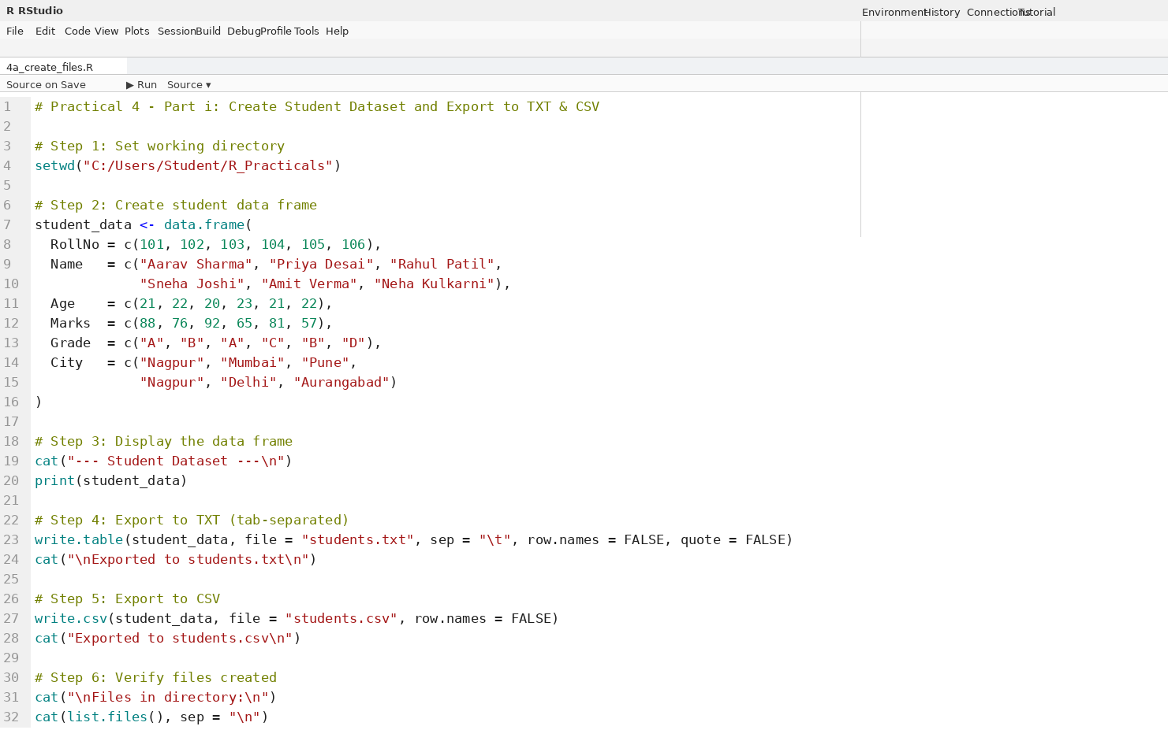
Output for Part i:
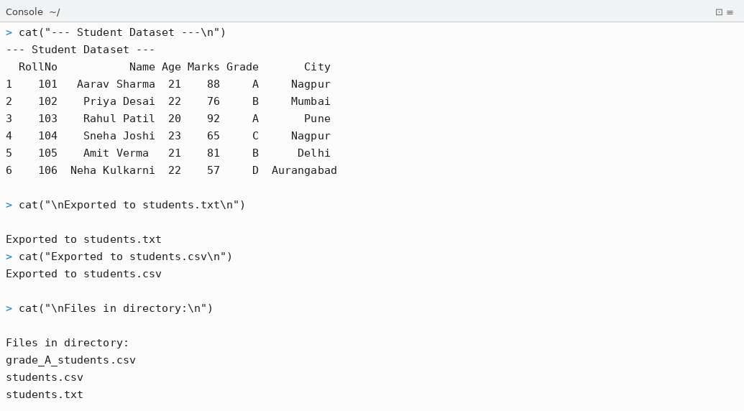

Part II — Loop Control Structures on Text File (students.txt)

Program 4b — for Loop on students.txt
Code for Program 4b — for Loop on TXT File:
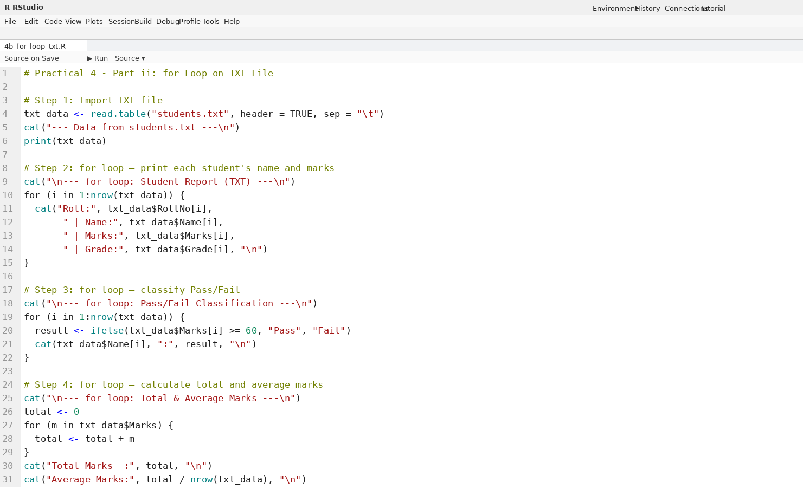
Output for Program 4b:
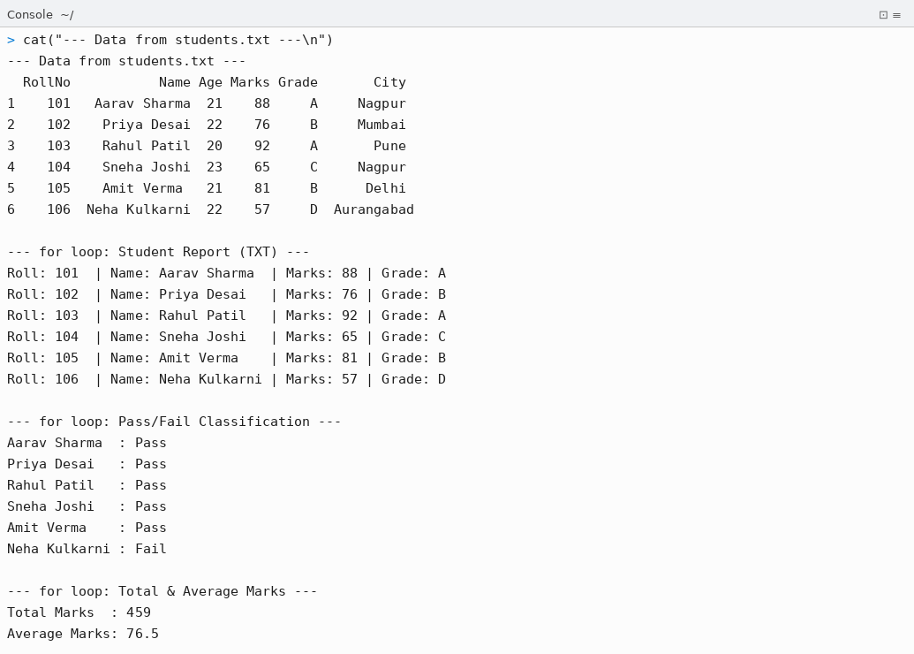

Program 4c — while Loop on students.txt
Code for Program 4c — while Loop on TXT File:
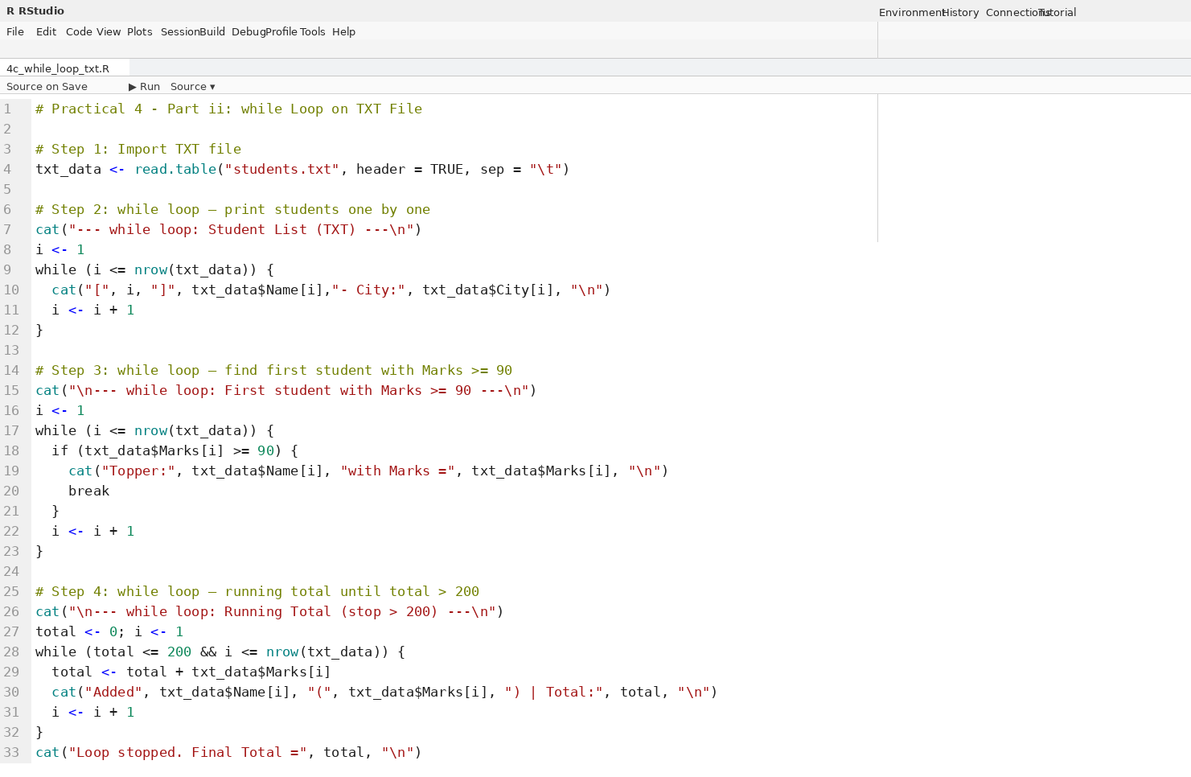
Output for Program 4c:
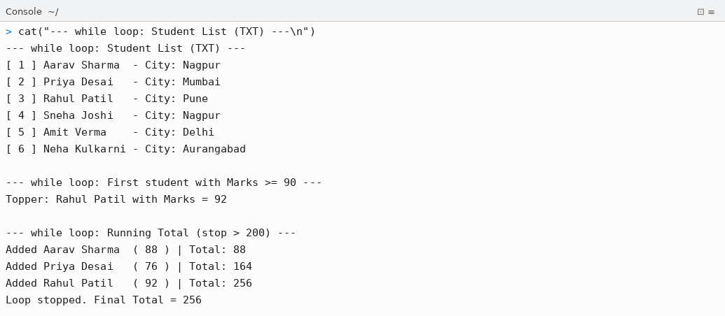

Program 4d — repeat Loop on students.txt
Code for Program 4d — repeat Loop on TXT File:
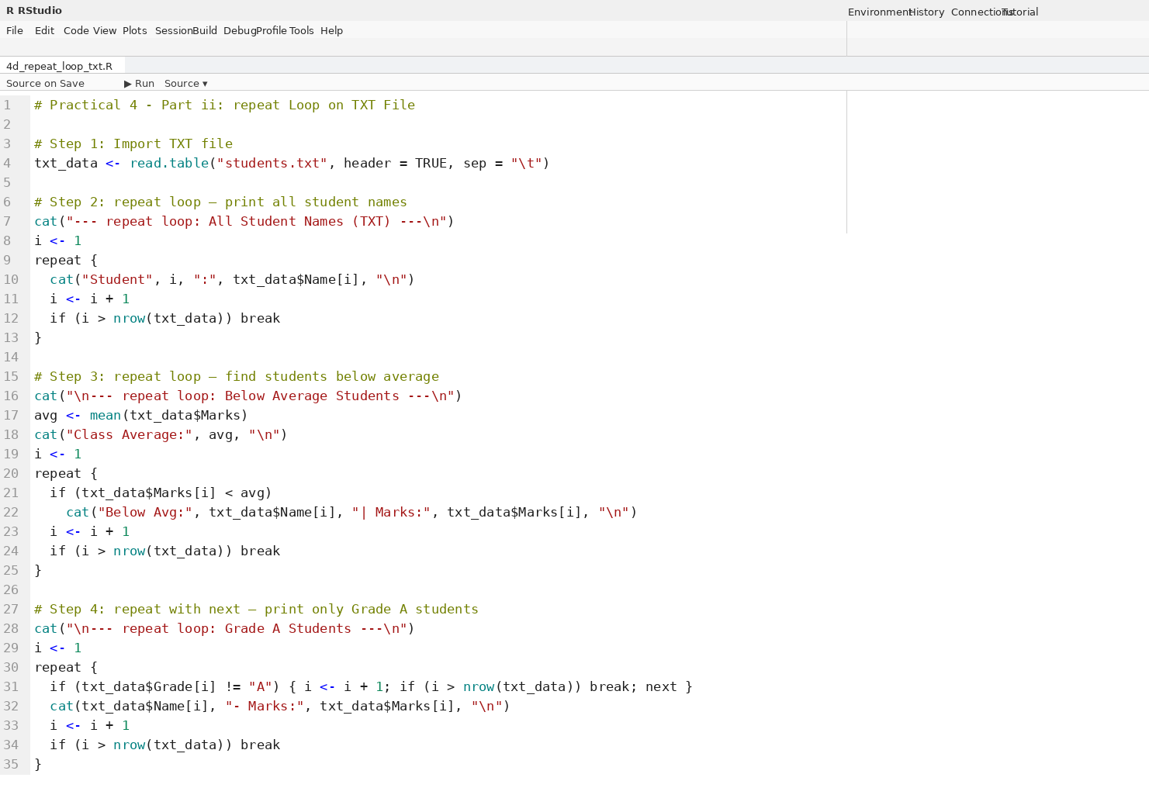
Output for Program 4d:
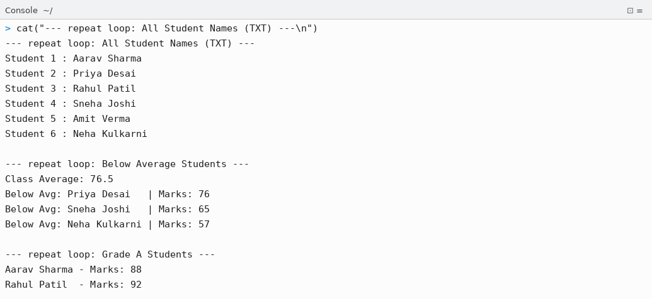

Part II — Loop Control Structures on CSV File (students.csv)

Program 4e — for Loop on students.csv
Code for Program 4e — for Loop on CSV File:
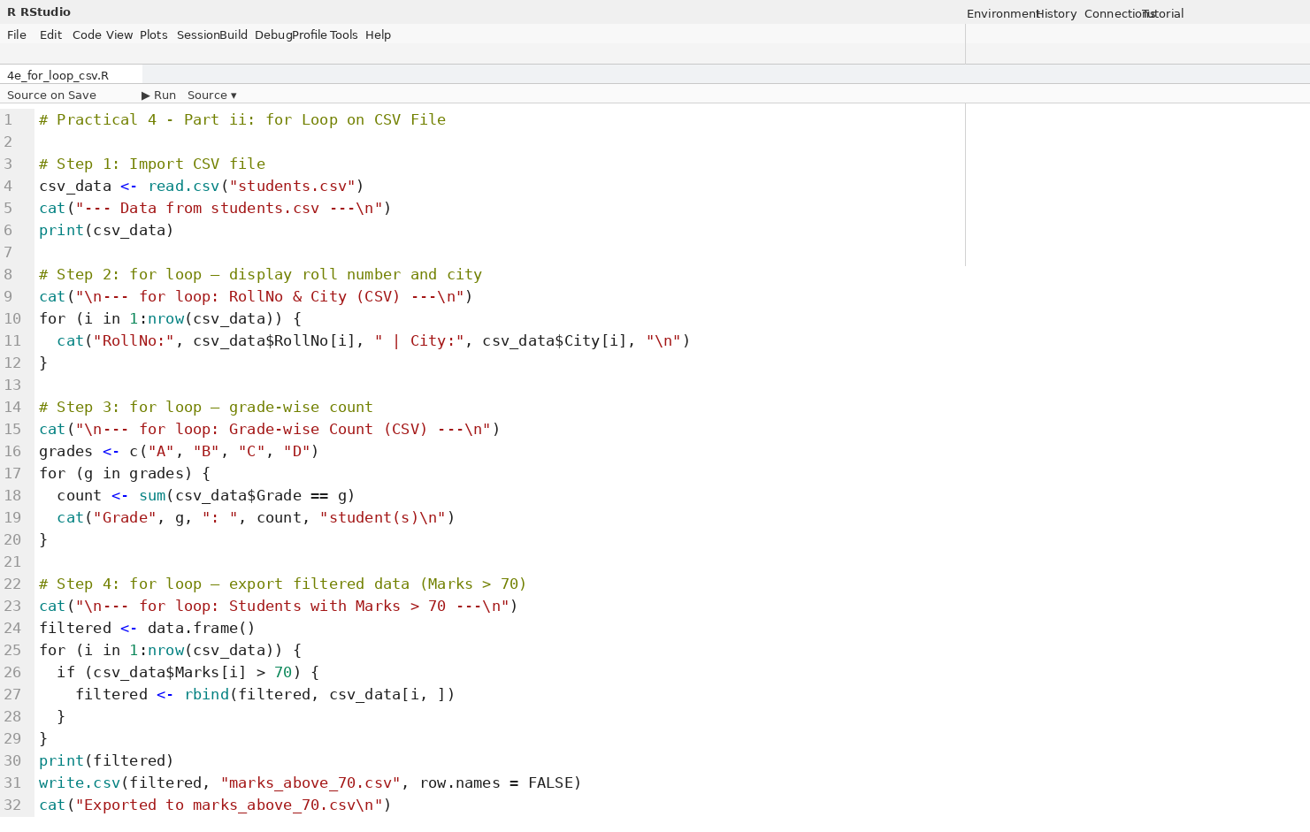
Output for Program 4e:
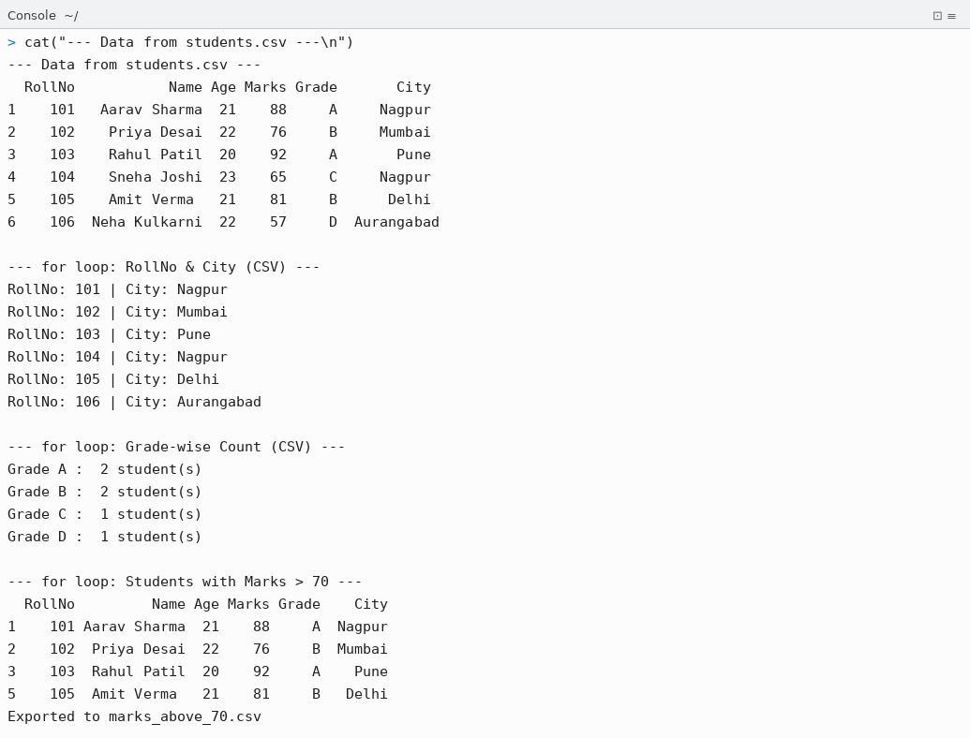

Program 4f — while & repeat Loops on students.csv
Code for Program 4f — while and repeat Loops on CSV File:
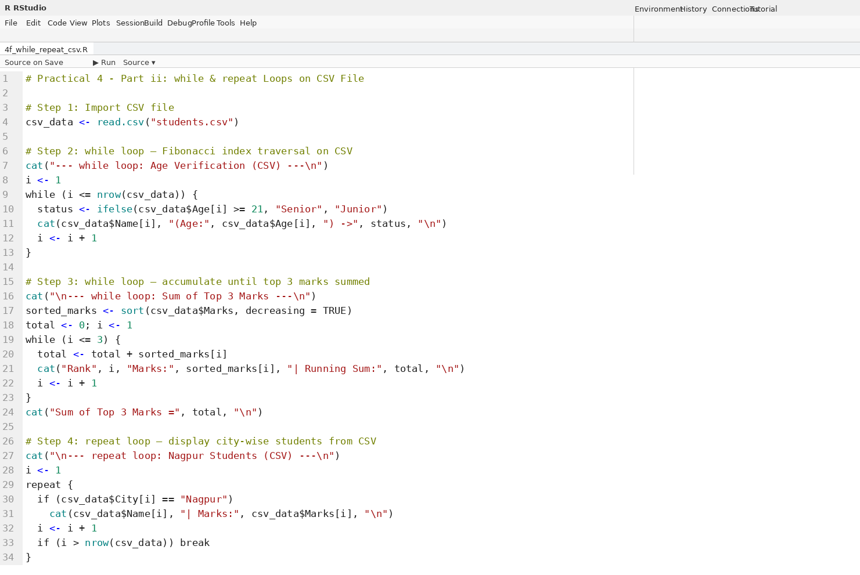
Output for Program 4f:
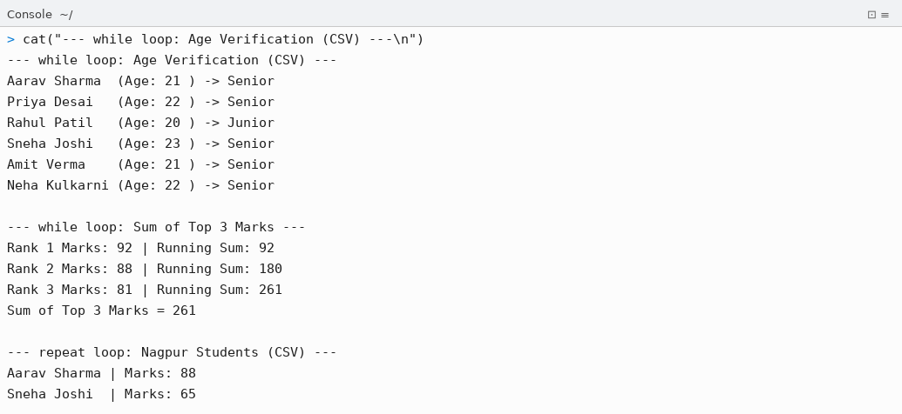

Conclusion
Thus, the following R programs for Practical 4 were successfully written, executed in RStudio, and outputs were verified:

- Part i: A 6-record student dataset (RollNo, Name, Age, Marks, Grade, City) was created as an R data frame and exported to students.txt using write.table() (tab-separated) and to students.csv using write.csv(). Both files were confirmed in the working directory using list.files().
- Program 4b (for loop on TXT): Imported students.txt using read.table(). Used for loop to print each student's roll number, name, marks, and grade; classify Pass/Fail based on marks >= 60; and compute total (459) and average (76.5) marks.
- Program 4c (while loop on TXT): Used while loop to traverse the dataset and print name-city pairs; find the first student with marks >= 90 (Rahul Patil — 92) using break; and accumulate a running total that stops once total exceeds 200.
- Program 4d (repeat loop on TXT): Used repeat loop to print all student names sequentially; identify below-average students (Priya, Sneha, Neha); and filter Grade A students using next to skip non-A grades.
- Program 4e (for loop on CSV): Imported students.csv using read.csv(). Used for loop to display RollNo-City pairs, count students per grade (A:2, B:2, C:1, D:1), filter students with Marks > 70 using rbind(), and export the filtered result to marks_above_70.csv.
- Program 4f (while & repeat on CSV): Used while loop for age-based classification (Senior/Junior) and to sum the top 3 marks (92+88+81=261). Used repeat loop to extract and display only Nagpur-based students from the CSV.

All loop control structures — for, while, and repeat — were successfully applied to both text and CSV file data in R, demonstrating their practical utility in real-world data processing tasks.

YCCE | M.Tech Data Science | Sem II | 2025-26 | Practical 4 | Open Source Tools Lab

