Theory
Functions are reusable blocks of code that perform a specific task. In R, user-defined functions are created using the function() keyword and can accept parameters, perform computations, and return results.

R Function Syntax:
- function_name <- function(arg1, arg2, ...) { body; return(value) }
- Arguments can have default values: function(x, n = 2) { ... }
- return() sends one or more values back to the caller; use list() to return multiple values.
- Functions can call built-in R functions like mean(), sd(), var(), round() inside their body.

Key Concepts:
- Central Tendency — Mean: average value; Median: middle value; Mode: most frequent value.
- Spread / Dispersion — Variance: average squared deviation; Std Dev: sqrt(variance); Range: max-min; IQR: Q3-Q1.
- Area of Circle — Formula: A = pi * r^2. R provides the constant 'pi' built-in (3.141593).

Problem 5a — Measures of Central Tendency and Spread
A user-defined function stats_summary(x) is created that accepts a numeric vector and computes all measures of central tendency (Mean, Median, Mode) and spread (Range, Variance, Std Dev, IQR, Min, Max, Length). It prints a formatted report and returns a named list.

Expected Values for x = c(2, 4, 10, 11, 5, 7)

Measure | Formula / Function | Result
Mean | sum(x) / length(x) | 6.5
Median | middle value (sorted) | 6.0
Mode | most frequent element | 2
Min | min(x) | 2
Max | max(x) | 11
Range | range(x) | 2 to 11
Variance | var(x) | 12.3
Std Deviation | sd(x) | 3.5071
IQR | IQR(x) = Q3 - Q1 | 5.25
Length | length(x) | 6

Code for Problem 5a — Function Definition and Function Call:
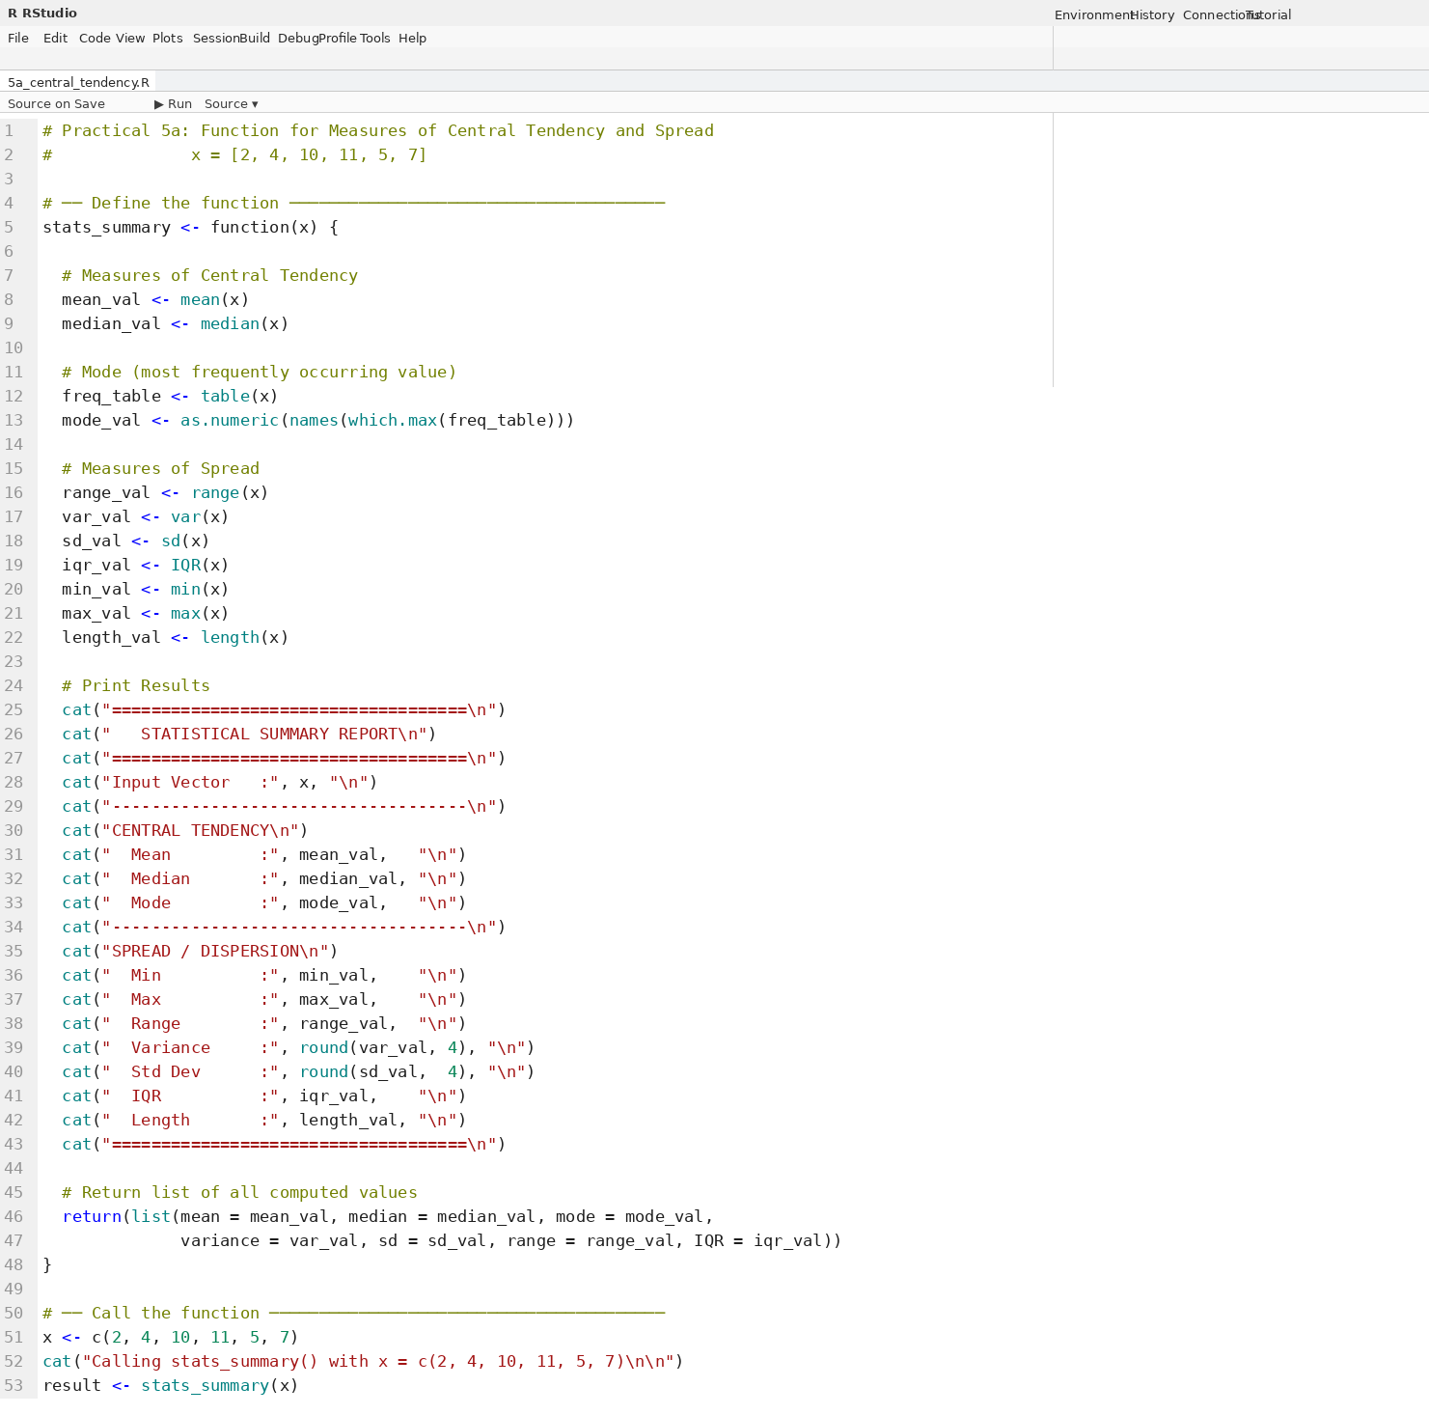

Output for Problem 5a — Statistical Summary Report:
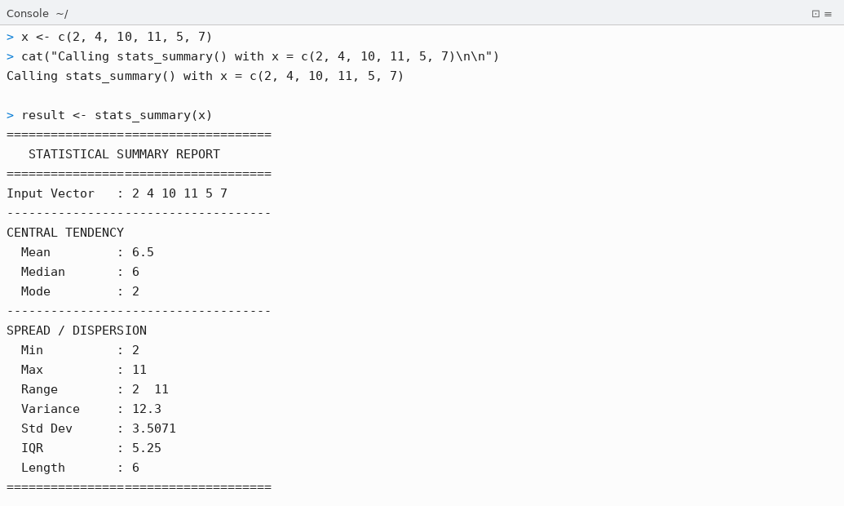
Code for Problem 5a — Verify Returned List and Cross-Check with summary():
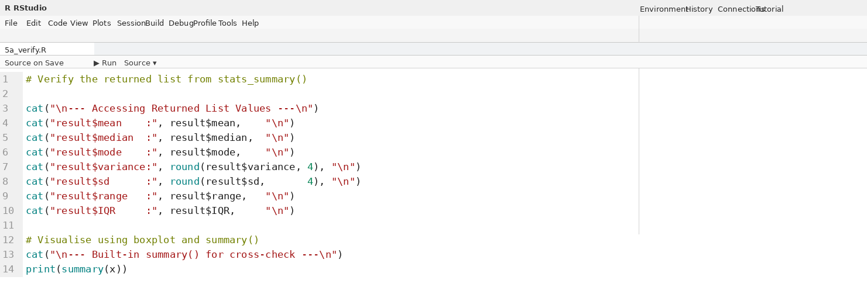
Output for Problem 5a — Returned List Values and Built-in summary():
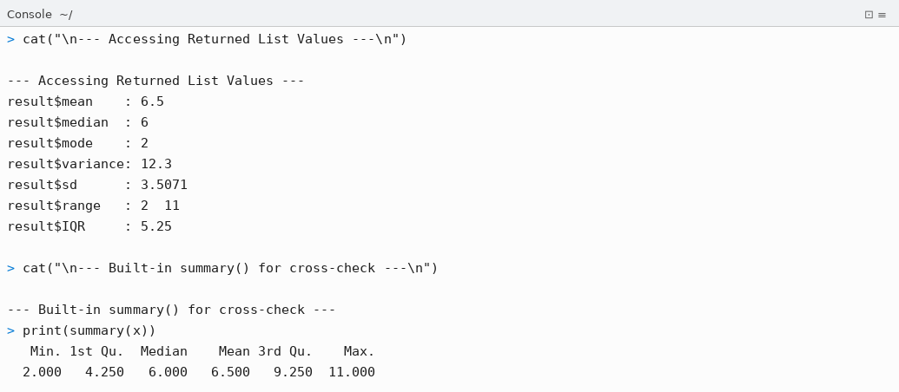

Problem 5b — Area of Circle Function
A user-defined function area_of_circle(radius) is created that accepts radius as a parameter, validates that it is positive, and computes the Area, Diameter, and Circumference of the circle using the built-in constant pi. The function is tested with radii = 5, 7.5, 1, and an invalid -3.

Formulae Used

Property | Formula | For r = 5
Diameter | D = 2 × r | 10 units
Area | A = π × r² | 78.5398 sq. units
Circumference | C = 2 × π × r | 31.4159 units

Code for Problem 5b — Area of Circle Function Definition and Test Cases:
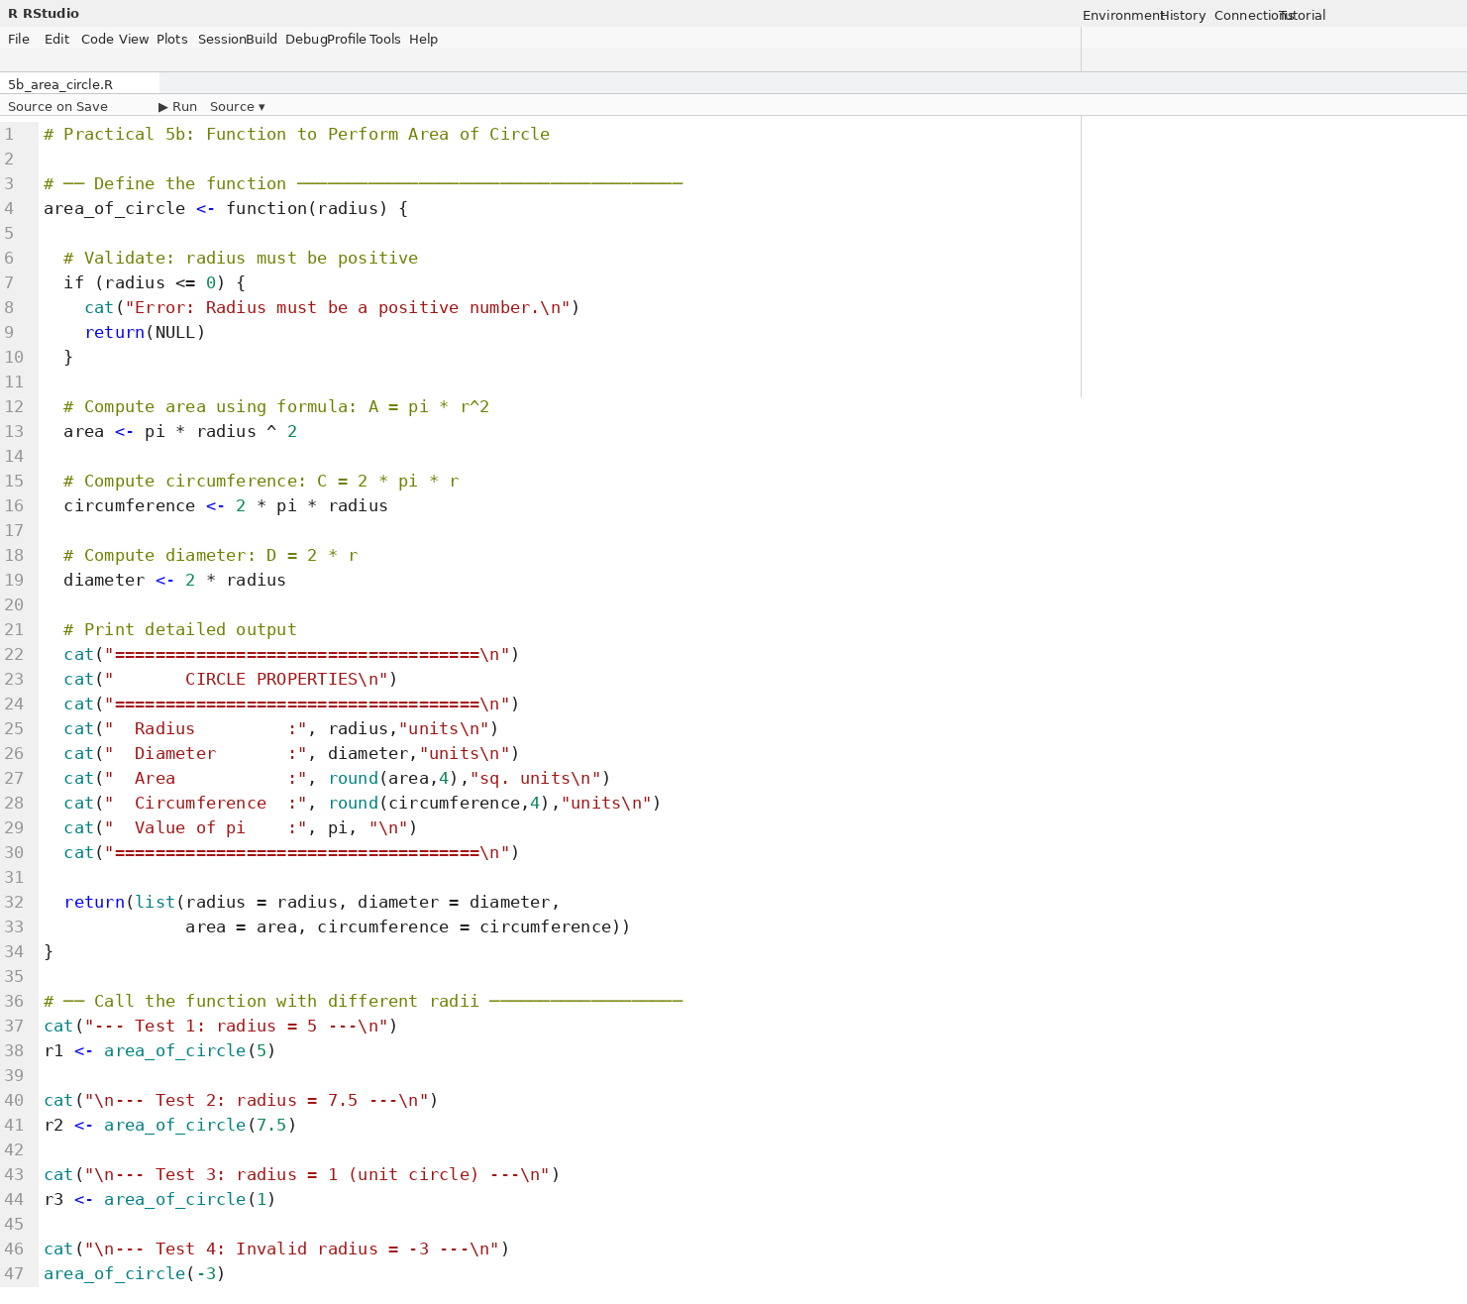

Output for Problem 5b — Circle Properties for All Test Cases:
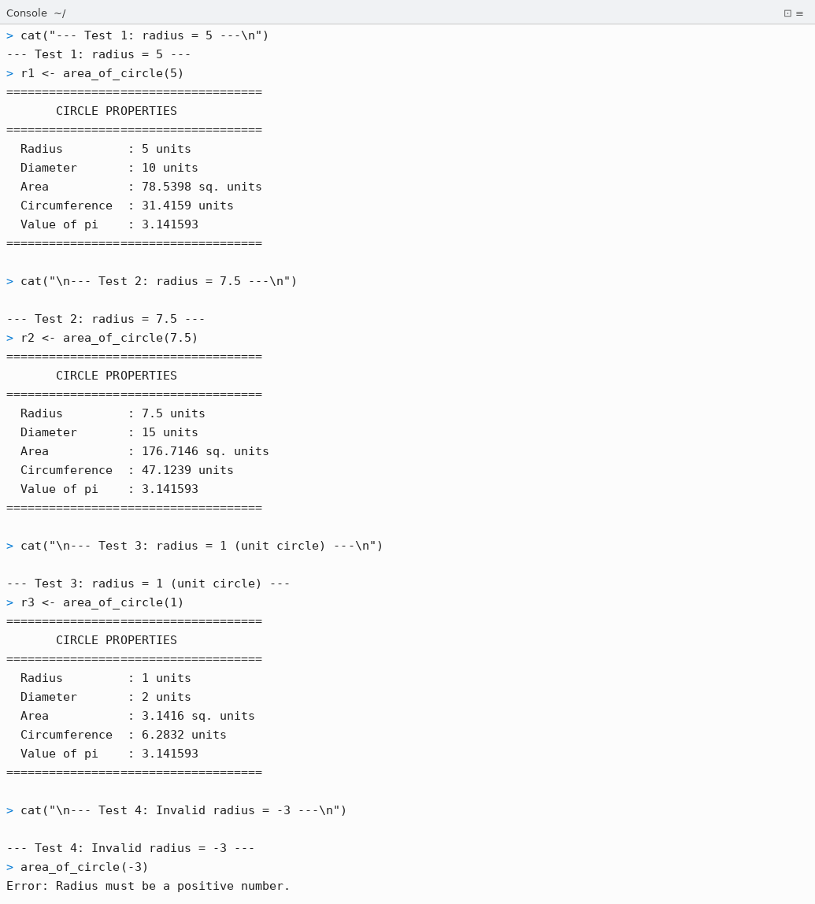

Conclusion
Thus, the following R programs on user-defined functions for Practical 5 were successfully written, executed in RStudio, and outputs were verified:

- Problem 5a: A function stats_summary(x) was defined to compute all measures of central tendency and spread for the vector x = c(2, 4, 10, 11, 5, 7). The function correctly calculated Mean = 6.5, Median = 6, Mode = 2, Variance = 12.3, Std Dev = 3.5071, IQR = 5.25, Range = 2 to 11, and Length = 6. The function returns a named list, allowing individual values to be accessed via result$mean, result$sd, etc. Results were cross-verified using R's built-in summary() function.
- Problem 5b: A function area_of_circle(radius) was defined using the formula A = pi * r^2. It includes input validation (returns error for negative radius), and also computes Diameter (D = 2r) and Circumference (C = 2*pi*r). The function was tested with four cases: r=5 (Area=78.5398), r=7.5 (Area=176.7146), r=1 (Area=3.1416), and r=-3 (error message printed correctly).

Both programs demonstrated the concept of user-defined functions in R — encapsulating logic into reusable, parameterized blocks that accept inputs, perform computation, print formatted output, and return structured results.

YCCE | M.Tech Data Science | Sem II | 2025-26 | Practical 5 | Open Source Tools Lab

