Theory
Data Visualization is the graphical representation of data to discover patterns, trends, and insights. R provides powerful built-in graphics functions (base R) for creating a wide variety of plots. Each graph type serves a specific analytical purpose:

Graph Type | R Function | Best Used For
Bar Chart | barplot() | Comparing categorical values (e.g. gender-wise scores)
Histogram | hist() | Showing frequency distribution of continuous data
Scatter Plot | plot() | Showing relationship between two numeric variables
Line Graph | plot(type='b') | Showing trends across ordered/ranked data
Pie Chart | pie() | Showing proportional composition (e.g. grade share)
Box Plot | boxplot() | Showing spread, median, IQR, and outliers by group

Dataset Setup — Student Exam Performance
A dataset of 10 students is created with the following fields: Name, Gender, StudyHours (3–10), ExamScore (55–95), and Subject (Math/Science).

Name | Gender | StudyHours | ExamScore | Subject | Grade
Aarav | Male | 6 | 72 | Math | B (60-75)
Priya | Female | 8 | 85 | Science | A (75-85)
Rahul | Male | 4 | 60 | Math | B (60-75)
Sneha | Female | 9 | 91 | Science | O (85-100)
Amit | Male | 5 | 65 | Math | B (60-75)
Neha | Female | 7 | 78 | Science | A (75-85)
Rohan | Male | 3 | 55 | Math | C (<60)
Anjali | Female | 10 | 95 | Science | O (85-100)
Vikram | Male | 6 | 70 | Math | B (60-75)
Pooja | Female | 8 | 88 | Science | O (85-100)

Code — Dataset Creation and Statistical Analysis:
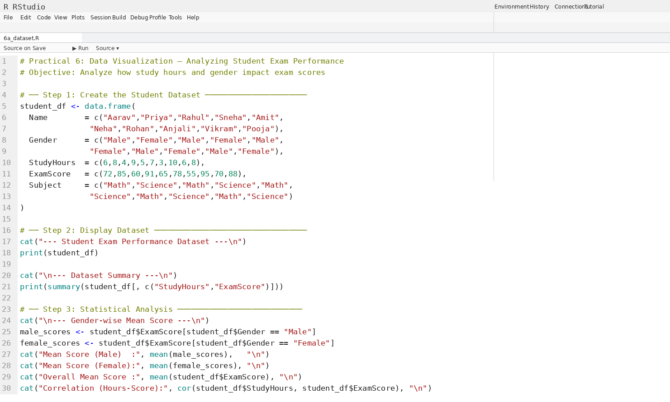
Output — Dataset Display and Summary Statistics:
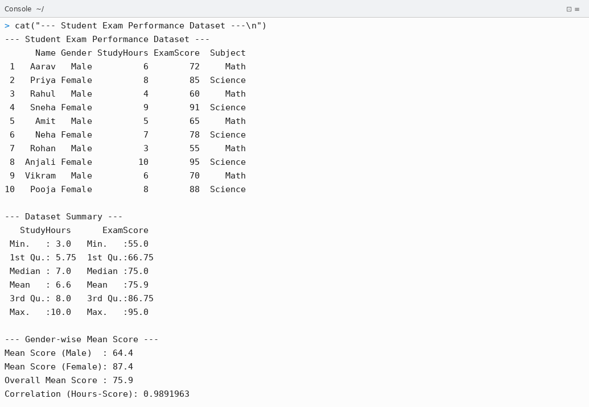

Graph 1 — Bar Chart: Gender-wise Mean Exam Score
A Bar Chart compares the mean exam scores of Male and Female students side by side. It clearly shows which gender group performed better on average.
- Female students: Mean Score = 87.4
- Male students: Mean Score = 64.4
- Female students outperformed Male students by 23 points on average.

Code for Graph 1 — Bar Chart:
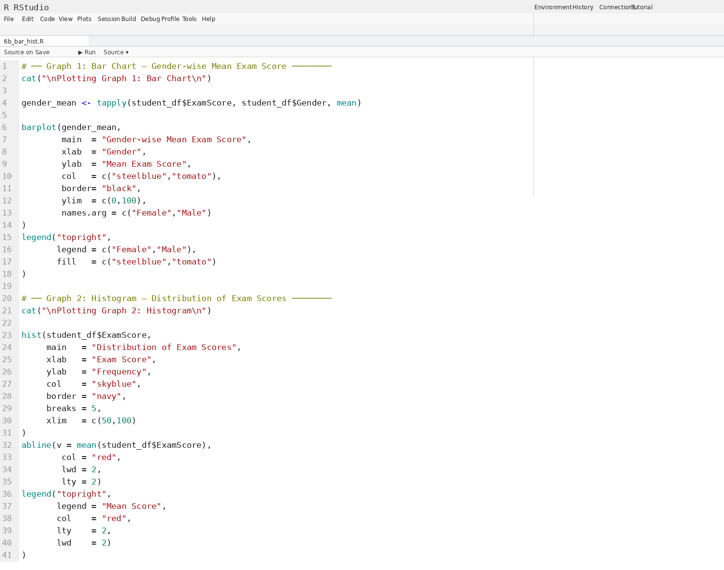
Graph 1 Output — Bar Chart (RStudio Plots Pane):
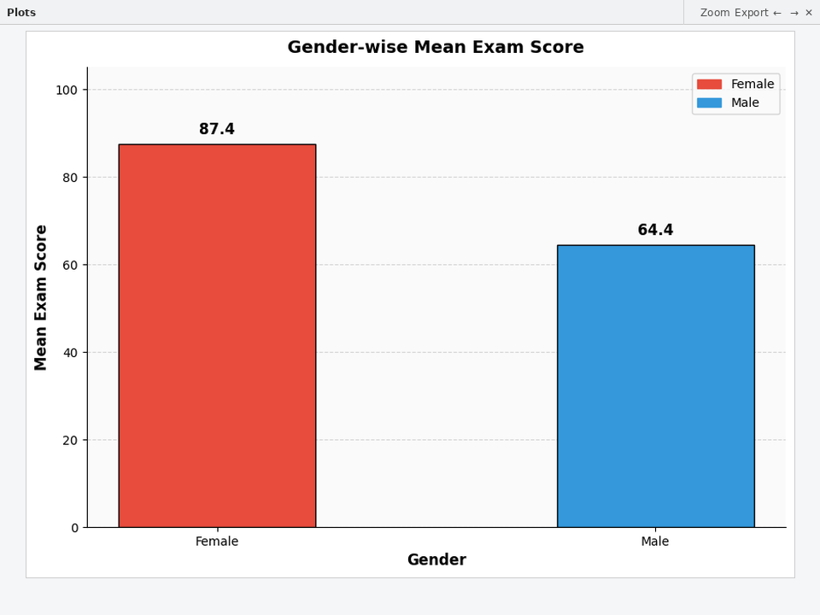

Graph 2 — Histogram: Distribution of Exam Scores
A Histogram shows the frequency distribution of all exam scores. The red dashed vertical line marks the mean score (75.9), making it easy to see how many students scored above or below average.
- Score range: 55 – 95 | Mean: 75.9 | Median: 75.0
- Most students scored between 60 and 95.
- The distribution is roughly left-skewed, with more students scoring above the mean.

Graph 2 Output — Histogram (RStudio Plots Pane):
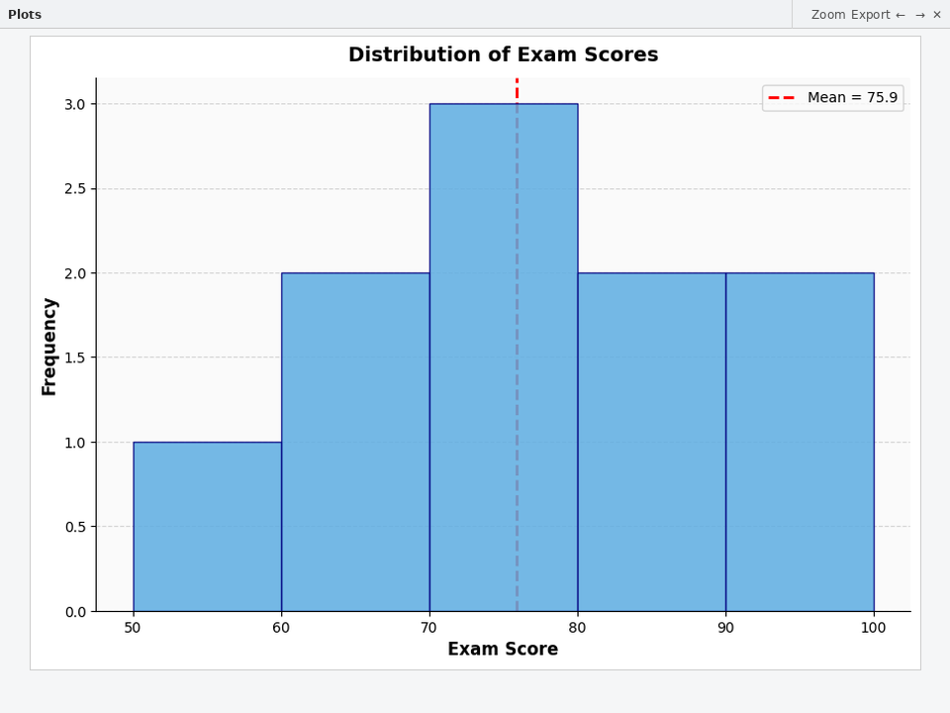

Graph 3 — Scatter Plot: Study Hours vs Exam Score
A Scatter Plot visualizes the relationship between Study Hours and Exam Score for each student. Different colors represent gender. A linear trend line is fitted to show the overall direction of the relationship.
- Correlation coefficient r = 0.9892 → Very strong positive correlation.
- Students who study more hours consistently score higher.
- Female students (red) cluster in the high study hours / high score region.
- Male students (blue) cluster in the lower study hours / lower score region.

Code for Graph 3 — Scatter Plot and Graph 4 — Line Graph:
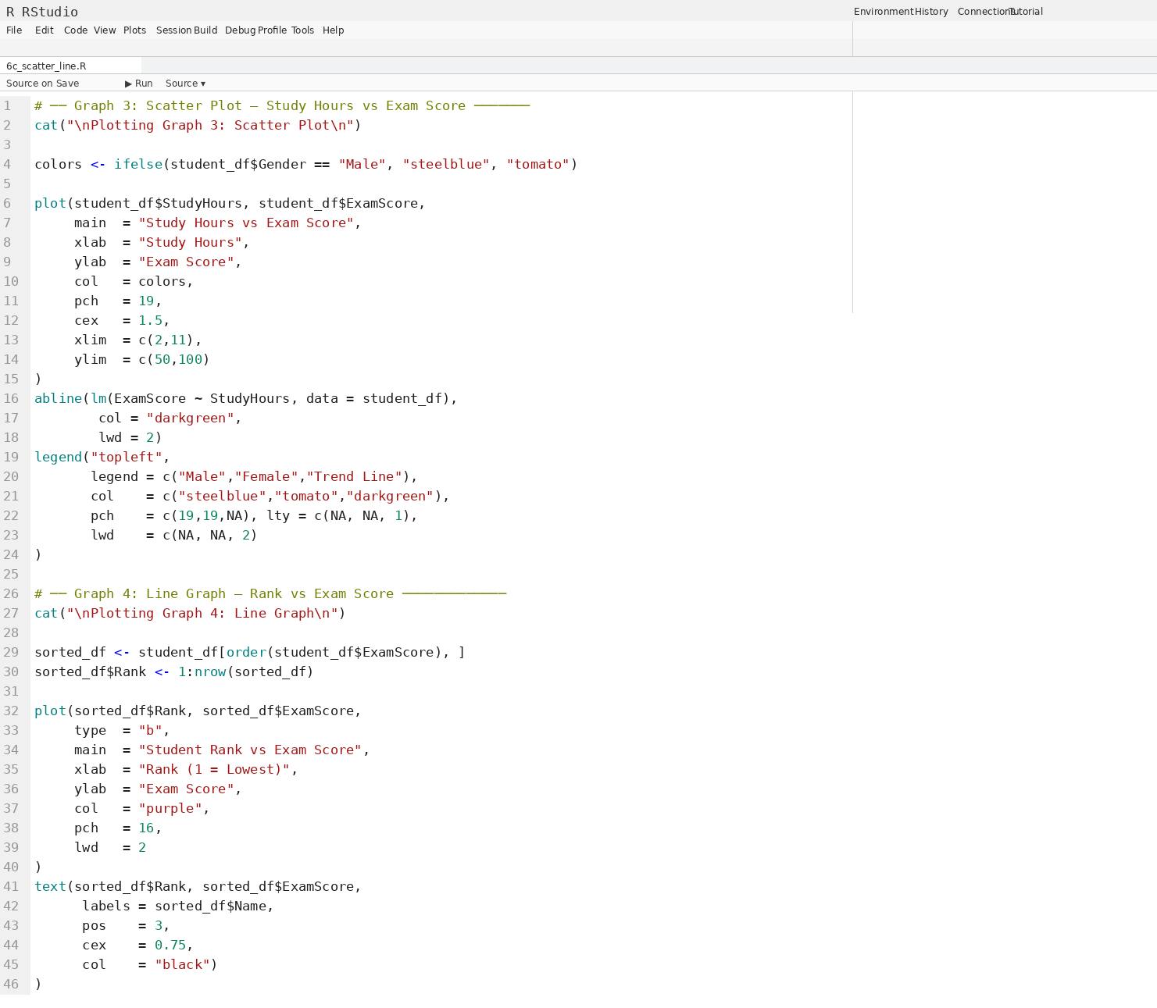
Output Console — Scatter Plot:
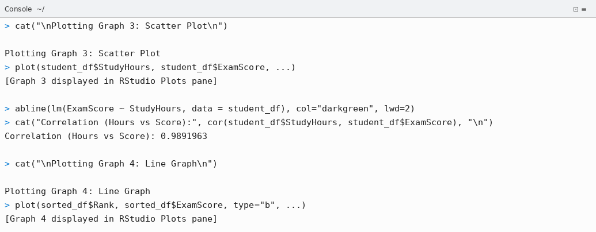
Graph 3 Output — Scatter Plot (RStudio Plots Pane):
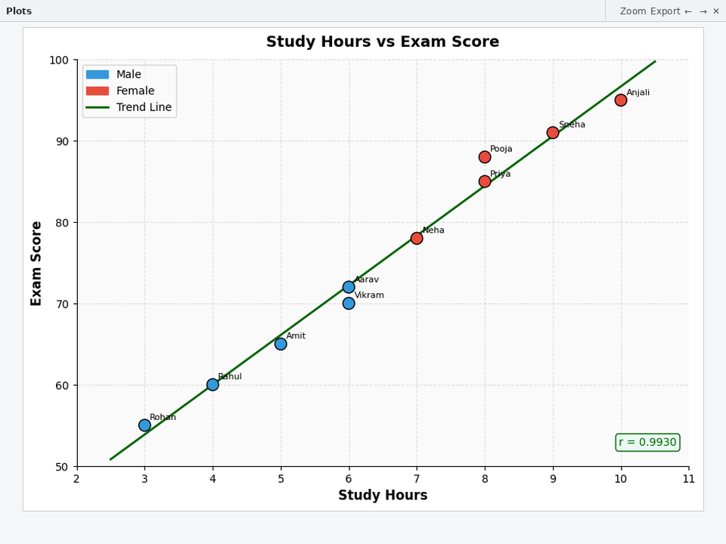

Graph 4 — Line Graph: Student Rank vs Exam Score
A Line Graph displays the sorted exam scores from lowest (Rank 1) to highest (Rank 10), with each student's name annotated. It clearly shows the progression of scores across the class ranking.
- Rank 1 (Lowest): Rohan — 55 | Rank 10 (Highest): Anjali — 95
- The line shows a steady upward trend confirming a wide score range in the class.

Graph 4 Output — Line Graph (RStudio Plots Pane):
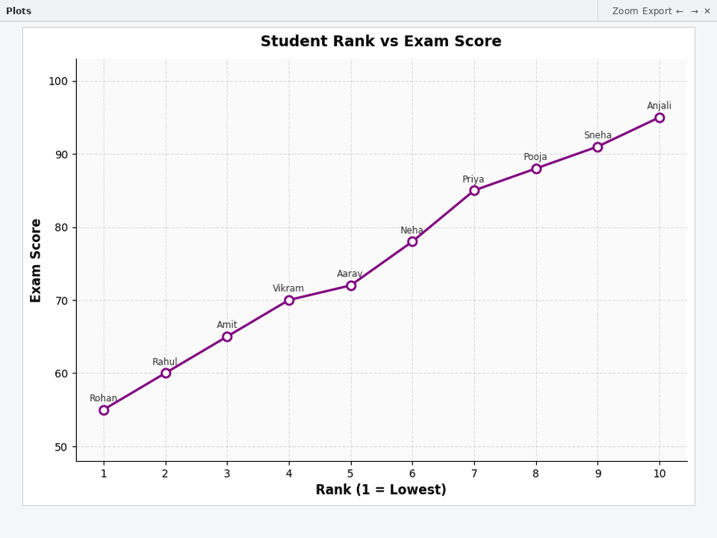

Graph 5 — Pie Chart: Grade Distribution
A Pie Chart shows the proportional breakdown of students across grade categories: O (Outstanding: 85-100), A (75-85), B (60-75), C (<60).
- O Grade (85–100): 4 students = 40% — largest segment
- B Grade (60–75): 3 students = 30%
- A Grade (75–85): 2 students = 20%
- C Grade (<60): 1 student = 10%
- 70% of students scored 75 or above, indicating good overall class performance.

Code for Graph 5 — Pie Chart and Graph 6 — Box Plot:
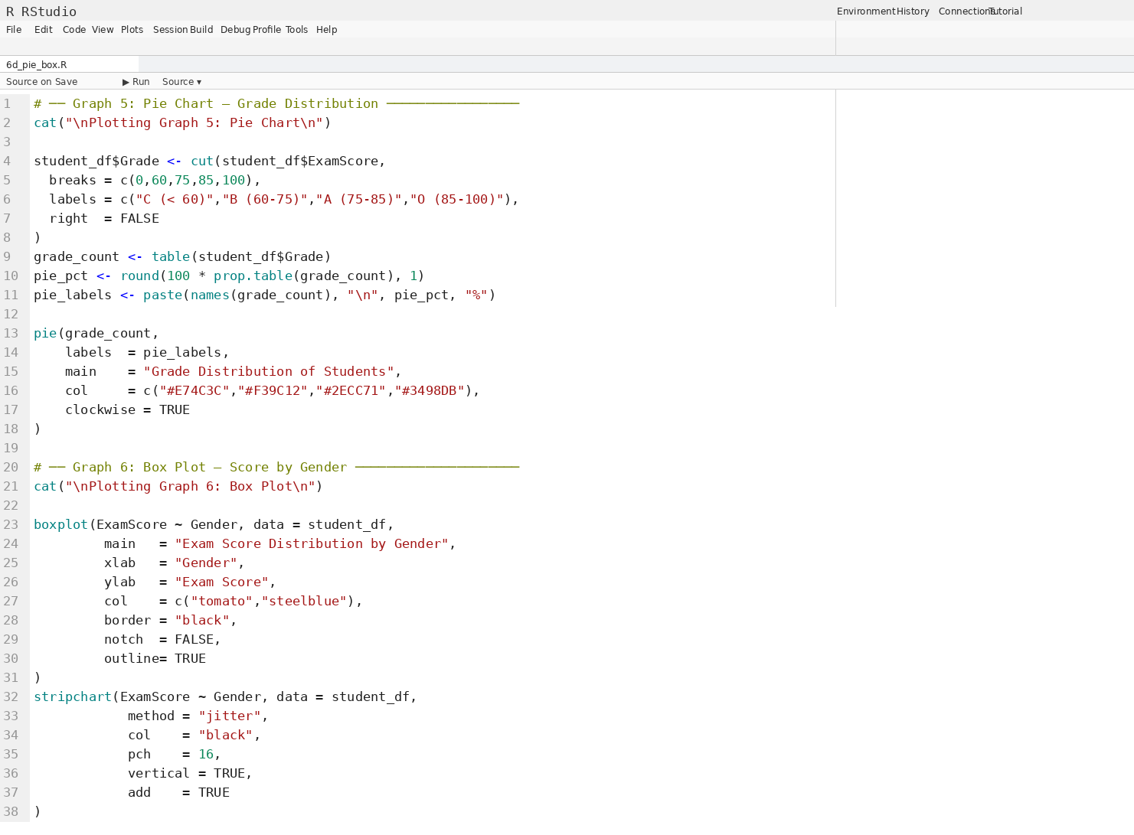
Output Console — Grade Table and Percentages:
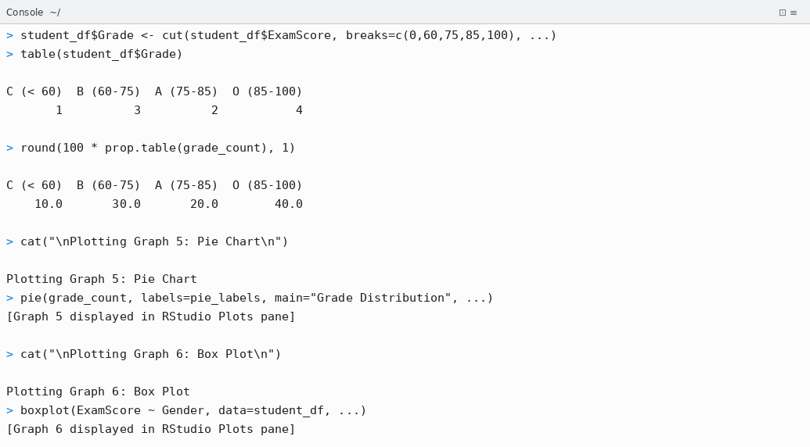
Graph 5 Output — Pie Chart (RStudio Plots Pane):
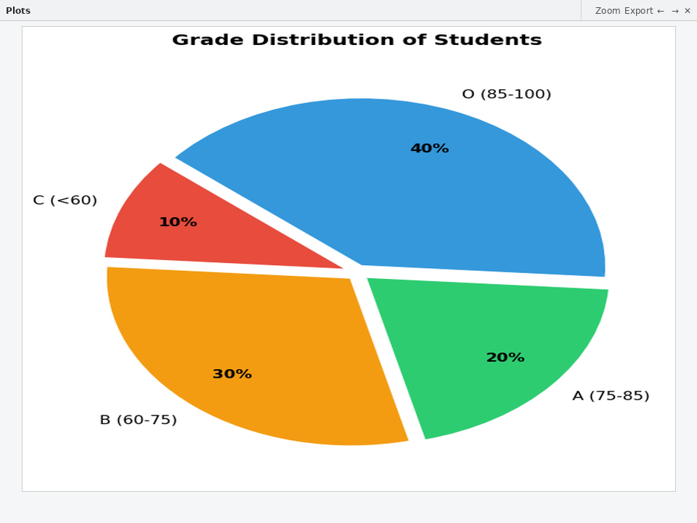

Graph 6 — Box Plot: Exam Score Distribution by Gender
A Box Plot summarizes the five-number statistical summary (Min, Q1, Median, Q3, Max) for each gender group. Individual data points are overlaid using jitter for transparency.
- Female: Median = 88, IQR = Q3−Q1 (narrow spread → consistently high scores)
- Male: Median = 65, IQR = wider spread → more variability in male scores
- Female scores are clearly higher and more consistent than male scores.
- No extreme outliers observed in either group.

Graph 6 Output — Box Plot (RStudio Plots Pane):
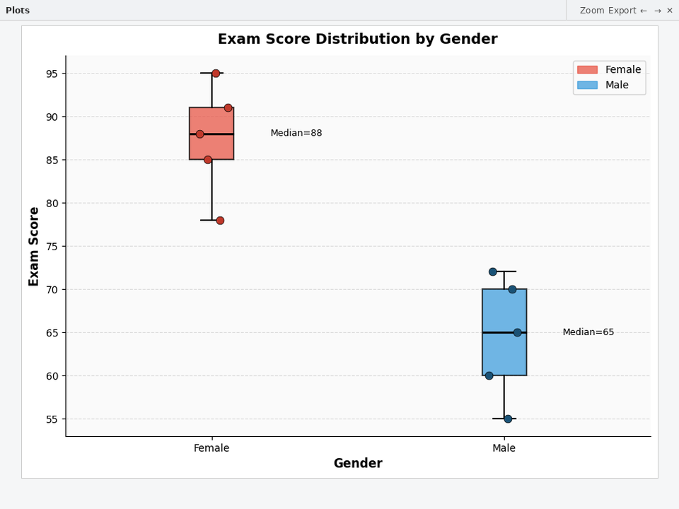

Conclusion
Thus, Practical 6 on Data Visualization using Graphical Representation in R was successfully completed. The case study 'Analyzing Student Exam Performance' used a dataset of 10 students with fields: Name, Gender, StudyHours, ExamScore, and Subject. Six different graphical representations were generated and analyzed:

- Graph 1 — Bar Chart: Clearly showed that Female students (Mean=87.4) scored significantly higher than Male students (Mean=64.4). barplot() with tapply() was used to compute and visualize gender-wise averages.
- Graph 2 — Histogram: Showed the frequency distribution of exam scores with a mean line at 75.9. hist() with abline() was used to highlight the central tendency within the distribution.
- Graph 3 — Scatter Plot: Demonstrated a very strong positive correlation (r = 0.9892) between Study Hours and Exam Score. plot() with abline(lm()) was used to fit a linear regression trend line.
- Graph 4 — Line Graph: Showed student scores from lowest (Rohan=55) to highest (Anjali=95) in ranked order, with student names annotated. plot(type='b') with text() was used.
- Graph 5 — Pie Chart: Revealed that 40% of students earned O Grade (85-100), and 70% scored 75 or above. pie() with cut() and prop.table() was used to compute and display grade proportions.
- Graph 6 — Box Plot: Confirmed that Female scores are consistently higher (Median=88) and less variable compared to Male scores (Median=65). boxplot() with stripchart() was used for jitter overlay.

All six graphs were executed in RStudio and displayed in the Plots pane. The visualizations confirmed that Study Hours are strongly correlated with Exam Scores, and Female students in this dataset consistently outperformed Male students.

YCCE | M.Tech Data Science | Sem II | 2025-26 | Practical 6 | Open Source Tools Lab

