User Manual FindTargetsWeb v 1.1

This manual presents a step-by-step procedure to perform a metabolic network analysis using FindTargetsWEB v1.1, in order to obtain a list of potential targets for a given metabolic network model described in SBML L3.

1 - To access the FindTargetsWeb application, use the following URL:

<http://pseudomonas.procc.fiocruz.br/FindTargetsWEB>

2 - After selecting the link above, the application opening screen is shown:

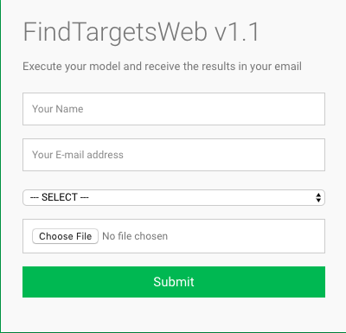

This first screen describes a data entry form containing the following fields:

* Name: The name of the user (Alphanumeric field)
* E-mail: The e-mail to which the analysis result will be sent (Alphanumeric field, format xxxxx@xxxxx.com)
* Organism: The species of organism that will be analyzed. (e.g. *Pseudomonas aeruginosa*, *Klebsiella pneumoniae*, etc.) (selection list).

o Please note that additional organism species corresponding to gram-negative or gram-positive bacteria can be included in this selection list. If you have any suggestion of new organisms to be added to this list, send an email to our support team at **findtargetsweb_fiocruz@hotmail.com**

* SBML file: The file in the SBML L3 format containing the metabolic network for analysis. (Field for file upload with the extension SBML or XML). Note that the input file should be previously converted using the COBRA command cobra.io.sbml3.write_sbml_model if it is in an older SBML format. An example file in the SBML L3 format is available at <http://pseudomonas.procc.fiocruz.br/index.php/data/ccbh4851-metabolic-network/download/6-metabolic-network-data/23-metabolic-network-v3>
* Submit button: button that confirms the reported data.

All fields are required. It is worth noting that some elements of the user interface can automatically adjust to the default language the user’s computer is configured to.

3 - After filling the form, the user must confirm the information by selecting the "Submit" button. The application shows the following screen:

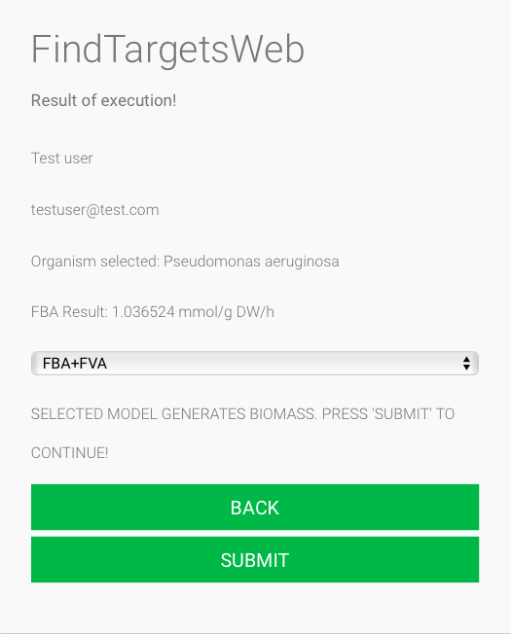

The screen above presents the result of a preliminary analysis of the informed metabolic network model. If the biomass flux generation obtained through FBA analysis is equal to zero, the application warns the user that it is not possible to continue. Otherwise, the screen above shows the data entered in the initial form.

4 – The user should now select the analysis method. Two methods are available in FindTargetsWEB:

* FBA-only: Select potential targets which inhibition result in a biomass flux equal to zero
* FBA+FVA: Select potential targets which satisfies two conditions: its inhibition results in a biomass flux equal to zero **and** has an FVA range equal to zero

After selecting the type of analysis, the user should press the Submit button in order to start the analysis. A confirmation screen appears:

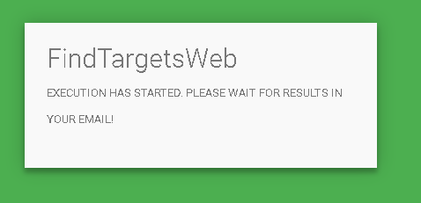

5 - When FindTargetsWEB displays the screen above, the metabolic network analysis begins, and the result will be sent to the email informed by the user. The attached file containing the complete set of results is in ZIP format and includes the following files:

* *08-filter_ECNumbers_DrugBank* - This spreadsheet contains the EC number of putative targets, along with product, organism name, Uniprot ID and Drugbank ID
* *11- hits_Uniprot* - This spreadsheet contains additional information related to Uniprot queries, such as percentage of sequence similarity, BLAST e-value, gene name, pathway, function, catalytic activity.
* *13-list_inhibitors_per_target* - This spreadsheet lists all inhibitors found for all targets. Included information are drug name, drug group (e.g. experimental, approved, investigational), and drug action.
* *14-list_inhibitors_approved* - This spreadsheet lists all inhibitors with approved drugs found for all targets. Included information are drug name, drug group (approved), and drug action.
* *model_data* - This spreadsheet lists data related to the input SBML L3 file, such as gene IDs and associated reactions. The complete information of which reactions are associated with each gene in the metabolic network model is included in this file.
* *summary_results* - This spreadsheet contains a summary of data included in the previous files. Included fields are EC numbers, product, organism name, gene name, pathway, function, catalytic activity, drug name, drug group and drug action.