[Algorithms] PA1 Report

B08901158 電機三 吳詩昀

#### Running Time and Memory Usage Table

(Generated at EDA U6)

|  |  |  |  |  |  |  |  |  |
| --- | --- | --- | --- | --- | --- | --- | --- | --- |
| Input Size | IS | | MS | | QS | | HS | |
| CPU Time (ms) | Memory (kB) | CPU Time (ms) | Memory (kB) | CPU Time (ms) | Memory (kB) | CPU Time (ms) | Memory (kB) |
| 4000.case2.in | 0.105 | 5904 | 0.839 | 5904 | 0.285 | 5904 | 0.794 | 5904 |
| 4000.case3.in | 12.097 | 5904 | 1.054 | 5904 | 0.684 | 5904 | 0.807 | 5904 |
| 4000.case1.in | 6.426 | 5904 | 1.625 | 5904 | 0.974 | 5904 | 0.922 | 5904 |
| 16000.case2.in | 0.115 | 6056 | 1.612 | 6056 | 1.07 | 6056 | 1.309 | 6056 |
| 16000.case3.in | 85.996 | 6056 | 1.726 | 6056 | 1.61 | 6056 | 1.505 | 6056 |
| 16000.case1.in | 45.697 | 6056 | 3.598 | 6056 | 1.647 | 6056 | 2.536 | 6056 |
| 32000.case2.in | 0.135 | 6188 | 2.017 | 6188 | 1.722 | 6188 | 3.013 | 6188 |
| 32000.case3.in | 331.835 | 6188 | 2.116 | 6188 | 2.416 | 6188 | 2.977 | 6188 |
| 32000.case1.in | 165.135 | 6188 | 5.49 | 6188 | 2.29 | 6188 | 3.803 | 6188 |
| 1000000.case2.in | 1.231 | 12144 | 70.57 | 14004 | 49.053 | 12144 | 96.749 | 12144 |
| 1000000.case3.in | N/A | N/A | 76.749 | 14004 | 50.887 | 12144 | 76.06 | 12144 |
| 1000000.case1.in | N/A | N/A | 149.559 | 14004 | 82.33 | 12144 | 142.523 | 12144 |

Note: N/A is for cases that run over 3 minutes.

#### Growth of Run Time

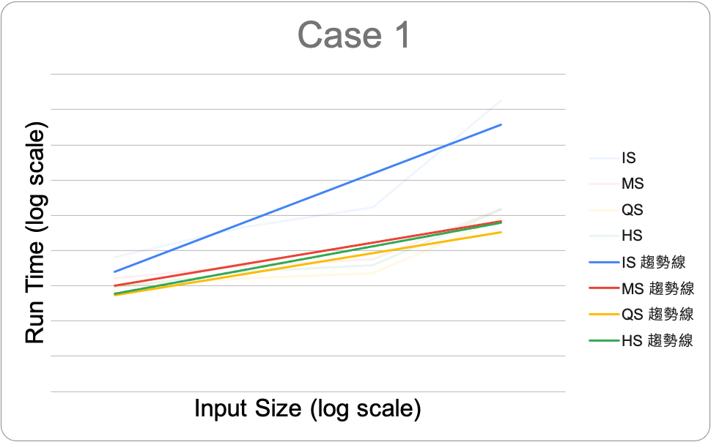Case 1

Case 1 is the average case. Insertion sort has time complexity, while the others are, ending up running faster than insertion sort.

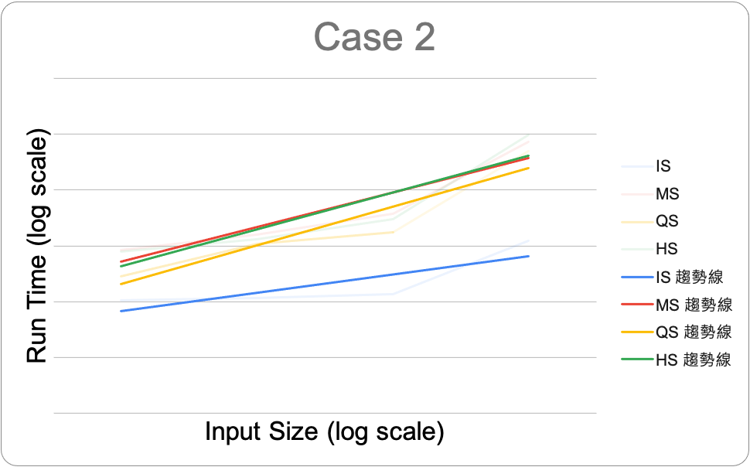Case 2

The input for case 2 is a sorted array. We can see that insertion sort uses the least amount of time, since it has linear complexity for best case. Since, in quick sort, I chose the pivot randomly, its time complexity is approximately same as MS and HS. All three are .

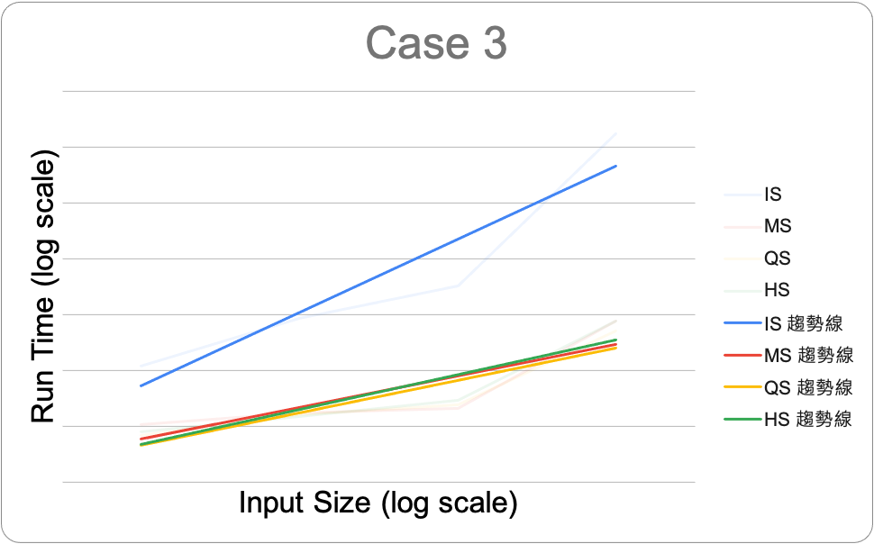Case 3

The input for case 3 is a reversely-sorted array, which is a worst case for insertion sort withtime complexity. As for other three, the time complexity is Therefore, insertion sort is running slower than all other sorter.

Note: For the above three cases, I use random quick sort.