Data Analysis Project Submission Report Template

1. Title Page
- Project Title: Sales Performance Analysis
- Submitted By:
  - Student Name: AP Ann Fiona
  - Roll Number: 2460608
  - College Email ID: ap.ann@btech.christuniversity.in
- Course: Fundamental Data Analysis
- Instructor Name: Dhiraj
- Institution: Christ Deemed To Be University Kengeri Campus
- Date of Submission: 18/08/2025

2. Abstract

This project was a deep dive into a retail dataset to uncover meaningful business insights. I started with raw transactional data that included customer details, order dates, product categories, sales, and profit figures.

Using Excel, I cleaned and organized the data, then built PivotTables and charts to answer five key questions: which product category generates the most sales, which region is most profitable, how sales trends vary over time, which sub-categories are unprofitable despite high sales, and who the top 5 customers are by revenue. I used sorting, filtering, value-based analysis, and visual tools like pie charts, bar graphs, and line charts to make the findings clear and engaging.

The final dashboard is easy to navigate and packed with insights that can help guide smarter decisions in marketing, inventory, and customer strategy. It was a hands-on, practical project

3. Objectives
- Clean and prepare the raw dataset for analysis.
- Formulate and answer five key questions based on the dataset.
- Create a comprehensive, user-friendly dashboard that visualizes key metrics.
- Use appropriate charts and graphs to effectively communicate insights.
- Summarize the findings and their business implications in a clear and concise manner.

4. Scope of the Project
Explain what the project includes and any boundaries:
This project covers a full-cycle analysis of a retail sales dataset using Microsoft Excel. It includes:
- Data Cleaning & Preparation: Organizing raw transactional data with fields like order date, customer name, product category, sales, and profit.
- Exploratory Analysis: Answering five key business questions through PivotTables, filters, and charts:
  - Which product category generates the highest sales?
  - Which region is most profitable?
  - How do sales trends vary over months and years?
  - Which sub-categories have high sales but low profit?
  - Who are the top 5 customers by sales?
- Visualization: Creating pie charts, bar graphs, and line charts to make insights easy to understand.
- Dashboard Creation: Compiling all findings into a clean, interactive dashboard for stakeholders.

- Focused on data cleaning, analysis, and visualization only.
- No programming languages (like Python or R) or advanced statistical modelling used.
- All work is contained within a single Excel file.
- Analysis is limited to the provided dataset.

5. Tools & Technologies Used
Tool/Technology | Purpose
Microsoft Excel | Data manipulation, analysis, and dashboard creation
PivotTables | Summarizing data for analysis
Charts & Graphs and conditional formatting | Data visualization

6. Data Cleaning & Preparation
- The dataset began as a raw export of retail transactions, containing detailed information such as order IDs, dates, customer names, product categories, sales, quantity, discount, and profit. While the data was rich in content, it was not immediately analysis-ready. It included multiple rows per order, mixed data types, and lacked structure for answering business questions directly.
- Missing Values: Checked key columns; no major gaps found.
- Duplicates: Removed repeated rows to ensure accurate totals.
- Data Types: Fixed date formats and ensured numeric fields were correctly typed.
- Text Standardization: Cleaned category names for consistent grouping
To support deeper analysis, a few calculated fields and features were added:
- Year and Month Columns: Extracted from the order date to analyze sales trends over time.
- Customer Sales Aggregation: Grouped sales by customer name to identify top performers.
- Profitability Flags: Created logic to highlight sub-categories with high sales but negative profit, helping identify unprofitable products.
- Top N Ranking: Used formulas and filters to isolate the top 5 customers by total sales.

7. Dashboard Design Strategy
Layout & Design:
The dashboard is structured for clarity and quick insights:
  - Title at the top left for context.
  - Pie Chart on the left shows category-wise sales in California.
  - Line Graph in the centre tracks sales and profit trends over time.
  - Bar Chart on the right compares customer-wise sales and profit.
  - Tables at the bottom provide detailed breakdowns by order date, customer ID, and state.
Visualization Choices:
  - Line Chart: Ideal for visualizing time-based trends in sales and profit.
  - Bar Chart: Effective for comparing performance across customers.
  - Pie Chart: Used to show proportional sales distribution by category.
  - Tables: Offer granular data for validation and deeper analysis.
Interactive Elements:
  - Slicers for filtering by region, category, or date.
  - Dropdown filters to drill into specific customer segments or time periods.
  - Dynamic highlights that respond to user selections.

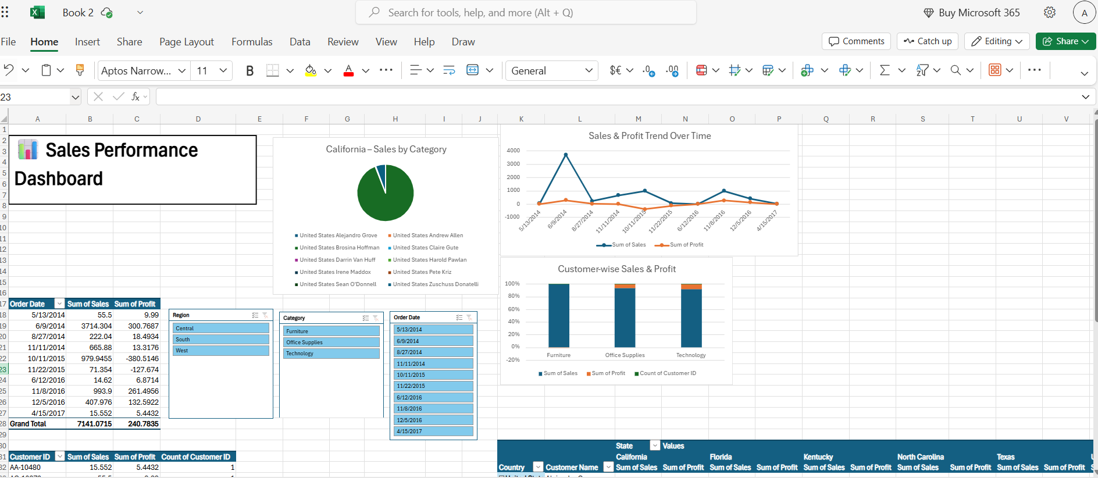

8. Questions & Solutions
- Question 1: Which product category generates the highest sales?]
  - Analysis: I used pivot table feature by putting category in rows and sales in value
  - Solution: Furniture is the highest revenue-generating category, contributing ₹3,706.52, which is over 51.9% of total sales. This is clearly reflected in both the table and the dominant blue segment of the pie chart

- Question 2: Which region is most profitable?
  - Analysis: I used pivot table feature here by putting region in rows and profit in values which gives the sum
  - Solution: Both Central and South regions are operating at a loss, while only the West region shows positive profitability.
The West region is the most profitable, contributing ₹468.72 in profit and offsetting losses from other regions. This makes it the key driver of overall profitability.

- Question 3: How do sales trends vary over months and years?
  - Analysis: I used pivot table and I put order date in rows and put sales in values to calculate the sum.
  - Solution: 2014 saw the highest spike, especially on 6/9/2014 with ₹3,714.30 in sales. Sales dipped in 2015, with moderate peaks in October and November.2016 showed a recovery, with November reaching₹993.90.2017 started slow, with minimal sales in April.

- Question 4: Which sub-categories give high sales but low profit (unprofitable products)?
  - Analysis: I used pivot table option then added sub category in the row and sales and profit in the values so it can calculate the sum. Then with the help of conditional formatting I used the” lesser than 0” rule and highlighted the profit in red, by this we can see the negative profits in red .
- Solution: The image shows that Tables and Appliances have high sales but negative profit, making them unprofitable. Storage and Phones also have strong sales but low profit margins, signalling a need for cost or pricing review

- Question 5: Who are the top 5 customers by sales?
  - Analysis: I reviewed the table and bar chart showing customer names and their total sales. By sorting the sales values in descending order, I identified the top five customers contributing the most revenue. I used pivot table and a bar chart here.
  - Solution: These five customers account for the majority of the ₹6,762.01 total sales, with Brosina Hoffman alone contributing over 55% of the total.

9. Challenges Faced & Solutions
Challenge | Solution
Challenge 1: e.g., Difficulty in handling missing values | Solution: e.g., Used the "find and replace" feature to fill in missing data points with "N/A" or "Unknown"
Challenge 2: e.g., Choosing the right chart type to visualize a specific trend | Solution: e.g., Experimented with different chart types (line, bar, pie) and settled on a line chart for clarity in showing the trend over time
Challenge 3: e.g., Data was not in a tidy format for PivotTables | Solution: e.g., Used the "Text to Columns" feature and rearranged data columns to create a clean table

10. Outcome
Key Insights:
- Furniture is the highest revenue-generating product category, contributing over 50% of total sales.
- The West region is the most profitable, offsetting losses in other regions.
- Sales trends vary significantly across years, with 2014 showing peak performance and 2015 experiencing a dip.
- Some sub-categories like Tables and Appliances have high sales but negative profit, highlighting unprofitable segments.
- A small number of top customers contribute the majority of revenue, emphasizing the importance of customer-focused strategies.
Usefulness of the Dashboard:
- The interactive dashboard consolidates key metrics in a single view, enabling quick, informed decisions for marketing, inventory, and customer management.
- Visual elements like pie charts, bar charts, and line graphs make trends and patterns easy to understand at a glance.
- Slicers and dropdown filters allow users to explore data dynamically across regions, categories, and time periods.
Skills Learned and Enhanced:
- Developed expertise in data cleaning, preparation, and transformation using Excel.
- Strengthened abilities in PivotTables, charts, conditional formatting, and dashboard design.
- Gained practical experience in analyzing real-world datasets and translating data into actionable business insights.
- Improved problem-solving, analytical thinking, and presentation skills through structured reporting and visualization

11. Screenshots of Final Outpu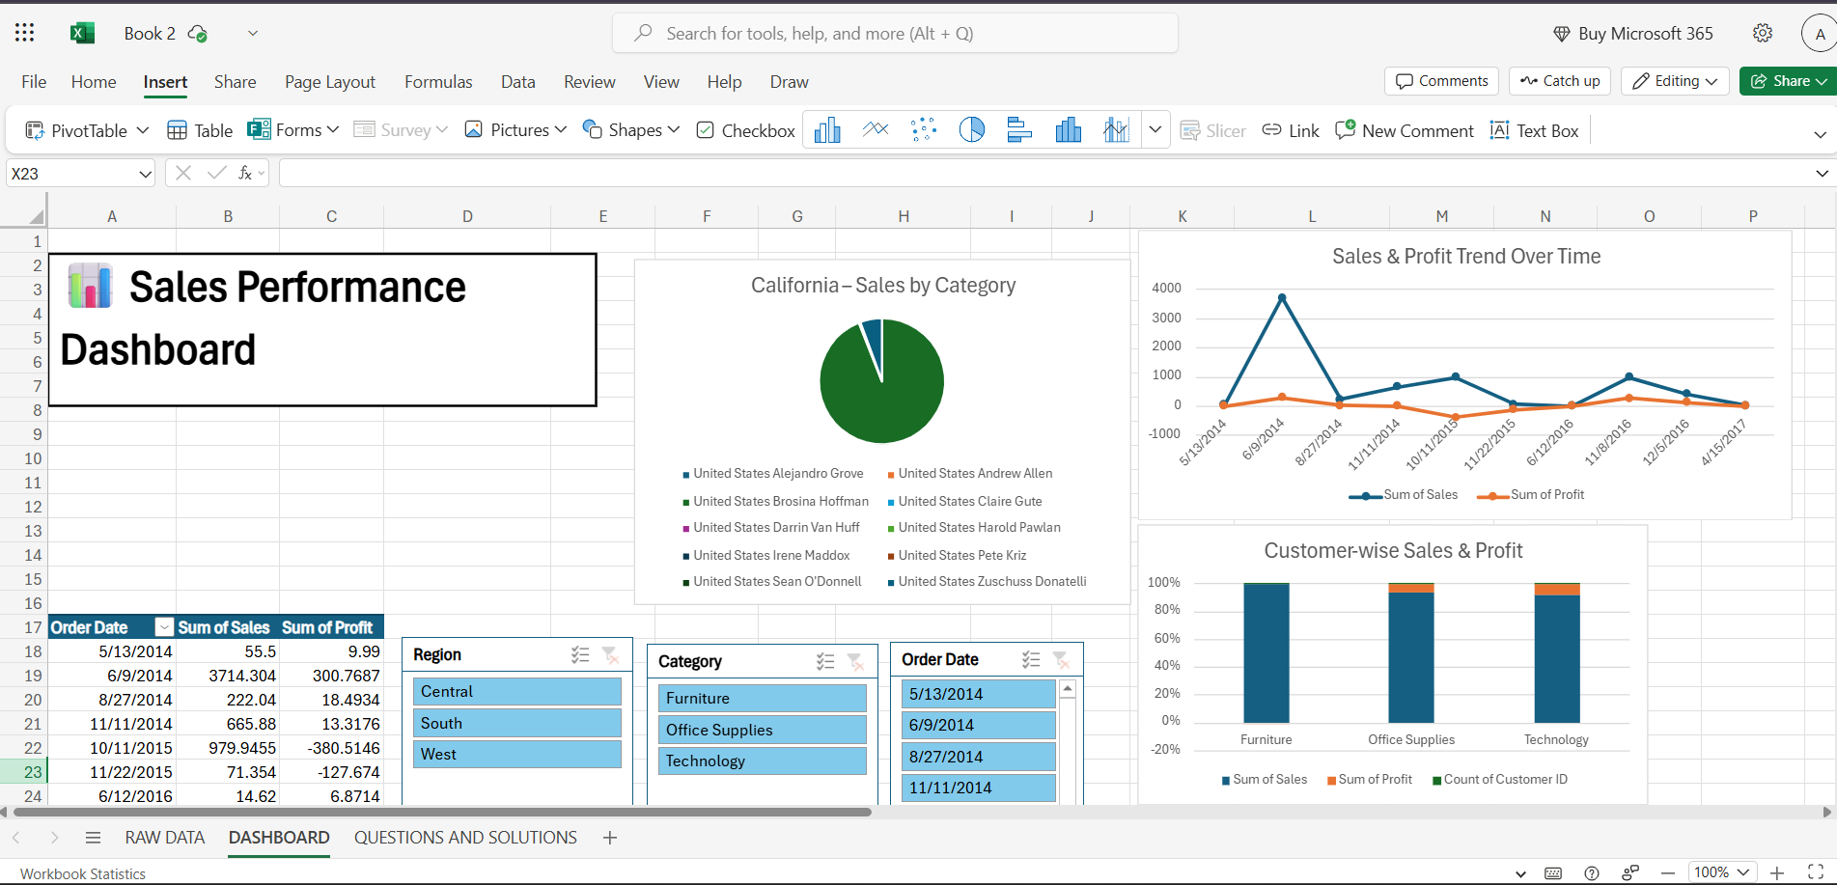
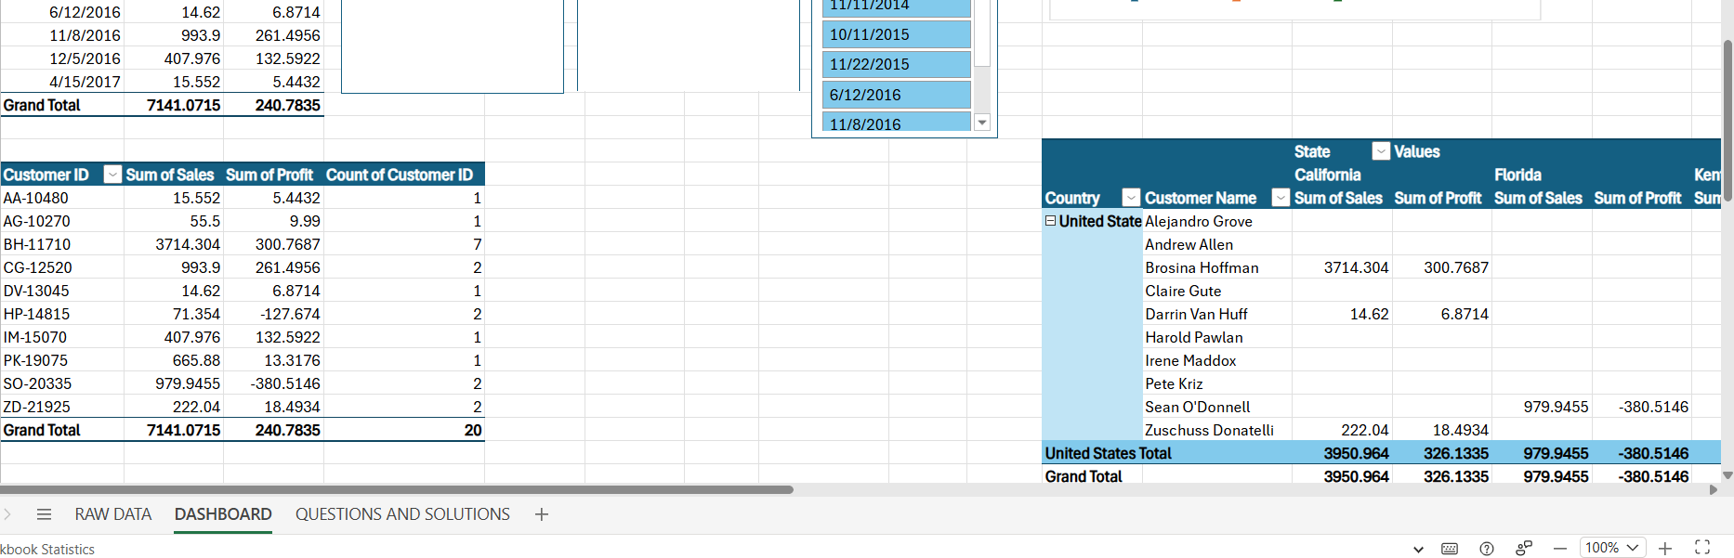
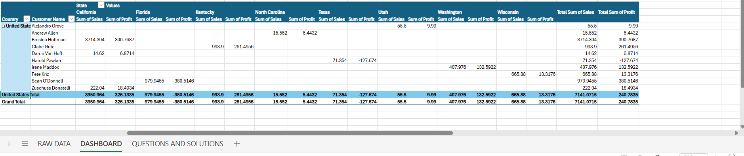
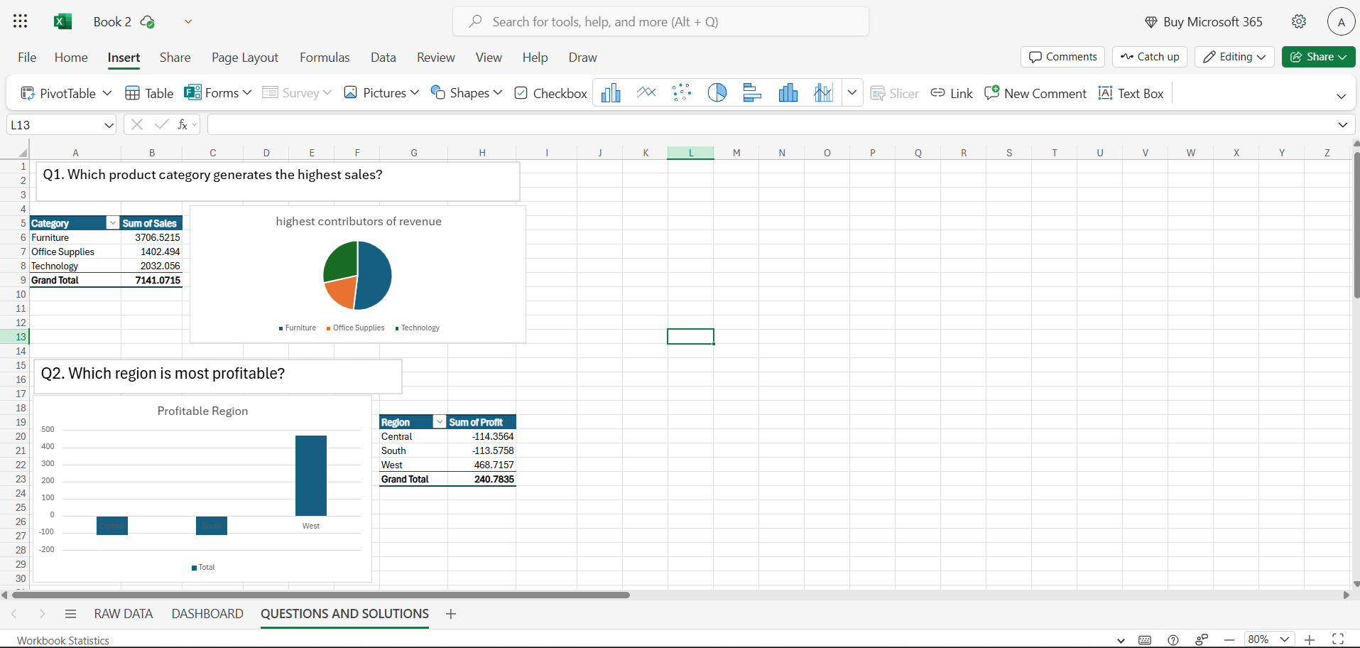
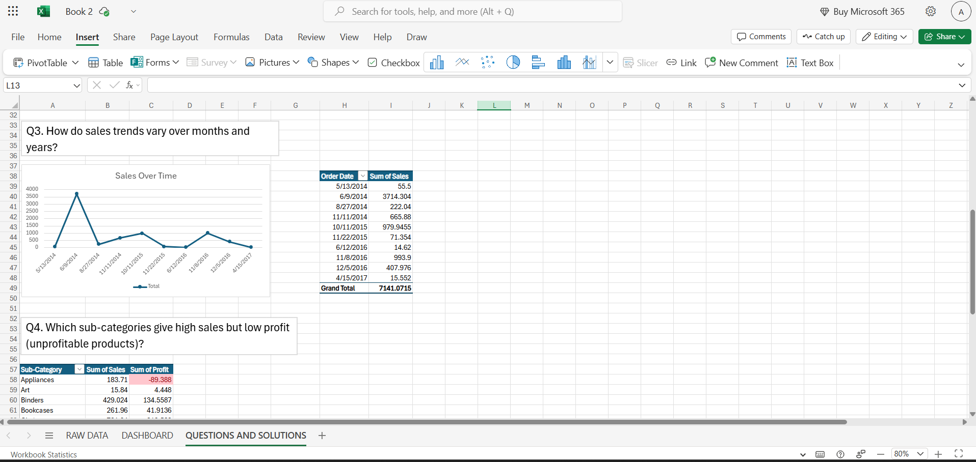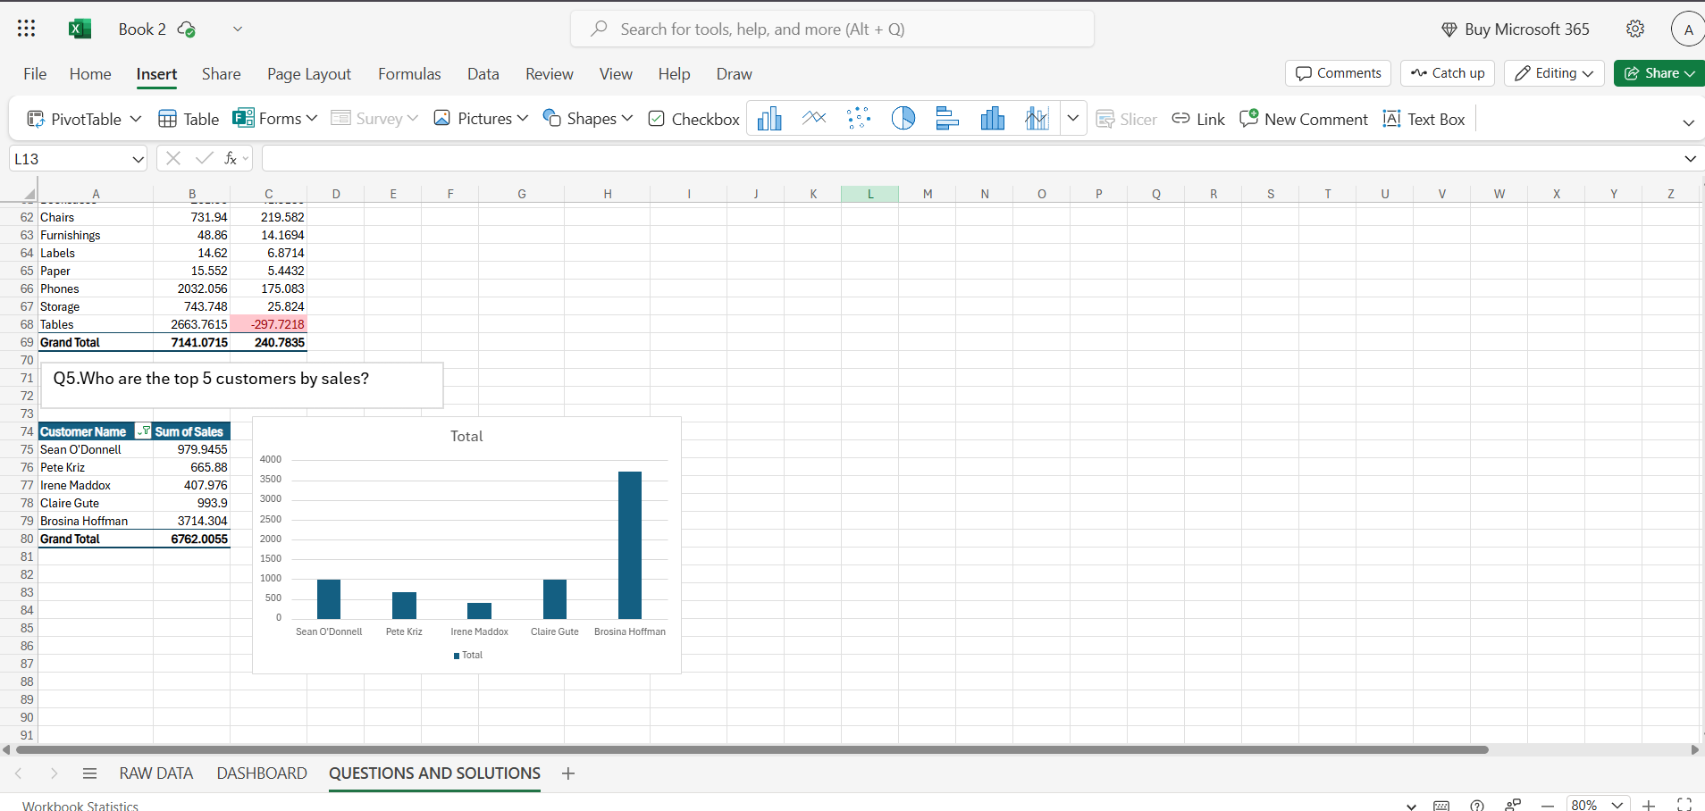

12. Conclusion

This project strengthened my data analysis skills using Microsoft Excel. I gained practical experience in cleaning, transforming, and visualizing data, and learned how insights can guide business decisions. The hands-on approach provided a deeper understanding of how raw data can be converted into actionable insights.

13. References
- Microsoft Excel Official Documentation – support.microsoft.com/excel
- Excel Easy – www.excel-easy.com
- Chandoo.org – chandoo.org

