Fiona Shalom D’Mello

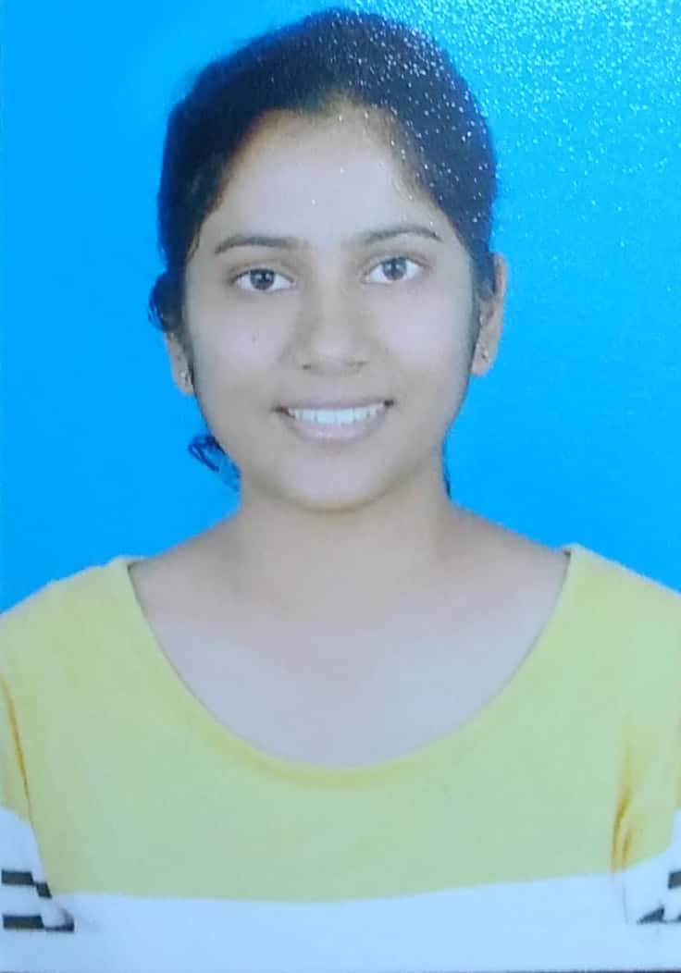

D/o Edwin N. D’Mello

“Shalom”, H.No 4-49(2), Golijara road,

Kinnigoli Post, Mangalore – 574150,

Dakshina Kannada, Karnataka, India.

Email ID: [shalomdmello@gmail.com](mailto:shalomdmello@gmail.com)

Contact No.: +91 9481177267(Mobile)

Objective:

To work in an organization, where I

* Can make use of the knowledge and capabilities that I currently possess for the benefit of my employer.
* Will be constantly encouraged to enhance both – my knowledge and capabilities, by means of working on relevant projects.

Education:

* Master of Science (Physics) - Manipal Institute of Technology , Manipal.

Course completed in May 2017

CGPA: 9.05

* Bachelor of Science (Physics, Chemistry, Mathematics) - St. Agnes College (Autonomous), Mangalore.

Degree provided by Mangalore University, Mangalore.

Course completed in April 2015

Aggregate percentage: 87.30

* Pre-University College – St.Agnes P.U. College, Mangalore.

Exam conducted by the department of Pre-University Education, Bangalore.

Course completed in April 2012

Percentage: 91.5

* S.S.L.C – Maryvale High School, Kinnigoli (Mangalore).

Exam conducted by the Karnataka state education examination board, Bangalore.

Course completed in April 2010

Percentage: 92

Projects and Academic Achievements:

* Worked on a year-long project in the field of Cosmology, titled “Numerical study of large scale structure (LSS) formation in the universe” , under the guidance of Dr.Kazuyuki Furuuchi from Manipal Centre for Natural Sciences (MCNS), Manipal. I undertook this project as a part of my M.Sc course.
* Participated in a Summer Research Internship organized by Manipal Centre for Natural Sciences (MCNS), Manipal in June-July 2016. I worked in field of Gravitation and Cosmology under the mentorship of Dr. Kazuyuki Furuuchi.
* Participated in the 7th annual KSTA National Conference in February 2015, on “Science, Technology and Productization – A means for growth”, held in Bangalore.
* Participated and won in quiz events organized by St. Aloysius College (Autonomous), Mangalore as a part of their annual national level science fest (Imprints) in the year 2014 and 2015.
* Worked as an assistant event manager and helped organize a science event as a part of the annual college fest “Vittoria-2014”, at St. Agnes College (Autonomous).

Technical Skills:

I am familiar with the following:

* Operating systems – Ubuntu and Microsoft Windows.
* Programming languages and level – C (Basics), Python (Basics)
* Other relevant software applications that I am familiar with – LaTex, Microsoft Word, Microsoft Power Point.

Work Experience:

I have worked as an Assistant Professor in the Department of Physics at Shri Devi Institute of Technology (Kenjar, Mangalore), from 01-02-2018 to 31-05-2018.

Personal Profile:

Phone No.: 0824-2295413 (Residence)

Date of Birth: 31/01/1995

Age: 23 years

Sex: Female

Nationality: Indian

Religion: Christian (Roman Catholic)

Mother Tongue: Konkani

Languages Known: English, Kannada, Hindi, French (basic).

Marital Status: Single

Declaration:

I do hereby confirm that the information furnished above is true to the best of my knowledge and belief.