Generative Radial Geometry (GRG)

Area and Circumference of the Circle without π

# 🔎 Introduction

Generative Radial Geometry (GRG) proposes a discrete method for calculating the area and circumference of a circle using only the radius as a known parameter. Instead of relying on formulas based on π, GRG uses regular subdivisions (of the base or the angle) to precisely determine each point on the circumference and compute geometric quantities through summation.

# 📐 Calculating the Area of the Circle

The area is calculated by summing the projected heights of radial segments multiplied by a constant base. In the Cartesian method, the base of the quarter circle is divided into N equal parts. Each point on the circumference is determined using the Pythagorean theorem, and the vertical component becomes the height of the corresponding rectangle. The following formula represents the sum of these rectangles.

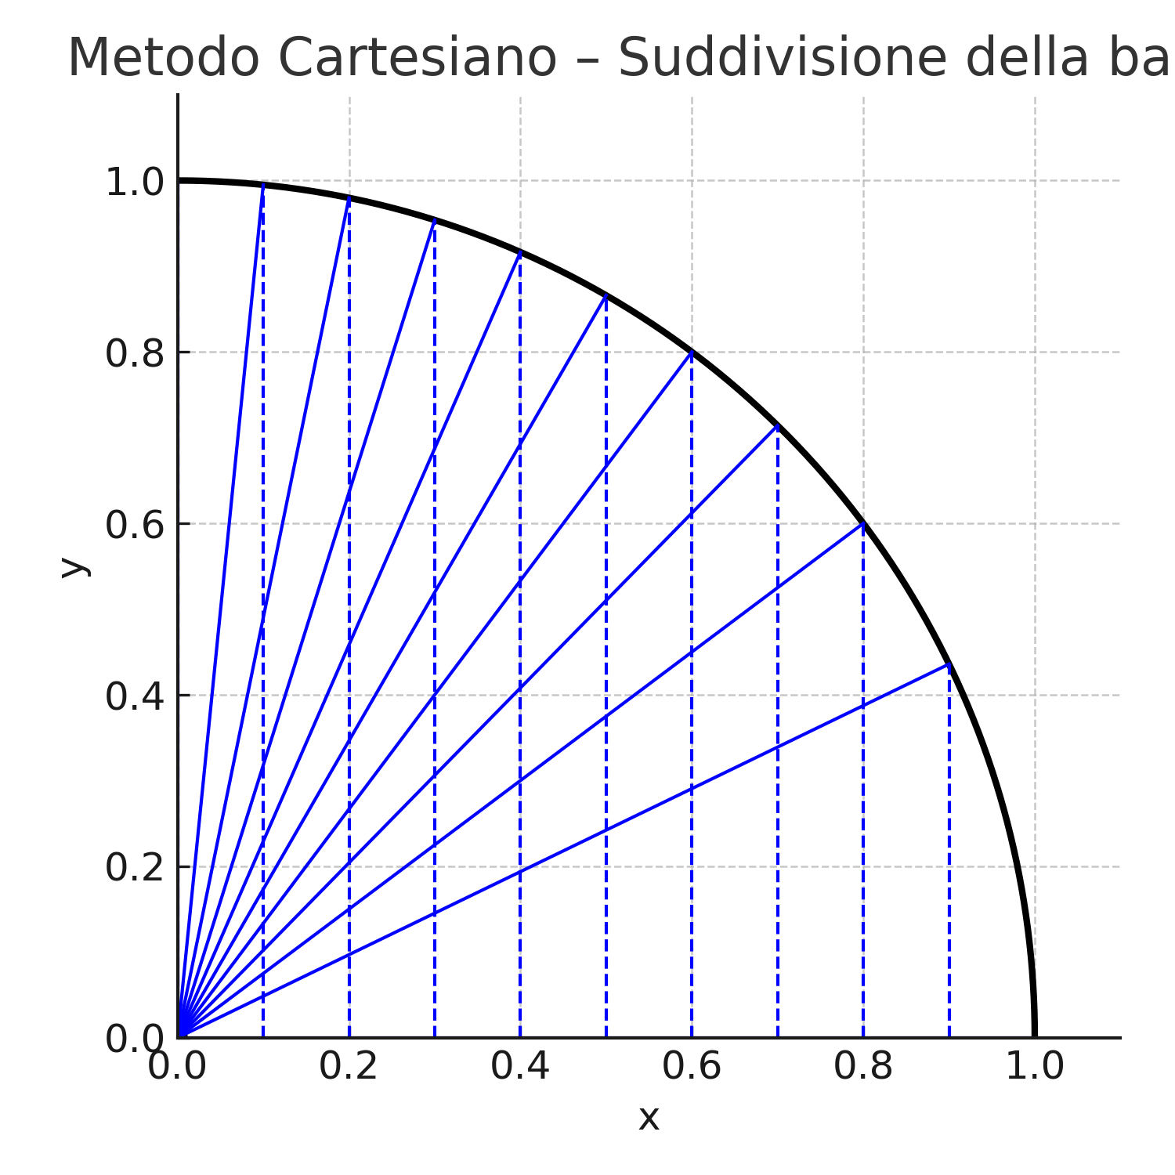

🔹 Area of the quarter circle:



🔸 Full circle area (multiplied by 4):

A = 4 · A_quarto

# 📏 Calculating the Circumference of the Circle

For the circumference, the angular method is preferred, which divides the arc into N equal angular portions. Each point on the circumference is calculated from the known radius and angle θᵢ. The distance between consecutive points yields a segment of arc, and summing these gives the quarter-circle arc length.

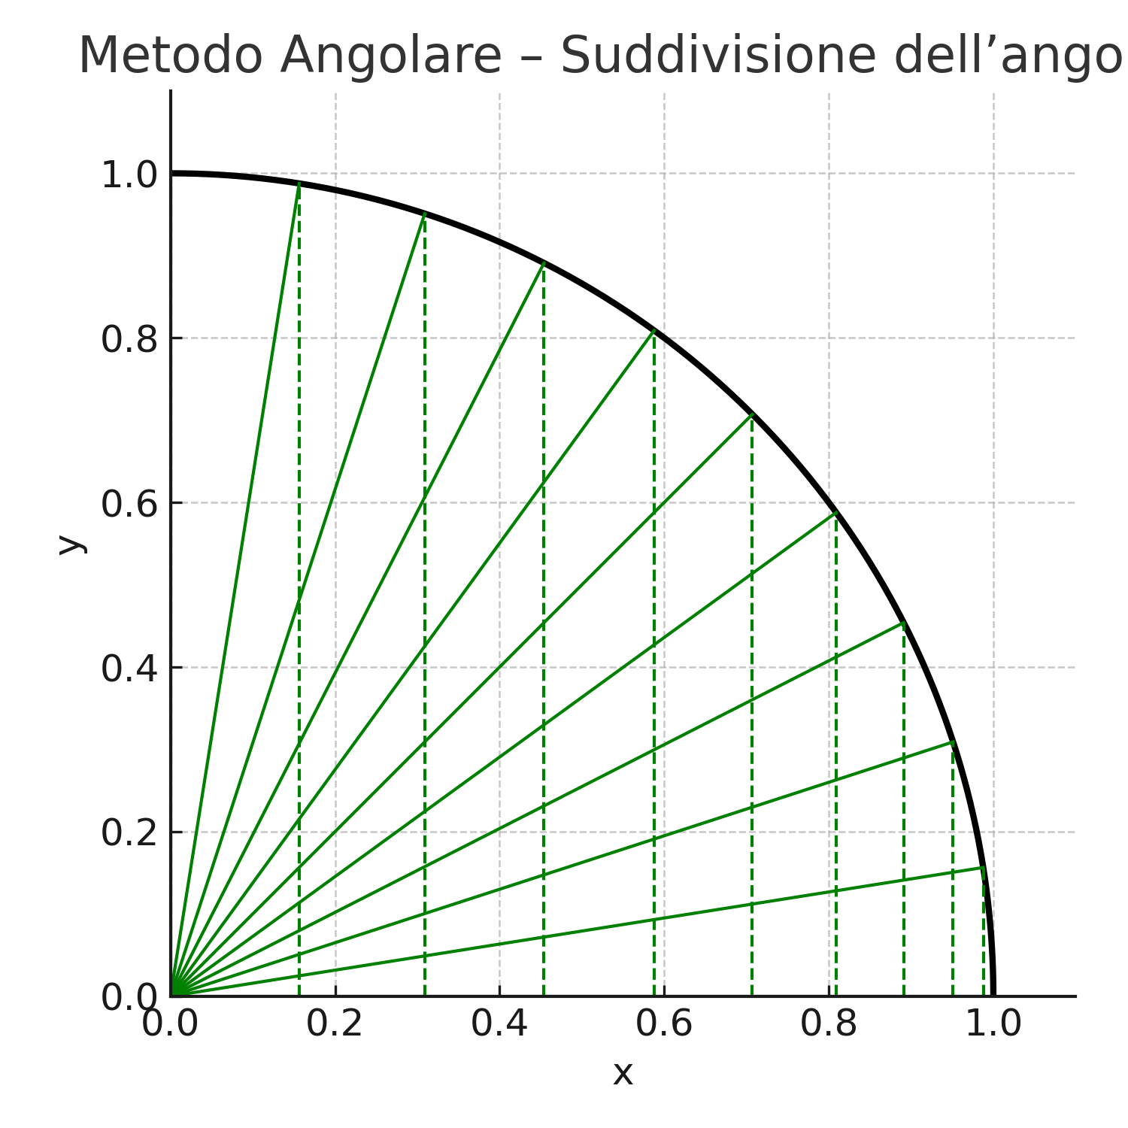

🔹 Quarter-circle circumference:

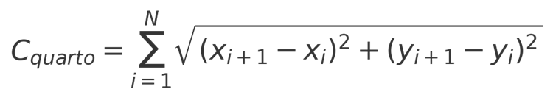

🔸 Full-circle circumference (multiplied by 4):



# 🎓 Conclusion

GRG enables the calculation of the circle’s area and circumference using only the radius and regular subdivisions, without relying on the number π. The Cartesian method is more accurate for the area, while the angular method is more consistent for the circumference. In both cases, the points on the circumference are determined with absolute precision, and the formulas converge exactly to the real value as N increases.