Generative Radial Geometry (GRG)

# Area and Circumference of the Circle without π

## 🔎 Introduction

Generative Radial Geometry (GRG) proposes a discrete and internal method for calculating the area and circumference of a circle using only the radius r and a fixed number of subdivisions N. Instead of relying on formulas based on π, GRG reconstructs the circle by generating points through either radial or angular progression. All constructions are made on a quarter of a circle, ensuring higher resolution and symmetry, and results are multiplied by 4 for the full circle. The same value of N is used for both area and circumference to ensure a coherent structure.

## 📐 Calculating the Area of the Circle

The area is computed by summing the vertical projections of radial segments on the base of the quarter circle. The base (radius) is divided into N equal parts, and for each step i, the vertical projection is:



The area of the quarter circle becomes:

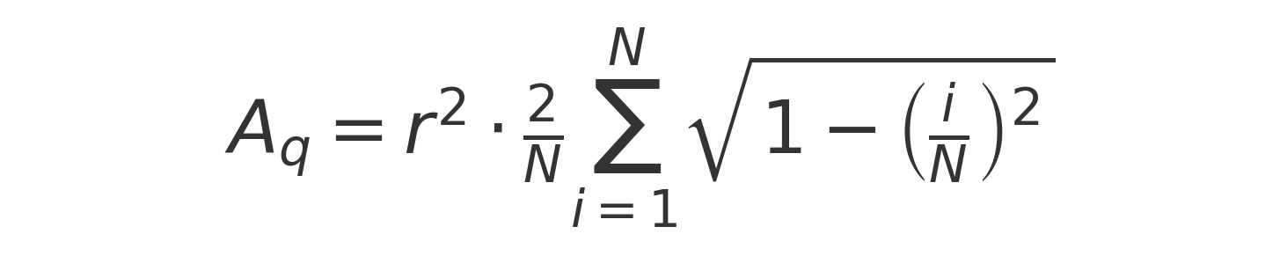

Then the full area is:



Visual representation of the area projection on a quarter circle:

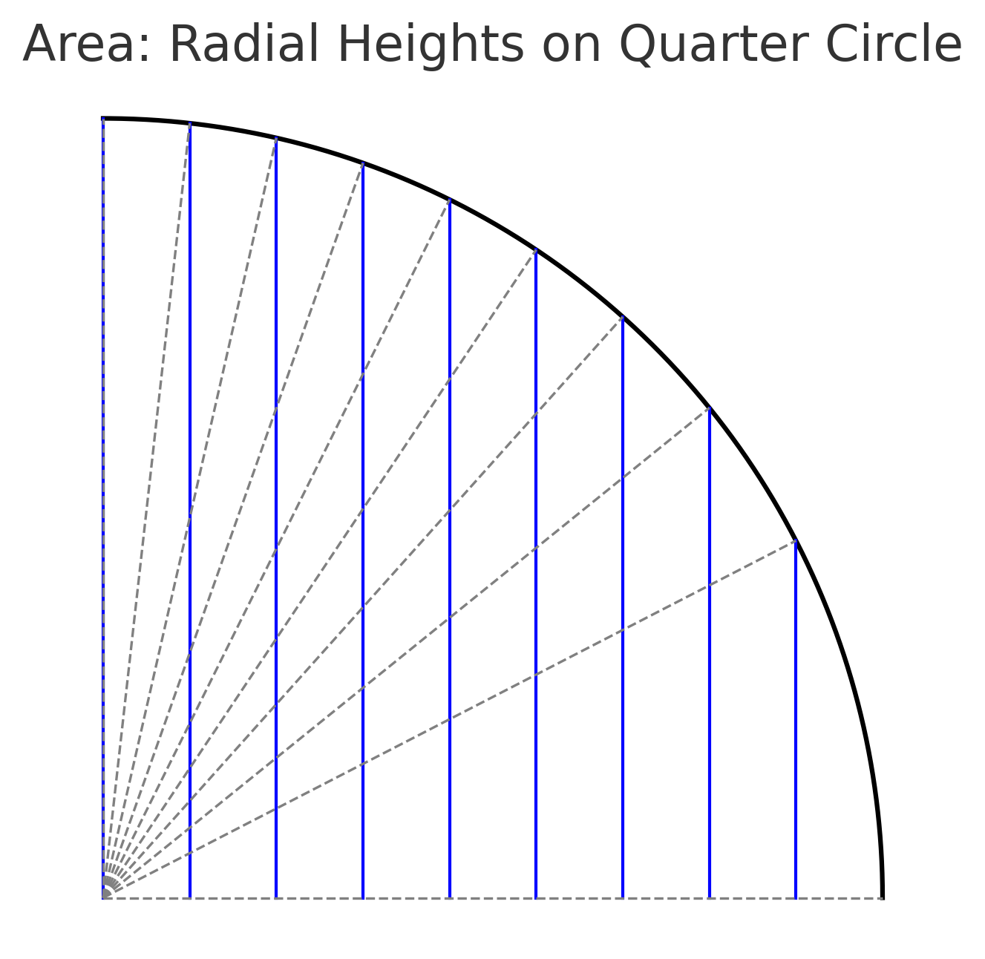

## 📏 Calculating the Circumference of the Circle

The circumference is calculated by dividing the quarter of a circle into N equal angular steps. Each angular increment is:



The length of each chord between two consecutive points on the circumference is:



Then the length of the quarter circle is:



And the full circumference becomes:



Visual representation of chords on a quarter circle:

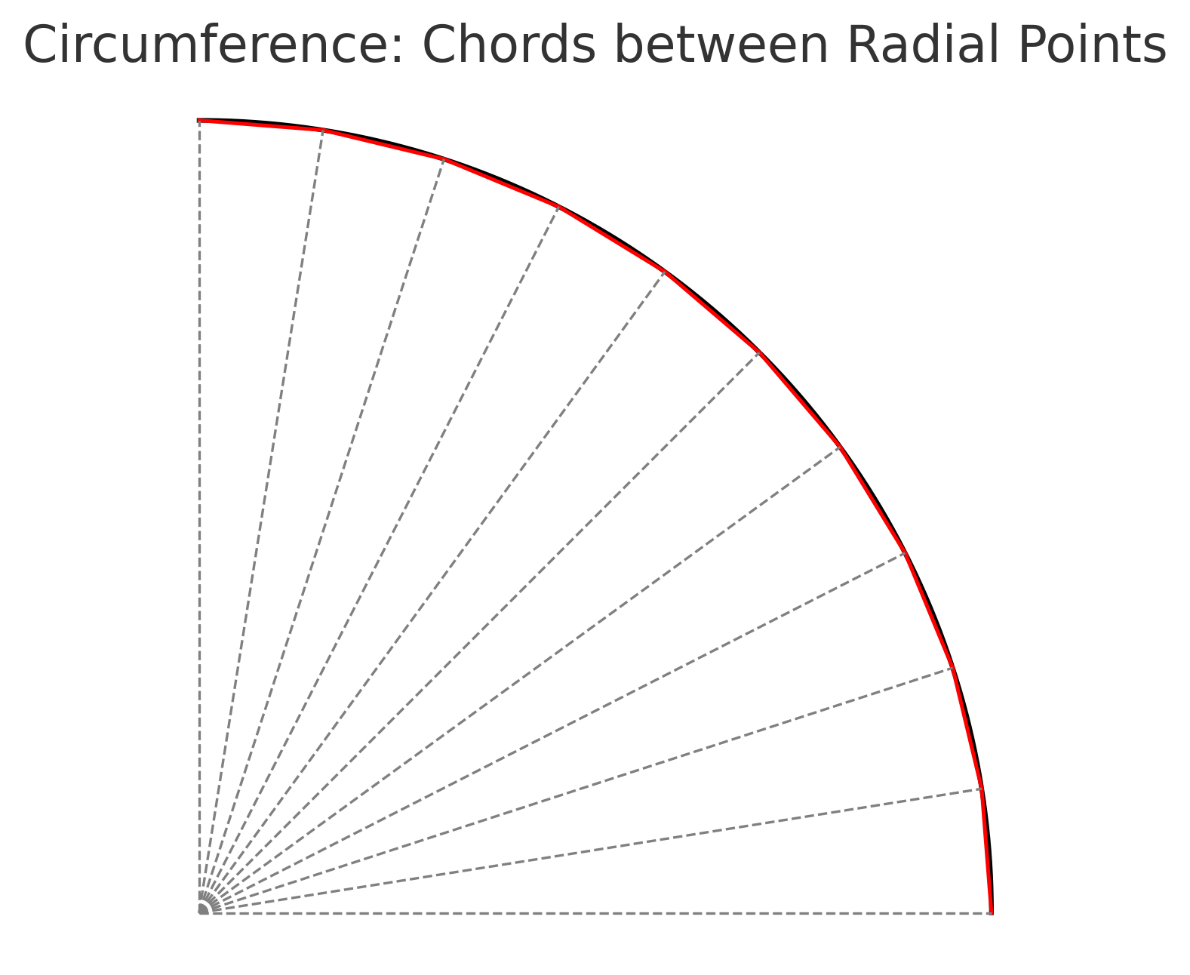

## 🧭 Common Discrete Parameter N

Both the area and the circumference are calculated using the same discrete parameter N, applied to the quarter circle. This unified subdivision creates a coherent geometric framework where the inside and the border of the circle are generated by compatible and symmetrical procedures.

## 🎓 Conclusion

GRG provides a discrete, generative alternative to traditional geometry. Using only the radius r and the number of subdivisions N, both the area and the circumference are calculated from first principles, without invoking π. Working on the quarter circle allows for higher resolution and structural clarity. The formulas converge exactly to classical values as N → ∞, while remaining conceptually independent of transcendental constants.