BINUS UNIVERSITY
ARTIFICIAL INTELLIGENCE USE DECLARATION FORM

I/We* hereby:
Name | : Gheraldy Moses Tarigan
Student ID | : 3002918263
Course Code | : COMP6112036
Course Title | : Algorithm and Programming
Assignment Title | : LAB Personal Assignment
Assignment Type | Integrated / Partial / Flexible / Limited / Independent (circle one)
Declare that I/we* have/have not* used AI in the completion and preparation of the assignment listed above.
If Yes, the AI tools used are as follows:
Assignment part | Used AI Tool? | Tool(s) Used | Key Prompt
Idea and content discussion | Yes/No | Deepseek | I have to work on a C program that processes 5 test scores stored in an array and I have to manipulate the array using pointers. After compiling this program, the unused variable 'avg' is displayed and the program cannot display the average. Please analyze the code below, explain what is wrong and how to make sure that the pointer accesses to the array are correct.”
Text/Script generation | Yes/No
Image/Video/Graphics generation | Yes/No
Translation, grammar, and spelling check | Yes/No
Others…….. | Yes/No
Approximate contribution of AI in the final submission of assignment is 20%
I/We* also declare that any use of AI/artificial intelligence for the course mentioned above has been disclosed in this letter.
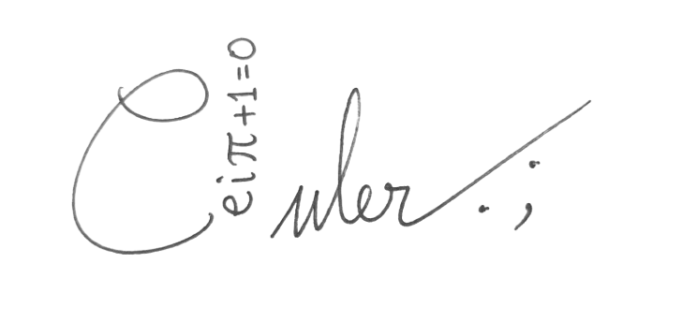
Kabanjahe, 27 September 2026

Gheraldy Moses Tarigan
3002918263

Promt :
I have to work on a C program that processes 5 test scores stored in an array and I have to manipulate the array using pointers. After compiling this program, the unused variable 'avg' is displayed and the program cannot display the average. Please analyze the code below, explain what is wrong and how to make sure that the pointer accesses to the array are correct.
#include <stdio.h>

int main() {

int nilaiUjian[5];
float avg;

for (int i = 0; i < 5; ++i) {
printf("Masukkan nilai ujian ke-%d: ", i+1);
scanf("%d", &nilaiUjian[i]);
}

for (int i = 0; i < 5; ++i) {
printf("nilai ujian ke-%d : %d\n", i+1, nilaiUjian[i]);
}

int max = nilaiUjian[0];

for (int i = 1; i < 5; ++i) {
if (nilaiUjian[i] > max) {
max = nilaiUjian[i];
}
}

printf("nilai tertinggi adalah : %d\n", max);

int min = nilaiUjian[0];

for (int i = 1; i < 5; ++i) {
if (nilaiUjian[i] < min) {
min = nilaiUjian[i];
}
}

printf("nilai terendah adalah : %d\n", min);

return 0;
}

AI Response :
a. Cause of the `unused variable 'avg'` warning
The variable `float avg;` is declared on line 10 but is neither calculated nor printed. The compiler issues a warning because the variable is created but never used. The average calculation is missing because:
- There is no calculation of the total score, and
- There is no `printf` statement for the average.
Note that `nilaiUjian` is of type `int`, so the average must be calculated using floating-point division rather than integer division to prevent the result from being truncated. Example:
avg = (float) total / 5; // cast ke float agar hasil decimal
b. Pointer access to arrays
Currently, all access still uses the index `nilaiUjian[i]`; the following is an example of switching to using pointers:
int *ptr = nilaiUjian; // pointer menunjuk elemen pertama array
scanf("%d", ptr + i); // ptr + i setara &nilaiUjian[i]
int nilai = *(ptr + i); // *(ptr + i) setara nilaiUjian[i]
Since an array name is the address of its first element, `ptr + i` yields the address of the *i*-th element, and `*(ptr + i)` retrieves its value. This demonstrates that arrays and pointers can be used interchangeably.
c. Min/max search
The search for the minimum and maximum values ​​can be combined into a single loop using an `if ... else if ...` structure for greater efficiency (requiring only one pass).
Reflection :
The AI's response makes it clear that the warning `unused variable 'avg'` does not stem from a syntax error; rather, it occurs because the variable `avg` was declared but never computed or displayed, which is why the average is absent. I also recognize that `Testvalue` is an `int` type, meaning the division for the average needs to be cast to `float` so that the outcome is not truncated (for instance, `85.88` instead of `85`). Moreover, the explanation concerning pointers is what matters most to me: given that the array name represents the address of its initial element, `(ptr + i)` can substitute for `TestValue[i]`. Following this consultation, I refined the code by computing the average with `float`, introducing `int ptr = TestValue;` pointers for both `scanf` and printing. Merging the searches for the highest and lowest values into a single `if-else` loop.
Improvement results:
For the results of code improvements, you can see tugas2.c

