MINOR PROJECT – 1
CYBERSECURITY RISK ASSESSMENT FRAMEWORK FOR SMALL BUSINESSES

Name: Lakshay Saini
Roll No.: 24BCS10149
Course: B.E. – Computer Science & Engineering
University: Chandigarh University
Internship Organization: Navigation Solution
Academic Year: 2026

Abstract
This project develops a structured cybersecurity risk assessment framework for small and medium enterprises. It identifies common threats, assigns likelihood, impact, and exposure scores, ranks risks, maps mitigations to security controls, and validates the model through three fictional SME case studies. The implementation is an academic risk-ranking tool and does not scan or attack real systems.

1. Introduction
Small businesses often have limited security budgets, staff, and formal security processes. A repeatable risk model helps prioritize the threats that could cause the greatest operational or financial harm.

2. Objectives
Research common SME risks; develop a repeatable assessment model; create a severity-impact metric; propose mitigations; validate the approach through case studies; and document practical best practices.

3. Threat Landscape
Common risks considered are phishing, ransomware, insider threats, weak access control, unpatched software, data leakage, and insecure backups.

4. Assessment Framework
The model uses three dimensions: Likelihood (1–5), Impact (1–5), and Exposure (1–5). Risk Score = Likelihood × Impact × Exposure. Scores 1–19 are Low, 20–47 Medium, 48–80 High, and 81–125 Critical.

5. Risk Matrix and Prioritization
The multiplication model provides a transparent numerical ranking. A high score means the organization should prioritize mitigation, monitoring, and management attention.

6. Mitigation Strategies
Ransomware: offline backups, patching, endpoint protection, MFA. Phishing: awareness training, email filtering, MFA. Insider threats: RBAC, least privilege, logging and separation of duties. Weak access control: strong authentication and access reviews. Unpatched systems: asset inventory and patch management.

7. Case Study Validation
Three fictional cases were evaluated: a retail SME, a professional-services SME, and a small manufacturer. The cases demonstrate that the same metric can prioritize different threats depending on exposure and impact.

8. Implementation
The Python implementation in implementation/risk_assessment.py accepts structured threat records and calculates scores and levels. sample_case_studies.csv contains the validation dataset.

9. Required Evidence
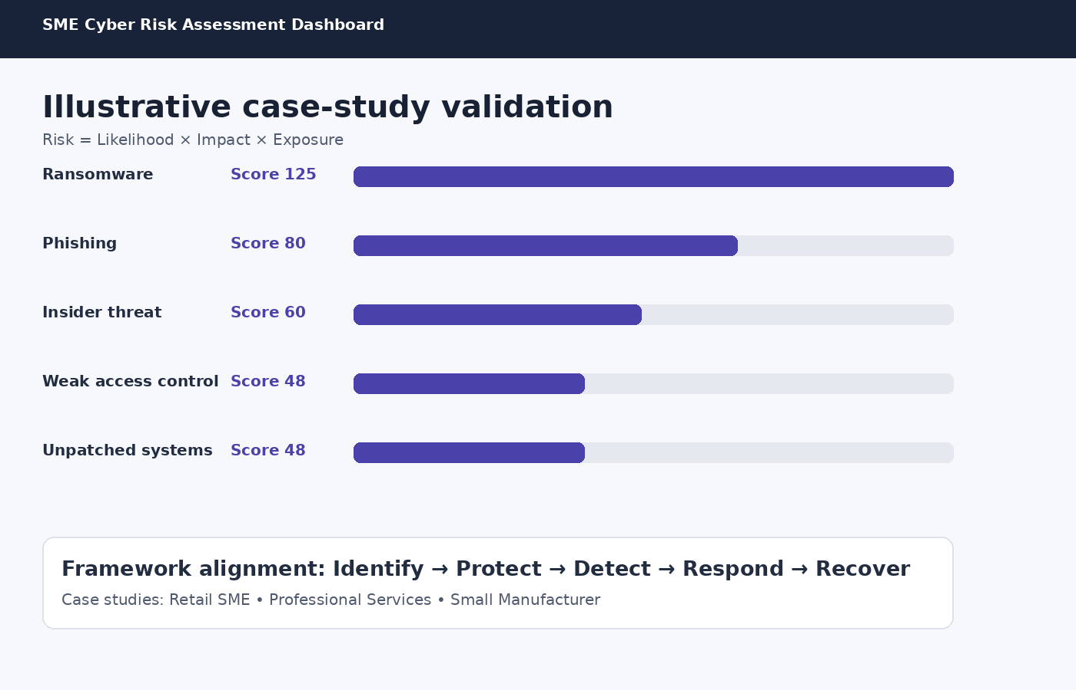
Figure 1. Illustrative risk-ranking dashboard based on the supplied minor-project requirements.

10. Results
The model ranks ransomware as the highest-risk example in the validation dataset, followed by phishing and insider-threat scenarios. The results demonstrate how a small organization can convert qualitative security concerns into a prioritized mitigation list.

11. Best Practices
- Maintain an asset inventory.
- Use MFA for important accounts.
- Apply least privilege and RBAC.
- Maintain tested offline backups.
- Patch operating systems and applications.
- Train employees to recognize phishing.
- Centralize important logs and review them.
- Create and test an incident-response plan.

12. Limitations
The model is a simplified academic framework. Scores depend on assessor judgment, and case studies are fictional validation examples rather than audits of real companies.

13. Future Scope
Future work can add asset criticality, control maturity, financial impact, automated reporting, authenticated dashboards, and alignment with an organization's formal risk register.

14. Conclusion
The project provides a practical and explainable method for SMEs to identify, rank, and mitigate cybersecurity risks while keeping implementation lightweight and suitable for a small organization.

15. References
Supplied minor-project brief: Cybersecurity Risk Assessment Framework for Small Businesses.
NIST Cybersecurity Framework (CSF) concepts used as the requested example framework.
Project implementation and synthetic case-study dataset.

