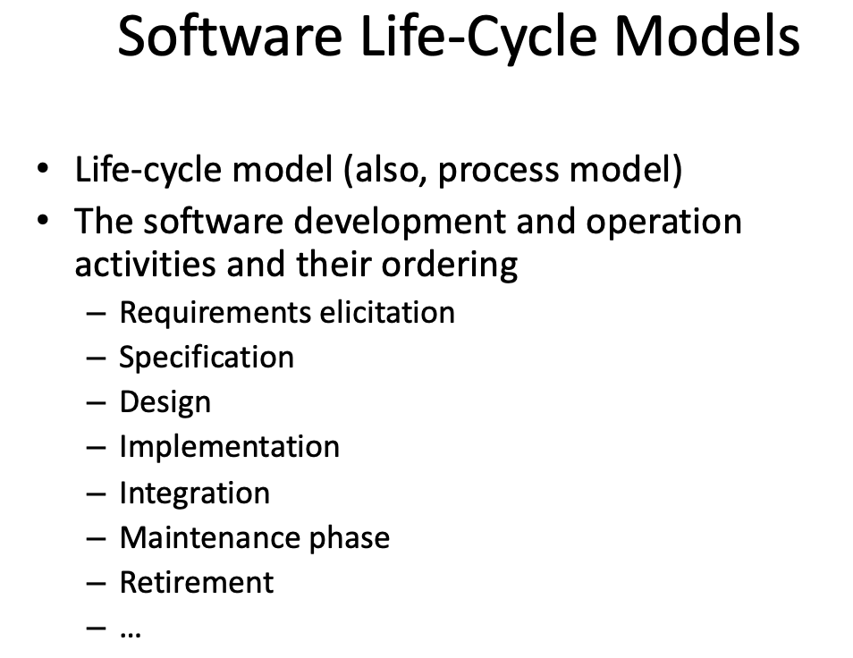

**WATERFALL MODEL**

**4 variables of a project:**

* Development Cost (bad)
  + can only increase this incrementally
* Time (bad)
  + Deadlines are predetermined anyways
* Quality (bad)
  + Low quality isn’t good anyways
* Scope (good)

**Function Points:** Measure of the functionality of the system

* Steps

1. **Count information domain (counting)**

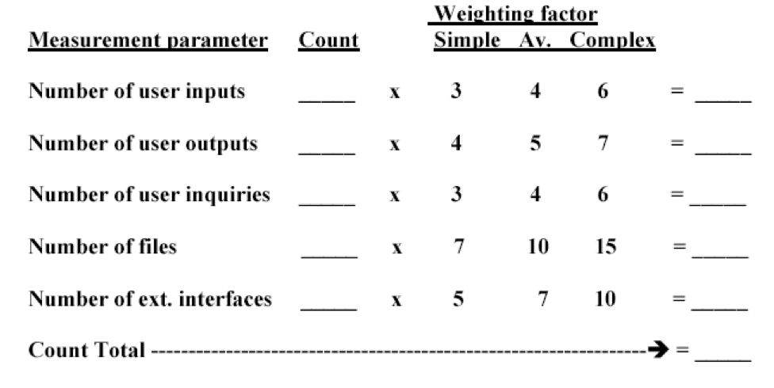

1. **Assess complexity of software (adjusting)**

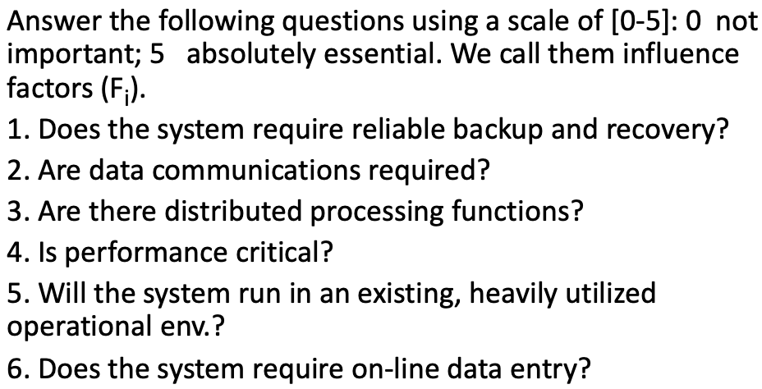

1. **Apply relationship to come up with LOC or P-months based on adjustments**