SMART LESSON NOTE ON CHEMISTRY FOR WEEK 1

Class: Senior Secondary 1 (SS1)
Topic: Introduction to Chemistry & The Scientific Method
Duration: 120 Minutes (Double Period)
Date: Week 1
Teacher's Name: Mr. Jonathan
Lesson Objectives
By the end of this 120-minute lesson, learners should be able to:
- Specific: Define chemistry, list the five main branches, and name six career options related to chemistry.
- Measurable: Outline five adverse effects of chemicals and state the five core steps of the scientific method in sequential order.
- Achievable: Differentiate between independent, dependent, and controlled variables in a given experimental case study with 100% accuracy.
- Realistic: Relate industrial applications of chemistry to local Nigerian context (e.g., oil refining, agricultural fertilizer production, NAFDAC regulatory oversight).
- Time-bound: Complete all group activities, variable identification exercises, and evaluation tasks within the allocated 120 minutes.

Instructional Materials
- Chart showing the branches of chemistry and career pathways.
- Flowchart display of the Scientific Method.

Lesson Development Table
Stage | Teacher’s Activities | Learners’ Activities | Duration
Introduction | Displays household products (salt, vinegar, detergent, rust samples). Asks: "What do all these items have in common?" Introduces Chemistry as the foundational science of matter. | Observe displayed objects, share ideas, and connect everyday items to chemical science. | 10 mins
Presentation | Defines Chemistry and outlines its 5 main branches (Organic, Inorganic, Physical, Analytical, Biochemistry). Details applications in Hospitals, Defense, Agriculture, Petrochemicals, Space Science, and Teaching. | Take structured notes, ask clarifying questions on branches, and identify target career goals. | 25 mins
Explanation | Explains adverse effects of chemicals (Pollution, Poisoning, Corrosion, Drug Abuse). Details regulatory roles of NAFDAC, NDLEA, and NESREA. Introduces the Scientific Method and variable types. | Follow explanations, copy chemical reaction for rusting, and analyze the progression from Hypothesis to Law. | 25 mins
Group Discussion | Divides class into 4 groups. Assigns each group a real-life scenario: Group A (Oil spillage in Niger Delta), Group B (Drug abuse among youth), Group C (Selecting best fertilizer for cassava farming), Group D (Designing a rust-free roof). | Engage in group discussions, formulate hypotheses, assign variables, and present findings through group leaders. | 20 mins
Class Activity | Distributes a case-study worksheet requiring students to identify independent, dependent, and control variables for a salt solubility experiment. | Solve the worksheet independently, write down responses, and self-correct during class walkthrough. | 20 mins
Evaluation | Administers oral and quick written quiz questions assessing key objectives. | Answer evaluation questions verbally and in writing. | 20 mins

Evaluation Questions
- Define Chemistry in terms of matter and its transformations.
- State two career paths available to a chemistry graduate in the agricultural and health sectors.
- List the steps of the scientific method in correct order.
- Distinguish between an independent variable and a dependent variable in an experiment.

Assignment (Homework)
- Read the label of any three packaged food or pharmaceutical items in your home. Record their active chemical ingredients, manufacturing dates, expiry dates, and NAFDAC registration numbers.
- A farmer observed that crops grown near a cement factory produced poor yields compared to those further away.
a) Formulate a testable hypothesis for this observation.
b) Identify the independent and dependent variables for an experiment to test this hypothesis.
c) Suggest two control measures to protect the crops.

LESSON NOTE
TOPIC: Introduction to Chemistry

Meaning of Chemistry
Chemistry is defined as the branch of physical science that deals with the study of the structure, composition, properties, and transformations of matter, as well as the energy changes that accompany these processes.
- Matter is defined as anything that has mass and occupies space.
- Substance is a form of matter that has a constant composition and consistent properties throughout.

Major Branches of Chemistry
Chemistry is broadly categorized into five main branches:

- Organic Chemistry: The study of carbon compounds, particularly hydrocarbons and their derivatives (excluding simple oxides and carbonates).
- Inorganic Chemistry: The study of non-organic compounds, minerals, metals, non-metals, and organometallic materials.
- Physical Chemistry: The study of the physical properties, chemical kinetics, thermodynamics, and underlying principles governing chemical systems.
- Analytical Chemistry: The branch concerned with the identification (qualitative) and quantification (quantitative) of matter.
- Biochemistry: The study of chemical processes and substances occurring within living organisms.

Career Prospects Tied to Chemistry
An education in chemistry opens doors to numerous technical, professional, and industrial disciplines essential for national development:
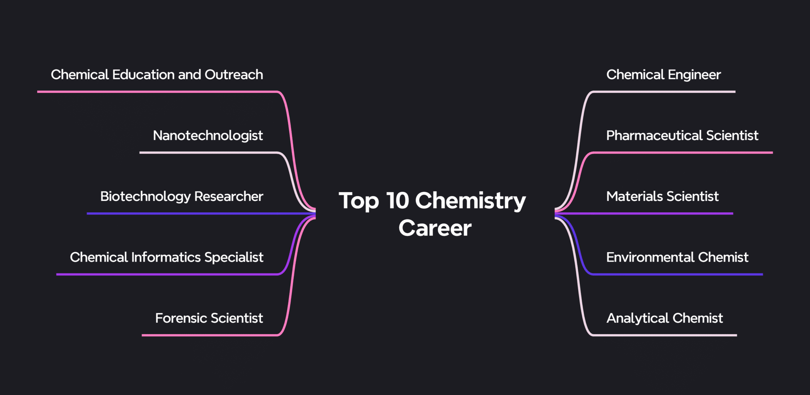

Career Discipline | Primary Roles and Functions | Key Industries / Employers
Chemical Engineering | Designing, scaling, and operating industrial chemical synthesis and separation processes. | Petroleum refineries, petrochemical plants, fertilizer plants.
Pharmacy & Pharmacology | Formulating, synthesizing, testing, and dispensing therapeutic drugs and vaccines. | Pharmaceutical companies, hospitals, regulatory bodies (e.g., NAFDAC).
Medicine & Surgery | Understanding physiological biochemical pathways, metabolic disorders, and clinical diagnostics. | Hospitals, biomedical research centers.
Petroleum Chemistry | Analyzing crude oil fractions, catalytic cracking, gas refining, and petrochemical synthesis. | NNPC, Dangote Petroleum Refinery, international oil companies (IOCs).
Agricultural Chemistry | Developing soil conditioners, synthetic fertilizers (NPK/Urea), insecticides, and fungicides. | Fertilizer companies (e.g., Indorama), agricultural research institutes (e.g., IITA).
Materials Science & Metallurgy | Extracting, refining, and alloy-blending metals for construction, aerospace, and electronics. | Steel rolling mills, manufacturing firms, mining sectors.
Forensic Science | Applying analytical chemistry to criminal investigation, drug identification, and toxicology testing. | Law enforcement agencies, military diagnostic labs, forensic facilities.
Science Education / Research | Teaching chemistry, conducting basic/applied research, and writing scientific policy. | Secondary schools, universities, research institutes (e.g., NBRRI, FIIRO).

Applications of Chemistry in Society
Chemistry directly impacts everyday life, national infrastructure, and economic growth across multiple sectors:
- Hospitals and Medicine: Synthesis of analgesics, antibiotics, anesthetics, intravenous fluids, diagnostic reagents, and sterile surgical materials.
- Military and Defense: Production of propellants, smoke screens, synthetic explosives (e.g., TNT, RDX), armor-grade polymer composites, and chemical defense equipment.
- Chemical and Petrochemical Industries: Conversion of raw Nigerian crude oil into Premium Motor Spirit (PMS), Automated Gas Oil (AGO), Dual Purpose Kerosene (DPK), plastics, polymers, and synthetic detergents.
- Space Science: Formulation of specialized rocket fuels (liquid oxygen/hydrazine), high-temperature ceramic thermal tiles, and life-support lithium hydroxide (LiOH) carbon dioxide scrubbers.
- Agriculture: Production of ammonium nitrate and urea fertilizers, soil pH adjusters (lime), pest control chemicals, and food preservatives.
- Teaching and Academia: Developing scientific literacy, fostering innovation, and training the technical workforce required for industrial development.

Adverse Effects of Chemicals & Mitigation Strategies
While chemicals drive technological progress, improper handling, abuse, or industrial discharge creates significant hazards:
- Drug Abuse and Addiction: Misuse of pharmaceutical or illicit chemical substances alters brain chemistry, leading to physical dependence, organ damage, and social instability.
- Chemical Poisoning: Accidental or occupational ingestion, inhalation, or absorption of toxic compounds (e.g., carbon monoxide CO, lead Pb, mercury Hg, or organophosphate pesticides).
- Corrosion: The gradual electrochemical destruction of metals reacting with environmental oxygen and moisture.
$$Iron + Oxygen + Water→ Hydrated Iron(III) Oxide (Rust)$$
$$4Fe_{(s)}+3O_{2\left(g\right)}+xH_{2}O_{(l)}→2Fe_{2}O_{3}•xH_{2}O_{(s)}$$
- Environmental Pollution:
  - Air Pollution: Release of sulfur dioxide (SO₂), nitrogen oxides (NO_{x}), and chlorofluorocarbons (CFCs) causing acid rain and ozone layer depletion.
  - Water Pollution: Industrial effluent discharge, oil spillage in coastal zones (e.g., Niger Delta region), and agricultural fertilizer run-off leading to eutrophication.
  - Soil Contamination: Non-biodegradable plastics and heavy metal accumulation inhibiting plant growth.

Regulatory Oversight in Nigeria
To mitigate chemical risks, regulatory agencies enforce strict compliance:
- NAFDAC: National Agency for Food and Drug Administration and Control.
- NDLEA: National Drug Law Enforcement Agency.
- NESREA: National Environmental Standards and Regulations Enforcement Agency.

The Scientific Method
The Scientific Method is a systematic, evidence-based procedure employed by scientists to investigate natural phenomena, acquire new knowledge, or correct existing concepts.

Steps of the Scientific Method:

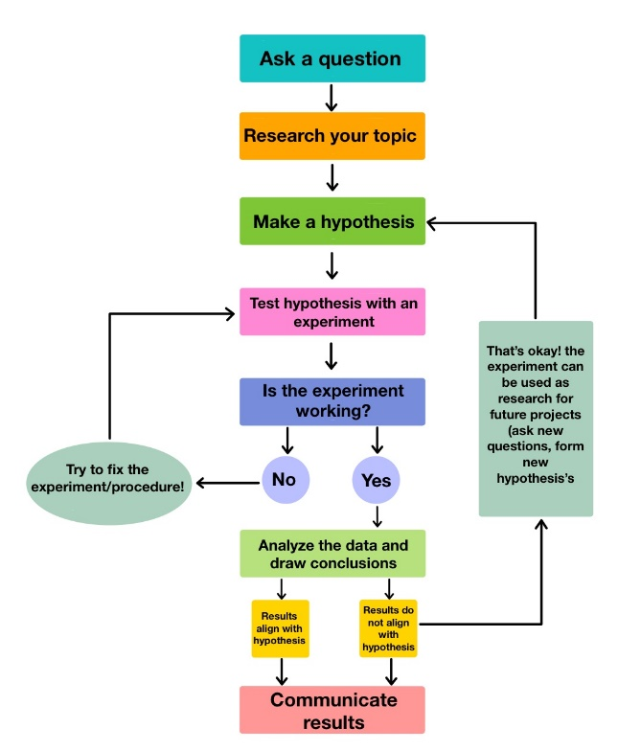
- Observation: Noticing and describing a natural phenomenon using senses or instruments.
- Formulation of Problem / Question: Defining the precise question arising from observation.
- Hypothesis: Formulating a sensible, tentative, testable explanation for the observed phenomenon.
- Experimentation: Performing controlled procedures to test the hypothesis.
  - Independent Variable: The parameter intentionally changed by the experimenter (e.g., temperature).
  - Dependent Variable: The parameter measured to observe the effect (e.g., rate of reaction).
  - Control Variable: Parameters kept strictly constant to ensure a fair test.
- Data Analysis & Conclusion: Interpreting results to either support or reject the hypothesis.
- Theory: A well-tested, broad scientific explanation supported by substantial experimental evidence (e.g., Kinetic Theory of Gases).
- Scientific Law / Principle: A concise statement describing an invariant physical relationship under specified conditions, often expressed mathematically (e.g., Boyle's Law: P₁V₁ = P₂V₂).

Worked Examples & Application Scenarios

Scenario 1: Applying the Scientific Method
Problem: A student observes that iron nails rust rapidly in Lagos (coastal region) but take much longer to rust in Maiduguri (arid region). Formulate a hypothesis and design a simple experiment to identify the cause.
Solution / Step-by-Step Breakdown:
- Step 1: Observation: Iron nails rust faster in Lagos than in Maiduguri.
- Step 2: Hypothesis: The higher moisture/humidity and salt content in coastal air accelerates the rusting of iron.
- Step 3: Experimental Variables:
  - Independent Variable: Presence of moisture and dissolved salts.
  - Dependent Variable: Rate of rust formation on nails.
  - Control Variables: Type and size of iron nails, ambient temperature, exposure duration.
- Step 4: Experimental Setup:
  - Tube A: Iron nail in dry air (silica gel present).
  - Tube B: Iron nail in boiled, distilled water (air excluded with an oil layer).
  - Tube C: Iron nail exposed to water and atmospheric air.
  - Tube D: Iron nail exposed to saltwater solution and air.
- Step 5: Deduction: Rust forms only when both oxygen and water are present, and saltwater significantly speeds up the process.

Scenario 2: Classification of Variables
Problem: An analyst tests how varying the concentration of hydrochloric acid (HCl) affects the volume of carbon dioxide (CO₂) gas evolved per minute when reacted with calcium carbonate (CaCO₃). Identify the independent, dependent, and control variables.
Solution:
- Independent Variable: Concentration of Hydrochloric Acid (HCl).
- Dependent Variable: Volume of CO₂ gas produced per minute.
- Control Variables: Mass and surface area of CaCO₃ chips, reaction temperature, total solution volume.

Scenario 3: Environmental Impact Identification
Problem: A factory discharges untreated nitrogen and phosphorus compounds into a nearby river. State the biological phenomenon that occurs and outline two consequences.
Solution:
- Phenomenon: Eutrophication (excessive nutrient enrichment of water bodies).
- Consequences:
  - Rapid growth of algal blooms, blocking sunlight from aquatic plants.
  - Depletion of dissolved oxygen during bacterial decomposition of dead algae, resulting in mass fish deaths.

Practice Question Bank (WAEC/NECO SSCE Standard)
- Define chemistry and state the three primary states of matter.
- Differentiate clearly between an independent variable and a dependent variable in a scientific experiment.
- List four major chemical industries in Nigeria and name one raw material used by each.
- Explain how eutrophication damages aquatic life.
- Identify the regulatory body in Nigeria responsible for:
a) Regulating and controlling drugs and processed foods.
b) Controlling and prosecuting illegal drug trafficking.
c) Enforcing environmental protection standards.
- Outline the main sequence of five steps in the scientific method.
- What is the key difference between a scientific theory and a scientific law?
- Name two applications of chemistry in the space exploration sector.
- Write the balanced chemical word expression representing the rusting of iron.
- State three personal habits that constitute drug abuse and list two societal consequences.

