|  |  |  |
| --- | --- | --- |
| NO | NAME | ID |
| 1. | **ABDULKERIM ARAGAW** | **BDU1200663** |
| 2. | **ASSEFA MIHRETU** | **BDU1200980** |
| 3. | **ASHENAFI HAILE** | **BDU1200993** |
| 4. | **ESTIBEL YIDEG** | **BDU1301882** |
| 5. | **FIRAOL TOLESSA** | **BDU1201719** |
| 6. | **KIDUS TADESSE** | **BDU1202155** |



**PROPOSAL ON**

**DESIGNING AN AUTOMATED WATER SUPPLY SYSTEM FOR GARDENING AT B.D.U**

**BAHIR DAR UNIVERSITY BAHIR DAR INSTITUTE OF TECHNOLOGY**

**FACULTY OF ELECTRICAL AND COMPUTER ENGINEERING**

**DEPARTMENT OF COMPUTER ENGINEERING**

Advisor : Siransesh Getu

Submission date: January 31, 2023

BahirDar, Ethiopia

# Declaration

We are students of Bahir Dar University at Bahir Dar Institute of technology (BIT), faculty of Electrical and Computer Engineering. The information found in this proposal project is our original work. And all sources of materials that will be used for the project work will be fully acknowledged.

Name Signature

1. ____________ ____________

2. ____________ ____________

3. ____________ ____________

4. ____________ ____________

5. ____________ ____________

6. ____________ ____________

January 31, 2023: This project proposal has been submitted for examination with our approval as a university advisor.

Project advisor Signature Date

__________ _________ __________

# Acknowledgment

Firstly thank God almighty for everything He has given and done for us.

Furthermore we would like to express our deepest gratitude to our Mentor/ Advisor Mrs. Siranesh G. for her unwavering dedication to help guide us in the stream of knowledge. Her persistence and caring character has helped us to dream big and achieve more. “Think big , start small and scale fast”. She has idealized this concept in us , to cross the horizon and be the solution providers rather than problem creators.

“What is a friend if not a single soul in two bodies”. To list all who have aided us in preparing and helping build this report , one page will not be enough. Its our friends , our class mates who gave us the necessary motivation and drive to achieve this milestone. We are forever indebted to them , ever tied to them , by the cord of family hood.

# Abstract

It has become a necessity to include well designed gardens in the work environments and educational facilities as they boost motivation, reduce stress and also for the mere fact that they feast our eyes and minds. To design such gardens is one thing but to efficiently maintain their state is another matter. This is where many companies and institutions lack their focus on. Due to lack of effective and automated water supply and management system water wastage and tiresome work labor to maintain gardens have become evident.

The use of automated system is key in tackling the hurdles faced in gardening as the task of garden keeping ought not to be so tiresome and time demanding. Using systems which can detect the need of water and can supply the right supply of water to the exact place with little human involvement is the primary advantage of such technologies. Through this technologies garden keeping will not demand huge amount of effort and labor power.

It is also without a doubt that technology is key in developing a country. Exposing students to such technological advancements is nonetheless important. The system we proposed not only helps the University body, B.D.U, manage water efficiently but helps students be exposed to technological developments and part take in solution findings through cooperation and creativity . It is our ambition and drive that through the right display of technological tools and their applications in the campus environment students will be motivated to risk more , take on great challenges and achieve great things.

In this research we have outlined the structure and layout of what we think is the appropriate setup for gardening in the test environment. Since in this modern age , technology is advancing by the minute we hope that this research will be an input to further development of gardening scheme technologies with the goal of scalability, integration and automation in mind

.

**Table of contents**

Contents

Declaration I

Acknowledgment II

Abstract III

Abbreviations 1

Introduction/Background 2

Literature Review 4

Statement of the Problem 6

Objective/Aim of the study 6

Main objective 6

Specific objective 6

Research Methods and Procedures 7

Modeling the Control Unit 7

List of components 8

Function of components and working mechanism 8

Modeling and selecting sprinkler layout around Gion-garden 10

List of component needed 12

Working principle 12

Power supply unit 12

Exposing technology to students 13

Methodology 13

Result 13

Result Analysis 14

Scope 15

Significance of the Study 15

Work Plan 16

Budget 17

References 18

# Abbreviations

B.D.U – Bahirdar University

I/O -Input Output

P.V.C -Polyvinyl chloride

# Introduction/Background

Gardens are a safe house. They are a means of recollecting oneself and have proven they are effective in the line of healthcare and workplace environment in reducing stress and boosting creativity. An extract of a study on the effect on garden in workspace highlights that studies in landscape architecture, health, and horticulture disciplines have produced evidence that gardens in the workplace and even indoor plants and views of green space can help to reduce stress [2].

As such many organizations such as Bahirdar university, have incorporated these ideology in their landscape design to help boost creativity and to create an open and inviting environment. But the use of technological solutions have been neglected in the field of gardening at B.D.U. The means of supplying and managing water has long been done through manual labor which though is tiresome, has yielded outcomes, through the dedication of the workers. But a lack of technology in garden keeping has restrained the outcome of what it could be. The use of technological solutions such as sprinkler technologies and control unit models can in our belief give way to an easier and efficient management of water and gardening actives.

Water is a vital resource which needs to be dealt with care. As a university body ,Bahirdar university poly campus, consumes a lot of water for different activities where one of them is gardening. Therefore an efficient system needs to be in place for managing water resources as the neglect of these will result in a major water wastage.

Currently to manage water for gardening the university has employed many staff whom use plastic hoses , where some of the lines has been cut due to wear and tear . They have to put effort when they want to transport the hose from on part of the campus to other, especially from the faculty of Electrical and Computer Engineering to Digital Library. These transportation as we addressed earlier will wear and tear the hose and will give way to water leakage where often plastic or rubber is used to insulate it which is ,in most cases, inefficient. Also to scale the current watering system will require a huge workforce and network of hoses which have to be maintained consistently due to the factor addressed.

The use of sprinkler technology and controlling unit is an effective means for supplying and managing water resource. The utilization of a low pressure sprinklers is key as the supply for high pressure water piping is not currently available. As stated in [1] the use of low pressure sprinkler technologies in supplying precision water is invaluable. Incorporating this technology together with control units such as arduino as demonstrated by [2] or by using microcontroller as demonstrated by [3] is an effective solution.

The other crucial part of our research implores the effect of showcasing students new technologies in action and the implication it has on their creativity and motivation in study. In campuses the effect of campus environment on students motivation has been a key consideration in the design of campuses. Exposing students to innovative outlooks through display of innovative technologies is key in motivating students to create , innovate and explore new things . Vinny Stephanie [4], have stated that , “Campus environment affects the students Learning Motivation. Universities can continuously improve the campus environment, so that the comfort of students in their activities will increase.”

# Literature Review

Water is vital especially in regions prone to drought and which are mostly rain fed. Giving the proper amount of water exactly at the desired place is key for effective yield and the minimization of water consumption .The main technologies utilizing water management schemes are of those in the irrigation sector and there have been many developments. We can apply similar schemes for our gardening research on a small scale by adopting such technologies.

Many advancements in sprinkler technologies as well as electronic control units have allowed sectors such as agriculture to benefit from the fruits of its innovation. It has been demonstrated by Abhishek Gupta [3]by the use of a PIC microcontroller , timer circuit , a 4x4 keypad , LCD screen , relay circuit and a custom made soil moisture sensor that they can achieve in building an automatic plant watering system. The use of microcontroller with an interfacing device such as a keypad for setting time of watering is an essential design system of this research. Relays are used to carry out electrical command signals to mechanical outputs, in here by shutting of the pump. Though the significance of the study is key this research lacks in showing how to effectively distribute the water to the field but still highlights water effect on plants.

Controller devices such as arduino and copper plated moisture sensors are utilized in projects done by Ipin Prasojo [2]. They have tested and analyzed different soil conditions to get a threshold value for moisture sensitivity. Other researchers such as Prema Kannan [5], have made use the concept of fuzzy logic and teleportation to sense moisture and make controls automatically.

The sprinkling technology which is nonetheless vital in the design of a gardening system have seen many advancements for the better. Sprinklers uses mechanical and hydraulic devices to apply irrigation water to the soil surface. As highlighted by the study of Hong Li [1] the use of low pressure sprinklers have come to dominate but the cost of installing them is ever increasing with the demand of them rising.

Though sprinklers are great crops remains wet after watering without a control unit integrated, thus increasing incidence of pests or diseases. Another challenge in sprinkler systems is how to avoid runoff. A properly designed sprinkler irrigation has higher application efficiency that can avoid runoff.

Therefore buying technologies that are cheap and are currently under our disposal such as microcontrollers , relays and sprinkler technologies we can help manage water management in gardening sector.

# Statement of the Problem

Bahirdar University in total has 8 campuses to which Poly is one of them. Poly campus seats at the heart of Bahirdar and is a beacon of engineering mind-sets and solutions. The campus has a vast amount of land allocated to it through which the majority is covered in greenery landscape designs. As such the proper caring of this greenery plants and vegetation plays an integral role in the development of a caring and hospitable environment. The method that is currently being used to water the plants and vegetation is a tiresome and time consuming task. Gardeners use a hose to water them and in many occasions the hoses they use will tear and leak due to the fact that transportation of these long hoses in the campus roads is difficult and will in most cases ware and tear them. We plan to design an automated watering system which will incorporate the already existing piping and will possess a control station together with a water dispersing station which will help manage water resource.

# Objective/Aim of the study

## Main objective

* Designing an automated water supply system for gardening at B.D.U

## Specific objective

* Designing a control unit for the distribution of water
* Selecting an effective water dispersing unit
* Designing the layout of the system for the test environment
  + The test environment will be the green area found in front of Gion building

# Research Methods and Procedures

## Modeling the Control Unit

The control unit is the hub and brains of the operation in our design which does the task of analyzing the set time of watering duration and gives proper instructional commands to the relay unit which controls the solenoid to cut off or supply the flow of water in the sprinklers. We have incorporated different components that are readily accessible and are scalable by nature for future implementation in mind.. 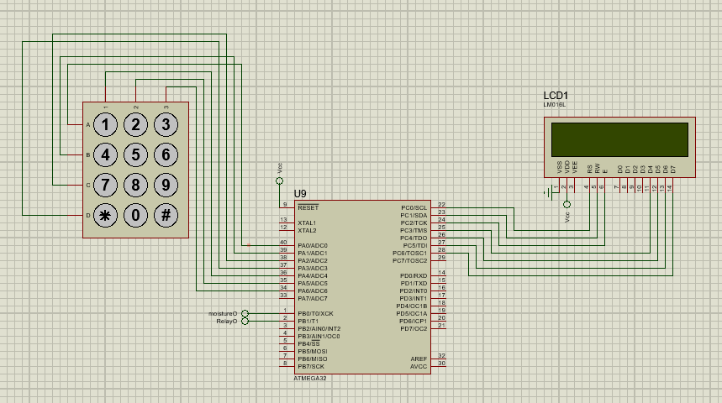

Time set

Figure Atmega32 connected to keypad and LCD screen to interface with user

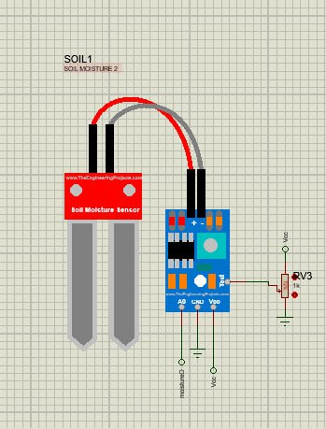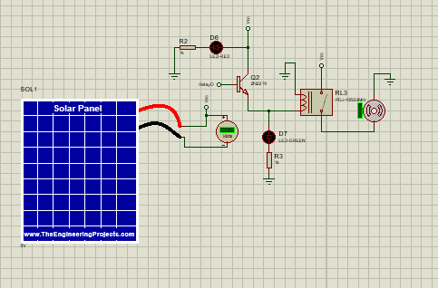

Figure 3 Soil moisture sensor with signal conditioning circuit

Figure Power source and water control valve circuit

### List of components

|  |  |  |
| --- | --- | --- |
|  |  |  |
| Component | Quantity | Specification |
| Atmega-32 microcontroller | 1 | 8-bit AVR Microcontroller with 32K Bytes In-System Programmable Flash |
| Soil Moisture Sensor | 1 | YL-69 hygrometer |
| Keypad touch (4x4) | 1 | A four by four keypad |
| Relay-Normally open | 1 |  |
| Solenoid | 2 | A normally closed valve |
| Resistor (Ω) | 5 |  |
| `LED | 2 |  |

### Function of components and working mechanism

#### Working principle

The value set from the keypad and that are store in register A are accessed by the microcontroller to deduce the time that has been sent and will essentially act as a timer circuit. It will set the default on time of the system to the one set by this input. The value read through register B is quite essential as it is hooked up to the moisture sensor which in a sense gives the controller a sensory input through which it will act We program the microcontroller using atmel studio. The simple logics here are :

If(

Keypad == Active){

Input1 = read();

Input2 = read();

start_time = input1;

end_time = input2;

}

If (

soil_moisture_reading > threshold AND

(current_time >= start_time AND

current_time <=end_time)){

Relay = LOW;

}

(**Pseudocode**)

#### Atmega-32 microcontroller

This is the brain of the control unit. Receives input from the soil moisture sensor as well as the 4x4 key pad to set the time of operation of the sprinklers. The controller comes with the feature of being programmable through avr‑isp programmer module to tweak and adjust the reading and threshold of operation. The microcontroller comes with 4 by 8 pin blocks where it can sense input and give out output. This gives us more I/O ports for connecting different devices.

In our case we have used the:

* DDRA as an input from the keypad
* DDRB as an input from the soil moisture sensors analog output
* DDRB also as an output to the relay
* DDRC as an output to LCD Screen

#### Soil moisture sensor

This incorporates both a sensing element(probe) and a signal conditioning circuit with both analog and digital output. We chose this sensor because of its design and the variety in choice of the outputs . It supplies both analog and digital output which can both be fed to the analog inputs of the microcontroller.

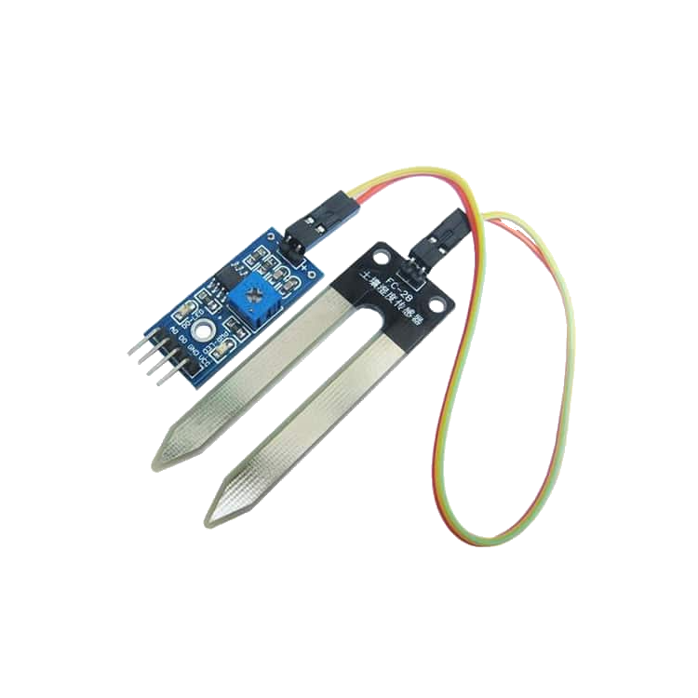

Figure 4 techzeero.com/sensors-modules/soil-moisture-sensor/

#### Keypad and solenoid valve

In the means of interconnecting the physical world to the digital and vice versa components such as input devices and actuators play a vital role. We have used a 4x4 keypad which interfaces with the microcontroller to give information regarding the start time and end time of the watering period. We will use a multiplexed interfacing model with the atmega-32 because attaching all the key outputs will require 16 independent inputs which will take a lot of the I/O pins of the microcontroller.

To control the water flow we have decided to use a solenoid valve which has a huge application in the world of water management. When the microcontroller signals an output the relay will close and the solenoid will open letting water through to the sprinklers.

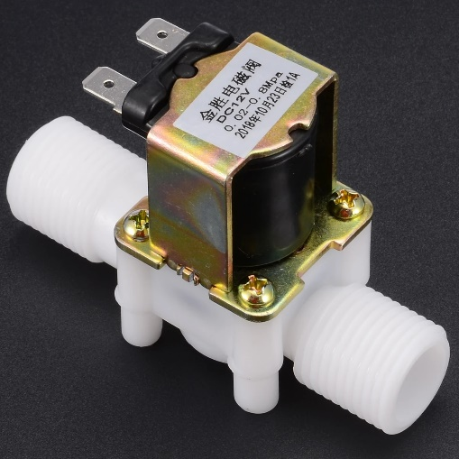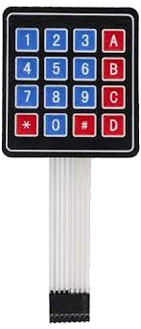

Figure www.aliexpress.com

Figure wiki.sunfounder.cc

## Modeling and selecting sprinkler layout around Gion-garden

Inorder to design the layout of the sprinkler system we used a google map photo of the garden we are about to implement the technology on , figure 4, and we used an online free website called gardena to model the sprinkle technology to get the feel of what sprinkler to use , currently t380 and t200, and the water dispertion rate and area, figure 5.

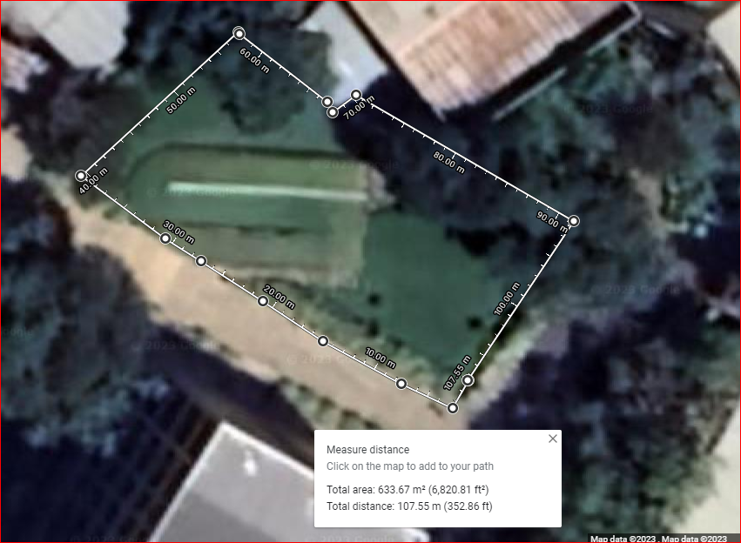

Figure 7 Google Map of the gion Garden

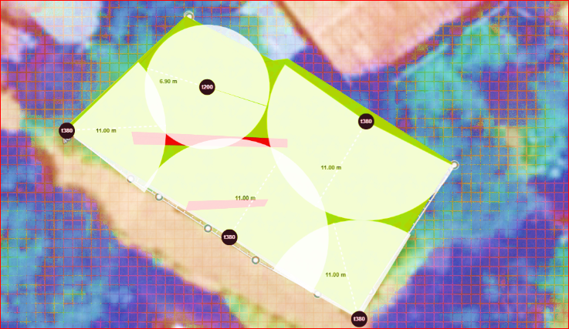

22m

18m

6m

6m

6m

6m

C.U

Figure 8 Sprinkler setup design using Gardena

We have used

* (4x) t380 with 11 meter range
* (1x) t200 with 6 meter range

### List of component needed

|  |  |  |
| --- | --- | --- |
|  |  |  |
| Component | Quantity | Description |
| T380 | 4 | A sprinkler which is implanted in the ground with 11meter range |
| T200 | 1 | A sprinkler which is implanted in the ground with 6 meter range |
| P.V.C 25 mm | 96 m | A 25 mm connecting P.V.C pipe spanning the field |
| MDPE 25mm | 2 | MDPE Pipe Elbow Compression Fittings |
| PVC Connector 25mm | 3 | 3 Way Elbow connector |

### Working principle

The sprinklers are all connected together through a 25 mm P.V.C piping which all connect the central hub the Control unit. Each sprinkler is fitted with a 3 way elbow connector to allow series connection and the sprinkle at the end points are connected to a curved elbow fitting. All the water supply is controlled by the control unit by solenoids that are present on both side of the control unit , marked in a black rectangle.

## Power supply unit

The main objective here is to design an automated gardening system. As we are designing the system for a technology university we thought that technological solutions should be applied in every aspect including the power supply. We have chosen a solar panel together with a battery as the main energy source .we can use the Omnivoltaic M600, which is supplied by RYNSYS Engineering, as the source for our control unit because our control unit components doesn’t require higher voltage specifications.

## Exposing technology to students

We have organized a survey about the relevance of showcasing technological innovation around the campus and the effect it has on the creativity mindset. As the result shows most of the students have responded in it having a great impact in how they see things as well us opening new horizons to them .Most students have recalled the innovation implemented during the corona period , hand washing system, and have said that displaying innovation such as this helps us grasp what we already know and transform it to an everlasting knowledge.

### Methodology

We conducted a survey on whether technological solution that are integrated in the campus environments will help students become more creative. We organized a questionnaire and organized a random sampling. Our sample include :

* Students from Bahirdar university B.I.T
* Students from Bahirdar university Peda campus
* Our family members and relatives

### Result

Figure 9 Results of survey conducted in regards to questionnaire organized, Jan,25, 2023

### Result Analysis

From the data we got it shows that more students and concerned bodies were in favor of seeing technological solutions being integrated in the campus environment as it boosts creativity and helps students become exposed to new outlooks and findings.

We have observed that 32.5% of the participants didn’t want these innovations set in the campus environment as they will hinder the development of new technologies. It is the exposure to harsh conditions that makes students become more active and find out new things.

In conclusion we found the data from the sample to represent what we also believe in. It is through exposure to technological innovation that students get to know how their specific academic disciplines apply in the real world. It is also necessary that programs be organized ,like Agri-hackatons , to give students problem sets and real challenged they can tackle with the innovative minds they posses.

# Scope

The coverage of this study includes the design of the layout of the physical system together with the control and water dispensing unit design. This study also includes the effect of an innovative environment (workplace) on students creativity. The study however does not cover the implementation and prototype build due to the limited time we have.

# Significance of the Study

In this research we hope to outline the need for a technological integration in the campus environment. In this we hope we will motivate others to create and innovate new solutions. Our system which is going to be applicable in the B.D.U poly campus environment will help give relief to workers currently undertaking gardening duties and help alleviate the tiresome works they currently endure. This system will also demonstrate to students the applicability of technological innovation in solving real world problem.

It is without a doubt that the university is the prime beneficiary from this system as it helps save money by cutting costs related to unmanaged water and help boost in creating an innovative environment which is highly desired in higher learning institutions.

# Work Plan

|  |  |  |  |  |  |  |  |  |  |  |
| --- | --- | --- | --- | --- | --- | --- | --- | --- | --- | --- |
| No | Action | Week 1 | Week 2 | Week 3 | Week 4 | Week 5 | Week 6 | Week 7 | Week 8 | Week 9 |
| 1. | Collection of soil samples for setting sensor threshold |  |  |  |  |  |  |  |  |  |
| 2. | Setting up the circuit and testing in the field |  |  |  |  |  |  |  |  |  |
| 3. | Conducting talks with the plumbing department |  |  |  |  |  |  |  |  |  |
| 4. | Running P.V.C tubing for the selected sprinklers |  |  |  |  |  |  |  |  |  |
| 5. | Installing the sprinkler heads |  |  |  |  |  |  |  |  |  |

# Budget

|  |  |  |  |  |
| --- | --- | --- | --- | --- |
| N | Item | Quantity | Unit cost  (E.T.B) | Total cost |
| 1. | T380 | 4 | 3200 | 12,800 |
| 2. | T200 | 1 | 2800 | 2,800 |
| 3. | PVC 25mm | 96 meter | 150 | 14,400 |
| 4. | MDPE 25mm | 2 | 300 | 600 |
| 5. | PVC three way connector | 3 | 400 | 1200 |
| 4. | Omnivoltaic M600 | 1 | 12,000 | 12,000 |
| 6. | Atmega-32 | 1 | 270 | 270 |
| 7. | Soil moisture sensor (YL-69) | 1 | 200 | 200 |
| 8. | Keypad(4*4) | 1 | 250 | 250 |
| 9. | Relay | 1 | 200 | 200 |
| 10. | Solenoid | 1 | 950 | 950 |
| 11. | 2n2222 Transistor | 1 | 30 | 30 |
| Total cost | | | | 45,700 |

# References

[1] Hong Li , Zakaria Issaka , Yue Jiang , Pan Tang and Chao Chen ,” Overview of emerging technologies in sprinkler irrigation to optimize crop production”, Department of Agricultural Engineering, Tamale Technical University, Northern Region, Tamale, Ghana ,2019

[2] 1Ipin Prasojo, 2Andino Maseleno, 3Omar tanane and 4Nishith Shahu,” Design of Automatic Watering System Based on Arduino”, 1Sarjana Terapan Elektromedik, ITS PKU Muhammadiyah Surakarta, Indonesia,2Institute of Informatics and Computing Energy, Universiti Tenaga Nasional, Malaysia. 3Faculty of Sciences Ben M'sik, University Hassan II of Casablanca, Casablanca, Morocco 4Department of Electrical Engineering, Gujarat Technological University, India,2020

[3] Abhishek Gupta , Shailesh Kumawat and Shubham Garg,” Automatic Plant Watering System”, Department of Electrical Engineering, SKIT Jaipur, India,2016

[4] Vinny Stephanie Hidayat , Debbianita , Nyoman Agus Wijaya , and Sherin Ivana Dewi,” The Effect of Campus Environment towards the Learning Motivation”, Maranatha Christian University,2021

[5] Prema Kannan, Senthil Kumar Natarajan and Subhransu Sekhar Dash,” Design and Implementation of Fuzzy Logic Controller for Online Computer Controlled Steering System for Navigation of a Teleoperated Agricultural Vehicle”, Department of Electronics and Instrumentation Engineering, SRM University, Mepco Schlenk Engineering College, SRM University, India,2013

[6] 1Helena Chance, 2Daniel Winterbottom , 1Jonathan Bell and Amy Wagenfeld, 1Buckinghamshire New University, UK 2University of Washington, USA 3Rush University, USA,2015