Renewable Energy Project Update
Sample business report for taxonomy practice
Date: 24 October 2026

Project overview
The Green Horizon team is installing rooftop solar panels at three office locations. The first site is complete, and the remaining installations are planned for the next quarter.

Progress and milestones
Site A has 120 panels installed. Site B is completing its electrical inspection. Site C is waiting for delivery of mounting equipment.

Key observations
The project is on schedule overall. The team identified a need for clearer delivery tracking and more frequent safety briefings.

Recommended actions
- Confirm delivery dates with the supplier.
- Complete the Site B electrical inspection.
- Hold a safety briefing before work begins at Site C.

Installation status
Site | Panels planned | Status | Target date
Site A | 120 | Complete | September
Site B | 150 | Inspection | November
Site C | 100 | Equipment pending | December

Panels planned by site
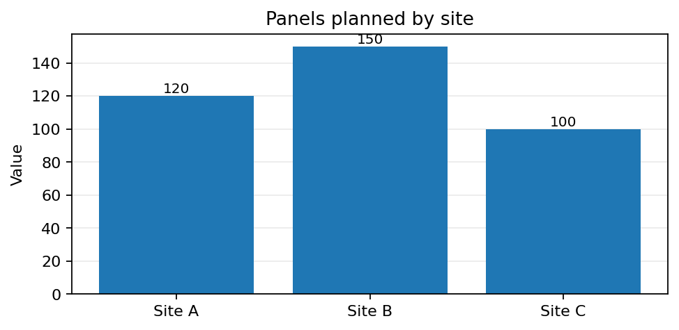

Illustrative visual: a simple solar-panel layout

Note: All figures and project details in this file are fictional and provided for sample taxonomy practice.

Taxonomy included in this file
This table follows the six-column structure in the supplied taxonomy sample: ID, TYPE, SUB-TYPE, SOURCE, LOCATION, and ITEM.
ID | TYPE | SUB-TYPE | SOURCE | LOCATION | ITEM
1 | text content | main heading | doc file | page 1 | Renewable Energy Project Update
2 | text content | headings | doc file | throughout document | Section headings such as Project overview
3 | text content | body | doc file | main content pages | The Green Horizon team is installing rooftop solar panels at three office locations. The first site is co...
4 | list | bullet list | doc file | action points section | Confirm delivery dates with the supplier.; Complete the Site B electrical inspection.
5 | visual content | bar graph | doc file | chart section | Panels planned by site
6 | table content | rows and columns | doc file | data table section | Installation status (3 data rows)
7 | visual content | image | doc file | illustration section | SOLAR ARRAY / SITE PLAN

