Community Water Conservation Report
Sample community project report for taxonomy practice
Date: 24 October 2026

Background
The Riverside community centre has started a water-saving programme. The programme focuses on reducing leaks, improving awareness, and tracking monthly water use.

Activities completed
Maintenance staff repaired four leaking taps. Volunteers delivered two short awareness sessions and placed reminder signs near wash areas.

Results and next steps
The centre will compare water meter readings over the next three months. A monthly inspection checklist will help the team identify new leaks early.

Recommended actions
- Record the meter reading at the start of each month.
- Inspect taps and flush systems every Friday.
- Share water-saving tips in the community newsletter.

Water-saving action tracker
Action | Owner | Frequency | Status
Check taps | Maintenance team | Weekly | In progress
Record meter | Centre manager | Monthly | Started
Awareness session | Volunteer group | Quarterly | Planned

Water use index by month
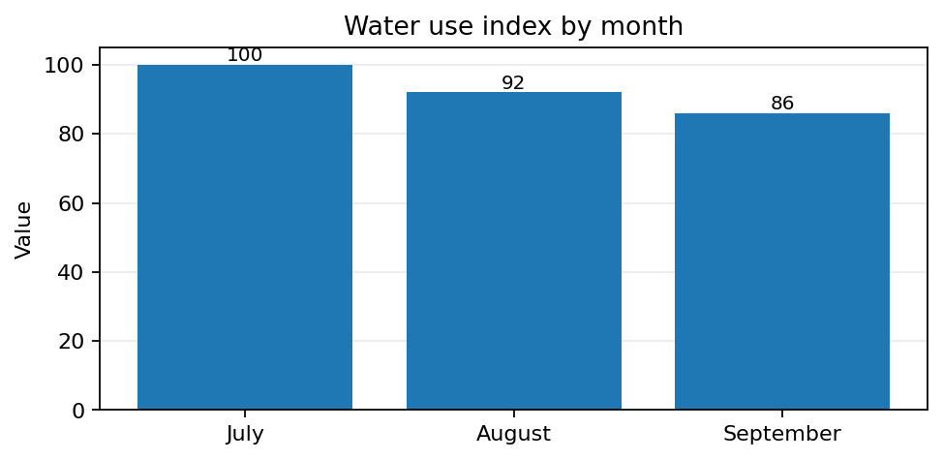

Illustrative visual: a water conservation reminder card

Note: All figures and project details in this file are fictional and provided for sample taxonomy practice.

Taxonomy included in this file
This table follows the six-column structure in the supplied taxonomy sample: ID, TYPE, SUB-TYPE, SOURCE, LOCATION, and ITEM.
ID | TYPE | SUB-TYPE | SOURCE | LOCATION | ITEM
1 | text content | main heading | doc file | page 1 | Community Water Conservation Report
2 | text content | headings | doc file | throughout document | Section headings such as Background
3 | text content | body | doc file | main content pages | The Riverside community centre has started a water-saving programme. The programme focuses on reducing le...
4 | list | bullet list | doc file | action points section | Record the meter reading at the start of each month.; Inspect taps and flush systems every Friday.
5 | visual content | bar graph | doc file | chart section | Water use index by month
6 | table content | rows and columns | doc file | data table section | Water-saving action tracker (3 data rows)
7 | visual content | image | doc file | illustration section | SAVE WATER / CHECK FOR LEAKS

