**PROJECT-2**

**DEPLOY WORDPRESS MANUALLY IN AWS**

**1**. Create an IAM user

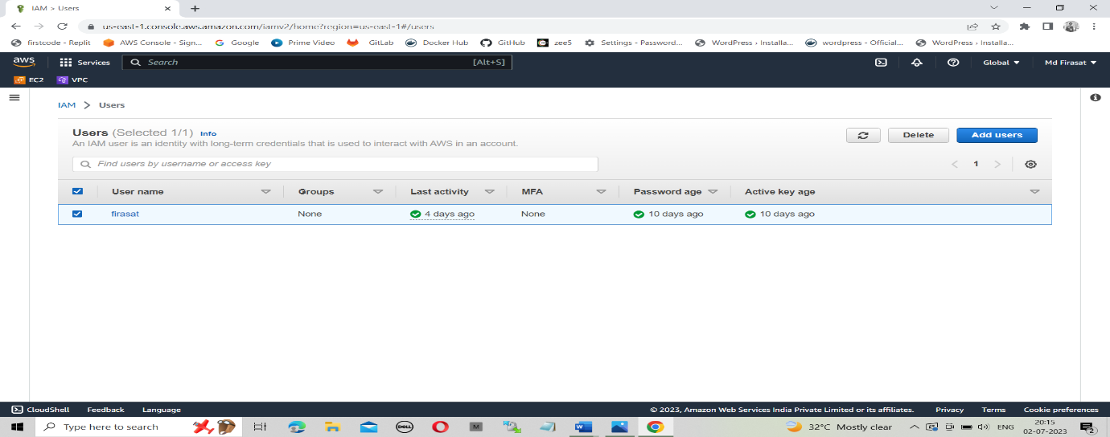

**2**. Create a custom vpc. Create an internet gateway and attach it to vpc.

create Public and private subnets, public route table, and private route table. Attach subnets to route tables.

Create a Nat gateway and attach it to a private route table to allow internet access to private instance.

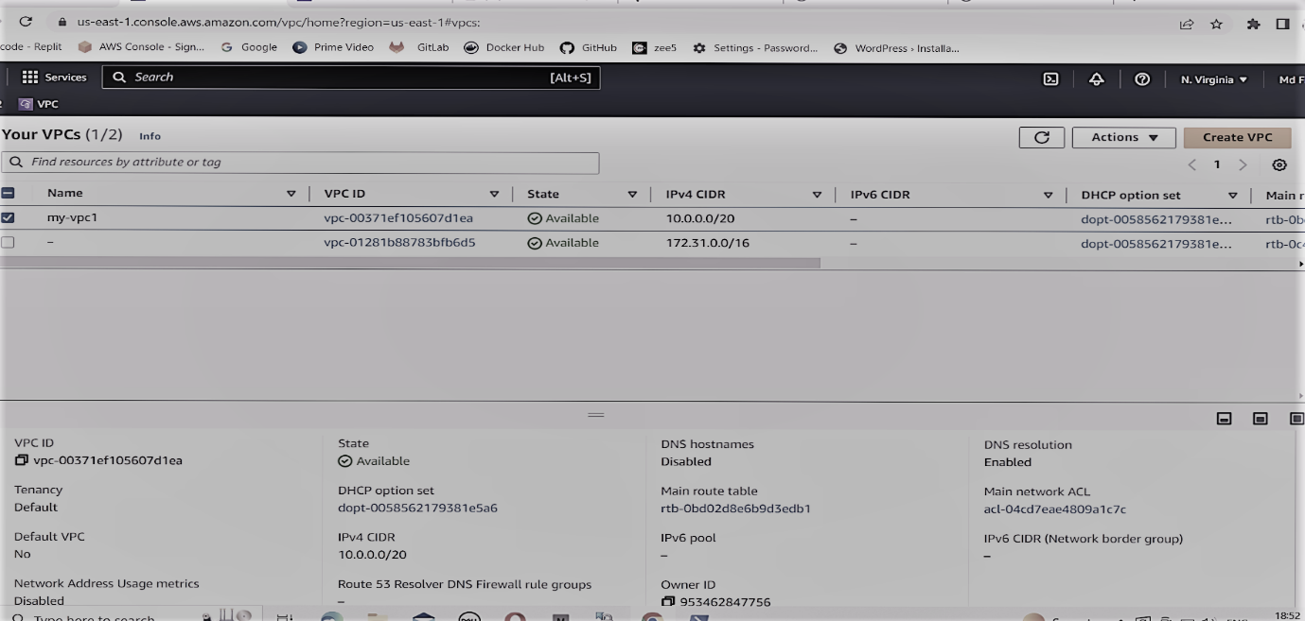

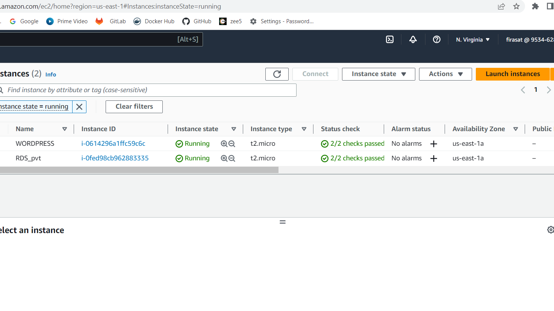

**3**. Connect to public instance.

Connect private instance with public instance by copying pem file into public instance.

Command: scp -i .\mykey. pem .\mykey.pem ec2-user@public Ip:~

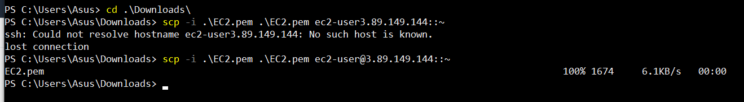

**4**. Create MySQL database in AWS console by providing required configuration.

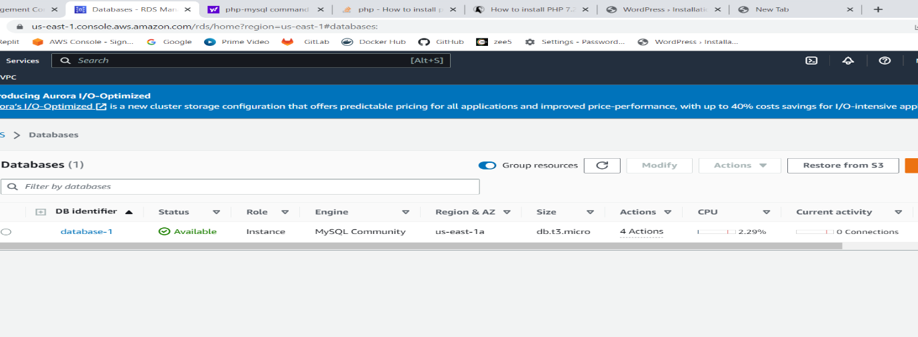

**5**.Install MySQL in a private instance and connect MySQL with database which is created in AWS.

Command to connect MySQL with database: mysql -h endpoint if db -u username -p

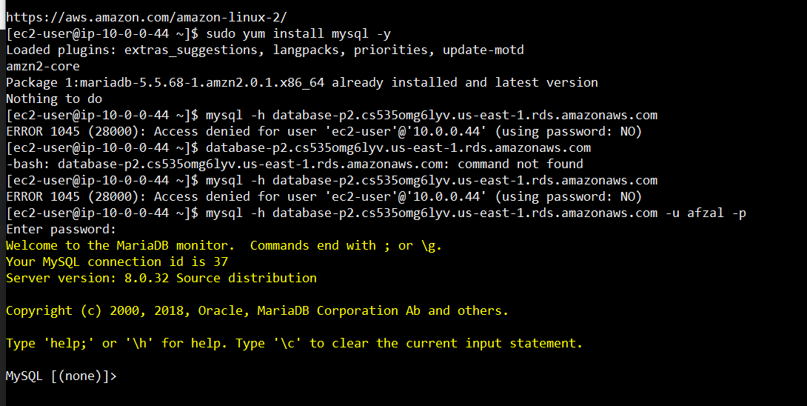

**6**.Create a new SQL user with below command.

Command: CREATE USER 'username' IDENTIFIED BY 'PASSWORD' (give username and password)

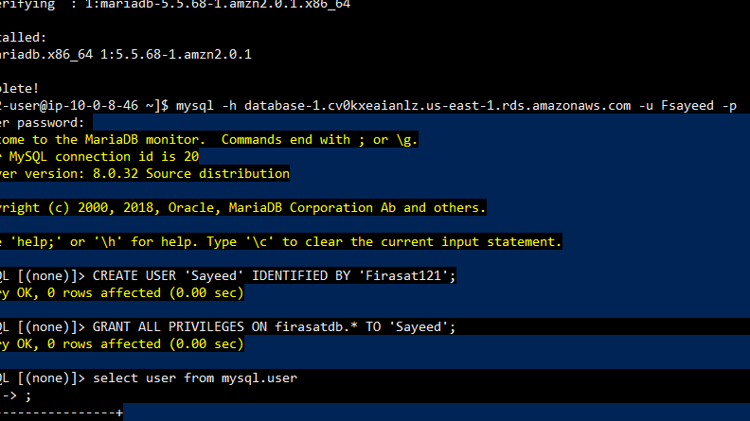

**7**. Grant all privileges to newly created MySQL user.

Command: GRANT ALL PRIVILEGES ON database_name. * TO 'database_user' ;

**8**. Check MYSQL user by executing command “SELECT user FROM mysql.user

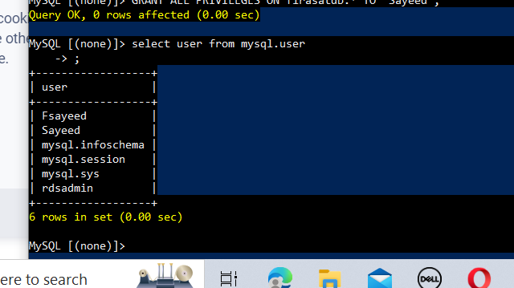

**9**. Exit from MYSQL and private instance.

**10**. Install wordpress in public instance.

Command: sudo wget <https://wordpress.org/latest.tar.gz>

After installing wordpress a zip file will be downloaded with name latest.zip

Unzip file by executing command “unzip latest.zip

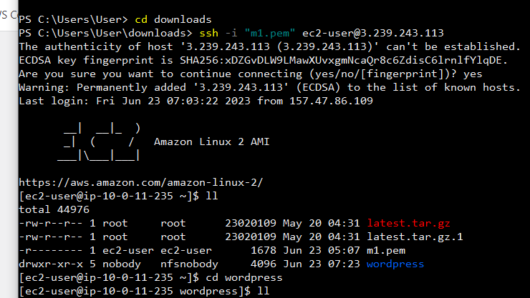

**11**. Copy wp-config-sample.php file with name wp-config.php

Command: cp wp-config-sample.php wp-config.php

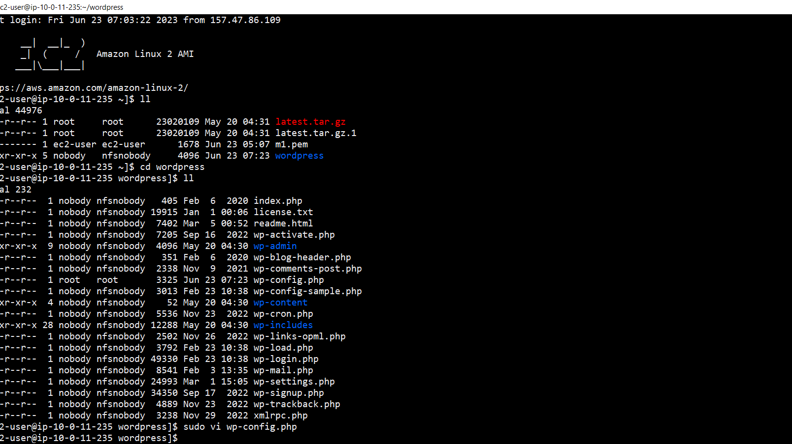

**12**. Add keys and Database configurations in wp-config.php file by executing vi command.

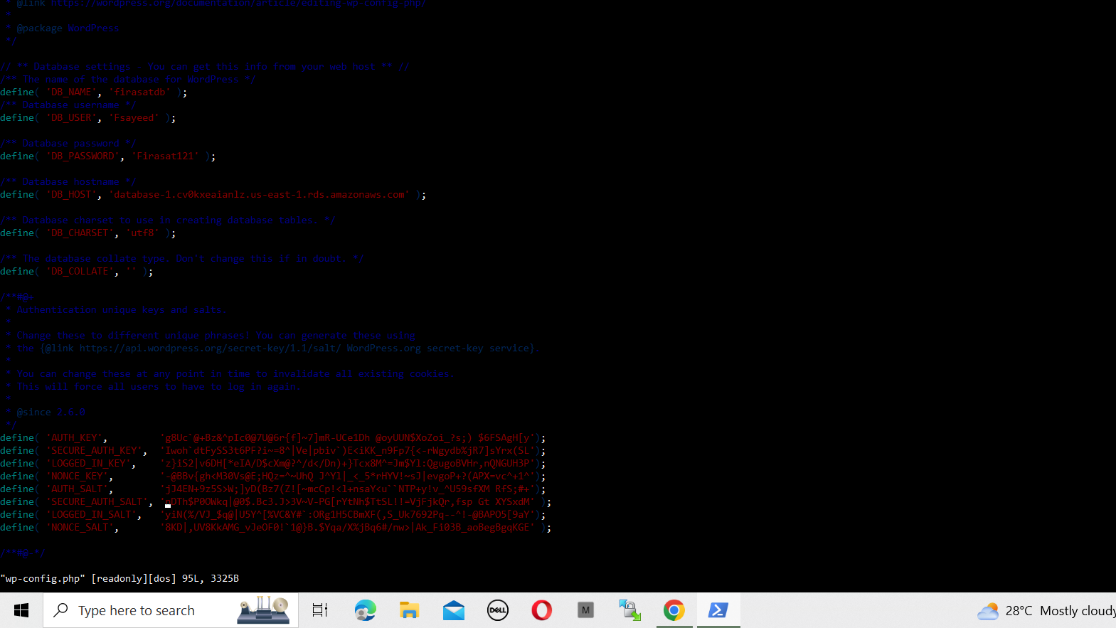

**13:** Install mysql in public instance

Command: sudo yum install mysql -y

**14:** Install php and php-mysql in public instance.

Command: sudo amazon-linux-extras install -y lamp-mariadb10.2-php7.2 php7.2

* Sudo yum install php-mysql -y

**15:** Install httpd in public instance.

Command: sudo yum install httpd -y

* Sudo systemctl start httpd
* Sudo systemctl enable httpd

**16:** Copy all wordpress file in httpd default directory.

Restart httpd server by executing sudo systemctl restart httpd.

**17:** Browse with public ip of public instance to see wordpress page.

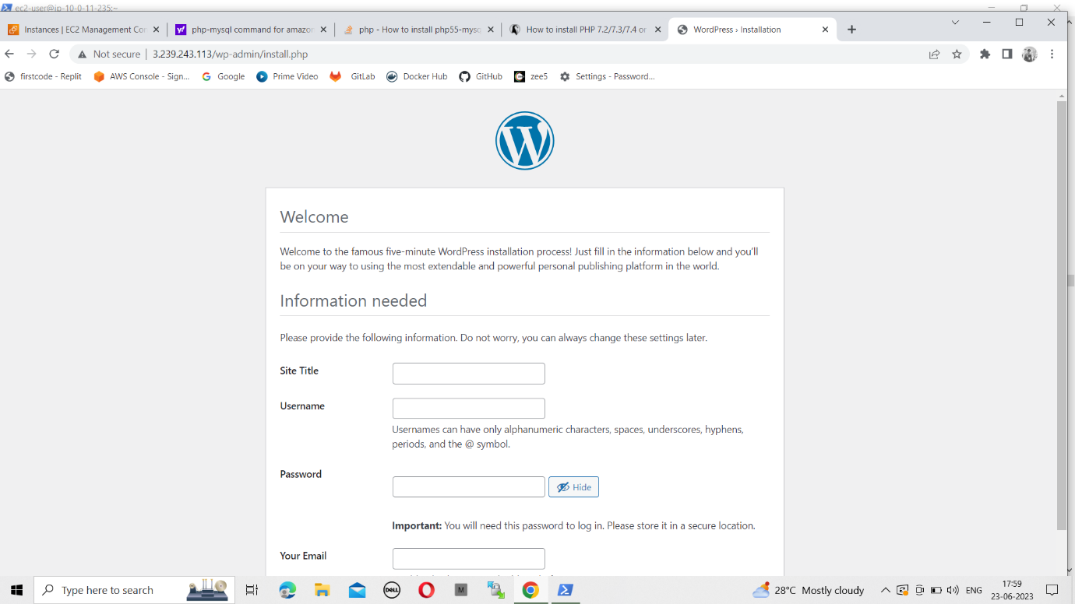

**DEPLOYMENT OF WORDPRESS WITH DOCKER-COMPOSE**

**What is Docker?**

* Docker is a containerization tool.
* Docker is a set of platform as a service product that uses OS-level virtualization to deliver software in packages called “Container”.
* Docker is used for developing, shipping, and running application. Docker will take care of dependency to run an application.

**What is Docker-Compose?**

Docker-Compose is a tool that is used to manage multi-container based applications. By using docker-compose we can deploy multi-container-based applications.

**Step-1:** Launch an EC2 Instance and connect to the Instance.

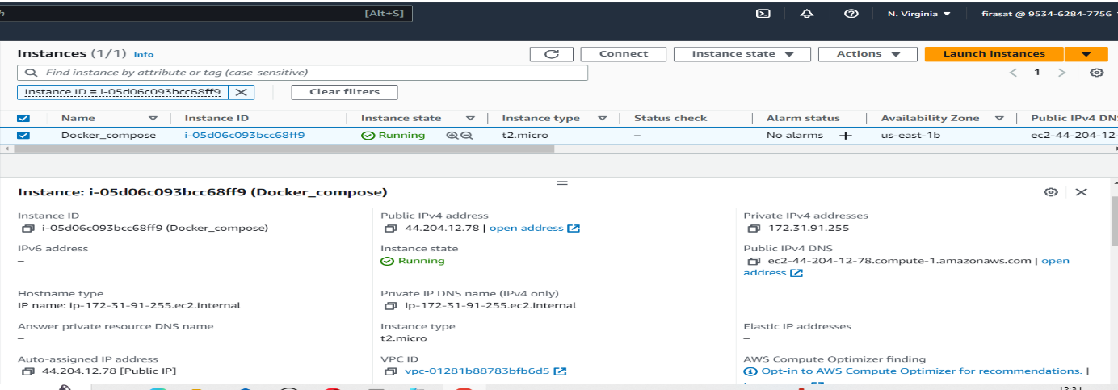

**Step -2:** Install the Docker server in the instance.

Command: sudo yum install docker -y.

**Step -4:** Start the docker service.

Command: sudo service docker start

**Step -5:** Add the user to the docker group by executing the below command.

Command: sudo usermod -aG docker ec2-user

**Step -6:** Install Docker-compose in the instance.

Command: sudo curl -L https://github.com/docker/compose/releases/download/1.22.0/docker-compose-$(uname -s)-$(uname -m) -o /usr/local/bin/docker-compose

* After installing Docker-compose add permission.

Command: sudo chmod +x /usr/local/bin/docker-compose

**Step -7:** Create one directory with the mkdir command and create one yaml file with .yaml extension (docker-compose. yaml) inside the directory.

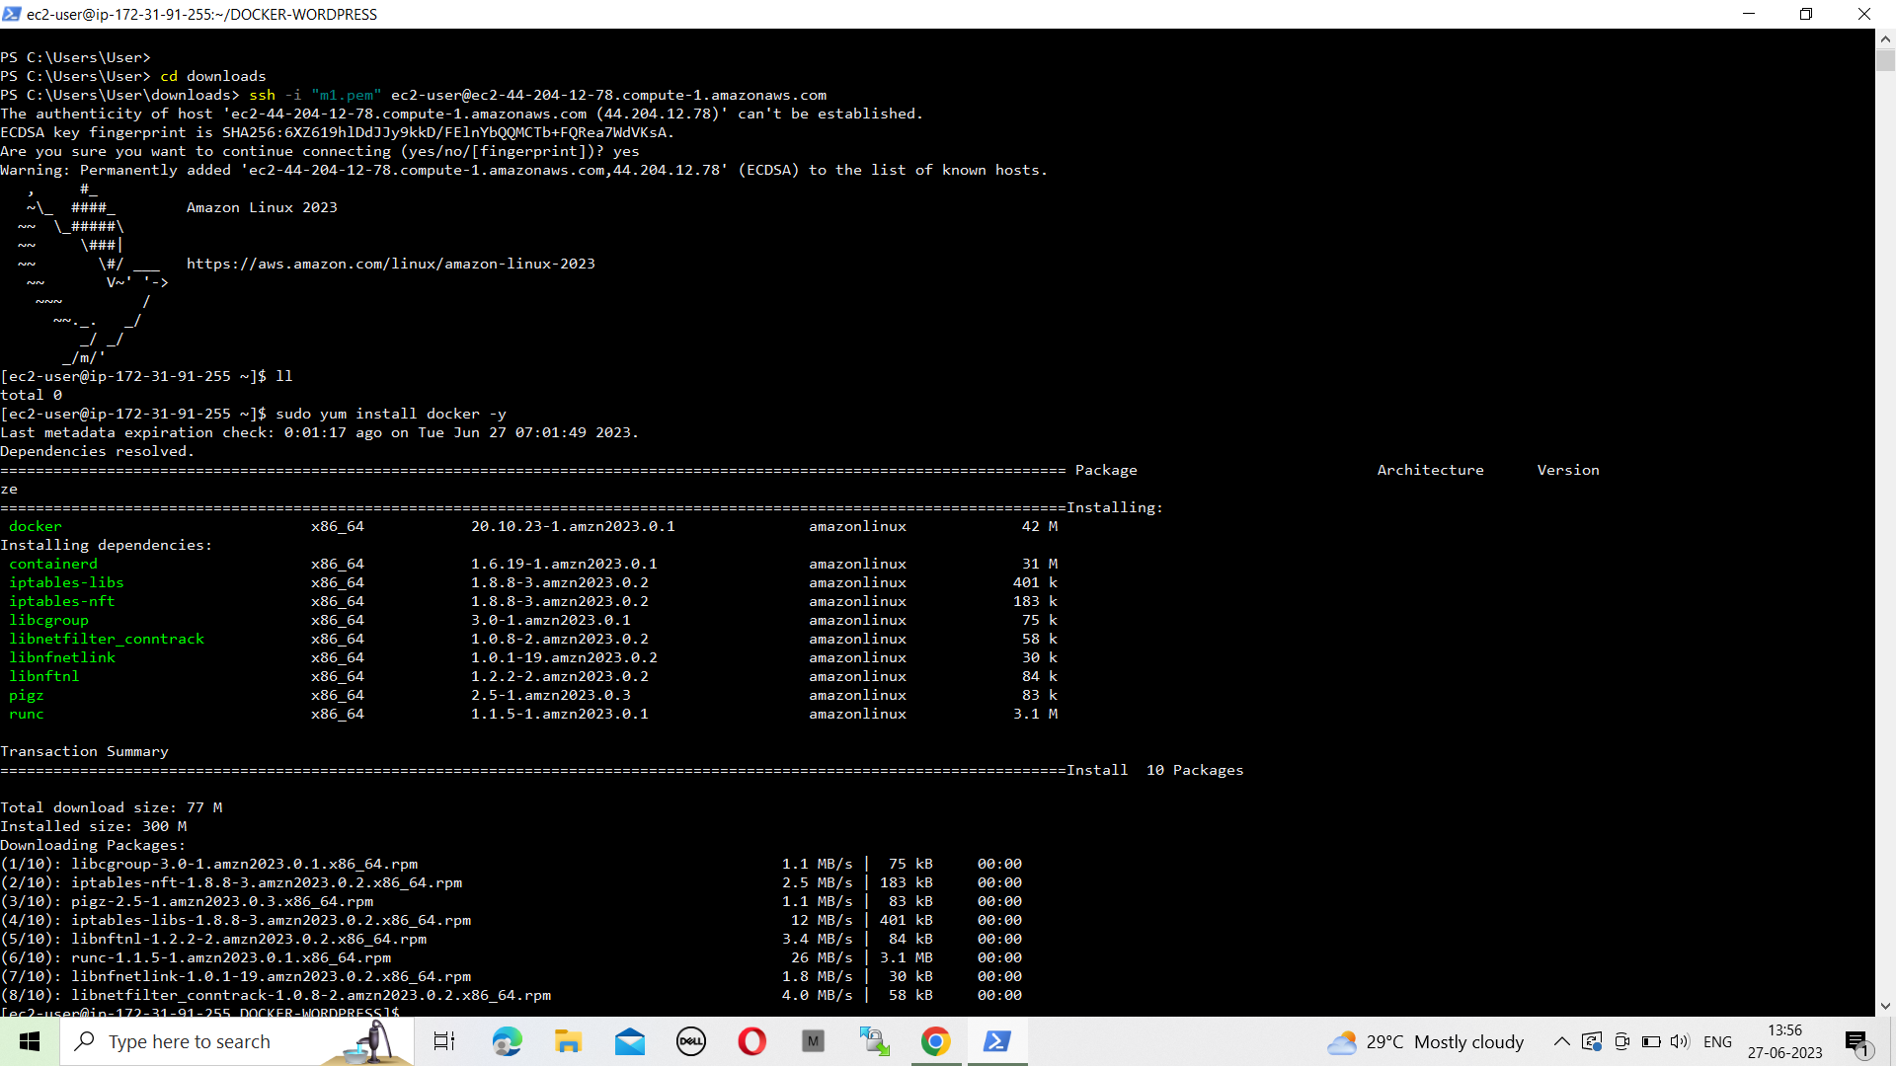

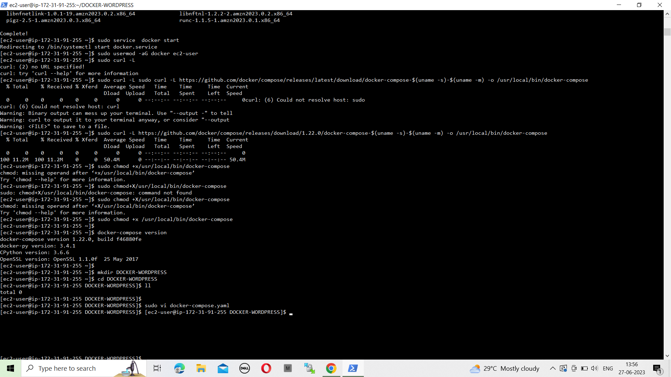

**Step -8:** Edit yaml file with vi command. write Database and WordPress configurations in the yaml file and save the file.

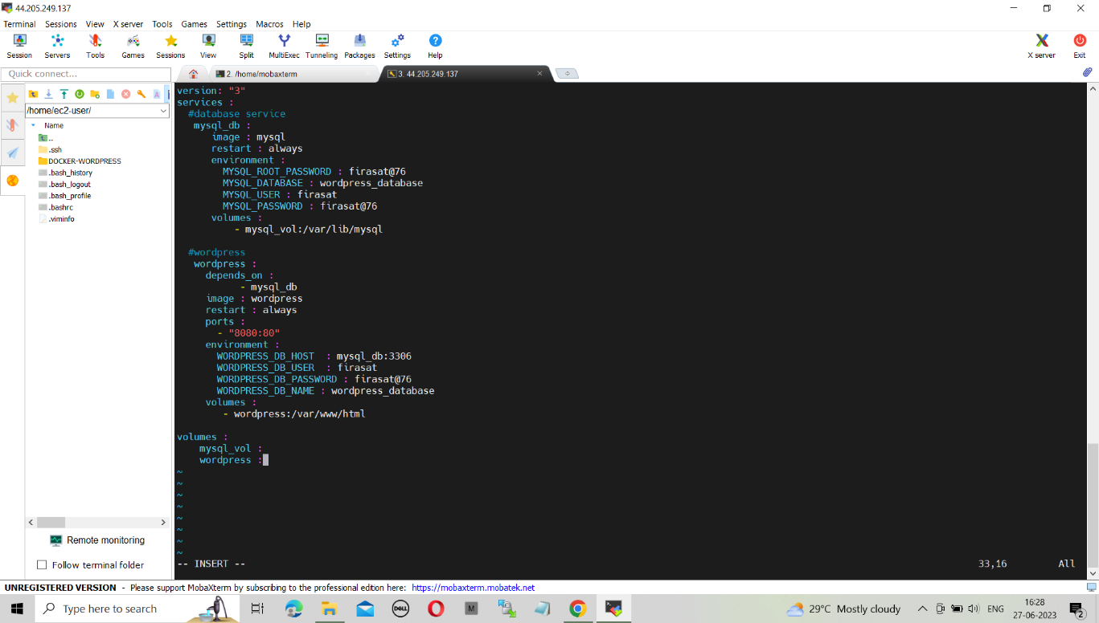

**Step -9:** After creating a yaml file start the container by executing below command.

Command: Docker-compose up -d

* Two container will start one for MYSQL and another for WordPress.

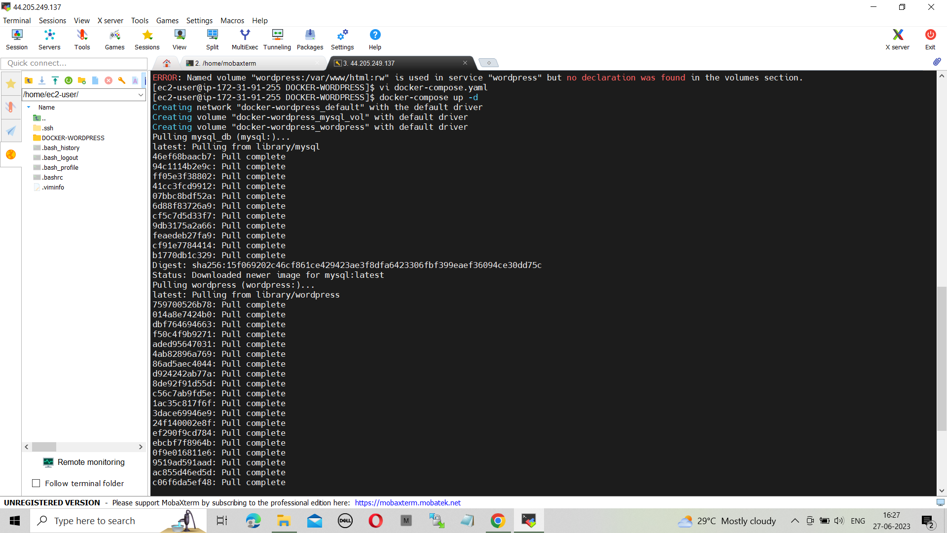

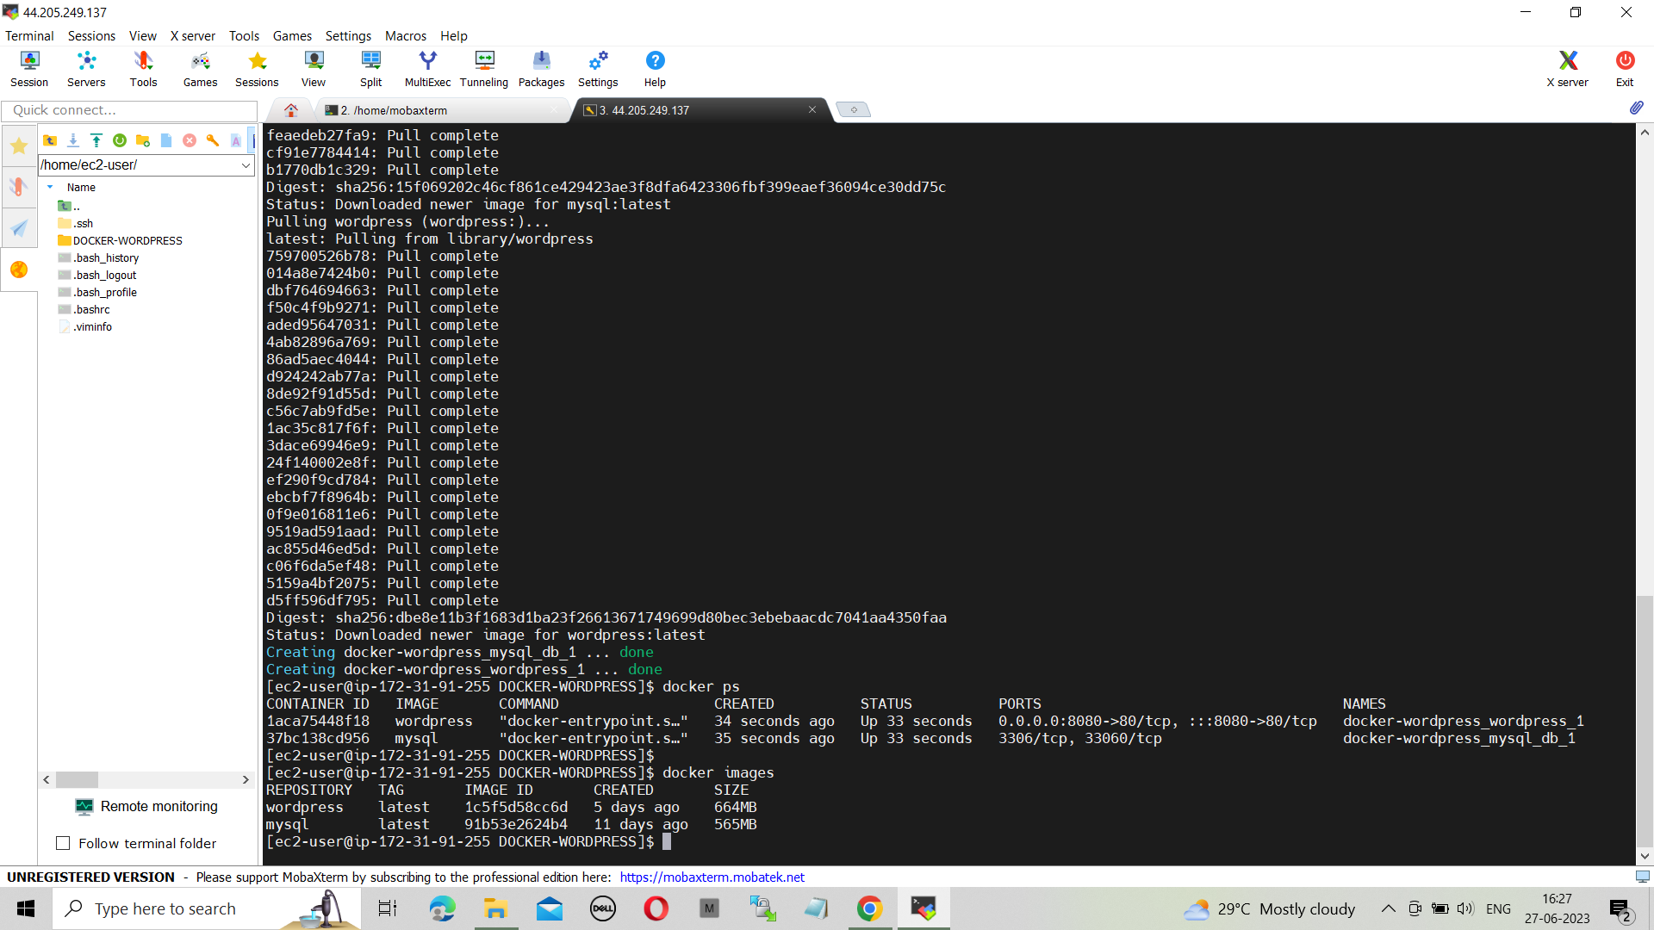

**Step -10:** After executing docker-compose up command, browse the instance public Ip with 8080 port to check WordPress output.

