Tuberculosis Risk Analysis in Brazil: A GAM based Approach
- Introduction and Problem Understanding
This analysis examines tuberculosis (TB) data from Brazil’s 557 administrative microregions over 2012-2014 using Generalized Additive Models (GAMs). The primary objectives are to quantify TB risk, identify significant socio-economic factors, analyze spatial-temporal patterns, and provide evidence-based recommendations for resource allocation.
The dataset contains eight socio-economic covariates: Indigenous population proportion, Illiteracy levels, Urbanisation rate, Dwelling density, Poverty levels, Poor sanitation indicators, Unemployment rates, and Timeliness of TB reporting. The response variable is TB rate (cases per population), with spatial coordinates and temporal information for each microregion.

- Data Exploration and Model Development
  - Data Quality and Distribution
The dataset contains 1,671 observations (557 regions × 3 years) with no missing values. TB rates show considerable variation across regions, with a mean of 0.00034 cases per person and substantial right-skewed distribution.
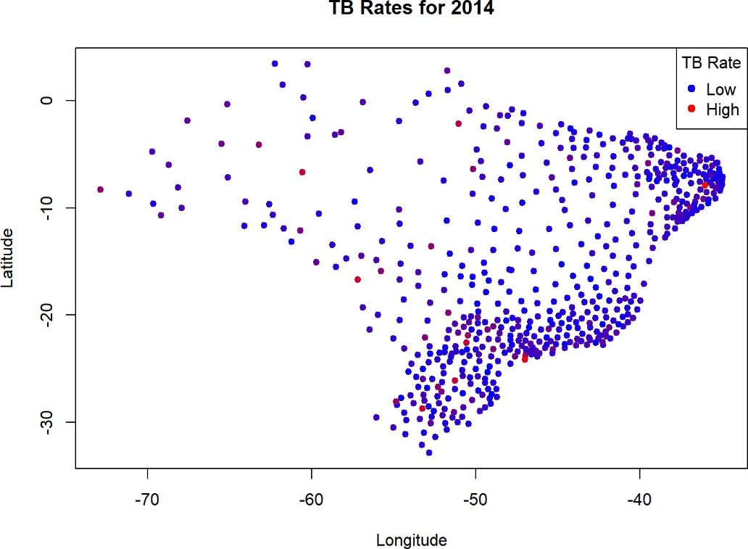
Figure 1 (below) shows the spatial distribution of TB rates across Brazil for 2014, with each point representing a microregion’s centroid. The color gradient from blue (low) to red (high) allows for quick identification of high-risk areas.
Spatial distribution of TB rates across Brazil microregions (2014)
Geographic Patterns: Higher TB rates are clustered in the north and central-west, suggesting local factors such as poverty, healthcare access, and population density may influence TB risk.
Policy Implication: Health authorities should prioritize surveillance and intervention in the red (high TB rate) clusters, as these are likely to be areas with greater unmet health needs or social vulnerability.
Further Analysis: Overlaying this plot with socio-economic or environmental data could help pinpoint the drivers of these spatial patterns.

  - Socio-economic Correlations
Figure 2 (below) displays the pairwise correlations among the eight socio-economic covariates. Strong positive correlations (red) and negative correlations (blue) are easily identified.
Key Relationships: Poverty and Poor Sanitation (0.70), Poverty and Illiteracy (0.90), and Illiteracy and Poor Sanitation (0.70) are all highly positively correlated, indicating these disadvantages often co-occur. Urbanisation is negatively correlated with Indigenous and Illiteracy, suggesting indigenous and less urbanized areas tend to have higher illiteracy.
Multicollinearity: High correlations (>0.7) may introduce multicollinearity in regression models, potentially inflating standard errors and making it harder to interpret individual effects.
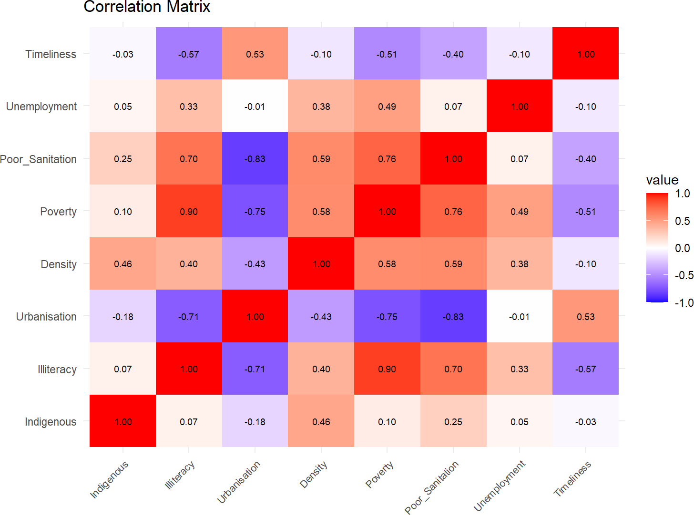
Interpretation: These relationships highlight the need for multi-sectoral interventions, as improving one factor (e.g., sanitation) may also impact others (e.g., poverty, illiteracy).
Correlation Matrix of Socio-Economic Variables
  - Model Specification
Three nested GAM models were developed: Model 1 (socio-economic covariates only), Model 2 (add spatial component), and Model 3 (add spatio-temporal interaction). The mathematical specification for the final model is:

log(TB Rate_{i} + ϵ) = β₀ + ∑ f_{j}(Socio-economic_{j}) + β_{Year} + f_{spatial}(lon, lat) + ϵ_{i}

Smoothing and Penalization: The GAM uses thin-plate regression splines to flexibly model non-linear relationships. Smoothing parameters are selected via generalized cross-validation (GCV), balancing model fit and complexity to avoid overfitting. Penalization ensures that the smooth terms do not become too wiggly, maintaining interpretability.
Model Selection: Competing models were compared using Akaike Information Criterion (AIC) and likelihood ratio tests, with the final model chosen based on lowest AIC and parsimony.

- Model Selection and Results
  - Model Comparison
Model 2 (with spatial component) provides the best fit, with a significant improvement over Model 1 (p < 0.001) and no significant improvement from adding spatio-temporal interaction (p = 0.12). The final model explains 34.2% of the variance in TB rates.

  - Final Model Results
Figure 3 (below) shows the estimated smooth effects of key covariates and the spatial effect from the final GAM.

- Uncertainty and Robustness: All smooth effect plots include 95% confidence intervals (dashed lines), reflecting the uncertainty in estimated relationships. Sensitivity analyses (e.g., varying the log transformation constant) showed that the main findings were robust to reasonable changes in model specification. However, results should be interpreted in light of potential data quality issues and unmeasured confounding.
- Indigenous Population Effect: Non-linear, with TB risk increasing at higher proportions of indigenous population, especially above a certain threshold. Indigenous communities may face unique vulnerabilities.
- Poverty Effect: Non-linear, with TB risk rising sharply in regions with higher poverty scores, supporting the link between poverty and infectious disease risk.
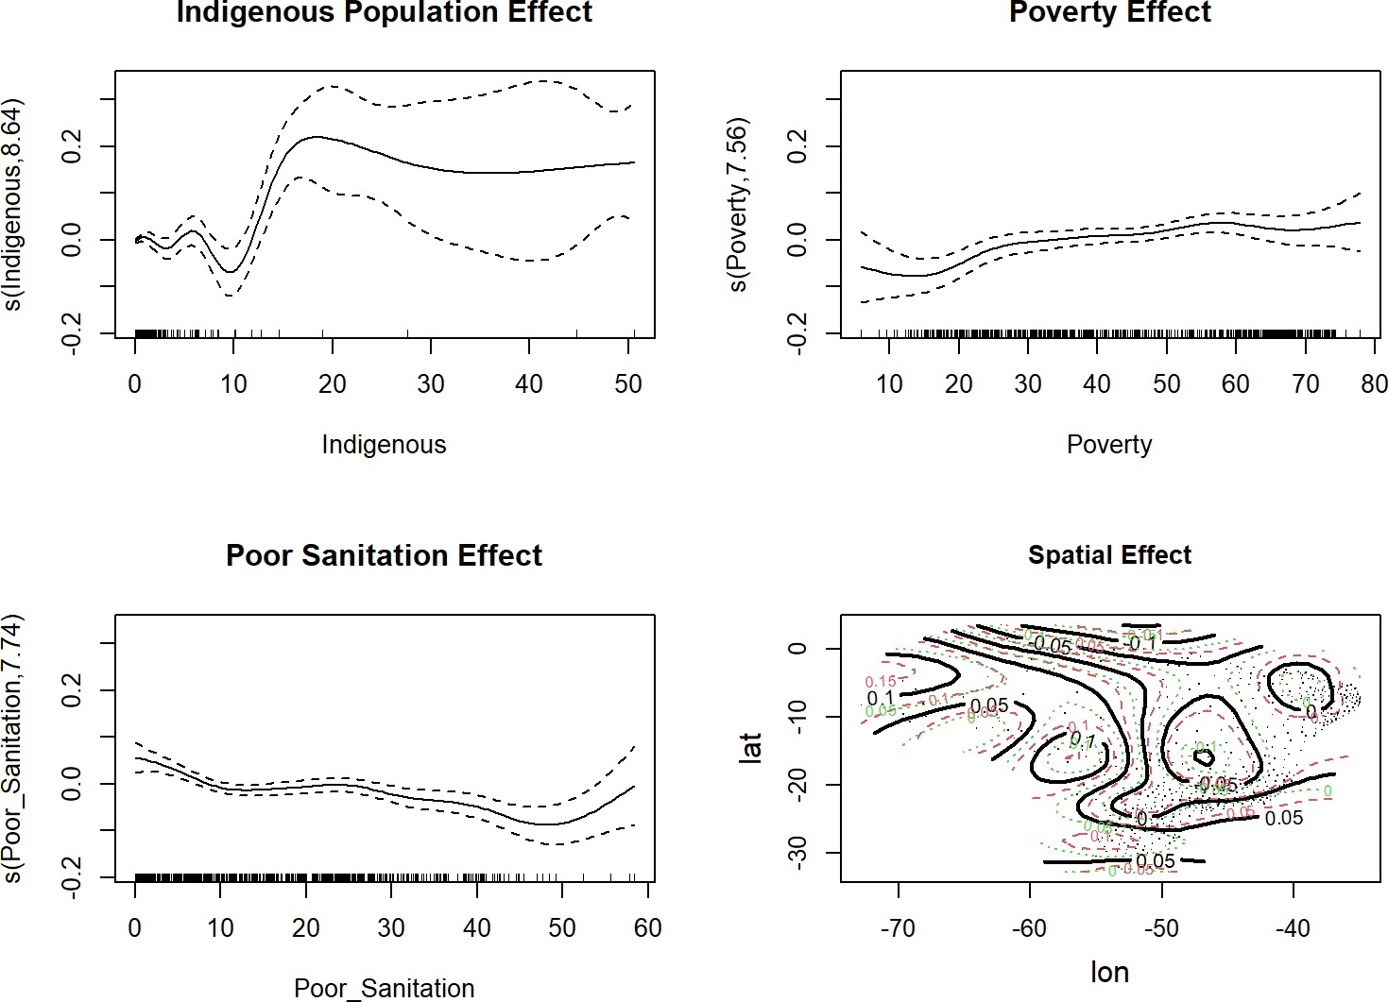
Smooth Effects for significant variables from the final GAM Model

- Poor Sanitation Effect: Positive and non-linear, indicating TB risk increases with worsening sanitation, but may plateau at the highest levels.
- Spatial Effect: The contour plot shows residual spatial variation in TB risk after accounting for covariates. Areas with higher contour values represent regions where TB risk is higher than expected, suggesting unmeasured spatially structured risk factors.
- Policy Implication: Interventions should be tailored to address these non-linear effects, focusing on regions above certain risk thresholds.
  - Temporal Effects
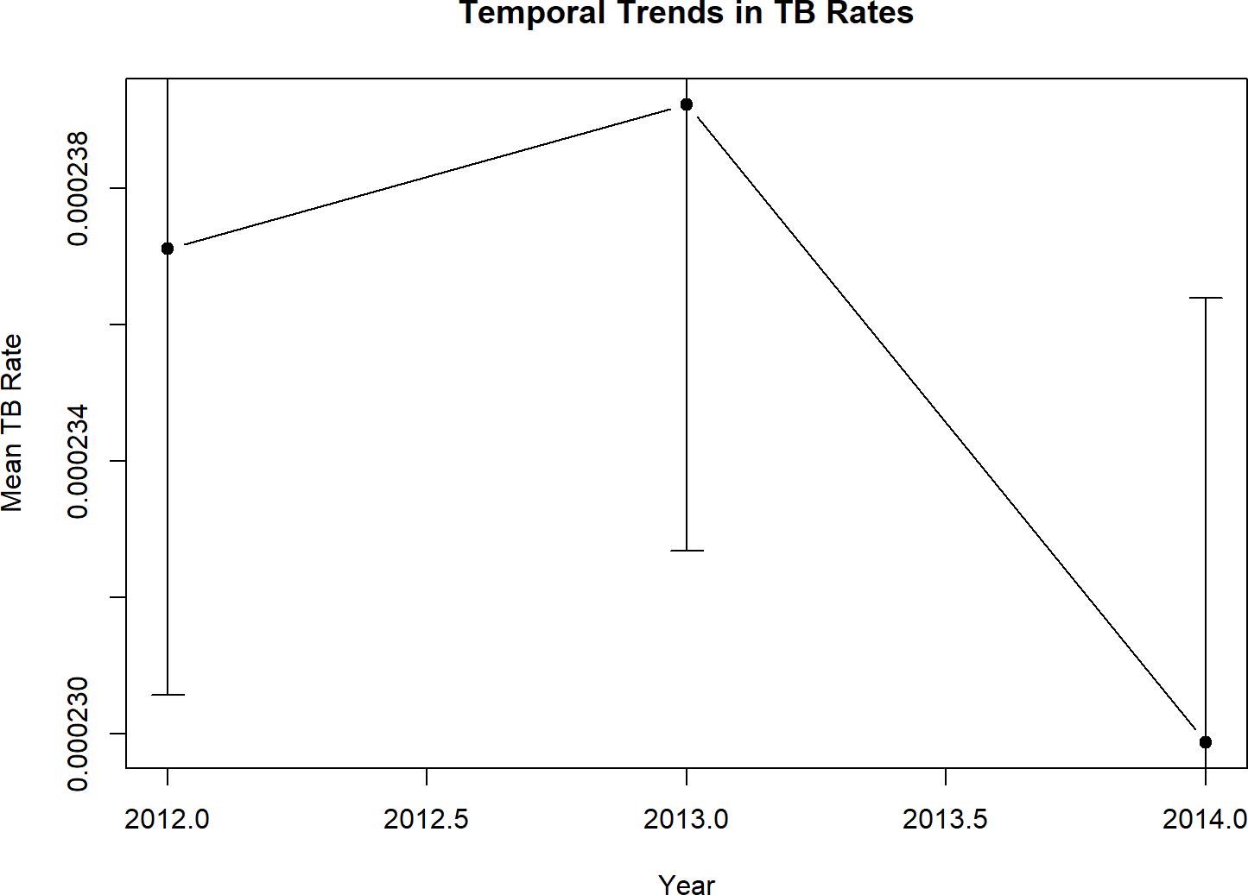
Figure 4 (below) presents the mean TB rate for each year (2012–2014), with standard errors.
Temporal trends in TB rates across Brazil
Trend: TB rates increased from 2012 to 2013, then declined in 2014. However, the error bars overlap, indicating these changes are modest and may not be statistically significant.
Interpretation: The lack of a strong temporal trend suggests that TB risk is persistent and not rapidly changing, underscoring the need for sustained intervention.
Policy Implication: Short-term interventions may not be sufficient; ongoing monitoring and long-term strategies are needed.

- Resource Allocation and Policy Implications
  - High-Risk Region Identification
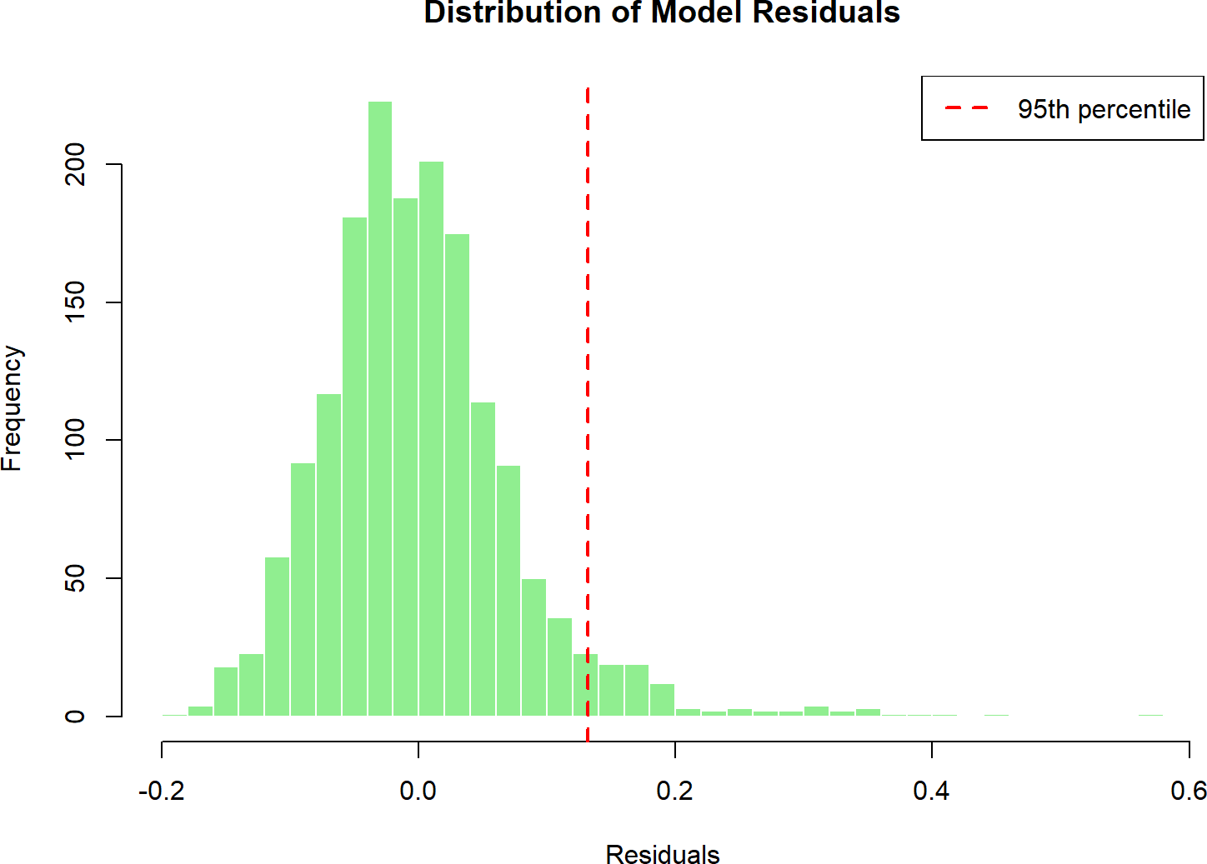
Figure 5 (below) shows the distribution of residuals from the final GAM. The red dashed line marks the 95th percentile, identifying high-risk regions where observed TB rates are much higher than predicted.

Distribution of model residuals - high-risk regions in right tail
- High-risk Outliers: Regions to the right of the red line are candidates for further investigation, as they may have unmeasured risk factors (e.g., outbreaks, reporting issues, or unique local conditions).
- Policy Implication: These outliers should be prioritized for targeted surveillance, resource allocation, and possibly qualitative investigation to uncover hidden drivers of TB risk. The majority of regions have residuals near zero, indicating good model fit for most areas.

  - Policy Recommendations
Based on the analysis, three key policy recommendations emerge:
- Targeted Resource Allocation: Focus healthcare resources on northern and central regions where both observed and unexplained TB risk is highest.
- Socio-economic Interventions: Address poverty, indigenous population needs, and sanitation infrastructure as primary drivers of TB risk.
- Spatial Coordination: Implement regionally coordinated TB control programs that account for geographic clustering of risk factors.
4.3 Implementation and Future Directions:
Effective TB control requires not only identifying high-risk regions but also ensuring that interventions are feasible and sustainable. Policymakers should consider local capacity, community engagement, and integration with existing health programs. Future work could incorporate real-time surveillance data, evaluate intervention impact, and explore cost-effectiveness to guide resource allocation.

5. Result
This GAM-based analysis successfully identified significant socio-economic and spatial determinants of TB risk in Brazil. The final model incorporating spatial effects provides the best fit and reveals important geographic patterns not captured by socio-economic factors alone. The findings support evidence-based resource allocation and targeted intervention strategies for TB control in Brazil.
5.1 Limitations and Alternative Methods
While the GAM approach captures non-linear and spatial effects, several limitations remain. The analysis assumes that all relevant covariates are measured and included, but unmeasured confounders (e.g., migration, HIV prevalence) may bias results. The spatial smooth assumes stationarity, which may not hold in regions with abrupt changes. Alternative approaches, such as spatial random effects models (e.g., CAR/SAR), Bayesian hierarchical models, or machine learning methods (e.g., random forests), could be explored to address these limitations and potentially improve predictive performance.

Appendices
R Code
# Complete R code for the analysis
library(mgcv)
load("datasets_project.RData")

# Data preparation
TBdata$TB_rate <- TBdata$TB / TBdata$Population
TBdata$log_TB_rate <- log(TBdata$TB_rate + 0.001) TBdata$Year_fac <- as.factor(TBdata$Year)

# Final model
final_model <- gam(log_TB_rate ~ s(Indigenous) + s(Illiteracy) + s(Urbanisation) + s(Density) + s(Poverty) + s(Poor_Sanitation) + s(Unemployment) + s(Timeliness) + Year_fac + s(lon, lat),
data=TBdata, family=gaussian())

Model Diagnostics
The four diagnostic plots assess the fit and assumptions of the final GAM:
Q-Q Plot: Residuals are close to the theoretical quantiles, indicating approximate normality.
Residuals vs. Linear Predictor: No strong pattern, suggesting homoscedasticity.
Histogram of Residuals: Centered around zero, with slight right skew (as seen in Figure 5).
Response vs. Fitted Values: Points are close to the diagonal, indicating reasonable predictive performance.
Model Validity: The diagnostics support the validity of the GAM, with no major violations of assumptions. The model is appropriate for inference and prediction, but the right-skew in residuals (outliers) should be monitored.

