IEEE 1016: Software Design Specification

The Software Design Specification for EXE Computer Science club website

1. Purpose of Website

Provide information to prospective students who are interested in joining the EXE Computer Science club at Texas State, to current EXE club members, and Texas State staff/Administration. Communication between existing club members and potential members is a vital role that must be accomplished, and is intended to be accomplished through use of this website. Club members can benefit from being notified of upcoming events, career services for Club Member's field of interest, and using the site as a facilitated form of communication.

2. Revision History

Name | Date | Reason For Changes | Version
Trey Dalziel | 11/10/2015 | Initial version. | 1.0
Trey Dalziel | 11/10/2015 | Added Events design | 1.1
Firdaus Botirzoda | 11/11/2015 | Added Project's page design | 1.2
Firdaus Botirzoda | 11/11/2015 | Added Forum's page design | 1.3
Jie Zhou | 11/11/2015 | Added Officer's page design | 1.4
Raul Zuniga | 11/16/2015 | Added 5.1.0 for Global, Right Side &Footer Navigation design.  Added 5.1.1 Home page design Added 5.1.5 Join page design.  Added site map to section 5.1  Added screen shots of pages. | 1.5
Antonio Villegas | 11/16/2015 | Added Responsive Design  Added examples of responsive web design | 1.6
Trey Dalziel | 11/19/2015 | Added 5.1.9 Constitution page  Added 5.1.9 traceability matrix | 1.7

3. Scope of the development project

The system will provide information about the Exe Club and its activities. The scope of the site will include information about the club, its constitution and ongoing projects. Free and paid member online registration will be offered. As news and events change news and calendar events will be delivered dynamically. Career opportunities and job skill enhancement will be addressed. A discussion board or forums will address specific topics of interest to the club and offer a platform for communication. The system will include a relational database containing member, news, and event and discussion information.
The benefits of the site will include topical information to those interested in computer science and computer information systems. Opportunities for skill enhancement and social interaction will be promoted. The system will connect to social media such as Facebook and Twitter to allow the club to communicate with its members in real time. The site will provide a sense of community to the students and its supporters outside of the classroom.

4. References

Texas State Computer Science Club. n.d. 6 October 2015. <http://exe-txst.weebly.com/>.
IEEE. IEEE Std 1016-2009 IEEE Recommended Practice for Software Design Document. Prod. IEEE Computer Society. 1998.

5. System Design description
5.1 Overview of web pages
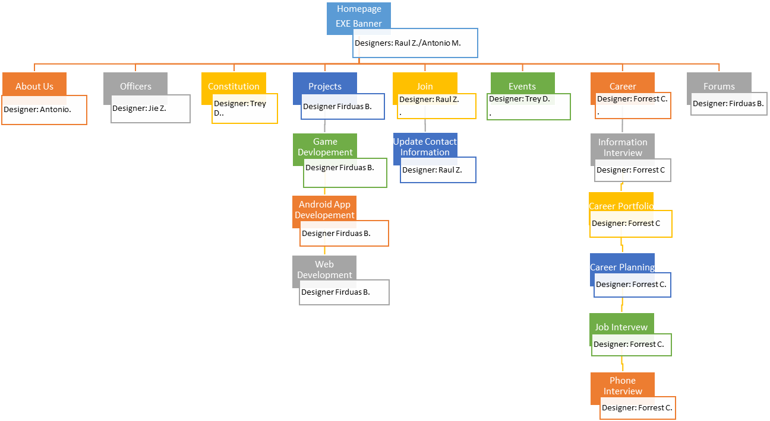

5.1.0 Global Right Side Navigation and Footer

Technical Requirement ID | Test Case ID | Functional Requirement Description | Priority | Type
4.1.1.1 | 1 | The logo of the Exe Club will be displayed in the top left of each page of the site | Should | Interface
4.1.1.2 | 2 | There shall be a link to the Home page in a global navigation bar for each page. | Shall | Functional
4.1.1.3 | 3 | There shall be a link to the About Us page in a global navigation bar for each page. | Shall | Functional
4.1.1.4 | 4 | There shall be a link to the Constitution page in a global navigation bar for each page. | Shall | Functional
4.1.1.5 | 5 | There shall be a link to the Projects page in a global navigation bar for each page. | Shall | Functional
4.1.1.6 | 6 | There shall be a link to the Join Us page in a global navigation bar for each page. | Shall | Functional
4.1.1.7 | 7 | There shall be a link to the Events page in a global navigation bar for each page. | Shall | Functional
4.1.1.8 | 8 | There shall be a link to the Forums page in a global navigation bar for each page. | Shall | Functional
4.1.1.9 | 9 | There shall be a link a login screen in a global navigation bar for each page. | Shall | Functional
4.1.2.1 | 10 | There shall be an e-mail icon displayed | Shall | Interface
4.1.2.2 | 11 | The user's email client will be invoked when the e-mail icon is clicked | Shall | Functional
4.1.2.3 | 12 | The EXE contact will be listed in the email header | Shall | Functional
4.1.2.4 | 13 | There will be a Facebook icon displayed | Shall | Interface
4.1.2.5 | 14 | When the Facebook icons clicked, it will take you to their Facebook page | Shall | Functional
4.1.2.6 | 15 | There shall be a list of events with their dates and times displayed.
4.1.3.1 | 16 | A footer navigation bars shall will be on each page on the sit | Should | Functional
4.1.3.2 | 17 | Copyright information will displayed in the footer | Should | Functional

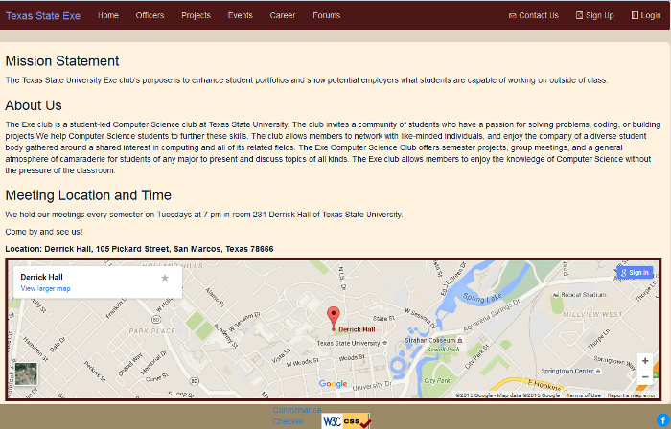

At the top of each page of the site will be a global navigation bar. The content will be created in HTML5 and styled with CSS and Twitter Bootstrap library. In the left side of the global navigation bar will be the club logo which was already completed and provided to us. In the global navigation bar will be an unorderedlist.

In the list will be the following links to the following pages:
- A link to the Home page
- A link to the About us page
- A link to the Constitution page
- A link to the Projects page
- A link to the Join Us page
- A link to the Events page
- A link to the Forums page
- An e-mail icon will be displayed and when the user clicks on it it will invoke the user’s email client by default (whatever software the user has the machine set up to use for their e-mail). The EXE contanct will be automatically listed in the email’s header.

On the right side of each page will be a navigation bar. The content will be created in HTML5 and styled with CSS and Twitter Bootstrap library. There will be a Facebook icon displayed and when it is clicked it will take you to the EXE Facebook page. There will also be a list of events in the right side navigation bar. The event, it’s time, and date will be displayed. On the bottom of every page will be a footer. The content will be created in HTML5 and styled with CSS and Twitter Bootstrap library. It will contain copyright information for the site.

5.1.1 Home page

4.2.1.1 | 18 | On the home page there shall be images displayed of different activities of the group that will be displayed on the page for a few seconds | Should | Interface
4.2.1.2 | 19 | On the home page a new image shall be rotated in to replace the previous image after three seconds | Should | Interface
4.2.1.3 | 20 | On the home page a brief descriptions of the Exe Club's mission statement will be displayed in a paragraph | Shall | Interface

The content of the home page will be written in HTML5 and will be styled with CSS and Twitter Bootstrap library. At the top of the home page will be a carousel implemented with Twitter Bootstrap library, CSS, HTML. It will display images of different club activities of the group. Each image will be displayed on the the page for just a few seconds before the next image is slided in. The carousel wil automatically slide but it can be done manually as well. Underneath the carousel the home page will have a paragraph with the club's mission statement.

using Twitter Bootstrap will allow the page to be responsive and and work with different screen resolutions including desktop, tablet, and mobile phone.

5.1.2 About us page

4.3.1.1 | 21 | On the About Us page it will contain information about the Texas State Computer Science Club | Shall | Interface
4.3.1.2 | 22 | On the About Us page it will display dates and times of the meetings. | Shall | Interface
4.3.1.3 | 23 | On the About Us page a google map will show the location of Derrick Hall | Shall | Functional

5.1.3 Officers page

4.4.1.1 | 24 | The officers page shall contain pictures of the officers | Shall | Interface
4.4.1.2 | 25 | The officers page shall contain each officers joined date. | Shall | Interface
4.4.1.3 | 26 | The officers page shall contain information about each officers position | Shall | Interface
4.4.1.4 | 27 | The officers page shall list each officers achievements | Shall | Interface

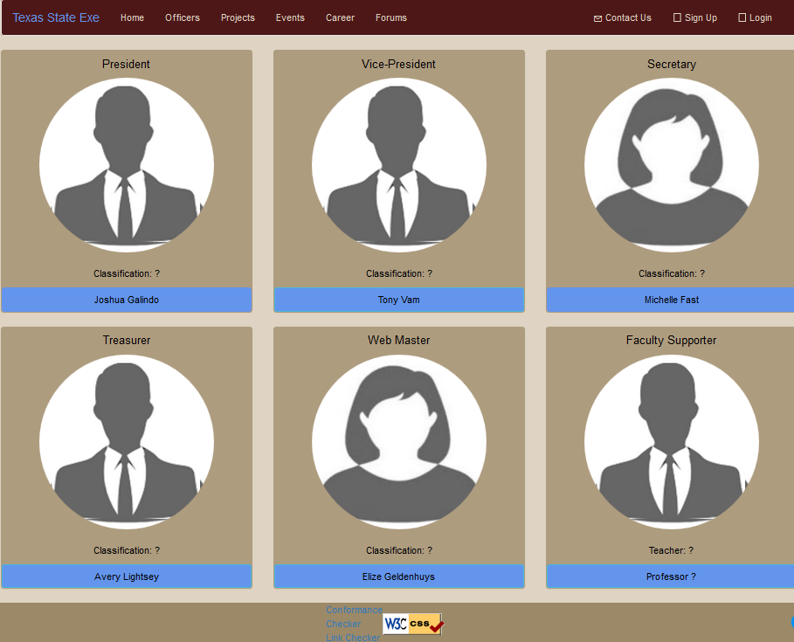

This page will display officers` information, on the left upper corner of this page, there will be a picture of the offer, right side next to the picture will display this offer`s information such as the full name, position and joined date. on the lower side where below the picture will show some description and all the officer`s achievements. on the very bottom, there will be two arrow icon which link to next or previous officer`s page. This page is developed using HTML for showing the picture and the information for the officers, and CSS for the style and layout, using bootstrap to let page responsive to different screen resolutions.

5.1.4 Projects page

4.6.1.1 | 31 | The Projects page shall contain an image that is a link to Game Development page | Shall | Functional
4.6.1.2 | 31 | The Projects page shall contain a description underneath the imageof the Game Development group | Shall | Interface
4.6.1.3 | 32 | The Projects page shall contain an image that is a link to the Android Application Development page. | Shall | Functional
4.6.1.4 | 33 | The Projects page shall contain a description underneath the image of the Android Application Development group. | Shall | Interface
4.6.1.5 | 34 | The Projects page shall contain an image that is a link to the Web Development page | Shall | Functional
4.6.1.6 | 35 | he Projects page shall contain a description underneath the image of the Web Development group | Shall | Interface
4.6.1.7 | 36 | The Projects page shall contain an image that is a link to the Program Development page | Shall | Functional
4.6.1.8 | 37 | The Projects page shall contain a description underneath the image of the Program Development group | Shall | Interface
4.6.2.1 | 38 | In the Projects page there shall be a link to the Game Development page in a left side navigation bar. | Shall | Functional
4.6.2.2 | 39 | In the Projects page when Game Development link is clicked, it takes the user to the Game Development page | Shall | Functional
4.6.2.3 | 40 | In the Projects page there shall be a link to the Web Development page in a left side navigation bar | Shall | Functional
4.6.2.4 | 41 | In the Projects page when the Web Development link is clicked, it takes the user to the Web Development page | Shall | Functional
4.6.2.5 | 42 | In the Projects page there shall be a link to the Program Development page in a left side navigation bar | Shall | Functional
4.6.2.6 | 43 | In the Projects page when the Program Development link is clicked, it takes the user to the Program Development page | Shall | Functional
4.6.2.7 | 44 | In the projects page there shall be a link to the Android Development page in a left side navigation bar | Shall | Functional
4.6.2.8 | 45 | In the Projects page when the Android Development link is clicked, it will take the user to the Android Application Development page | Shall | Functional

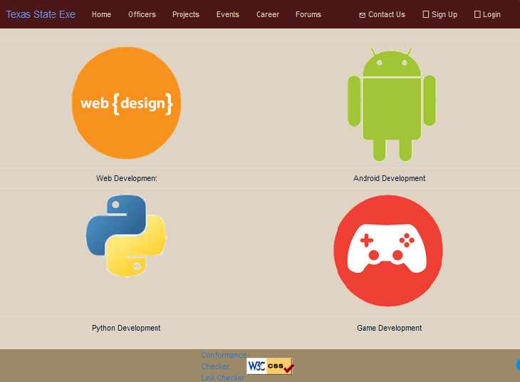
The projects page will contain an image that is a link to another page. The page is implemented using Twitter's bootstrap library. Bootstrap helps the page to be more responsive. For example, if project's page is accessed using a mobile phone, it will only show a list of the links for each project's page instead of a picture, since the image would be too large to display. There will be a left side navigation bar, which will contain links to each project's page at any given time within the project's folder. That will include Android, Web, Python and Game development links. Each project's page will contain a detailed description of the project, which will be hardcoded in the HTML file, since the description will be static most of the time. Besides using bootstrap, the project's page will use CSS for its design.

5.1.4.1 Game development subpage

4.6.3.1 | 46 | The Game Development page will contain information about the Game Development group | Shall | Interface

5.1.4.2 Android application development subpage

4.6.4.1 | 47 | The Android Development page will contain information about the Android Application Development group | Shall | Interface

5.1.4.3 Web development subpage

4.6.5.1 | 48 | The Web Development page will contain information about the Web Development group | Shall | Interface

5.1.4.4 Program development subpage

4.6.6.1 | 49 | The Program Development page will contain information about the Program Development group | Shall | Interface

5.1.5 Join page

4.7.1.1 | 50 | The Join page shall contain a HTML form for a person to enter information | Shall | Functional
4.7.1.2 | 51 | The Join page shall contain a header stating that the purpose of the form is for membership signup | Shall | Functional
4.7.1.3 | 52 | The Join page shall contain an input for entering the first name | Shall | Functional
4.7.1.4 | 53 | The Join page shall require the first name input | Shall | Functional
4.7.1.5 | 54 | The Join page shall contain an input for entering the middle initial | Shall | Functional
4.7.1.6 | 55 | The Join page shall contain input for entering the last name | Shall | Functional
4.7.1.7 | 56 | In the Join page the last name input shall be required. | Shall | Functional
4.7.1.8 | 57 | The Join page shall contain an input for entering an email address | Shall | Functional
4.7.1.9 | 58 | The email address input will be required | Shall | Functional
4.7.1.10 | 59 | The Join page shall contain a drop down list, which specifies a major | Shall | Functional
4.7.1.11 | 60 | In the Join page the drop down list for major shall contain ‘computer science’ | Shall | Functional
4.7.1.12 | 61 | The Join page shall contain the drop down list for major shall contain ‘computer information systems’ | Shall | Functional
4.7.1.13 | 62 | The Join page shall contain the drop down list for major shall contain ‘other’ | Shall | Functional
4.7.1.14 | 63 | The Join page shall contain the drop down list for major shall contain ‘other’ | Shall | Functional
4.7.1.15 | 64 | In the Join page the drop down list for major shall contain ‘freshman’ | Shall | Functional
4.7.1.16 | 65 | In the Join page the drop down list for major shall contain ‘sophomore’ | Shall | Functional
4.7.1.17 | 66 | In the Join page the drop down list for major shall contain ‘junior’ | Shall | Functional
4.7.1.18 | 67 | In the Join page the drop down list for major shall contain ‘senior’ | Shall | Functional
4.7.1.19 | 68 | The Join page shall contain an input for the graduation date | Shall | Functional
4.7.1.20 | 69 | In the Join page the graduation date input will allow the user to type in the date | Shall | Functional
4.7.1.21 | 70 | In the Join page the graduation date input will allow the user to click the field and a calendar widget shall appear | Shall | Functional
4.7.1.22 | 71 | In the Join page the graduation widget shall graphically select the day, month, and year | Shall | Functional
4.7.1.23 | 72 | The Join page shall contain a drop down list, which specifies the size of a t-shirt. | Should | Functional
4.7.1.24 | 73 | In the Join page the drop down list for major shall contain ‘small’ | Should | Functional
4.7.1.25 | 74 | In the Join page the the drop down list for major shall contain ‘medium | Should | Functional
4.7.1.26 | 75 | In the Join page the the drop down list for major shall contain ‘medium | Should | Functional
4.7.1.27 | 76 | In the Join page the the drop down list for major shall contain ‘extra large’ | Should | Functional
4.7.1.28 | 77 | The Join page shall contain a Submit button | Shall | Functional
4.7.1.29 | 78 | The Join page shall contain a Reset button | Shall | Functional
4.7.1.30 | 79 | The Join page shall retain any information entered if the user navigates to another page and comes back before submitting the form | Shall | Functional
4.7.1.31 | 80 | In the Join page when Submit button is pressed the information in the required fields (first name, last name, and email) shall be validated for correct format. | Shall | Functional
4.7.1.32 | 81 | The Join page when the Submit button is pressed the form information will be stored | Shall | Functional
4.7.1.33 | 82 | The Join page when the Reset button is pressed, it will clear all input fields within the form | Shall | Functional

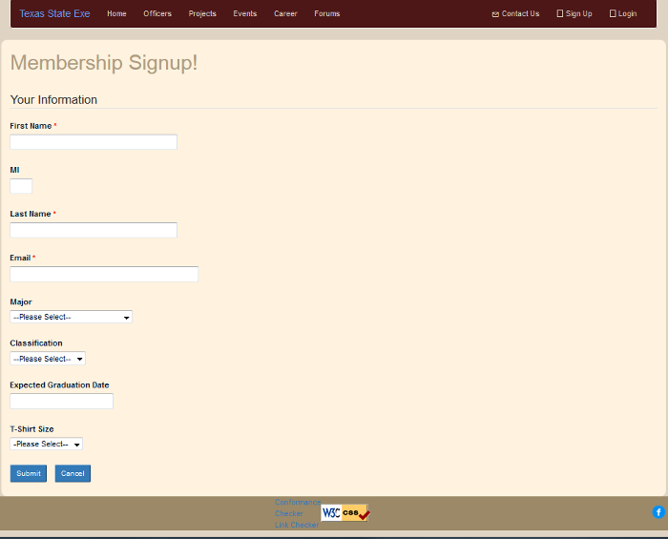

The join.html page will be written in HTML5 and will be styled with CSS and Twitter Bootstrap library. The join.html page shall contain a HTML5 form for a person to enter his information so he can become a member. There shall be a HTML5 header stating that the purpose of the form is for membership signup. The page shall contain the following inputs listed in the next table.

The design will try to allow the least amount of typing by the user to avoid errors in the data before it is put into a database which requires data integrity. HTML5 input for e-mail will be used since it is self-validating. There will three required inputs which will uniquely identify the member to the club; the first name, last name and e-mail address. The user will not be allowed to send the form unless those three fields are filled out.

Input | Child  Input | HTML5  type | Purpose | Required to be filled
first name |  | text | For entering first name | Yes
middle initial |  | text | For entering middle initial | No
last name |  | text | For entering last name | Yes
e-mail |  | e-mail | For entering e-mail address | Yes
major | computer science, computer information systems, other | drop down list | For specifying the classification | No
classification | freshman, sophomore, junior, senior | drop down list | For specifying the major | No
tshirt | small, medium, large, extra large | drop down list | For specifying tshirt size | No

When the Reset button is pressed the form will be cleared. If the Submit button is pressed it the information in the required fields will be validated for correct format by a JavaScript file. The data will then be sent to a server using the POST command to be stored in a database. If the user enters any information and navigate to another page and comes back before hitting the Send button the data in the form will be retained using an HTML5 feature called WebStorage.

5.1.6 Events page

4.8.1.1 | 83 | The Events page shall show based calendar with up upcoming events | Shall | Functional
4.8.1.2 | 84 | In the Events Page the calendar shall display names of upcoming events throughout the current month | Shall | Interface
4.8.1.3 | 85 | In the Events Page the calendar will show the name of the event in bold | Shall | Interface
4.8.1.4 | 86 | In the Events Page the calendar shall contain the event date | Shall | Interface
4.8.1.5 | 87 | In the Events Page the calendar shall show the name of the event creator | Shall | Interface
4.8.1.6 | 88 | In the Events Page the mouse over information shall show the time(s) of the event | Shall | Interface

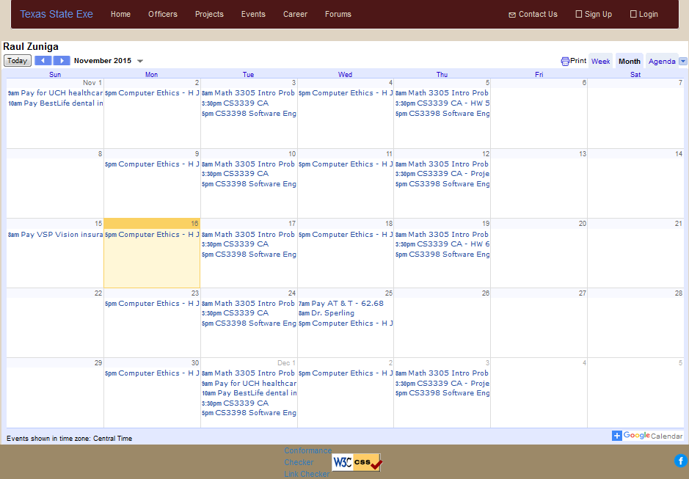

The events calendar is using Google Calendar API. The calendar that is displayed is from the club's Google account. The calendar is implemented with Twitter Bootstrap library. This makes the calendar to be responsive to different screen resolutions. Twitter Bootstrap allows switching to a different view on mobile phones. On mobile phones, an agenda is displayed rather than a large calendar to fit to the smaller display. The agenda lists the events of the calendar.
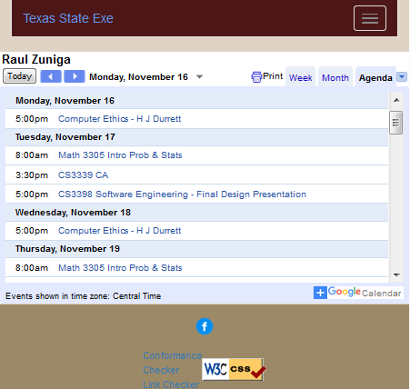

Each event on the calendar is to maintain five parameters, name of the event, event date, event creator, time of the event, and event location. Since Google calendar uses iframes, which cannot be made responsive using Bootstrap, CSS will be used to make an iframe responsive. Make a CSS class with a styling for the iframe, then call that class from the HTML file where the iframe is specified. The Google account shall be public in order display event information to everyone.

-page written in HTML5
-content embedded in an iframe that is put into the page
-styled with CSS3
-made responsive with Bootstrap library

5.1.7 Career page
4.9.1.1 | 89 | In the Careers page there shall be a text box containing information about Job fairs | Shall | Interface
4.9.1.2 | 90 | In the Careers page there shall be a text box containing information on other job opportunities. | Shall | Interface
4.9.2.1 | 91 | In the Careers page there shall be a text box containing information about how to build a resume that will stand out | Shall | Interface
4.9.2.3 | 92 | In the Careers page there shall be links to completed resumes/career portfolios from past members | Shall | Interface
4.9.3.1 | 93 | In the Careers page there will be a text box containing information on different career paths in the Computer Science field. | Shall | Interface
4.9.3.2 | 94 | In the Careers page there shall be a link to the Texas State Career Services page | Shall | Interface
4.9.3.3 | 95 | In the Careers page the link will be called "Career Planning". | Shall | Interface
4.9.4.1 | 96 | In the Careers page there shall be a text box containing tips and tricks about going into a job interview | Shall | Interface
4.9.4.2 | 97 | In the Careers page there shall be a text box containing information on how to properly conduct a phone interview. | Shall | Interface

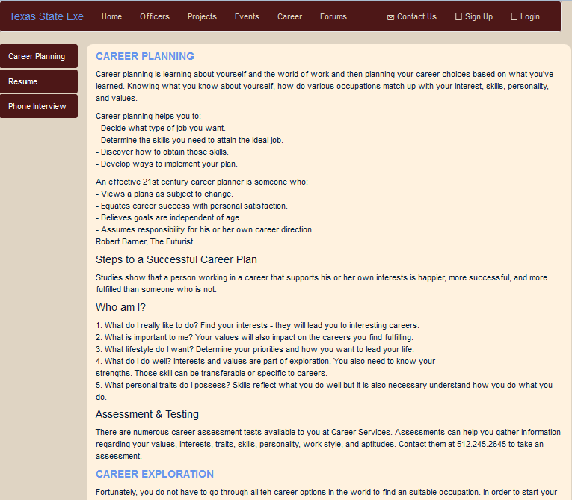

5.1.8 Forums page

4.10.1.1 | 98 | In the Forums page it shall contain links for each topic with a short description | Shall | Functional
4.10.1.2 | 99 | In the Forums page each topic will contain list of comments | Shall | Functional
4.10.1.3 | 100 | In the Forums page each comment will have username of the commenter and number of likes | Shall | Functional

The forums page will be build using front end and back end technologies. Front end will include using HTML, CSS and bootstrap to create and design the forms (i.e. a textbox that receives a comment), making the page interactive, and a back end, which includes the database. For the back end, there are two main technologies that will be used to implement it: MySQL and Node.js. MySQL is for storing and querying all the data to and from the database tables. Node.js is called a controller, which is used for front and back end interactions. A user must be logged in to be authenticated. The design pattern that we will be using is a model/view controller - reusable way of doing thing. The page will be very interactive, where each topics page will have comments updated frequently.
The figure below references an architecture design of the database, which shows an entity relationship diagram between a 'Comment' and 'Forum' entities.
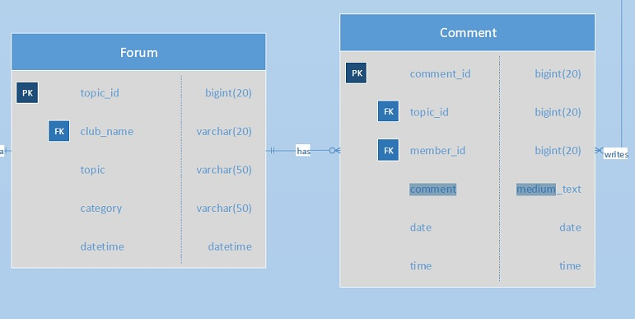

5.1.9 Constitution page

4.5.1.1 | 28 | The constitution page shall specify the club rules. | Shall | Interface
4.5.1.2 | 29 | The constitution page shall have a button for printing the constitution | Shall | Functional

The Constitution page will display the club rules in the center content of this page, there will be a picture of printer for printing the constitution. This page is developed using HTML for showing the picture and the information for the officers, and CSS for the style and layout, using bootstrap to let page responsive to different screen resolutions.

6. Responsive Design

This website includes fluid grids and media queries which are part of responsive design. Fluid grids are used to have consistent column width and media queries are used to adapt the layout of a page to conditions such as screen resolution of any device. Media queries are part of cascading style sheets (CSS). Responsive design provides different ways to access the content of this website. It does not matter if an individual is using a mobile phone browser or a desktop browser, the layout of the website will be adaptive and responsive. Every page of the website uses bootstrap, a front-end framework, which makes web page layouts more flexible. Bootstrap include JavaScript code which contain pagination, drop-downs, tabs, buttons, a navigation system and a photo carousel effect. The main reason to use responsive design is for the different experiences the users are going to be using to access the content; mobile, tablet, laptop, and desktop experiences.

