**IEEE 1016: Software Design Specification**

**CS4398 Online Multiplayer Game**

# Purpose of Website

Provide information to prospective students who are interested in joining the EXE Computer Science club at Texas State, to current EXE club members, and Texas State staff/Administration. Communication between existing club members and potential members is a vital role that must be accomplished, and is intended to be accomplished through use of this website. Club members can benefit from being notified of upcoming events, career services for Club Member's field of interest, and using the site as a facilitated form of communication.

# Revision History

|  |  |  |  |
| --- | --- | --- | --- |
| **Name** | **Date** | **Reason for Changes** | **Version** |
| Raul Zuniga | 3/2/2015 | Initial version. | 1.0 |
| Raul Zuniga | 3/2/2015 | Added Section 5.2 Class Diagram | 1.1 |
| Raul Zuniga | 3/2/2015 | Added Section 3 Project Scope | 1.2 |
| Raul Zuniga | 3/2/2015 | Add Section 4 References | 1.3 |

# Project Scope

The system will provide a fun, free, online first person shooter game experience. Only one person and two person games will be allowed. Multiple game sessions shall be allowed via a real-time connection mechanism. The user will only need to navigate to the URL and configure some settings and start a game from any personal computer, tablet or smart phone.

The game will be provided by a host server which will contain all the project files, a game engine called Impact.js, All maps and characters in the game will be provided by a level editor called Weltmeister that comes packaged with Impact.js. A Node.js controller running on the server, and a real-time connection using a web socket library called socket.io that is available with Node.js.

Players will start at one end of map and progress to the other end of the map where there is a portal they can enter to finish the level. There will be players in the map that can kill the player. The player will have to shoot and kill the enemies to allow him to progress towards the portal. As the player finished a level he will advance to the next level. As the player progresses through the levels of the game the difficulty of the game will get progressively harder. The system will not save the state of the game with the player quits the game. When the user plays the game again, the player will start at the beginning of the first level.

# References

# Davy Cielen, Arno Meysman. *HTML5 Game Development with ImpactJS*. Packt Publishing, 2013. <http://www.packtpub.com>.

Foundation, Node.js. *https://nodejs.org/en/*. 2016. March 2016.

Freeman, Jesse. *HTML5 Game Development*. Sebastopol: O'Reilly, 2012.

Szablewski, Dominic. *Impact - HTML5 Canvas & JavaScript Game Engine*. n.d. March 2016. <http://www.impactjs.com>.

# System Design description

## Architectural Design

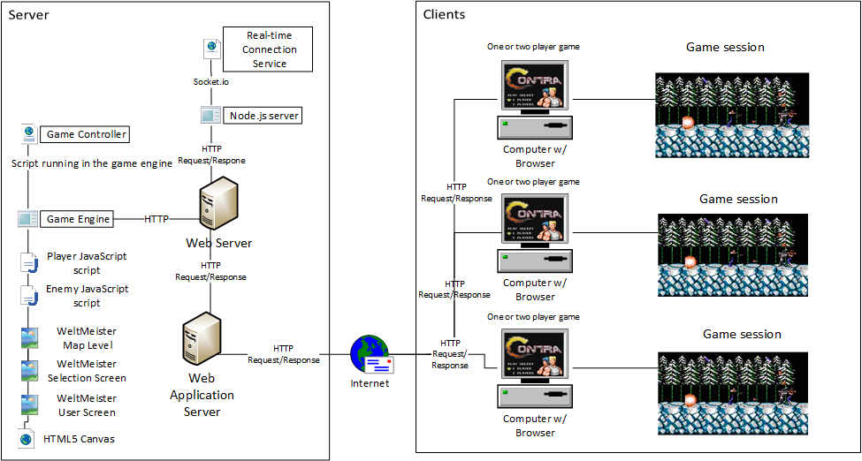

## Class Diagram

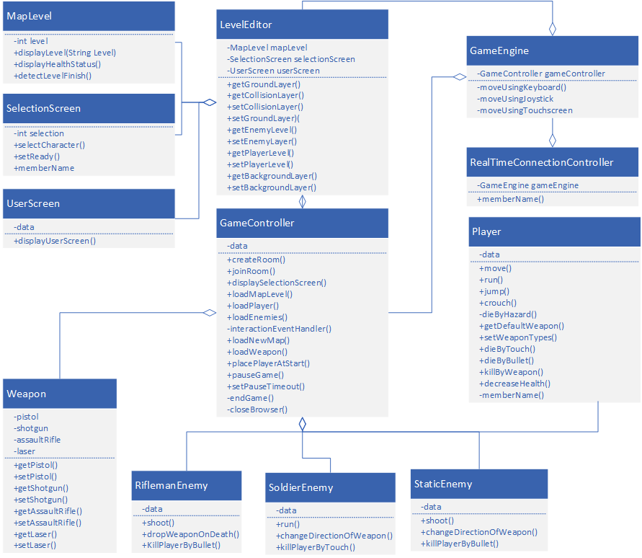

Figure 1 Class Diagram

## State Diagram Game Controller

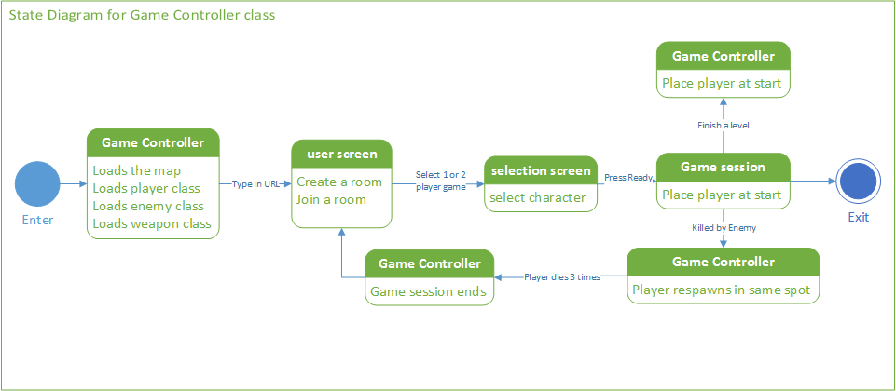

## Functional Requirements

### User Screen

|  |  |  |  |  |
| --- | --- | --- | --- | --- |
| **Technical Requirement ID** | **Test Case ID** | **Functional Requirement Description** | **Priority** | **Type** |
| 3.1.1 | 1 | In the User screen the input box for username will have system created username by default. |  | Interface |
| 3.1.2 | 2 | A User screen shall be the first screen displayed in the browser when the user types in the game URL and presses enter. |  | Functional |
| 3.1.3 | 3 | In the User screen the input box for username will have system created username by default. |  | Functional |
| 3.1.4 | 4 | The User screen shall have a selector to create a room for a one player game. |  | Functional |
| 3.1.5 | 5 | The User screen shall have a selector to join a room for a two-player game. |  | Functional |
| 3.1.6 | 6 | Creating a room takes the player to the Selection screen. |  | Functional |

### Starting a 1-player game

|  |  |  |  |  |
| --- | --- | --- | --- | --- |
| **Technical Requirement ID** | **Test Case ID** | **Functional Requirement Description** | **Priority** | **Type** |
| 3.2.1 | 7 | In the User screen the player starts a one-player game by selecting the selector for creating a room. |  | Functional |
| 3.2.2 | 8 | After the selector for creating a room is selected the Selection screen appears. |  | Functional |

### Starting a 2-player game

|  |  |  |  |  |
| --- | --- | --- | --- | --- |
| **Technical Requirement ID** | **Test Case ID** | **Functional Requirement Description** | **Priority** | **Type** |
| 3.3.1 | 9 | In the User screen two players can start a two-player game by selecting the selector to join a room. |  | Functional |
| 3.3.2 | 10 | After the selector for creating a room is selected the Selection screen appears. |  | Interface |

### Selection Screen

|  |  |  |  |  |
| --- | --- | --- | --- | --- |
| **Technical Requirement ID** | **Test Case ID** | **Functional Requirement Description** | **Priority** | **Type** |
| 3.4.1 | 11 | The Selection screen shall have a character select screen for each player. |  | Functional |
| 3.4.2 | 12 | The character select screen shall have an image of each character that can be selected by using an arrow button. |  | Functional |
| 3.4.3 | 13 | In the character select screen the image of the character will appear in color if there exists another player. |  | Interface |
| 3.4.4 | 14 | In the character select screen the image of the character will appear in black and white if there doesn’t exist another player. |  | Functional |
| 3.4.5 | 15 | In the Selection screen there shall be a button called “ready” to start the game. |  |  |
| 3.4.6 | 16 | In the Selection screen there shall be a “ready” button that will light up green after it’s clicked. |  | Functional |



Figure x Mockup of Selection Screen

### Starting a game

|  |  |  |  |  |
| --- | --- | --- | --- | --- |
| **Technical Requirement ID** | **Test Case ID** | **Functional Requirement Description** | **Priority** | **Type** |
| 3.5.1 | 17 | In the Selection screen the user starts a one-player game by pressing the “ready” button. |  | Functional |
| 3.6.1 | 18 | In the Selection screen the user starts a two-player game by pressing the “ready” button for a two-player game. |  | Interface |

### Creating a game session

|  |  |  |  |  |
| --- | --- | --- | --- | --- |
| **Technical Requirement ID** | **Test Case ID** | **Functional Requirement Description** | **Priority** | **Type** |
| 3.7.1 | 19 | Once the game is started by pressing the “ready” button for either a one-player or two-player game, the game engine loads the level map. |  | Interface |
| 3.7.2 | 20 | After the game session has been initiated and the level map loaded, the dependent game libraries are loaded. |  | Interface |
| 3.7.3 | 21 | The main game screen shall briefly display “Level 1” which indicates the current level of the game. |  | Interface |
| 3.7.4 | 22 | The game shall display the health indicator of the player during game play. |  | Interface |
| 3.7.5 | 23 | The player character(s) shall appear at the start of the map with default weapon loaded |  | Functional |
| 3.7.6 | 24 | The game engine will load enemy sprites. |  | Interface |
| 3.7.7 | 25 | Interaction events between enemy sprites and players will wait to be triggered by player movement. |  | Interface |

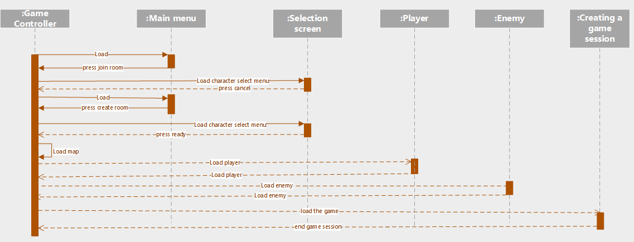

Figure x A game session sequence diagram

### Enemy Movement

|  |  |  |  |  |
| --- | --- | --- | --- | --- |
| **Technical Requirement ID** | **Test Case ID** | **Functional Requirement Description** | **Priority** | **Type** |
| 3.8.1 | 26 | Enemy classes shall move enemy sprites within the game. |  | Interface |
| 3.8.2 | 27 | Enemies will have autonomous movement. |  | Interface |
| 3.8.3 | 28 | The game shall allow enemy movement dependent on enemy type. |  | Interface |
| 3.8.4 | 29 | Riflemen-type enemies shall not be allowed to move. |  | Functional |
| 3.8.5 | 30 | Soldier-type enemies shall be allowed to move (run and jump) toward players. |  | Functional |
| 3.8.6 | 31 | Static-type enemies shall be allowed to change direction of their weapon toward a player but othewise may not move. |  | Functional |

### Enemy Combat

|  |  |  |  |  |
| --- | --- | --- | --- | --- |
| **Technical Requirement ID** | **Test Case ID** | **Functional Requirement Description** | **Priority** | **Type** |
| 3.9.1 | 31 | The game shall allow enemies to use various weapons but only one at a time. |  | Interface |
| 3.9.2 | 32 | The game shall allow the weapon type: pistol. |  | Functional |
| 3.9.3 | 33 | The game shall allow the weapon type: shotgun |  | Interface |
| 3.9.4 | 34 | The game shall allow the weapon type: assault rifle |  | Functional |
| 3.9.5 | 35 | The tame shall allow the weapon type: laser. |  | Interface |
| 3.9.6 | 36 | Each weapon will have different capabilities (bullets per shot, distance bullets travel, firing rate). |  | Functional |
| 3.9.7 | 37 | The enemy weapon shall be dropped upon enemy death. |  | Interface |
| 3.9.8 | 38 | The game shall allow enemies to kill a player. |  | Functional |

### Player Movement

|  |  |  |  |  |
| --- | --- | --- | --- | --- |
| **Technical Requirement ID** | **Test Case ID** | **Functional Requirement Description** | **Priority** | **Type** |
| 3.10.1 | 39 | An individual Player class shall move a player within the game. |  | Functional |
| 3.10.2 | 40 | Players will have autonomous movement within the game. |  | Functional |
| 3.10.3 | 41 | The player shall have the ability to run. |  | Functional |
| 3.10.4 | 42 | Each player shall have the ability to jump. |  | Functional |
| 3.10.5 | 43 | Each player shall have the ability to crouch. |  | Functional |
| 3.10.6 | 44 | The player shall die if player falls into a hazard such as a pit. |  | Functional |

### Player Combat

|  |  |  |  |  |
| --- | --- | --- | --- | --- |
| **Technical Requirement ID** | **Test Case ID** | **Functional Requirement Description** | **Priority** | **Type** |
| 3.11.1 | 45 | The default weapon for a player will be a pistol. |  | Functional |
| 3.11.2 | 46 | A player shall not possess more than one weapon at a time. |  | Interface |
| 3.11.3 | 47 | The PC user shall be able to shoot a weapon by pressing a key on the keyboard. |  | Interface |
| 3.11.4 | 48 | The mobile device user shall be able to shoot a weapon by touching a spot on the screen. |  | Interface |
| 3.11.5 | 49 | The player shall be able to kill an enemy by shooting it. |  | Interface |
| 3.11.6 | 50 | The player shall die if touched by enemy. |  | Functional |
| 3.11.7 | 51 | The player shall die if shot by an enemy with one bullet. |  | Functional |

### Player Completes a mission

|  |  |  |  |  |
| --- | --- | --- | --- | --- |
| **Technical Requirement ID** | **Test Case ID** | **Functional Requirement Description** | **Priority** | **Type** |
| 3.13.1 | 57 | The end of a map level shall be designated by a door or portal. |  | Functional |
| 3.13.2 | 58 | A player shall finish a map level by finding the exit portal and entering it. |  | Functional |
| 3.13.4 | 59 | A new map level will be loaded when a player finishes a map level. |  | Functional |
| 3.13.5 | 60 | A player will start a new level with only the default weapon (a pistol). |  | Functional |

### Game input devices

|  |  |  |  |  |
| --- | --- | --- | --- | --- |
| **Technical Requirement ID** | **Test Case ID** | **Functional Requirement Description** | **Priority** | **Type** |
| 3.14.1 | 61 | On a personal computer the user shall be able to move the player using a keyboard. |  | Functional |
| 3.14.2 | 62 | On a personal computer the user shall be able to move the player using a joystick. |  | Functional |
| 3.14.3 | 63 | On a tablet the user shall be able to move the player using the touchscreen. |  | Functional |
| 3.14.4 | 64 | On a mobile phone the user shall be able to move the player using the touchscreen. |  | Functional |
| 3.14.5 | 65 | On a mobile phone the user shall be able to move the player using the keyboard. |  | Functional |

### Pausing the game

|  |  |  |  |  |
| --- | --- | --- | --- | --- |
| **Technical Requirement ID** | **Test Case ID** | **Functional Requirement Description** | **Priority** | **Type** |
| 3.15.1 | 66 | The game will have a pause system to temporarily halt game progress. |  | Functional |
| 3.15.2 | 67 | For one-player games, the pause system shall have no timeout duration. |  | Functional |
| 3.15.3 | 68 | For two-player games, players shall not have the ability to pause. |  | Functional |

## Nonfunctional Requirements

### Response Time

|  |  |  |  |  |
| --- | --- | --- | --- | --- |
| **Technical Requirement ID** | **Test Case ID** | **Functional Requirement Description** | **Priority** | **Type** |
| 4.2.1 | 69 | The response time from the server shall be under 100 milliseconds. |  | Functional |
| 4.2.2 | 70 | The server shall be able to handle a maximum of 100 real-time connections. |  | Functional |
| 4.2.3 | 71 | The game should allow a minimum of 1 one-player and 1 two-player game to be played simultaneously. |  | Functional |
| 4.2.4 | 72 | The game shall support a minimum of two users at the same time. |  | Functional |